Laboratory Accreditation
Specification Validation Procedure
Traceability of dye solutions for
Wavelength check
Version 1.1

Date: December 1997
Written by: | Mr. Mathew, LI-E1
Authorized by: | Mr. Kolsch, LI-TG
Checked by: | Mr. Bamberg, LI-E1
Released by: | Mr. De Caluwé, LI-E

This sheet provides a Validation procedure to comply with the requirements of laboratory accreditation standards.

This sheet is an uncontrolled copy.

Laboratory Accreditation Spec. Validation Procedure
on Traceability of dye solutions for
Wavelength check

Content:

1 Purpose
2 Validity
3 General description & measuring theory
4 Traceability of the Validation Standards
4.1 Calibration hierarchy of photometer and photometric standards
5 Absorbence spectrum of wavelength dyes
6 Error Budget / Tolerance Zone
7 Literature
8 History of Changes

Purpose
This validation procedure describes the traceability chain and the error budgets for the dyes which are used for the validation of wavelength inaccuracy. Since the recipe for these solutions or the traceability chain can change, this procedure is valid for production lots listed under „Validity“ only.

Validity
This procedure is valid for the following solutions of production lots LOT 06 or higher

LOT | Solutions | Analyser
 | W480Y, W570B | all HITACHI analysers
LOT 05 | KW340Y, KW415B, KW450Y, KW505Y, KW40B, KW570B, KW660G, KW750B | KEYSYS
 | W480Y, W570B | all HITACHI analysers
LOT 06 | KW340Y, KW415B, KW450Y, KW505Y, KW40B, KW570B, KW660G, KW750B | KEYSYS
 | ES422B | ES300, ES600, ES700
table 1

General description & measuring theory
The dyes used for the wavelength check consist from different coloured solutions. The wavelenght/absorbence slope as well as the absorbence at the target-wavelength (to be measured on AUT*) of these solutions is known. Due to the steep wavelength/absorbence slope, a small change in wavelength results in an strong change of absorbence. The deviation from the target-wavelength is a function of the absorbence measured by AUT* and can be calculated by the reference-values delivered with the dyes (absorbence at target-wavelength and slope).
* AUT = Analyser Under Test

Traceability of the Validation Standards
All solutions are produced in a production environment where all equipment and production personnel is submitted to the requirements of GMP, FDA and ISO9001. The dyes are measured by a „SWEDISH NATIONAL LABORATORY“ (SP-Sveriges Provnings- och Forskningsinstitut, 15 Boras). The reference no’s. of the calibration certificates are listed in the packing inserts of each validation kit. The transmittance standard as well as the wavelength standard at SP are traceable to the „National Physical Laboratory, Great Britain“.

Calibration hierarchy of photometer and photometric standards

National Physical Laboratory
Great Britain

NBS Transmittance-Standard

HOLMIUM Wavelength-Standard

SP
Swedish National Testing
and Research Institute

Boehringer Mannheim GmbH

Liquid Wavelength Standards
W480Y, W570B, EW422B

AUT

Analyzer under Test

fig. 1

Absorbence spectrum of wavelength dyes

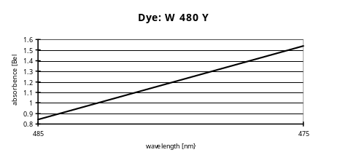 | 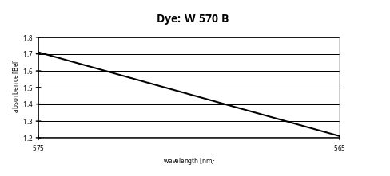
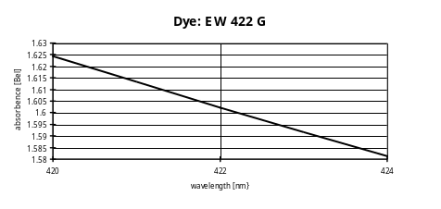 | 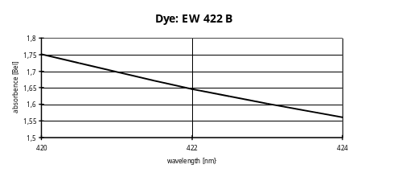
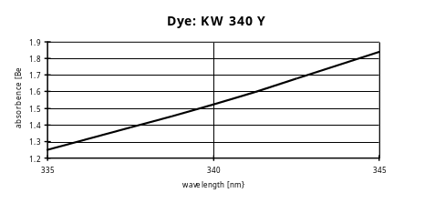 | 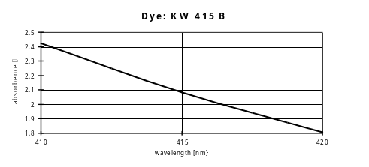
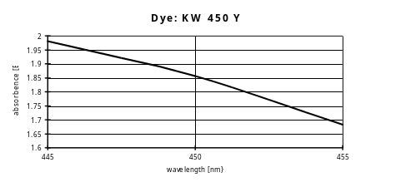 | 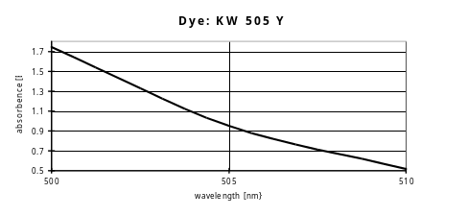
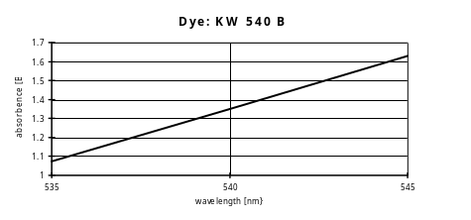 | 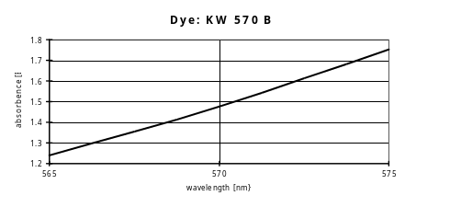
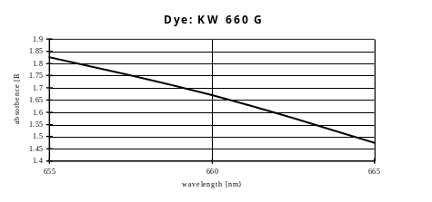 | 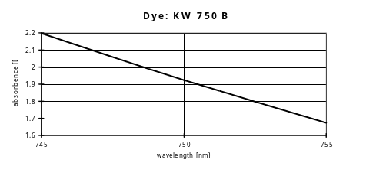

Error Budget / Tolerance Zone

The tolerance zone consists from the uncertainty of the validation method itself and the analysers uncertainty. The table below shows the total uncertainty for all analysers which can be checked by the dye solutions. Furthermore an analyser specific method-uncertainty is given. This uncertainty describes, for example, additional uncertainties which are caused by cuvettes on systems where no cuvette-blank for the elimination of the cuvette impact can be used.

For all analysers the medians of the measurements for each dilution step are used.

The tolerance zones are symmetrical. The total uncertainty G_{total} is specified as follows:
G_{total} = G_{analyzer} + u₁ + u₂ + u₃ + u₄

G_{total} = Total uncertainty
G_{analyzer} = specified analyser wavelength uncertainty
u₁ = absorbence instability of dye. A absorbence drift of the dye solution will lead to a error in the determination of wavelength deviation from target wavelength. The quantity of this error depends on the absorbence/wavelength slope of each individual dye solution. It can be calculated by multiplication of each absorbence error with the absorbence/wavelength slope, which is shown in table 1.
u₂ = wavelength uncertainty of reference photometer
u₃ = absorbence uncertainty of reference photometer, expressed in wavelength uncertainty like described under u₁
u₄ = absorbence uncertainty caused by cuvettes and other errors, expressed in wavelength uncertainty like described under u₁
u₅ = absorbence uncertainty of AUT (analyser), expressed in wavelength uncertainty like described under u₁
u₆ = wavelength uncertainty of AUT

All uncertainties u₁ - u₆ for all solutions and all analysers are listed in table 1

dye parameters |  |  |  | reference photometer parameters |  | analyser specific parameters
dye | used for  analyser | λ/Bel  slope of dye | dye instability  incl. non-linearity | ref.photometer  uncertainty of  wavelength | ref.photometer  uncertainty of  absorbence | cuvette impact  water-carry-over and other errors | analyser uncertainty of absorbence(long-term stability | analyser uncert. for wavelength | Σ u  = G_{total}
 |  |  | u₁ | u₂ | u₃ | u₄ | u₅ | u₆
W 480 Y | HITACHI | 15nm/Bel | 50mBel * slope  = 0.75nm | 0.5nm | 5mBel * slope  = 0.075nm | 7mBel * slope  = 0.1nm | 5mBel * slope  = 0.075nm | 5nm | 6.70nm
W 570 B | HITACHI | 20nm/Bel | 60mBel * slope  = 1.2nm | 0.5nm | 5mBel * slope  = 0.1nm | 7mBel * slope  = 0.14nm | 5mBel * slope  = 0.1nm | 5nm | 7.30nm
EW 422 B | ES | 21m/Bel | 0.200Bel * slope  = 4.20nm | 0.5nm | 5mBel * slope  = 0.105nm | 20mBel * slope  = 0.420nm | 10mBel * slope  = 0.21nm | 1nm | 6.70nm
KW 340 Y | KEYSYS | 14nm/Bel | 85mBel * slope  = 1.19nm | 0.5nm | 5mBel * slope  = 0.070nm | 20mBel * slope  = 0.28nm | 10mBel * slope  = 0.14nm | 2nm | 4.18nm
KW 415 B | KEYSYS | 16nm/Bel | 100mBel * slope  = 1.60nm | 0.5nm | 5mBel * slope  = 0.080nm | 20mBel * slope  = 0.32nm | 10mBel * slope  = 0.16nm | 2nm | 4.66nm
KW 450 Y | KEYSYS | 31nm/Bel | 150mBel * slope  = 4.65nm | 0.5nm | 5mBel * slope  = 0.155nm | 20mBel * slope  = 0.62nm | 10mBel * slope  = 0.31nm | 2nm | 8.24nm
KW 505 Y | KEYSYS | 9nm/Bel | 200mBel * slope  = 1.80nm | 0.5nm | 5mBel * slope  = 0.045nm | 20mBel * slope  = 0.18nm | 10mBel * slope  = 0.09nm | 2nm | 4.62nm
KW 540 B | KEYSYS | 16nm/Bel | 85mBel * slope  = 1.36nm | 0.5nm | 5mBel * slope  = 0.080nm | 20mBel * slope  = 0.32nm | 10mBel * slope  = 0.16nm | 2nm | 4.42nm
KW 570 B | KEYSYS | 19nm/Bel | 85mBel * slope  = 1.62nm | 0.5nm | 5mBel * slope  = 0.095nm | 20mBel * slope  = 0.38nm | 10mBel * slope  = 0.19nm | 2nm | 4.78nm
KW 660 G | KEYSYS | 30nm/Bel | 100mBel * slope  = 3.00nm | 0.5nm | 5mBel * slope  = 0.150nm | 20mBel * slope  = 0.60nm | 10mBel * slope  = 0.30nm | 2nm | 6.55nm
KW 750 B | KEYSYS | 20nm/Bel | 85mBel * slope  = 1.70nm | 0.5nm | 5mBel * slope  = 0.100nm | 20mBel * slope  = 0.40nm | 10mBel * slope  = 0.20nm | 3nm | 5.90nm
table 2

Literature
- DIN 1319
„Grundbegriffe der Meßtechnik“
Basic concepts of measurements; concepts for uncertainty of measurement and evaluation of measuring instruments

- Absorbenc Standard Nigrosine (S100)
Standards in absorbtion spectrometry-Techniques in visible and UV spectrometry; Vol I, UV spectrometry group (1981), Chapman and Hall Ltd.

- Vocabulary and symbols
ISO 3534-1977(E/F)
Statistics - Vocabulary and symbols, first edition - 1977-07-01
Statistique - Vocabulaire et symboles, Première édition - 1977-07-01

- Photometer specifications
DIN 5030 Teil 1, Juni 1985
DIN 5030 Teil 2, Sept. 1982
DIN 5030 Teil 3, Dez. 1984
Spektrale Strahlungsmessung
- Guidelines for the Expression of Uncertainty of Measurement in Calibrations
Western European Calibration Co-operation, WECC Doc. 19-1990

History of Changes
Version | Date | Changes, Amendments
V 0.1 | March ‘97 | 1. Edition
V 1.1 | Dec. ‘97 | Adapted to ref. determin. at SP, Sweden
table 3

