Laboratory Accreditation
Specification Validation Procedure
CAL 917.32 Part 2, Photometric Linearity
BM/Hitachi 917
Version: 3.2

Date: December 1997
Written by: | Mr. Trefzger, LI-E
Authorized by: | Mr. Ringsleben, LI-TS
Checked by: | Mr. Yabe, HID
Released by: | Mr. De Caluwé, LI-E

This sheet provides a validation procedure to comply with the requirements of laboratory accreditation standards.

This sheet is an uncontrolled copy.
Laboratory Accreditation Spec. Validation Proc.
on
Photometric Linearity
BM/Hitachi 917
Content:
1 Purpose
2 General description
3 Traceability to National Standard
4 Operating Conditions
5 Handling of the validation standards
6 Test procedure
7 Evaluation and Documentation
8 Error Budget
9 Literature
10 Appendix: Validation Form

Purpose
The purpose of this validation procedure is the determination of the photo-metric linearity of the automatic analyzer BM/Hitachi 917.

General description
The linearity of the photometer is checked for each single wavelength with a dilution series (S100 down to S20) of an aqueous solution of a stable dye (nigrosine) .

The original dye (S100) solution is diluted in order to obtain five different absorbance steps in the range from about 0.2 to 2.0 Bel. The absorbance for each dilution step differs from wavelength to wavelength:
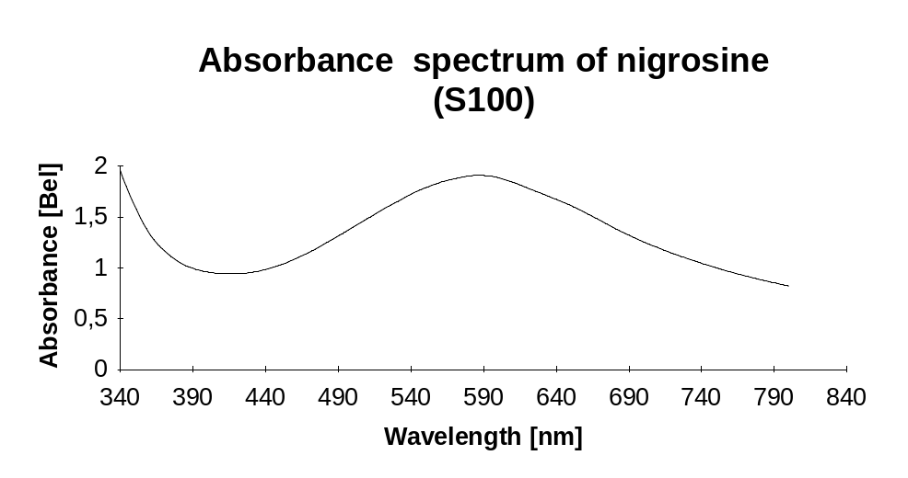

The absorbances of the different dilutions are measured at each wavelength.

Linearity is expressed as the deviation of the individual median values of the various test solutions from the linear range, which is calculated by linear regression. The base for regression calculation are the results obtained by measuring the four solutions of lower concentration. This calculation has to be performed for each single wavelength.

To reduce the necessary time for the total procedure also the dyes used for part 5 (wavelength deviation) are measured in this part of the validation procedure.

Traceability to National Standard
Refer to Procedure „Traceability of dye solutions for Linearity Check

Operating Conditions
The validation should be performed under normal operating conditions, i.e.

temperature: 15 to 30 °C
relative humidity: 30 to 80 %

Before starting the procedure the instrument shall be switched on for at least 15 minutes.

The validation procedure must be performed by trained service personnel only.

Handling of the validation standards
The validation standards have to be handled carefully. Take care of the following items:
- Store the validation solutions in a dark and cold place (refrigerator)
- In order to minimise formation of air-bubbles take care that the validation solutions have at least room temperature before usage
- Before usage homogenise the validation solutions by carefully turning the bottles (do not shake the bottles !)
- Avoid contamination while distribution of samples (by dust or dirty pipette-tips)
- If the bottles once have been opened, use them up within one week
- Close the bottles tightly, immediately after distribution of samples (to avoid contamination and/or evaporation)
- Don’t expose the solutions directly to sunlight (UV-light)

Test procedure
- Replace three reaction cuvette segments by new segments (see instruction manual »Replacing Reaction Cuvette« in section »maintenance and checkup«).
- Perform cellblank at least 2 times. Check cell blank values to be stable and within ± 200 E-4 Bel.
- When the cellblank is finished take out the first three segments and dry them by blowing out each single cell with a duster for optical use (compressed gas, like »Microfilter Duster Duster«, Oriel Corporation, 250 Long Beach BLVD., P.O. Box 872, Stratford, CT, U.S.A).
- Demantle the washneedles of the rinsing mechanism shift and put these into empty bottles. The movement of the whole mechanism must be possible.
- Pour out manually 380 µl of the different solutions into each cell of the cuvettes as follows:

Position | Solution
1 | dist. water
2..6 | S 20
7..11 | S 40
12..16 | S 60
17..21 | S 80
22..32 | S 100
33..37 | W 480
38..42 | W 570

- Close the openings of the cuvettes by a plastic film (for example: TESAFILM).
- Put back the prepared cuvette segements onto the analyzer and start a CELL BLANK.
- In menu Print à Maint/ Util select Cell Blank Measurement and start print the values of Cell Blank. When the absorbances of the first 43 cells are printed out press the STOP key to cancel the CELL BLANK. The measuring values of the cells 2 to 43 will be needed for the evaluation and documentation.
- Fit back the washing needles of the rinsing mechanism. Perform a CELL WASH and then another complete CELL BLANK.

Evaluation and Documentation
For evaluation and documentation use the enclosed validation form or the Excel-spreadsheet for Validation of the BM/Hitachi 917.

- regression cofficients A = 20*m20 + 40*m40 + 60*m60 + 80*m80

B = m20 + m40 + m60 + m80

- slope of straight line 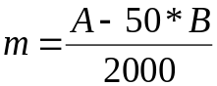

- intercept 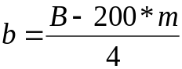

- theoretical absorbances Y20 = b + m * 20
Y40 = b + m * 40
Y60= b + m * 60
Y80 = b + m * 80
Y100= b + m * 100

- linearity errors 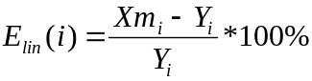

The linearity check is passed if all calculated linearity errors are within the tolerance zone (G_{total}) described in procedure „Traceability of dye solutions for Linearity Check“

Error Budget

Refer to Procedure „Traceability of dye solutions for Linearity Check“

Literature
- Absorbance Standard Nigrosine (S100)
- Standards in absorbtion spectrometry-Techniques in visible and UV spectrometry; Vol I, UV spectrometry group (1981), Chapman and Hall Ltd.
- Vocabulary and symbols
ISO 3534-1977(E/F)
Statistics - Vocabulary and symbols, first edition - 1977-07-01
Statistique - Vocabulaire et symboles, Première édition - 1977-07-01
- Photometer specifications
DIN 5030 Teil 1, Juni 1985
DIN 5030 Teil 2, Sept. 1982
DIN 5030 Teil 3, Dez. 1984
Spektrale Strahlungsmessung
- Validation procedure „Traceability of dye solutions for Linearity Check“
Description of traceability and error budget for linearity check

Appendix: Validation Form
Validation ID

Validation Form for Cal 917.32 P2

Linearity check at λ= nm

1. Determination of the medians mi

Cell No. i | Measured Absorbance xi [Bel]
2
3
4
5
6
m20 =

Cell No. i | Measured Absorbance xi [Bel]
7
8
9
10
11
m40 =

Cell No. i | Measured Absorbance xi [Bel]
12
13
14
15
16
m60 =

Validation ID

Linearity check at λ= nm (continued)

Cell No. i | Measured Absorbance xi [Bel]
17
18
19
20
21
m80 =

Cell No. i | Measured Absorbance xi [Bel]
22
23
24
25
26
27
28
29
30
31
32

Calculation of average X100: 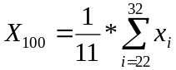

X100 =

Validation ID

Linearity check at λ= nm (continued)

Standard deviation S100 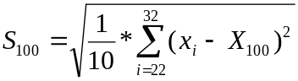

S100 =

Calculation of CV : 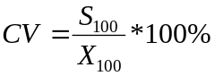

CV =

2. Determination of regression cofficients

A = X20 * 20 + X40 * 40 + X60 * 60 + X80 * 80

A =

B = (X20 + X40 + X60 + X80)

B =

• Slope m of the straight line :

m =

Validation ID

Linearity check at λ= nm (continued)

• Intercept b of the straight line:

b =

3. Calculation of theoretical Absorbances

For calculating the theoretical absorbances use the equation

Y = mx + b

with the values for m and b determined in 2.

Y20 = b + m * 20 Y20 =

Y40 = b + m * 40 Y40 =

Y60 = b + m * 60 Y60 =

Y80 = b + m * 80 Y80 =

Y100 = b + m * 100 Y100 =

4. Determination of Linearity

The linearity error is caluculated as follows

Validation ID

i | Xm,i | Yi | Elin(i) [%] | G_{total}
20
40
60
80
100

Result of Validation

The result of the performed linearity check at λ = nm is:

o All determined linearity errors are less than the given maximum errors. The linearity of the photometer is within the specifications.

o Not all linearity errors are within the given tolerances.

