Laboratory Accreditation
Validation Procedure
CAL 917.32 Part 3, Photometric Accuracy & Precision
BM/Hitachi 917
Version: 3.2

Date: December 97
Written by: | Mr. Trefzger, LI-E
Authorized by: | Mr. Ringsleben, LI-TS
Checked by: | Mr. Yabe, HID
Released by: | Mr. De Caluwé, LI-E

This sheet provides a validation procedure to comply with the requirements of laboratory accreditation standards.

This sheet is an uncontrolled copy.
Laboratory Accreditation Spec. Validation Proc.
on
Photometer Accuracy and Precision
BM/Hitachi 917
Content:
1 Purpose
2 General Description
3 Traceability to National Standard
4 Handling of the validation standards
5 Test Procedure
6 Evaluation and Documentation
7 Error Budget
8 Literature
9 Appendix: Validation Form

Purpose
The purpose of this validation procedure is the determination of the photo-metric accuracy and precision of the automatic analyzer BM/Hitachi 917.

General Description
The photometric accuracy and precision at all wavelengths used by the BM/Hitachi 917 is determined. Because the corresponding results from the validation procedure Cal 917.32 P2 can be used. No extra procedure is performed.

The accuracy is determined by comparing measured absorbances with absolute absorbance values given in the calibration kit. For each used wavelength one individual reference value exists. The precision is checked by calculating the coefficient of variation for a series of 11 measurement values.
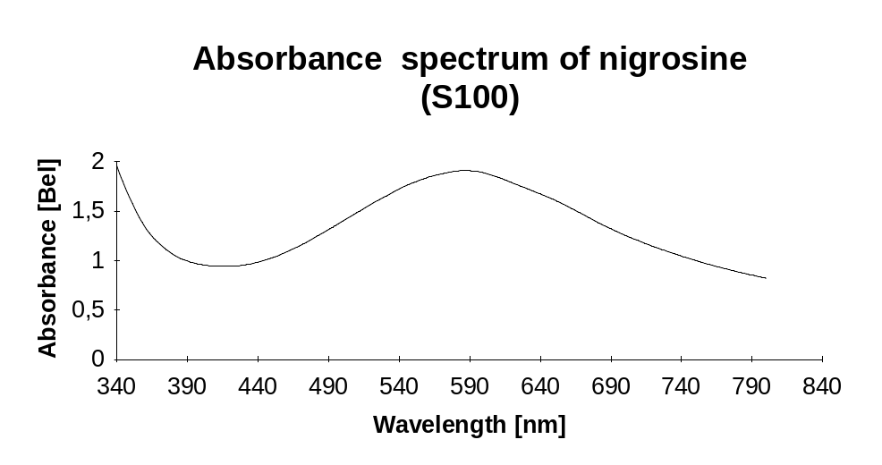

Traceability to National Standard
Refer to Procedure „Traceability of dye solutions for Absorbence Check

Handling of the validation standards
The validation standards have to be handled carefully. Take care of the following items:

- Store the validation solutions in a dark and cold place (refrigerator)
- In order to minimise formation of air-bubbles take care that the validation solutions have at least room temperature before usage
- Before usage homogenise the validation solutions by carefully turning the bottles (do not shake the bottles !)
- Avoid contamination while distribution of samples (by dust or dirty pipette-tips)
- If the bottles once have been opened, use them up within one week
- Close the bottles tightly, immediately after distribution of samples (to avoid contamination and/or evaporation)
- Don’t expose the solutions directly to sunlight (UV-light)

Test Procedure
The results of part 2, »photometric linearity«, can be used for evaluation. No extra procedure exits.

The evalution of the data must be performed by trained service personnel only.

Evaluation and Documentation
For evaluation and documentation use the enclosed validation form or the Excel-spreadsheet for validation of the BM/Hitachi 917.

- median m = median of 11 measurements
- Standard deviation, n=11: 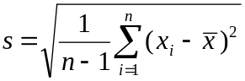
- Coefficient of variation 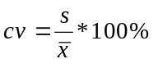

The reference values Xref are delivered together with the validation kit containing the dye.

The absorbence check is passed when all cv’s are less or equal 1.0% and all absorbence errors are within the tolerance zone (G_{total}) described in procedure „Traceability of dye solutions for Absorbence Check“

Error Budget
Refer to Procedure „Traceability of dye solutions for Absorbence Check“

Literature
- Absorbance Standard Nigrosine (S100)

- Standards in absorbtion spectrometry-Techniques in visible and UV spectrometry; Vol I, UV spectrometry group (1981), Chapman and Hall Ltd.

- Vocabulary and symbols
ISO 3534-1977(E/F)
Statistics - Vocabulary and symbols, first edition - 1977-07-01
Statistique - Vocabulaire et symboles, Première édition - 1977-07-01
- Photometer specifications
DIN 5030 Teil 1, Juni 1985
DIN 5030 Teil 2, Sept. 1982
DIN 5030 Teil 3, Dez. 1984
Spektrale Strahlungsmessung

- Validation procedure „Traceability of dye solutions for Absorbence Check“
Description of traceability and error budget for linearity check

Appendix: Validation Form
Validation ID

Validation Form for Cal 917.32 P3

λ [nm] | m [Bel] | Xref [Bel] | Error =  ⏐m - Xref⏐ | Gtotal [Bel] | Passed | Failed
340
376
415
450
480
505
546
570
600
660
700
800

λ [nm] | s [Bel] | CV [%] | PassedCV≤1.0% | Failed
340
376
415
450
480
505
546
570
600
660
700
800

