Boehringer Mannheim GmbH

Host Interface Test Program for the ASTM protocol
(Elecsys 2010/1010, STA Compact)

Version 1.7 (October 1997)

Product Info

Contents:

1. Main Screen of the ASTM Interface Test Program
2. Main Menu System
3. Technical Details
3.1. Displaying large text files
3.2. Record editor rules
4. Software Updates of the ASTM Host Interface Test Program
5. Data Flow of ASTM Test program for ELECSYS 2010

1 Main Screen of the ASTM Interface Test Program

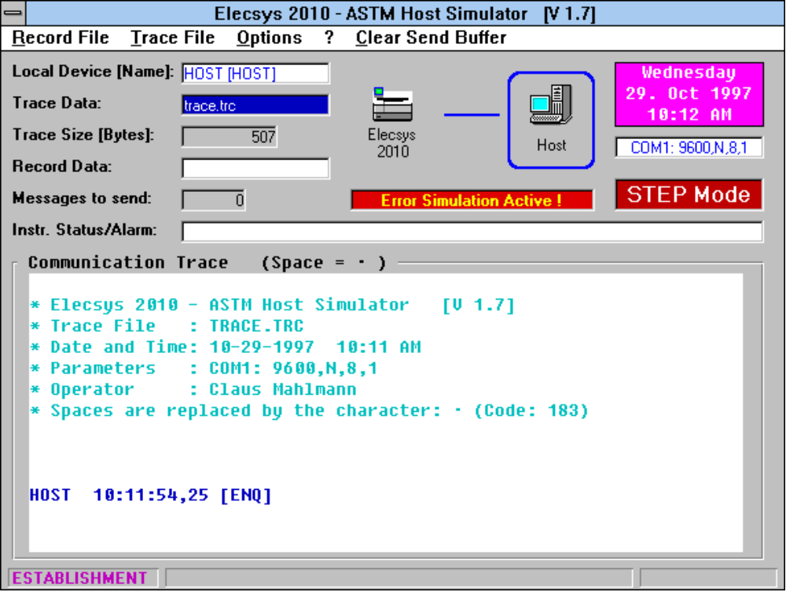

The Main Screen contains the following items (top down):

- Title line (containing the selected instrument, the programs name and version)

- Pull-down menu system (see chapter 2.1)

- Local Device setting (HOST or INST) and their names
The ‘Operating Mode’ setting screen can be accessed by clicking on this field

- Symbolic indication of the local device (blue frame)
A click on the corresponding icon selects the local device

- actual Date and Time

- actual RS232-Parameter setting
The ‘RS232 Parameter’ setting screen can be accessed by clicking on this field

- Step-Mode status (visible or invisible means enabled or disabled)

- Instrument Status/Alarm
if program works as host simulator for Elecsys 2010, the contents of the ‘Processing Messages’ and ‘Instrument Status’ messages is displayed

- actually opened Trace file name
The file selection mask for trace files can be accessed by clicking on this field

- Size of the actually opened trace file in bytes.

- actually opened Record file name
The file selection mask for record files can be accessed by clicking on this field

- Number of messages to send

- Communication Trace Window
Sent messages are displayed in green, received messages in blue and error messages in red color. If the space character (code 20hex) within records is replaced by another character, this is indicated above the trace window.
Clicking with the right mouse button on the Communication Trace Window allows to enter a comment line which is written to the trace file.

- Status line
Indication of the actual transition state (Idle, Transfer, Receive) and the active keys with time counter, if STEP mode is enabled)

2 Main Menu System

Record File

Open for Recording | A file can be opened where all received records are stored
Close | The file which was opened with the above option can be closed again
Delete | Record files which are no longer needed can be deleted from the harddisk
Display/Edit/Parser/Create | A record file can be displayed, printed, searched, ... with a multi-functional text editor (see 2.1 for a description of the editor options)
Send | Any record file can be sent via the serial interface
Exit | This option quits the program

Trace File

Open for Recording | A file can be opened where the complete communication in both directions is stored with time and sender information
Close | The above opened trace file can be closed with this option
Delete | Trace files which are no longer needed can be deleted from the harddisk
Display/Edit | Any trace file can be displayed, printed, searched, ... with a multi-functional text editor (see 2.1 for a description of the editor options)
Extract Records | All records of any trace file are extracted and written to a record file by this option.
Insert Comment | This option allows to enter a comment which is written to the actually open trace file.
Clear Window | This option clears the trace window.

Options

RS232-Parameters | Baudrate, data-, stopbits, parity, COM port and kind of handshaking can be set with this option. This option can also be opened by clicking on the RS232 parameter field on the main screen
Operating Mode | The following settings can be done on this screen:  - the connected instrument  - the local device (HOST or INSTRUMENT) incl. the device names  - the colors for the trace messages  - enable/disable step mode  - enter the operators name  - enable/disable acustical error signal  - enable/disable test selection default profile (the profile can be defined with the ‘Host Messages’ option within the record editor)  - enable/disable general database access  - enable/disable storage of received manufacturer records in the database  - definition of a space replacement character for the trace display  - enable/disable storage of manufacturer records in the trace file
Timer Settings | All timing and retry adjustments can be done on this screen
Delimiters | The four delimiter characters of the ASTM protocol can be selected with this option
Lew-Level Errors | Different kind of error simulation can be activated for testing the interface software of the connected device
DB Access | This screen allows to take a look at the different database tables which contain the received data. Test selections and test selection requests can be generated and sent to the connected device.  There are two options for the database in a pull-down menu available:  - ‘Compress DB’ eliminates ‘holes’ in the database file and decreases the file size  - ‘Store Column Width’ stores the actual column width of the displayed table after a manual adaptation.  - ‘Create Report’ creates result reports, if the result table is displayed

Desktop | The programs desktop language can be selected (german or english)
Communication Test | This option initiates a short [ENQ] - [ACK] - [EOT] sequence for testing the communication, if the test program is connected to itself.  This test is supported by the STA Compact, it is not supported by the Elecsys 2010 interface !

?

Help | This option gives access to the integrated online help for the testprogram itself as well as the two ASTM specification documents
About | An info window is displayed which also includes a button for displaying system information

Clear Send Buffer | Clears all message that are to be send

3 Multifunctional text editor
For displaying record and trace files there is a text editor with the following menu options:

 | File
 | Open | Another record/trace file can be opened
 | Save as | The modified file or a selected part of it can be stored in another file
 | Print | The whole file, a selected part of it or the parser information (only for record files) can be written to the printer, a text file or the clipboard.
 | Send | (only available, if record files are displayed)  The contents of the text window is sent to the other device
 | Exit | This option quits the text editor

 | Edit
 | Cut | the selected part of the text is cut and copied to the clipboard
 | Copy | the selected part of the text is copied to the clipboard
 | Paste | the contents of the clipboard is inserted at the cursor position
 | Delete | the selected part of the text is deleted

 | Search
 | Search text | any expression can be searched in the text file
 | Search again | the above specified search is repeated

text editor menu system (cont)

 | Options
 | Parser | (only available, if record files are displayed)  if a record file is displayed the text window is divided into two parts. In the upper part, the record file is displayed, in the lower part the field information of the selected record is displayed. If the Parser option is deactivated, the text window increases to full height.

 | Instrument Messages | (only visible, if record files are displayed and the program works as instrument simulator)  All messages that the instrument can send during operation are offered in a option box. The selected message is displayed with default values in the text editor window and can be modified.

 | Host Messages | (only visible, if record files are displayed and the program works as host simulator)  All messages that the host sends during operation are offered in a option box. The selected message is displayed with default values in the text editor window and can be modified.  On this screen the test selection default profile can be displayed, modified and stored in a separate file.

 | Small/Large Window | with this option, the text editor window can be reduced to the half height. So it is possible to observe the trace window on the main screen while the text editor is open. If a record file is displayed and the small window is selected, the parser option is disabled

 | Help
 | ? | This option gives access the integrated online help and the System Information window
 | ELECSYS Test List | This option displays the ELECSYS 2010 and 1010 Test Code and name list, if one of the above instruments is selected

4 Technical Details

5 Displaying large text files

Since the size of the text editor window is limited to 28 kB, it is necessary to display larger trace of record files ‘stepwise’. The text file is divided into 28 kB parts which are displayed one after the other. If you move the cursor up/down, the software detects the start/end of the actually displayed text block and automatically loads the previous/next text block. To indicate the position within the text file, there is an additional scroll indicator on the right side of the text window.
The ‘large files’ cannot be modified. It is possible to select and store parts of the text file with the ‘Save as’ option.

6 Record editor rules

The record text file can contain more than one message (a message starts with the Header record, contains several data records and ends with the Termination record). Each message has to start with a Header record; otherwise it is not sent.
The time delay between messages can be specified on the ‘Timer Settings’ screen.

7 Software Updates of the ASTM Host Interface Test Program

Version 1.01
Distributed to the participants of the Host Interface Training from 22.4. to 26.4.96 in Mannheim

Version 1.02
BUG If in the 'Low-Level Errors' screen the 'Send [ENQ]' or 'Send [NAK]', close and open again before the error simulation takes place, the program aborts with an error message (Error No. 5)
BUG When sending a test selection out of the database the first test number and dilution factor were '^^^N^R' because of accessing the wrong table columns.
BUG When sending a test selection out of the database and a test number is set but the corresponding dilution factor cell is empty, a '0' ist sent.
BUG The font style for the editor print option is set to 'Courier New'.

NEW The parser also lists the contents of components within a field.
NEW If enabled on the 'Record Editor/Options/Parser' screen an additonal list box appears within the parser window where the field name and, if available the different options of that field are displayed.
NEW The use of a TS default profile can be enabled on the 'Options/Operating Mode' screen.
The default profile can be generated with the Record Editor and stored with the 'Store TS default profile' button on the 'Host Messages' screen. On this screen there is also the option to display the actual TS default profile.
NEW With the Record editor the following control lines may be inserted before any record:
!C ccccc ... = Trace comment line ccccc
!D d = Delay time d seconds
!F f = Wrong frame number f
!S x = Wrong Checksum x times; 1 time if x is missing
NEW A new option on the 'Mode of Operation' screen allows to specify a character by entering the character code, which replaces the space (20hex) within records when displaying them in the trace window or storing them in the trace file.
NEW A new option on the 'Mode of Operation' screen allows to disable the storage of manufacturer defined records in the trace file. The records are still displayed in the trace window but not stored in the trace file.
NEW When sending result entries as INSTrument out of the database, there is the option of sending all results of the selected sample in the result table or only the selected results.
NEW Implementation of all test program features for the STA/STA Compact coagulation analyzer.
Parser, Access DB, Record-Editor Message generation support, realtime requests.
The instrument is selected on the ‘Mode of Operation’ screen.
Each instrument has its own host and instrument names for the trace file in the ASTM.INI file.

Version 1.03
BUG If a large trace or record file (> 28 KB) with several text parts is displayed with the Editor option, the Search option automatically loads the next text part when the search text is not found.

NEW An additional option box on the Delimiter Selection screen makes it possible to select between using the locally defined delimiters or the received delimiters. If the second option is selected the received delimiters in the header record from the other side overwrite then locally defined delimiters.

Version 1.04
BUG On the ‘Options > RS232 Parameters’ screen the handshake options Xon/Xoff and RTS/CTS were exchanged.
BUG If a TA frame with empty application data was received the program was terminated with an error message.
BUG If a large file with additional scroll bar was displayed in the record editor and a default host or instrument message was selected, the scroll bar did not disappear.

NEW There are menu options for opening help files that contain the ASTM Specifications 1394 and 1381 in the Help menu.
NEW There are different device names (host and instrument) stored for each supported instrument.

Version 1.05
BUG Elemination of trailing delimiters and blanks.

Version 1.06
BUG If a result message with multiple result records was received by the Host simulator, only the last result was stored in the database.

NEW On the ‘Mode of Operation’ screen an 18-character operator name can be entered which appears in the head lines of the trace and record files.
NEW The records of the trace file of the CAEV evaluation system can also be extracted with the trace extract function.

Version 1.07
NEW If an update of the test program (newer version) is started after installation the ASTM.INI is deleted and newly created with default values.

Version 1.08
NEW The two ASTM Specification help files have been updated.
NEW The actually selected instrument is displayed in the title bar of the Host- / Instrument Messages Windows within the record editor.
BUG The delimiter definition within the Header record was mis-interpreted in the parser window.

Version 1.09
BUG If STA was selected as instrument, TS default profile was deactivated and there is no worklist for a specific request, the host simulator sent a Header and a Termination Record to the instrument.
BUG The option not to save the Manufacturer Records in the trace file did not work well. Now all messages that contain a Manufacturer Record as second (!) record after the Header record are not stored in the trace file.
BUG The TS Request/TS Info handling after Contention was improved.
BUG The size of the Action Code field in the TestSelection and TestResults tables had to be enlarged to avoid error messages when receiving records with more than 1 character information in this field.

Version 1.10
BUG If the Editor screen was left via the Close menu option of the Control box, the software crashed.
BUG A software send buffer allows to create and send a record file (ELECSYS 2010 in INST mode) with multiple requests completely, even if the host interrupts by answering test selections.
The max. number of records for the send buffer is limited to 200. If the record file contains more records a corresponding error message is displayed and the last incomplete message in the record file is removed.
NEW For ELECSYS 2010 the non-barcode mode is supported. Test selections can be requested by barcode or by sequence no. The test selection table has additional fields for sequence, carrier and position no.
NEW On the Error simulation screen there is an additional option of sending a record without the record delimiter (carriage return before ETX). In the receiving routine the existence of this record delimiter is checked.
NEW On the ‘Operation Mode’ screen the colors for host and instrument trace messages can be selected.
NEW Different instrument icons on the main screen.
NEW There is an additional ‘System Info’ window available on the Info screen.

Version 1.11
NEW The Elecsys 1010 is implemented. It can be selected on the ‘Operation Mode’ screen. There is a separate database and parser info file.
NEW If Elecsys 2010 or 1010 is selected, there is an additonal menu option in the Help menu of the Trace/Record editor. This menu option ‘ELECSYS Test List’ displays all test codes and names of the Elecsys systems.
NEW Whereever the BM test no. appears in a field of a record, the test name is displayed in the parser information window behind the code in brackets.
NEW As additional indication the text color within the trace/record editor changes to blue as soon as a text change takes place. When the text is stored it appears again in black.

Version 1.2
BUG In the german version, the Parity options ‘Gerade’ and ‘Ungerade’ have been exchanged.
BUG The software crashed, if in Host mode DB Access was disabled and requests have been received.

NEW The instrument icons are integrated in the software. They are no longer included as ICO files.
NEW The sequence no. is echoed within the test selection message from host to the ELECSYS.
NEW A new menu option in the ‘Trace’ menu allows to enter a comment line which is inserted into the trace file. This option is also available by clicking the right mouse button on the trace window.
NEW The actual trace file size is displayed below the trace file name.

Version 1.3
NEW Not only the sequence no. is echoed within the test selection message from host to the ELECSYS but all components of the instrument specimen ID.
NEW There are new columns for the Container Type info in the Request, TestSelection and Result database tables for ELECSYS 2010 and 1010.
The database files are not compatible with the previous version !!!

Version 1.4
NEW On the ‘Mode of Operation’ screen there are separate option controls for echoing Sequence No, Carrier No, Position No, Carrier Type, Container Type of the Request Record Q within the Order Record O of the test selection message from Host to analyzer.

Version 1.5
NEW A different send buffer structure allows to send multiple request (as instrument simulator) where, with the appropriate timing setting, the host may answer each single request.
The number of messages to send is displayed above the trace window.
The new main menu item ‘Clear Send Buffer’ allows to delete all messages to send and thus abort a running transmission.
NEW A comment above the trace window indicates an active error simulation.
NEW On the DB form there is a main menu item ‘Create Report’ displayed, if the results table is displayed. If exactly one sample in the results table is selected, a report with all results of that sample in generated and stored to the text file ‘REPORT.TXT’
NEW When installing the software version 1.5, the database files are normally not updated. However, since the version 1.4 the structure of the Elecsys databases has changed. If an old database structure is detected when starting the 1.5 for the first time, the database files for Elecsys are deleted and the operator is asked to install the software again. Then a default database with the new structure is installed.

Version 1.6
BUG In Elecsys 2010-Host mode, you may select on the ‘Operation Mode’ screen, which data item shall be echoed within the order record of the test selection message (Seq.no, Carrier No, ...) This setting is now also used if the default profile is sent or if the empty test selection (‘Z’ as Report Type) is sent to the Elecsys 2010.
BUG If the above mentioned empty test selection was sent, there were two field delimiters instead of one between Test ID and Priority (fields 5 and 6 of the Order Record)
BUG In Elecsys 2010-Host mode, the tool displayed an error message as soon as it received a Request Record with empty ID field.

Version 1.7
BUG There were invalid time values within the Communication Trace when the tool was activated over midnight.

8 Data Flow of ASTM Test program for ELECSYS 2010
The table on the following pages lists the data flow options of the test program (version 1.6) for the ELECSYS 2010 analyzer.
Depending on wether the program works as Host or Instrument simulator it is shown which messages can be generated, modified and send with which option.

(mm) each selected DB entry is sent in a separate message
(mr) each selected DB entry is sent in a separate record within one message
(sr) if more than one entry is selected only the first will be sent

 |  | INSTrument Mode |  |  |  |  | HOST Mode
Message | Record | Record Editor  (Requests) | Record-Editor  (Data) | DB read | answer requests | DB write | Record Editor  (Requests) | Record-Editor  (Data) | DB read | DB write
Calibration Result | CR |  | edit and send |  |  | store received data |  |  |  | store received data
Calibration Parameters | XT, CP |  | edit and send |  |  | store received data | edit and send request | edit and send |  | store received data
Control Parameters | XT, QP |  |  |  |  | store received data | edit and send request | edit and send |  | store received data
Diluent Parameters | XT, DP |  |  |  |  | store received data | edit and send request |  |  | store received data
Instrument Config | IC |  | Edit and send | select DB and send (sr) | send 1. entry of DB on request | store received data | edit and send request | edit and send |  | store received data
Instrument Status | IS |  | Edit and send | select DB and send (sr) | send 1. entry of DB on request | store received data | edit and send request |  |  | store received data
Log File | LF |  | Edit and send | select DB and send (lf) | send on request with date and category check | store received data | edit and send request |  |  | store received data
Processing Message | PM |  | Edit and send | select DB and send (sr) |  | store received data |  |  |  | store received data
Request Cancel |  |  |  |  |  |  | edit and send request
Sample Status | SS |  | Edit and send | select DB and send (sr) | send 1. entry of DB on request | store received data | edit and send request |  |  | store received data
Service Data | SD |  |  | select DB and send (sr) |  | store received data |  |  |  | store received data
Substance Data | XT |  |  |  |  | store received data | edit and send request |  |  | store received data
Test Application | TA |  |  | select DB and send (sr) |  | store received data |  |  |  | store received data
Test Conditions | TC |  | Edit and send | select DB and send (mr) | send 1. entry or all of DB on request | store received data | edit and send request | edit and send |  | store received data
Test Results | P, O, R |  | Edit and send | select DB and send (mr) |  | store received data | edit and send request |  |  | store received data
Result Context | RC |  |  |  |  | store received data |  |  |  | store received data
Raw Result | RR |  |  |  |  | store received data |  |  |  | store received data
Test Selection | Q, P, O | edit and send TS Requests |  | select Request DB and send (mm) |  | - store received TS data  - create no. of requests |  | edit and send | - select DB and send (mm)  - send on request, if available, or default TS if enabled | store received request  create no. of TS

