Boehringer Mannheim GmbH
STA Coagulation Analyzer
Host Interface Manual

STA Analyzer Host Interface Manual
Including features of Version 620
BM / ID.No. 1704559-001

0000.doc

1. Introduction
2. Interface Set-up
2.1 Data Cable
2.2 Pin Description
2.3 Transmission Specifications
3. Host Interface Specific Operation - Protocol Independent
3.1 General Information
3.1.1 Calculation of Access Code
3.1.2 Access Code Examples
3.2 Result Transmission in Real-Time Mode
3.3 Setting Up Method Ranking
3.4 Loading Samples
3.5 Result Transmission in Batch Mode
3.6 Quality Control Result Transmission in Batch Mode
4. Protocol Description
5. Std-Bi Protocol
5.1 Host Interface Settings (Std-Bi)
5.2 Definitions
5.2.1 Trace Format (Std-Bi)
5.2.2 Checksum Calculation (Std-Bi)
5.3 User Maintenance (Std-Bi)
5.3.1 <F1> Line Test.
5.3.2 <F2> Connect / Disconnect
5.4 Data Transmission Control (Std-Bi)
5.4.1 Establishment Phase
5.4.2 Worklist Request / Worklist
5.4.3 Result Transmission
5.4.4 Line Test
5.4.5 Termination Phase
6. ASTM Protocol
6.1 Host Interface Settings (ASTM)
6.2 Definitions
6.2.1 Trace Format (ASTM)
6.2.2 Checksum Calculation (ASTM)
6.3 User Maintenance (ASTM)
6.4 Data Transmission Control (ASTM)
6.4.1 Common Transmission Procedure
6.4.2 Communication Phases
6.4.3 Flow Charts
6.4.4 Record Sequence
6.5 Record Structure
6.5.1 Record Types
6.5.2 General Record Format
6.5.3 Record Details
6.6 Trace Examples (ASTM)
6.6.1 Worklist Request from STA to Host
6.6.2 Worklist from Host to STA
7. Service Maintenance
8. Figures and Tables
8.1 Figures
8.2 Tables
8.3 Trace Examples
Appendix A - Alarm Messages
Appendix B - ASCII Chart

Introduction
This manual describes the connection of the Boehringer Mannheim STA Analyzer to a 3rd Party Laboratory Host System via an RS232C asynchronous serial port. It details the communication protocols, the required hardware, and considerations to be taken when interfacing different computer systems.
The following fundamental questions are considered:
Hardware
- What interface hardware is required?
- How is the physical connection established?
Operation and Data Transmission
- How to set transfer and communication parameters?
- What is the format of the transmitted data and how is it used?
- What type of data can be transmitted?
- How is the data transfer initiated?
Software
- What communication protocol is used?
- What are the Host´s software requirements?
In case of difficulty please contact the Boehringer Mannheim Service Department or alternatively the Service Management of the Central Marketing Department of Boehringer Mannheim GmbH (Germany):
Boehringer Mannheim GmbH
Technical Product Management
Data Technique
Sandhofer Straße 116
D-68305 Mannheim
Tel: (49) 621 / 759-2464
Fax: (49) 621 / 759-4519

Interface Set-up

Data Cable
Figure 1 : Data Cable Wiring Diagram
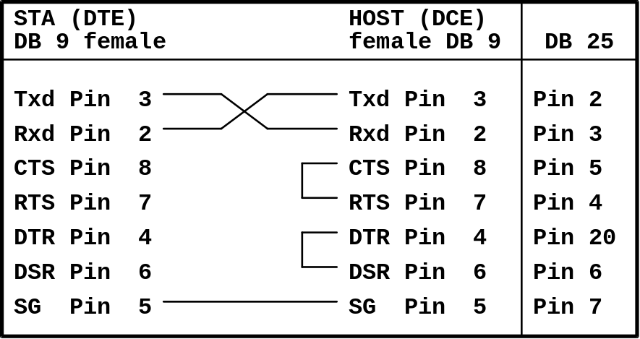
Figure 1 illustrates the wiring of the data cable used to connect the STA Analyzer to the Host.
Connect to the 9-pin male socket at the rear of the analyzer.

Pin Description
Pin no | Signal | Explanation | Direction
3 | Txd | Transmit Data | out
2 | Rxd | Receive Data | in
5 | SG | Signal Ground | -
Table 1 : Pin-Out Descriptions
Table 1 gives the pin-out descriptions of the used pins. None of the handshake lines is used. They remain unconnected.

Transmission Specifications
The data transmission specifications are given below.
Item | Specification | Remarks
Interface | RS232C Asynchronous Serial Interface | Max. Cable Length 15m
Handshaking | Software
Communication Method | Half Duplex
Character Code | ASCII
Table 2 : Transmission Specification

Host Interface Specific Operation - Protocol Independent

General Information

Calculation of Access Code
Certain menus items are only available after a 6-digit Access Code is entered. (Setup ⇒ Global Options).
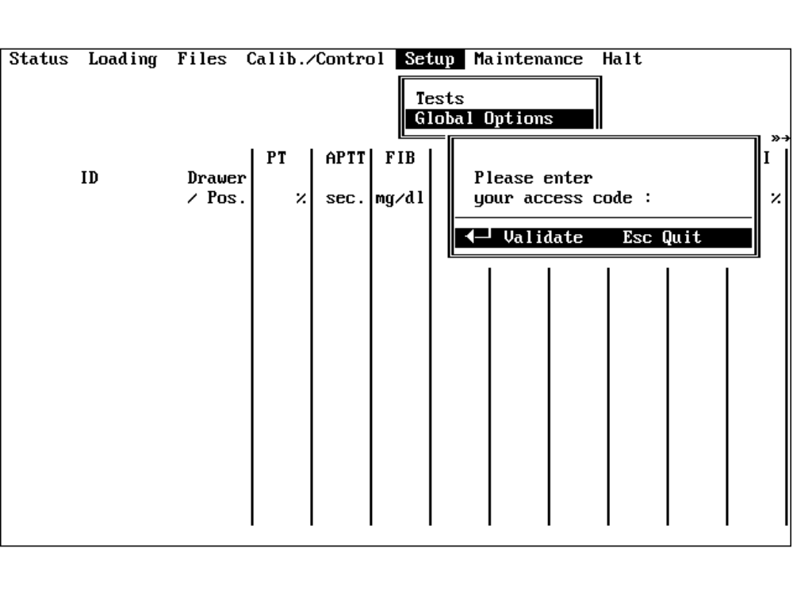
Figure 2 : Entering the Access Code
The Access Code is derived from the system date and is format dependent.
Digit 1: First digit of day/month (date format dependent)
Digit 2: First digit of month/day (date format dependent)
Digit 3: Second digit of day/month (date format dependent)
Digit 4: Second digit of month/day (date format dependent)
Digits 5 and 6: Sum of digits 1 to 4 with leading zero if less than 10

Access Code Examples
Example 1:
Calendar Date: 25th of October, 1994.
System Date: 25/10/1994 (date format: DD/MM/YYYY)
Access Code: 215008
Example 2:
System Date: 10/25/1994 (date format: MM/DD/YYYY)
Access Code: 120508

Result Transmission in Real-Time Mode
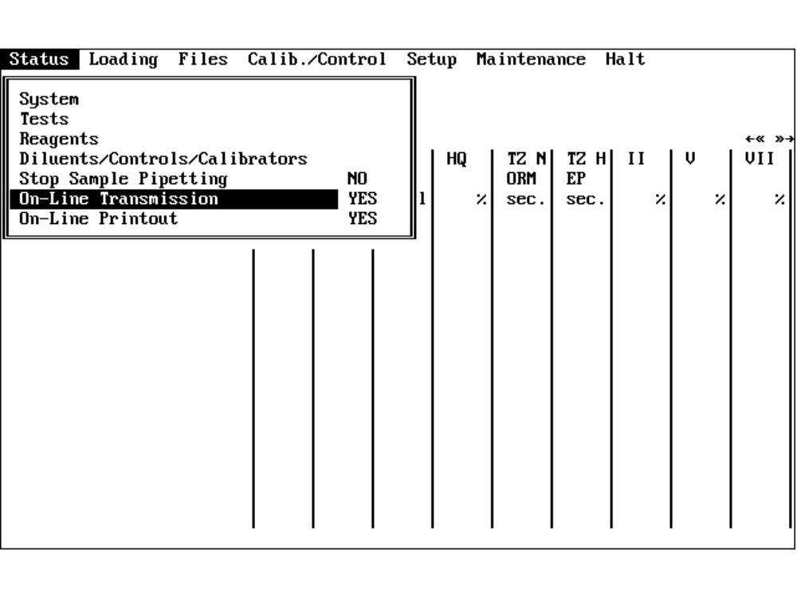
Figure 3 : The Status Menu
Setting the On-Line Transmission option to ‘YES’ sends the test results as soon as they are available after the measurement.
Note: A transmission rank should be defined first.
(See 3.3 Setting Up Method Ranking)

Setting Up Method Ranking
The STA Analyzer can define one main, and up to 3 auxiliary tests. Each test is given a unique 2-digit transmission number. This number is used twice during the communication protocol:
- When a test is selected using the main test transmission number.
- When the test results are sent to the Host.
Select Setup ⇒ Tests (Screen Page 3/3). A list of installed tests appears. The Transmission Numbers can be set from here.
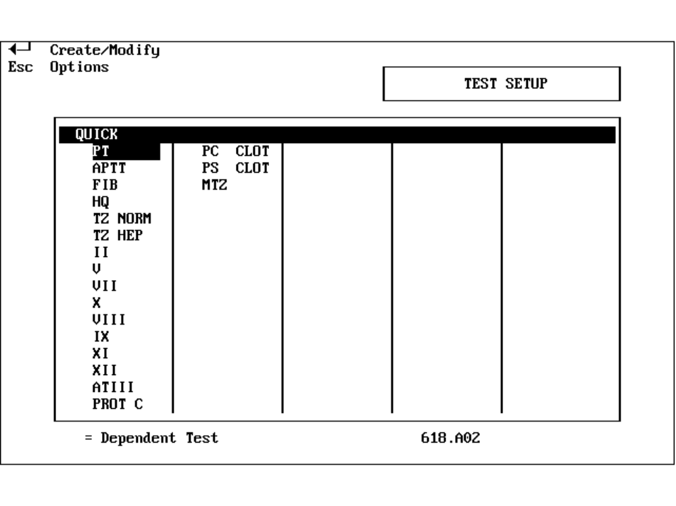
Figure 4 : Setup-Tests, Test List
Selecting a test and pressing <Enter> calls Test Setup (Screen Page 1/3). Pressing <PageDown> twice displays the Transmission Test Number setup page.
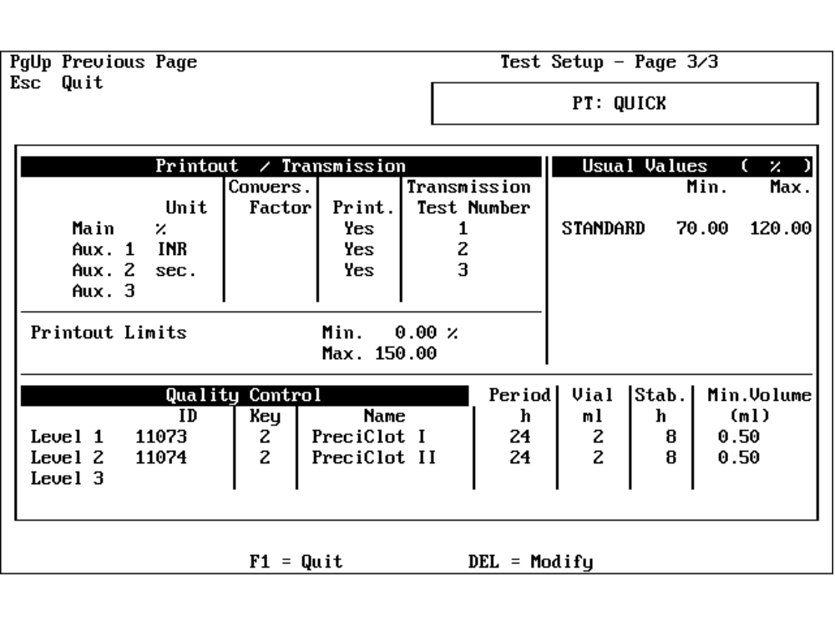
Figure 5 : Test Setup Screen
The section Printout / Transmission contains the items
- Unit
- Conversion Factor
- Print
- Transmission Test Number
To modify a Transmission Number, select the number and press <Del>. The following screen will appear.
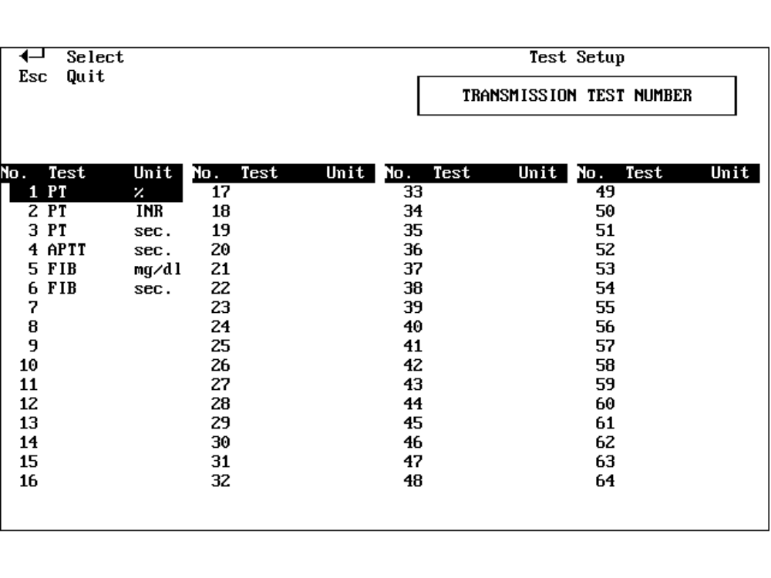
Figure 6 : Transmission Numbers List
Select a free number in the test list and press <Enter>. The test number is automatically entered in the Transmission Test Number column ( Screen Page 3/3 ).
It is not possible to select an allocated number.
To change a test number return to the Transmission Test Number section on Screen Page 3/3. Select a test number and press <F1> to delete it. The number can now be reused.
Exiting Test Setup gives a prompt to save any changes. The Access Code must be given. (See 3.1.1 Calculation of Access Code, Page 8).

Loading Samples
The samples are identified and placed in the sample drawer one at a time. The following settings are required to request a Worklist from the Host.
Enter Loading ⇒ Samples>Drawer 1 or press the button at the front of the drawer. The following screen appears:
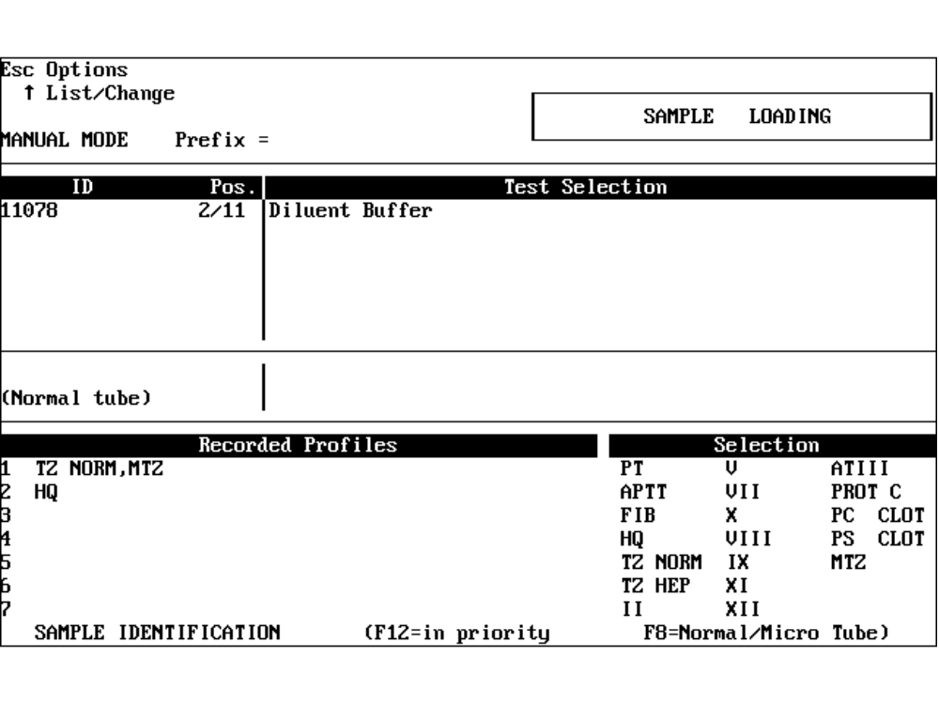
Figure 7 : Sample Loading Screen in MANUAL MODE
The cursor is positioned on the ID field. The instrument then waits for a bar-coded sample cup to pass in front of the bar-code reader, or alternatively, manual input of the bar-code number.
The mode must be changed from MANUAL MODE to AUTO before the instrument requests a Worklist from the Host. To change the mode press <Esc>. A small menu appears in the upper left of the screen. The options are:
- Change Profiles
- Change Prefix
- AUTO mode
- Return to Loading
- Quit
Select AUTO mode.
The Sample Loading screen changes slightly.
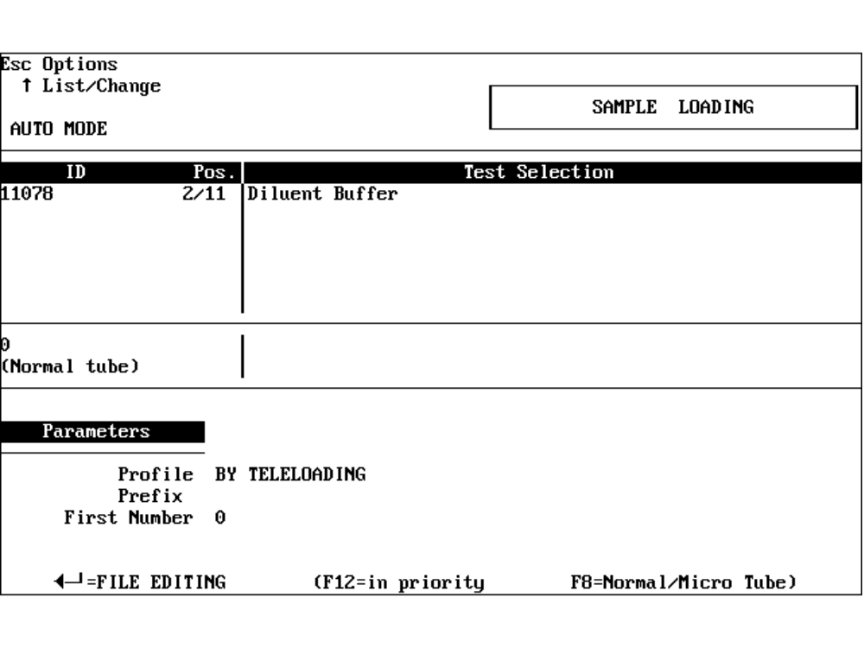
Figure 8 : Sample Loading Screen in AUTO MODE
The Profile should be By Teleloading. If not, press <Esc> and select Change Profile.

Figure 9 : Profile Modification Screen
This menu allows:
- Creation of a group of up to 12 tests.
- Creation of a default group of tests in AUTO mode.
- Downloading.
To Download move the bar to the ‘AUTO’ row, press <Enter> and type ‘0’ for Downloading. Press <F10> to save and then <Esc> to Quit and return to the Sample Loading menu.
The work flow is as follows:
- The operator identifies a sample (via manual entry or bar-code reader).
- The operator inserts the sample in the drawer.
- The STA Analyzer sends a request for a Worklist for that sample.
- The Host returns the Worklist (if available).
- Repeat the above until all samples are loaded.
The run is initiated upon closing the drawer.
When the option Verify Patient Data is set to ‘YES’ in Setup ⇒ Global Options (Screen Page 2/2), the STA Analyzer expects the Host to send four extra information fields as part of the Worklist.
(See Figure 13 Page 20 and Figure 26 Page 43) These four fields are displayed in a separate window and must be confirmed with <F10>.
See Figure 10.
Info Field 1 (16 characters) example below: 1234567890123456
Info Field 2 (12 characters) example below: 123456789012
Info Field 3 (6 characters) example below: 123456
Info Field 4 (4 characters) example below: 1234
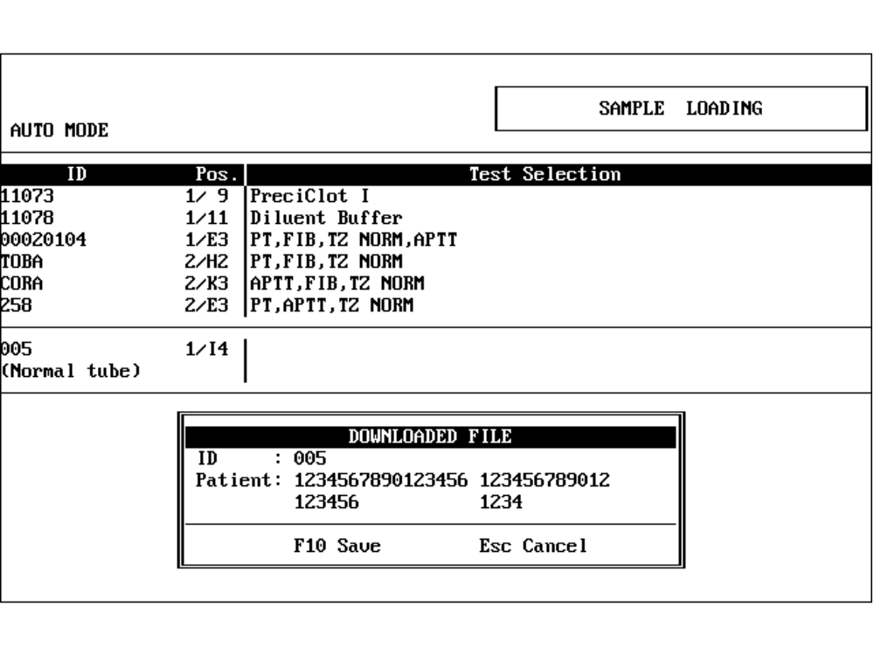
Figure 10 : Info Field Window on Reception of Worklist

Result Transmission in Batch Mode
The operator can repeat the transmission of the run's results in ‘Batch Mode’.
Select Files ⇒ Confirmation>Printout>Transmission. The Sample List is then displayed.
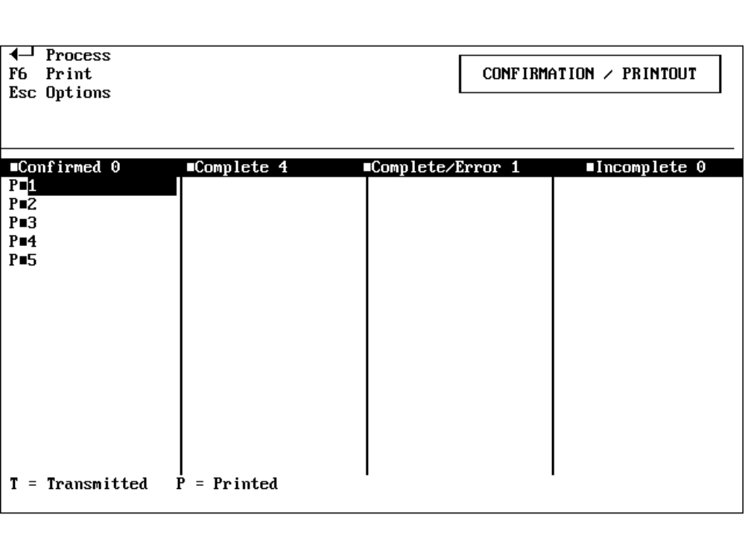
Figure 11 : Sample List Screen
Press <Esc> to call up a small menu in the upper left of the display. This gives the following options:
- Change File Selection
- Transmit
- Print
- Quit
‘Transmit’ offers the choice of transmitting all, or only new results to the Host.
At the Sample List select the required sample using the cursor keys. Press <Enter> to show a sample’s results.
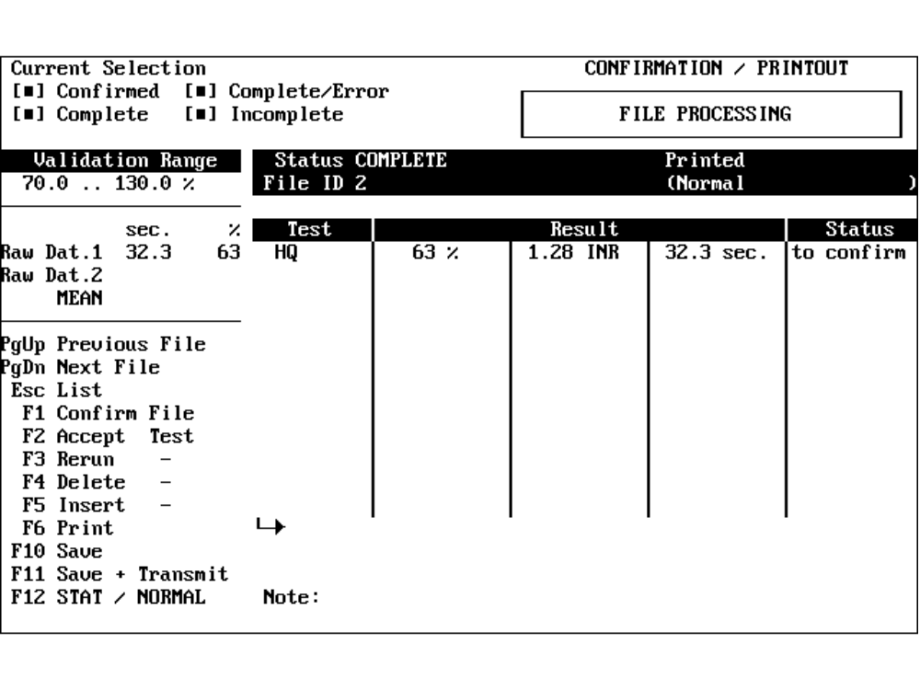
Figure 12 : Results Screen
A single test can be selected and sent to the Host by pressing <F11>.

Quality Control Result Transmission in Batch Mode
Quality Control Results are sent to the Host in real-time when the ASTM protocol is selected.
The Quality Control Results can be sent in Batch Mode after the run.
Select Calib./Control ⇒ Quality Control. The Test List is then displayed.
Select the required test and press <Enter>.
Display the Result List with <F1>.
Transfer the Control Results with <F11>.

Protocol Description
The STA Analyzer provides two different Host interface protocols:
- Std-Bi Protocol
- ASTM Protocol
Use Setup ⇒ Global Options (Screen Page 2/2) to select the working protocol. See Figure 13 on page 20 for Std-Bi Protocol, and Figure 26 page 43 for ASTM.
Std-Bi operation is described in Chapter 5. ASTM is described Chapter 6.

Std-Bi Protocol

Host Interface Settings (Std-Bi)
All Host Interface Settings are made in Setup ⇒ Global Options (Screen Page 2/2)
Access to the Global Options screen requires the 6-digit Access Code. (See 3.1.1 Calculation of Access Code Page 8)
Successful entry of the Access Code displays Global Options (Screen Page 1/2). Press <PageDown> to display the following screen:
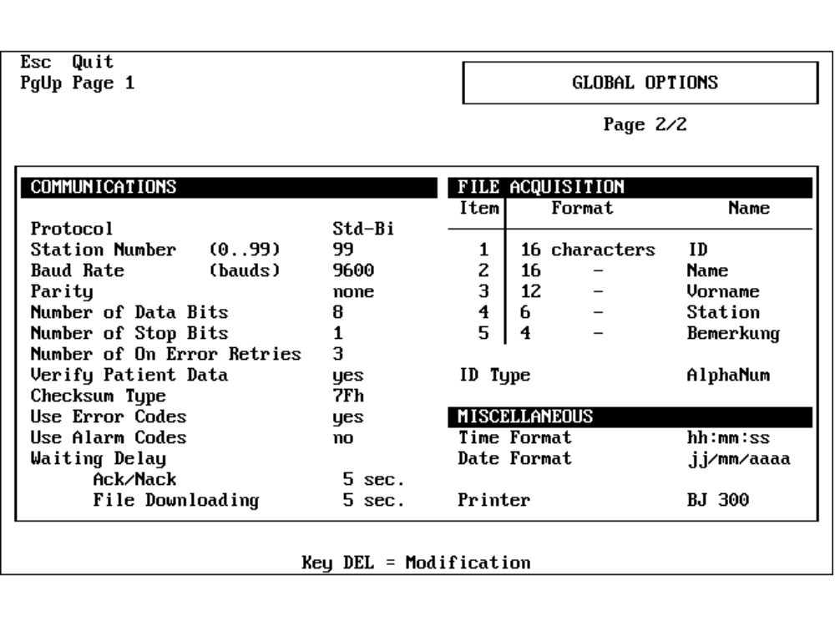
Figure 13 : STA Global Options Screen (Std-Bi)
Global Options (Screen Page 2/2) shows the following options for the Std-Bi protocol:
- Protocol
Selection of the protocol type
Range: Std-Bi/ASTM
- Station Number
2-digit Instrument Identification Number
Range: 0 to 99
- Baud Rate
Baud rate of the serial interface (baud = bits per second)
Range: 9600, 4800, 2400, 1200, 600, 300
- Parity
Type of parity check
Range: none, odd or even
- Number of Data Bits
Number of data bits per character
Range: 7 or 8
- Number of Stop Bits
Number of stop bits
Range: 1 or 2
- Number of On Error Retries
Number of times the STA repeats a message when a [NAK] is received
Range: 1 to 9
- Verify Patient Data
YES: If the worklist from the host contains the info fields they are displayed after receiption in a separate window for confirmation.
NO: Even if the worklist from the host contains the info fields they are not displayed for confirmation.
Range: YES / NO
- Checksum Type
7Fh Each character (except [STX], [ETX] and 7Fh) is XOR’d with 7Fh. If the result is equal to 03h then the character is replaced with 7Fh.
OR 40 Each character is OR’d with the checksum character and 40h.
Range: 7Fh / 40h
- Use Error Codes
Range: YES/NO
- Use Alarm Codes
Range: YES/NO
Use Error Codes | Use Alarm Codes | Action Taken
NO | NO | Only validated results transmitted
YES | NO | All results sent with Error Code
YES | YES | All results sent with Error/Alarm Code
There are two different tables for Error/Alarm codes. See Table 10 page 34
- Waiting Delay Ack/Nack
Time, in seconds, the STA waits for a [ACK] or [NAK] before generating a time out error.
Range: 1 to 99 seconds
- Waiting Delay File Downloading
Time, in seconds, the STA waits for a Worklist before generating a time out error.
Range: 1 to 99 seconds
- ID Type
Format of the 8-character Patient ID.
The STA can define a 16-character Patient ID. For compatibility with the Std-Bi protocol, this is reduced to 8 characters.
Numerical: Only Numerical ID’s accepted. Values less than 9999999 are padded with leading zeros (30h).
Alphanum: Only the first 8 characters are accepted. If the length is less than 8 the input is padded with leading spaces (20h).
Range: Numerical/Alphanum
Note: Any ID defined with more than 8 characters will not be transmitted.

Definitions

Trace Format (Std-Bi)
To aid readability the following control character definitions will be used:
Code | Description | Mnemonic
01 hex | Connect Request | [SOH]
02 hex | Start of Text | [STX]
03 hex | End of Text | [ETX]
06 hex | Acknowledge | [ACK]
15 hex | Not Acknowledged | [NAK]
20 hex | Space Character | ( = Code 250 )
00 to FF | Checksum Character | [xxh]
Table 3 : Control Character Definitions used in Std-Bi Example Traces

Checksum Calculation (Std-Bi)
The typical Std-Bi protocol text structure is as follows:
Item | Start-of-Text | Text | Checksum | End-of-Text
Length | 1 | Variable | 1 | 1
Trace | [STX] |  | [xxh] | [ETX]
Table 4 : Typical Text Format for the Std-Bi Protocol.
The Checksum Method is defined in Global Options (Screen Page 2/2).
(See Figure 13 Page 10).

The 7Fh Checksum Method
- The Exclusive-OR sum of all characters in the Text section is found.
- Only if the result has the value 03h it is replaced by the value 7Fh.

The OR 40h Checksum Method
- The Exclusive-OR sum of all characters in the Text section is found.
- The result OR’d by 40h to obtain the final Checksum.

User Maintenance (Std-Bi)
The User Maintenance menu is accessed via the main menu option Maintenance.
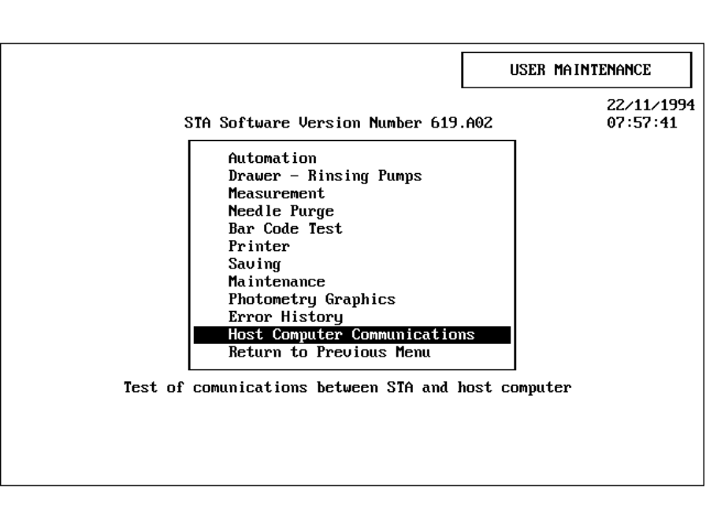
Figure 14 : Main Menu of User Maintenance.
Select Host Computer Communications to display the communication parameters:
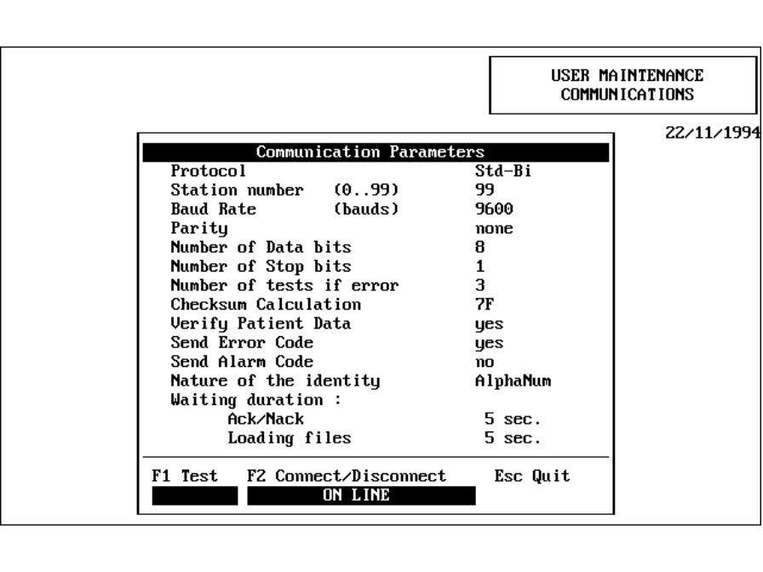
Figure 15 : User Maintenance Parameters and Test Functions (Std-Bi).
Modify the Parameters via the Setup ⇒ Global Options Menu (Screen Page 2/2). (See Figure 13 Page 20). Refer to Chapter 5.1 for an explanation of the parameters.
Two test functions are available on this screen:
- <F1> Line Test.
- <F2> Connect/Disconnect.

<F1> Line Test.
When <F1> is pressed the STA Analyzer sends: [STX]EF[ETX]
(This is the character ‘E’ with an incorrect Checksum character ‘F’).
If the Host returns the expected [NAK] : PASSED is displayed.
If not; FAILED is displayed.

<F2> Connect / Disconnect
The <F1> Line Test is made with a check on the return delay from the Host against the parameters specified in Global Options.
The STA Analyzer then sends a [SOH] to establish a connection.
If the Host returns the expected [SOH] : ON LINE is displayed.
If not; OFF LINE is displayed.
After a successfully establishing a connection the <F2> key just initiates the Line Test.

Data Transmission Control (Std-Bi)
This section describes the complete protocol between the STA Analyzer and the Host.

Establishment Phase

Objective
After switching the analyzer ON a Global Verification is performed. The STA Analyzer automatically performs the Line Test (see chapter 5.4.4).
If the Line Test fails the STA tries to establish the connection by sending a control character.
If the connection is unsuccessful the operator can request a connection manually via the Maintenance ⇒ Host Computer Communications menu.
See Chapter 5.3 User Maintenance (Std-Bi) Page 23
Protocol:
The STA Analyzer sends [SOH].
The Host returns a [SOH] within the pre-determined time.
If the return is not within the specified delay, or not received, the Establishment Phase is considered false.

Data Flow
Figure 16 : Establishment Phase with Successful Response.
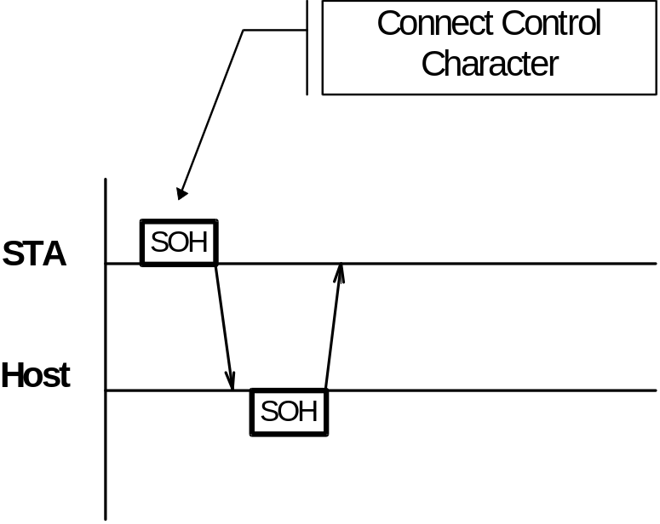

Flow Chart
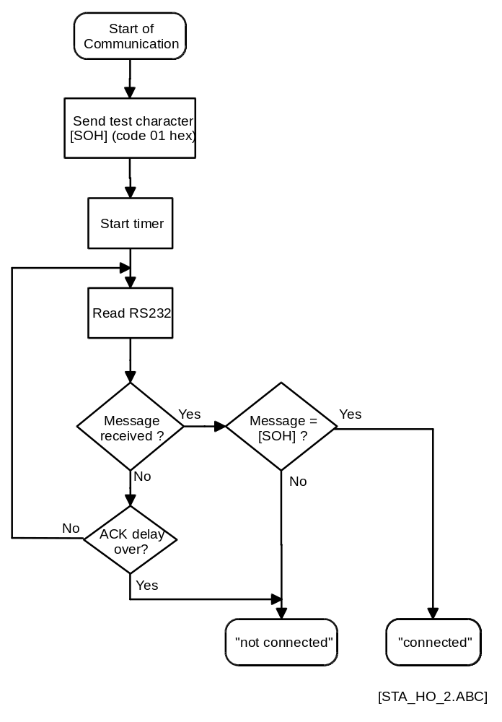
Figure 17 : Flow Chart of Establishment Phase (Std-Bi).

Trace Example
STA 16:27:05 [SOH]
Host 16:27:05 [SOH]

Trace Example 1 : Establishment Phase

Worklist Request / Worklist

Objective
- Assuming the the STA is configured AUTO MODE and BY TELELOADING, then a Worklist Request is sent to the Host after a sample is placed and identified.
- The Host responds to the Worklist Request by sending a Worklist containing the transmission numbers of the selected tests.
Protocol:
The STA sends a Worklist Request ‘Q’ message and waits for a [ACK] or [NAK] from the Host within the specified delay. See Global Options (Screen Page 2/2).
When the Host responds with [ACK], the STA waits for the Worklist ‘T’ message to arrive within the pre-defined File Downloading Delay. If unsuccessful that patient sample is regarded as invalid and the Worklist Not Received error is displayed.
When the Host responds with [NAK], the STA repeats the message until the required ‘Number of On Error Retries’ is reached. If all attempts fail then that patient sample is regarded as invalid and the Worklist Not Received error is displayed.

Message Format
- Worklist Request
Item | Start-of-Text | Frame ID | Station | Patient ID | Checks | End-of-Text
Length | 1 | 1 | 2 | 8 | 1 | 1
Trace | [STX] | Q | xx | pppppppp | [cch] | [ETX]
Code | 02 hex | 51 hex |  |  |  | 03 hex
Note |  |  | 1 | 2 | 3
Table 5 : Structure of Worklist Request Message (Std-Bi).
- Worklist Type 1 - Without Information Fields.
Item | Start-of-Text | Frame ID | Station | Patient ID | Methods | Checks | End-of-Text
Length | 1 | 1 | 2 | 8 | 2 to 24 | 1 | 1
Trace | [STX] | Q | xx | pppppppp | mm | [cch] | [ETX]
Code | 02 hex | 51 hex |  |  |  |  | 03 hex
Note |  |  | 1 | 2 | 4 | 3
Table 6 : Structure of Worklist Message Without Info. (Std-Bi).
- Worklist Type 2 - With Information Fields
Item | Start-of-Text | Frame ID | Station | Patient ID | Info | Methods | Checks | End-of-Text
Length | 1 | 1 | 2 | 8 | 38 | 2 to 24 | 1 | 1
Trace | [STX] | Q | xx | pppppppp | aaaa... | mm | [cch] | [ETX]
Code | 02 hex | 51 hex |  |  |  |  |  | 03 hex
Note |  |  | 1 | 2 | 5 | 4 | 3
Table 7 : Structure of Worklist Message With Info. (Std-Bi).
Notes:
Note 1: Station Number. Defined in Global Options (Screen Page 2/2).
Note 2: Patient Identification. Defined as an 8-character Numerical or Alphanumerical. See Global Options (Screen Page 2/2).
The Numerical ID is left justified and padded with zeros (30h).
The Alphanumeric ID is left justified and padded with spaces (20h).
Note 3: Checksum. Method defined in Global Options (Screen Page 2/2).
Note 4: Methods. This field is repeated up to 12 times depending on the number of methods requested. See Test Setup menu for Method Ranking. For each method one main unit and one rank is defined. There are up to 3 ranks for secondary units. The main unit rank is used to determine the method. The other ranks are only used to send the results.
Note 5: Info. This Patient Information Field must contain the obligatory character ‘/’ (2F hex) at the end of Info Field 1.
- The STA Analyzer automatically identifies the format (1 or 2).
- If format 2 is found the INFO field is truncated as follows:
Info Field 1 | 16 | Characters (including ‘/’)
Info Field 2 | 12 | Characters
Info Field 3 | 6 | Characters
Info Field 4 | 4 | Characters
Total | 38 | Characters
The Operator is strongly recommended to keep these settings. This ensures a clear Patient Information display in the various menus of the STA software.

Data Flow
Figure 18 : Worklist Request and Worklist Response
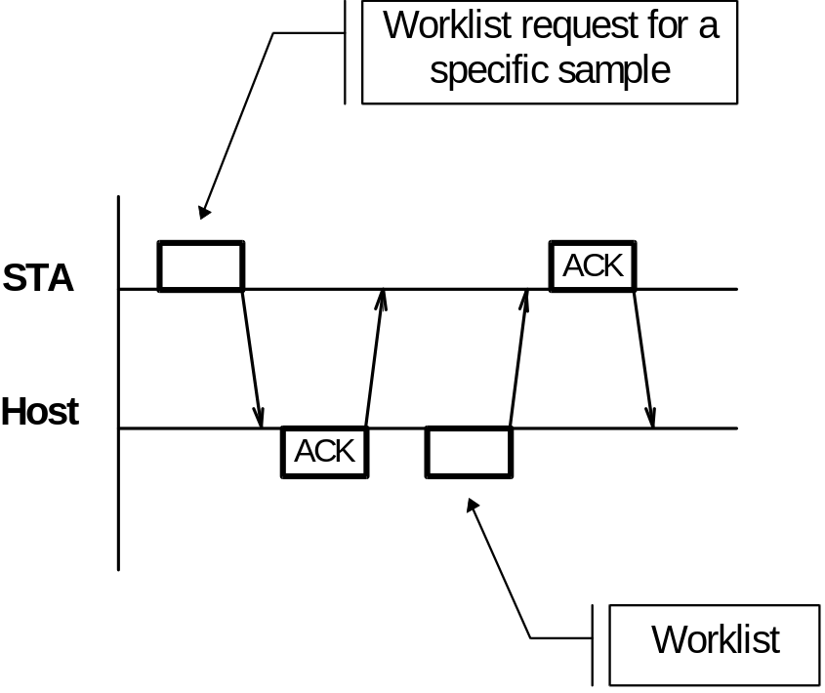

Flow Chart
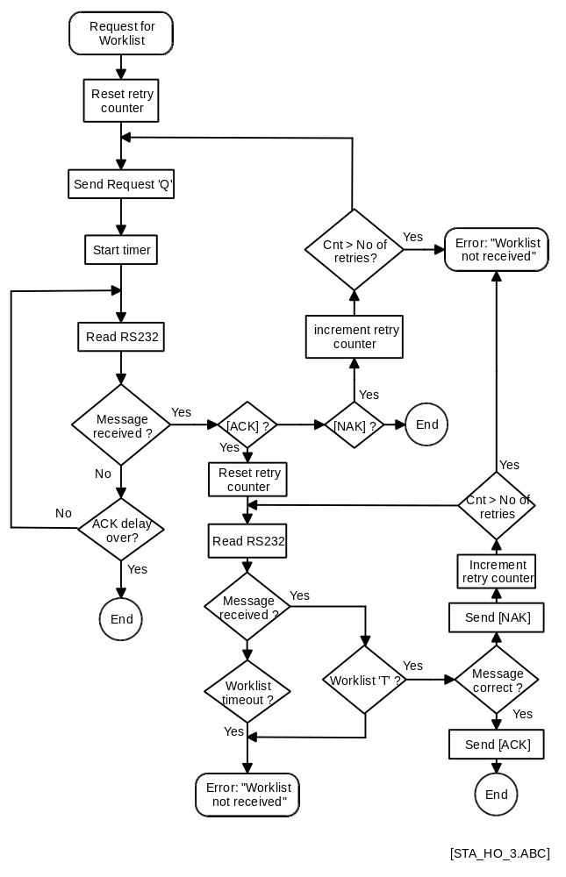
Figure 19 : Flow Chart of Worklist Request (Std-Bi)

Trace Example
- Worklist with Information Fields
STA 16:27:51 [STX]Q99·····003[42h][ETX]
Host 16:27:51 [ACK]
Host 16:27:51 [STX]T99·····003Inf1···········/Inf2········Inf3··Inf401
04[49h][ETX]
STA 16:27:51 [ACK]

Analyzer sends worklist request.

STA 16:27:51 [STX]Q99·····003[42h][ETX]

[STX]  Q  99  ·····003  End code  [42h]  [ETX] | Start of text (ASCII code 02 hex)  Frame character: Worklist request  Station number : 99  Sample-ID : 003  Code 42 hex represents for the checksum character ‘B’  End of text (ASCII code 03 hex)

Host sends back the worklist.

Host 16:27:51 [STX]T99·····003Inf1···········/Inf2········Inf3··Inf401
04[49h][ETX]

[STX]  T  99  ·····003  Info fields  Inf1···········/  Inf2········  Inf3··  Inf4  Selected methods  0104  End code  [49h]  [ETX] | Start of text (ASCII code 02 hex)  Frame character: Worklist  Station number : 99  Sample-ID : 003  Info field 1 (16 characters)  Info field 2 (12 characters)  Info field 3 ( 6 characters)  Info field 4 ( 4 characters)  Tests with method numbers 1 and 4 selected  Code 49 hex represents the checksum character ‘I’  End of text (ASCII code 03 hex)
Trace Example 2 : Worklist Request and Worklist with Info Fields (Std-Bi).
- Worklist without Info Fields
STA 16:28:10 [STX]Q99......003[42h] [ETX]
Host 16:28:10 [ACK]
Host 16:28:10 [STX]T99......0030104[42h] [ETX]
STA 16:28:10 [ACK]
See example a) for format explanation.

Result Transmission

Objective
Results are transmitted to the Host in Real-Time (as and when available), or in Batch Mode after the completion of the run (operator initiated).
Protocol:
The STA sends a Result ‘R’ message and waits for a [ACK] or [NAK] from the Host within the specified delay.
When the Host responds with [ACK], the STA waits 500 msec before sending the message.
If the Host responds with [NAK], the STA repeats the message until the required ‘Number of On Error Retries’ is reached. See Global Options (Screen Page 2/2).
If all attempts fail then STA stops transmission and reports a communication failure.

Message Format
Item | Start-of-Text | Frame ID | Station | Patient ID | Zeros | Results | Checks | End-of-Text
Length | 1 | 1 | 2 | 8 | 4 | See Below | 1 | 1
Trace | [STX] | R | xx | pppppppp | 0000 |  | [cch] | [ETX]
Code | 02 hex | 52 hex |  |  | 4 * 48 hex |  |  | 03 hex
Note |  |  | 1 | 2 |  |  | 3
Table 8 : Structure of Result Message (Std-Bi).
Format of the Results Field:
 | Test Result 1 |  |  | .... | Test Result n
Item | Method Rank | Value | Alarm
Length | 2 | 4 | 2
Trace | mm | RRRR | AA
Note | 5 | 6 | 7

Notes:
Note 1: Station Number. Defined in Global Options (Screen Page 2/2).
Note 2: Patient Identification. Defined as 8-character Numeric or Alphanumeric.
See Global Options (Screen Page 2/2).
The numerical ID is left justified and padded with zero’s (30h).
The alphanumeric ID is left justified and padded with spaces (20h).
Note 3: Checksum. Method defined in Global Options (Screen Page 2/2).
Note 4: Results. Total Length never exceeds 237 characters. Patient Files of greater size are sent as several messages with the same heading.
Note 5: Method Rank. See Test Setup Menu for Method Ranking definition. For each method one main unit and one rank is defined. There can be up to 3 ranks for secondary units. The main unit rank is used to determine the method. The other ranks are only used to send the results.
The field is right justified and padded with zeros (30h).
Note 6: Result Value. The Result Field RRRR holds an integer value. A division factor is applied to obtain the real value. See Table 9.
Units | Division Factor
sec | 10
% | 1
INR | 100
g/l | 100
mg/dl | 1
ratio | 100
ng/ml | 100
U/ml | 100
IU/ml | 100
AU1 | **
AU2 | **
AU3 | **
Table 9 : Units and Division Factors
**: Consistent with decimal point position defined in Global Options (Screen Page 1/2).
The Result Field is right justified and with padded zeros.
Note 7: Error or Error/Alarm Code. There are 2 characters in this field. The first character is always 7Fh. The second character indicates the Error or Error Alarm Code. See the tables below.
If ‘Use Error Codes’ and ‘Use Alarm Codes’ are both set to ‘NO’ in Global Options (Screen Page 2/2) only validated 6-character results are transmitted (2 character Method Rank and 4 character Value).
Error Codes
When ‘Use Error Codes’ = ‘YES’ and ‘Use Alarm Codes’ = ‘NO’, the following applies:
Characters | ASCII Code | Error Message
‘1’ | 31 hex | To be confirmed
‘2’ | 32 hex | Technical Error
‘3’ | 33 hex | > T max.
‘4’ | 34 hex | < T min.
‘5’ | 35 hex | Margin > Tolerance
‘8’ | 38 hex | R < R min./Colorimetry
‘A’ | 41 hex | Confirmed
Table 10 : Error Codes (Std-Bi).
Error and Alarm Codes
When ‘Use Error Codes’ = ‘YES’ and ‘Use Alarm Codes’ = ‘YES’, the following applies:
 | Characters | ASCII Code | Error Message | Alarm Code
Group 1 | ‘2’ | 32 hex | Technical Error | Not Used
 | ‘3’ | 33 hex | T > T max. | Not Used
 | ‘4’ | 34 hex | T < T min. | Not Used
 | ‘5’ | 35 hex | Margin < Tolerance | Not Used
 | ‘8’ | 38 hex | Linearity | Not Used
Group 2 | ‘A’ | 41 hex | Confirmed | Without
 | ‘B’ | 42 hex | Confirmed | 1
 | ‘C’ | 43 hex | Confirmed | 2
 | . | . | . | .
 | . | . | . | .
 | ‘O’ | 4F hex | Confirmed | 14
Group 3 | ‘1’ | 31 hex | To be confirmed | Without
 | ‘b’ | 62 hex | To be confirmed | 1
 | ‘c’ | 63 hex | To be confirmed | 2
 | . | . | . | .
 | . | . | . | .
 | ‘o’ | 6F hex | To be confirmed | 14
Table 11 : Error and Alarm Codes (Std-Bi).

Code | Description
1 | Result: | Confirmed with T>max.
2 | Calibration Control: | Overridden
3 | Quality Control: | Out of Range or Not Done
4 | Quality Control: | Overridden
5 | Arm #3: | No Level Detection
6 | Arm #2: | No Level Detection
7 | Arm #1: | No Level Detection
8 | Result: | Value in Primary Unit Skewed
9 | Result: | Dilution Change
10 | Result: | Rerun Test
11 | Reagent Drawer | Temperature Out of Limits
12 | Syringe Arm #3: | Maintenance Data Overdue
13 | Syringe Arm #2: | Maintenance Data Overdue
14 | Syringe Arm #1: | Maintenance Data Overdue
Table 12 : Alarm Code Descriptions (Std-Bi).
Note: If there are multiple alarms for a result, the highest priority code is transmitted. Code 1 is the highest of 14 priority levels.

Data Flow
Figure 20 : Result Transmission with Positive Acknowledgment.
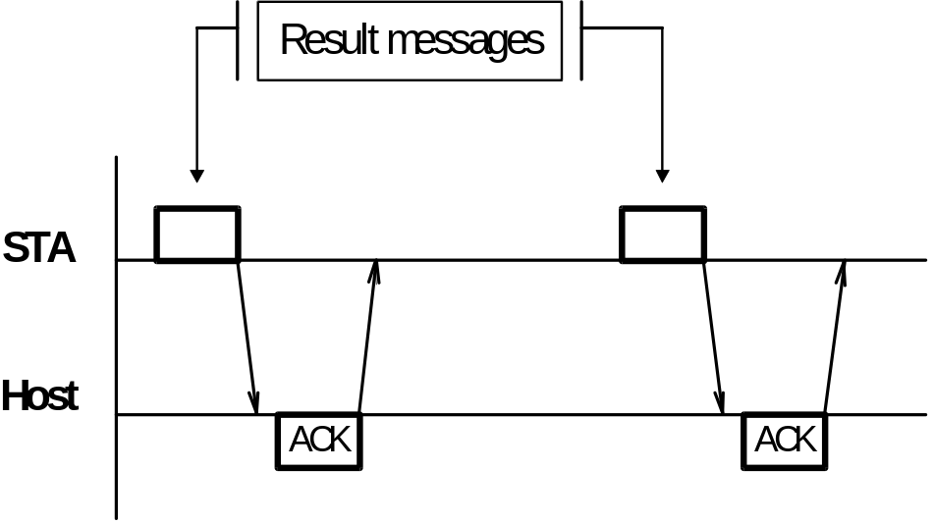

Flow Chart
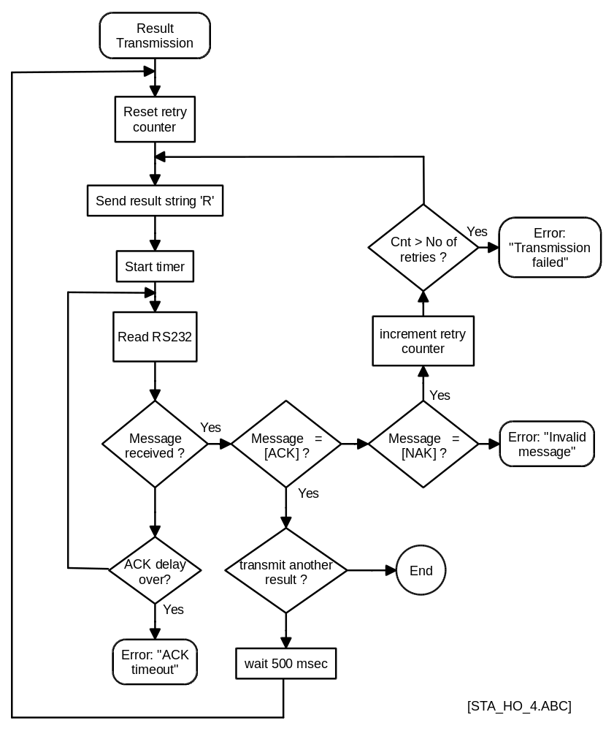
Figure 21 : Flow Chart of Result Transmission (Std-Bi).

Trace Example
- Results with Error Codes
STA 16:31:50 [STX]R99·····0030000010123A024567103005410404561[33h]
[ETX]
Host 16:31:50 [ACK]

Analyzer sends results with error codes.

STA 16:31:50 [STX]R99·····0030000010123A024567103005410404561[33h]
[ETX]
(the character  represents the character code 7F hex)
[STX]  R  99  ·····003  Results  0000  01  0123  A  02  4567  1  03  0054  1  04  0456  1  End code  [33h]  [ETX] | Start of text (ASCII code 02 hex)  Frame character: Result  Station number : 99  Sample-ID : 003  4 zeros  Method rank : 1  Result : 123  Error code : A ( = confirmed)  Method rank : 2  Result : 4567  Error code : 1 ( = to be confirmed)  Method rank : 3  Result : 54  Error code : 1 ( = to be confirmed)  Method rank : 4  Result : 456  Error code : 1 ( = to be confirmed)  Code 33 hex represents the checksum character ‘3’  End of text (ASCII code 03 hex)
Trace Example 3 : Result transmission with error codes (Std-Bi)
- Results without Error Codes - only validated results are transmitted.
STA 16:31:31 [STX]R99·····0030000010123[40h][ETX]
Host 16:31:31 [ACK]

Analyzer sends only validated results.

STA 16:31:31 [STX]R99·····0030000010123[40h][ETX]

[STX]  R  99  ·····003  Results  0000  01  0123  End code  [40h]  [ETX] | Start of text (ASCII code 02 hex)  Frame character: Result  Station number : 99  Sample-ID : 003  4 zeros  Method rank : 1  Result : 123  Code 40 hex represents the checksum character ‘@’  End of text (ASCII code 03 hex)
Trace Example 4 : Result transmission without error codes (Std-Bi)

Line Test

Objective
Test the communications link between the STA Analyzer and the Host.
This message is always sent by the STA software during ‘Global Verification’.
The operator can request a the test from the Maintenance ⇒ Host Computer Communication menu. See User Maintenance (Std-Bi) Page 23.
The Line Test initiates a message with an incorrect checksum. The Host should then respond with a [NAK].
Protocol:
The STA Analyzer sends a message with an incorrect checksum and waits for a [NAK] within the pre-defined delay time. If the Host fails to respond, or is late or incorrect, then the line is considered disconnected and no transmission is possible.

Message Format

Item | Start-of-Text | Frame Type | Checksum | End-of-Text
Length | 1 | 1 | 1 | 1
Trace | [STX] | E | [46h] | [ETX]
Code | 02 hex | 45 hex | 46 hex | 03 hex
Table 13 : Structure of Line Test (Std-Bi).

Data Flow
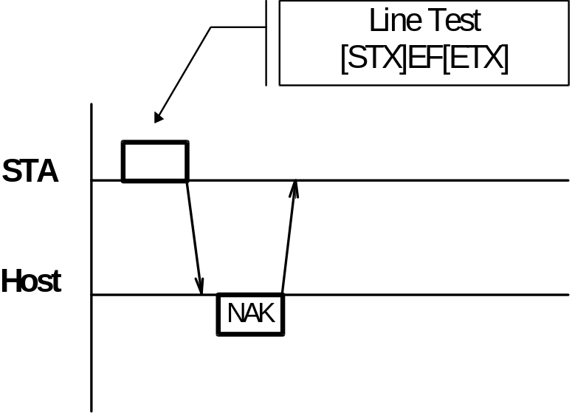
Figure 22 : Line Test with Correct Response.

Flow Chart
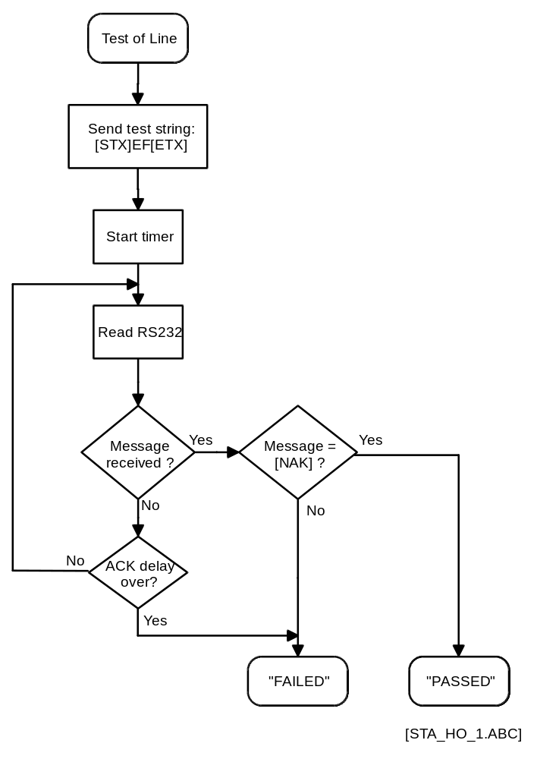
Figure 23 : Flow Chart of Line Test (Std-Bi).

Trace Example
STA 16:27:12 [STX] E [46h] [ETX]
Host 16:27:12 [NAK]

Trace Example 5 : Line Test (Std-Bi).

Termination Phase

Objective
The STA Analyzer sends an ‘E’ to the Host to terminate communications. No check is made for acknowledgment from the Host. The Termination Phase is optional. Its use depends upon the Host Computer.

Message Format
Item | Start-of-Text | Frame Type | Checksum | End-of-Text
Length | 1 | 1 | 1 | 1
Trace | [STX] | E | [45h] | [ETX]
Code | 02 hex | 45 hex | 45 hex | 03 hex
Table 14 : Structure of Termination Message (Std-Bi).

Data Flow
Figure 24 : Termination Phase Without Response
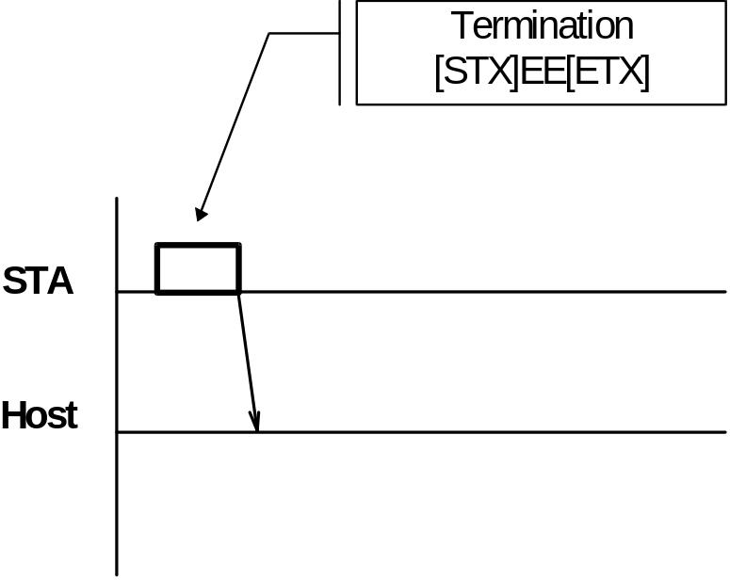

Flow Chart
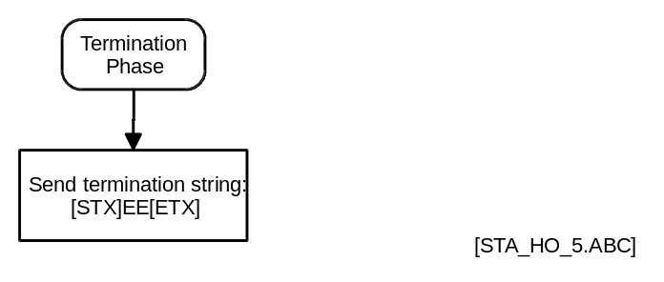
Figure 25 : Flow Chart of Termination Phase

Trace Example
STA 16:27:18 [STX] E [45h] [ETX]

Trace Example 6 : Termination Phase (Std-Bi).

ASTM Protocol
Details of the ASTM protocol can be found in the following papers:
- ASTM E1381-94 Low Level Protocol:
Specification for Low Level Protocol to Transfer Messages Between Clinical Laboratory Instruments and Computer Systems.
- ASTM E1394-91 High Level Protocol:
Standard Specification for Transferring Information Between Clinical Instruments and Computer Systems.

Host Interface Settings (ASTM)
All Host Interface settings are made in Setup ⇒ Global Options (Screen Page 2/2).
Access to the Global Options screen requires the 6-digit Access Code. (See 3.1.1 Calculation of Access Code Page 8)
Successful entry of the correct Access Code displays Global Options (Screen Page 1/2). Press <PageDown> to display the following screen:
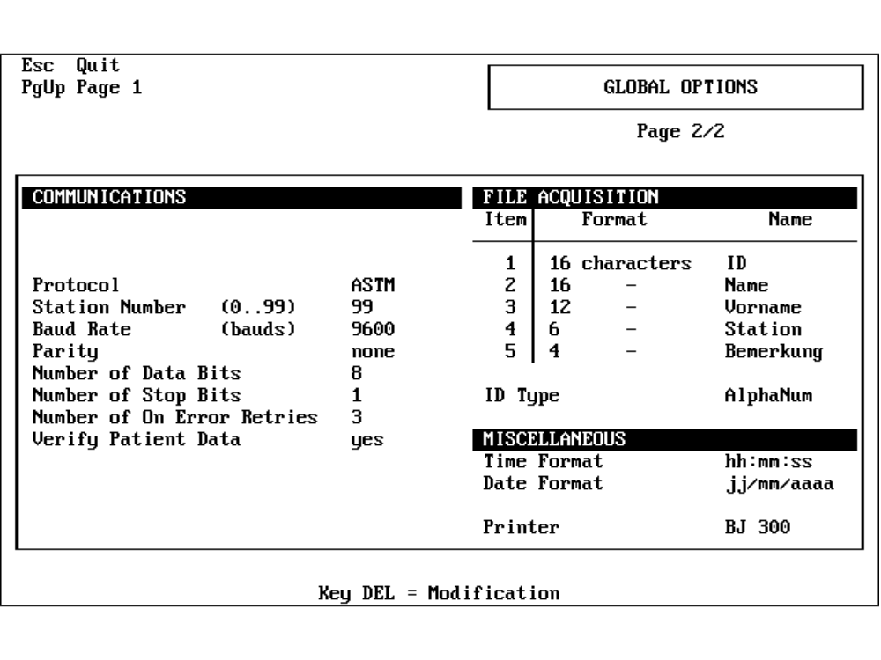
Figure 26 : STA Global Options Screen (ASTM)
Global Options (Screen Page 2/2) displays the following options for the ASTM protocol:
- Protocol
Selection of the protocol type
Range: Std-Bi/ASTM
- Station Number
2-digit Instrument Identification Number
Range: 0 to 99
- Baud Rate
Baud rate of the serial interface (baud = bits per second)
Range: 9600, 4800, 2400, 1200, 600, 300
- Parity
Type of parity check
Range: none, odd or even
- Number of Data Bits
Number of data bits per character
Range: 7 or 8
- Number of Stop Bits
Number of stop bits
Range: 1 or 2
- Number of On Error Retries
Number of times the STA repeats a frame when it receives a character different from [ACK] or [EOT]. This number has to be set to 6.
Range: 1 to 9
- Verify Patient Data
YES: The four information fields in the Worklist from Host are displayed after receiption in a separate window for confirmation.
NO: The four information fields in the Worklist from Host are not displayed in a separate window for confirmation..
Range: YES / NO
- ID Type
Format of the 16-character Patient ID.
Range: Numerical/Alphanum

Definitions

Trace Format (ASTM)
To aid readability the following control character definitions will be used:
Code | Description | Mnemonic
02 hex | Start of Text | [STX]
03 hex | End of Text | [ETX]
04 hex | End of Transmission | [EOT]
05 hex | Enquiry | [ENQ]
06 hex | Acknowledge | [ACK]
0A hex | Line Feed | [LF]
0D hex | Carriage Return | [CR]
15 hex | Not Acknowledged | [NAK]
17 hex | End of Transmission Block | [ETB]
Table 15 : Control Character Definitions used in ASTM Example Traces

Checksum Calculation (ASTM)
The record format for the ASTM protocol is as follows:
Item | Start-of-Text  [STX] | Data Section | End Code  [ETX] CH CL [CR] [LF]
Length | 1 | Variable | 5
Table 16 : Common Text Format for the ASTM Protocol.
The Checksum is the sum of all the characters except; the Checksum, [CR] and [LF].That is the Data Section + [ETX]. The Checksum is the Least Significant 8-bits of the result, in hexadecimal format.
Example:
Sum of all character codes: 122 decimal
Hexadecimal Format 7A hex
The two characters ‘7’ and ‘A’ are transferred as the Checksum characters CH and CL respectively.

User Maintenance (ASTM)
The User Maintenance menu is accessed via the main menu option Maintenance.
Figure 27 : Main Menu of User Maintenance.
Select Host Computer Communications to display the Communication Parameters:
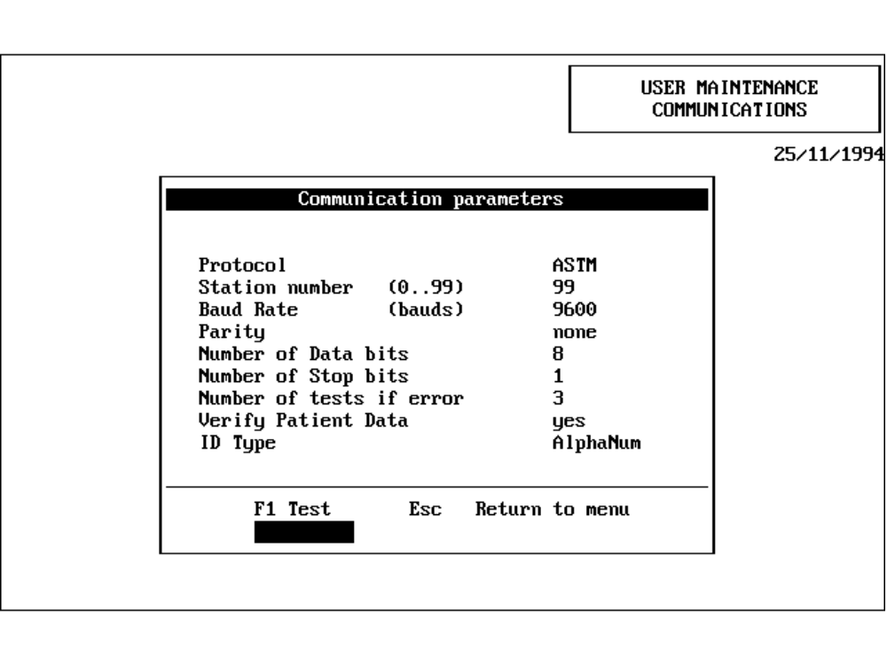
Figure 28 : User Maintenance Parameters and Test Functions (ASTM).
Modify the Parameters via the Setup ⇒ Global Options Menu (Screen Page 2/2). (See Figure 26 Page 43).
Refer to 6.1 Host Interface Settings (ASTM) Page 43 for an explanation of the parameters.
There is one test function available on this screen:
- <F1> Line Test.
The STA Analyzer sends [ENQ] to the Host.
The Host is expected to respond with [ACK].
When the [ACK] is received the STA Analyzer terminates the Line Test with [EOT] and the PASSED message is displayed.
If the Host failed to respond, FAILED is displayed.

Data Transmission Control (ASTM)
The following chapters describe the complete communication between the STA Analyzer and the Host Computer.

Common Transmission Procedure
As required by the ASTM Protocol Specification the STA Analyzer recognizes three line modes:
- Idle: No communication in progress.
- Tx: Transmission by STA Analyzer
- Rx: Reception by STA Analyzer
The following procedure is used whenever information is sent over the link by either the STA or the Host. This procedure has three phases:
- Establishment Phase
The link is claimed by the sender (STA or Host).
- Transfer Phase
Transmission of the different records making up the message.
- Termination Phase
The link is released
The three phases are shown below:
Figure 29 : Transmission Control of Information Exchange (ASTM).
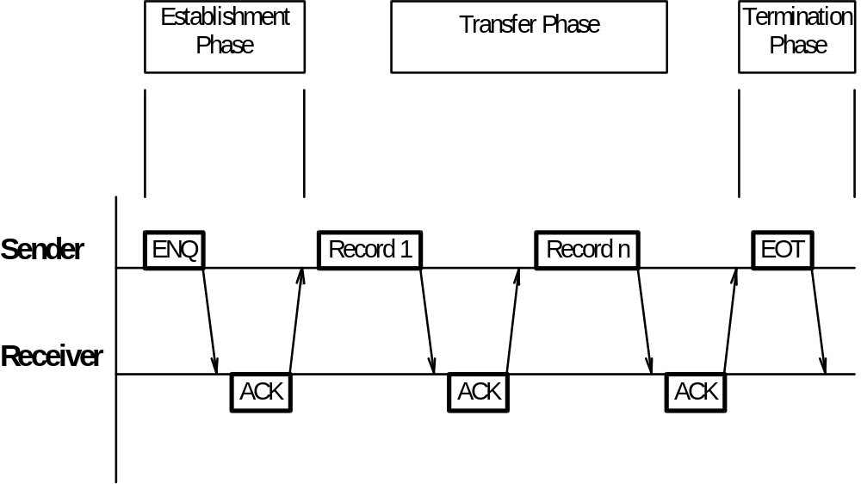

Communication Phases

Establishment Phase (STA to Host)
If the STA is in Idle Mode it sends an [ENQ]. The possible responses from the Host are:
- The Host sends an [ACK].
The STA changes to Transmission Mode. If the STA is in Normal Mode it initiates the Record Transfer. Alternatively, if the STA is in Test Mode, it initiates the Termination Phase by sending an [EOT].
- The Host sends an [ENQ].
The STA waits 5 seconds and then returns another [ENQ]. This cycle is repeated until a [ACK], [NAK], or any other character is received.
- The Host sends some other characters.
The STA waits 10 seconds and then returns another [ENQ]. This cycle is repeated until the ‘Number of On Error Retries’ is reached. At this point the STA initiates the Termination Phase by sending an [EOT] and displays an error message.
- The Host does not respond.
The STA waits 15 seconds, initiates the Termination Phase by sending an [EOT], and displays an error message.

Transfer Phase (STA to Host)
The STA transmits the first record. The possible responses from the Host are:
- The Host sends a [ACK] or [EOT].
The STA sends the next record.
Caution! The STA regards the [EOT] as an acknowledgment and continues to transmit records.
- The Host sends some other characters.
The STA waits 10 seconds and then repeats the transmission of the record. This cycle is repeated until the ‘Number of On Error Retries’ is reached. At this point the STA initiates the Termination Phase by sending an [EOT] and displays an error message.
- The Host does not respond.
The STA waits 15 seconds, initiates the Termination Phase by sending an [EOT] and displays an error message.

Termination Phase (STA to Host)
The STA transmits an [EOT]. It does not wait for a response. The STA changes to Idle Mode.

Receiver Reaction (Host to STA)
The possible responses from the STA to a Host message are:
- The Host sends a [ENQ]
If the STA is in Idle Mode it replies with an [ACK] and changes to Reception Mode.
- The Host sends a [EOT]
If the STA is in Reception Mode and a Header Record has been received, the STA goes to Idle Mode and releases the link. The received records are then analyzed by the STA.
If the STA is in Transmission Mode, the STA regards the [EOT] as an acknowledgment and continues to transmit records.
- The Host sends some other characters.
The STA receives the characters as part of a record. When a complete record is transmitted the STA verifies the Checksum. If this is satisfactory, the STA returns an [ACK]. If not, a [NAK] is sent.

Flow Charts

Reception/Transmission Sequence
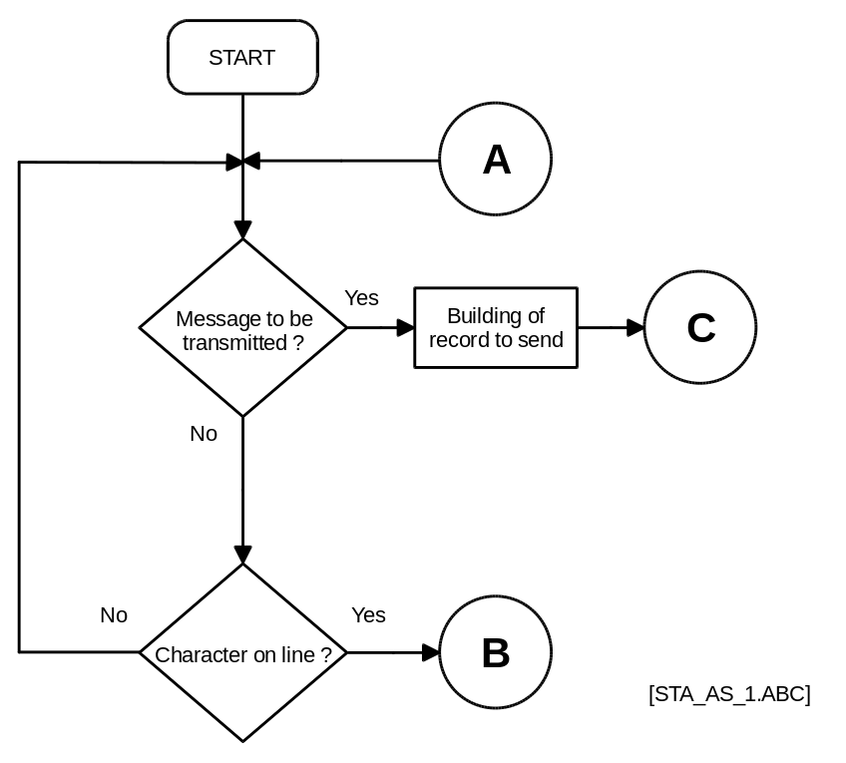
Figure 30 : Flow Chart of Reception/Transmission (ASTM).

Reception of a Record
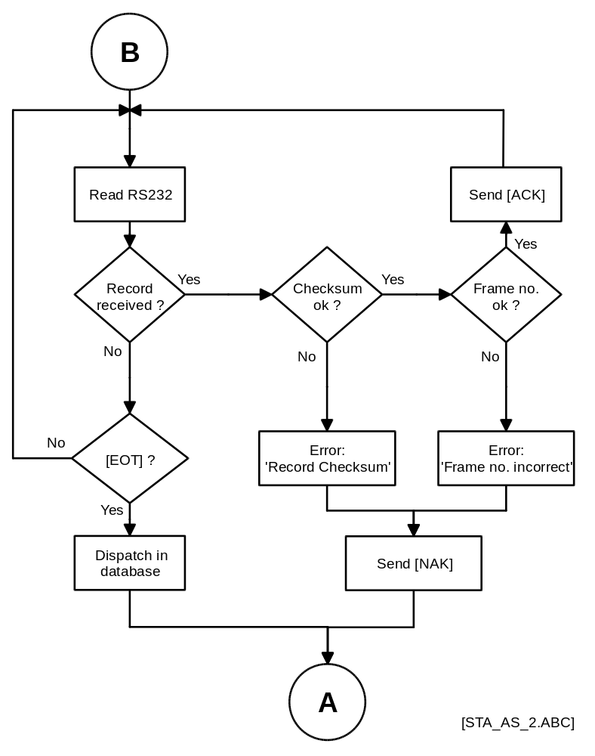
Figure 31 : Flow Chart of Reception of a Record (ASTM).

Establishment Phase
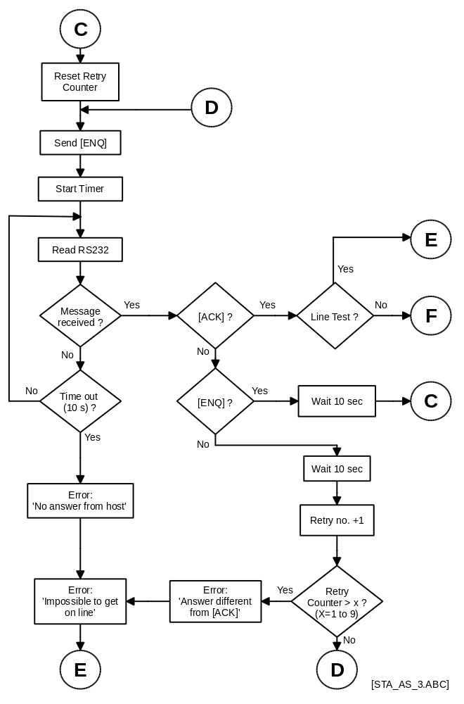
Figure 32 : Flow Chart of Establishment Phase (ASTM).

Transfer Phase
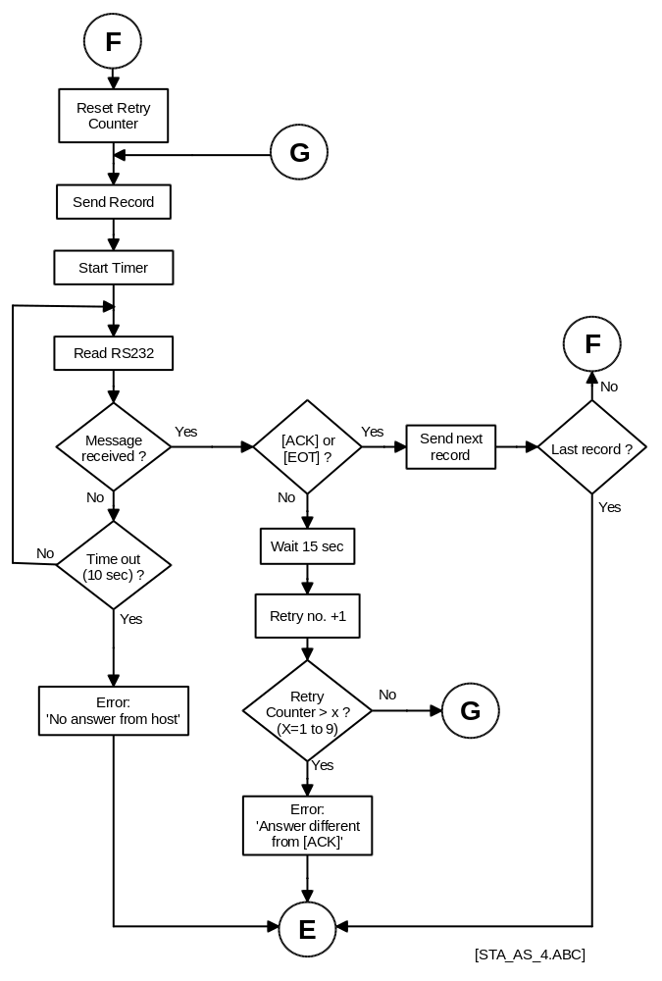
Figure 33 : Flow Chart of Transfer Phase (ASTM).

Termination Phase
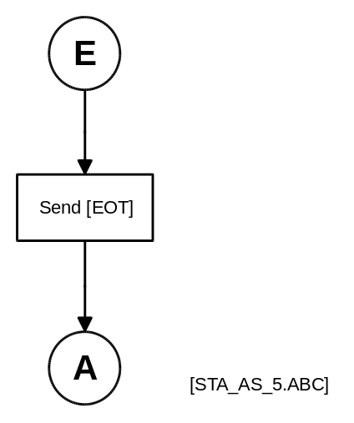
Figure 34 : Flow Chart of Termination Phase (ASTM).

Record Sequence
There are three different messages sent between the STA and the Host. Each of these contain Records (Refer to ASTM-1394-91 specifications):
- Request for Worklist: (STA to Host)
Message Header Record
Request Info. Record
Message Terminator Record
- Worklist: (Host to STA)
Message Header Record
Patient Record
Test Order Record 1
...
Patient Record (optionally)
Test Order Record 1 (optionally)
Message Terminator Record
- Result: (STA to Host)
Message Header Record
Patient Record
Test Order Record 2
Result Record (Unit 1)
Manufacturer Information Record (Unit 1)
...
Result Record (Unit n, with n=1 to 4)
Manufacturer Information Record (Unit n, with n=1 to 4)
Message Terminator Record
A Worklist is normally sent in response to a Worklist Request, although, the ASTM protocol also allows the sending of a modified Worklist for an already existing sample entry at the STA without first sending a request.
If the operator identifies and positions the samples in routine so fast that the worklist request for the next sample is earlier than the worklist from the host for the previous sample the request from the STA has higher priority and the host must buffer the request until he gets the line for sending the worklist.
Depending on the speed of the operator it could happen that the host must buffer all requests of one drawer.
When the host gets the line for worklist transmission the host can send the methods for all buffered samples within one worklist transmission by repetition of the Patient and Test Order records (see 2. Worklist above)

Record Structure

Record Types
Table 17 lists the different Record types with their identification characters and the included information.
No | Name | Char | Sender | Contents (STA specific) | ASTM
1 | Message Header | H | STA/Host | Delimiters, Station no.,  Version no., Date, Time | 7.1.
2 | Patient Information | P | STA/Host | four Info fields | 8.1.
3 | Request Information | Q | STA | Sample ID | 12.1.
4 | Test Order 1 | O | Host | Sample ID, selected Methods | 9.4.
5 | Test Order 2 | O | STA | Sample ID | 9.4.
6 | Result | R | STA | Method no, Result, Unit,  Date and Time (if control result) | 10.1.
7 | Manufacturer Information | M | STA | Error and Alarm code | 15.1
8 | Message Terminator | L | STA/Host |  | 13.1.
Table 17 : Record Types (ASTM)

General Record Format
All the above listed records have the same record format. This is shown below in Table 18. The Data Section consists of several Data Fields containing the information. The format of these Data Fields is defined in the ASTM specification.
Item | Start-of-text  [STX] | Frame Number | Record Type | Data Section | End Code  [ETX] CH CL [CR][LF]
Length | 1 | 1 | 1 | variable | 5
Table 18 : General Record Format (ASTM)
If the Record Field (Record Type + Data Section) exceeds 240 characters the message is divided into several parts. Each part, except the last, replaces the [ETX] character with [ETB].

Record Details
The following delimiters are used inside the Records:
Delimiter | Char | Code
Field | | | 7C hex
Repeat | \ | 5C hex
Component | ^ | 5E hex
Escape | & | 26 hex
Table 19 : Record Delimiters (ASTM)
The STA recognizes the delimiters used by the Host; thus the Host and the STA may use different delimiters.

Header Record
In the following tables only the marked Data Fields are used.
Upload Example:
[STX]1H|\^&|||99^2.00|||||||P|1.00|19950112104500[CR][End-code]

Download Example:
[STX]1H|\^&|||99^2.00[CR][End-code]

Example | Content | Upload  STA > Host  WL Request / Result | Download  Host > STA  Worklist | Len | ASTM
[STX] | Start-of-text |  |  | 1 | 1381
1 | Frame number from 0 to 7 |  |  | 1 | 1381
H | Record Type ID  H = Header record |  |  | 1 | 7.1.1
|\^& | Delimiter definition  | = field delimiter  \ = repeat delimiter  ^ = component delimiter  & = escape delimiter |  |  | 4 | 7.1.2
 | Message Control ID |  |  |  | 7.1.3
 | Access Password |  |  |  | 7.1.4
99  ^  2.00 | Sender Name or ID  Station number (1 to 99)  Defined in Global Options  ^  Version of STA implementation |  |  | 2  4 | 7.1.5
 | Sender Street Address |  |  |  | 7.1.6
 | Reserved Field |  |  |  | 7.1.7
 | Sender Telephone Number |  |  |  | 7.1.8
 | Characteristics of sender |  |  |  | 7.1.9
 | Receiver ID |  |  |  | 7.1.10
 | Comment or special instructions |  |  |  | 7.1.11
P | Processing ID  P = Production  Q = Quality Control |  |  | 1 | 7.1.12
1.00 | Version No  ASTM protocol version, currently ‘1.00’ |  |  | 4 | 7.1.13
19950112  104500 | Date and time of message  Format: YYYYMMDDHHMMSS |  |  | 14 | 7.1.14
[CR] | Carriage return |  |  | 1 | 1394
[End-code] | End-of-text, Checksum, Carriage return,  Line feed |  |  | 5 | 1381
Table 20 : Record Header Structure (ASTM)

Patient Record
Upload / Download Example
[STX]1P|1|||Info 1^Info 2^Info 3^Inf4[CR][End-code]

Example | Content | Upload  STA > Host  Result | Download  Host > STA  Worklist | Len | ASTM
[STX] | Start-of-text |  |  | 1 | 1381
1 | Frame number from 0 to 7 |  |  | 1 | 1381
P | Record Type ID  P = Patient record |  |  | 1 | 8.1.1
1 | Sequence Number |  |  | max. 2 | 8.1.2
 | Practice Assigned Patient ID |  |  |  | 8.1.3
 | Laboratory Assigned ID |  |  |  | 8.1.4
Info 1  ^  Info 2  ^  Info 3  ^  Inf4 | Patient ID No.3  Information no. 1 (e.g. name)  ^  Information no. 2 (e.g. forename)  ^  Information no. 3 (e.g. bed no)  ^  Information no. 4 (e.g. department) |  |  | max.  16  max.  12  max.  6  max.  4 | 8.1.5
[CR] | Carriage return |  |  | 1 | 1394
[End-code] | End-of-text, Checksum, Carriage return,  Line feed |  |  | 5 | 1381
Table 21 : Patient Record Structure (ASTM)
Note: Empty Information Fields do not overwrite existing Information Fields at the instrument.

Request Record

[STX]1Q|1|^100001[CR][End-code]

Example | Content | Upload  STA > Host  WL Request | Download  Host > STA | Len | ASTM
[STX] | Start-of-text |  |  | 1 | 1381
1 | Frame number from 0 to 7 |  |  | 1 | 1381
Q | Record Type ID  Q = Request record |  |  | 1 | 12.1.1
1 | Sequence Number |  |  | max. 2 | 12.1.2
^  100001 | Starting range ID number  Computer System Patient ID  ^  Specimen ID |  |  | max. 16 | 12.1.3
[CR] | Carriage return |  |  | 1 | 1394
[End-code] | End-of-text, Checksum, Carriage return,  Line feed |  |  | 5 | 1381
Table 22 : Request Record Structure (ASTM)

Test Order Record
Upload Example
[STX]1O|1|100001|||R[CR][End-code]

Download Example
[STX]1O|1|100001||^^^10\^^^11\^^^12|R[CR][End-code]

Example | Content | Upload  STA > Host  Result | Download  Host > STA  Worklist | Len | ASTM
[STX] | Start-of-text |  |  | 1 | 1381
1 | Frame number from 0 to 7 |  |  | 1 | 1381
O | Record Type ID  O = Order record |  |  | 1 | 9.4.1
1 | Sequence Number |  |  | max 2 | 9.4.2
100001 | Specimen ID |  |  | max 16 | 9.4.3
 | Instrument Specimen ID |  |  |  | 9.4.4
^  ^  ^  10  \^^^11  \^^^12 | Universal Test ID  Universal Test ID Part 1  ^  Universal Test ID Name  ^  Universal Test ID Type  ^  Manufacturers or Local Code  (Transmission rank of the main unit of the test to be performed.)  If there is more than one test, the following tests will be separated by the repeat delimiter |  |  | max. 3 per rank | 9.4.5
R | Priority  R = Routine  S = STAT |  |  | 1 | 9.4.6
[CR] | Carriage return |  |  | 1 | 1394
[End-code] | End-of-text, Checksum, Carriage return,  Line feed |  |  | 5 | 1381
Table 23 : Test Order Record Structure (ASTM)

Result Record

[STX]1R|1|^^^10|100|%||||F||||19950112134500[CR][End-code]

Example | Content | Upload  STA > Host  Result | Download  Host > STA | Len | ASTM
[STX] | Start-of-text |  |  | 1 | 1381
1 | Frame number from 0 to 7 |  |  | 1 | 1381
R | Record Type ID  R = Result record |  |  | 1 | 10.1.1
1 | Sequence Number |  |  | max. 2 | 10.1.2
^  ^  ^  10 | Universal Test ID  Universal Test ID Part 1  ^  Universal Test ID Name  ^  Universal Test ID Type  ^  Manufacturer's or Local Code  (Transmission rank of the measured data) |  |  | max. 3 per rank
100 | Data Measurement or Value |  |  | max. 7 | 10.1.4
% | Units |  |  |  | 10.1.5
 | Reference Ranges |  |  |  | 10.1.6
 | Result Abnormal Flags |  |  |  | 10.1.7
 | Nature of Abnormality Testing |  |  |  | 10.1.8
F | Result Status  F = Final results |  |  | 1 | 10.1.9
 | Date of Change in instrument normative Values or Units |  |  |  | 10.1.10
 | Operator Identification |  |  |  | 10.1.11
 | Date / Time Test started |  |  |  | 10.1.12
19950112  134500 | Date / Time Test completed  Format: YYYYMMDDHHMMSS | only for control results |  | 14 | 10.1.13
[CR] | Carriage return |  |  | 1 | 1394
[End-code] | End-of-text, Checksum, Carriage return,  Line feed |  |  | 5 | 1381
Table 24 : Result Record Structure(ASTM)
List of Units:
Units | Result Format
sec | xxx.x
%, mg/dl | xxxxx
OD, OD/min | x.xxx
Ratio, g/l, ng/ml, U/ml, IU/ml | xx.xx
UA1, UA2, UA3 | 0 to 3 decimals

A result record is always followed by a Manufacturer Information Record.

Manufacturer Information Record for Error / Alarm Codes

[STX]1M|1|A|@[CR][End-code]

Example | Content | Upload  STA > Host  Result | Download  Host > STA | Len | ASTM
[STX] | Start-of-text |  |  | 1 | 1381
1 | Frame number from 0 to 7 |  |  | 1 | 1381
M | Record Type ID  M = Manufacturer Information record |  |  | 1 | 15.1.1
1 | Sequence Number |  |  | max. 2 | 15.1.2
A | Error Code  A = Validated (see Tables below) |  |  | 1 | 15.1.3
@ | Alarm Code  @ = No Alarm (see Tables below) |  |  | 1 | 15.1.4
[CR] | Carriage return |  |  | 1 | 1394
[End-code] | End-of-text, Checksum, Carriage return,  Line feed |  |  | 5 | 1381
Table 25 : Structure of Manufacturer Information Record for Error/Alarm codes (ASTM)

Definition of Error Codes
Character | ASCII Code | Error Code Definition | Result from STA
‘1’  ‘2’  ‘3’  ‘4’  ‘5’  ‘8’  ‘A’ | 31 hex  32 hex  33 hex  34 hex  35 hex  38 hex  41 hex | ‘to be confirmed’  ‘technical error’  ‘> Tmax’  ‘< Tmin’  ‘margin > tolerance’  ‘R < R min. /colorimetry’  ‘confirmed’ | Result value  no result  Tmax value  Tmin value  no result  no result  Result value
Table 26 : Definition of Error Codes (ASTM)

Definition of Alarm Codes
Characters | ASCII Code | Alarm Description
@  ‘A’  ‘B’  ‘C’  ‘D’  ‘E’  ‘F’  ‘G’  ‘H’  ‘I’  ‘J’  ‘K’  ‘L’  ‘M’  ‘N’ | 40 hex  41 hex  42 hex  43 hex  44 hex  45 hex  46 hex  47 hex  48 hex  49 hex  4A hex  4B hex  4C hex  4D hex  4E hex | No alarm:  Result:  Calibration Control:  Quality Control:  Quality Control:  Arm #3:  Arm #2:  Arm #1:  Result:  Result:  Result:  Reagent drawer:  Syringe Arm #3:  Syringe Arm #2:  Syringe Arm #1: | Confirmed with T>max.  Overridden  Out of range or not done  Overridden  No level detection  No level detection  No level detection  Value in primary units skewed  (results cut to limit value)  Dilution change (in rerun)  Rerun test  Temperature out of limit  Maintenance date overdue  Maintenance date overdue  Maintenance date overdue
Table 27 : Definition of Alarm Codes (ASTM)
Note: If there are multiple alarms for a result, the highest priority code is transmitted. Alarm codes are classified from @ to N. The highest priority is code @.

Terminator Record
Upload / Download Example
[STX]1L|1|N[CR][End-code]

Example | Content | Upload  STA>Host  Wl request  Result | Download  Host>STA  Worklist | Len | ASTM
[STX] | Start-of-text |  |  | 1 | 1381
1 | Frame number from 0 to 7 |  |  | 1 | 1381
L | Record Type ID  L = Terminator record |  |  | 1 | 13.1.1
1 | Sequence Number |  |  | 1 | 13.1.2
N | Terminator Code  N = Normal end of message |  |  | 1 | 13.1.3
[CR] | Carriage return |  |  | 1 | 1394
[End-code] | End-of-text, Checksum, Carriage return,  Line feed |  |  | 5 | 1381
Table 28 : Structure of Termination Record (ASTM)

Trace Examples (ASTM)
The following definitions are used to aid readability:
Code | Meaning | Mnemonic
02 hex | Start of Text | [STX]
03 hex | End of Text | [ETX]
04 hex | End of Transmission | [EOT]
05 hex | Enquiry | [ENQ]
06 hex | Acknowledge | [ACK]
0A hex | Line Feed | [LF]
0D hex | Carriage Return | [CR]
15 hex | Not Acknowledged | [NAK]
17 hex | End of Transmission Block | [ETB]
Table 29 : Replaced Control Characters in Example Traces (ASTM)

Worklist Request from STA to Host
STA 12:38:42 [ENQ]
Host 12:38:42 [ACK]
STA 12:38:42 [STX]1H|\^&|||99^2.00|||||||P|1.00|19950307123642[CR][ET
X]28[CR][LF]
Host 12:38:42 [ACK]
STA 12:38:42 [STX]2Q|1|^001[CR][ETX]AB[CR][LF]
Host 12:38:42 [ACK]
STA 12:38:43 [STX]3L|1|N[CR][ETX]06[CR][LF]
Host 12:38:43 [ACK]
STA 12:38:43 [EOT]

Analyzer initiates Worklist request transmission.

Header Record  [STX]  1  H  |\^&  99  2.00  P  1.00  19950307  123642  [CR][ETX]28[CR][LF] | Start of text (ASCII code 02 hex)  Frame number  Header record  Delimiter Definition  Station number  Version level of Stage instrument implementation  Production  Version level of ASTM specs. (E1394-91)  Date (Format: YYYYMMDD)  Time (Format: HHMMSS)  End-code with Checksum ‘28’
Request Record  [STX]  2  Q  1  001  [CR][ETX]AB[CR][LF] | Start of text (ASCII code 02 hex)  Frame number  Request record  Request number  Sample Identification  End-code with Checksum ‘AB’
Termination Record  [STX]  3  L  1  N  [CR][ETX]06[CR][LF] | Start of text (ASCII code 02 hex)  Frame number  Termination record  Sequence no.  Normal end  End-code with Checksum ‘06’
Trace Example 7 : Worklist Request (ASTM)

Worklist from Host to STA
Host 12:38:43 [ENQ]
STA 12:38:43 [ACK]
Host 12:38:43 [STX]1H|\^&|||99^2.00[CR][ETX]E9[CR][LF]
STA 12:38:44 [ACK]
Host 12:38:44 [STX]2P|1|||Info 1^Info 2^Info 3^Inf4[CR][ETX]B8[CR][LF]
STA 12:38:44 [ACK]
Host 12:38:45 [STX]3O|1|001||^^^6\^^^9|R[CR][ETX]11[CR][LF]
STA 12:38:45 [ACK]
Host 12:38:45 [STX]4L|1|N[CR][ETX]07[CR][LF]
STA 12:38:45 [ACK]
Host 12:38:45 [EOT]

Host initiates Worklist transmission.

Header Record  [STX]  1  H  |\^&  99  2.00  [CR][ETX]E9[CR][LF] | Start of text (ASCII code 02 hex)  Frame number  Header record  Delimiter Definition  Station number  Version level of Stage instrument implementation  End-code with Checksum ‘E9’
Patient Record  [STX]  2  P  1  Info 1  Info 2  Info 3  Inf4  [CR][ETX]B8[CR][LF] | Start of text (ASCII code 02 hex)  Frame number  Patient record  Patient number  Info field 1  Info field 2  Info field 3  Info field 4  End-code with Checksum ‘B8’
Test Order Record 1  [STX]  3  O  1  001  6\9  R  [CR][ETX]11[CR][LF] | Start of text (ASCII code 02 hex)  Frame number  Test order record  Test order record number  Sample Identification  Selected methods : 6, 9  Routine Result  End-code with Checksum ‘11’
Termination Record  [STX]  4  L  1  N  [CR][ETX]07[CR][LF] | Start of text (ASCII code 02 hex)  Frame number  Termination record  Sequence no.  Normal end  End-code with Checksum ‘07’
Trace Example 8 : Worklist (ASTM)

Routine Result Transmission
STA 11:16:09 [ENQ]
Host 11:16:09 [ACK]
STA 11:16:09 [STX]1H|\^&|||72^2.00|||||||P|1.00|19950614111501[CR][ET
X]17[CR][LF]
Host 11:16:09 [ACK]
STA 11:16:09 [STX]2P|1|||STAT^^^[CR][ETX]09[CR][LF]
Host 11:16:09 [ACK]
STA 11:16:10 [STX]3O|1|000012|||R[CR][ETX]A4[CR][LF]
Host 11:16:10 [ACK]
STA 11:16:10 [STX]4R|1|^^^17|14.7|Sek||||F||||[CR][ETX]4C[CR][LF]
Host 11:16:10 [ACK]
STA 11:16:10 [STX]5M|1|A|@[CR][ETX]B8[CR][LF]
Host 11:16:10 [ACK]
STA 11:16:11 [STX]6R|2|^^^18|0.84|Ratio||||F||||[CR][ETX]2C[CR][LF]
Host 11:16:11 [ACK]
STA 11:16:11 [STX]7M|2|A|@[CR][ETX]BB[CR][LF]
Host 11:16:11 [ACK]
STA 11:16:11 [STX]0L|1|N[CR][ETX]03[CR][LF]
Host 11:16:11 [ACK]
STA 11:16:12 [EOT]

Analyzer initiates result transmission.

Header Record  [STX]  1  H  |\^&  72  2.00  P  1.00  19950614  111501  [CR][ETX]17[CR][LF] | Start of text (ASCII code 02 hex)  Frame number  Header record  Delimiter Definition  Station number  Version level of Stage instrument implementation  Production  Version level of ASTM specs. (E1394-91)  Date (Format: YYYYMMDD)  Time (Format: HHMMSS)  End-code with Checksum ‘17’
Patient Record  [STX]  2  P  1  STAT  [CR][ETX]09[CR][LF] | Start of text (ASCII code 02 hex)  Frame number  Patient record  Patient number  Info field 1  Info fields 2 to 4 are empty  End-code with Checksum ‘09’
Test Order Record 2  [STX]  3  O  1  000012  R  [CR][ETX]A4[CR][LF] | Start of text (ASCII code 02 hex)  Frame number  Test order record  Record number  Sample Identification  Routine  End-code with Checksum ‘A4’
Trace continued.
Result Record 1  [STX]  4  R  1  17  14.7  Sek  F  [CR][ETX]4C[CR][LF] | Start of text (ASCII code 02 hex)  Frame number  Result record  Result number  Main unit rank  Result for main unit  Unit  Final result  End-code with Checksum ‘4C’
Manufacturer Info Record 1  [STX]  5  M  1  A  @  [CR][ETX]B8[CR][LF] | Start of text (ASCII code 02 hex)  Frame number  Manufacturer information record  Sequence number  Error code  Alarm code  End-code with Checksum ‘B8’
Result Record 2  [STX]  6  R  2  18  0.84  Ratio  F  [CR][ETX]2C[CR][LF] | Start of text (ASCII code 02 hex)  Frame number  Result record  Result number  Secondary unit rank  Result for secondary unit  Unit  Final result  End-code with Checksum ‘2C’
Manufacturer Info Record 2  [STX]  7  M  2  A  @  [CR][ETX]BB[CR][LF] | Start of text (ASCII code 02 hex)  Frame number  Manufacturer information record  Sequence number  Error code  Alarm code  End-code with Checksum ‘BB’
Termination Record  [STX]  6  L  1  N  [CR][ETX]09[CR][LF] | Start of text (ASCII code 02 hex)  Frame number  Termination record  Sequence no.  Normal end  End-code with Checksum ‘09’
Trace Example 9: Result Transmission (ASTM)

Quality Control Result Transmission
STA 13:37:59 [ENQ]
Host 13:37:59 [ACK]
STA 13:37:59 [STX]1H|\^&|||99^2.00|||||||Q|1.00|19950307133600[CR][ETX]24[CR][LF]
Host 13:38:00 [ACK]
STA 13:38:00 [STX]2P|1|||[CR][ETX]B3[CR][LF]
Host 13:38:00 [ACK]
STA 13:38:00 [STX]3O|1|11073|||R[CR][ETX]7D[CR][LF]
Host 13:38:01 [ACK]
STA 13:38:01 [STX]4R|1|^^^6|50|%||||F||||19950307104300[CR][ETX]81[CR][LF]
Host 13:38:01 [ACK]
STA 13:38:02 [STX]5M|1|A|@[CR][ETX]B8[CR][LF]
Host 13:38:02 [ACK]
STA 13:38:02 [STX]6L|1|N[CR][ETX]09[CR][LF]
Host 13:38:02 [ACK]
STA 13:38:03 [EOT]

Analyzer initiates result transmission.

Header Record  [STX]  1  H  |\^&  99  2.00  Q  1.00  19950307  133600  [CR][ETX]24[CR][LF] |  | Start of text (ASCII code 02 hex)  Frame number  Header record  Delimiter Definition  Station number  Version level of Stage instrument implementation  Quality Control  Version level of ASTM specs. (E1394-91)  Date (Format: YYYYMMDD)  Time (Format: HHMMSS)  End-code with Checksum ‘24’
Patient Record  [STX]  2  P  1  [CR][ETX]B3[CR][LF] | Start of text (ASCII code 02 hex)  Frame number  Patient record  Patient number  End-code with Checksum ‘B3’
Test Order Record 2  [STX]  3  O  1  11073  R  [CR][ETX]7D[CR][LF] | Start of text (ASCII code 02 hex)  Frame number  Test order record  Record number  Control Identification  Routine  End-code with Checksum ‘7D’
Result Record  [STX]  4  R  1  6  50  %  F  19950307  104300  [CR][ETX]81[CR][LF] |  |  | Start of text (ASCII code 02 hex)  Frame number  Result record  Result number  Main unit rank : 1  Result for main unit : 50  Unit  Final result  Date  Time  End-code with Checksum ‘81’
Manufacturer Info Record  [STX]  5  M  1  A  @  [CR][ETX]B8[CR][LF] |  |  | Start of text (ASCII code 02 hex)  Frame number  Manufacturer information record  Sequence number  Error code  Alarm code  End-code with Checksum ‘B8’
Termination Record  [STX]  6  L  1  N  [CR][ETX]09[CR][LF] |  |  | Start of text (ASCII code 02 hex)  Frame number  Termination record  Sequence no.  Normal end  End-code with Checksum ‘09’
Trace Example 10 : Quality Control Result Transmission (ASTM)

Service Maintenance
From the main User Maintenance menu access the Service Maintenance menu by pressing <Alt>+<F10> and entering the Access Code. See Chapter page for the calculation of this code)
This is the main Service Maintenance menu:
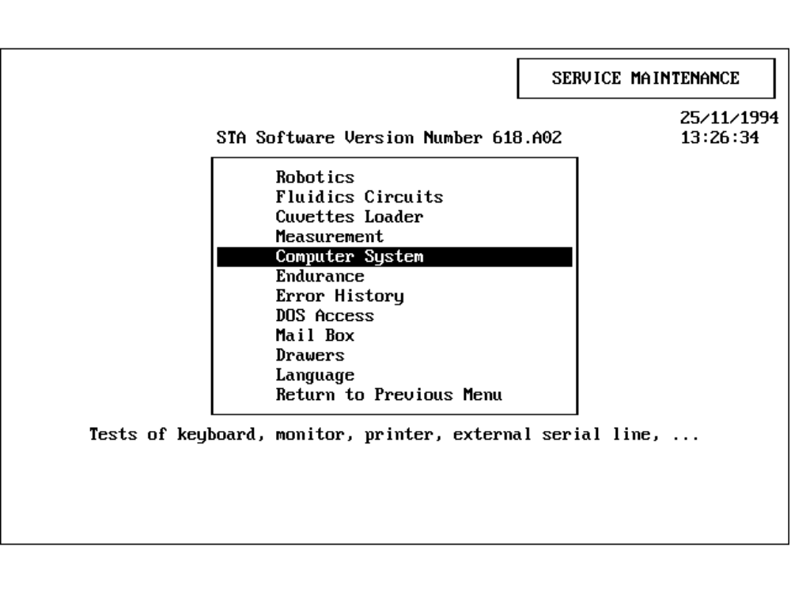
Figure 35 : Main menu of Service Maintenance
Selecting the menu option Computer System opens another menu with the following options:
- Printer
- Keyboard
- External Serial Line
- Beep
- Monitor
- Return to previous menu
The option External Serial Line opens the serial interface screen:
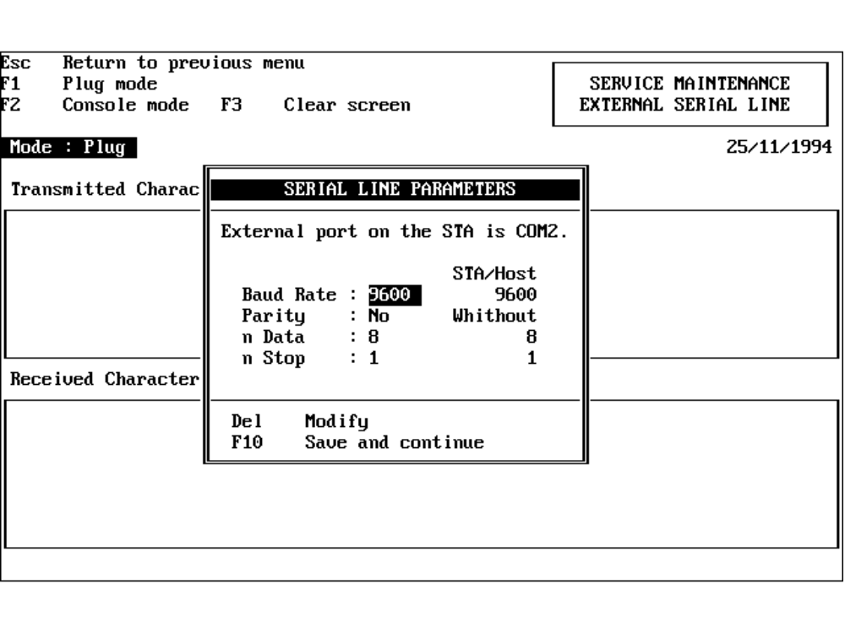
Figure 36 : External Line Test function within Service Maintenance
The Baud Rate, Parity, Number of Data and Number of Stop Bits are defined from the start up window.
Confirm the configuration with <F10>.
From this point on all keyboard input is sent via COM2 to the Host.
There are two test modes which are selected by the <F1> and <F2> keys:
- <F1> Plug Mode
Placing a 'Loop Back' connector at rear of the STA allows typed characters to be received and displayed in the ‘Received Characters’ window.
This plug directly connects the Transmit and Receive pins (2 and 3).
- <F2> Console Mode
Characters are sent via the Host port to an external device.
These options test the function of COM2 port.

Figures and Tables

Figures
Figure 1 : Data Cable Wiring Diagram
Figure 2 : Entering the Access Code
Figure 3 : The Status Menu
Figure 4 : Setup-Tests, Test List
Figure 5 : Test Setup Screen
Figure 6 : Transmission Numbers List
Figure 7 : Sample Loading Screen in MANUAL MODE
Figure 8 : Sample Loading Screen in AUTO MODE
Figure 9 : Profile Modification Screen
Figure 10 : Info Field Window on Reception of Worklist
Figure 11 : Sample List Screen
Figure 12 : Results Screen
Figure 13 : STA Global Options Screen (Std-Bi)
Figure 14 : Main Menu of User Maintenance.
Figure 15 : User Maintenance Parameters and Test Functions (Std-Bi).
Figure 16 : Establishment Phase with Successful Response.
Figure 17 : Flow Chart of Establishment Phase (Std-Bi).
Figure 18 : Worklist Request and Worklist Response
Figure 19 : Flow Chart of Worklist Request (Std-Bi)
Figure 20 : Result Transmission with Positive Acknowledgment.
Figure 21 : Flow Chart of Result Transmission (Std-Bi).
Figure 22 : Line Test with Correct Response.
Figure 23 : Flow Chart of Line Test (Std-Bi).
Figure 24 : Termination Phase Without Response
Figure 25 : Flow Chart of Termination Phase
Figure 26 : STA Global Options Screen (ASTM)
Figure 27 : Main Menu of User Maintenance.
Figure 28 : User Maintenance Parameters and Test Functions (ASTM).
Figure 29 : Transmission Control of Information Exchange (ASTM).
Figure 30 : Flow Chart of Reception/Transmission (ASTM).
Figure 31 : Flow Chart of Reception of a Record (ASTM).
Figure 32 : Flow Chart of Establishment Phase (ASTM).
Figure 33 : Flow Chart of Transfer Phase (ASTM).
Figure 34 : Flow Chart of Termination Phase (ASTM).
Figure 35 : Main menu of Service Maintenance
Figure 36 : External Line Test function within Service Maintenance

Tables
Table 1 : Pin-Out Descriptions
Table 2 : Transmission Specification
Table 3 : Control Character Definitions used in Std-Bi Example Traces
Table 4 : Typical Text Format for the Std-Bi Protocol.
Table 5 : Structure of Worklist Request Message (Std-Bi).
Table 6 : Structure of Worklist Message Without Info. (Std-Bi).
Table 7 : Structure of Worklist Message With Info. (Std-Bi).
Table 8 : Structure of Result Message (Std-Bi).
Table 9 : Units and Division Factors
Table 10 : Error Codes (Std-Bi).
Table 11 : Error and Alarm Codes (Std-Bi).
Table 12 : Alarm Code Descriptions (Std-Bi).
Table 13 : Structure of Line Test (Std-Bi).
Table 14 : Structure of Termination Message (Std-Bi).
Table 15 : Control Character Definitions used in ASTM Example Traces
Table 16 : Common Text Format for the ASTM Protocol.
Table 17 : Record Types (ASTM)
Table 18 : General Record Format (ASTM)
Table 19 : Record Delimiters (ASTM)
Table 20 : Record Header Structure (ASTM)
Table 21 : Patient Record Structure (ASTM)
Table 22 : Request Record Structure (ASTM)
Table 23 : Test Order Record Structure (ASTM)
Table 24 : Result Record Structure(ASTM)
Table 25 : Structure of Manufacturer Information Record for Error/Alarm codes (ASTM)
Table 26 : Definition of Error Codes (ASTM)
Table 27 : Definition of Alarm Codes (ASTM)
Table 28 : Structure of Termination Record (ASTM)
Table 29 : Replaced Control Characters in Example Traces (ASTM)

Trace Examples
Trace Example 1 : Establishment Phase
Trace Example 2 : Worklist Request and Worklist with Info Fields (Std-Bi).
Trace Example 3 : Result transmission with error codes (Std-Bi)
Trace Example 4 : Result transmission without error codes (Std-Bi)
Trace Example 5 : Line Test (Std-Bi).
Trace Example 6 : Termination Phase (Std-Bi).
Trace Example 7 : Worklist Request (ASTM)
Trace Example 8 : Worklist (ASTM)
Trace Example 9: Result Transmission (ASTM)
Trace Example 10 : Quality Control Result Transmission (ASTM)

- Appendix A - Alarm Messages

No | Title | Text
12.01.00 | SYSTEM HOST RECEPTION | Incorrect station number  Message not taken into account
12.02.00 | SYSTEM HOST RECEPTION | Identity not found in database  Message not taken into account
12.03.00 | SYSTEM HOST RECEPTION | All transmitted ranks unknown  Message not taken into account
12.03.01 | SYSTEM HOST RECEPTION | Duplicated rank transmitted  Message not taken into account
12.04.00 | SYSTEM HOST RECEPTION | Buffer tempo writing impossible
12.05.00 | SYSTEM HOST RECEPTION | Buffer tempo reading impossible
12.06.00 | SYSTEM HOST TRANSMISSION | NACK transmission impossible
12.07.00 | SYSTEM HOST RECEPTION | Incorrect checksum
12.08.00 | SYSTEM HOST TRANSMISSION | ACK transmission impossible
12.09.00 | SYSTEM HOST RECEPTION | No response
12.09.01 | SYSTEM HOST RECEPTION | Defective transmission  (NACK response)
12.09.02 | SYSTEM HOST RECEPTION | Work list not returned
12.10.00 | SYSTEM HOST TRANSMISSION | File transmission impossible
12.11.00 | SYSTEM HOST TRANSMISSION | No result for this identification
12.12.00 | SYSTEM HOST TRANSMISSION | STA not connected  Please connect
12.13.00 | SYSTEM HOST TRANSMISSION | Identity not found in database
12.14.00 | SYSTEM HOST TRANSMISSION | Invalid identity  > 8 characters
12.15.00 | SYSTEM HOST TRANSMISSION | Invalid Result format
12.20.00 | SYSTEM HOST TRANSMISSION | Impossible to open line
12.21.00 | SYSTEM HOST TRANSMISSION | Response different of ACK
12.22.00 | SYSTEM HOST TRANSMISSION | No response
12.23.00 | SYSTEM HOST RECEPTION | Incorrect sequence number
12.24.00 | SYSTEM HOST RECEPTION | Incorrect sequence checksum
12.25.00 | SYSTEM HOST RECEPTION | Incorrect instrument number
12.26.00 | SYSTEM HOST RECEPTION | Incorrect version number
12.27.00 | SYSTEM HOST RECEPTION | Returned identity unknown

- Appendix B - ASCII Chart

Char  Hex Dec | Char  Hex Dec | Char  Hex Dec | Char  Hex Dec | Char  Hex Dec | Char  Hex Dec | Char  Hex Dec | Char  Hex Dec
NUL  00 0 | DLE  10 16 | Space  20 32 | 0  30 48 | @  40 64 | P  50 80 | `  60 96 | p  70 112
SOH  01 1 | DC1  11 17 | !  21 33 | 1  31 49 | A  41 65 | Q  51 81 | a  61 97 | q  71 113
STX  02 2 | DC2  12 18 | "  22 34 | 2  32 50 | B  42 66 | R  52 82 | b  62 98 | r  72 114
ETX  03 3 | DC3  13 19 | #  23 35 | 3  33 51 | C  43 67 | S  53 83 | c  63 99 | s  73 115
EOT  04 4 | DC4  14 20 | $  24 36 | 4  34 52 | D  44 68 | T  54 84 | d  64 100 | t  74 116
ENQ  05 5 | NAK  15 21 | %  25 37 | 5  35 53 | E  45 69 | U  55 85 | e  65 101 | u  75 117
ACK  06 6 | SYN  16 22 | &  26 38 | 6  36 54 | F  46 70 | V  56 86 | f  66 102 | v  76 118
BEL  07 7 | ETB  17 23 | '  27 39 | 7  37 55 | G  47 71 | W  57 87 | g  67 103 | w  77 119
BS  08 8 | CAN  18 24 | (  28 40 | 8  38 56 | H  48 72 | X  58 88 | h  68 104 | x  78 120
HT  09 9 | EM  19 25 | )  29 41 | 9  39 57 | I  49 73 | Y  59 89 | i  69 105 | y  79 121
LF  0A 10 | SUB  1A 26 | *  2A 42 | :  3A 58 | J  4A 74 | Z  5A 90 | j  6A 106 | z  7A 122
VT  0B 11 | ESC  1B 27 | +  2B 43 | ;  3B 59 | K  4B 75 | [  5B 91 | k  6B 107 | {  7B 123
FF  0C 12 | FS  1C 28 | ,  2C 44 | <  3C 60 | L  4C 76 | \  5C 92 | l  6C 108 | |  7C 124
CR  0D 13 | GS  1D 29 | -  2D 45 | =  3D 61 | M  4D 77 | ]  5D 93 | m  6D 109 | }  7D 125
SO  0E 14 | RS  1E 30 | .  2E 46 | >  3E 62 | N  4E 78 | ^  5E 94 | n  6E 110 | ~  7E 126
SI  0F 15 | US  1F 31 | /  2F 47 | ?  3F 63 | O  4F 79 | _  5F 95 | o  6F 111 | DEL  7F 127

