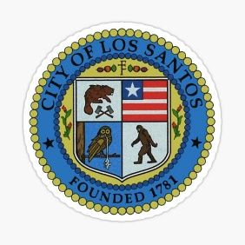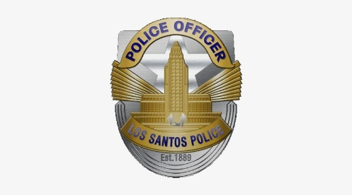COMMUNITY ALERT

LOS SANTOS POLICE DEPARTMENT

OFFICIAL PUBLICATION OF THE {{DIVISION_CAPS}} PATROL DIVISION CRIME ANALYSIS DETAIL

{{OFFENSE}}

MO: {{DESCRIPTION}}

|  |  |  |  |  |
| --- | --- | --- | --- | --- |
| DATE | TIME | LOCATION | RD | DR# |
| {{DATE}} | {{TIME}} | {{LOCATION}} | {{RD}} | {{DR}} |



SUSPECT DESCRIPTION:

{{FULL_NAME}}

{{SEX}}, {{ETHNICITY}}, {{HAIR}}

{{AGE}}

WEAPON(S):

{{WEAPONS}}

Anyone with information about the crime is asked to call {{DIVISION}} Patrol Investigator {{detective1_1}} {{ detective1_2}}, {{ detective1_badge}} at {{detective1_num}} or {{detective2_1}} {{ detective2_2}}, {{ detective2_badge}} at {{detective2_num}}. During non-business hours or weekends, call should be directed to 1-847-LSPD-24-7. Anyone wishing to remain anonymous should call Crime Stoppers at 1-273-555-0164. Tipsters may also contact crime stoppers by texting the word "TIPLA" and the message to phone number 1-611-555-TIPS with a cell phone. Tipsters may also go to www.lscrimestoppers.org, click "Submit a Tip" and follow the prompts.

For additional information contact {{DIVISION}} Patrol Detectives at 1-328-555-0103.



1-611-555-TIPS (0163)

Text TIPLA plus your tip to 1-611-555-0163 (CRIMES)

LScrimestoppers.org