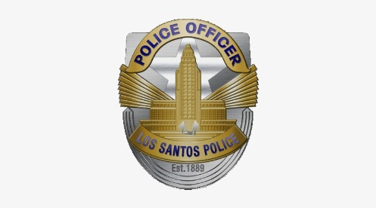COMMUNITY ALERT

LOS SANTOS POLICE DEPARTMENT

OFFICIAL PUBLICATION OF THE VALLEY PATROL DIVISION CRIME ANALYSIS DETAIL

DOUBLE MURDER OF POLICE OFFICERS

MO: At approximately 12:05AM the suspect walked around his house with an MP% in his hand, ambushed the poliec car stationed nearby and shot two full clips into the 2013 FPIU that was parked there, shooting and killing both officers inside. Following that, suspect fled in his grey sedan car in an unknown direction.

|  |  |  |  |  |
| --- | --- | --- | --- | --- |
| DATE | TIME | LOCATION | RD | DR# |
| 10/02/2023 | 12:05 | Carson Avenue | 735 | 17-12-09390 |

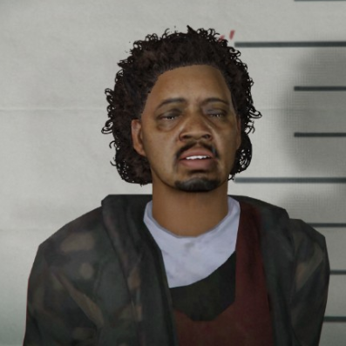SUSPECT DESCRIPTION:

Willie Jackson Dale

Male, Armenian, Black hair, beard

25

WEAPON(S):

MP5 SMG

Anyone with information about the crime is asked to call Valley Patrol Investigator *name*, *badge*, at *number* or *another detective's description*. During non-business hours or weekends, call should be directed to 1-847-LSPD-24-7. Anyone wishing to remain anonymous should call Crime Stoppers at *number*. Tipsters may also contact crime stoppers by texting the word "TIPLA" and the message to phone number *number* with a cell phone. Tipsters may also go to www.lscrimestoppers.org, click "Submit a Tip" and follow the prompts.

For additional information contact Valley Patrol Detectives at *number*.



*phone number*-TIPS (8477)

Text TIPLA plus your tip to *number* (CRIMES)

LScrimestoppers.org