Table of contents

Table of contents 1

DjangoDocker01Draft 2

Prerequisites 2

Getting Started 2

Cloning the GitHub Repository 2

Quick Install 2

Installation verification 5

DjangoDocker01Draft

This is a draft django project that comes with a minimum we need to get started. Project run on a Docker image and it’s developed on the local machine using Visual Code Studio. “Docker compose” is used for installation.

Prerequisites

Make sure you have installed all of the following prerequisites on your development machine:

* Visual Code Studio (https://code.visualstudio.com/)
* Docker Desktop (https://www.docker.com/products/docker-desktop/)
* Git (https://git-scm.com/)

Getting Started

Run Docker Desktop and Visual Code Studio.

Run Command Prompt and open installation folder:

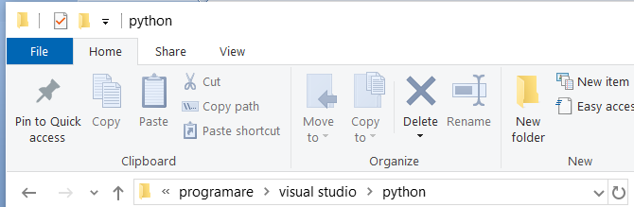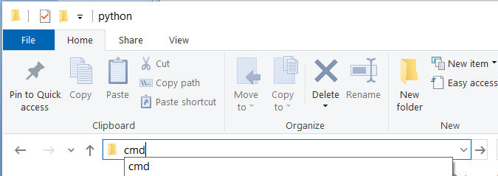

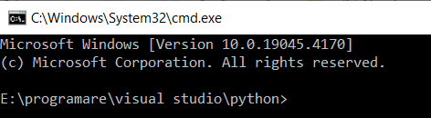

Cloning the GitHub Repository

The recommended way to get installation files is to use git to directly clone the repository:

git clone https://github.com/vadancorneliu/DjangoDocker01Draft.git

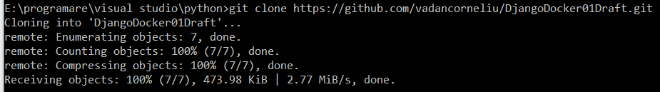

Quick Install

Open the project folder in Visual Code Studio by running Visual Code Studio and using the *File > Open Folder* command.

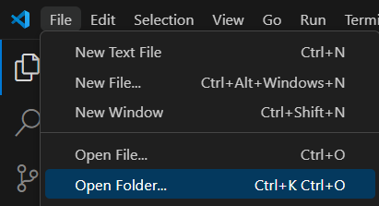

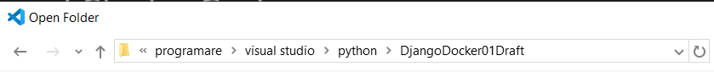



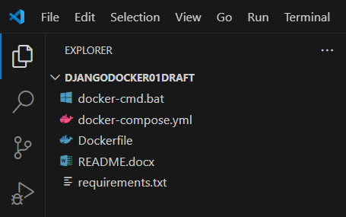

Open a new terminal from Visual Code Studio menu (*Terminal > New Terminal*)

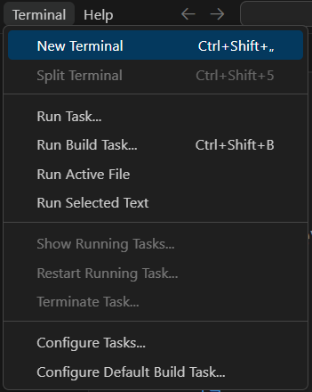

* Power Shell terminal:



* Command Prompt terminal:

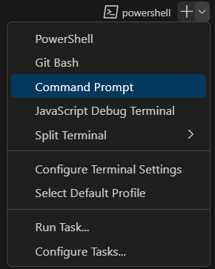

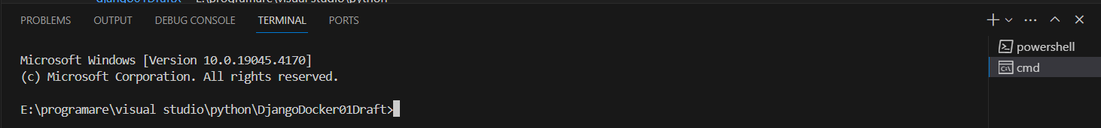

Run docker-cmd.bat file in Power Shell terminal:

.\ docker-cmd.bat



or in Command Prompt terminal:

docker-cmd.bat



The following command are displayed in the terminal:

* docker compose build - create a custom image (build) from Dockerfile (tag image is defined in the docker-compose.yml file)

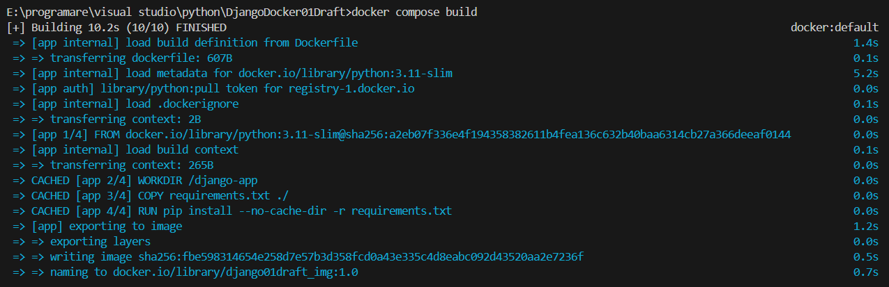

* docker compose run --rm app django-admin startproject core . - create django core file (create container and run the service (app) defined in the docker-compose.yml file, run a custom command (django-admin startproject core .) and remove container (--rm))



* docker compose up - recreate the container

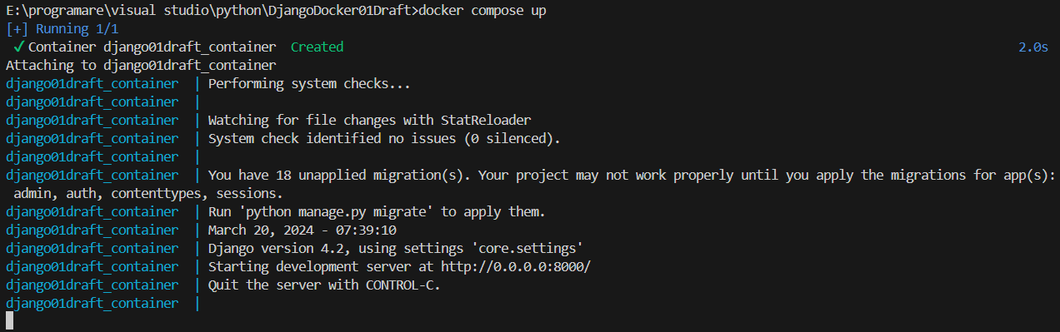

Installation verification

After run docker-cmd.bat file, we have:

* Core folder with his python files, manage.py file and db.sqlite3 file

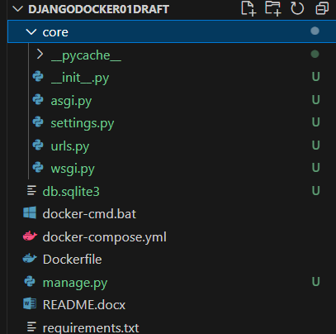

* Docker image

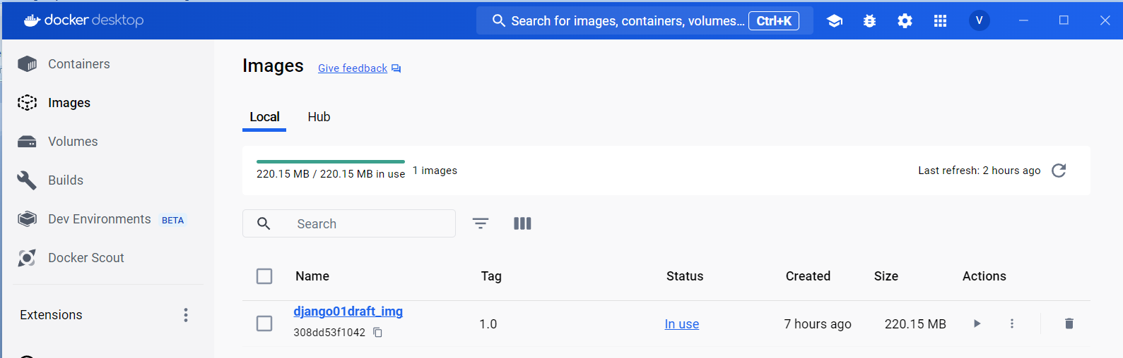

* Docker container

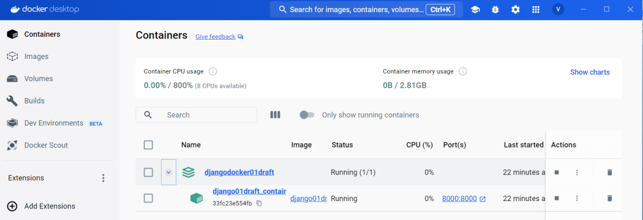

Your Django project is now live, locally. In your browser, go to: http://localhost:8000.

