Table of Contents

Table of Contents 1

Dockerized Django Server 2

Requirements 2

Note 2

Installation 2

1. Open Command Prompt 2

2. Cloning the GitHub Repository 2

3. Run provided script 2

Usage 5

Dockerized Django Server

This project provides a Dockerized environment for running a Django server. By downloading the files onto your local machine and executing docker-cmd.bat, a Docker container will be created and initialized with the Django server. You can then modify the Django script using Visual Studio Code on your local machine.

Requirements

Make sure you have installed all of the following prerequisites on your development machine:

* Visual Code Studio (https://code.visualstudio.com/)
* Docker Desktop (https://www.docker.com/products/docker-desktop/)
* Git (https://git-scm.com/)

Note

* Ensure Docker is properly configured and running on your system;
* Make sure to have the necessary permissions to execute the batch file.

Installation

To get started with this project, follow these steps:

1. Open Command Prompt

Run Command Prompt and open installation folder:

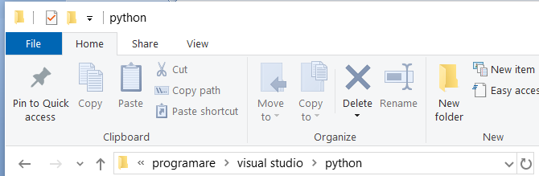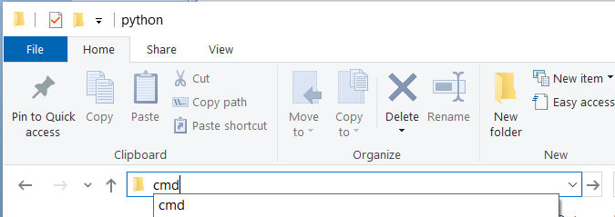

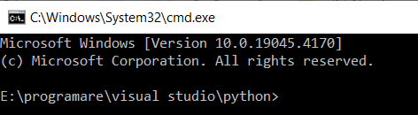

2. Cloning the GitHub Repository

The recommended way to get installation files is to use git to directly clone the repository:

git clone https://github.com/vadancorneliu/DjangoPostgresqlDocker01Draft.git

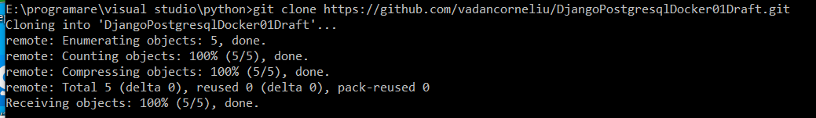

3. Run provided script

Open the project folder in Visual Code Studio by running Visual Code Studio and using the *File > Open Folder* command.

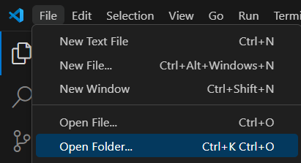





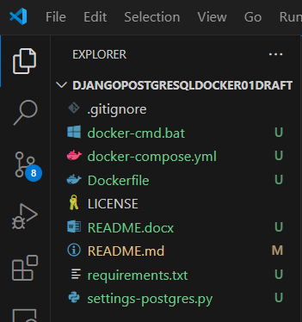

Open a new terminal from Visual Code Studio menu (*Terminal > New Terminal*)

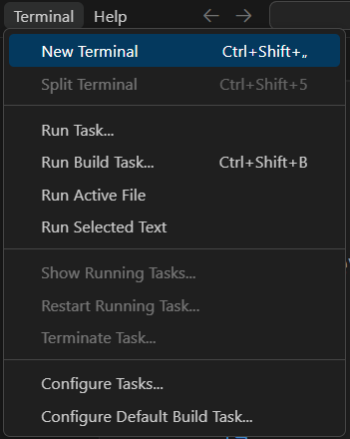

* Power Shell terminal:



* Command Prompt terminal:

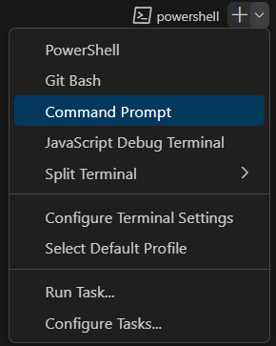

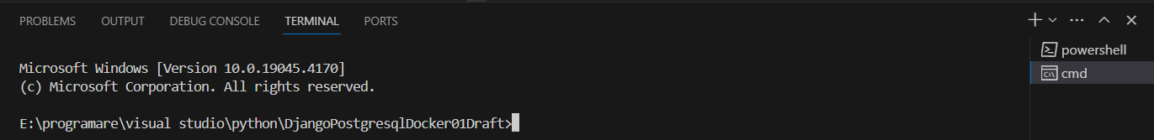

Run docker-cmd.bat file in Power Shell terminal:

.\ docker-cmd.bat



or in Command Prompt terminal:

docker-cmd.bat



The following command are displayed in the terminal:

* docker compose build - create a custom image (build) from Dockerfile (tag image is defined in the docker-compose.yml file)

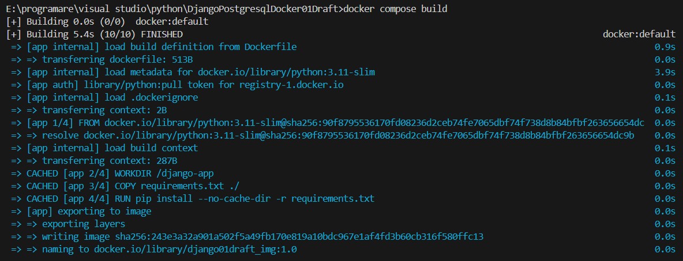

* docker compose run --rm app django-admin startproject core . - create django core file & postgres data file (create container and run the service (app) defined in the docker-compose.yml file, run a custom command (django-admin startproject core .) and remove container (--rm))

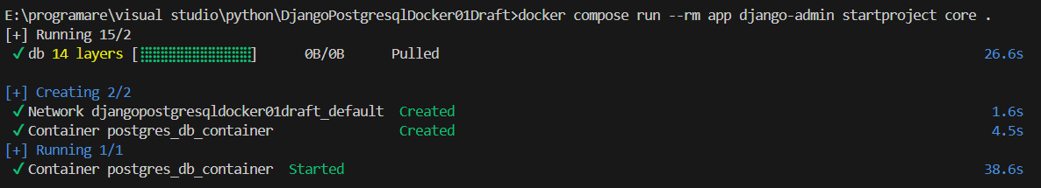

* xcopy "settings-postgres.py" "./core/settings.py" /Y – overwrite settings.py file



* docker compose up --detach - recreate the containers



* timeout /t 30 - delay for starting db server



* docker start django01draft_container - start container django01draft_container



Usage

After run docker-cmd.bat file, we have:

* Core folder with its python files, manage.py file and data folder with its postgresql files

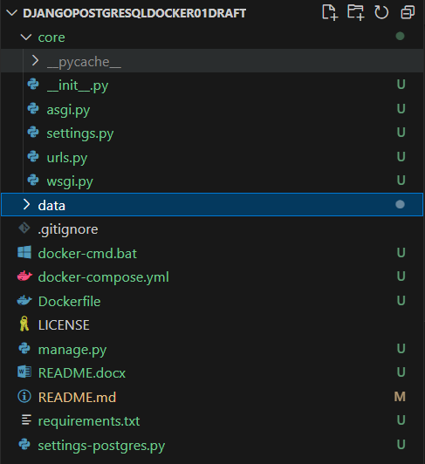

* Docker images

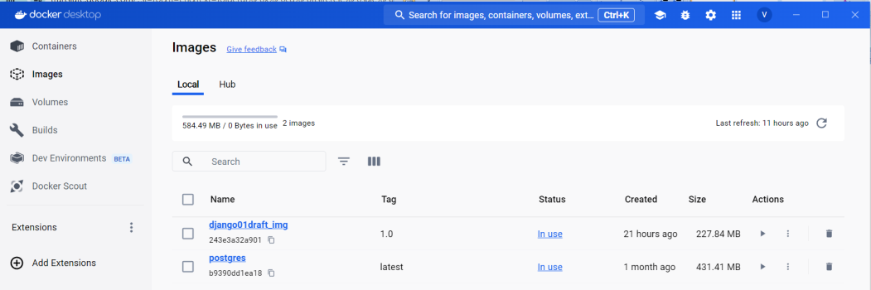

* Docker containers

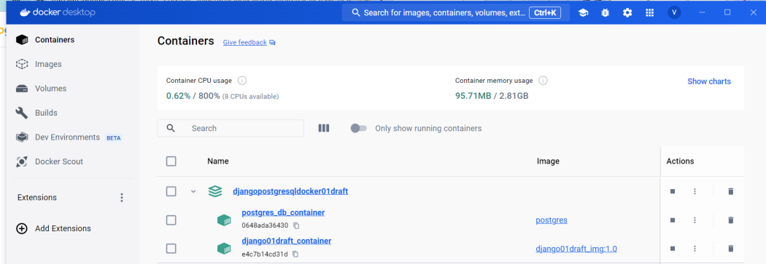

Once the containers is up and running, you can access the Django server locally at http://localhost:8000.

