


INTRODUCTION TO DATABASE[L]
MD SAJID BIN-FAISAL
PROJECT NAME: Hospital Management System
NAME | ID
S.M.MONIRUL HASAN | 22-46202-1
TAMANNA NASIR NISHAD | 22-46497-1
BIDHAN SAHA | 22-47153-1
BEDANTA SAHA | 22-47152-1

Introduction
The topic of this project is Hospital Management System. The main aim of our project is to simplify the procedure for physicians, reduce administrative costs, decrease error and provide a better experience for patients. Hospital Management System is designed and developed to deliver real conceivable benefits to hospitals.
There are many advantages of a Hospital Management System. It saves time for all the system users and gives them up-to-date information. It can easily access patient data. The system will assist in lowering costs for both the patient and the hospital. The Hospital Management System tries to reduce any kind of error. It also increases data security and retrievability of any patient information. It improves the quality of patient care. The Hospital Management System will benefit the entire hospital.

1

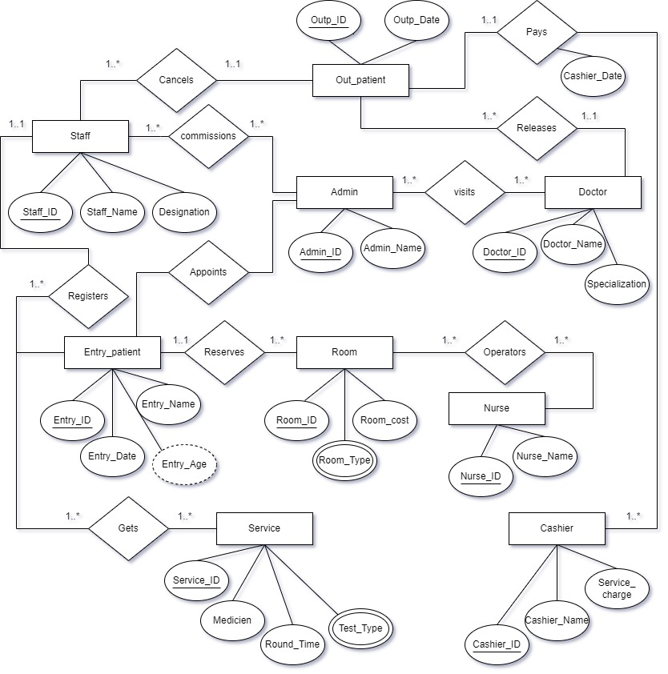
ER Diagram

2
Scenario

In a hospital management system, there are admin, doctor, staff, entry_patient,out_patient, room, service, and nurse. An admin can appoint many staff. The system stores staff_ID, staff_name, and designation. One staff can register many entry_patient ones by one. The information of the entry_patient will be their patient entryp_ID, entryp_name, entryp_date, and entryp_age. A doctor can visit when the admin Appoints the entry_patient under the doctor. Many entry_patient cans app`oint many Doctor by admin. The Doctor is identified by the doctor_ID, doctor_name, and specialization. The entry_patient can reserve many rooms. The room is identified by room_ID, room_cost, and room_type. There may be multiple types of rooms. The entry_patient gets services, such as medicine, round_time, and test_type. There may be multiple types of test_type. For any kind of room service, the nurses operate many rooms. There can be many nurses whose are operate many room The information of the nurse is stored as nurse_ID and nurse_name. When the entry_patient gets well the doctor releases the patient as out_patient. One Doctor can release many out_patient. The out_patient is identified by Outp_ID and Outp_date. The outpatient can pay the cashier. The cashier will check the cashier_ID, cashier_date, cashier_number, and service charge. Many out_patient can pay many charges. Where the payment has been completed the staff can undo the out_patient. many staff can cancel one out_patient.

3
Normalization
1.Registrar
UNF: staff-id, destination, staff name, entry_P_id, entry_P_age, entry_P_ date, entry_p_name.
1NF: staff-id, destination, staff name, entry_P_id, entry_P_age, entry_P_ date, entry_p_name.
2NF:
1.staff_id, destination, staff name.
2.entry_P_id, entry_P _age, entry_P_ date, entry_p_name, staff_id (FK).
3NF:
1.staff_id, destination, staff name.
2.entry_P_id, entry_P _age, entry_P_ date, entry_p_name, staff_id (FK).
2.Release
UNF: out_p_id, out_p_date, doctor _id, doctor _name, specialization.
1NF: out_p_id , out_p_date, doctor _id , doctor _name, specialization.
2NF:
1. out_p_id, out_p_date, doctor_id (FK)
2. doctor _id, doctor _name, specialization.
3NF:
1. out_p_id, out_p_date, doctor_id (FK)
2. doctor _id, doctor _name, specialization.

3.pays
UNF: out_p_id, out_p_date, cashier_id, cashier _date, cashier _number, service _charge.
4

1NF: out_p_id, out_p_date, cashier_id, cashier _date, cashier _number, service charge.
2NF:
- Out_p_id, out_p_date.
- cashier-id, cashier-date, cashier-number, service _charge, out_p_id (FK).
3NF:
      - Out_p_id, out_p_date.
      - cashier-id, cashier-date, cashier-number, service _charge, out _p_ id(FK).
4.Visit:
UNF: Admin _id, Admin _name, doctor_ id, doctor_ name, specialization.
1NF: Admin _id, Admin _name, doctor _id, doctor_ name, specialization.
2NF:
- Admin _id, Admin _name.
- doctor _id, doctor _name, specialization.
- Admin _id (FK), doctor _id (FK).
3NF:
- Admin _id, Admin _name.
- doctor _id, doctor _name, specialization.
- Admin _id (FK), doctor _id (FK).
5.Reserves:
UNF: entry _id, entry _age, entry_date, entry_name, Room_id, Room_cost , Room_type.

5

1NF: entry _id, entry _age, entry_date, entry_name, Room_id, Room _cost,
Room _type.
2NF:
- entry _id, entry _age, entry_date, entry_name
- Room_id, Room_cost, Room _type, entry _id (FK).
3NF:
1.entry _id, entry _age, entry_date, entry_name
2.Room_id, Room_cost, Room _type, entry _id (FK).
6 Gets:
UNF: entry _id, entry _age, entry _date, entry _name, service _id, medicine, round _time, test _type.
1NF: entry _id, entry _age, entry _date, entry _name, service _id, medicine, round _time, test _type.
2NF:
- entry _id, entry _age, entry _date, entry _name.
- service _id, medicine, round _time, test _type.
- entry _id (FK), service _id (FK).
3NF:
      - entry _id, entry _age, entry _date, entry _name.
      - service _id, medicine, round _time, test _type.
      - entry _id (FK), service _id (FK).

6

7 operators:
UNF: Room_id, Room_cost, Room_ type, nurse_ id, nurse _name.
1 NF: Room_id, Room_cost, Room_ type, nurse _id, nurse _name.
2NF:
1.Room-id, Room-cost, Room-type.
2. nurse-id, nurse _name.
3. Room-id (FK), nurse-id (FK).
3NF:
1.Room-id, Room-cost, Room-type.
2. nurse-id, nurse _name.
3. Room-id (FK), nurse-id (FK).
8 Cancel:
UNF: out_p _id,out_p_date, out _p_ name, staff _id, destination, staff _name.
1NF: out _p _id, out_ p_ date, out_ p_ name, staff _id ,destination, staff_ name.
2NF:
- out_ p _id, out_ p_ date, out_ p_ name.
- staff _id, destination, staff_ name, out_ p_ id(FK).

3NF:
- out_ p _id, out_ p_ date, out_ p_ name.
- staff _id, destination, staff_ name, out_ p_ id (FK).

7

9 commission:
NUF: admin _id, admin _name, staff _id, destination, staff _name.
1NF: admin _id, admin_ name, staff _id, destination, staff _name.
2NF:
- admin _id, admin _name.
- staff _id, destination, staff _name.
- admin _id (FK), staff _id (FK).
3NF:
- admin _id, admin _name.
- staff _id, destination, staff _name.
- admin _id (FK), staff _id (FK).
10 Appoints:
UNF: admin _id, admin _name, entry _id, entry _ age, entry_ date, entry_ name.
1NF: admin _id, admin _name, entry _id, entry_ age, entry_ date, entry_ name.
2NF:
- admin _id, admin _name.
- entry -id, entry _age, entry_ date, entry_ name.
- admin _id (FK), entry _id (FK).
3NF:
- admin _id, admin _name.
- entry -id, entry _age, entry_ date, entry_ name.
- admin _id (FK), entry _id (FK).

8
Finalization

Admin
- Admin_ID, Admin_name.
Staff
- Staff_ID, Destination, Staff_name.
Commissions
- Admin_ID (PK), staff_ID (FK).
Registers
- Entry_P_ID, Entry_P_age, Entry_P_date, Entry_P_name, staff_ID (FK).
Doctor
- Doctor_ID, Doctor_ name, Specialization.
Visit
- Admin _ID (PK), Doctor_ID (FK).
Entry_patient
- Entry_p_ID, Entry_p_Age, Entry_p_Date, Entry_p_Name.
Appoints
- Admin_ID (PK), Entry_p_ID (FK).
Reserves
- Room_ID, Room_cost, Room_type, Entry_ID (FK).

9
Service
- Service _ID, Medicine, Round_Time, Test_Type.
Gets
- Entry_p_ID (PK), Service_ID (FK).
Room
- Room_ID, Room_cost, Room_Type.
Nurse
- Nurse_ID, Nurse_Name.
Operators
- Room_ID (PK), Nurse_ID (FK).
Releases
- Out_p_ID, Out_p_Date, Doctor_id (FK)
Out_patient
- Out_p_ID, Out_p_Date.
Pays
- Cashier_ID, Cashier_Date, Cashier_Name, Service_charge, Out_p_id (FK).
Cancels
- Staff _ID, Destination, Staff_Name, Out_p_id (FK)
Cashier
- Cashier_ID, Cashier_Date, Cashier_Name, Service_charge

10

Table
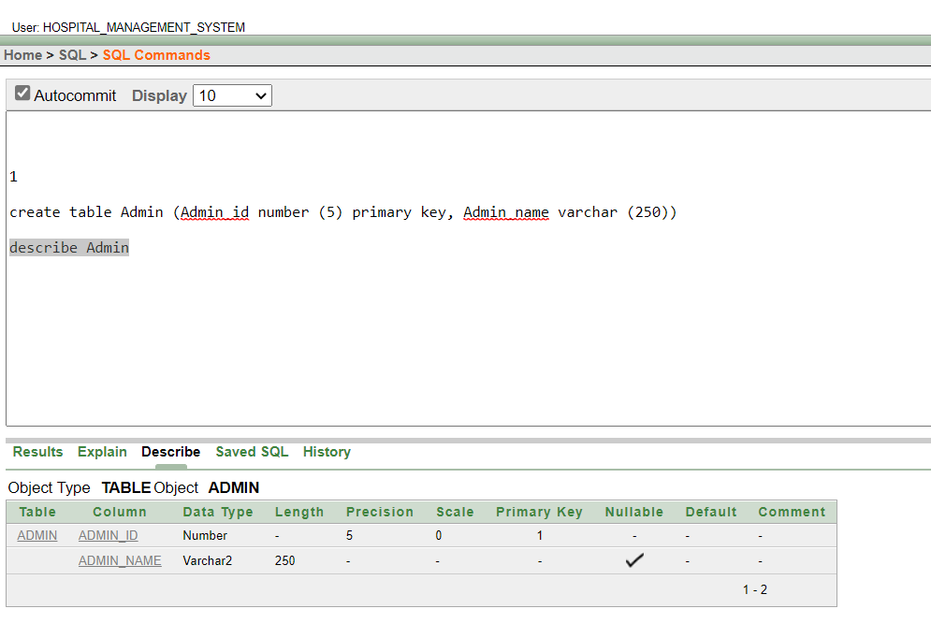

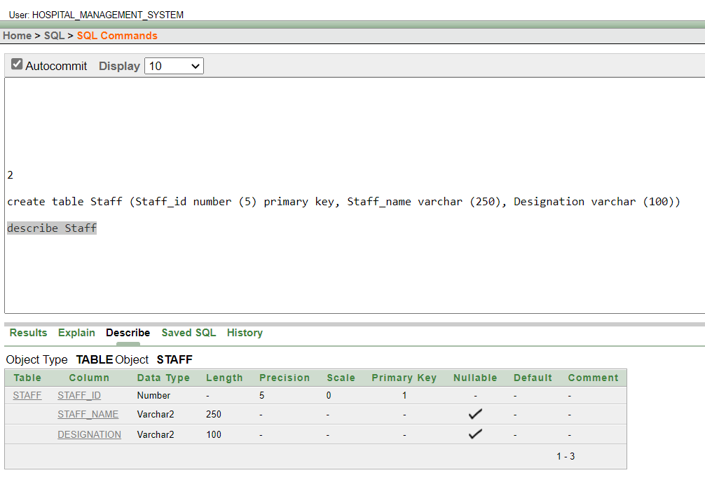
11
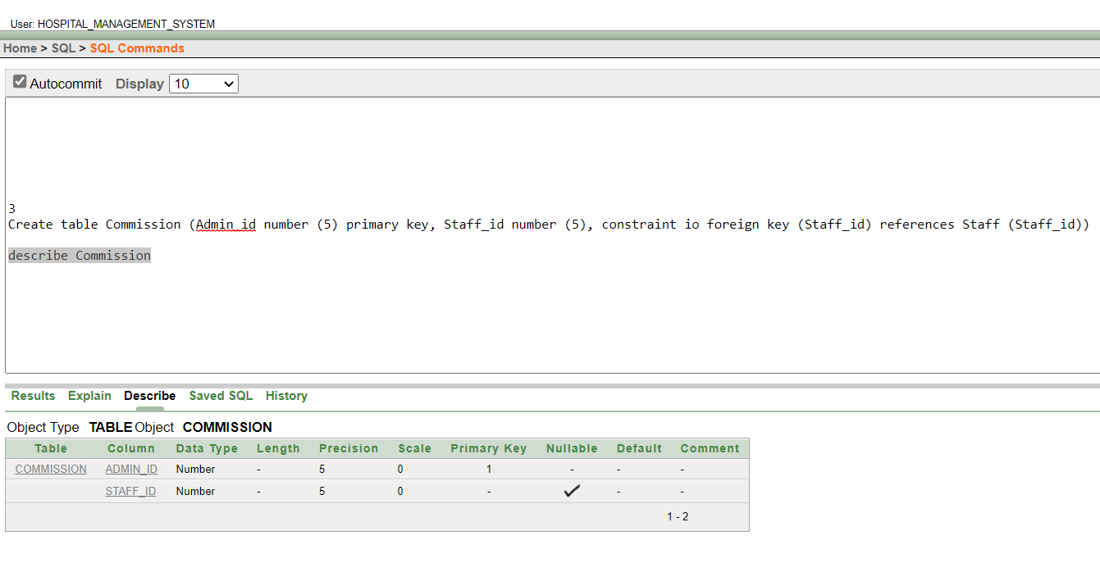

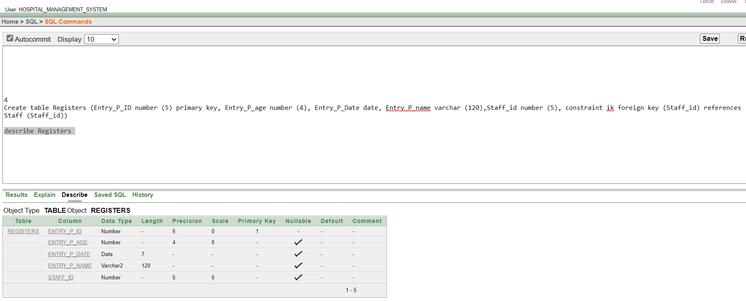
12

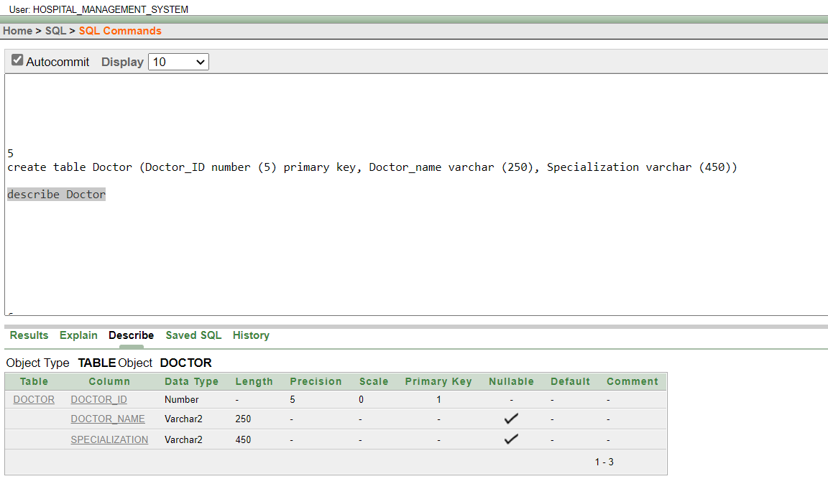
13
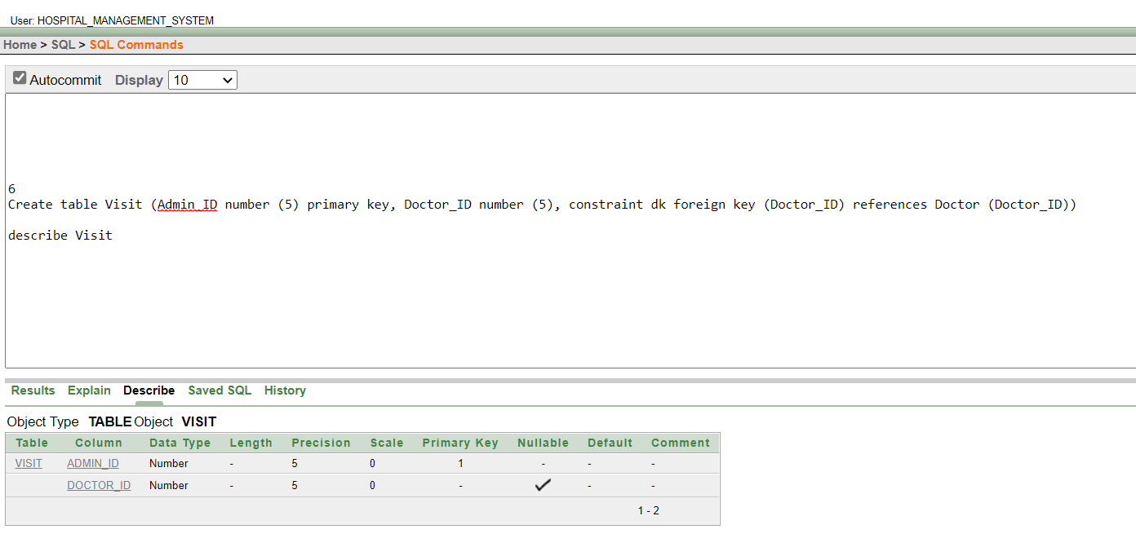
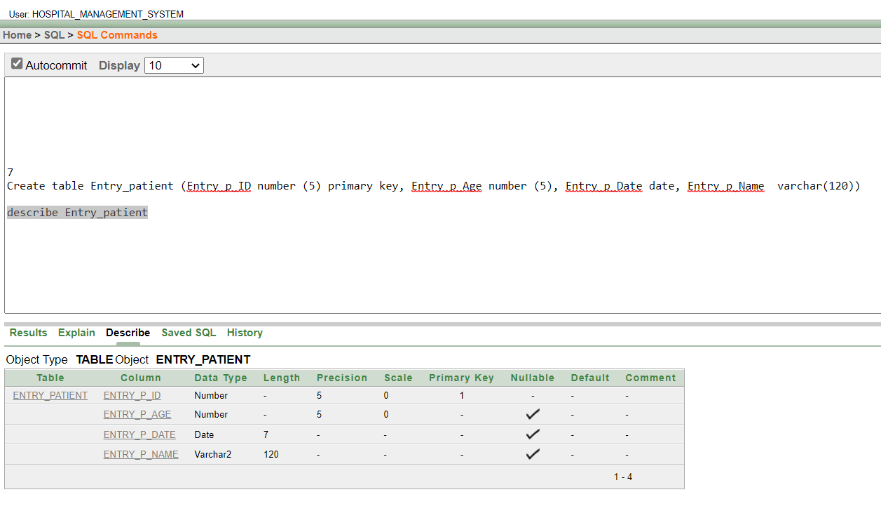
14
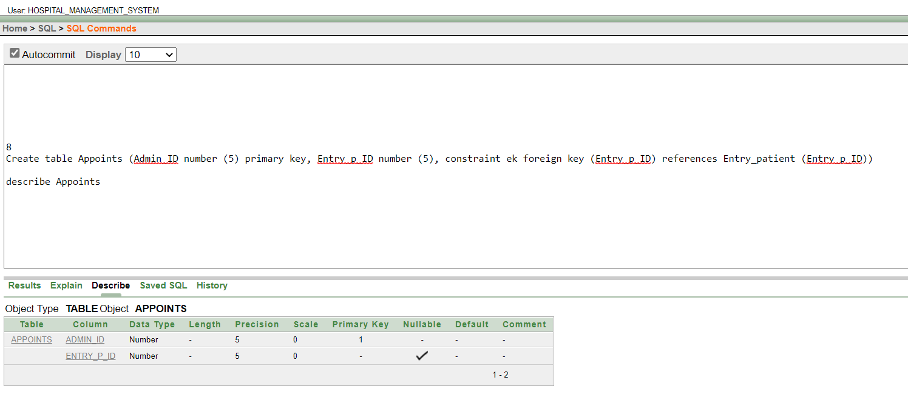
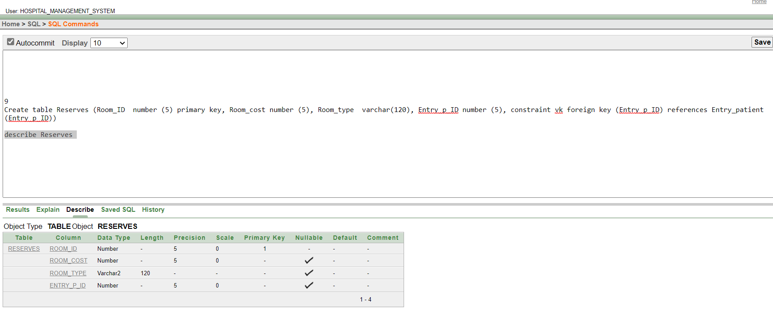
15
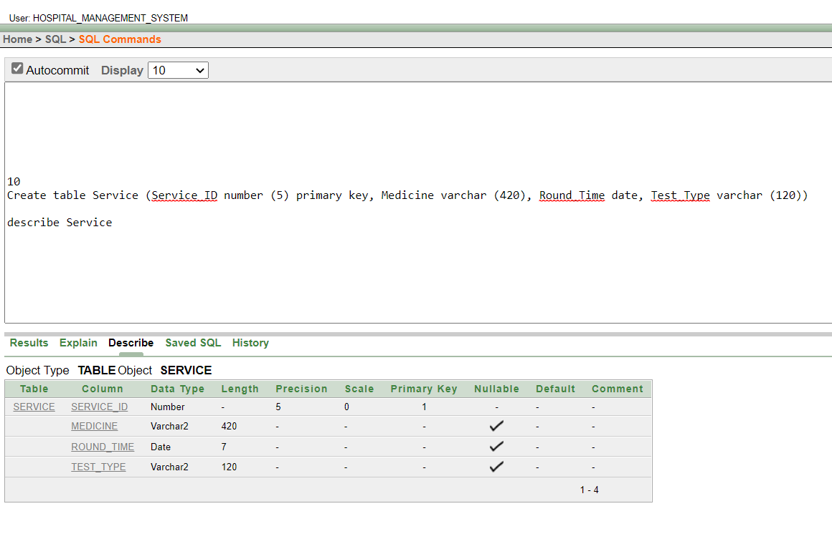
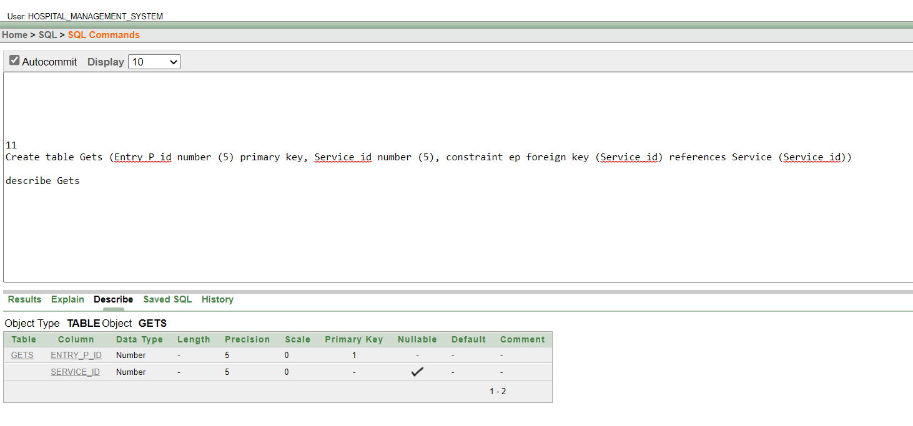
16
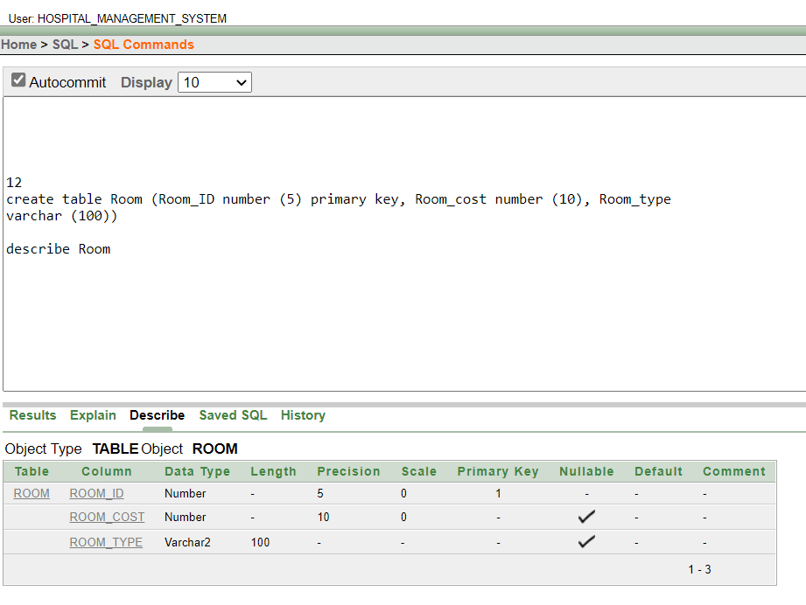

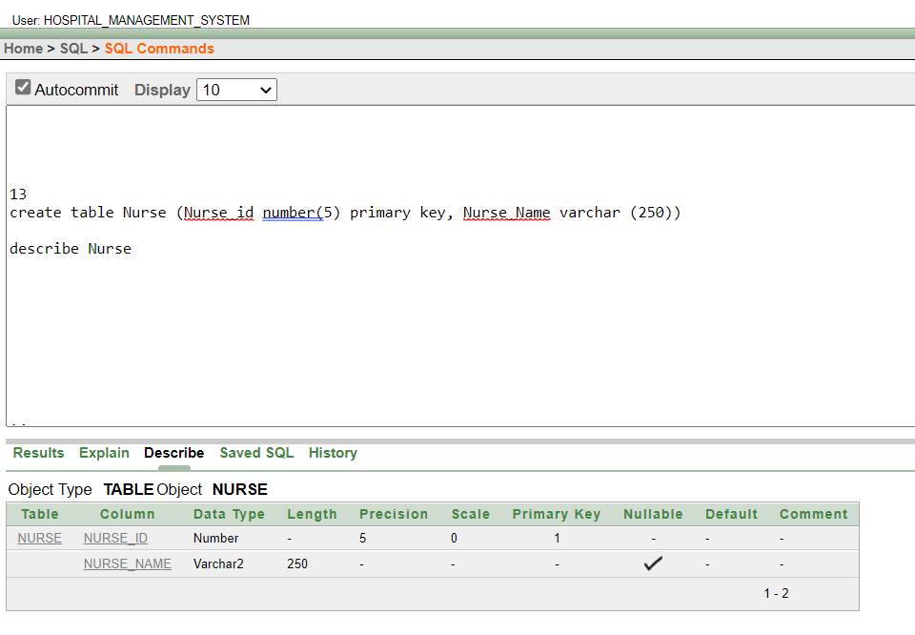
17
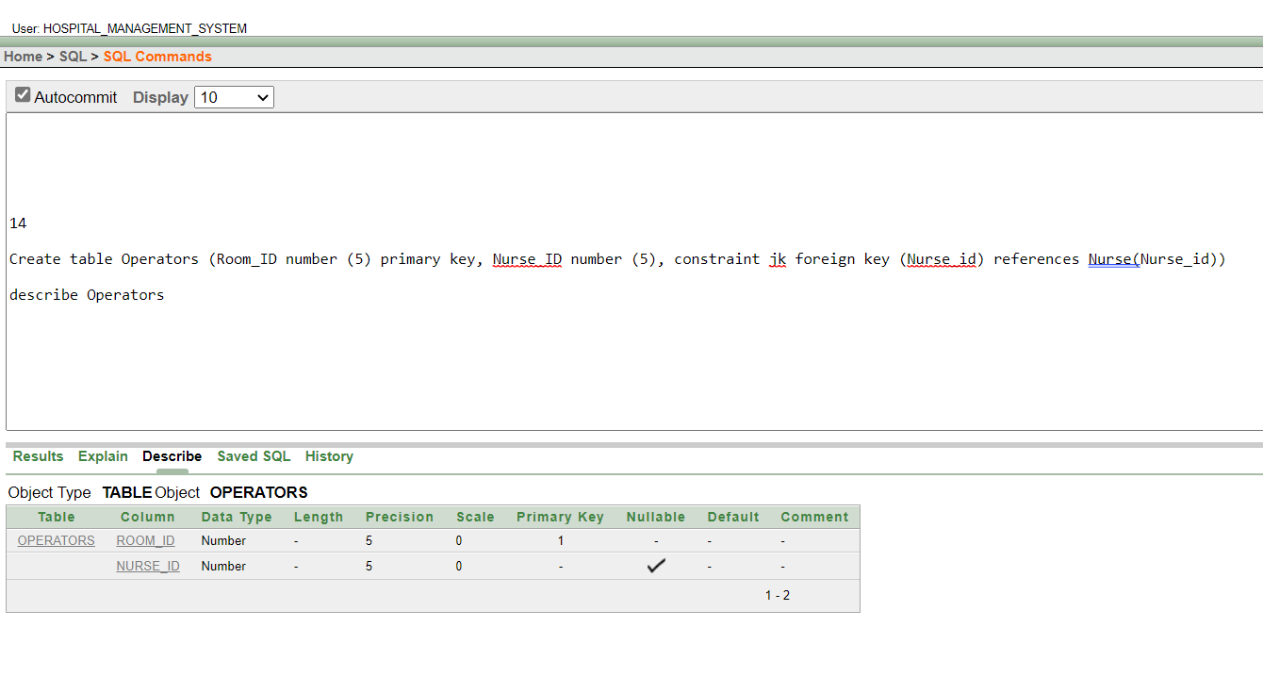
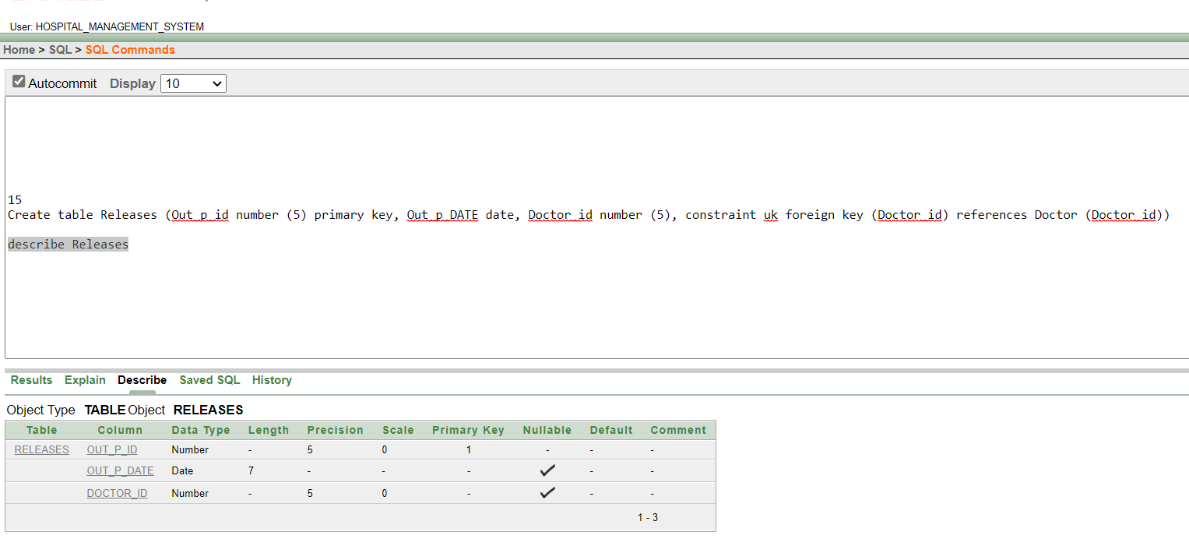
18
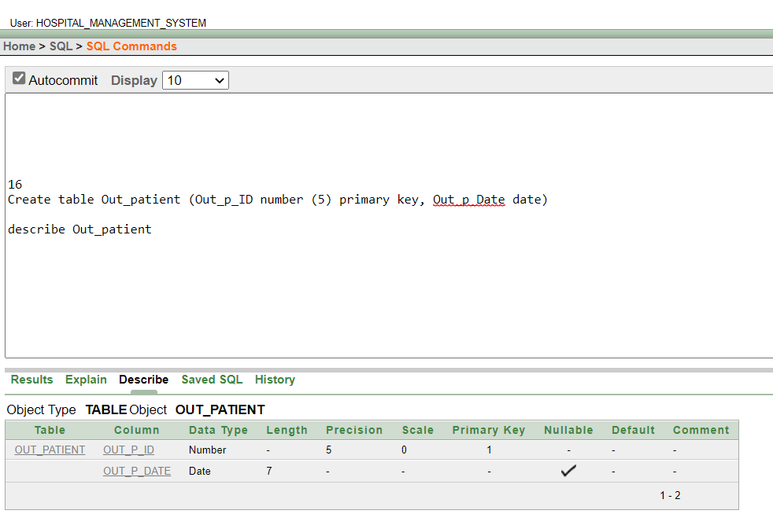
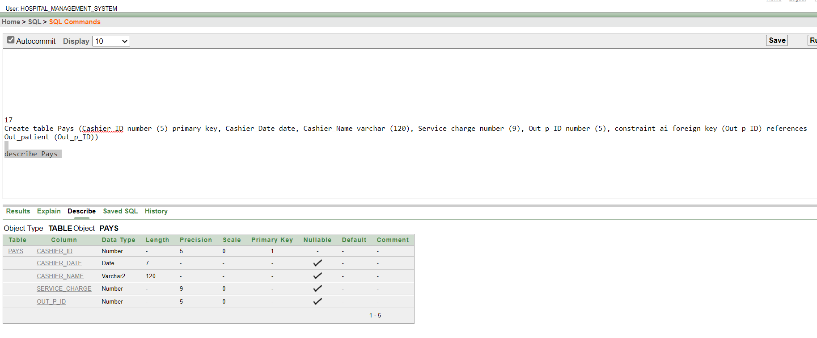
19
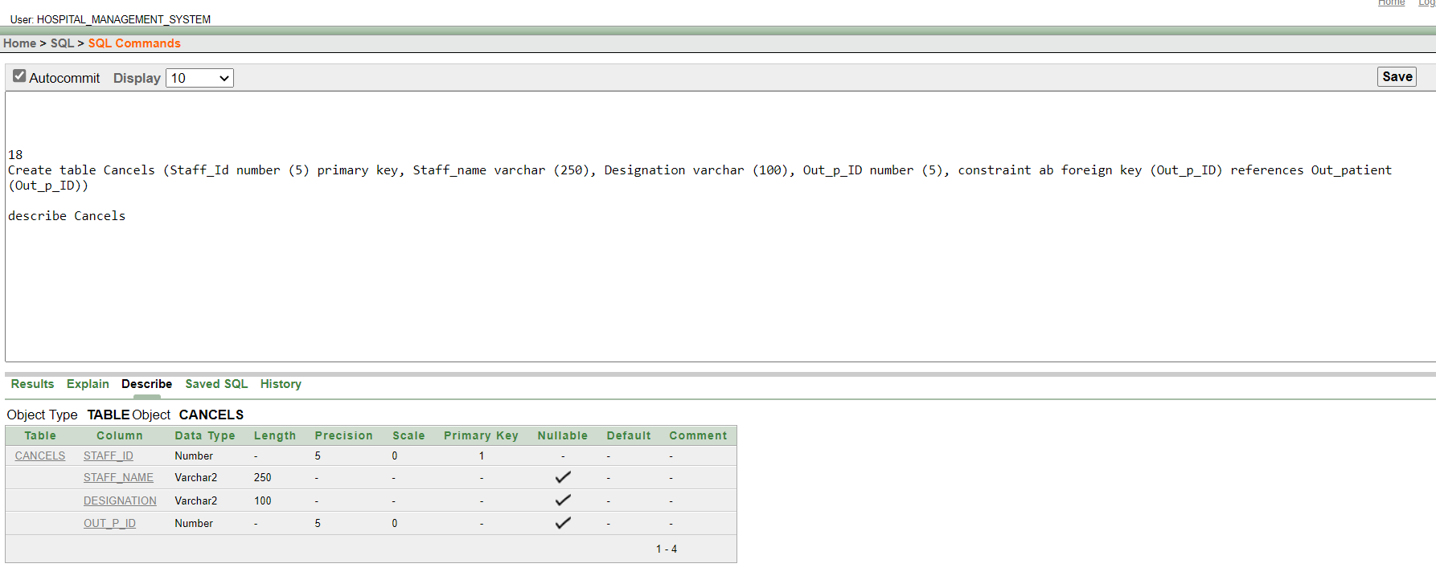

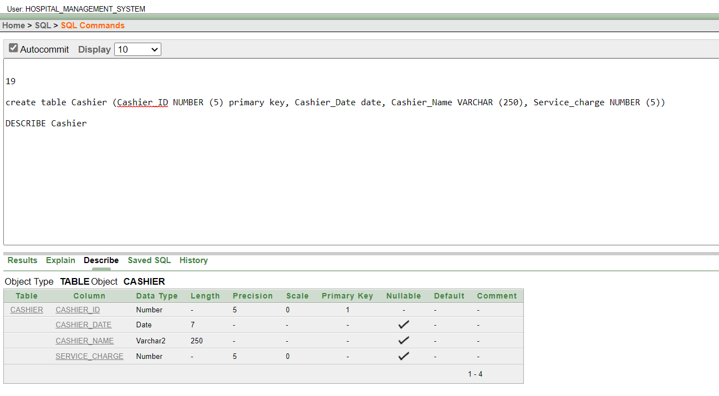
20
Value Insert
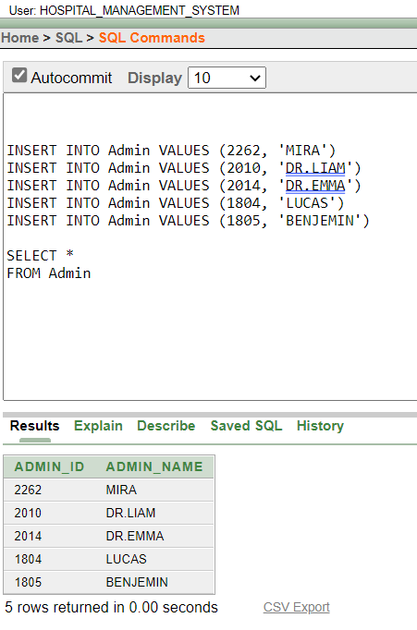

21
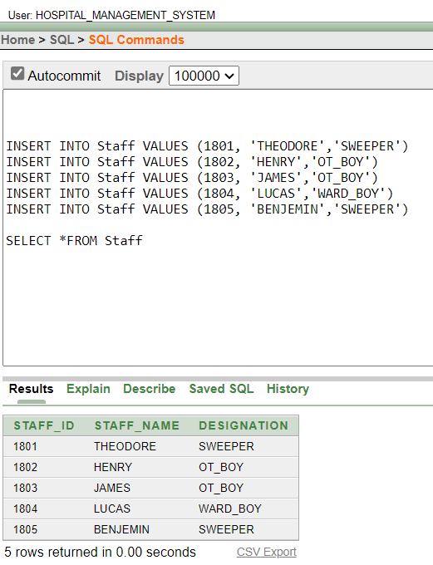

22

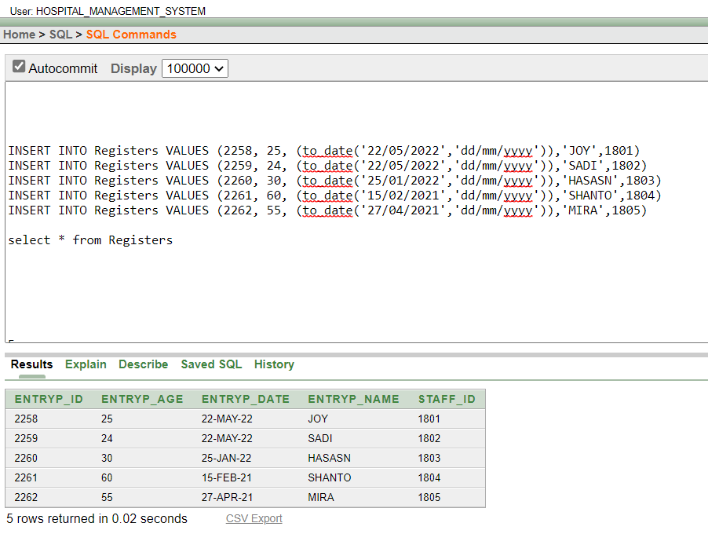

23
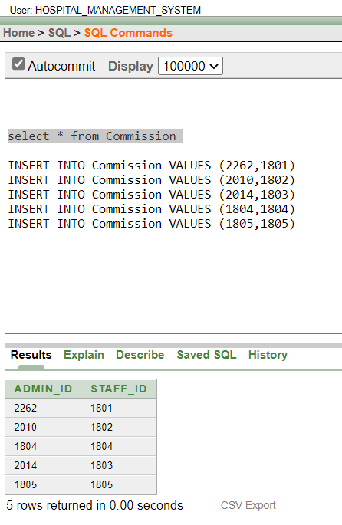

24
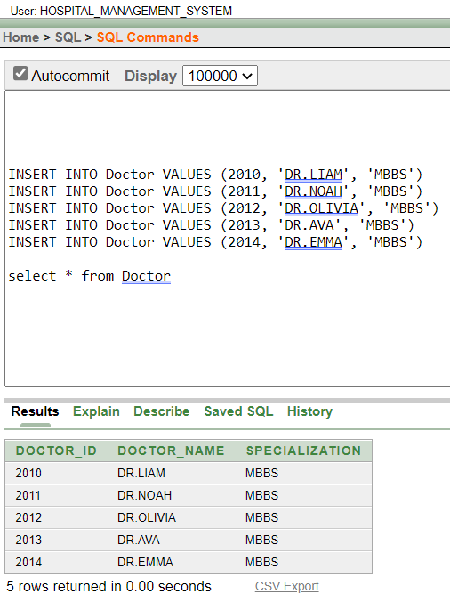

25
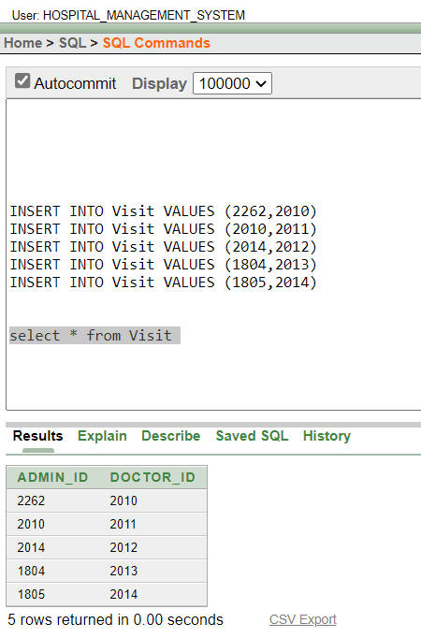

26

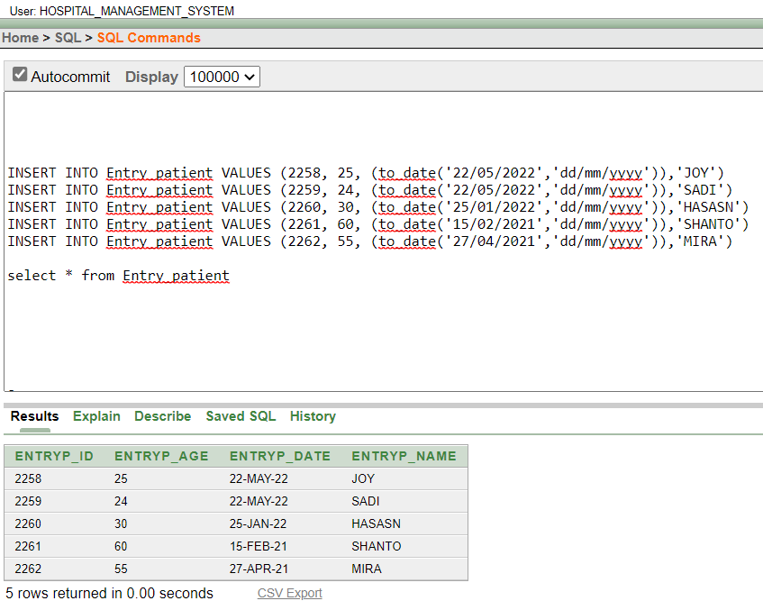

27

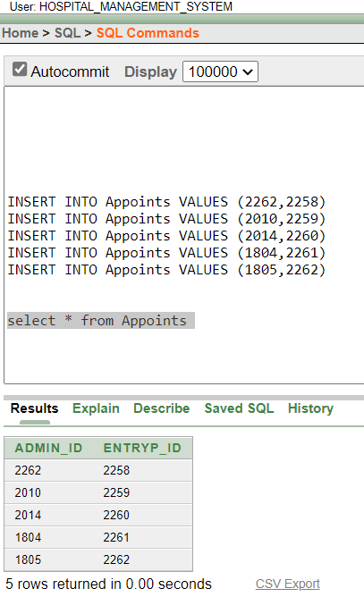

28
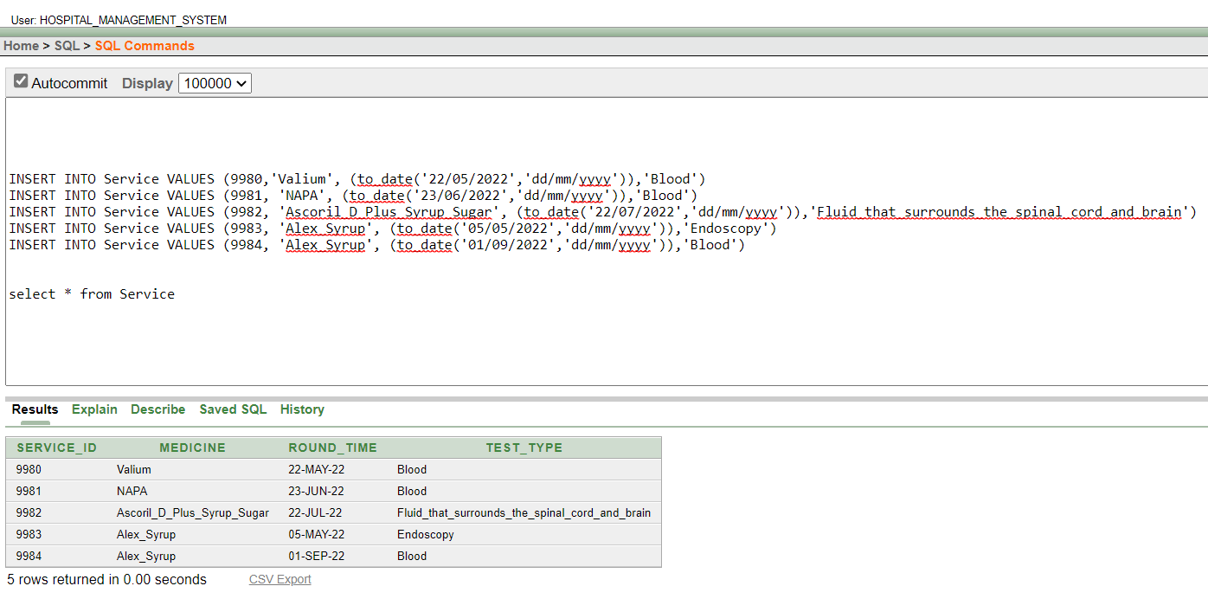

29

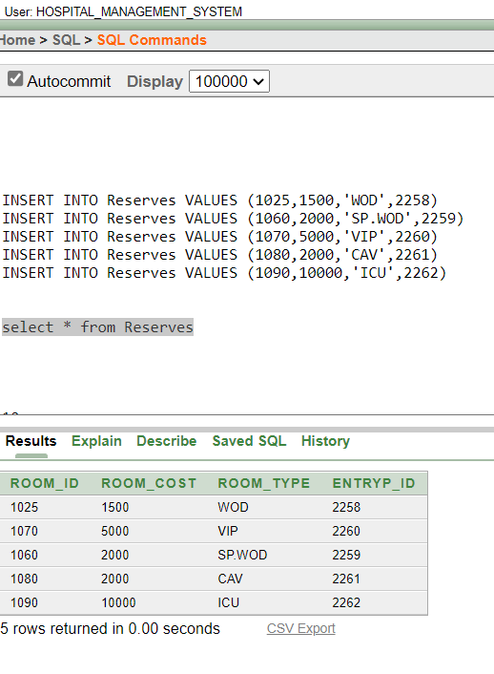

30
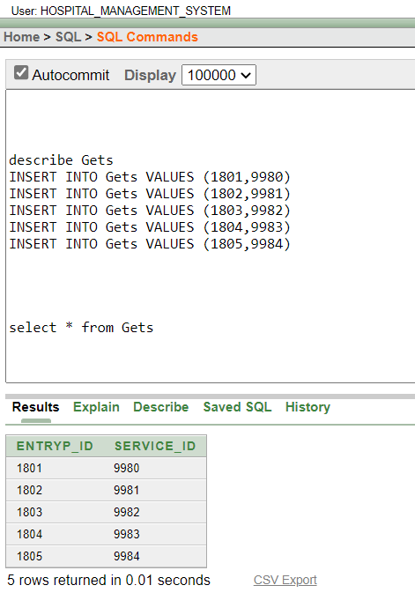

31

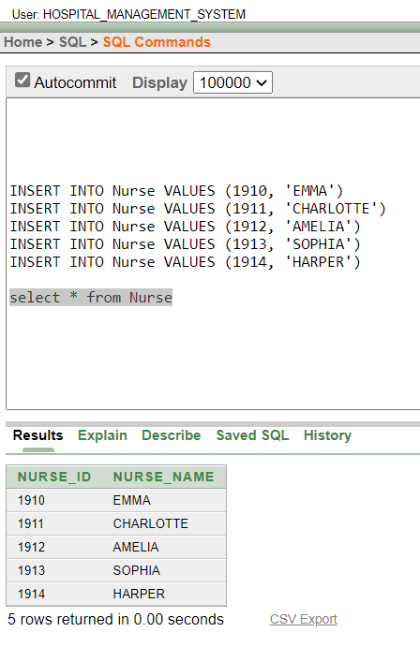

32

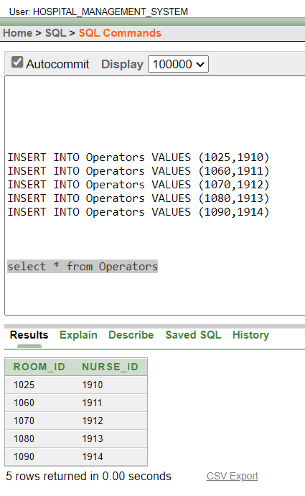

33
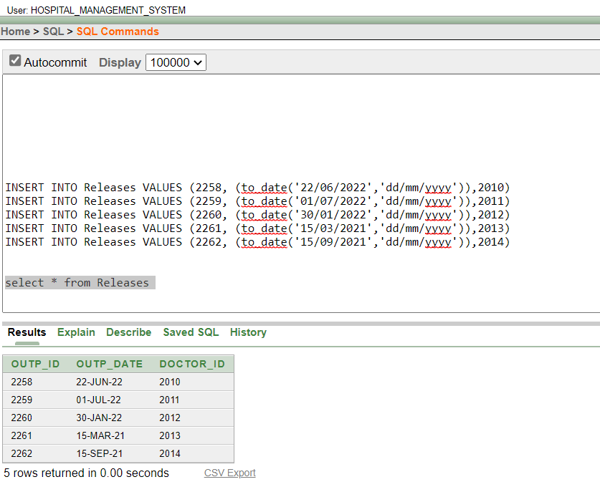

34
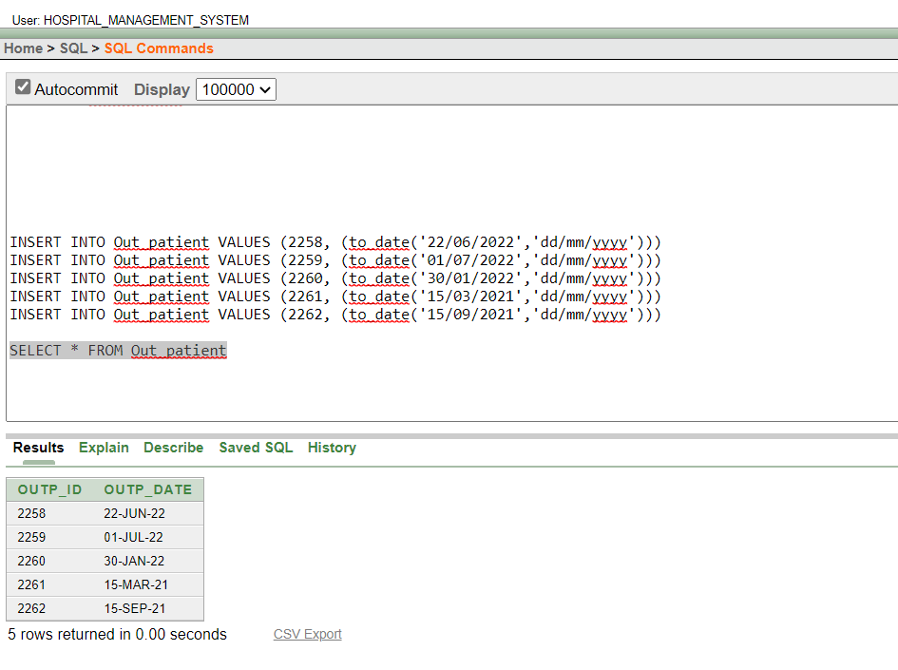

35
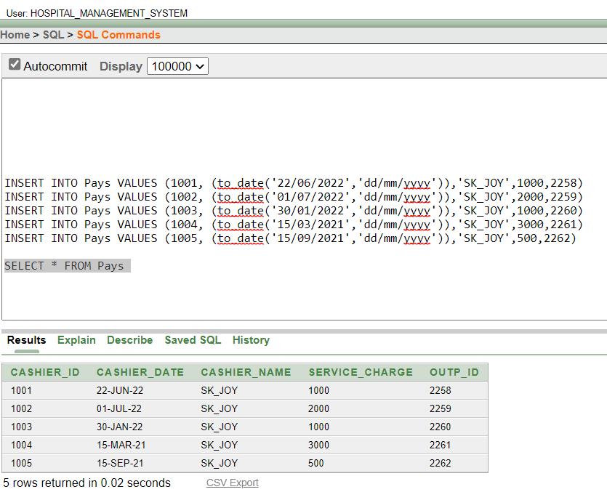

36
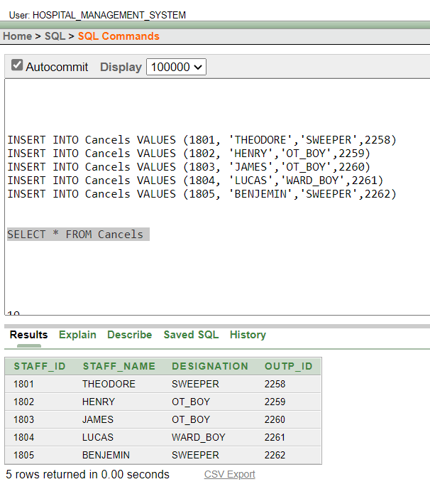

37
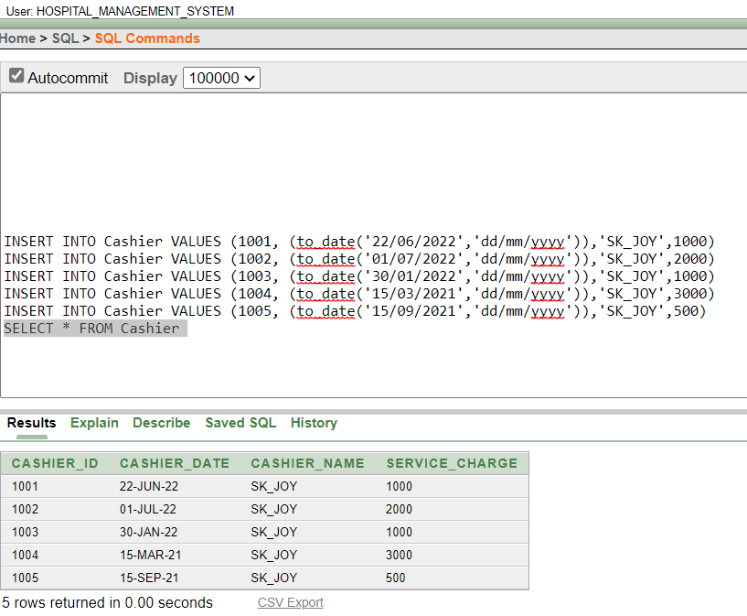

38

Query Test
single-row query
Show the CASHIER_ID, SERVICE_CHARGE AS DISCOUNT from CASHIER table where SERVICE_CHARGE greater-than 500
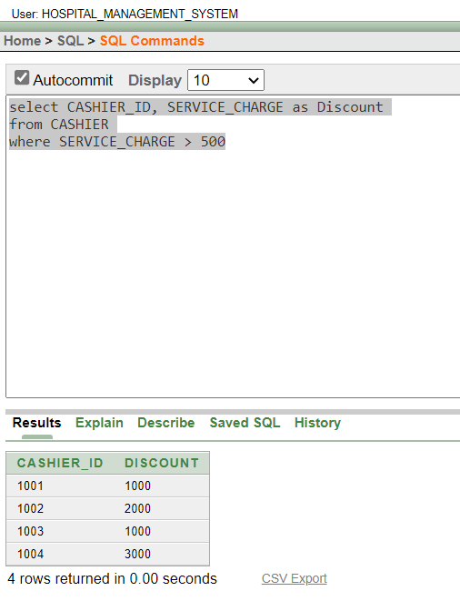
39

Aggregate function query
Show the OUTP_ID, Average SERVICE_CHARGE from pays table
Group by (ascending).
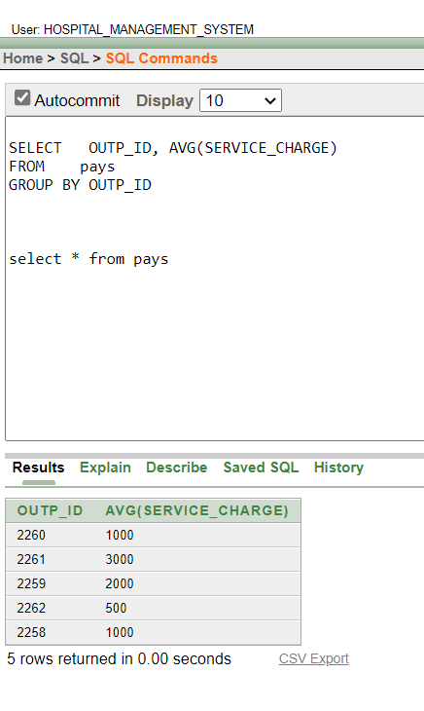
40
Subquery
Single Row Subquery
- Show the ENTRYP_NAME FROM registers table where ENTRYP_AGE is less then ENTRYP_AGE and ENTRYP_ID equal 2260
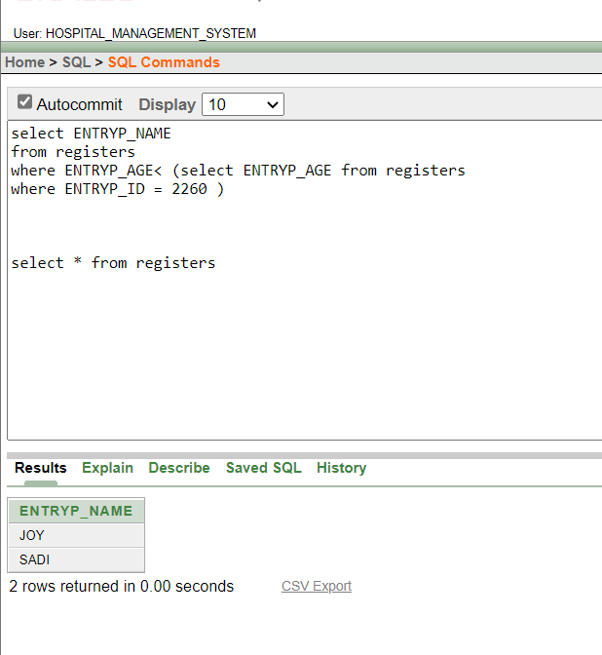

41

Single Row Subquery
- Show the ROUND_TIME, TEST_TYPE from service where TEST_TYPE less then test type, and SEPVICE_ID equal 9982.
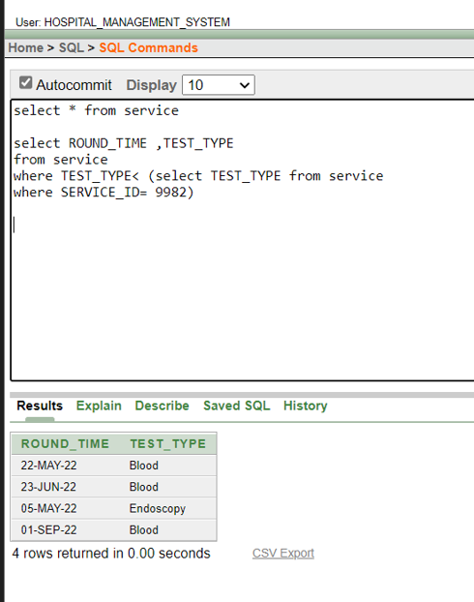
42

Multiple Row Subquery
Show the ROOM_ID, ROOM_COST, ROOM_ TYPE from reserves table where ROOM_TYPE greater than for all ROOM_TYPE from reserves room _ cost less than 1090.
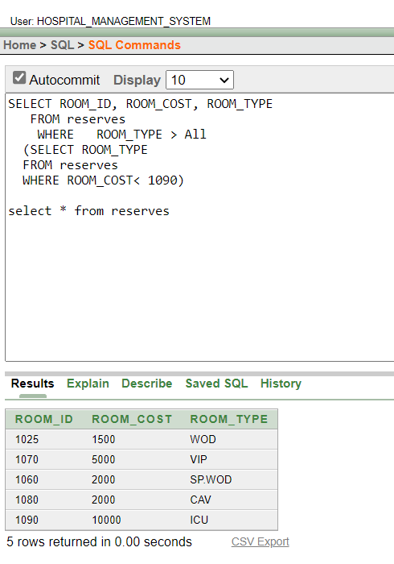
43
Show the ENTRYP_ID, ENTRYP_AGE, ENTRYP_NAME from reserves table where ENTRYP_AGE greater than for ANY ENTRYP_AGE average from reserves GROUP BY ENTRYP_ID.
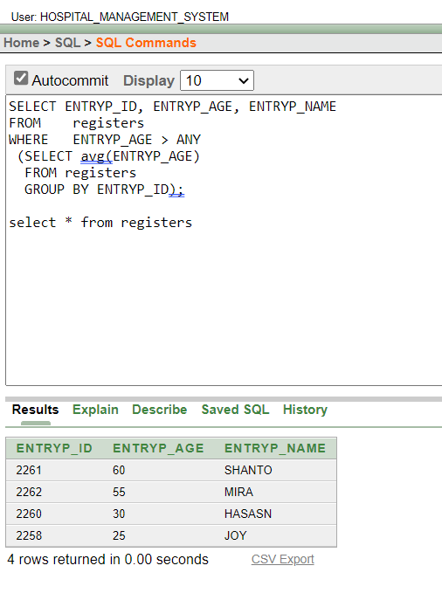

44
Joining
Self joins
Show the admin_ id, Staff_ id from commission table where admin_ id is equal Staff_ id.
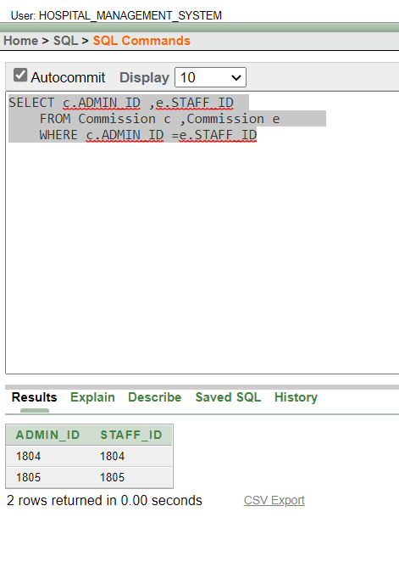
45

Equijoins
Show the admin_ id, admin_ name from admin table and staff_id from commission table where admin_ id is equal Staff_ id.
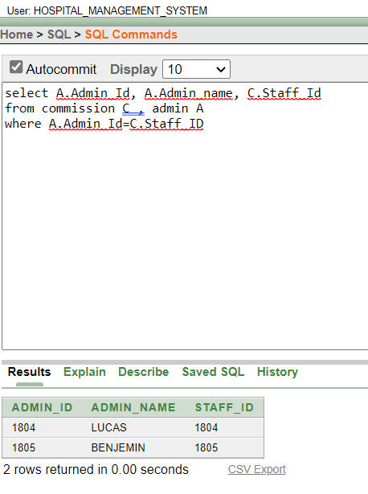

46

VIEW
Create a view as paysvu20 and Show the view from PAYS table .where the Cashier_Name is ‘SK_JOY’.
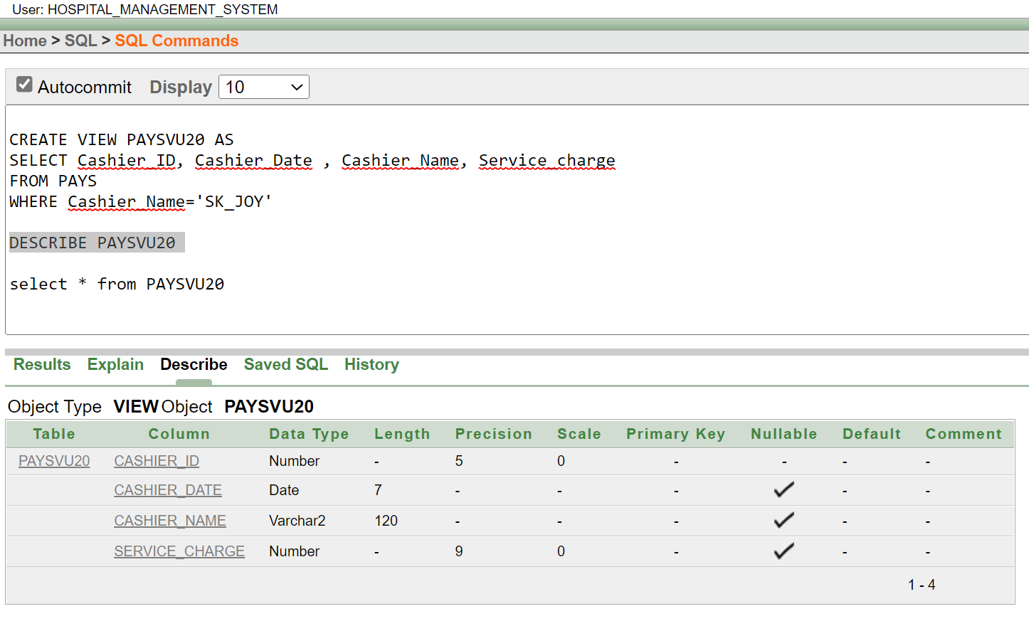

47

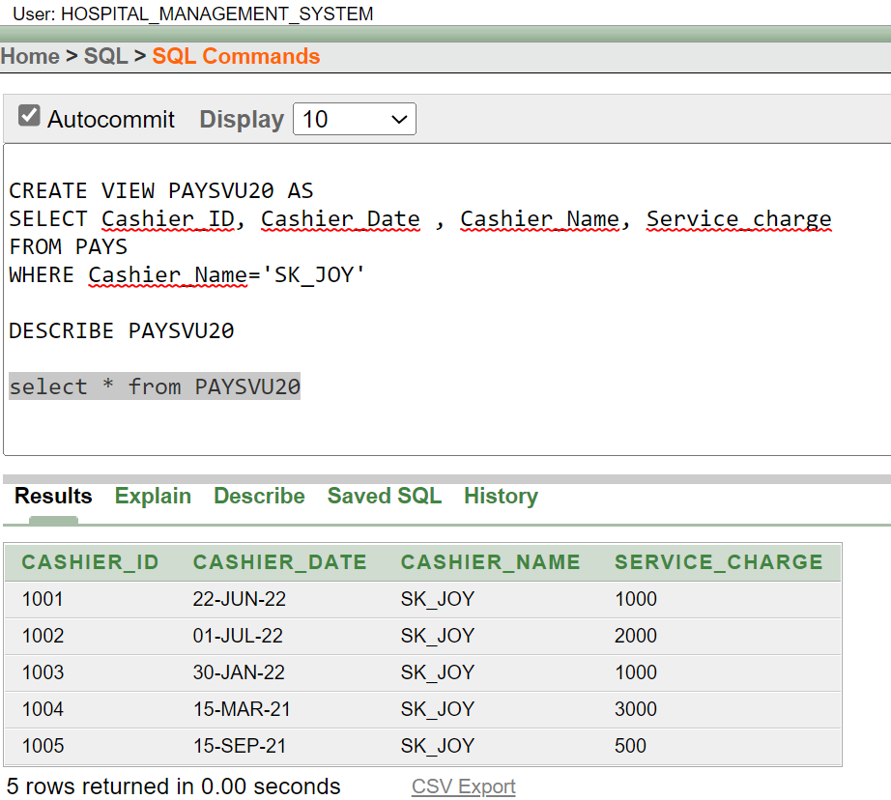

48

Conclusion
The Hospital Management System is done successfully by using ‘oracle10g’. As the project is based on Hospital Management System so we want to use it for hospital. Since we are entering the details of the patients digitally in the Hospital Management System, patient’s data will be secured. Using this system, we can retrieve patients’ history with a single click. That’s why processing information will be faster. It will maintain and guarantee the accuracy of patient details. In addition, the Hospital Management System will reduce human effort and increase efficiency speed.

In The Future Work:
Like any other systems our system has also some limitations and mistakes. But we have done our best to improve the system. Our system will provide the accurate data regarding the patient and system will keep the data secure. Also, our system will give the patient a pleasant experience. In the future we can upgrade this system by including more facilities like pharmacy system for the regular details of medicines in the pharmacy. Providing such features enable the users to include more comments into the system. More comments about the system will help us to improve it more in the future.

THANK YOU
49

