EXPERIMENT – 09
Create a Snapshot of a VM and Test it by loading the Previous Version/Cloned VM using virtual box.
Aim:
To create a snapshot of a Virtual Machine in VirtualBox and test it by restoring to the previous version or cloned state.
Procedure:
- Open Oracle VirtualBox on your host machine.
- Select the virtual machine (VM) for which you want to take a snapshot.
- Go to the Snapshots tab on the top-right corner of VirtualBox.
- Click the Take Snapshot button (camera icon).
- Provide a snapshot name (e.g., “Before Changes”) and an optional description.
- The snapshot now saves the VM’s current state, including OS, files, memory, and settings.
- Start the VM and make some changes, such as installing software or editing files.
- Power off the VM.
- In the Snapshots tab, select the snapshot you created and click Restore.
- Start the VM to verify that it has reverted to the previous saved state, undoing any changes made after the snapshot.

Output:
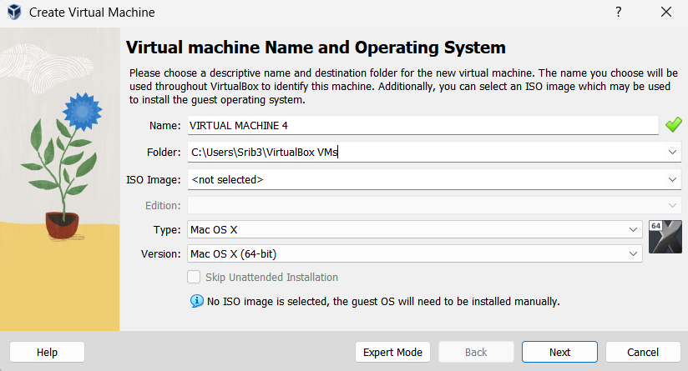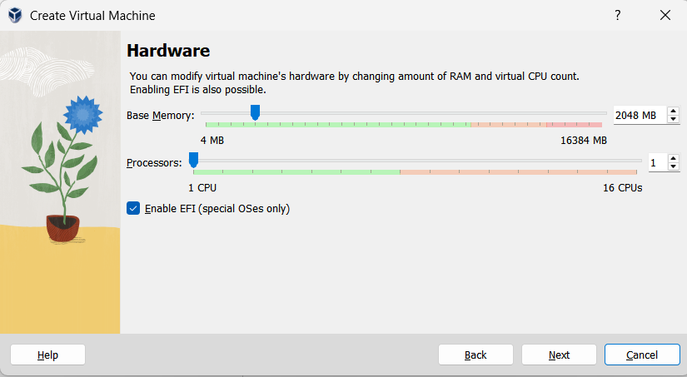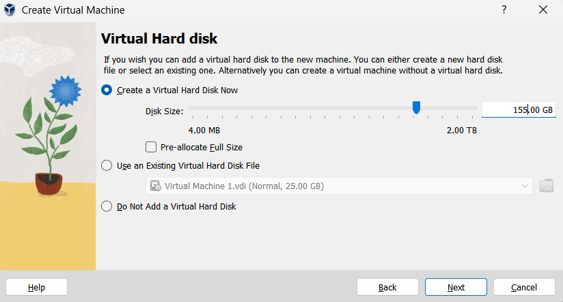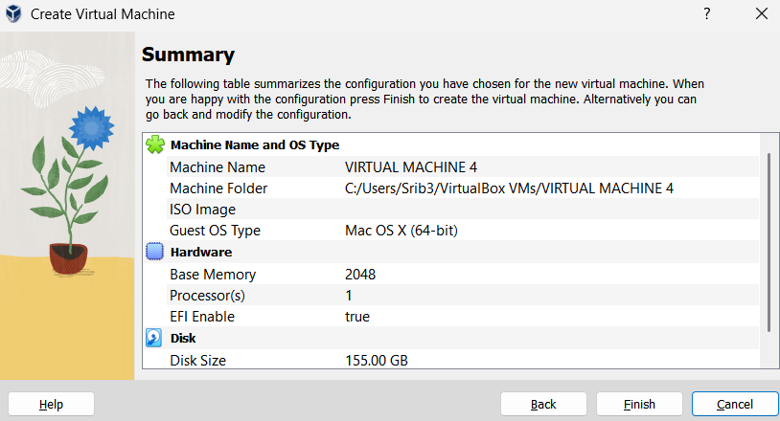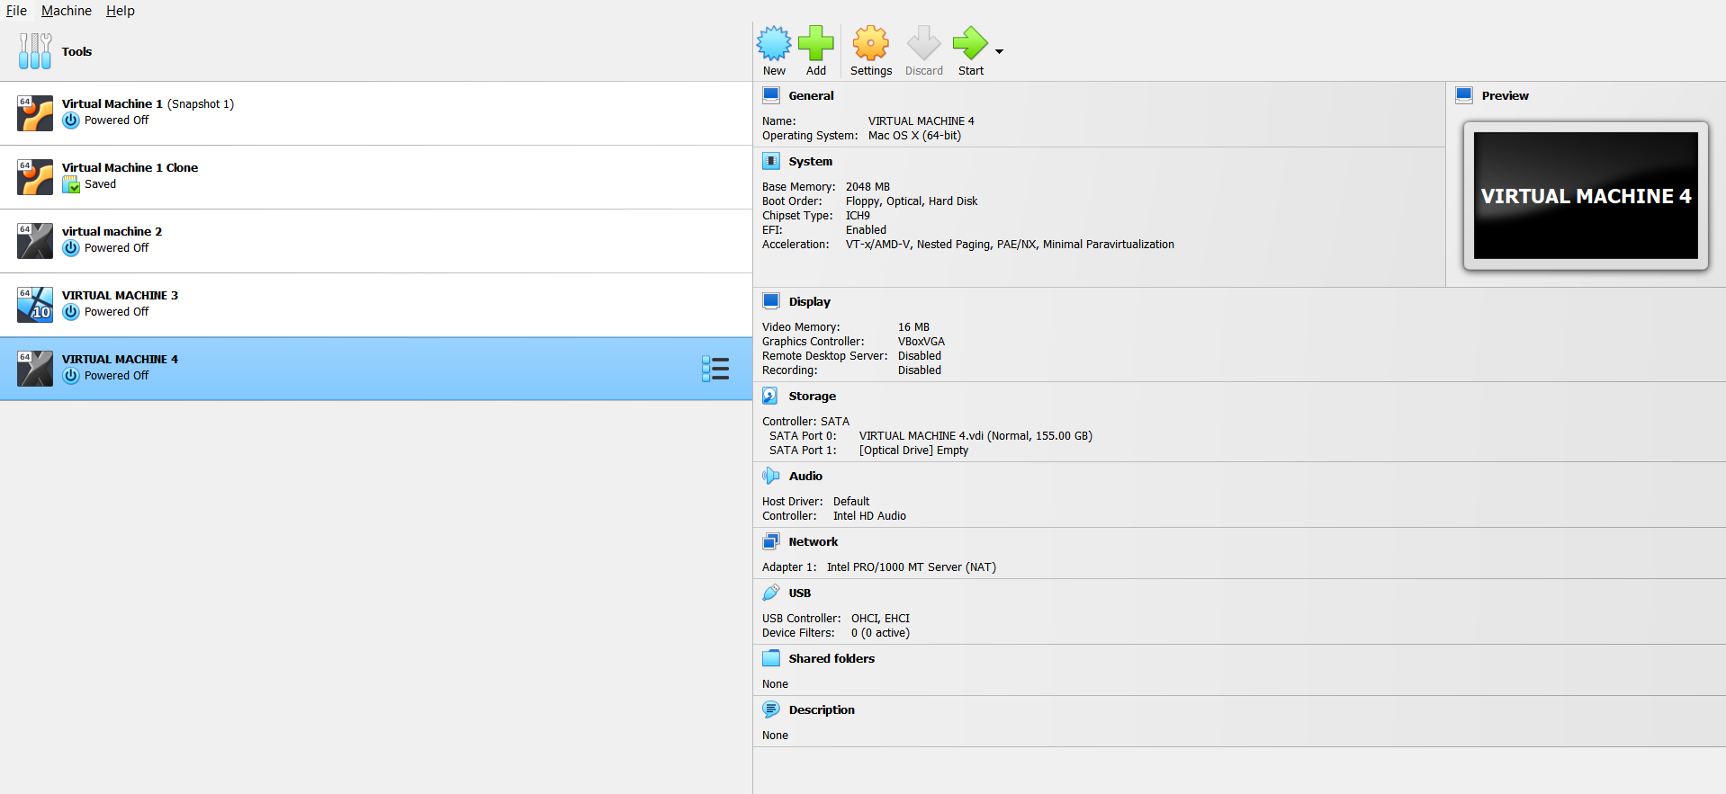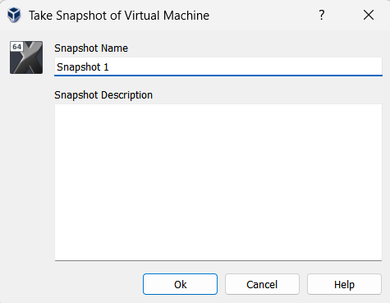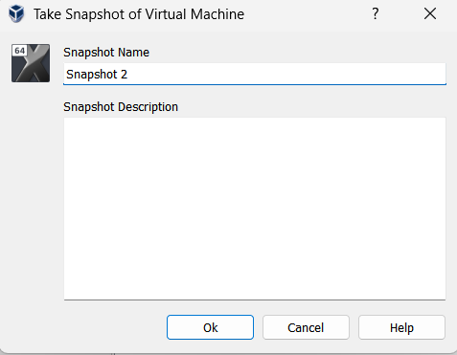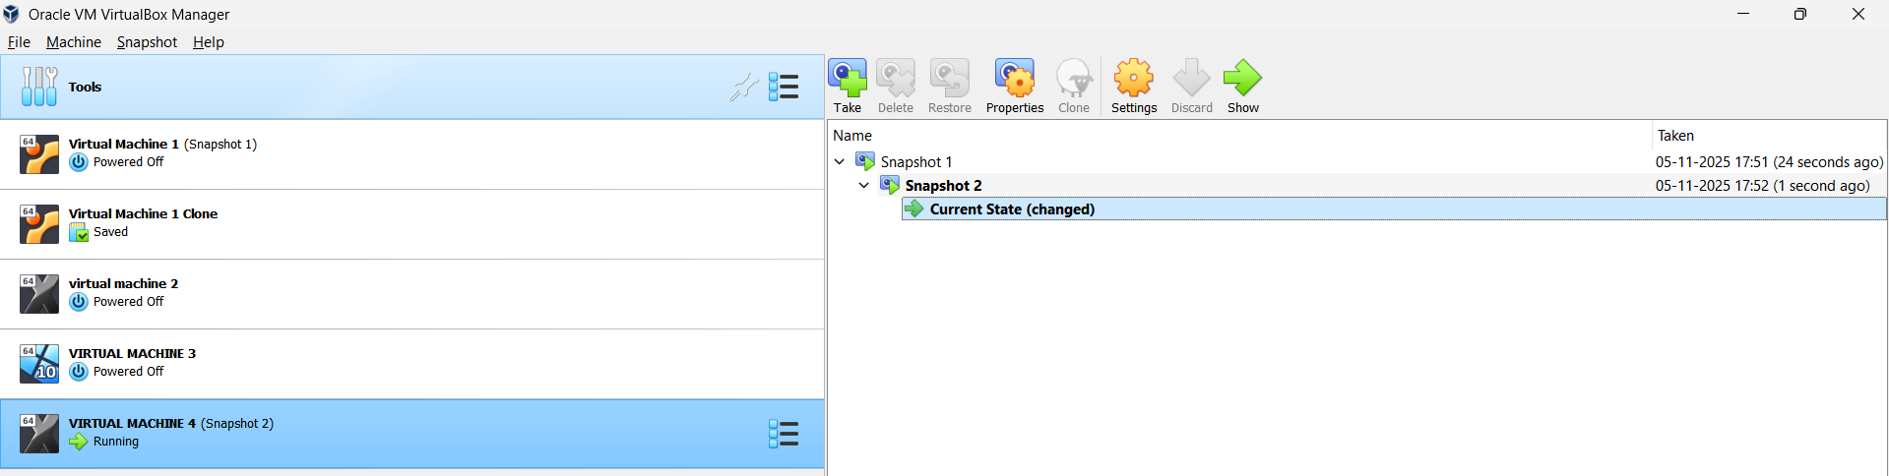

Result:
A snapshot of the VM was successfully created in VirtualBox. Restoring the snapshot reverted the VM to its previous state, demonstrating the functionality of snapshots for backup and testing purposes.

