**USER MANUAL**

Internship Management System

Introduction The student Internship management system is an Android app that is an online internship management android application in which a student can be able to apply for an internship by submitting his application form online through the application to the concerned faculty on the other end faculty could be able to go through the application form that is submitted by the student and review the details of the employer during which the student can be able to find the internship. The admin can examine both the overall number of students and the number of students who applied for internships in the meanwhile. The development of the software application will result in the paperless, real-time streamlining of the application process, which might help the company save time. Many students will find it helpful to apply for an internship using this straightforward software since it will be the only place, they can seek rather than going via several job portals and applications and monitoring them, which will be quite challenging. Many students also are unaware of the application procedure for internships, which causes them to lose out on possibilities. Our application will serve as a central location for students from various universities to apply for internship opportunities in any department of any organization.

By using this user manual, you can follow the STEPS TO install the application APK on your phone and start using it right away.

STEP 1

1.1 Use this link to download the APK file for your mobile <https://github.com/vaddekrishn/CIS-634/blob/Develop/apk/app-debug.apk>

STEP 2

1.2 When you try to install the 3rd part applications

On your android phones that not let you to install directly

without unchecking the security features.

WHEN YOU SEE THIS ON YOUR PHONE SCREEN

1.2.1 Go to the Settings menu, and you can be able to see the Security > Unknown sources and disable it AND THEN INSTALL THE APPLICATION THE APK OF THE Internship Management System’s

These steps are to make the Unknown Sources disable even before installing the application

* Step#1: Go to Settings
* Step#2: Open the Security Option.
* Step#3: Click on the “Unknown Sources” option in security.
* Step#4: Click on Ok to Continue.
* Step#5: That’s It!

If you don’t face any problem over installing this application that’s a great news still If you cant install that means try to turnoff any antivirus software applications like McAfee, 360 security etc.. and try again.

**********YOU ARE NOW SUCCESSFULLY INSTALLED THE APPLICATION CONGRATULATIONS **********

STEP 3

As soon as you open the application that will display you the best tips for

Your education that’s like a walk through into the application.

You will be seeing two buttons

Skip step & Next that will handle the application walk through Guide

When you go all the way to the last page that will take you to the

LET’S CONNECT TOGETHER UI

STEP 3

YOU CAN SEE 3 BUTTONS TAKE YOU TO THE Sign In , Sign Up and Admin Login UI pages when you click on them

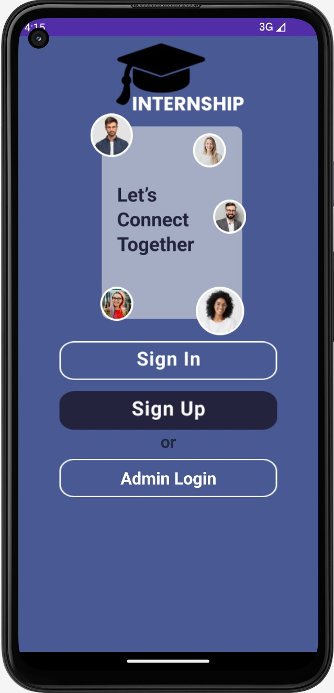

SAME WAY FOR THE ADMIN BUT AT THE LET’S CONNECT TO GETHER PAGE YOU WILL BE CLICKING THE ADMIN IF YOU ARE A ADMIN HOW IS ABLE TO TRYING TO REGISTER OR RESET THE PASSWORD.

STEP 4

If you click on the Sign In button that will take you to this UI page where you will be giving your Login ID and Password

(Don’t worry if you didn’t created yet you can use the Sign Up button at the beginning UI page called “Lets connect together”) or you can clink on the red colored Sign up button picture says Don’t have an account you can still able to use it to create the User ID and Password.

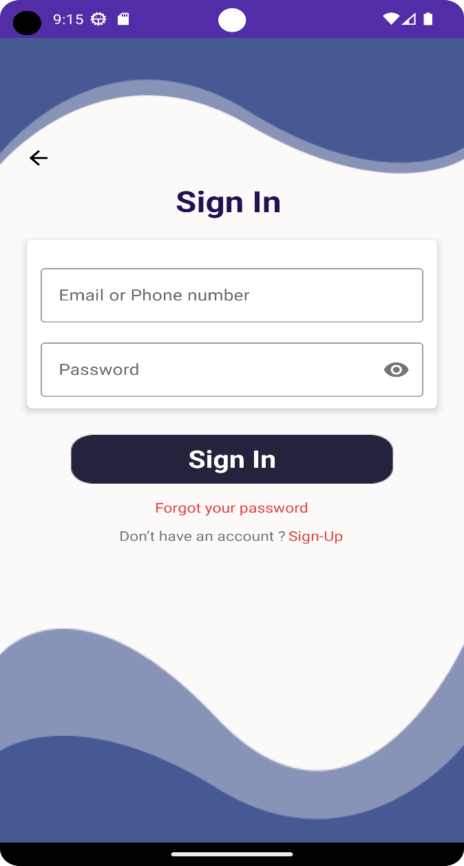

For the Forgot your password Go to the STEP 6

SAME WAY FOR THE ADMIN BUT AT THE LET’S CONNECT TO GETHER PAGE YOU WILL BE CLICKING THE ADMIN IF YOU ARE A ADMIN HOW IS ABLE TO TRYING TO REGISTER OR RESET THE PASSWORD.

STEP 5

Here you will be giving First Name, Last Name , US mobile number, Email, Password, Confirm Password details.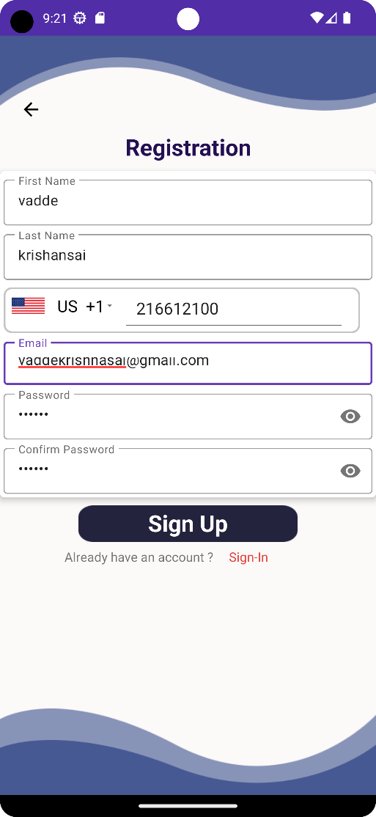 This is a demo you can see the pre filled information you will be performing as it is.

AND CLICK ON SIGN UP THAT’S IT YOU WILL BE REGISTERED IN OUR DATA BACE

SAME WAY FOR THE ADMIN BUT AT THE LET’S CONNECT TO GETHER PAGE YOU WILL BE CLICKING THE ADMIN IF YOU ARE A ADMIN HOW IS ABLE TO TRYING TO REGISTER OR RESET THE PASSWORD.

STEP 6

FORGOT PASSWORD when you click on the red latter words forgot password that will prompt you to this page where you will be giving the email and click on the Send Link so that it will take you to the STEP 7

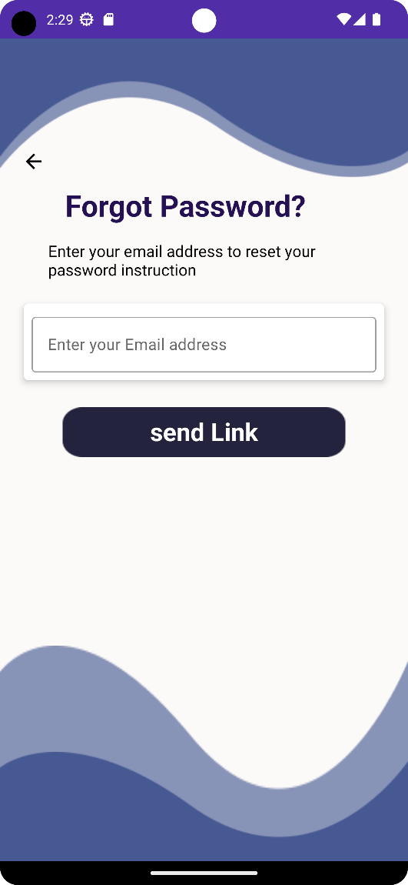 Re-type the email that you are already registered if you are not the SYSTEM will prompt you a pop up saying please register so you need to register in order to Forget the password WE ARE HERE DON’T WORRY.

SAME WAY FOR THE ADMIN BUT AT THE LET’S CONNECT TO GETHER PAGE YOU WILL BE CLICKING THE ADMIN IF YOU ARE A ADMIN HOW IS ABLE TO TRYING TO REGISTER OR RESET THE PASSWORD.

STEP 7

Phone Verification when you GET THE OTP put the password in this 4-digit box that way you will able to get to the STEP 8

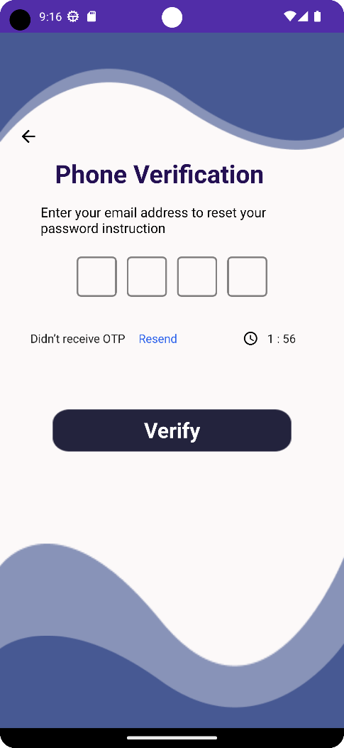 The Bule color Resend is used when you don’t get the OTP with in 30 seconds as you click on send the OTP.

SAME WAY FOR THE ADMIN BUT AT THE LET’S CONNECT TO GETHER PAGE YOU WILL BE CLICKING THE ADMIN IF YOU ARE A ADMIN HOW IS ABLE TO TRYING TO REGISTER OR RESET THE PASSWORD.

STEP 8

You will get this page where you get the chance the Reset Password So just put the New password and press Save that way you will be Registered and Reset the password.

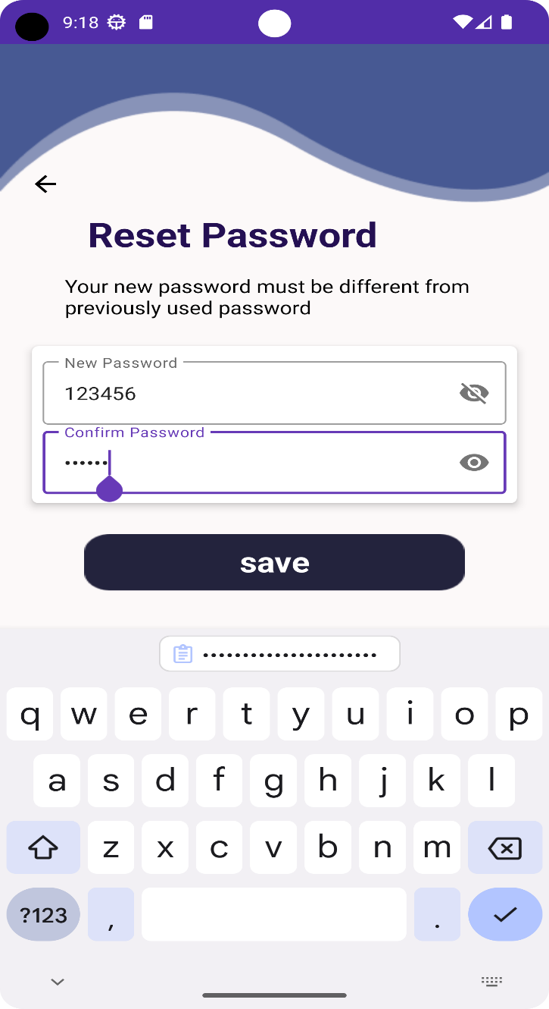

SAME WAY FOR THE ADMIN BUT AT THE LET’S CONNECT TO GETHER PAGE YOU WILL BE CLICKING THE ADMIN IF YOU ARE A ADMIN HOW IS ABLE TO TRYING TO REGISTER OR RESET THE PASSWORD.

STEP 9

This is the Home Screen where you will be seeing the option for Applying when you click on it will take you to the STEP 10

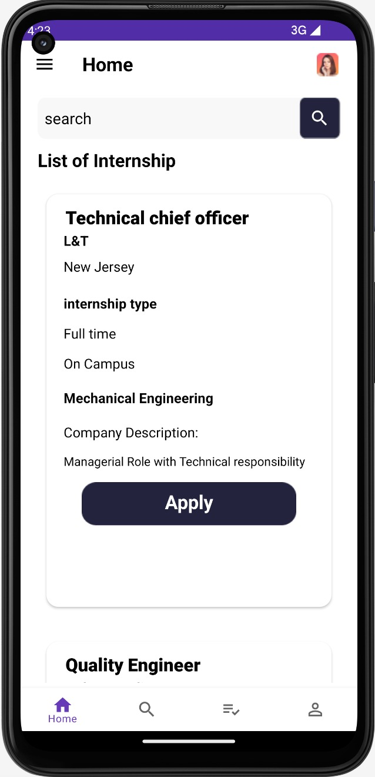

STEP 10

THIS PAGE IS FOR APPLYING FOR THE INTERNSHIP you LIKE fill all the necessary blanks and upload the RESUME by clicking the Choose File button and select the Right file and then Click on the Submit BUTTON THAT WILL BE SUBITTED AND YOU CAN SEE THAT IN THE NEXT STEPS

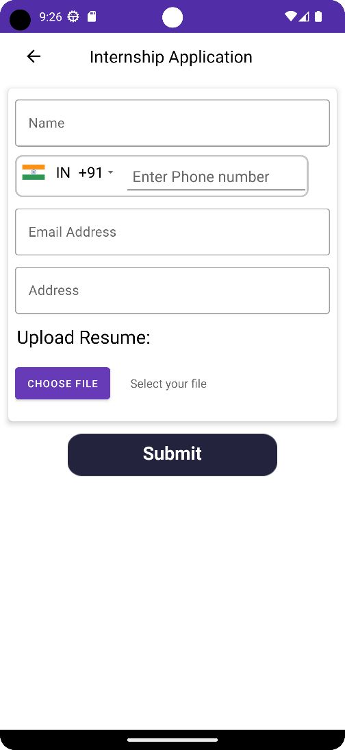

STEP 11

Relax and chill learning the concepts for your INTERVIEW the admin of the app will take care from here. With in 5 business days you will be able to see the status of your application in the STEP 12 if you applied that will be showing the list of the applied companies for the internship you can find it over the Applied Internship List right beside the search ICON or the PROFILE icon.

