**SQL**

**PROJECT**

**INVENTARY MANAGEMENT**

**objective:**

Students will design a database, create tables with the specified schemas, and perform various SQL operations based on provided questions.

**Database Setup**

* **Database Name:** Inventory Management
* **Create databsase inventory_management;**
* **Use inventory_management;**

1. **Products table**

* create table products(

product_id INT PRIMARY KEY AUTO_INCREMENT,

product_name VARCHAR(100) NOT NULL,

category_id INT NOT NULL,

price DECIMAL(10, 2) NOT NULL,

stock_quantity INT NOT NULL,

reorder_level INT NOT NULL);

* INSERT INTO products (product_name, category_id, price, stock_quantity, reorder_level)

VALUES

('Laptop', 1, 999.99, 50, 5),

('Smartphone', 1, 699.99, 120, 10),

('Tablet', 1, 299.99, 75, 8),

('Headphones', 2, 89.99, 200, 20),

('Wireless Mouse', 2, 25.49, 300, 25),

('Keyboard', 2, 49.99, 180, 15),

('Monitor', 3, 199.99, 40, 4),

('Printer', 3, 129.99, 60, 10),

('Camera', 1, 499.99, 30, 5),

('Speaker', 2, 55.00, 150, 18),

('Smartwatch', 1, 199.00, 100, 12),

('External Hard Drive', 2, 79.99, 90, 8),

('Router', 3, 59.99, 110, 15),

('Smart TV', 3, 1199.99, 25, 5),

('Game Console', 1, 399.99, 70, 10),

('USB Flash Drive', 2, 15.99, 500, 50),

('Projector', 3, 350.00, 20, 3),

('Fitness Tracker', 1, 149.99, 85, 12),

('Drone', 1, 999.99, 15, 5),

('Webcam', 2, 39.99, 150, 10),

('Microwave Oven', 4, 120.00, 60, 8),

('Refrigerator', 4, 899.99, 10, 2),

('Blender', 4, 60.00, 80, 5),

('Air Conditioner', 4, 450.00, 20, 3),

('Washing Machine', 4, 600.00, 15, 2),

('Coffee Maker', 4, 89.99, 50, 8),

('Vacuum Cleaner', 4, 250.00, 40, 5),

('Smart Light Bulb', 4, 29.99, 400, 100),

('Dishwasher', 4, 499.99, 25, 4),

('Air Purifier', 4, 150.00, 70, 6);

1. **Categories Table**

* create table categories(

category_id INT PRIMARY KEY AUTO_INCREMENT,

category_name VARCHAR(100) UNIQUE NOT NULL,

description TEXT );

* INSERT INTO categories (category_name, description)

VALUES

('Electronics', 'Devices and gadgets such as phones, laptops, and cameras'),

('Books', 'A wide range of printed materials including novels, textbooks, and comics'),

('Clothing', 'Apparel for men, women, and children'),

('Home & Kitchen', 'Products for home improvement and kitchen usage'),

('Beauty & Health', 'Cosmetics, skincare, and health-related products'),

('Sports & Outdoors', 'Equipment and gear for outdoor activities and sports'),

('Toys & Games', 'Children’s toys, games, and puzzles'),

('Automotive', 'Car accessories and automotive parts'),

('Jewelry', 'Rings, necklaces, earrings, and other jewelry items'),

('Music Instruments', 'Musical instruments including guitars, pianos, and drums'),

('Furniture', 'Home and office furniture such as chairs, desks, and tables'),

('Pet Supplies', 'Items for pet care, such as food, toys, and grooming supplies'),

('Garden & Outdoor', 'Gardening tools and outdoor decor'),

('Office Supplies', 'Stationery, pens, paper, and other office items'),

('Food & Grocery', 'Perishable and non-perishable food items'),

('Movies & TV Shows', 'DVDs, Blu-rays, and streaming content'),

('Footwear', 'Shoes, boots, and sandals for men, women, and children'),

('Watches', 'Wristwatches and timepieces'),

('Video Games', 'Console and PC games, as well as gaming accessories'),

('Art & Collectibles', 'Artwork and collectible items, including limited editions');

1. **Suppliers table**

* create table suppliers(

supplier_id INT PRIMARY KEY AUTO_INCREMENT ,

supplier_name VARCHAR(100) NOT NULL,

contact_name VARCHAR(50),

address TEXT ,

phone_number VARCHAR(15) UNIQUE );

* INSERT INTO suppliers (supplier_name, contact_name, address, phone_number) VALUES

('ABC Supplies', 'John Doe', '123 Elm St, Springfield', '555-1234'),

('XYZ Corp', 'Jane Smith', '456 Oak St, Springfield', '555-5678'),

('Acme Industries', 'Jim Brown', '789 Pine St, Springfield', '555-8765'),

('Global Tech', 'Emily White', '101 Maple Ave, Springfield', '555-4321'),

('MegaGoods', 'Michael Green', '202 Cedar St, Springfield', '555-6789'),

('Quick Supply', 'Sarah Johnson', '303 Birch St, Springfield', '555-3456'),

('ProTech Solutions', 'David Lee', '404 Willow St, Springfield', '555-7890'),

('Ultra Supplies', 'Laura Wilson', '505 Spruce St, Springfield', '555-2345'),

('Elite Services', 'Robert Clark', '606 Aspen St, Springfield', '555-6781'),

('Fast Track', 'Olivia Turner', '707 Chestnut St, Springfield', '555-5679'),

('Advance Tech', 'Daniel Scott', '808 Fir St, Springfield', '555-3457'),

('Superior Goods', 'Jessica Adams', '909 Poplar St, Springfield', '555-8901'),

('Dynamic Supplies', 'James Hill', '1001 Redwood St, Springfield', '555-1235'),

('Innovate Corp', 'Emma Thomas', '1101 Sycamore St, Springfield', '555-6783'),

('Reliable Goods', 'William Baker', '1201 Walnut St, Springfield', '555-4567'),

('Precision Tech', 'Mia Nelson', '1301 Magnolia St, Springfield', '555-8902'),

('Advanced Supplies', 'Liam Carter', '1401 Hickory St, Springfield', '555-2346'),

('Prime Services', 'Ava Martinez', '1501 Chestnut Ave, Springfield', '555-7891'),

('Pioneer Goods', 'Noah Thompson', '1601 Elm Ave, Springfield', '555-5672'),

('NextGen Supplies', 'Sophia Robinson', '1701 Oak Ave, Springfield', '555-3458');

1. **ORDERS TABLE**

* create table orders (

order_id INT PRIMARY KEY AUTO_INCREMENT,

order_date DATE NOT NULL,

supplier_id INT NOT NULL,

total_amount DECIMAL(10, 2) NOT NULL );

* INSERT INTO orders (order_date, supplier_id, total_amount) VALUES

('2024-01-10', 1, 150.75),

('2024-01-15', 2, 200.00),

('2024-01-20', 3, 175.50),

('2024-01-25', 4, 300.00),

('2024-02-01', 5, 250.25),

('2024-02-05', 6, 320.75),

('2024-02-10', 7, 180.60),

('2024-02-15', 8, 220.40),

('2024-02-20', 9, 275.85),

('2024-03-01', 10, 310.20),

('2024-03-05', 11, 290.10),

('2024-03-10', 12, 340.50),

('2024-03-15', 13, 330.75),

('2024-03-20', 14, 275.30),

('2024-03-25', 15, 295.40),

('2024-04-01', 16, 310.60),

('2024-04-05', 17, 265.90),

('2024-04-10', 18, 345.20),

('2024-04-15', 19, 285.50),

('2024-04-20', 20, 320.00);

1. **ORDERDETAILS TABLE**

INSERT INTO orderdetails (order_detail_id, order_id, product_id, quantity, unit_price) VALUES

(1, 1, 1, 2, 19.99),

(2, 1, 2, 1, 9.99),

(3, 2, 3, 3, 29.99),

(4, 2, 4, 2, 14.99),

(5, 3, 5, 5, 49.99),

(6, 3, 6, 1, 59.99),

(7, 4, 7, 4, 24.99),

(8, 4, 8, 6, 34.99),

(9, 5, 9, 2, 12.99),

(10, 5, 10, 1, 8.99),

(11, 6, 11, 3, 27.99),

(12, 6, 12, 2, 22.99),

(13, 7, 13, 4, 39.99),

(14, 7, 14, 1, 11.99),

(15, 8, 15, 6, 18.99),

(16, 8, 16, 2, 14.49),

(17, 9, 17, 5, 32.99),

(18, 9, 18, 3, 23.49),

(19, 10, 19, 4, 21.99),

(20, 10, 20, 1, 9.49);

**SQL QUERIES :**

1. Retrieve the names and prices of all products that are currently out of stock.

* **select product_name , price from products where stock_quantity is null;**

**\*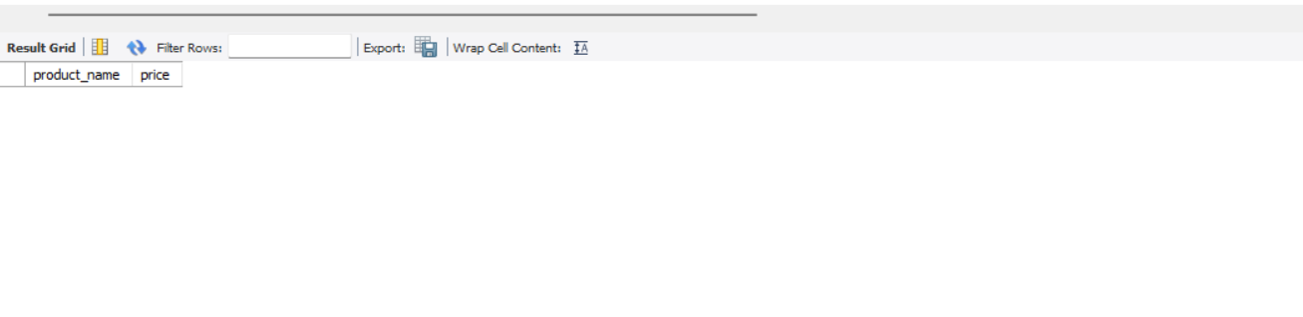**

1. List the total number of products in each category.

* **select category_id,count(*) as total_products from products group by category_id;**

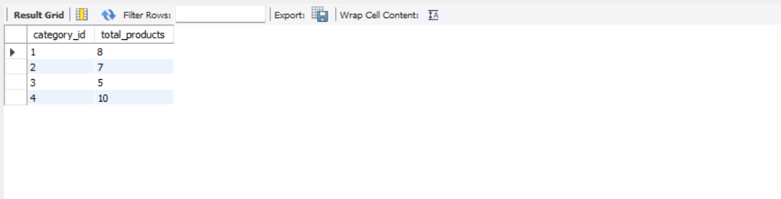

1. Find all suppliers who have supplied products worth more than $10,000.

* **select suppliers.supplier_name ,orders.total_amount from suppliers join**

**orders on suppliers.supplier_id =orders.supplier_id where orders.total_amount 10000 ;**

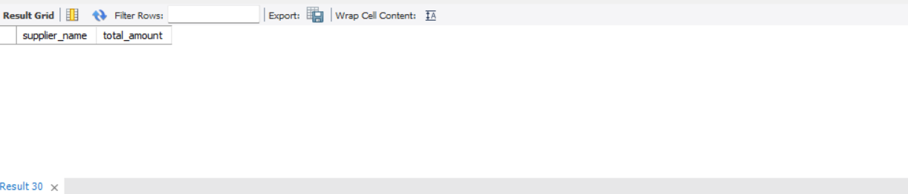

1. Get the details of products with a stock quantity less than their reorder level.

* **select * from products where stock_quantity < reorder_level;**

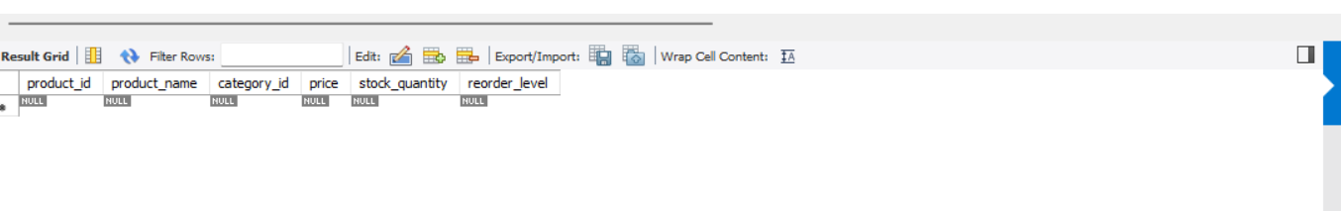

1. Retrieve the order IDs and total amounts for orders placed in the last 30 days.

* **select order_id ,total_amount from orders**

**where order_date >= curdate() - interval 30 day;**

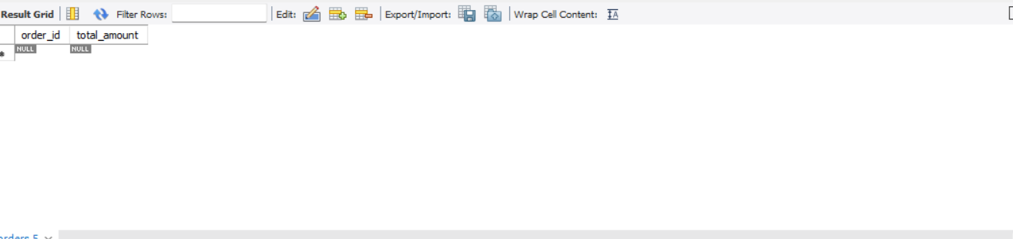

1. List all products along with their categories, ordered by product name.

* **select products.product_id,products.product_name,products.category_id,**
* **products.price,products.stock_quantity,products.reorder_level**
* **from products join categories on products.category_id =categories.category_id order by product_name;**

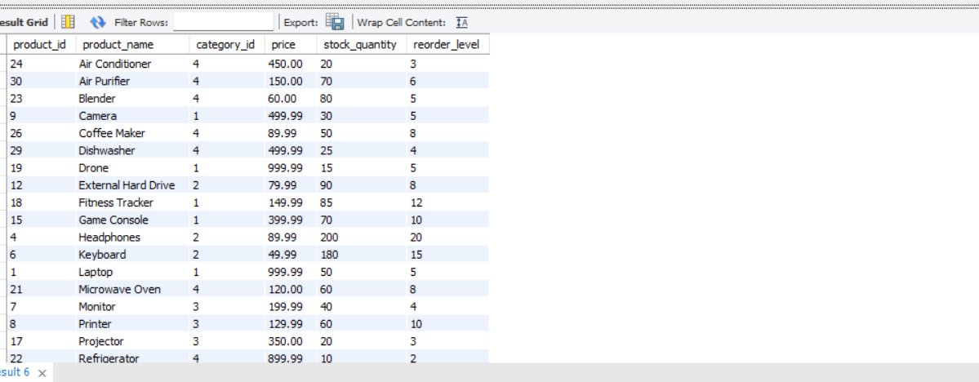

1. Get the names of suppliers who have not supplied any products in the last 6 months.

* **select s.supplier_name , s.contact_name from suppliers as s join orders as o on s.supplier_id = o.supplier_id**
* **where order_date is null >= current_date() - interval 6 month;**

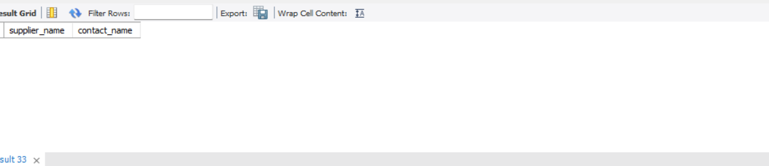

1. Find the total amount spent on orders for each supplier.

* **select supplier_id , sum(total_amount) from orders group by supplier_id;**

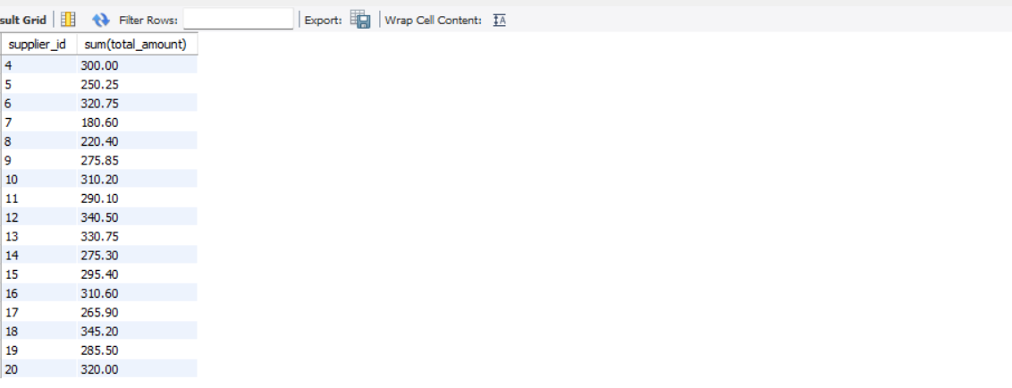

1. Retrieve the product names and total quantities ordered for each product in the last year.

* **select p.product_name,sum(d.quantity) from products as p join orderdetails as d**
* **on p.product_id = d.product_id join orders as o on d.order_id = o.order_id**
* **where order_date >= current_date() - interval 1 year group by p.product_id ;**
* 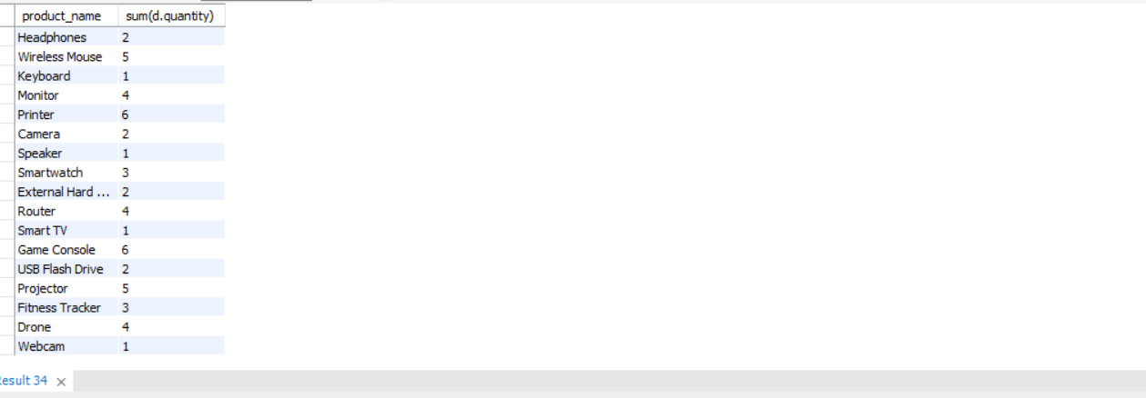

1. Get a list of products and have a price greater than 500.

* **select * from products having price > 500 ;**

