University of Roehampton London
MSc Data Science

Mathematics and Statistics for Data Science (CMP-L045-0)
Part 1: Applied Problem-Solving Activity
Global Income, Health and Development: A Mathematical Analysis of World Development Indicators, 2015–2025

Student name: ____________________
Student ID: ____________________
Module leader: Michael Ng
Submission date: 6 November 2026
Word count: 2,299 (Task 1: 401; Task 2: 1,724; Task 3: 174) (excluding cover, contents, screenshots, captions, references and the AI declaration)

Code (GitHub): https://github.com/abshivks-ass/CMP-L045-0-WDI-analysis
Dataset: https://databank.worldbank.org/source/world-development-indicators
Notebook: StudentName.ipynb (renamed to your name before submission)
Table of Contents
Task 1 – Dataset Selection and Justification 3
Task 2 – Mathematical Application 5
2.1 Linear Algebra – Vectors 5
2.2 Linear Algebra – Matrices 6
2.3 Descriptive Statistics and EDA 8
2.4 Random Variables and Probability 11
2.5 Interval Estimates 13
Task 3 – Critical Reflection 15
References 16
Declaration of Generative AI Use 17

Task 1 – Dataset Selection and Justification
Provenance. The data come from the World Banks World Development Indicators DataBank [1]. This is an open-data portal. It collects information, from statistical offices the UN Population Division, the World Health Organization and the OECD. The data extract was taken on November 2026. The database was last updated on 8th October 2026. The data are shared under a CC BY-4.0 licence. This is not a pre-cleaned teaching file. It arrives in wide format (one column per year), marks missing values with “..”, adds footer text, and mixes 218 economies with 48 regional and income aggregates such as “World” and “High income”, which would double-count countries if they were kept.
Variables. The extract contains six annual series for 2015–2025: GDP per capita (current US$), life expectancy at birth (years), current health expenditure (% of GDP), urban population (% of total), internet users (% of population) and fertility rate (births per woman). I reshaped it to make a panel consisting of 218 economies × 11 years = 2,398 rows, including 6 numeric variables and country, code and year. Matplotlib [3] was used to draw all figures.
Why the year of 2024 is the year of analysis. The most recent data matters, but it's not the latest year. The life expectancy and fertility rates are only projected to 2024, and the health expenditure is only available to 2023 for most countries (Table 1). Excluding health spending, which is the only indicator for which the latest year is 2024, I therefore choose 2024—the latest year for which all the other indicators are available—and the latest value for health spending for each country (2023 for 171 countries, 2024 for 22, and 2021 for 1).
What's the point of it. One of the big questions in development policy is how far health and opportunity in poor countries lag behind rich ones. Income and longevity are strongly but not perfectly linked, as the classic Preston curve shows [4]. The panel lets me test how well the module’s tools capture this inequality, the digital divide, and the COVID-19 shock of 2020–2021, which the WHO estimates wiped out almost a decade of progress in global life expectancy [5], together with the recovery that followed.
Self-defined criteria. I divided countries based on the 2024 GDP per capita which is seven thousand seven hundred fifty-four US dollars into a Higher-income group that has 101 countries and a Lower-income group that has 100 countries. Seventeen economies do not have a 2024 GDP figure. I also set up two yes/no attributes. The first attribute is internet use, by least 75% of the population. The second attribute is health spending of least 6% of GDP.
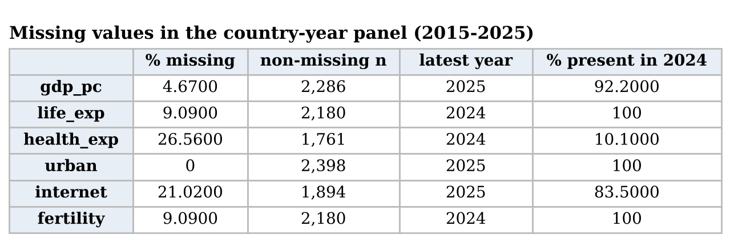
Table 1. Missing values and latest available year in the 2,398-row panel

Task 2 – Mathematical Application

2.1 Linear Algebra – Vectors
Each variable is a vector in ℝ^{n}, with one component per country. Let a and b be life expectancy in 2019 (the last year before COVID-19) and in 2024 (the latest year), for n = 218 countries. The operations follow the definitions in [6] and are computed with NumPy [7] (Table 2):
- Dot product a·b = Σa_{i}b_{i} = 1,188,922. The norms are ‖a‖ equals √(a·a) equals 1,084.0 and ‖b‖ equals √(b·b) equals 1,097.2.
- Cosine similarity cos θ equals a·b divided by (‖a‖‖b‖) equals 0.99963, which corresponds to an angle of 1.56°.
- Projection coefficient c equals (a·b) divided by (a·a) equals 1.012 and represents the multiple of a that comes closest to b: on average 2024 values are 1.2% above 2019 values.
- Difference vector d equals b minus a has a mean of 0.99 years ‖d‖ equals 32.55 and the root‑mean‑square change ‖d‖ divided by √n equals 2.20 years.
- The raw cosine similarity is close to 1 for any two positive variables because both vectors lie in the positive orthant. Therefore cosine similarity mainly measures their level rather, than their true association.Centring each vector (subtracting x̄1) turns the cosine into Pearson’s correlation, which is 0.972: the ranking of countries hardly changed over the pandemic. The difference vector tells a richer story. 197 out of 218 countries, which's 90.4% are now above their 2019 levels. However the RMS change is 2.20 years, which's more than double the mean change of 0.99 years. This shows that the changes vary a lot from one country to another. The lowest change is −6.6 years in the West Bank and Gaza. The highest change is +26.1 years in the Central African Republic. The 2019 value for the Central African Republic was 31.5 years, which was very low and reflected a crisis. For the log of GDP per capita and life expectancy, in 2024 the centred cosine is 0.862.
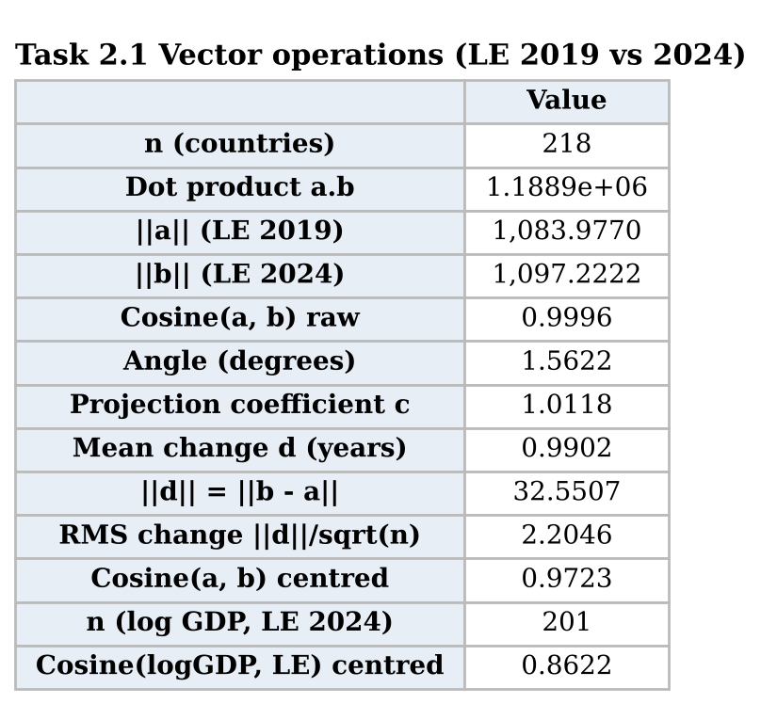
Table 2. Vector operations (notebook output)

2.2 Linear Algebra – Matrices
Data matrix. X is a 178 × 6 matrix (2024 complete cases) whose columns are ln GDP per capita, life expectancy, health expenditure, urban %, internet % and fertility.
Pre-processing with matrix operations. Columns are centred with H = I − (1/n)11^{T}, which is symmetric and idempotent (H² = H), and scaled by D⁻¹ with D = diag(s₁, …, s₆), giving Z = HXD⁻¹ [6]. Min–max scaling is the affine map (X − 1min^{T})diag(1/range). The code confirms that Z has zero column means and unit standard deviations.
Gram matrix X^{T}X. The 6 × 6 Gram matrix holds sums of squares on its diagonal and cross-products off it (Table 3). On raw data it is driven by units: the life-expectancy entry (973,136) mostly reflects the level of about 74 years, not how much countries differ. After standardising, Z^{T}Z/(n − 1) = R, the correlation matrix (Figure 1). Life expectancy correlates 0.86 with ln GDP and −0.83 with fertility, and internet use correlates 0.85 with ln GDP and −0.85 with fertility. Health expenditure is only weakly related to the others (|r| ≤ 0.29), because both rich and poor countries spend very different shares of GDP on health.
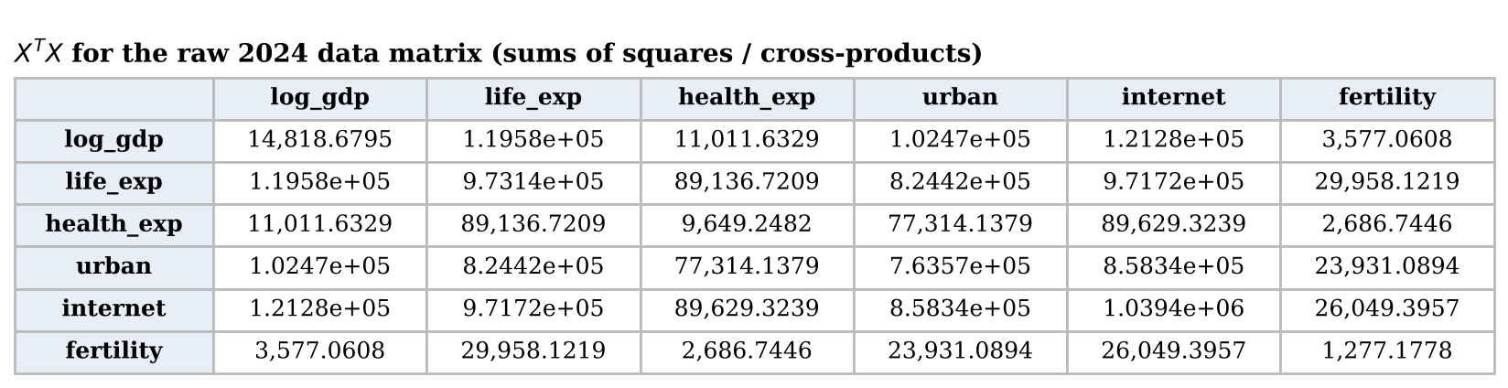
Table 3. X^{T}X for the raw 2024 data matrix
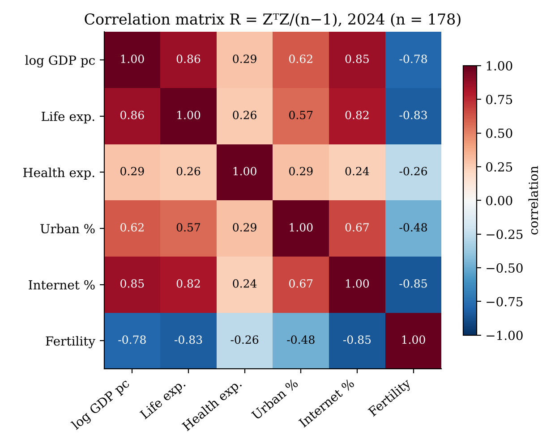
Figure 1. Correlation matrix R = Z^{T}Z/(n − 1)
Determinant. det(X^{T}X) = 4.3 × 10²² changes whenever the units change, so I interpret it through R instead: det R = Πλ_{k} = 0.0066 (Table 4). det R lies between 0 and 1 and equals 1 only when the columns are uncorrelated, so a value below 1% means the six columns occupy a thin slice of ℝ⁶: their generalised variance is less than 1% of that of six independent variables. The numbers explain it. Lambda one equals 4.07 holds 67.8 percent of the variance a single development dimension in the language of principal component analysis [8] while lambda six equals 0.095 is near zero and the condition number is 42.7. For one pair of variables the two by two determinant equals 1 minus r squared;, for log GDP and internet it is 0.273 so 27 percent of their variation is not shared.
In practice. Least-squares regression solves the equations beta hat equals the inverse of A transpose A multiplied by A transpose y. Predicting standardized life expectancy from the five variables gives an R squared value of 0.80. Yet internet use, which by itself has a correlation of 0.82 with life expectancy gets a coefficient of 0.03 because natural log GDP with a coefficient of 0.49 and fertility, with a coefficient of negative 0.39 already have the same information; its variance inflation factor, taken from the diagonal of the inverse of R is 6.4. A small determinant therefore leads to unstable, hard-to-interpret coefficients [9], which is an argument for using principal components or dropping overlapping variables.
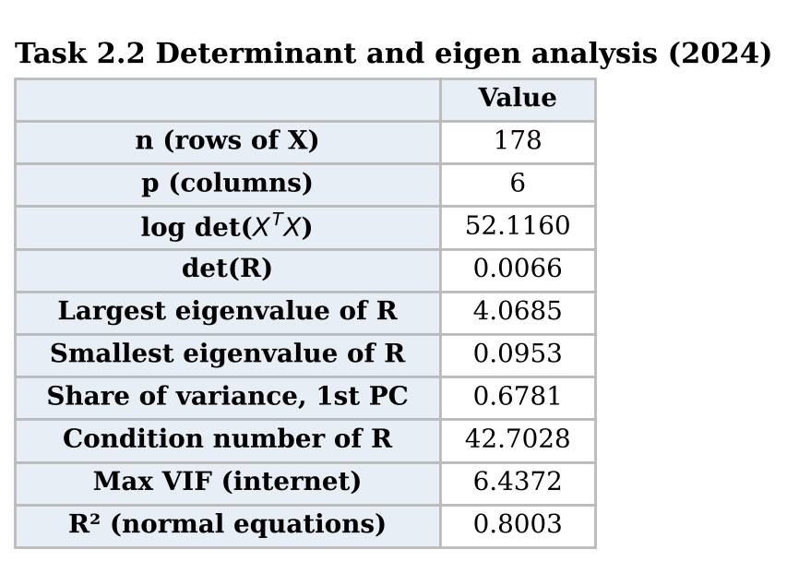
Table 4. Determinant, eigenvalue and regression results

2.3 Descriptive Statistics and EDA
Summary statistics use the moment formulas s² = Σ(x_{i} − x̄)²/(n − 1), g₁ = m₃/m₂^{3/2} and g₂ = m₄/m₂² − 3 (excess kurtosis) [10], implemented by hand and checked against SciPy [11] (Table 5).
Life expectancy (2024): mean 73.97 years, below the median of 74.70; s = 7.12; g₁ = −0.41; g₂ = −0.61. The distribution is slightly skewed to the left with a tail on the low end. Nigeria has the value at 54.6 years. The curve is flatter compared to a distribution as shown in Figure 2. Table 5, in the 2022 column explains why the choice of year is important. In 2022 the Central African Republic had a value of 18.8 years. This single low value strongly affected the skewness bringing it down to −1.71 and pushed the kurtosis up to 8.58. Because the third and fourth moments raise deviations to high powers, one extreme value can dominate them.
GDP per capita: the mean (US$22,262) is almost three times the median (US$7,754), and g₁ = 3.81 and g₂ = 20.48 show strong right skew and very heavy tails, with Monaco at US$288,000. This is typical of income, which grows multiplicatively. Taking logs gives g₁ = −0.05 and g₂ = −0.75 (Figure 3), which is close to symmetric, so ln GDP is used in the rest of the analysis.
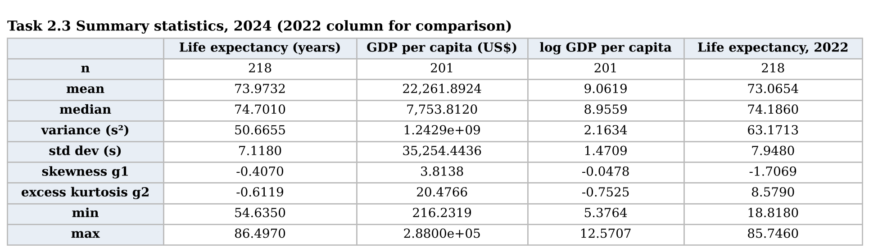
Table 5. Summary statistics, 2024 (with 2022 life expectancy for comparison)
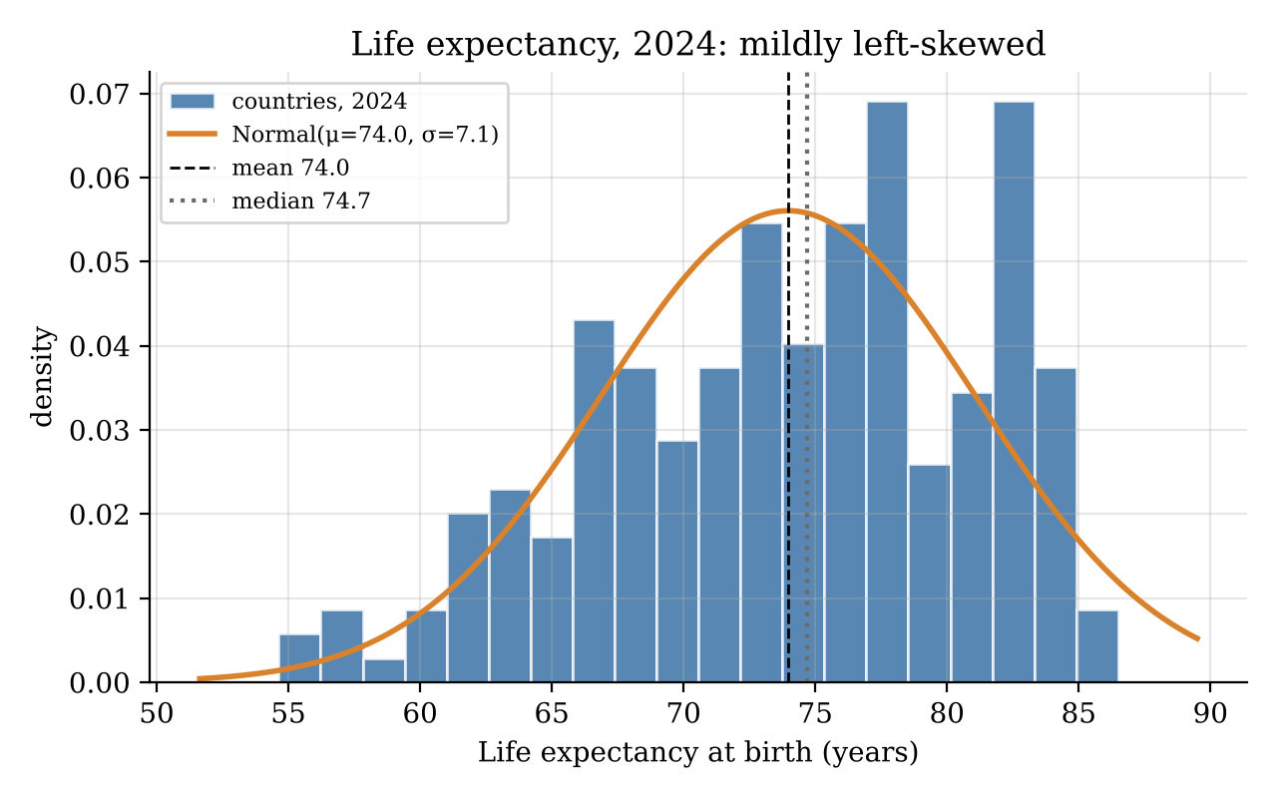
Figure 2. Histogram of life expectancy with fitted normal density, 2024
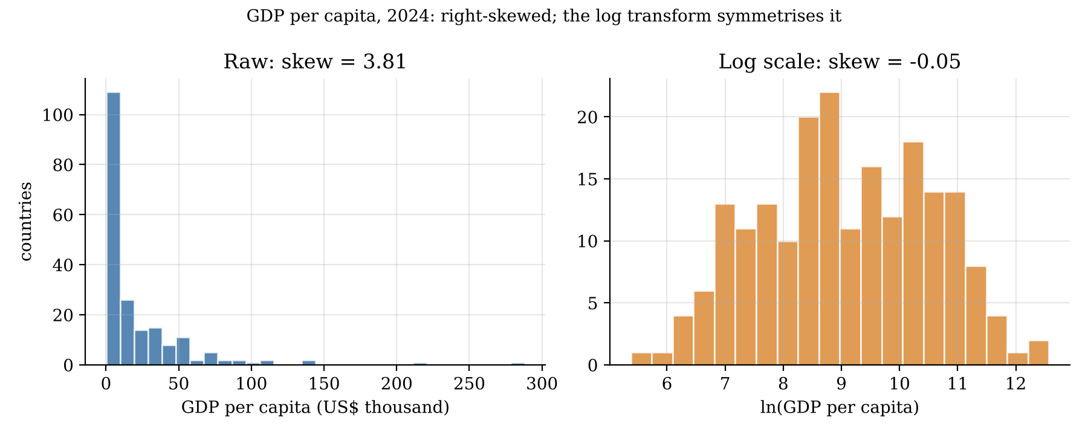
Figure 3. GDP per capita on raw and log scales, 2024
Figure 4 shows an almost linear relationship between life expectancy and ln GDP: LE = 35.9 + 4.18 ln(GDP), with r = 0.86. Doubling income goes with about 4.18 × ln 2 ≈ 2.9 extra years, so in dollar terms the relationship is concave, with diminishing returns, as Preston described [4].
Figure 5 shows a comparison of the self-defined groups. The higher-income group has an age of 79.0 years. The higher-income group has an IQR of 6.1. The lower-income group has an age of 68.3 years. The lower-income group has an IQR of 7.7. The boxes, in the chart do not overlap. The lower-income group shows spread out data. The 1.5 × IQR rule flags one outlier, Nauru (62.3 years), in the higher-income group.
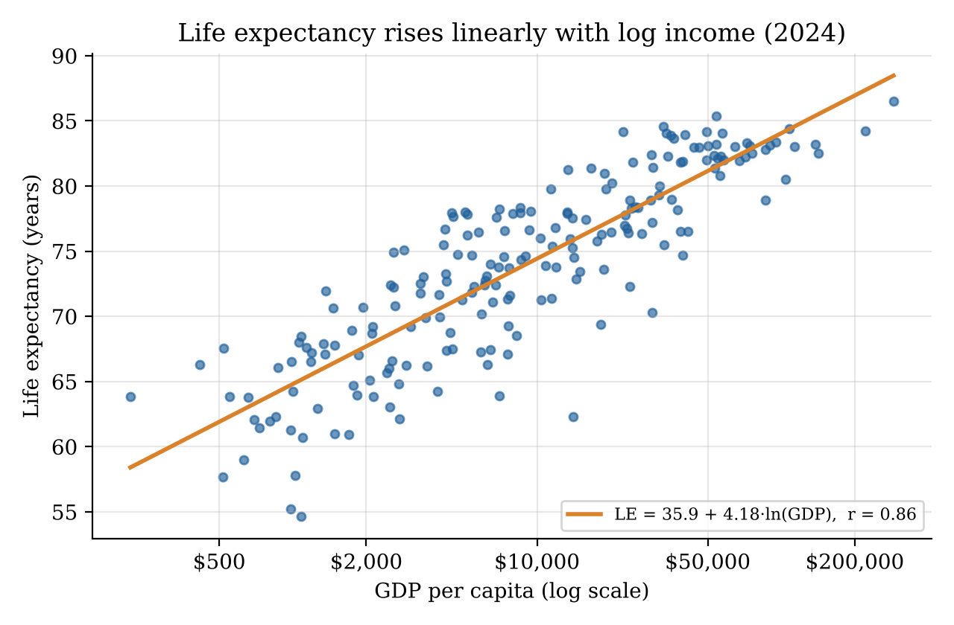
Figure 4. Life expectancy against log GDP per capita, 2024
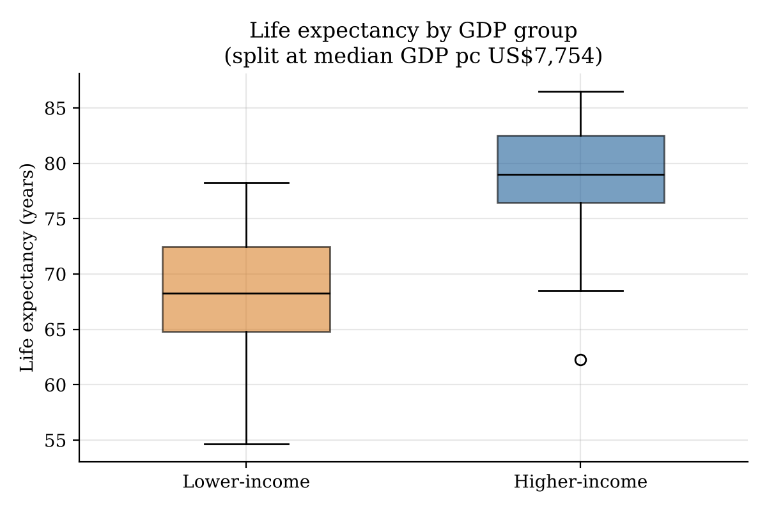
Figure 5. Life expectancy by self-defined income group, 2024
Figure 6 uses the full panelMean life expectancy increased from 72.07 years, in 2015 to 72.98 years in 2019.
During COVID-19 life expectancy fell to 71.75 years in 2021.Now life expectancy has risen again reaching 73.97 in 2024 which is one year higher than the level, before the pandemic. This dip and recovery matter for the probability model below.
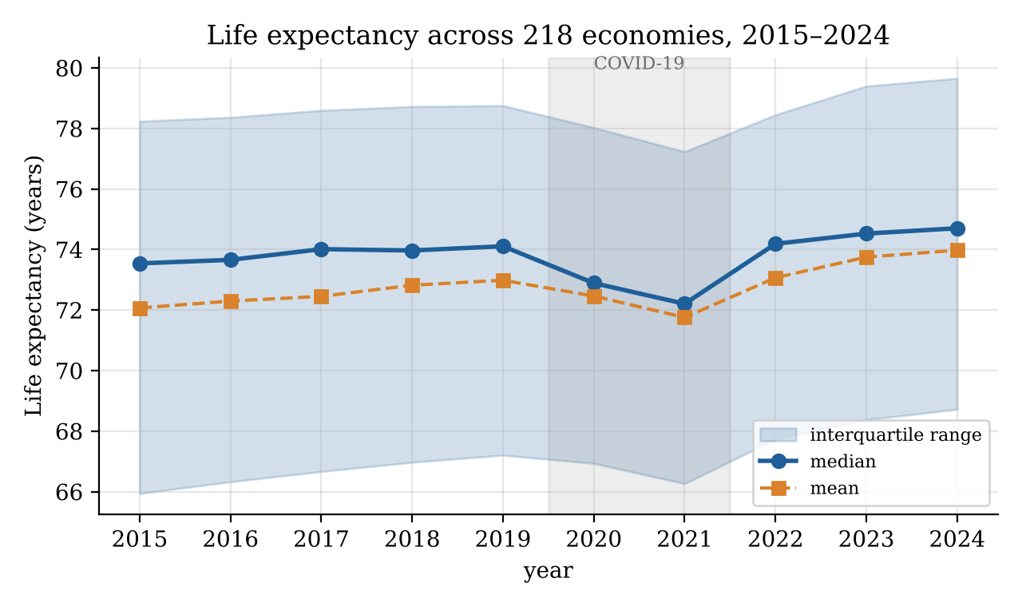
Figure 6. Life expectancy across 218 economies, 2015–2024

2.4 Random Variables and Probability
Discrete variable. K is the number of the nine year-on-year changes (2015–16 to 2023–24) in which a country’s life expectancy rose, so K ∈ {0, …, 9}. Each change is a Bernoulli trial. Pooling 218 × 9 trials gives p̂ = 0.747. If the trials were independent and had a constant probability p then K follows a distribution with 9 trials so K ~ Bin(9, p). The probability that K equals k is given by P(K = k) = C(9, k) * p^k * (1. P)^(9. K). The expected value of K is E[K] = 9p and the variance is Var K = 9p(1. P) [12].
The empirical probability mass function peaks at k = 7 with a probability of 0.339 and at k = 8 with a probability of 0.239 (Table 6 Figure 7). The model matches the expected value E[K] = 6.72 by construction. The variance is also close with 1.741 observed and 1.700 predicted. The model also matches P(K 5) almost exactly 0.170 compared to 0.171.. It underestimates the mode predicting 0.299 when the actual value is 0.339. It also predicts many countries improving every year with P(K = 9) = p̂^9 = 0.073 compared to the actual 0.055.
A chi-squared goodness-of-fit test, with cells pooled so that every expected count is least 5 gives χ² = 5.79, with 4 degrees of freedom and p = 0.22. The binomial model is not rejected under this test. However the trials are clearly not identically distributed. In years between 81% and 95% of countries improved.. In 2020 only 30% improved and in 2021 only 28% improved. Despite this the model fits the distribution even though its assumptions are not met.
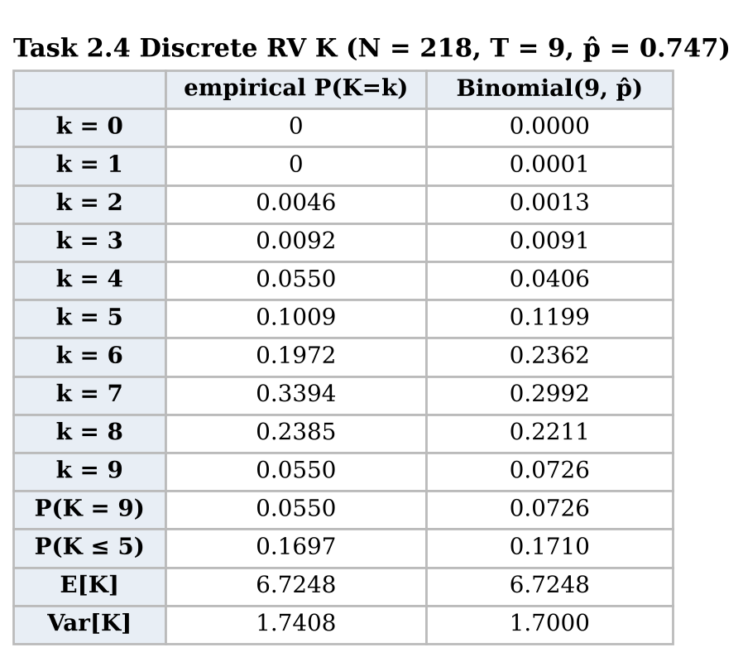
Table 6. Empirical and binomial probabilities for K
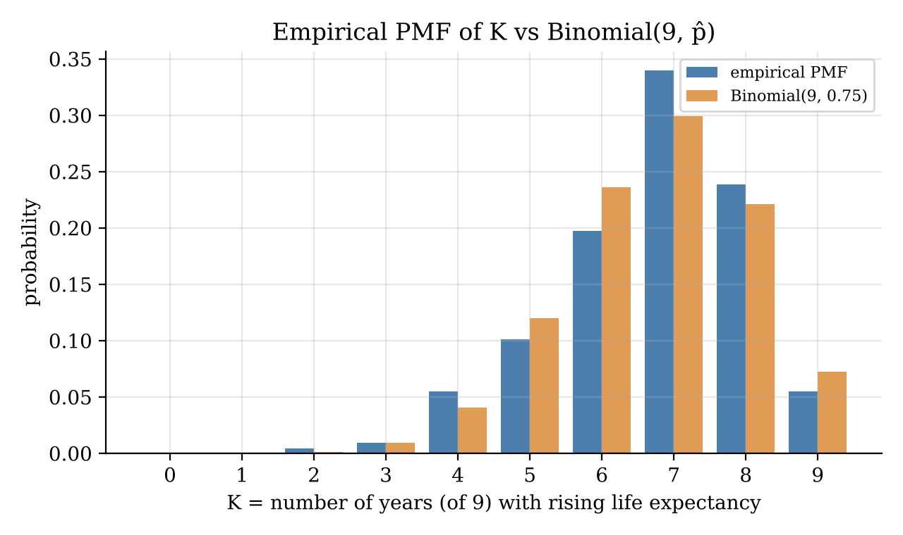
Figure 7. Empirical PMF of K against Binomial(9, 0.747)
Continuous variable. Life expectancy L is modelled as N(μ, σ²) with μ̂ = 73.97 and σ̂ = 7.12. For example, P(L > 80) = 1 − Φ((80 − 73.97)/7.12) = 1 − Φ(0.847) = 0.199, against 0.239 observed (Table 7). The normal model puts too much probability near the centre (P(65 < L < 75) = 0.454 against 0.385; within one σ, 0.683 against 0.615) and too little at the top, because the real distribution is flatter than normal (g₂ = −0.61). The Shapiro–Wilk test [13] rejects normality (p < 0.001), and the Q-Q plot bends at the upper end (Figure 8). GDP per capita is modelled as log-normal, ln G ~ N(9.06, 1.47²). This gives P(G > $20,000) = 0.284 against 0.328 observed, and P(G < $1,500) = 0.117 against 0.154. Normality of ln G is not rejected at the 5% level (p = 0.064, Q-Q r = 0.995), so the log-normal is the better-fitting model of the two.
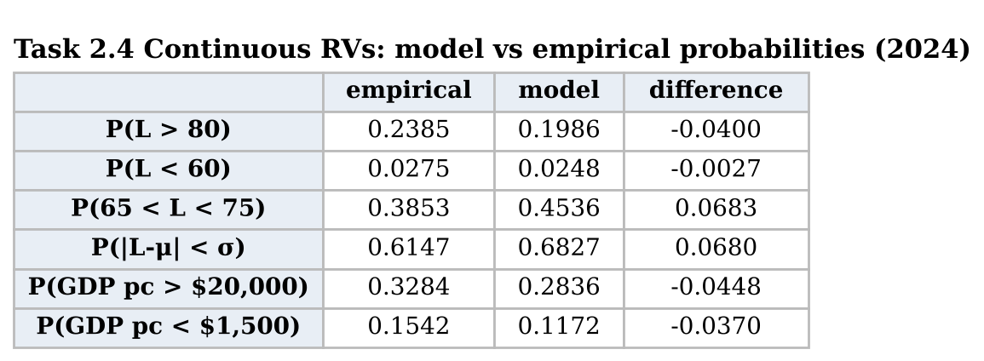
Table 7. Normal and log-normal model probabilities against observed frequencies
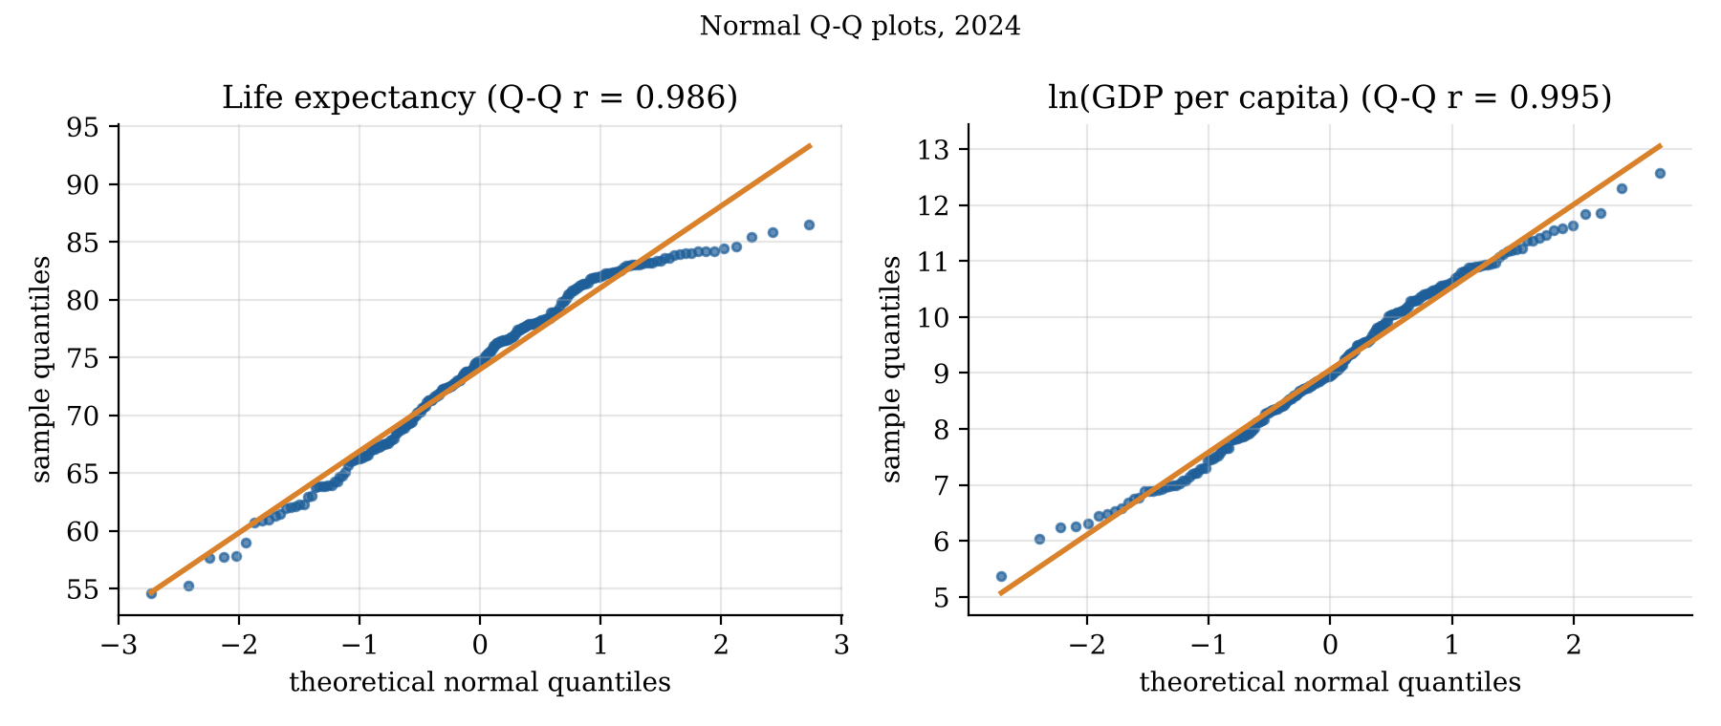
Figure 8. Normal Q-Q plots for life expectancy and ln GDP per capita, 2024

2.5 Interval Estimates
All confidence intervals are based on data from the year 2024 and a confidence level of 95 percent as shown in Table 8 and Figure 9.
- I see that the calculated mean life expectancy is 73.97 years with a margin of error of 1.971 × 0.482. This gives a life expectancy range from 73.02 to 74.92 years. The t interval is chosen because the population standard deviation is unknown. Because the sample size is 218 the central limit theorem allows us to use the t interval even though the data are not perfectly normal.
- I observe that the estimated proportion of people using the internet at seventy‑five percent is 0.599 (109 out of 182). The standard error for this proportion is 0.036 leading to a confidence interval from 0.528 to 0.670. The normal approximation works because the expected counts of successes and failures are 109 and 73 both larger, than ten. The Wilson interval [14], which performs better than the simple Wald interval in small samples [15], gives almost the same result: [0.526, 0.667].
- Two-sample mean difference (life expectancy, higher − lower income): 78.98 − 68.59 = 10.39 years, SE = √(s₁²/n₁ + s₂²/n₂) = 0.690, Welch–Satterthwaite ν = 189.8, t = 1.973, CI = [9.03, 11.75] years. Welch’s version [16] is used because the group variances differ (Figure 5); SciPy returns the same interval.
- Two-sample proportion difference (health spending ≥ 6 % of GDP): 59 out of 89 equals 0.663 versus 41 out of 99 equals 0.414. Difference is 0.249, error 0.070, confidence interval [0.111, 0.387]. Because the confidence interval does not include zero at the 5 % level higher‑income countries live between 9.0 and 11.8 years longer and are more likely to spend least 6 % of GDP on health. The mean interval is tight (±0.95 years) because the sample size is large. The proportion intervals are wide (±7 to ±14 percentage points) because yes/no data give information, per observation. “95%” describes the method: across repeated samples, 95% of intervals built this way would contain the true value; it is not a 95% probability for this particular interval [12].
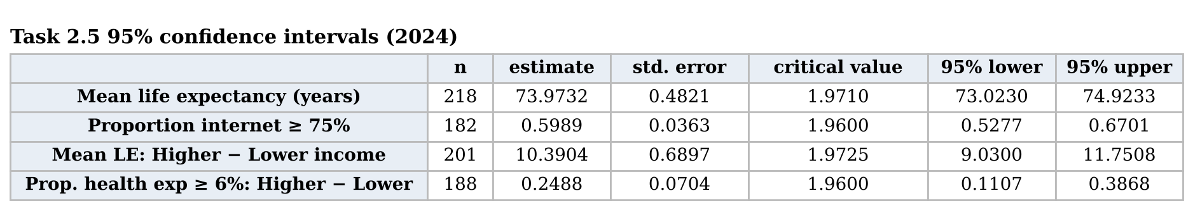
Table 8. 95% confidence intervals, 2024
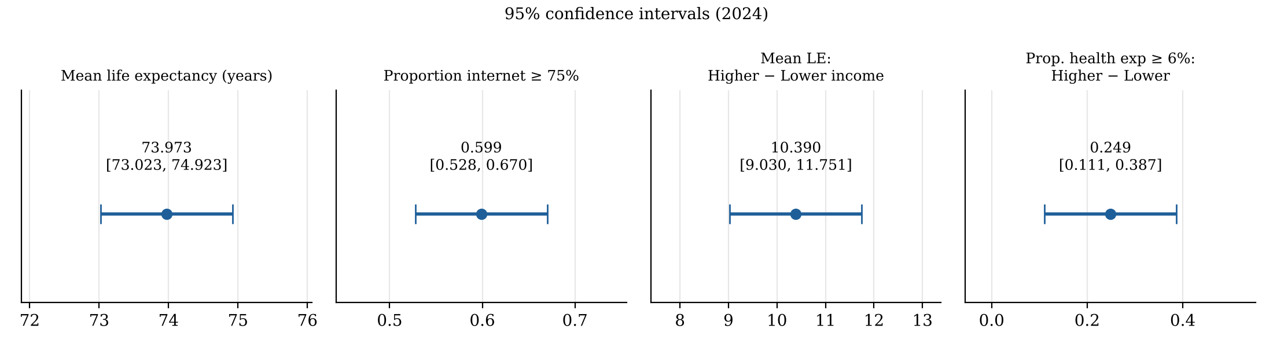
Figure 9. The four 95% confidence intervals

Task 3 – Critical Reflection
Where it worked. Linear algebra suited the data: centred cosines, Z^{T}Z and det R revealed one dominant development dimension, and the log transform made GDP nearly symmetric and linear in life expectancy.
Where it broke down. Randomness: the 218 economies are effectively the whole population (finite-population correction = 0), so the intervals describe a hypothetical super-population, not sampling error. Independence: COVID-19 hit almost every country in 2020–21, yet the binomial still passed its χ² test, so a good fit hid a false model. Normality and year choice: switching from 2022 to 2024 moved kurtosis from 8.58 to −0.61. Countries are also weighted equally (Tuvalu counts as much as India), GDP is in current US dollars rather than purchasing power, and health spending comes from 2023.
Misuse. A raw cosine of 0.9996 could be read as “unchanged”, internet use’s tiny coefficient as “irrelevant”, and a significant interval as proof that income causes longevity. Reporting robust statistics, testing sensitivity to outliers, years and cut-offs, and naming the population an interval refers to would reduce these risks.

References
[1] World Bank, “World Development Indicators,” DataBank, 2026. [Online]. Available: https://databank.worldbank.org/source/world-development-indicators [Accessed: Nov. 2, 2026].
[2] W. McKinney, “Data structures for statistical computing in Python,” in Proc. 9th Python in Science Conf., 2010, pp. 56–61.
[3] J. D. Hunter, “Matplotlib: A 2D graphics environment,” Computing in Science & Engineering, vol. 9, no. 3, pp. 90–95, 2007.
[4] S. H. Preston, “The changing relation between mortality and level of economic development,” Population Studies, vol. 29, no. 2, pp. 231–248, 1975.
[5] World Health Organization, World Health Statistics 2024: Monitoring Health for the SDGs, Sustainable Development Goals. Geneva, Switzerland: WHO, 2024.
[6] G. Strang, Introduction to Linear Algebra, 6th ed. Wellesley, MA, USA: Wellesley-Cambridge Press, 2023.
[7] C. R. Harris et al., “Array programming with NumPy,” Nature, vol. 585, pp. 357–362, 2020.
[8] I. T. Jolliffe and J. Cadima, “Principal component analysis: A review and recent developments,” Phil. Trans. R. Soc. A, vol. 374, no. 2065, Art. no. 20150202, 2016.
[9] D. A. Belsley, E. Kuh, and R. E. Welsch, Regression Diagnostics: Identifying Influential Data and Sources of Collinearity. New York, NY, USA: Wiley, 1980.
[10] D. N. Joanes and C. A. Gill, “Comparing measures of sample skewness and kurtosis,” J. Royal Statist. Soc. D (The Statistician), vol. 47, no. 1, pp. 183–189, 1998.
[11] P. Virtanen et al., “SciPy 1.0: Fundamental algorithms for scientific computing in Python,” Nature Methods, vol. 17, pp. 261–272, 2020.
[12] D. C. Montgomery and G. C. Runger, Applied Statistics and Probability for Engineers, 7th ed. Hoboken, NJ, USA: Wiley, 2018.
[13] S. S. Shapiro and M. B. Wilk, “An analysis of variance test for normality (complete samples),” Biometrika, vol. 52, no. 3/4, pp. 591–611, 1965.
[14] E. B. Wilson, “Probable inference, the law of succession, and statistical inference,” J. Amer. Statist. Assoc., vol. 22, no. 158, pp. 209–212, 1927.
[15] A. Agresti and B. A. Coull, “Approximate is better than ‘exact’ for interval estimation of binomial proportions,” The American Statistician, vol. 52, no. 2, pp. 119–126, 1998.
[16] B. L. Welch, “The generalization of ‘Student’s’ problem when several different population variances are involved,” Biometrika, vol. 34, no. 1/2, pp. 28–35, 1947.
[17] Anthropic, “Claude (Opus 5.5),” Large language model, 2026. [Online]. Available: https://claude.ai [Accessed: Nov. 2, 2026].

Declaration of Generative AI Use
The dataset was independently selected and downloaded from the World Bank Open Data portal. The analysis, interpretation of results, calculations and conclusions presented in this report are my own work. Digital tools were used for limited assistance during the preparation of the Python code and improvement of report wording. All code was independently executed, and the outputs, calculations and figures were reviewed and verified against the notebook results. I take full responsibility for the accuracy, originality and content of this report.

