1. Open your web browser and navigate to the AWS Management Console (<https://aws.amazon.com/console/>).
2. Log in using your AWS account credentials. If you don't have an account, you'll need to create one.

3. Once logged in, find the "Services" menu at the top of the console.

1. Click on “S3” under the "Storage" category, or you can type “S3” in the search box and select it from the results.

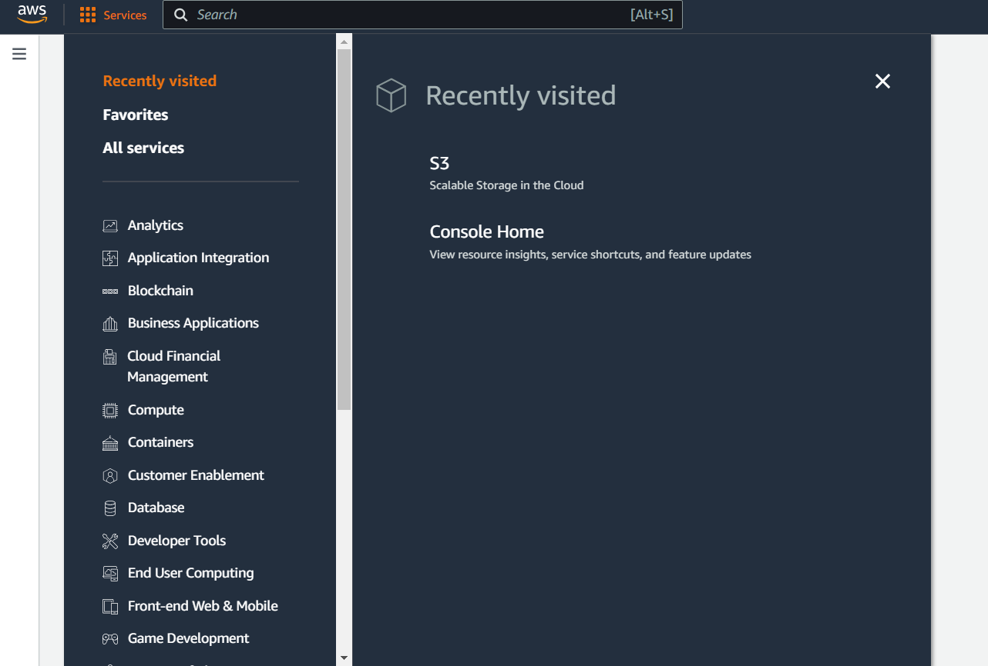

**Bucket name**: Enter a unique name for your bucket. Remember that this name must be globally unique across all existing bucket names in Amazon S3 (AWS does not allow two buckets to share the same name).

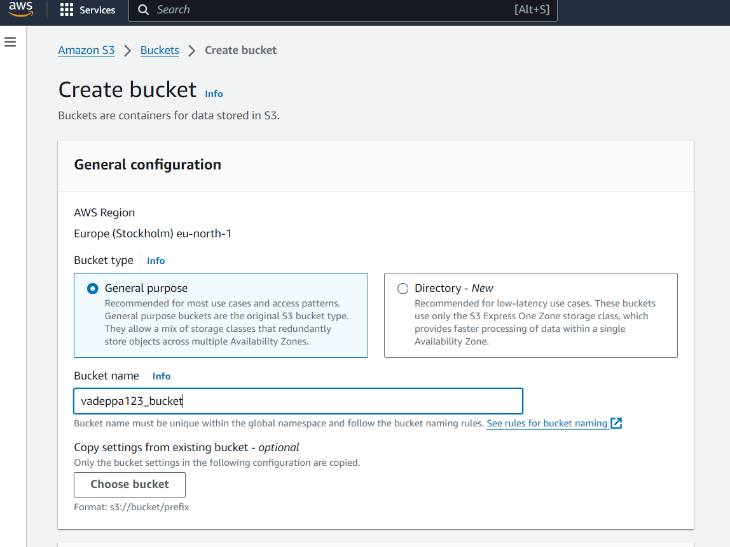

**Block Public Access settings**: It's recommended to leave these settings enabled to prevent accidental data exposure.

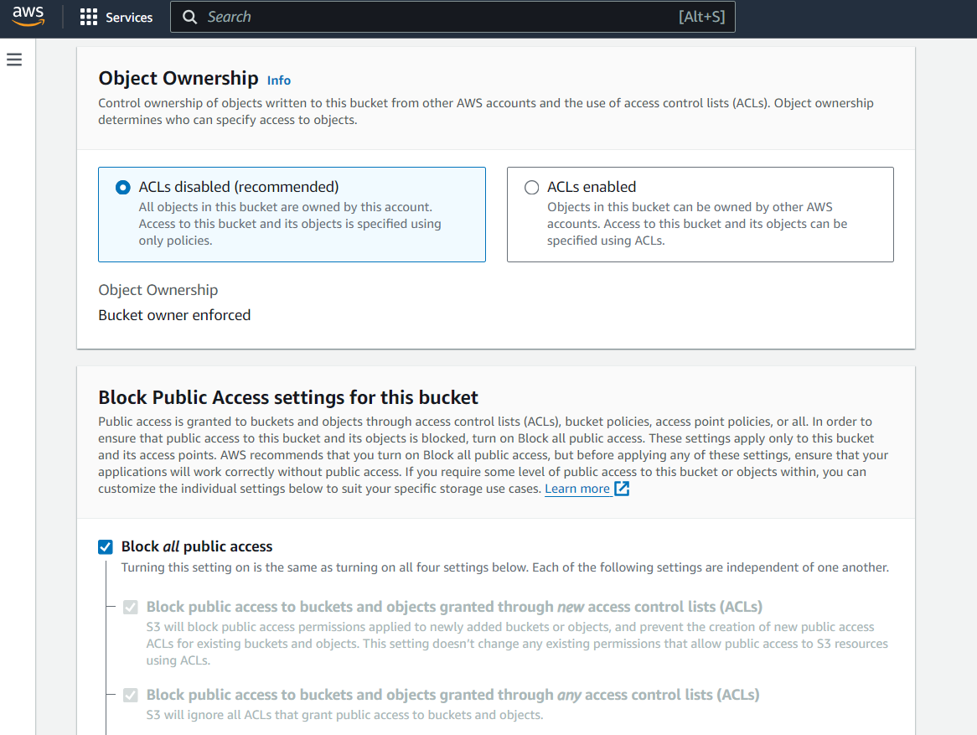

**Versioning**: Enable this if you want to keep multiple versions of an object in the same bucket.

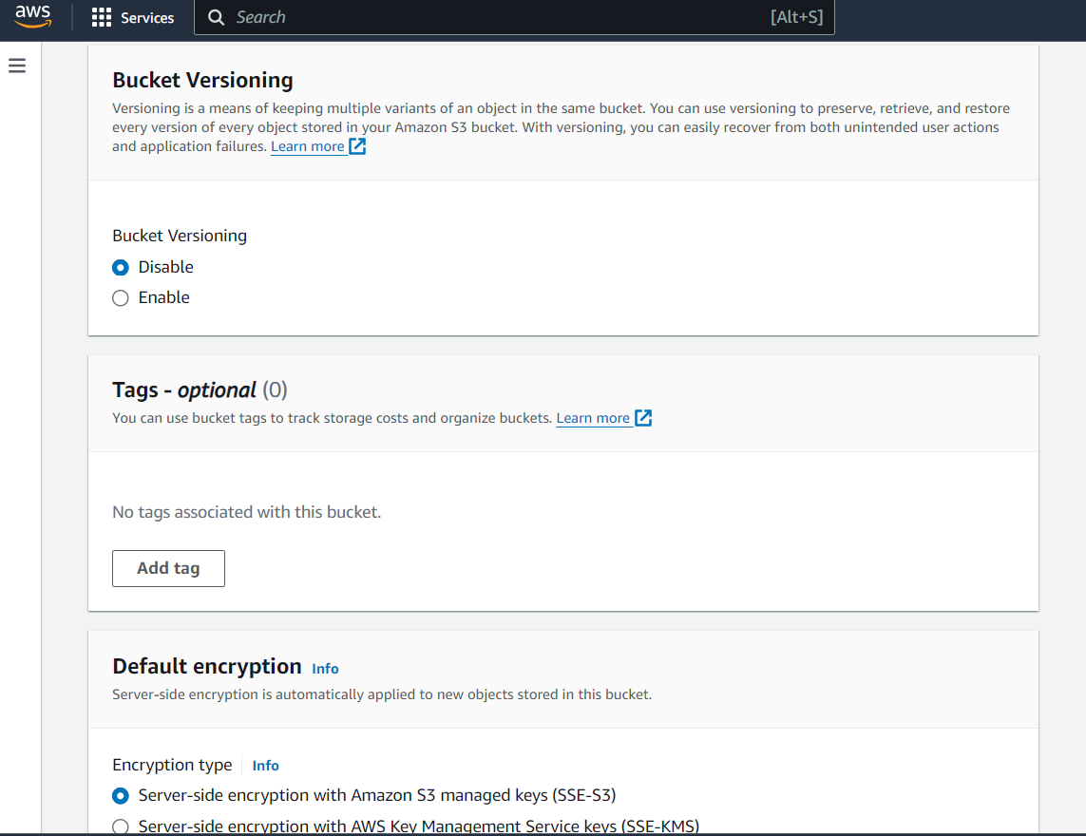

* **Tags**: Add metadata to your bucket, if required (useful for tracking resources).
* **Advanced settings** as needed (e.g., object lock, encryption).
* Click “Create bucket” at the bottom of the form.

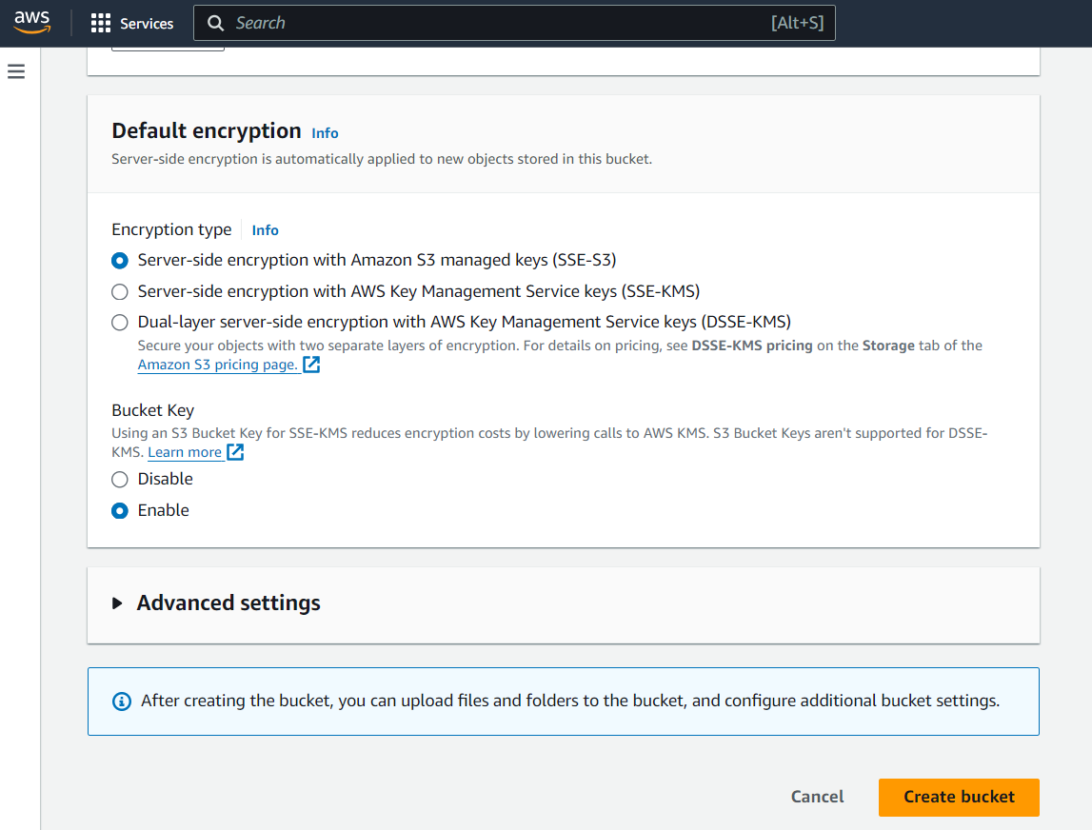

After creating successfully created bucket

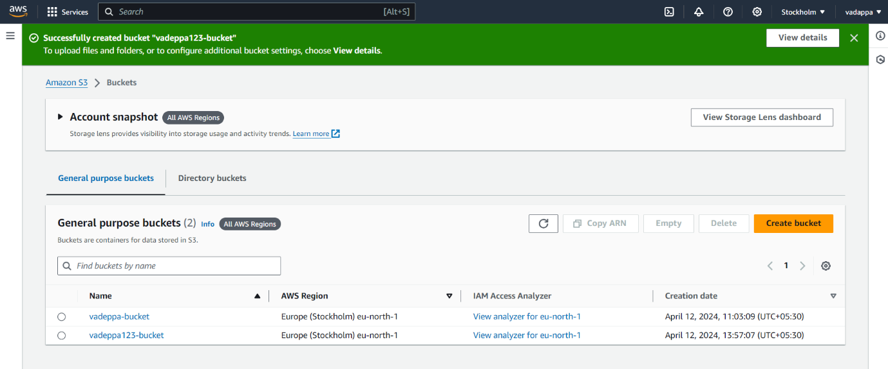

1. After your bucket is created, click on its name to open it.
2. Click the “Upload” button.

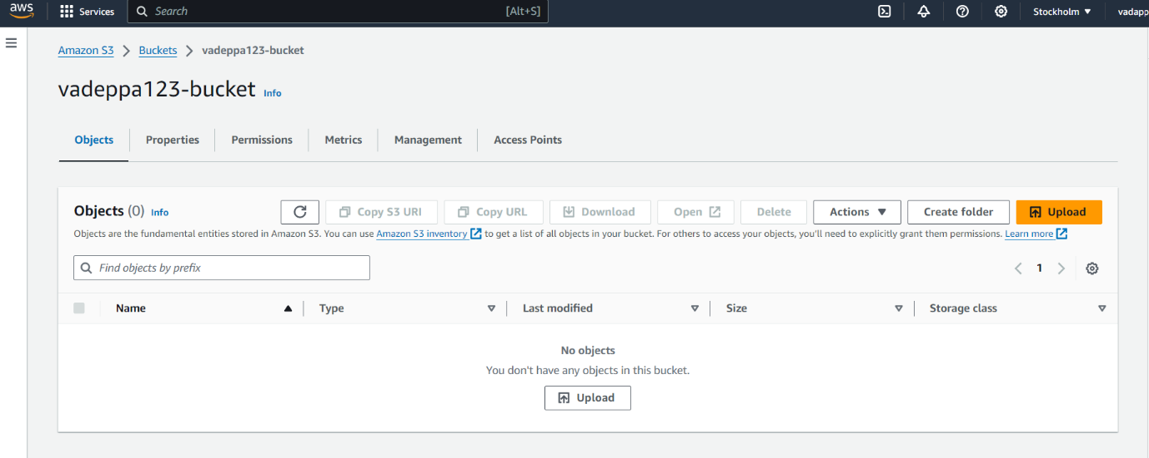

Click “Add files” or “Add folder” and select the file(s) or folder(s) from your computer that you want to upload.

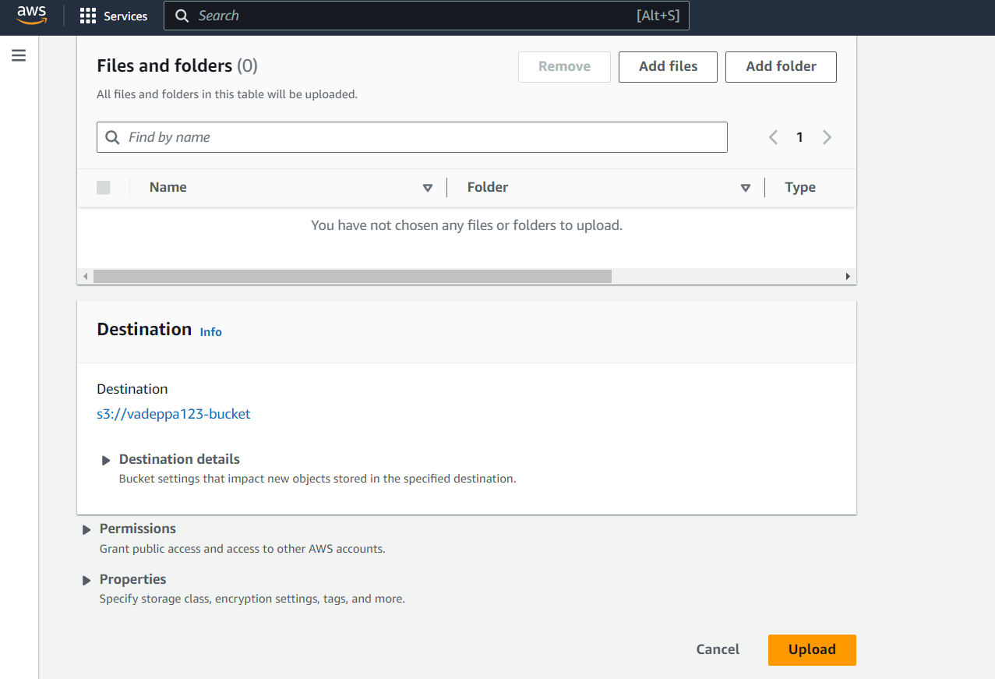

Now we can see uploaded successfully file

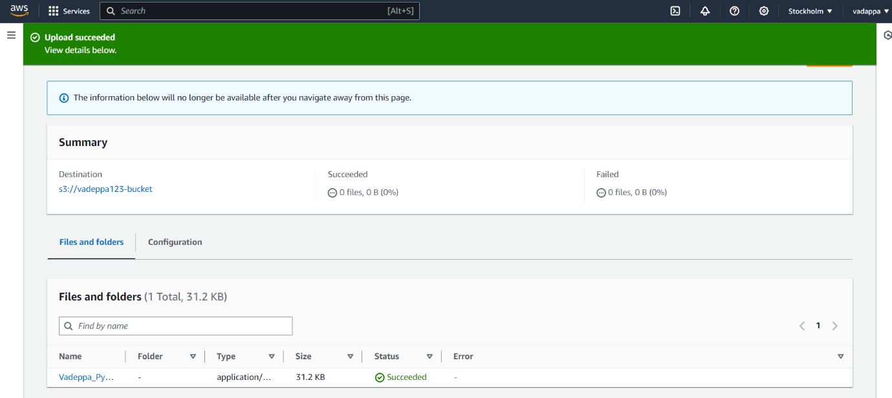

If you created the bucket for testing or no longer need it, remember to delete it to avoid ongoing charges.

1. Empty the bucket: Delete all objects in the bucket.
2. Delete the bucket: From the bucket list, select the bucket, and then click “Delete”.