1. Open your web browser and navigate to the AWS Management Console (<https://aws.amazon.com/console/>).
2. Log in with your AWS account credentials. If you don't have an account, you will need to create one.

Click on "EC2" under the "Compute" category, or type "EC2" in the search box and select it from the dropdown.

Page1

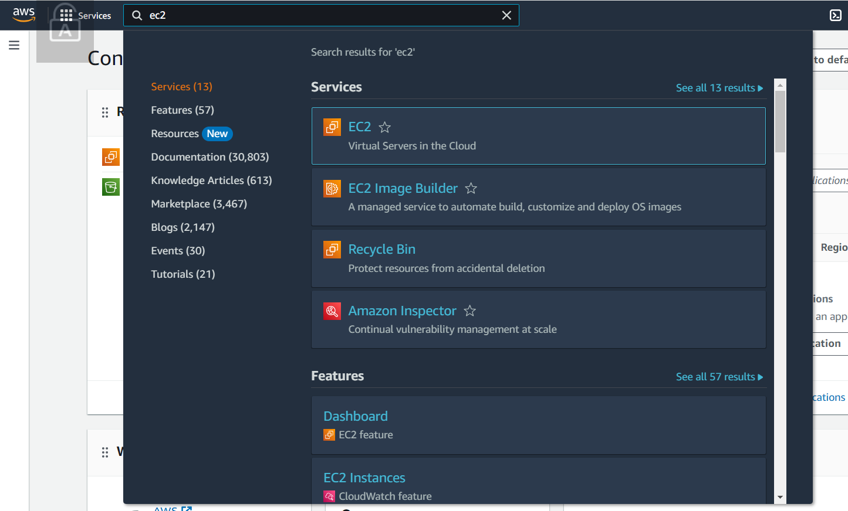

Page2

1. From the EC2 Dashboard, find the "Instances" section and click on "Instances" (or directly click the “Launch Instance” button if prompted).
2. Click the "Launch Instances" button to start the instance creation process.

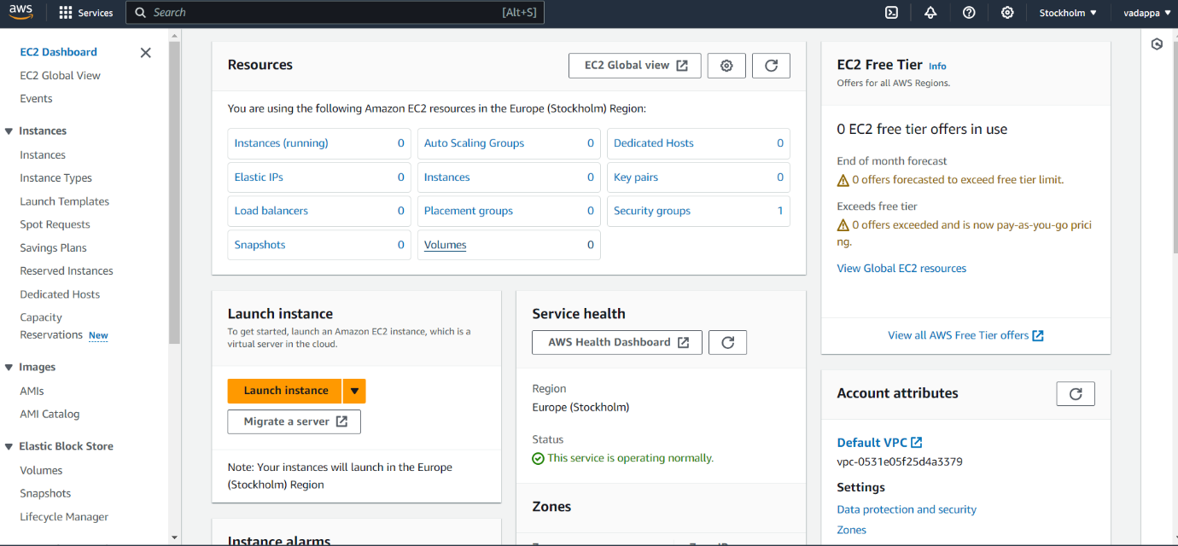

1. Page3You’ll be presented with a list of AMIs, which are pre-configured templates that include an operating system and other software configurations.

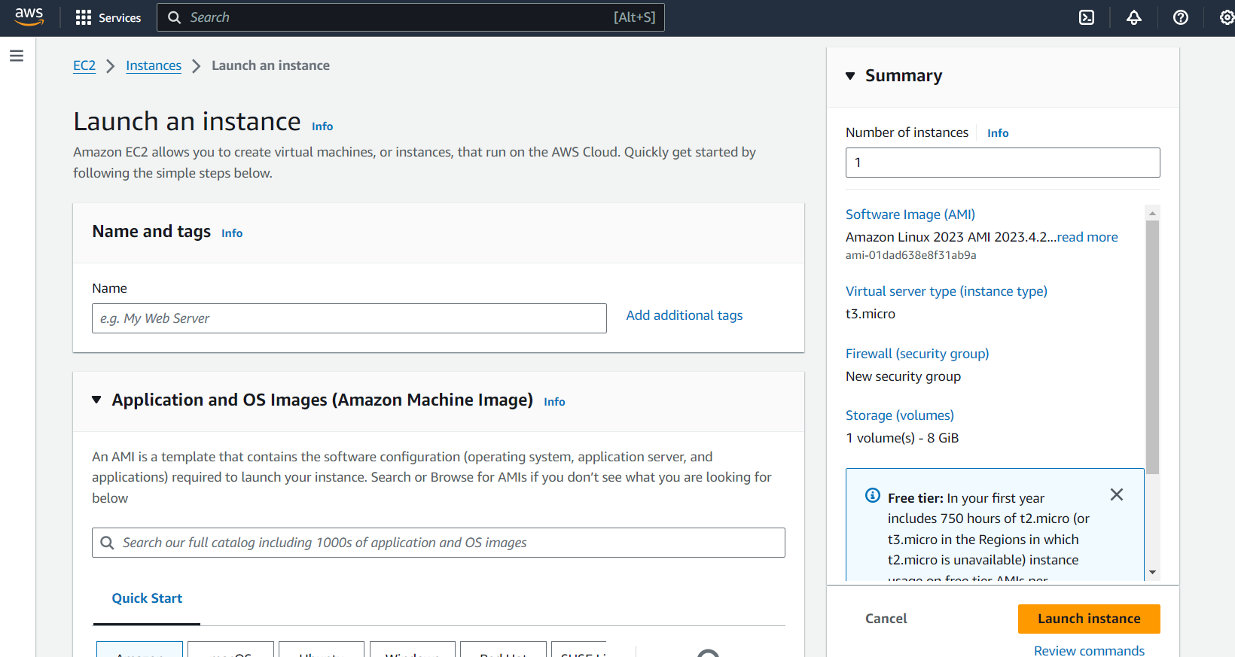

1. Select an AMI that fits your requirements. For example, choose an Amazon Linux AMI, Ubuntu Server, or Microsoft Windows AMI. There are free tier options available for new users. Choose ubuntu.

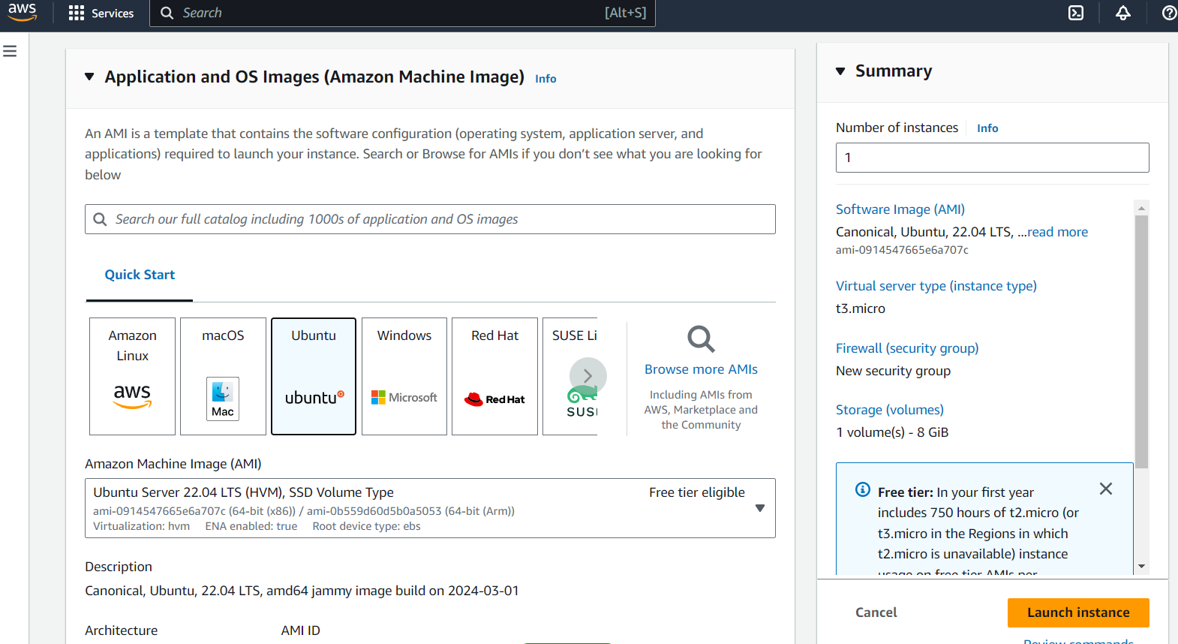

Tags are key-value pairs used for resource identification and management. For instance:

* Key: Name, Value: MyFirstInstance

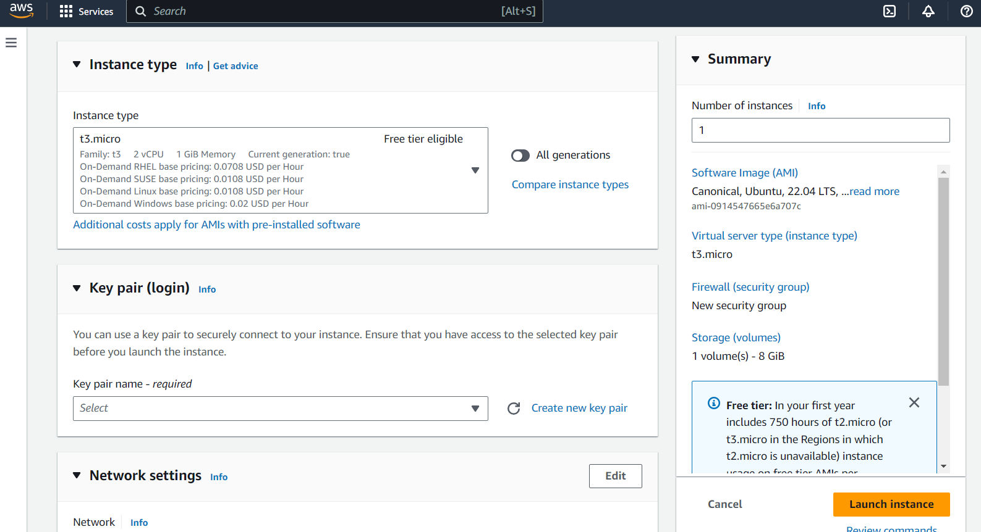

1. Create your key pair Name

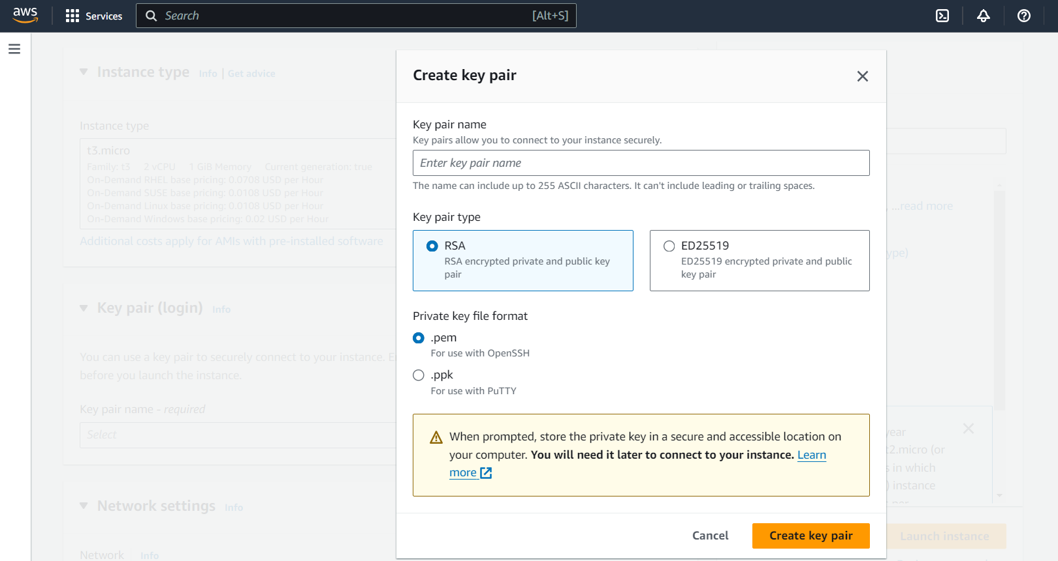

1. A security group acts as a virtual firewall that controls the traffic for one or more instances.
2. Create a new security group or select an existing one. Set rules to allow access:
   * For example, allow SSH (port 22) for Linux or RDP (port 3389) for Windows from your IP address.
3. Click "Review and Launch".

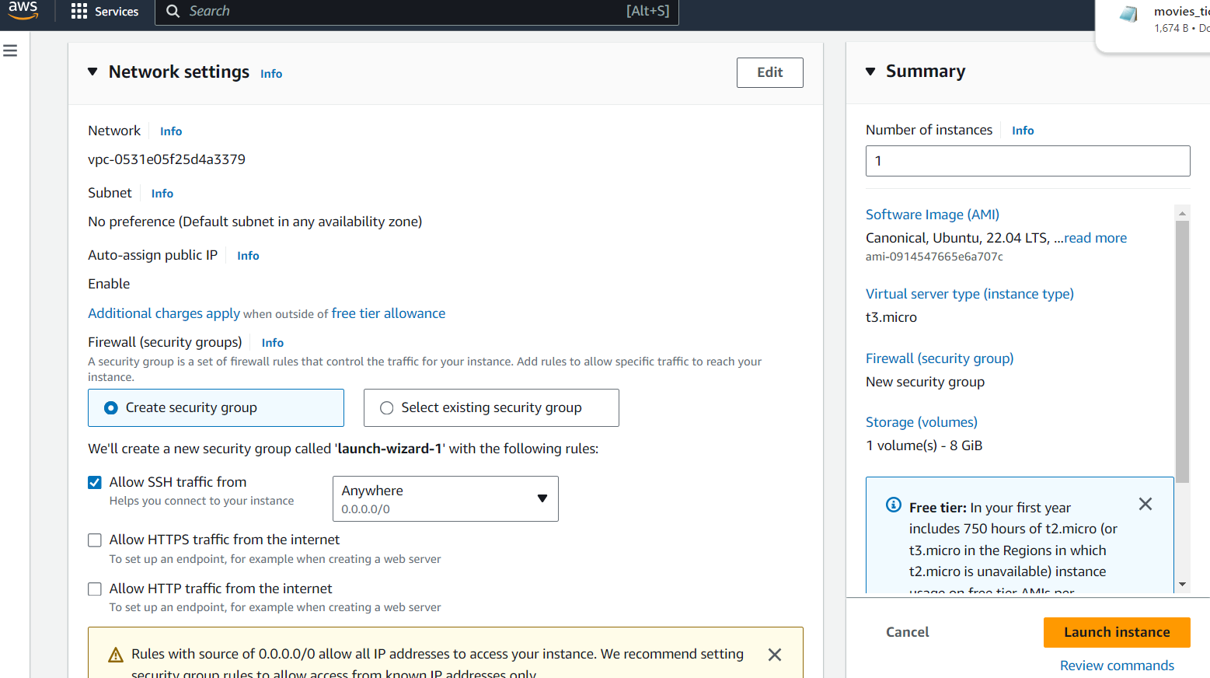

1. Configure You are storage

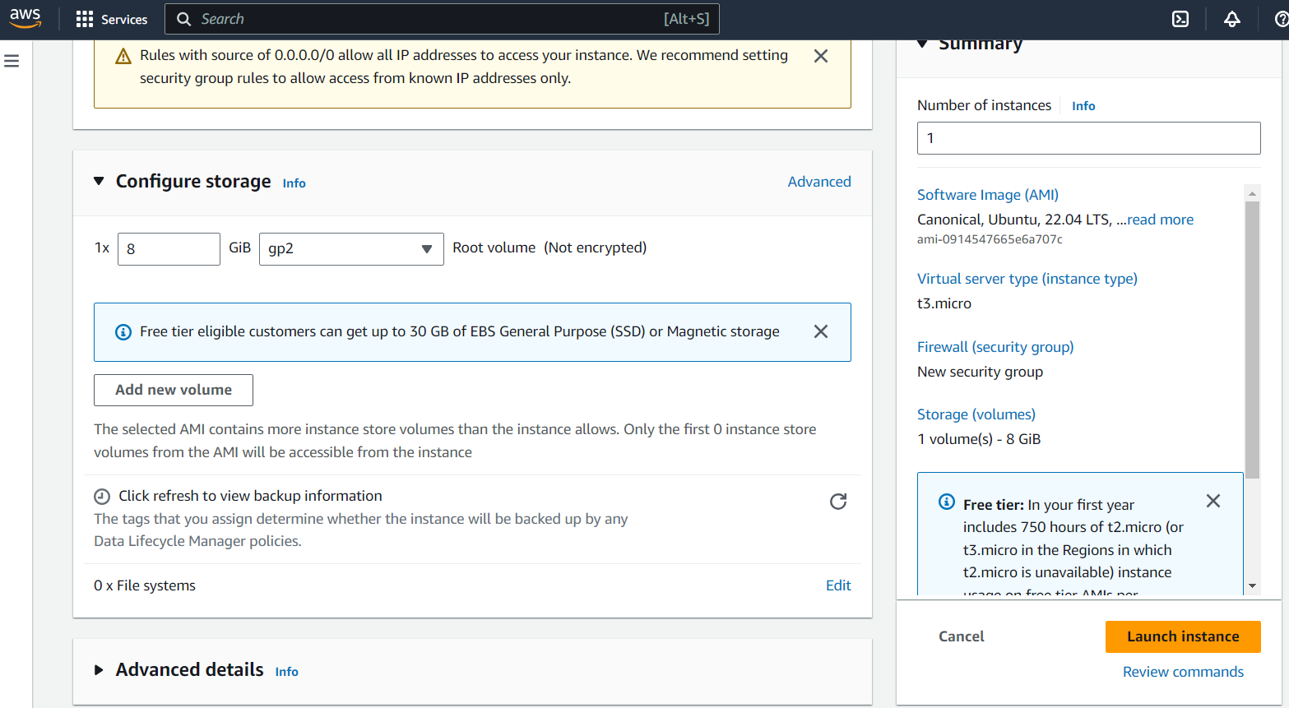

1. Click "Launch instance".

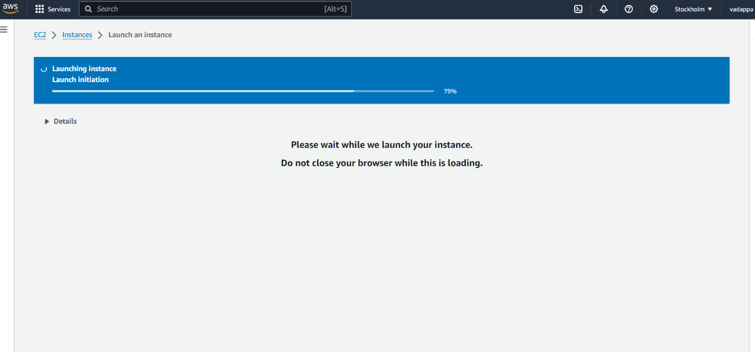

1. After launching, click "View Instances" to go to the instances screen.
2. You will see your new instance initializing. Once the status checks turn green, your instance is ready to use.

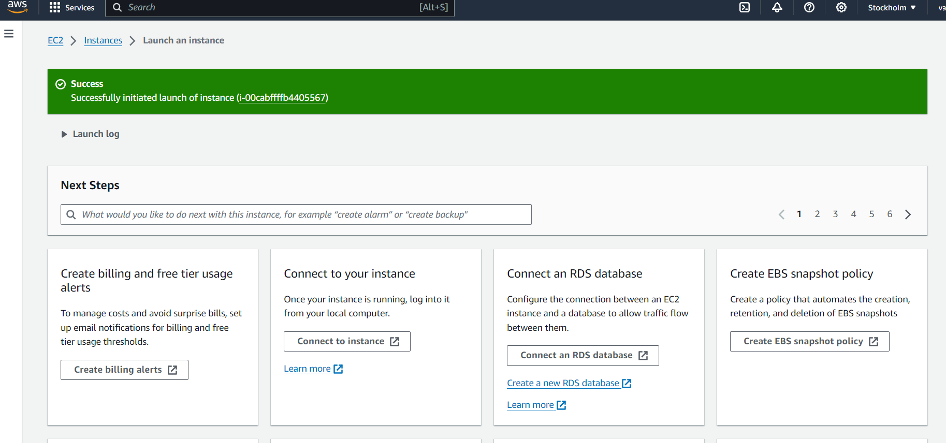

1. You are instance is running

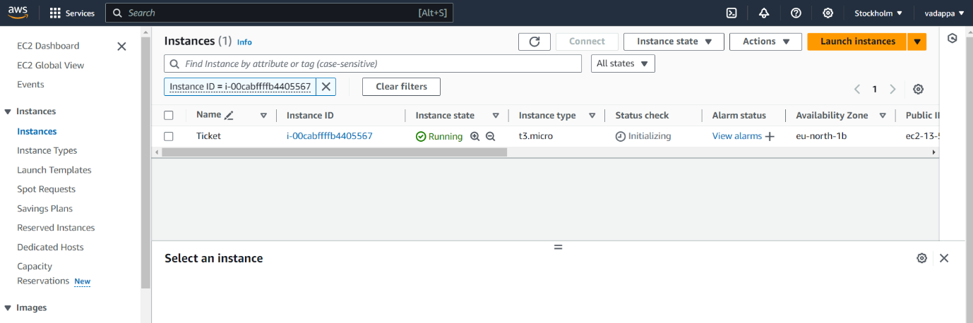

1. Stop You are instance

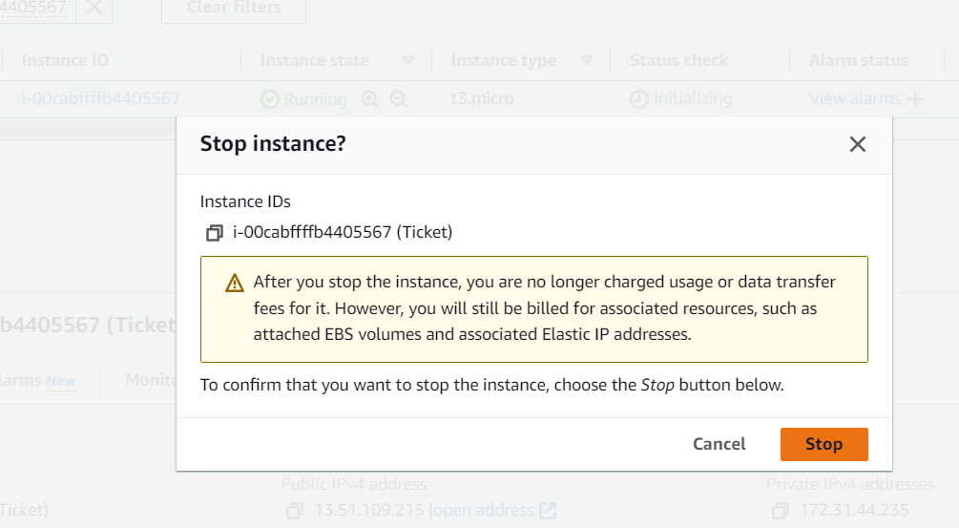

1. click stop button instance will stop

