File Structure:

The main folder contains the html files of every page, each html file has a corresponding folder that includes images, css files and javascript files sorted in folders.

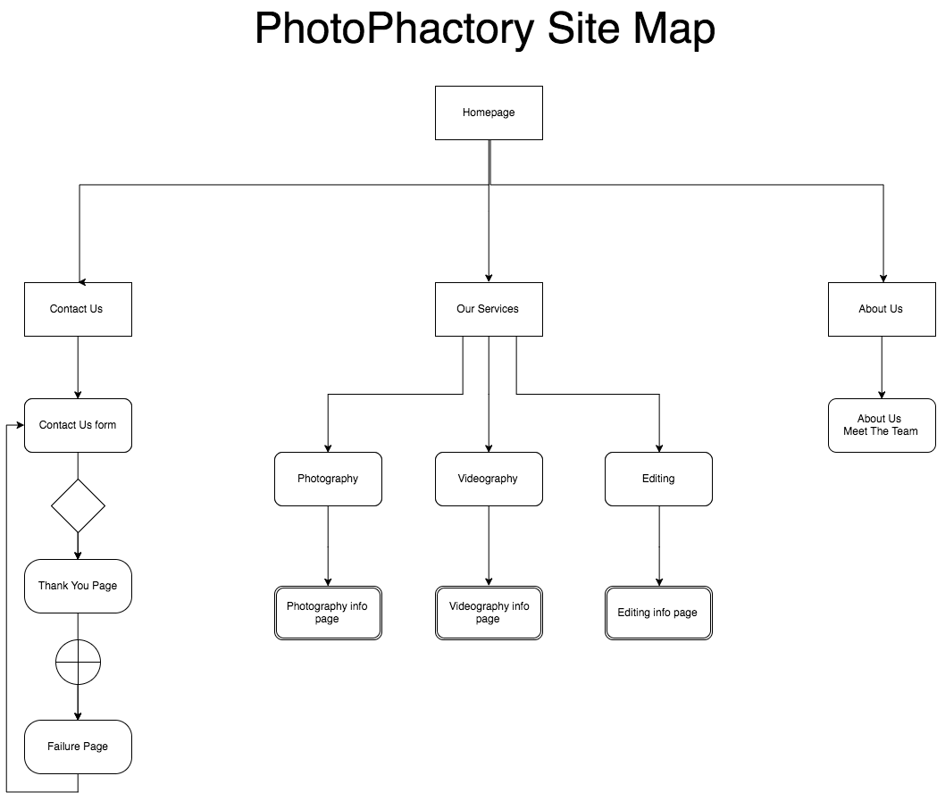

Essential Scripts:

The code uses HTML5, JavaScript and CSS3.

It also uses libraries (Bootstrap, jQuery).

Required image sizes:

Slider Photos: 3888 \* 2592 px.

Logo: 442.32 pt \* 134.88 pt

Icon: 134.88 pt \* 134.88 pt

Details of any unique or complex scripts:

The code uses a javascript set of libraries called Jquery.

It also uses Bootstrap.