BIRD SPECIES OBSERVATION ANALYSIS
Prepared by  Richard Joy Y  Data Analyst | Domain  Environmental Studies  Biodiversity & Ecology | Stack  Python · SQL Server  Streamlit · Plotly · Power BI

1. What This Project Is About

Every breeding season, trained observers walk through forests and grasslands across the Washington D.C. region and quietly count birds. They note the species, the time, the weather, how the bird was detected, and whether that species is considered at risk. It sounds straightforward, but the resulting dataset carries a lot of ecological meaning - and without proper analysis, most of those meaning stays buried in spreadsheets.

This project takes the 2018 NPS National Capital Region Bird Monitoring dataset and turns it into something usable. The raw data arrived as two multi- sheet Excel files - one for Forest surveys, one for Grassland - spanning 11 park units, 609 survey plots, and 17,077 individual observations collected between May and July 2018. The goal was to build a full analytical pipeline: clean the data, store it properly, explore it visually, and present the findings in an interactive dashboard.

The questions driving the analysis were practical ones:

- Which parks are the most biodiverse, and does habitat type explain the difference?
- When and where are birds most active during the breeding season?
- How do weather conditions affect what observers detect?
- Which parks carry the heaviest conservation burden, and which species need the most attention?

The answers to those questions have real implications - for how survey effort gets allocated, where conservation funding goes, which parks might support eco- tourism, and how NPS management justifies land use decisions.

2. The Dataset

The data comes from the NPS Inventory and Monitoring Programme. Field observers visited fixed survey plots and spent 10 minutes at each one, recording every bird they detected - by song, by call, or by sight. Each survey was divided into four 2.5- minute intervals, and observers noted whether a bird was detected in the first three minutes, which matters for detection probability calculations.

Each record has 29 original columns covering the bird species (common name, scientific name, AOU code, TSN), the survey context (park unit, plot, date, time, observer, visit number), the detection detail (method, distance band, flyover status, sex), and the environmental conditions at the time (temperature, humidity, sky condition, wind, disturbance level).

LOADED: ANTI — 333 rows
LOADED: CATO — 805 rows
LOADED: CHOH — 2202 rows
LOADED: GWMP — 386 rows
LOADED: HAFE — 422 rows
LOADED: MANA — 465 rows
LOADED: MONO — 370 rows
LOADED: NACE — 684 rows
LOADED: PRWI — 2463 rows
LOADED: ROCR — 289 rows
LOADED: WOTR — 127 rows

df_forest shape: (8546, 31)

Coverage across parks

Code | Park Name | Forest Records | Grassland Records
ANTI | Antietam National Battlefield | 333 | 3,588
CATO | Catoctin Mountain Park | 805 | 0
CHOH | C&O Canal National Historical Park | 2,202 | 0
GWMP | George Washington Memorial Parkway | 386 | 0
HAFE | Harpers Ferry National Historical Park | 422 | 117
MANA | Manassas National Battlefield Park | 465 | 1,811
MONO | Monocacy National Battlefield | 370 | 3,015
NACE | National Capital Parks- East | 684 | 0
PRWI | Prince William Forest Park | 2,463 | 0
ROCR | Rock Creek Park | 289 | 0
WOTR | Wolf Trap National Park | 127 | 0

A few things worth noting about the data quality before getting into the analysis. Sub_Unit_Code was missing for the majority of Forest records and was excluded entirely. The Sex field had roughly 60 to 70 percent nulls - birds in the field are difficult to sex by observation alone - so it was treated as an optional attribute. Seven of the Grassland sheets were empty because those parks simply had no grassland survey plots.
--- KEY METRICS ---
Total observations : 14,264
Unique species (common) : 126
Unique species (science) : 127
PIF watchlist species : 8
At-risk species : 25
Unique observers : 3
Unique plots : 609

3. How the Pipeline Works

The pipeline has five stages. Each one builds on the last, and together they take the project from raw Excel files to an interactive dashboard a non- technical stakeholder can use.

Phase 1 - Data Ingestion
The starting point was two Excel files. Each file had multiple sheets - one sheet per park unit - and the sheets were structured consistently enough to read programmatically. Using Python with pandas and openpyxl, each sheet was read into a DataFrame, tagged with its park code and habitat source (Forest or Grassland), and then all sheets across both files were stacked vertically into a single unified table.

This produced one DataFrame with 17,077 rows and 29 original columns. From that point forward, everything works with one clean input rather than jumping between separate files for Forest and Grassland data.
Phase 2 - Data Cleaning and Preprocessing
Raw survey data is never analysis- ready. This phase handled several categories of issues:
Missing values
The approach here was deliberate rather than fill- everything. Columns with structural missingness (Sub_Unit_Code missing for 16,355 of 17,077 rows) were dropped. Columns with high but acceptable missingness (Sex at 60- 70%) were retained but treated as optional in downstream analysis. Minor nulls in Distance and AcceptedTSN were handled with nullif logic in the SQL loading step.
Derived columns
Several new columns were computed during preprocessing to make analysis easier later. Start_Hour was extracted from Start_Time as an integer (0 to 23). Month_Name and Season were derived from the Date column - Season assigned as Spring for March to May, Summer for June to August, and so on. Distance_Clean standardised the raw distance band text into clean labels. Wind_Category bucketed the verbose wind descriptions into five levels from Calm to Strong. Sky_Clean normalised sky condition descriptions. At_Risk was created as a boolean flag combining PIF_Watchlist_Status and Regional_Stewardship_Status - any species flagged in either column was marked at risk.

Output
The cleaned file was exported as bird_observations_clean.csv with 43 columns - the 29 original plus 14 derived columns. This CSV is the input for all downstream steps.

Phase 3 - SQL Server Storage and Star Schema
Storing the data in SQL Server rather than keeping everything in pandas DataFrames was a deliberate architectural choice. It makes the data accessible to multiple tools simultaneously, enforces data types and referential integrity, and allows complex aggregations to run in the database engine rather than in Python. For a dataset this size it is not strictly necessary - but for any future multi- year version it will be essential.

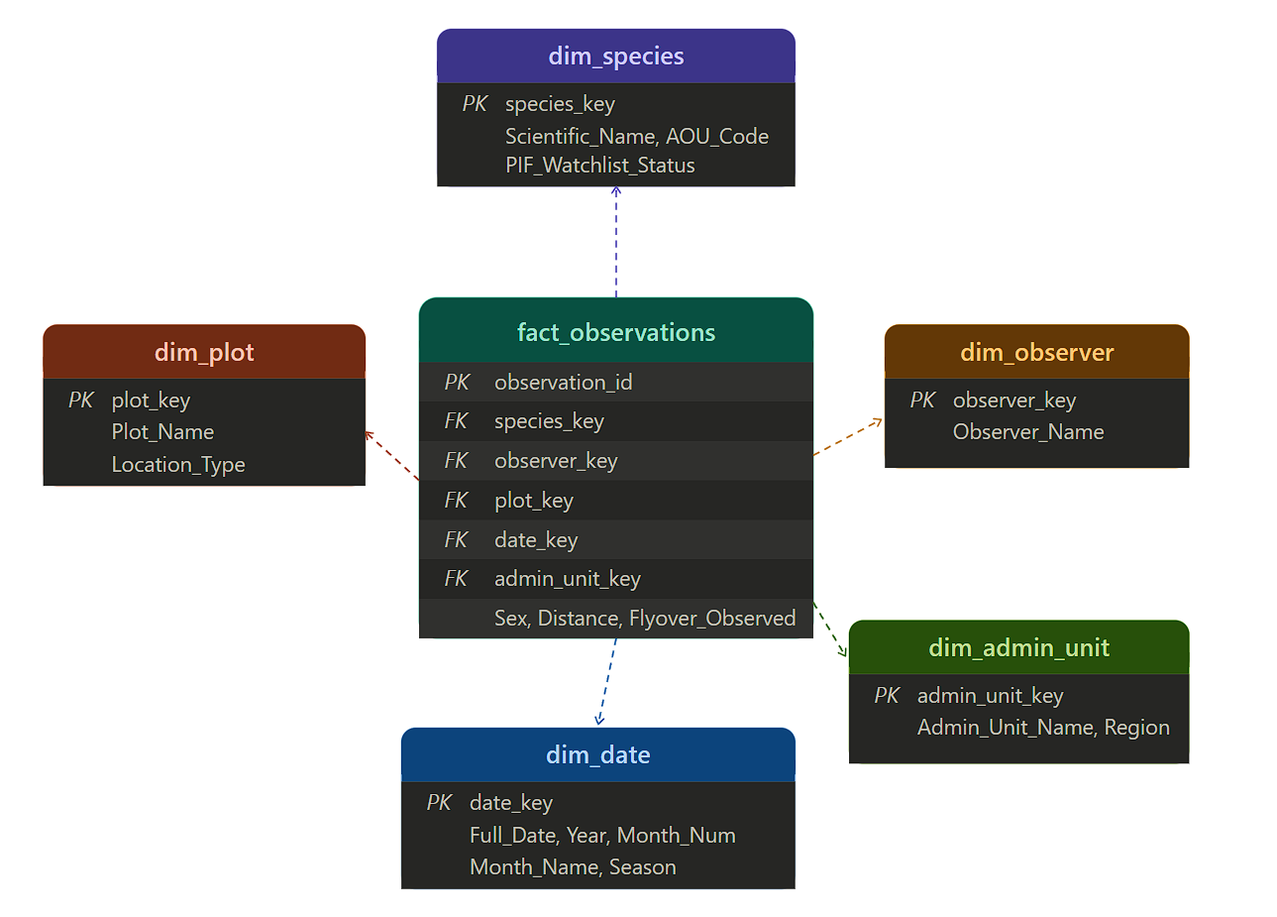

The staging table
The first SQL object is a staging table (stg_bird_raw) with all 43 columns stored as NVARCHAR(500). This is intentionally flexible - it accepts the raw CSV as- is, including the quirky cases like Wind values that contain embedded commas. A BULK INSERT step loads the CSV into staging with RFC 4180 CSV handling enabled, using UTF- 8 encoding and pandas- style LF line endings.

Dimension tables
Four-dimension tables sit around the central fact table. Each one holds a distinct category of descriptive data:

- dim_species - 127 rows, primary key is AOU_Code. Holds common name, scientific name, TSN, and both conservation flags.
- dim_plot - one row per unique survey plot. Holds the site name, admin unit code, and location type.
- dim_observer - 4 rows. Holds observer names. Small table but important for observer bias analysis.
- dim_date - seeded from 2015 to 2030. Holds year, month, quarter, season, and day of week. The generous date range means this schema can accept future seasons without any structural changes.

The fact table
fact_observations is the central table with one row per bird observation (17,077 rows). It holds foreign keys to all four dimension tables plus the full set of observation details: habitat source, interval, detection method, distance, flyover flag, sex, environmental readings, and the At_Risk flag. The Loaded_At column records when each row was inserted, which is useful for tracking incremental loads in future seasons.

Indexes
Five non- clustered indexes were created: on Admin_Unit_Code, on Date_Key, on AOU_Code, on a composite of Habitat + Year + Admin_Unit_Code (the most common multi- column filter combination), and on At_Risk + Admin_Unit_Code (for conservation- focused queries). Without these, queries on a growing dataset would do full table scans.

Analytical views
Four views pre- aggregate common query patterns so the dashboard does not have to repeat the same GROUP BY logic everywhere. vw_diversity_by_unit aggregates unique species count and at- risk counts per park and habitat. vw_temporal_heatmap rolls observations up by month and season. vw_top_species joins the fact and species dimensions and counts observations per species per park. vw_environmental_impact groups observation counts by sky condition, wind category, temperature bucket, and disturbance level.

Phase 4 - Exploratory Data Analysis
The EDA notebook (02_eda.ipynb) is structured into six analytical sections, each answering a different aspect of the core questions.

Section A - Dataset Overview
A quick sanity check confirming shape (17,077 rows, 43 columns), date range (7 May to 19 July 2018), habitat split (8,546 Forest vs 8,531 Grassland - nearly equal), and a null audit showing which columns still carry missing data and how much.

Section B - Temporal Analysis
Monthly bar chart showing June as the peak month (6,596 observations), followed by May (5,596) and July (4,885). A seasonal heatmap confirms the data spans only Spring and Summer since the survey window is May to July. An hourly distribution chart shows the 7:00 AM hour producing the single highest observation count - the dawn chorus effect. Activity drops sharply after 9:00 AM.
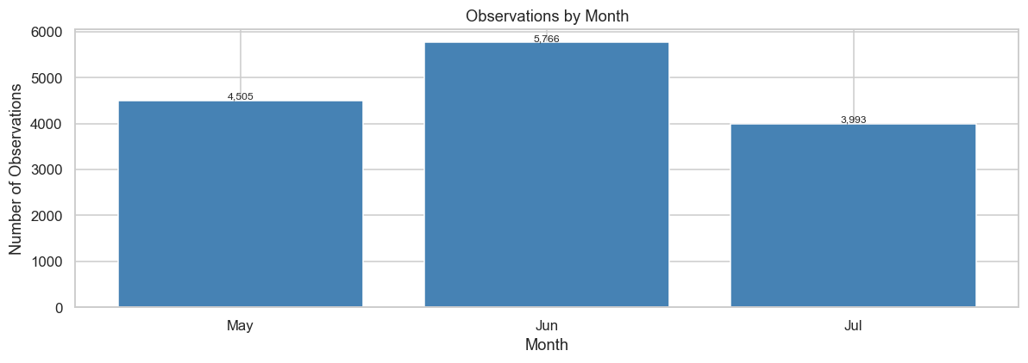
Section C - Spatial Analysis
Species richness per park unit broken down by habitat. MONO Grassland leads with 93 unique species. CHOH Forest is second at 80. A top- 15 plots chart shows MONO- 0057 and MANA- 0047 as the two richest individual survey plots in the entire dataset.
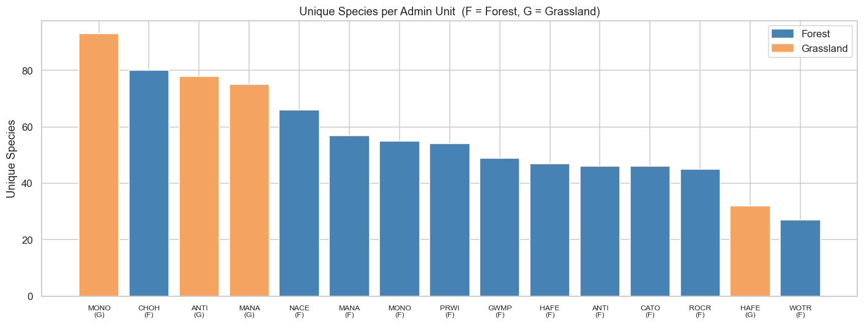
Section D - Species Analysis
A top- 20 most- observed species bar chart with Northern Cardinal well ahead of the field. A habitat preference chart for the top 12 species showing which ones are Forest specialists (Acadian Flycatcher, Red- eyed Vireo), which are Grassland specialists (Field Sparrow, Grasshopper Sparrow), and which appear broadly in both. A stacked sex distribution chart - most observations are logged as Undetermined, which is typical for field point- count surveys. A detection method breakdown showing 57.8% Singing, 23.8% Calling, 18.5% Visualization.
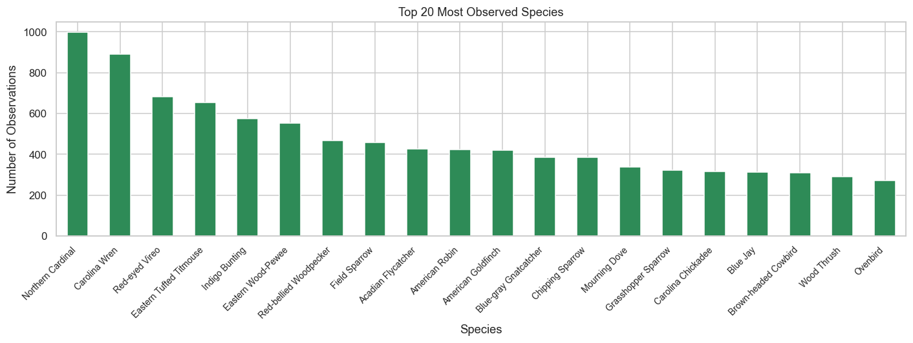
Section E - Environmental Analysis
Temperature histograms by habitat show Forest averaging 21.9 C and Grassland averaging 23.2 C. A hexbin scatter of Temperature vs Humidity confirms a statistically significant inverse relationship (Pearson r = - 0.349, p < 0.0001). Species richness by sky condition shows Partly Cloudy and Clear conditions producing the broadest species variety. A wind category chart shows the sharpest observation drop- off at Gentle Breeze and above - consistent with the idea that wind makes audio- based detection harder. A disturbance level chart shows Slight disturbance environments hosting more species than Moderate or High disturbance sites.
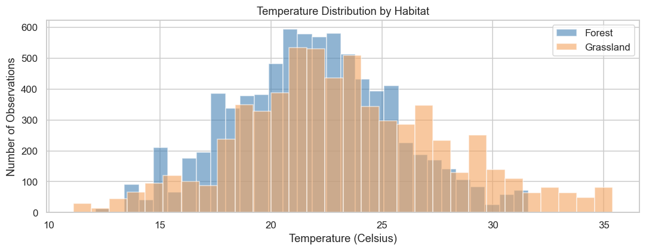

Section F - Conservation Analysis
A PIF Watchlist pie chart showing 2.2% of observations involve watchlisted species. An at- risk species count by park showing CHOH leading with 20 at- risk species. A stacked bar showing at- risk vs safe observations per park to give context for the relative conservation burden. A Shannon Diversity Index chart ranking all park- habitat combinations - ANTI Grassland tops at H = 3.57, WOTR Forest is lowest at H = 2.93.

Phase 5 - Visualization (Streamlit Dashboard)

The Streamlit dashboard (app.py) is the interactive layer. It loads the cleaned CSV at startup (with a fallback to the raw Excel files if the CSV is not present) and presents five tabs:

- Overview - six KPI cards showing total observations, unique species, at- risk species, PIF watchlist count, unique plots, and unique observers.
- Temporal - monthly trends, hourly activity charts, and a season- by- habitat grouped bar chart.
- Spatial - species richness per park, top plots by richness, and observer activity breakdown.
- Species - top species rankings, habitat preference charts, detection method breakdown, and distance distribution.
- Conservation - at- risk species by park, PIF watchlist pie, Shannon Diversity Index ranking, and stacked at- risk vs safe bars.
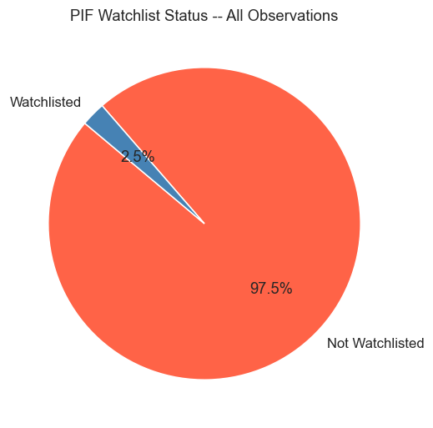
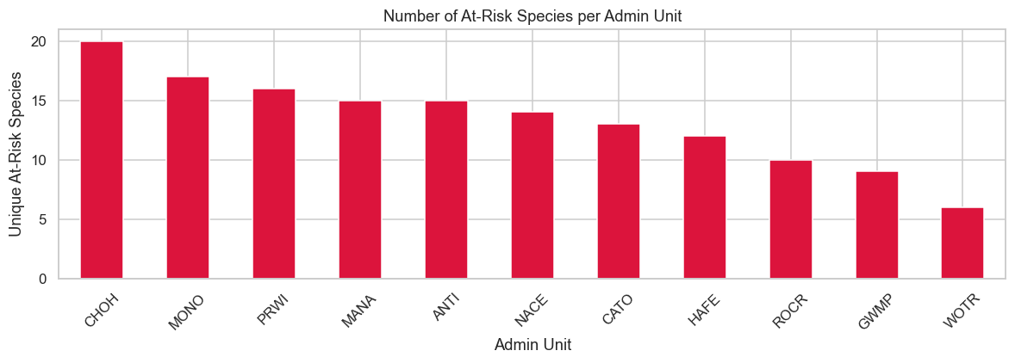
The sidebar carries habitat and park unit multi- select filters that cascade across all charts. The app uses a custom dark theme with CSS injected via st.markdown, and all charts are built in Plotly for hover interactivity and zoom.

A separate Power BI file provides a fixed- layout executive summary for stakeholders who prefer a structured report over an exploratory tool. It uses DAX measures for consistent KPI definitions and a custom theme matching the Streamlit colour scheme.

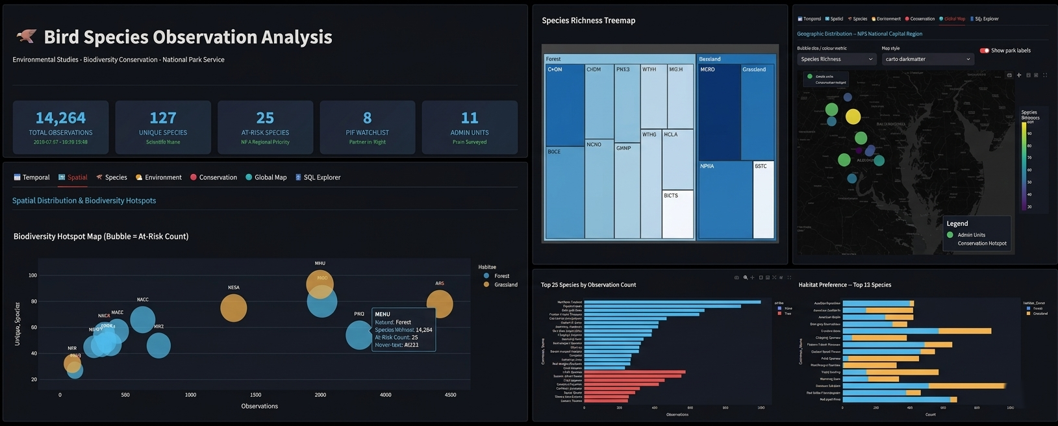

Phase 6 - SQL Explorer - Advanced Analytical Workspace (Streamlit Dashboard)
The SQL Explorer module is a key enhancement within the Bird Species Observation Analysis Dashboard, designed to empower users with flexible, query-driven data exploration capabilities. While the primary dashboard provides curated visual insights across temporal, spatial, environmental, and conservation dimensions, this workspace enables deeper, custom analysis using SQL.
The primary objective of the SQL Explorer is to bridge the gap between predefined analytics and ad-hoc data investigation, allowing analysts, researchers, and decision-makers to:
- Perform custom queries on the underlying bird observation dataset
- Validate insights derived from dashboard visualizations
- Conduct exploratory data analysis (EDA) without leaving the application
- Generate on-demand aggregations and filters for research and reporting
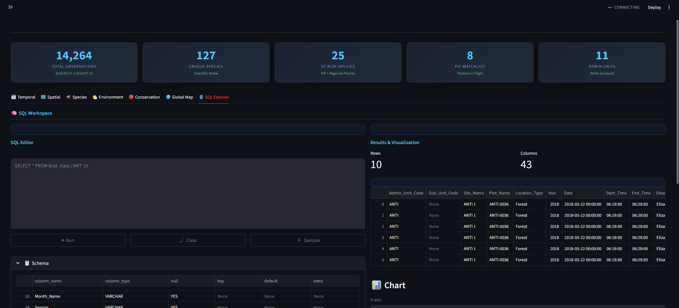
Core Features:
- Interactive SQL Editor
- Schema Visibility & Data Understanding
- Real-Time Query Results
- Integrated Visualization Engine
- Business Value & Use Cases
The SQL Explorer transforms the dashboard from a static reporting tool into a dynamic analytical platform. By combining structured querying with real-time visualization, it empowers users to move beyond predefined insights and unlock the full potential of the bird observation dataset.

4. Key Findings

These are the most meaningful results from the analysis - the things that actually change how you would make decisions about these parks.
Finding 1 - Grassland habitats are producing more species diversity than their size suggests
MONO Grassland recorded 93 unique species - the highest of any park- habitat combination in the dataset. ANTI Grassland (78 species) and MANA Grassland (75 species) also rank in the top four overall. Grassland habitats are represented in only four of the eleven park units, yet they account for three of the top four spots in species richness. This challenges the default assumption that larger forested parks are automatically the biodiversity priority.

The Shannon Diversity Index reinforces this: ANTI Grassland has the highest H value (3.57), meaning its species community is both large and evenly distributed - not dominated by a handful of common birds. WOTR Forest, by contrast, scores the lowest (2.93), suggesting its community is less varied at the species level.
Finding 2 - June mornings between 6 and 8 AM are when surveys are most productive
June produced 38.6% of all observations in the dataset (6,596 out of 17,077). The 7:00 AM hour was the single most productive time slot. This is not surprising ecologically - breeding- season dawn chorus peaks in late spring and early summer - but it has direct operational implications. Survey effort allocated outside of early- morning June windows is likely capturing a less representative slice of the bird community.

Finding 3 - Over half of all identifications are made by sound alone
57.8% of observations were made by singing, 23.8% by calling, and only 18.5% by direct visual confirmation. Together, audio- based methods account for more than four out of five identifications. This means that anything affecting sound transmission - strong wind, human noise, disturbance - directly degrades the quality of the survey data. The wind analysis confirms this: observation counts drop noticeably at Gentle Breeze (about 8 to 12 mph) and the drop becomes sharp at stronger wind categories.
Finding 4 - Temperature and humidity are meaningfully correlated
The Pearson correlation between Temperature and Humidity across the full dataset is r = - 0.349 with a p- value near zero. Hotter conditions come with lower relative humidity. Forest sites average 21.9 C while Grassland sites average 23.2 C - a 1.3 degree difference that partially explains why the two habitats host different species assemblages. As average temperatures in this region increase over time, we can reasonably expect some of those habitat- specific species communities to shift.

Finding 5 - CHOH carries the heaviest at- risk species burden, but the risk is concentrated
CHOH (Chesapeake and Ohio Canal) has the most at- risk species (20 unique at- risk species), followed by MONO and PRWI. However, at- risk observations account for only 2.2% of all records in the dataset. These species are genuinely rare - they are not just underreported. That rarity makes the parks that host them disproportionately important. Losing a habitat patch in CHOH is not comparable to losing the same area in a park where no watchlisted species have been detected.

Eight species appear on the Partners in Flight Watchlist, and 25 total species are flagged as at- risk. A targeted monitoring programme covering just CHOH, MONO, and PRWI would capture the majority of conservation- critical observations in the region.
Finding 6 - Northern Cardinal is a useful baseline species for trend monitoring
Northern Cardinal was the most observed species across both habitats with over 1,100 observations. Its consistent presence across nearly all park units and both habitat types makes it a useful control species for long- term trend analysis. If future breeding seasons show Cardinal counts declining in specific parks, that is a signal worth investigating - it would suggest broader habitat degradation rather than a species- specific issue.

=======================================================
KEY FINDINGS
=======================================================
Total observations : 14,264
Total unique species : 126

Most diverse unit : MONO (Grassland) -- 93 species
Peak survey month : Jun
Peak activity hour : 7:00
Most observed species : Northern Cardinal

At-risk species total : 25
Most at-risk unit : CHOH
PIF watchlist species : 8

Best sky for obs : Partly Cloudy
Most common wind : Light Air
Pearson r (Temp/Hum) : -0.337
5. Recommendations

Based on the findings above, here are the most practical next steps for NPS land managers, conservation planners, and survey coordinators.
Prioritise grassland habitat maintenance in ANTI and MANA
Both parks rank in the top four for species richness, and ANTI Grassland leads on Shannon diversity. Keeping these grasslands ecologically healthy - reducing invasive plant coverage, minimising mowing between May and July, managing edge habitats - will protect the conditions that produce this diversity. These parks punch well above their weight for biodiversity value.

Focus at- risk species monitoring on CHOH, MONO, and PRWI
These three parks account for the majority of at- risk species detections in the region. A dedicated monitoring protocol for each - including increased visit frequency, specialist surveys targeting watchlisted species specifically, and coordination with adjacent state wildlife agencies - would give NPS the data quality needed to make defensible conservation investment decisions.
Standardise survey start times to the 6:30 to 8:30 AM window in May and June
Peak detection occurs at 7:00 AM in June. Setting a regional standard for survey start times would reduce observer- dependent variation, increase detection consistency across parks, and ensure the most species- rich time window is captured uniformly. Current data suggests observation counts drop sharply after 9:00 AM.
Add a weather data feed to future seasons
Environmental conditions in the current dataset were recorded by field observers - which introduces measurement inconsistency. Connecting future seasons to a standardised weather data source (NOAA Climate Data Online or similar) would give cleaner environmental data and make the temperature- humidity correlation analysis more statistically rigorous. It would also enable proper multi- year climate comparison.
Use the existing SQL schema as the foundation for a multi- year monitoring system
The dim_date table is seeded to 2030. The star schema is designed so that adding a new breeding season means loading one CSV into the staging table and running the existing ETL queries - no structural changes needed. With two or three years of data, it becomes possible to calculate year- over- year species trend lines by park, detect early warning signals for population decline, and build a simple classification model for at- risk species encounters.
Build annual biodiversity scorecards for NPS reporting

The Power BI dashboard and SQL views already produce the metrics needed for annual scorecards. Formalising a one- page scorecard per park unit - total species count, Shannon H index, at- risk species count, year- over- year trend direction, and a RAG status relative to regional benchmarks - would give NPS management a structured reporting artefact for budget submissions and policy documentation.

6. Project Structure

Below is the folder layout for the full project. Every file is documented and follows the same naming convention.

File / Folder | What it contains
notebooks/01_preprocessing.ipynb | Data ingestion from raw Excel files, cleaning, derived column creation, CSV export
notebooks/02_eda.ipynb | Full visual EDA across six analytical sections - temporal, spatial, species, environmental, conservation
sql/schema.sql | Complete DDL - staging table, four dimension tables, fact table, five indexes, four analytical views, BULK INSERT script, referential integrity checks
dashboard/app.py | Streamlit application with dark theme, five tabs, sidebar filters, Plotly charts
data/Bird_Monitoring_Data_FOREST.XLSX | Raw source data - Forest surveys, one sheet per park unit
data/Bird_Monitoring_Data_GRASSLAND.XLSX | Raw source data - Grassland surveys, one sheet per park unit
bird_observations_clean.csv | Output of preprocessing notebook - 17,077 rows, 43 columns, used by all downstream steps

7. Future Work

The project is designed to be extended. A few directions that would add the most value:

- Incorporate 2019 and 2020 survey data. The schema handles it without changes. Two additional seasons would be enough to calculate meaningful population trend lines for the most- observed species.
- Build a predictive model for at- risk species encounters. With the current feature set (temperature, humidity, sky, wind, hour, month, park unit, habitat), a Random Forest classifier would be a reasonable starting point. The goal is to identify survey conditions that are especially likely to produce at- risk detections, so field teams can target those windows proactively.
- Integrate an automated weather data feed. Replace observer- recorded weather conditions with standardised NOAA station data for cleaner environmental analysis.
- Develop park- level biodiversity scorecards. Build a Power BI report page template that auto- generates a one- page summary per park, suitable for direct submission to NPS regional leadership.

Full source code is available at github.com/vaderrex. For questions about the methodology or to discuss the project further, reach out at richardjoy9946@gmail.com.

