Wire definition language
Wire is a network protocol definition language derived from Interface Definition Language (IDL). It is used to represent an on the wire representation of a certain network protocol in an intuitive and highly abstract manner. The Wire compiler is designed to address the automatic generation of code that handles all of the defined protocol's communications, parsing and construction of packets.
Coding handlers for network protocols is time consuming and highly error prone. One must deal with sanity checks upon packet parsing/construction, integer byte ordering and sizes, various charset encodings, data alignment and padding, error reporting and debugging. Furthermore when considering protocol operations, programmers must take into account memory allocation and buffering, timing, various types of operations such as blocking/nonblocking (synchronous/asynchronous) operations.
Programmers take various approaches for tackling coding of network protocol handlers and thus code reusability is low, modularity is weak and uniformity is non-existent (in most cases). Wire is intended to provide an intuitive way of defining a protocol that can be situated in OSI Layers 2-7. Furthermore the code generated by the compiler fits nicely with the network protocol theory and as such is easy readable. The API provided by the generated code library tends to be simple and easy to use, but of course that depends on the protocol definition. To that point Wire strives to provide an abstraction to its users from underlying networking technologies (Berkley sockets, WinSock, TLI) and host configurations (byte/bit ordering, register sizes, floating point representations).
The initial idea for Wire was to create a definition language in which one would define a protocol, run it trough a compiler and get a program library that would handle that particular network protocol. The protocol at hand is already suppose to have a specification such as Internet protocol or even HTTP. Thus with a single Wire definition a compiler could generate handlers in multiple languages and/or for various systems and frameworks. For example code generation could be extended to generate Lua libraries or more specifically NMAP NSE libraries which are written in Lua but exist in a more specialized framework. Also one could generate dissection methods for Wireshark or even use ti to make fuzzers to test some network implementation.
The extension to the initial idea is to define your own network protocol for whatever purposes. This makes Wire a definition language and the underlying encoding algorithms a serialization protocol. Similar technologies include ASN.1, JSON, XDR.
Wire conceptually differs from mentioned projects in the fact that these projects weren't designed to provide means to define an already existing protocol. The serialization protocol involved in encoding defined data types in definition language at hand is of no interest to a common user. For example a user defines an integer type to be transmitted over the communication line, all he wants is to send a number and receive that same number on the other endpoint. The format used to transfer that integer is of no interest to him. This concept is utilized in every of mentioned technologies but Wire. Wire is intended to describe the actual representation of data on the wire so the Wire definition language and the underlying serialization protocol a closely related. To elaborate this a bit further let's introduce some formalism.

Network protocol
What is a protocol? A computer protocol can be defined as a well-defined set of messages (bit patterns or, increasingly today, octet strings) each of which carries a defined meaning (semantics), together with the rules governing when a particular message can be sent. However, a protocol rarely stands alone. Rather, it is commonly part of a “protocol stack”, in which several separate specifications work together to determine the complete message emitted by a sender, with some parts of that message destined for action by intermediate (switching) nodes, and some parts intended for the remote end system.
In this “layered” protocol model:
- One specification determines the form and meaning of the outer part of the message, with a “hole” in the middle. It provides a “carrier service” (or just “service”) to convey any material that is placed in this “hole” .
- A second specification defines the contents of the “hole”, perhaps leaving a further hole for another layer of specification, and so on.

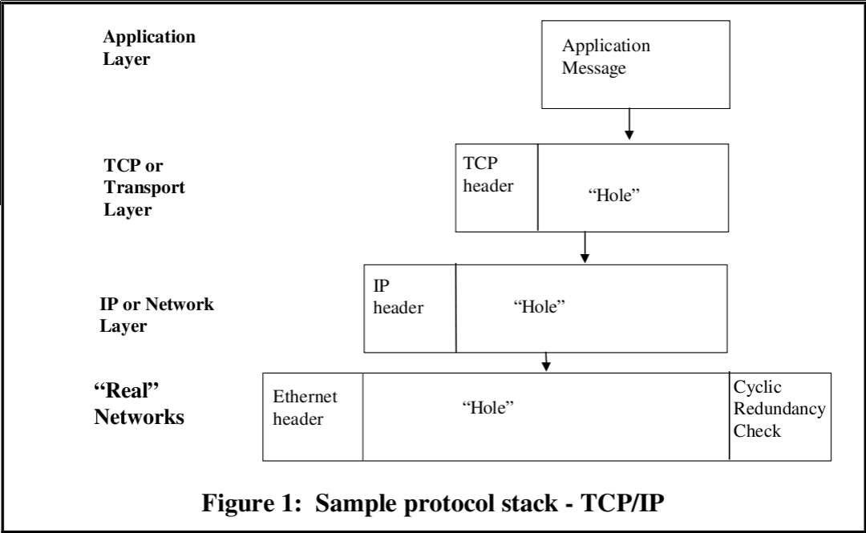
@SLIKA TCP/IP model illustrates a TCP/IP stack, where real networks provide the basic carrier mechanism, with the IP protocol carried in the “hole” they provide, and with IP acting as a carrier for TCP (or the the less well-known User Datagram Protocol - UDP), forming another protocol layer, and with a (typically for TCP/IP) monolithic application layer - a single specification completing the final “hole” . The precise nature of the “service” provided by a lower layer (lossy, secure, reliable), and of any parameters controlling that service, needs to be known before the next layer up can make appropriate use of that service. We usually refer to each of these individual specification layers as “a protocol”.
Note that in @SLIKA TCP/IP model, the “hole” provided by the IP carrier can contain either a TCP message or a UDP message - two very different protocols with different properties (and themselves providing a further carrier service). Thus one of the advantages of “layering” is in reusability of the carrier service to support a wide range of higher level protocols, many perhaps that were never thought of when the lower layer protocols were developed.
When multiple different protocols can occupy a hole in the layer below (or provide carrier services for the layer above), this is frequently illustrated by the layering diagram shown in @SLIKA LAYERING.

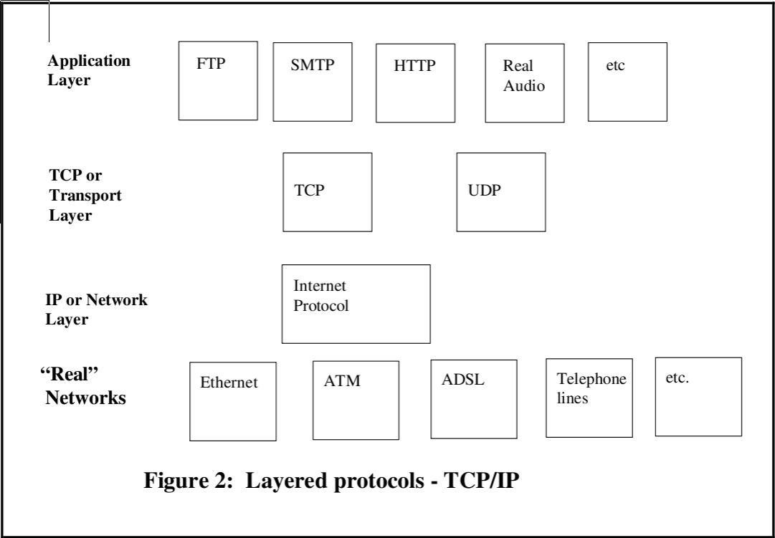

Protocol operations
Considering the layered model, lower layer network protocol provides services to a higher layer protocol. This services are exposed trough protocols interface. A protocol then performs certain operations to the point of servicing a higher layer protocol which requested a service. For example TCP provides connection-oriented, ordered and reliable transfer of data from one TCP endpoint to another, for higher level protocol such as SMTP or FTP. This is achieved using operations such as handshaking, acknowledging and signaling.
A simple protocol operation would be to start the operation and then wait for it to complete. But such an approach (called synchronous or blocking operation) would block the progress of a program while the communication is in progress, leaving system resources idle. The thread of control is blocked within the function performing the protocol operation, and it can use the result immediately after the function returns. This means that the processor can spend almost all of its time idle waiting for a certain protocol operation to complete.
Alternatively, it is possible, to start the operation and then perform processing that does not require that the operation has completed. This type of operation is called asynchronous or non-blocking operation. Any task that actually depends on the operation having completed (this includes both using the return values and critical operations that claim to assure that a protocol operation at hand has been completed) still needs to wait for the protocol operation to complete, and thus is still blocked, but other processing which does not have a dependency on the protocol operation can continue. Situations in which a protocol operation should operate in asynchronous mode are those that can get extremely slow, for reasons such as writing or reading from a hard drive (in the context of network file systems).
Additional issue which needs to be addressed concerning protocol operations is the time period in which they must perform. This are called operation timeouts and they vary a lot and usually depend on the semantics and the context of the operation itself.
Further we can separate operations to passive and active, considering if the operation is initiating communication with the other endpoint (eg. active), or is simply waiting for the communication to be initiated by the other endpoint (eg. passive). Also we can utilize terminology such as server operations and client operations, for passive and active operations, respectively.

Protocol data units
What it boils down to, a protocol operation is actually the exchange of messages. These messages are transmitted across a virtual communication line between endpoints or peers that reside on the same layer and thus speak the same protocol. The abstraction level that the layering approach provides us allows us to think of these peers being directly connected. The message that carries the required semantics among the protocol peers at hand is called the Protocol Data Unit (PDU).
A PDU in general consists of a header which contains some kind of protocol-control information and possibly user data of that layer. The other part is considered to be the payload data, formally referred to as Service Data Unit (SDU). The semantics and syntax of the SDU is know to the higher layer protocol which is being serviced by the lower layer protocol. The lower layer protocol has no such knowledge and thus SDU is considered as a “hole” to the protocol at hand.
For example in relation to the OSI model layers, the Physical layer PDU is a bit, the Data Link layer PDU is referred to as a frame, while the Network layer and the Transport layer use the terms packet and segment, respectively.
PDUs are commonly binary-based or text-based. Generally with binary-based PDUs protocol gains in speed and bandwidth usage, but in turn has to deal with different integer sizes and sign, floating point representations, bit and byte ordering. On the other hand text-based PDUs are relatively simple to handle as they are most commonly ASCII encoded and thus human-readable and easy debugged. Of course it's clear that such PDUs are heavy on bandwidth usage.

Network protocol specification
Protocols can be (and historically have been) specified in many ways. One fundamental distinction is between protocols that utilize character-based PDUs versus binary-based PDUs. Such specifications are commonly referred to as character-based and binary-based specification, respectively:
- Character-based specification The protocol is defined as a series of lines of ASCII encoded text. Also referred to as text-based protocols.
- Binary-based specification The protocol is defined as a string of octets or of bits.
Character-based protocols are often designed as a command line or statement-based protocols. The communication of such protocols consist of series of lines of text each of which can be thought of as a command or a statement, with textual parameters (frequently comma separated) within each command or statement. The examples of such text based protocols are HTTP, FTP, POP3, IMAP, SMTP, SIP, XMPP, IRC etc. The common way of defining a text based protocol is with use of Backus Naur Form or simply BNF. It is very powerful for defining arbitrary syntactic structures, but it does not in itself determine how variable length items are to be delimited or iteration counts determined.

SPACE := “ “
CRLF := “\r\n”

HTTP-REQUEST := HTTP-REQUEST-LINE HTTP-REQUEST-HEADERS HTTP-MESSAGE-BODY

HTTP-REQUEST-LINE := HTTP-METHOD SPACE HTTP-URI SPACE HTTP-VERSION CRLF

HTTP-METHOD := “OPTIONS” | “GET” | “HEAD” | “POST” | “PUT” | “DELETE” | “TRACE” | “CONNECT”

HTTP-VERSION := “HTTP/1.0” | “HTTP/1.1”

HTTP-REQUEST-HEADERS := HTTP-REQUEST-HEADERS HTTP-REQUEST-HEADER | HTTP-REQUEST-HEADER

HTTP-URI := ...
HTTP-REQUEST-HEADER := ...
HTTP-MESSAGE-BODY := ...

Binary protocols are more difficult to implement and their wire representation is not human-readable, but generally they are more efficient in both bandwidth usage and speed. For binary-based specification, approaches vary from various picture-based methods to use of separately defined notation (syntax) with associated application-independent encoding rules (serialization protocols).

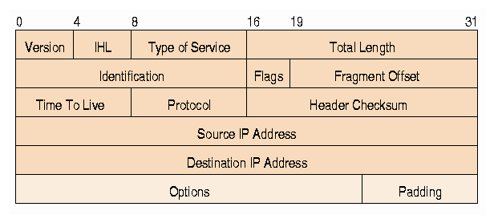
The later is called the “abstract syntax” approach. This is the approach taken with technologies such as ASN.1, Protocol Buffers, SUN-RPC, ONC-RPC, SOAP, REST etc. It has the advantage that it enables designers to produce specifications without undue concern with the encoding issues, and also permits application-independent tools to be provided to support the easy implementation of protocols specified in this way. Moreover, because application-specific implementation code is independent of encoding code, it makes it easy to migrate to improved encodings as they are developed.

FooProtocol DEFINITIONS ::= BEGIN

FooQuestion ::= SEQUENCE {
trackingNumber INTEGER,
question IA5String
}

FooAnswer ::= SEQUENCE {
questionNumber INTEGER,
answer BOOLEAN
}

END

Layering
The layering concept is perhaps most commonly associated with the International Standards Organization (ISO) and International Telecommunications Union (ITU) “architecture” or “7-layer model” for Open Systems Interconnection (OSI) shown in @SLIKA OSI LAYERS. To reduce their design complexity, most networks are organized as a stack of layers or levels, each one built upon the one below it. The number of layers, the name of each layer, the contents of each layer, and the function of each layer differ from network to network. The purpose of each layer is to offer certain services to the higher layers, shielding those layers from the details of how the offered services are actually implemented. This is know as encapsulation. In a sense, each layer is a kind of virtual machine, offering certain services to the layer above it.

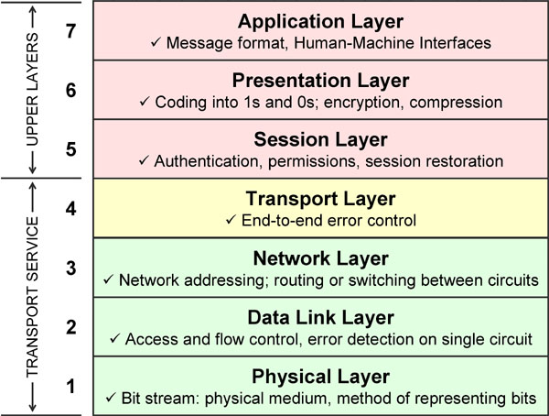
Between each pair of adjacent layers is an interface. The interface defines which primitive operations and services the lower layer makes available to the upper one. When network designers decide how many layers to include in a network and what each one should do, one of the most important considerations is defining clean interfaces between the layers. Doing so, in turn, requires that each layer perform a specific collection of well-understood functions. In addition to minimizing the amount of information that must be passed between layers, clear-cut interfaces also make it simpler to replace the implementation of one layer with a completely different implementation (eg., all the telephone lines are replaced by satellite channels) because all that is required of the new implementation is that it offer exactly the same set of services to its upstairs neighbor as the old implementation did. In fact, it is common that different hosts use different implementations.
While many of the protocols developed within this framework are not greatly used today, it remains an interesting academic study for approaches to protocol specification. In the original OSI concept in the late 1970s, there would be just 6 layers providing (progressively richer) carrier services, with a final "application layer" where each specification supported a single end-application, with no "holes".

PDU specification
A PDU is specified using various data types. Let's divide data types into primitive types or basic types and constructed types or composite types. Primitive types include integers, floating point numbers, characters, booleans etc. Constructed data types are constructed using primitive data types and other constructed types, they provide enclosure for some kind of set consisting of primitive types. Structures, arrays, strings, unions, enumerators etc., fall into constructed data type category.
Different kinds of computers use different conventions for the ordering of bytes within data types that are multiple of a byte. Some computers put the most significant byte (eg. MSB) within such data type first, this is called “big endian” order, and others put it last, thus called “little endian” order (eg. LSB). The same goes for bit ordering, all though it's rare to find little endian bit ordering into the wild, both on processor architecture and network protocol specifications. Integer sizes also differ amongst architectures, not to mention floating point representations. Strings have different character encodings (ie. character set or simply charset).
@PROC_ARCH_ATTR
So that machines with different conventions and specifications can communicate, the network protocol specification must clearly define these attributes to every data type transmitted over the network.
Formally we can define integers as a data type which represents some finite subset of mathematical integers (integral data type). When specifying an integer data type one must consider the following attributes:
- Size – Most commonly integer sizes are byte multiples, and as such are usually named with the following size specifiers: char, short, long, long long or hyper respectively pertaining to sizes of 1,2,4,8 bytes. It's not uncommon to define a bit multiple integer size, for instance 13 bits offset field in the IP PDU specification. The smallest integer size is of course 1 bit, and the largest is undefined.
- Byte order – Byte order concept is only valid with byte multiple sized data types so only byte sized integers must have byte ordering defined. Thus called byte-sized integers.
- Bit order – Data types that have size defined as bit multiple are called bit-sized data types, therefor such integers are called bit-sized integers. Bit order can be specified for both byte-sized and bit-sized integers. When specified for bit-sized integer the bits are arranged accordingly for the integer as a whole. For byte-sized integers the bit order is considered bytewise and thus is set for each byte.
- Sign – An integer can be signed or unsigned. Signed integers are stored in a computer using 2's complement. Distinction must be made as integer operations are different for unsigned versus signed integers.
In computer science, floating point describes a system for representing real numbers which support a wide range of values. The following are the attributes applicable to floating point data type:
- Representation – There are several floating point representations used today in computing. Different processor architectures utilize different representations. These are: IEEE754, VAX, Cray, IBM...
- Size - The size of a floating point type is usually determined by it's representation, and most commonly are byte sized.
- Byte order – As a byte-sized data type it must have a defined byte order.
- Bit order – Similar to byte-sized integers bit order is defined bytewise (not as a whole).
One more primitive data type is a character. A character data type is used to store symbols such as alphanumeric text, whitespace, punctuation and others. These symbols exist at a higher level of abstraction then integers and floating point numbers. But similarly to these primitive types, characters also must have a mapping from character abstraction to a certain binary representation that can be stored in computer memory or transmitted across a network. Essentially a character is mapped into an integer data type, so we can use object oriented paradigm terminology to describe a character type as being a specialized form of an integer type. As such a character inherits all of the mentioned integer data type attributes to additionally introducing some of its own:
- Character set – Also referred to as a charset, character encoding, character map or a code page. It represents a mapping of symbols into an integer for the purpose of storing these symbols in the computer memory or transmission over the network. These mapping can be either specified using a predefined set of symbol to number conversion (ASCII) or using an encoding algorithm (Unicode).
Boolean types are simple types for representing logical values. Their mapping to some form of binary representation must be defined. This data type is also derived from integer data type and additionally must define two attributes:
- True value – The integer value that represents a true boolean value.
- False value – The integer value that represents a false boolean value.

Abstract and transfer syntax
The terms abstract and transfer syntax were primarily developed within the OSI work, and are variously used in other related computer disciplines. These terms will provide us with the terminology for formally defining Wire language and it's purpose.
The following steps are necessary when specifying the messages forming a protocol:
- The determination of the information that needs to be transferred in each message. We here refer to this as the semantics associated with the message.
- The design of some form of data-structure (at about the level of generality of a high-level programming language, and using a defined notation) which is capable of carrying the required semantics. The set of values of this data-structure are called the abstract syntax of the messages. We call the notation we use to define this data structure or set of values the abstract syntax notation.
- The crafting of a set of rules for encoding messages such that, given any message defined using the abstract syntax notation, the actual bits on the line to carry the semantics of that message are determined by an algorithm specified once and once only (independent of the application). We call such rules encoding rules, and we say that the result of applying them to the set of messages for a given application defines a transfer syntax for that particular abstract syntax. Therefor, a transfer syntax is the set of bit-patterns to be used to represent the abstract values in the abstract syntax, with each bit-pattern representing just one abstract value.
So to simplify a little bit, let's say, for example, that we wish to make a notation to declare an integer type and assign it a value. To that point let us borrow the notation that C language uses or simply:
int a = 1;
We can now say that the value “1” is an abstract value that represents an integer value. The set of these abstract values (ie. {...-1, 0, 1, 2, 3, 4, 5, 6, 7...}) is called the abstract syntax. The notation used to declare and define an instance of an abstract syntax is called an abstract syntax notation.
The usage of term “abstract” is totally justified, considering we are dealing with the abstraction of integers, floating point numbers, characters etc.
The representation used to store an abstract syntax in computer memory is called the concrete syntax. For example IEEE754 floating point representation is one of the concrete syntaxes for storing floating point numbers. Abstract syntaxes should be independent of the concrete syntaxes which can and usually do differ amongst different machines.
The transfer syntax is the representation used to transfer the abstract syntax over the communication line. A certain instance of the abstract syntax or the abstract value must have a unique transfer value so it can be restored on the other endpoint. The transfer syntax must take in order the differences in concrete syntaxes between communicating peers, therefore the transfer syntax must correspond to some sort of protocol.
The protocol or algorithm or encoder or whatever you might call it, which maps the abstract syntax to a corresponding transfer syntax or even a concrete syntax, which carries its semantics, is called serialization.

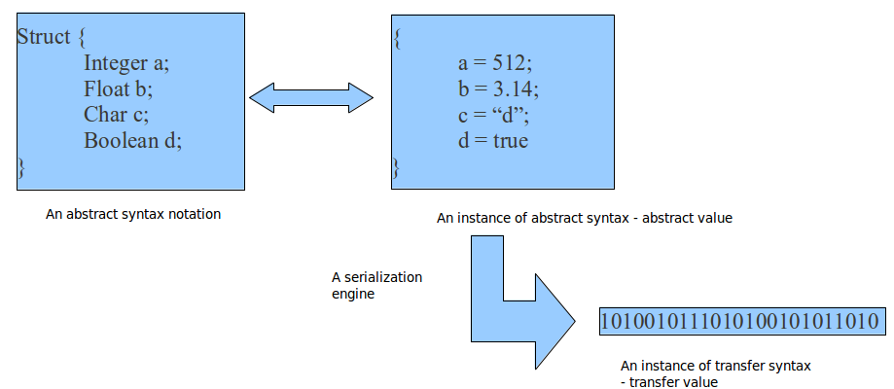
The figure above illustrates the mentioned concepts and their relations. What's left is to list some technologies and formally describe them using these newly learned terminology.
First lets mention the Abstract Syntax Notation One technology (ASN.1), which is, as you may noticed, named quite literal. Some of the abstract data types that the ASN.1 provides are:
- Basic (primitive) types boolean, integer, real, enumerated, bit string, octet string, null...
- Constructed types include sequence, set, choice...
The ASN.1 is an abstract syntax notation which uses several different serialization protocol to produce the transfer syntax:
- BER – Basic Encoding Rules.
- CER – Canonical Encoding Rules.
- DER – Distinguished Encoding Rules.
- XML – XML Encoding Rules.
- PER – Packed Encoding Rules.
- GSER – Generic String Encoding Rules.
Other popular technology that is utilized by the SUN-RPC remote procedure call protocol is the External Data Representation (XDR). XDR also includes an abstract syntax notation that defines basic data types such as integer and hyper, float and double, quadruple, bool and constructed data types such as structures, enumerations and unions. The serialization for each data type is specified in RFC4506.
JavaScript Object Notation or simply JSON is widely known and popular data interchange technology used in Web today. It consists of an abstract syntax notation that is a subset of JavaScript scripting language. All though its main purpose is the serialization and transmission of JavaScript objects between a server and a web application (client), JSON is language independent. The serialized objects, aka the transfer syntax, is in human-readable text form.

Formal Definition
By using the terminology and concepts elaborated in the previous sections, we will formally define the Wire project. First of all Wire is a computer language, more precisely a subset which is called a definition language. It's a domain-specific or a special-purpose language (we'll get to that later on), oppose to general-purpose languages such as C or Java. Also, to specify a bit deeper, Wire provides an abstract syntax notation.
The idea behind Wire is to provide a language which is used to describe/define (ie. definition language) the on the wire representation of an arbitrary network protocol. One could say that Wire is used to define the transfer syntax for some protocol. So an abstract syntax notation for describing a transfer syntax.
The compiler for the Wire language takes a specification of a certain protocol written in Wire and produces code that handles the defined protocol. By that I mean generates code to easily build and dissect protocol data units as well as handle all of the defined protocol operations. Obviously the code contains the serialization engine which maps the abstract syntax to the corresponding transfer syntax.
The Wire language constructs “attributes” contain instructions for the underlying serialization engine, thus giving us control over “on the wire” representation of the defined data types.

Overview
For the sake of demonstrating Wire, we will develop a custom network protocol. The development process and the making of the final specification will help us explain the purpose and the inner workings of Wire. Also it will show us some general guidelines and steps needed when designing a protocol.
So let's call this new network protocol “Math”, it will resemble a remote procedure call protocol which will offer a mathematical service. So we've already defined:
- Name – “Math”.
- Service – Mathematical operations.
So let's start writing a Wire definition of our “Math” protocol. This is the simplest protocol definition in Wire:
[
//protocol attributes
] protocol Math{
//data type declarations and definitions
//operation declarations
}

This represents nothing yet, but be patient...we'll get there. First we can notice line comments similar to those found in C syntax. Second thing to notice is the “protocol” keyword which is used to declare a new protocol object named “Math”. What precedes this keyword is a pair of square brackets. These will hold a list of attributes that are applicable to a protocol object. Actually every Wire object can have attributes applied to it, which attributes are applicable where we'll learn gradually.
Let's define our service a bit more. So we wish to provide basic mathematical operations such as addition, subtraction, multiplication, division and power:

[
//protocol attributes
] protocol Math{
//data type declarations and definitions
//operation declarations
operation Add();
operation Sub();
operation Mul();
operation Div();
operation Pow();
}

The “operation” keyword is assigned the honor of declaring our protocol operations. Currently these operations are dumb as they have an empty arguments list. The “operation” object can only have arguments of “pdu” type. This is reasonable as an operation is the exchange of messages between peers, these messages are called protocol data units and the “pdu” object embodies this concept in Wire.
So a “pdu” object is defined using the “pdu” keyword. I decided to define one general PDU that can capture all of the required semantics. I called it “Math” protocol data unit. One could decide to go with, for example, two PDUs, one which will carry the request information and the other that will hold the response information. Notice that this is a design issue and as such falls under personal preference.

[
//protocol attributes
] protocol Math{
//data type declarations and definitions
pdu Math{};
//operation declarations
operation Add([push] pdu Math math_req, [pull] pdu Math math_rep);
operation Sub([push] pdu Math math_req, [pull] pdu Math math_rep);
operation Mul([push] pdu Math math_req, [pull] pdu Math math_rep);
operation Div([push] pdu Math math_req, [pull] pdu Math math_rep);
operation Pow([push] pdu Math math_req, [pull] pdu Math math_rep);
}

Now our operations have a valid argument list. Each “pdu” object in the argument list has been applied an attribute. These “push” and “pull” attributes are only applicable to pdu objects that are placed in the argument list of an operation object:
- push – It's a notion used to define that a pdu object is being sent to the carrier service which conveys it to the other endpoint. The carrier service is situated at a lower layer, so the PDU is virtually being “pushed” down.
- pull – Similar to “push”, with the exception that the pdu object is being received from the other endpoint, or “pulled” up from the lower layer protocol.
Each operation pushes one pdu object, similar to function arguments, and pulls one, ie. function return value. Obviously these pdu object must be designed so that are able to carry all the required information such as integer number and/or real number arguments, result of the mathematical operation and quite possibly some sort of error messages that indicate an exception (for example division by zero).

[
//protocol attributes
] protocol Math{

//data type declarations and definitions

enum PDUType{
REQUEST = 0,
REPLY = 1
};

struct MathReq {};

struct MathRep{};

pdu Math{
enum PDUType epdu_type;
union <epdu_type> {
case REQUEST:
struct MathReq smathreq;
case REPLY:
struct MathRep smathrep;
default:
exception("epdu_type: value not used");
};
};

//operation declarations
operation Add([push] pdu Math math_req, [pull] pdu Math math_rep);
operation Sub([push] pdu Math math_req, [pull] pdu Math math_rep);
operation Mul([push] pdu Math math_req, [pull] pdu Math math_rep);
operation Div([push] pdu Math math_req, [pull] pdu Math math_rep);
operation Pow([push] pdu Math math_req, [pull] pdu Math math_rep);
};

We extended our “Math” pdu object with the “union” construct which allows us to define conditional structuring. A “union” object has a switch which determines the proper structure at runtime. The switch value is used to check the equality of “case”s so the code can unambiguously process the structure. This particular “union” object instance is an example of the, so called, “anonymous union” object, oppose to a “named union” object. Another handy data type we introduced with this progress is the “enum” data type. It's no novelty, but it's usage results in more elegant definitions. The “enum” object takes a list of names or identifiers for integer constants who will later on be referenced by that name.
Our “Math” pdu object is now equipped with sufficient information to carry both the request and response information. We've reached second checkpoint in designing a network protocol:
- Interface – We've designed the exact interface to our mathematical service. It consists of operations: Add, Sub, Mul, Div, Pow.
- PDU – Decided on the structure of the protocol data units. Preferred on a single PDU structure that can carry a more general information.
What's next is to exactly define the information that will be carried within request and reply structures. So we introduce the structure object with the “struct” keyword. Syntactically it's no different from the pdu object. Another primitive type used is the string object defined using the “string” keyword. We used it to carry the error message.
[
//protocol attributes
] protocol Math{

//data type declarations and definitions

enum PDUType{
REQUEST = 0,
REPLY = 1
};

enum ReplyType{
FAILURE,
SUCCESS
};

enum NumberType{
INTEGER,
REAL
};

struct MathReq {
enum NumberType enumber_type;
unsigned int narguments;
union <enumber_type> {
case INTEGER:
unsigned int size_arg;
signed int sint_args[narguments];
case FLOAT:
unsigned int size_arg;
float fp_args[narguments] ;
default:
exception("enumber_type: value not used");
} ;
};

struct MathRep{
enum ReplyType ereply_type;
union <ereply_type>{
case FAILURE:
string strerror;
case SUCCESS:
enum NumberType enumber_type;
union <enumber_type> {
case INTEGER:
unsigned int size_res;
signed int sint_res;
case REAL:
unsigned int size_res;
float fp_args[narguments]
default:
exception("enumber_type: value not used");
} ;
default:
exception("enumber_type: value not used");
};
};

pdu Math{
enum PDUType epdu_type;
union <epdu_type> {
case REQUEST:
struct MathReq smathreq;
case REPLY:
struct MathRep smathrep;
default:
exception("epdu_type: value not used");
};
};

//operation declarations
operation Add([push] pdu Math math_req, [pull] pdu Math math_rep);
operation Sub([push] pdu Math math_req, [pull] pdu Math math_rep);
operation Mul([push] pdu Math math_req, [pull] pdu Math math_rep);
operation Div([push] pdu Math math_req, [pull] pdu Math math_rep);
operation Pow([push] pdu Math math_req, [pull] pdu Math math_rep);
};

Notice the “exception” statement. It's a Wire construct used to designate an exception state of some kind. This “function call” like statement takes variable length list of arguments that are passed to the runtime that will eventually handle the exception at hand. What's considered an exception is decided by the protocol designer. I used it to designate the occurrence of invalid value.
At this point we've, semantically, fully defined the protocol from an abstraction level that only deals with information and its exchange trough operations. Needless to say we've defined the abstract syntax of the “Math” protocol. In the process we've encountered every Wire object: protocol, operation and data type objects. Primitive data type objects: integers, floats and strings and constructed data type objects: protocol data units, structures, unions, arrays and enumerations.
Now it's time to utilize the Wire attribute concept to exactly define the on the wire representation of the protocol at hand. Attributes can be applied to every Wire object. They are used to semantically link scope related objects, define sanity checks and to give instructions to both the Wire serialization engine and the communication engine. One could say that by using attributes you can exactly define the transfer syntax of a protocol.
First let's talk to the communication engine. What we need to define for Math protocol is the carrier service. The carrier service is a lower layer protocol which is assigned the job of carrying the Math PDUs to the other Math endpoint. To decide on the carrier service for Math, I took into consideration the following:
- Math endpoints must be able to communicate over the IP networks.
- The information exchanged over the wire is sensitive in a way that it must be correctly transported to the other side, thus we want reliable and ordered transport service.
So a common practice when met with such requirements is to choose the Transmission Control Protocol. TCP resides on top of the IP protocol and uses the “port” addressing concept to deliver data from one process to another. So let's choose our port number to be 31337.
Wire uses the “endpoint” attribute for defining protocol endpoint information. Generally “endpoint” takes a name and the addressing information of the carrier protocol. Note that a protocol can specify any number of carrier services, but practically it depends on the communication engine and what services it supports.
[
//protocol attributes
endpoint(“tcp:31337”),
size(4),
byte_order(“MSB”),
bit_order(“MSB”)
] protocol Math{

//data type declarations and definitions
[size(1)] enum PDUType{
REQUEST = 0,
REPLY = 1
};

enum ReplyType{
FAILURE,
SUCCESS
};

enum NumberType{
INTEGER,
REAL
};

struct MathReq {
enum NumberType enumber_type;
[size(2), byte_order(“LSB”)] unsigned int narguments;
union <enumber_type> {
case INTEGER:
[range(1,32)] unsigned int size_arg;
[size_bits(size_arg)] signed int sint_args[narguments];
case FLOAT:
[list(32,64)] unsigned int size_arg;
[size_bits(size_arg), fp_rep(“IEEE754”)] float fp_args[narguments] ;
default:
exception("enumber_type: value not used");
} ;
};

struct MathRep{
enum ReplyType ereply_type;
union <ereply_type>{
case FAILURE:
[charset(“ASCII”), delimiter(“\0”)] string strerror;
case SUCCESS:
enum NumberType enumber_type;
union <enumber_type> {
case INTEGER:
[range(1,32)] unsigned int size_res;
[size_bits(size_res)] signed int sint_res;
case REAL:
[list(32,64)] unsigned int size_res;
[size_bits(size_res), fp_rep(“IEEE754”)] float fp_args[narguments]
default:
exception("enumber_type: value not used");
} ;
default:
exception("enumber_type: value not used");
};
};

pdu Math{
enum PDUType epdu_type;
union <epdu_type> {
case REQUEST:
struct MathReq smathreq;
case REPLY:
struct MathRep smathrep;
default:
exception("epdu_type: value not used");
};
};

//operation declarations
[timeout(5)] operation Add([push] pdu Math math_req, [pull] pdu Math math_rep);
[timeout(5)] operation Sub([push] pdu Math math_req, [pull] pdu Math math_rep);
[timeout(5)] operation Mul([push] pdu Math math_req, [pull] pdu Math math_rep);
[timeout(5)] operation Div([push] pdu Math math_req, [pull] pdu Math math_rep);
[timeout(5)] operation Pow([push] pdu Math math_req, [pull] pdu Math math_rep);
};

The timeout attribute takes the number of seconds as the sole argument, and is applicable to operation objects. This states the maximum amount of time that the operation has to finish, timing from the invocation moment. If the operations has failed to do so for whatever reason the timeout exception is raised and handled by the application logic.
The attributes applicability is defined as the context in which the attribute is valid, or equally as the list of objects that are directly influenced by the attribute. For example the fp_rep attribute is applicable only to float objects, oppose to integer objects. An attribute can be placed in the attribute list of any Wire object, this allows us to define the attribute as the general attribute. The applicability is therefore checked only for primitive data type objects. So for example if we define byte_order in the protocol object attribute list it means that every enclosed object receives this attribute (except when overriden by a more specific statement).
We've defined a few general attributes for the Math protocol. We've set the general byte order and bit order to big endian, while defining the default primitive size to 4 bytes.
We've listed a few of the command attributes that are used to define the transfer syntax of our protocol, by commanding the serialization and the communication engine. There are also attributes that define certain semantic checks that must be performed for a given object at runtime. Range and list check for integers and float objects are example of such attributes.

Wire compiler
Lexical analysis is the process of converting a sequence of characters into a sequence of lexical units called tokens. A program or a function which performs lexical analysis is called a lexical analyzer, lexer or scanner. Wire uses Flex tool to generate the Wire tokenizer. Flex is really convenient for processing textual files as it allows users to simply describe tokens using regular expressions.
@APPENDIX lex contains the list of tokens and their regular expression.
Parsing or formally syntax analysis is the process of analyzing a text, made of a sequence of tokens (for example, words), to determine its grammatical structure with respect to a given (more or less) formal grammar. Wire utilizes the GNU Bison tool which reads a specification of a context-free language, warns about any parsing ambiguities, and generates a parser (either in C, C++, or Java) which reads sequences of tokens and decides whether the sequence conforms to the syntax specified by the grammar. Bison generates LALR parsers.
After the syntax analysis has been performed and the abstract syntax tree has been created, this abstract syntax tree is submitted to the semantic check. This is where attribute applicability is checked for, where arguments lists are checked for type consistency and where symbol scoping is defined.
The code that is generated is in Lua programming language. Lua is a powerful, fast, lightweight, embeddable scripting language. Lua combines simple procedural syntax with powerful data description constructs based on associative arrays and extensible semantics. Lua is dynamically typed, runs by interpreting bytecode for a register-based virtual machine, and has automatic memory management with incremental garbage collection, making it ideal for configuration, scripting, and rapid prototyping.
The serialization engine called “serdes” (Serialization/Deserialization) is written in C, as well as the communication engine. Both have bindings written for Lua so the generated code can access them.
WIRE compiler
Math.wire
Math.lua
[
…
]
protocol Math
{
...
}
module(..., package.seeall)
require(“serdes”);
require(“commeng”);
Math{
};

Lexical conventions

Lexical analysis is the process of converting a sequence of characters into a sequence of lexical units called tokens. Wire uses Flex tool to generate the Wire tokenizer. Flex is really convenient for processing textual files as it allows users to simply describe tokens using regular expressions. @APPENDIX WIRE_LEX holds the flex source file which lists all of the defined Wire tokens and their corresponding regular expressions.

Let's introduce some, more relevant, lexical conventions for Wire users. The following lists the reserved words:

byte, float, string, uint, sint, enum, struct, union, pdu, protocol, operation, import, typedef, default.

A Wire identifier follows C syntax rules, so the following are valid examples of Wire identifiers:

ident1234

ident_1234

ident1234_

_ident1234

A valid character set for a Wire identifier consists of alphanumerical characters and the underscore. Note that the first character must be a letter or an underscore sign.

The last thing that's left are the numeric constants and the string constant. Integer constants can be stated in decimal, hexadecimal, binary and octal form:

255

0xFF or 0xff

0377

0b11111111

Floating point number constants look like:

3.14

3.14e10

3.14E10

3.14e-10

The “e” or “E” notation is used for defining an exponent.

A string constant is enclosed between the two double apostrophe signs:

“this is a string constant”

Identically to C string constant syntax the backslash sign is used as the escape symbol.

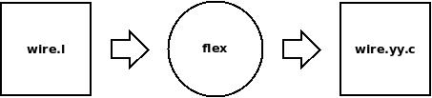Illustration 1: Wire tokenizer compilation process

@ILLUSTRATION WIRE_FLEX shows the compilation process which generates the Wire tokenizer code. The Flex tool takes a “wire.l” file as the input. This file holds token descriptions written in Flex syntax. Flex processes this file and produces the actual C code that does the lexical analysis (“wire.yy.c”).

Symbols and scopes
Wire language consists of declarations and definitions of Wire objects. In the compilation process , every object declared/defined in Wire source gets assigned a symbol. A symbol contains information about the object at hand, for example its identifier, type and scope level. Symbol can be defined one of following types:
protocol
operation
pdu
structure
union
enum
integer
float

Interface Definition Language is a language for specifying operations (procedures or functions), parameters to these operations, and data types.

