SCHOOL OF COMPUTER SCIENCE AND ARTIFICIAL INTELLIGENCE |  |  |  |  | DEPARTMENT OF COMPUTER SCIENCE ENGINEERING
ProgramName:B. Tech |  |  |  | Assignment Type: Lab |  |  | AcademicYear:2025-2026
CourseCoordinatorName |  |  |  | Venkataramana Veeramsetty
Instructor(s)Name |  |  |  | Dr. V. Venkataramana (Co-ordinator)  Dr. T. Sampath Kumar  Dr. Pramoda Patro  Dr. Brij Kishor Tiwari  Dr.J.Ravichander  Dr. Mohammand Ali Shaik  Dr. Anirodh Kumar  Mr. S.Naresh Kumar  Dr. RAJESH VELPULA  Mr. Kundhan Kumar  Ms. Ch.Rajitha  Mr. M Prakash  Mr. B.Raju  Intern 1 (Dharma teja)  Intern 2 (Sai Prasad)  Intern 3 (Sowmya)  NS_2 ( Mounika)
CourseCode |  |  | 24CS002PC215 | CourseTitle |  | AI Assisted Coding
Year/Sem |  |  | II/I | Regulation |  | R24
Date and Day  of Assignment |  |  | Week4 - Wednesday | Time(s)
Duration |  |  | 2 Hours | Applicableto  Batches
AssignmentNumber:9.3(Present assignment number)/24(Total number of assignments)
 | Q.No. | Question |  |  |  |  |  | ExpectedTime  to complete
 | 1 | Lab 8: Documentation Generation: Automatic documentation and code comments  Lab Objectives:  - To understand the importance of documentation and code comments in software development.  - To explore how AI-assisted coding tools can generate meaningful documentation and inline comments.  - To practice generating function-level and module-level docstrings automatically.  - To evaluate the quality, accuracy, and limitations of AI-generated documentation.  - To develop a small automated tool for documentation generation in Python..  Lab Outcomes (LOs):  After completing this lab, students will be able to:  - Apply AI-assisted coding tools to generate docstrings and inline comments for Python code.  - Critically analyze AI-generated documentation for correctness, completeness, and readability.  - Create structured documentation (function-level, module-level) following standard formats.  - Design and implement a mini documentation generator tool to automate code commenting and docstring creation.  Task Description#1 Basic Docstring Generation  - Write python function to return sum of even and odd numbers in the given list.  - Incorporate manual docstring in code with Google Style  - Use an AI-assisted tool (e.g., Copilot, Cursor AI) to generate a docstring describing the function.  - Compare the AI-generated docstring with your manually written one.  Expected Outcome#1: Students understand how AI can produce function-level documentation  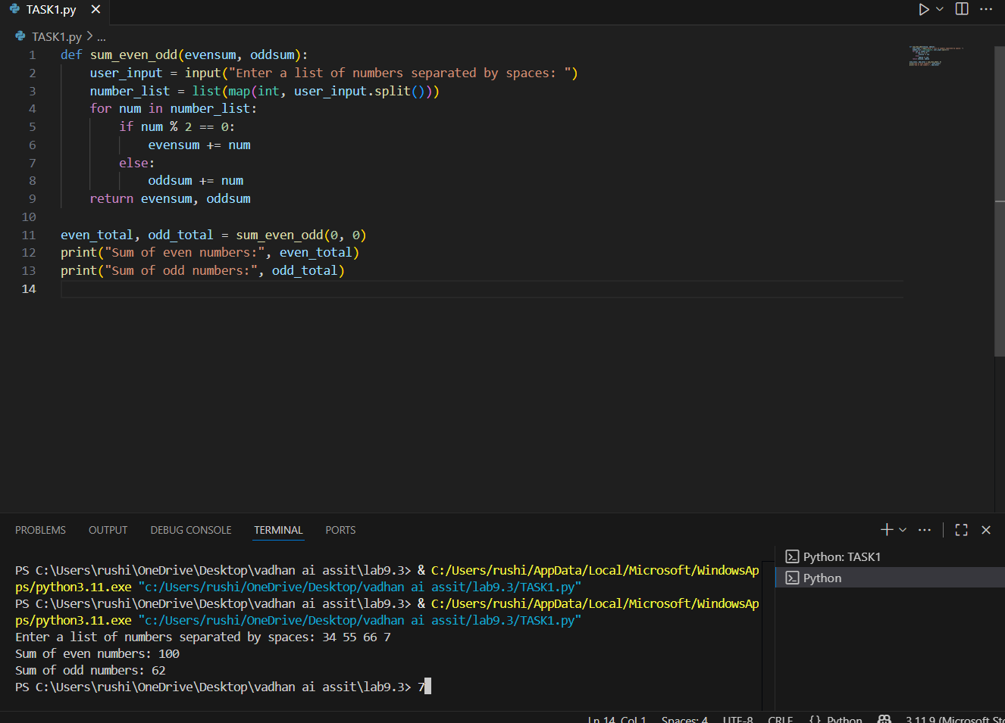  DOCSTRING:  """  Takes initial even and odd sums, asks the user to enter numbers,  and returns updated sums of even and odd numbers.  """  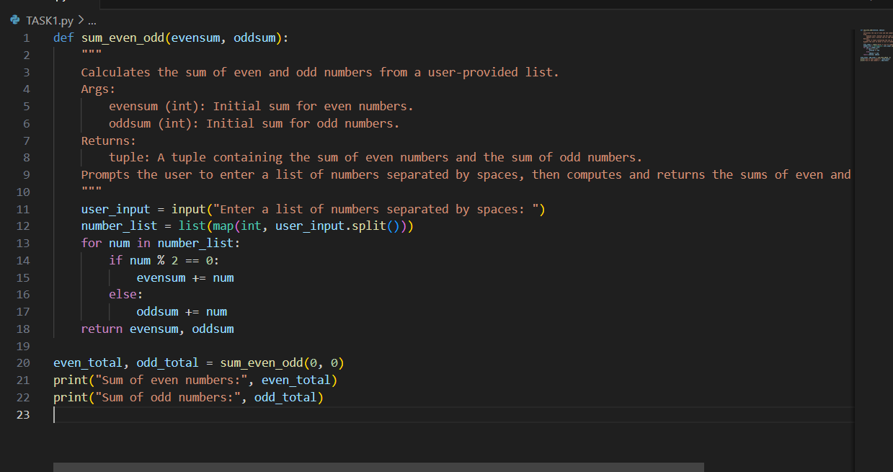  Task Description#2 Automatic Inline Comments  - Write python program for sru_student class with attributes like name, roll no., hostel_status and fee_update method and display_details method.  - Write comments manually for each line/code block  - Ask an AI tool to add inline comments explaining each line/step.  - Compare the AI-generated comments with your manually written one.  Expected Output#2: Students critically analyze AI-generated code comments.  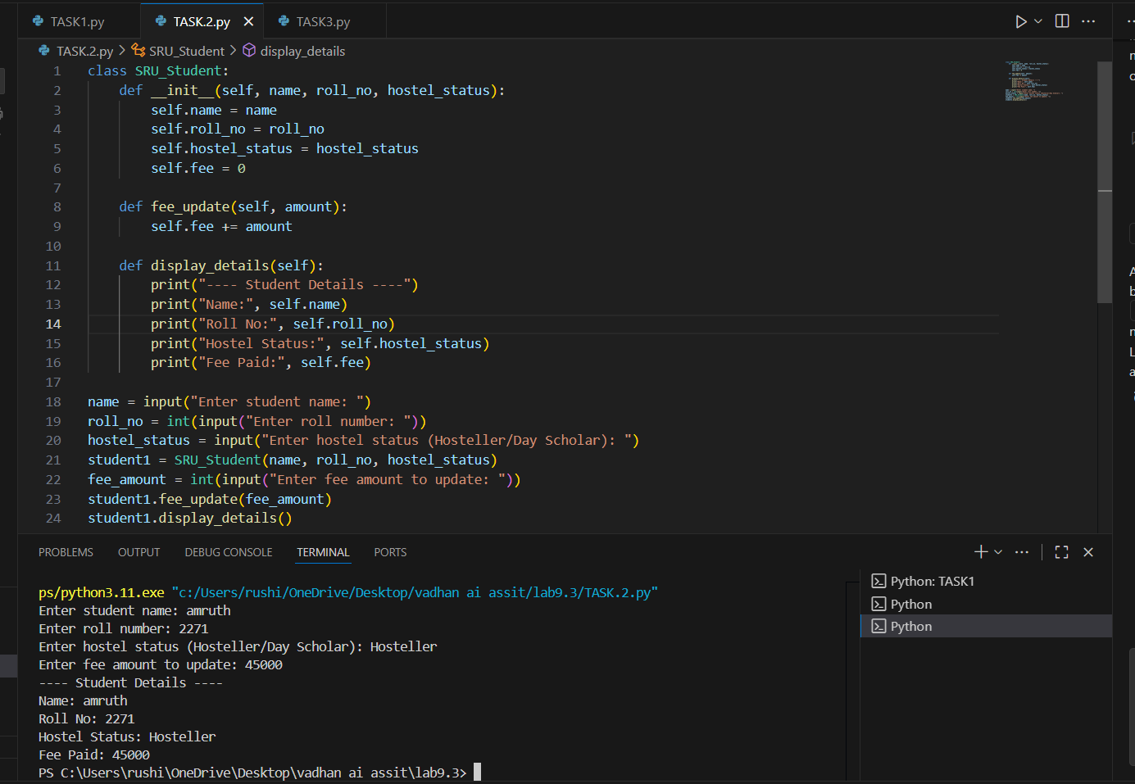  DOCSTRING:  ““““  The SRU_Student class represents a student enrolled at SRU University. It stores basic student information such as name, roll number, hostel status (either "Hosteller" or "Day Scholar"), and the total fee paid. When a new student object is created, the name, roll number, and hostel status are provided by the user, and the fee is initialized to zero. The class provides a method called fee_update which allows the user to add an amount to the existing fee. Another method, display_details, is used to print all student details in a readable format. This class helps manage student records in a simple and organized way, including fee tracking and status display.  ””””  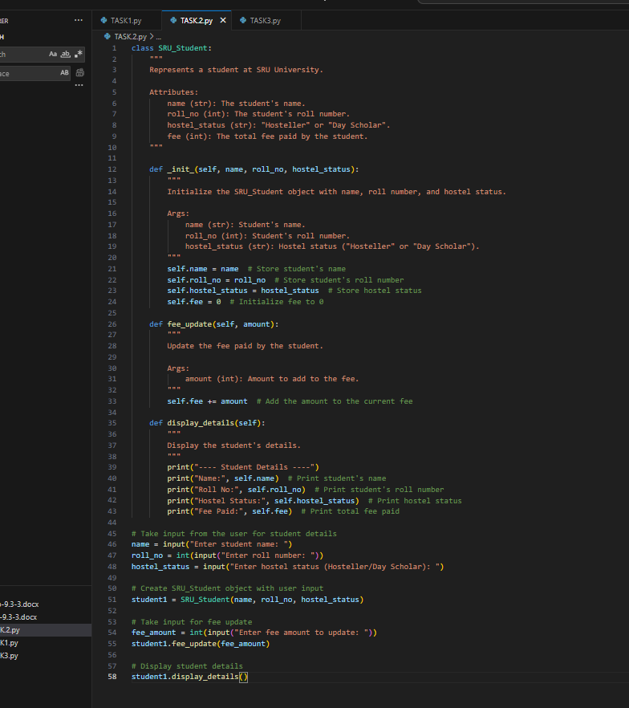  Task Description#3  - Write a Python script with 3–4 functions (e.g., calculator: add, subtract, multiply, divide).  - Incorporate manual docstring in code with NumPy Style  - Use AI assistance to generate a module-level docstring + individual function docstrings.  - Compare the AI-generated docstring with your manually written one.  Expected Output#3: Students learn structured documentation for multi-function scripts  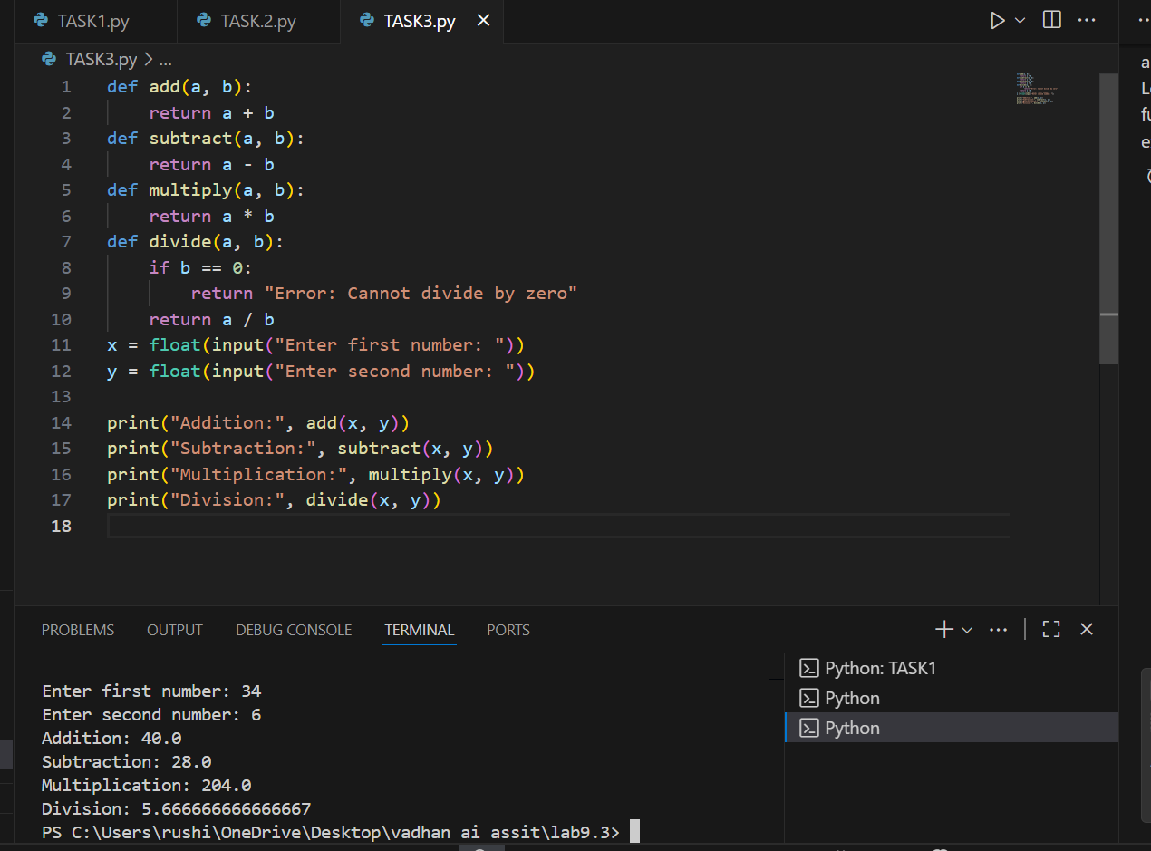  DOCSTRING:  “““  Descriptions of Calculator Functions  add(a, b)  This function adds two numbers together and returns the result.  subtract(a, b)  This function subtracts the second number from the first and returns the result.  multiply(a, b)  This function multiplies two numbers and returns the result.  divide(a, b)  This function divides the first number by the second. If the second number is zero, it returns an error message instead of dividing.  ”””  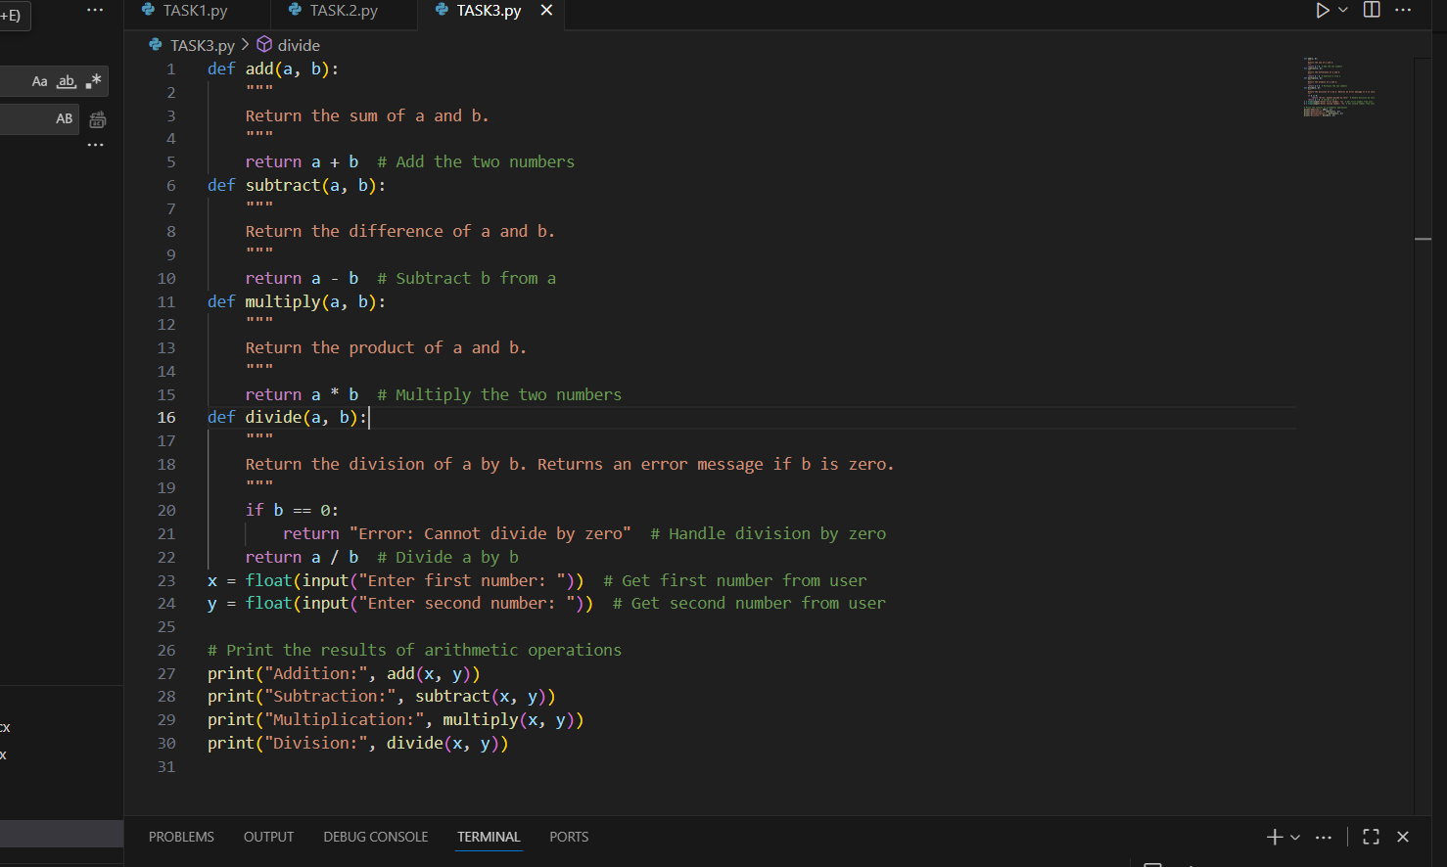  Push documentation whole workspace as .md file in GitHub Repository  Note: Report should be submitted a word document for all tasks in a single document with prompts, comments & code explanation, and output and if required, screenshots |  |  |  |  |  | Week4 - Wednesday

