SCHOOL OF COMPUTER SCIENCE AND ARTIFICIAL INTELLIGENCE |  |  |  |  | DEPARTMENT OF COMPUTER SCIENCE ENGINEERING
ProgramName:B. Tech |  |  |  | Assignment Type: Lab |  |  | AcademicYear:2025-2026
CourseCoordinatorName |  |  |  | Venkataramana Veeramsetty
Instructor(s)Name |  |  |  | Dr. V. Venkataramana (Co-ordinator)  Dr. T. Sampath Kumar  Dr. Pramoda Patro  Dr. Brij Kishor Tiwari  Dr.J.Ravichander  Dr. Mohammand Ali Shaik  Dr. Anirodh Kumar  Mr. S.Naresh Kumar  Dr. RAJESH VELPULA  Mr. Kundhan Kumar  Ms. Ch.Rajitha  Mr. M Prakash  Mr. B.Raju  Intern 1 (Dharma teja)  Intern 2 (Sai Prasad)  Intern 3 (Sowmya)  NS_2 ( Mounika)
CourseCode |  |  | 24CS002PC215 | CourseTitle |  | AI Assisted Coding
Year/Sem |  |  | II/I | Regulation |  | R24
Date and Day  of Assignment |  |  | Week3 - Wednesday | Time(s)
Duration |  |  | 2 Hours | Applicableto  Batches
AssignmentNumber:6.3(Present assignment number)/24(Total number of assignments)
 | Q.No. | Question |  |  |  |  |  | ExpectedTime  to complete
 | 1 | Lab 6: AI-Based Code Completion – Classes, Loops, and Conditionals  Lab Objectives:  - To explore AI-powered auto-completion features for core Python constructs.  - To analyze how AI suggests logic for class definitions, loops, and conditionals.  - To evaluate the completeness and correctness of code generated by AI assistants.  Lab Outcomes (LOs):  After completing this lab, students will be able to:  - Use AI tools to generate and complete class definitions and methods.  - Understand and assess AI-suggested loops for iterative tasks.  - Generate conditional statements through prompt-driven suggestions.  - Critically evaluate AI-assisted code for correctness and clarity.  Task Description#1 (Classes)  - Use AI to complete a Student class with attributes and a method.  - Check output  - Analyze the code generated by AI tool  Instructions:  - Initialize class with attributes like name, roll no, marks  - Method to display student details  - Method to calculate grade based on marks (A:>=90, B: >=75, C: >=60, else Fail)  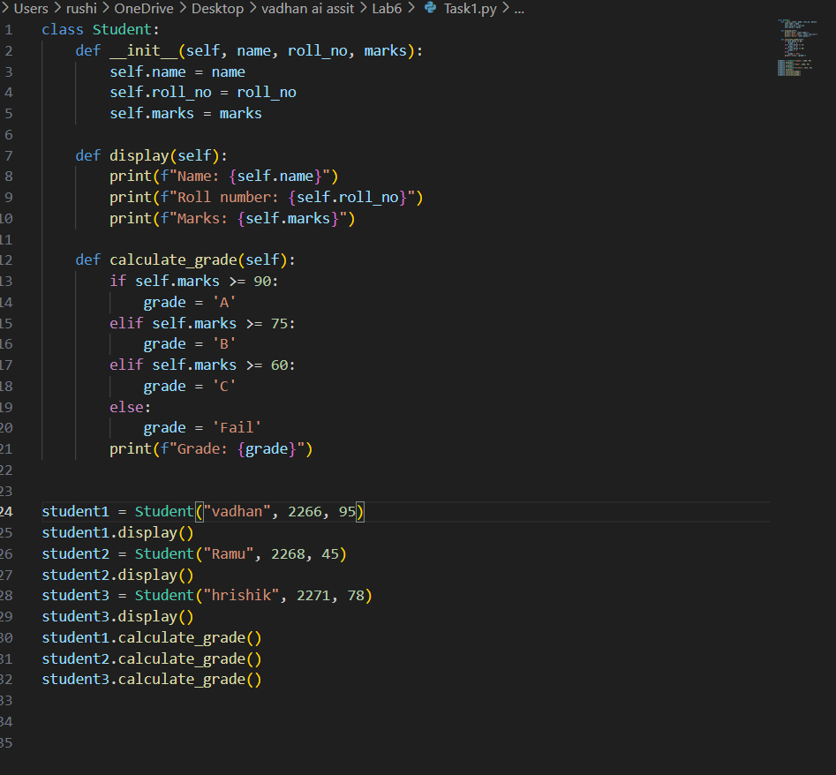  Start Writing code and auto complete using any AI tool  Expected Output#1  - Class with constructor and display_details() method  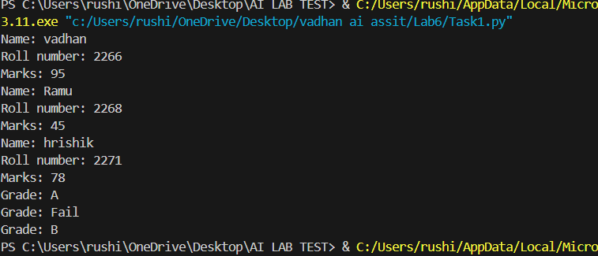  EXPLANATION: Task 1 defines a Student class in Python to represent a student with attributes for name, roll number, and marks. The class includes:  - An __init__ method to initialize the student's details.  - A display method to print the student's information.  - A calculate_grade method to determine and print the student's grade based on their marks:  - 90 or above: Grade A  - 75 to 89: Grade B  - 60 to 74: Grade C  - Below 60: Fail  The code then creates three student objects with different names, roll numbers, and marks, displays their details, and prints their grades.  Task Description#2 (Loops)  - Prompt AI to complete a function that prints the first 10 multiples of a number using a loop.  - Analyze the generated code  - Ask AI to generate code using other controlled looping  Write code using For Loop, later complete code using While Loop  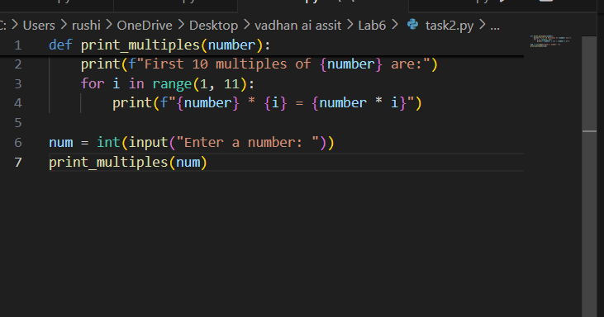  Expected Output#2  - Correct loop-based implementation  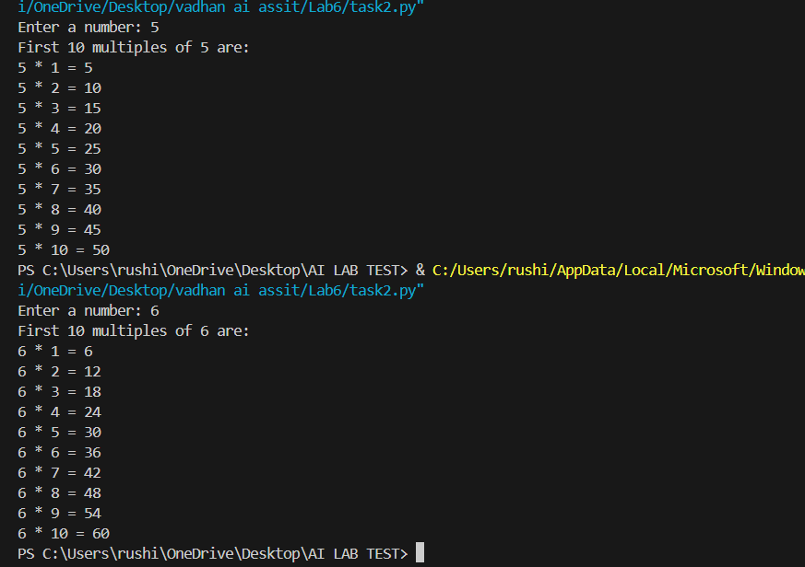  EXPLANATION:  Task 2 defines a function that prints the first 10 multiples of a given number. The steps are:  - The user is prompted to enter a number.  - The function print_multiples takes this number as input.  - It uses a loop to calculate and print the product of the number with values from 1 to 10, showing the multiplication table for that number.  Task Description#3 (Conditional Statements)  - Ask AI to write nested if-elif-else conditionals to classify age groups.  - Analyze the generated code  - Ask AI to generate code using other conditional statements  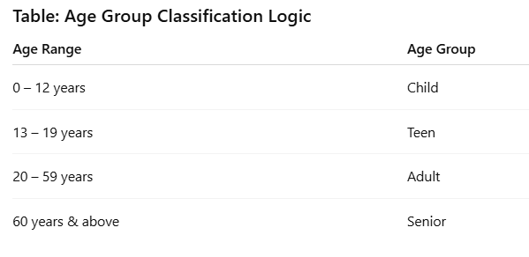  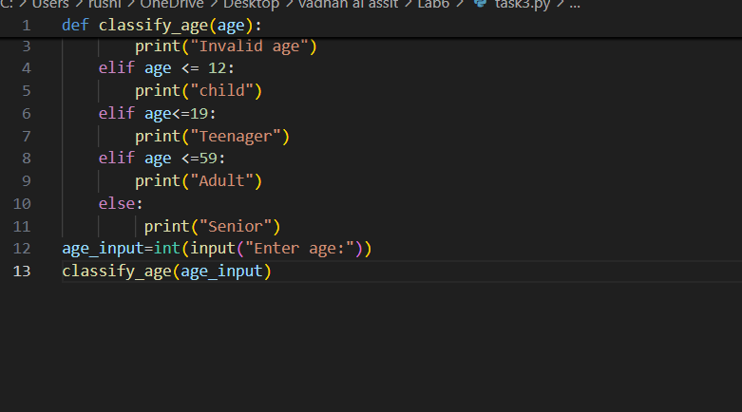  Expected Output#3  - Age classification function with appropriate conditions and with explanation  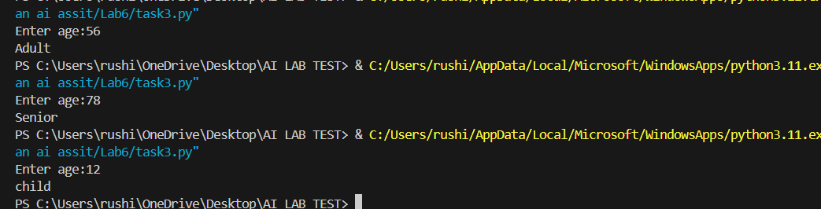  - EXPLANTION: The function classify_(age) takes an integer age as input.  - It checks the value of age and prints a category:  - If age is less than 0, it prints "Invalid age".  - If age is 0 to 12, it prints "child".  - If age is 13 to 19, it prints "Teenager".  - If age is 20 to 59, it prints "Adult".  - If age is 60 or above, it prints "Senior".  - The program asks the user to enter their age, converts the input to an integer, and calls classify_(age) to display the result.  Task Description#4 (For and While loops)  - Generate a sum_to_n() function to calculate sum of first n numbers  - Analyze the generated code  - Get suggestions from AI with other controlled looping  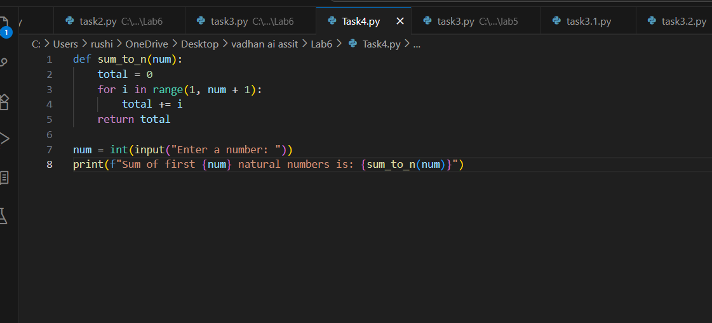  Expected Output#4  - Python code with explanation  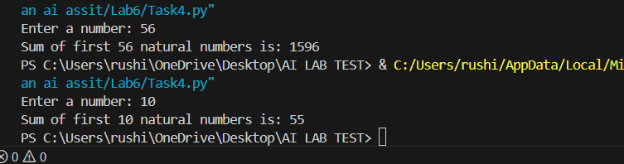  EXPLANATION:Task 4G likely involves writing a function to calculate the sum of the first n natural numbers. The user is prompted to enter a number, and the function adds all numbers from 1 to n, then prints the result. This demonstrates the use of loops, functions, and user input in Python.  Task Description#5 (Class)  - Use AI to build a BankAccount class with deposit, withdraw, and balance methods.  - Analyze the generated code  - Add comments and explain code  Instructions  - Initialize BankAccount class with attributes like name, balance  - Method to deposit amount  - Method to withdraw amount  - Method to check balance  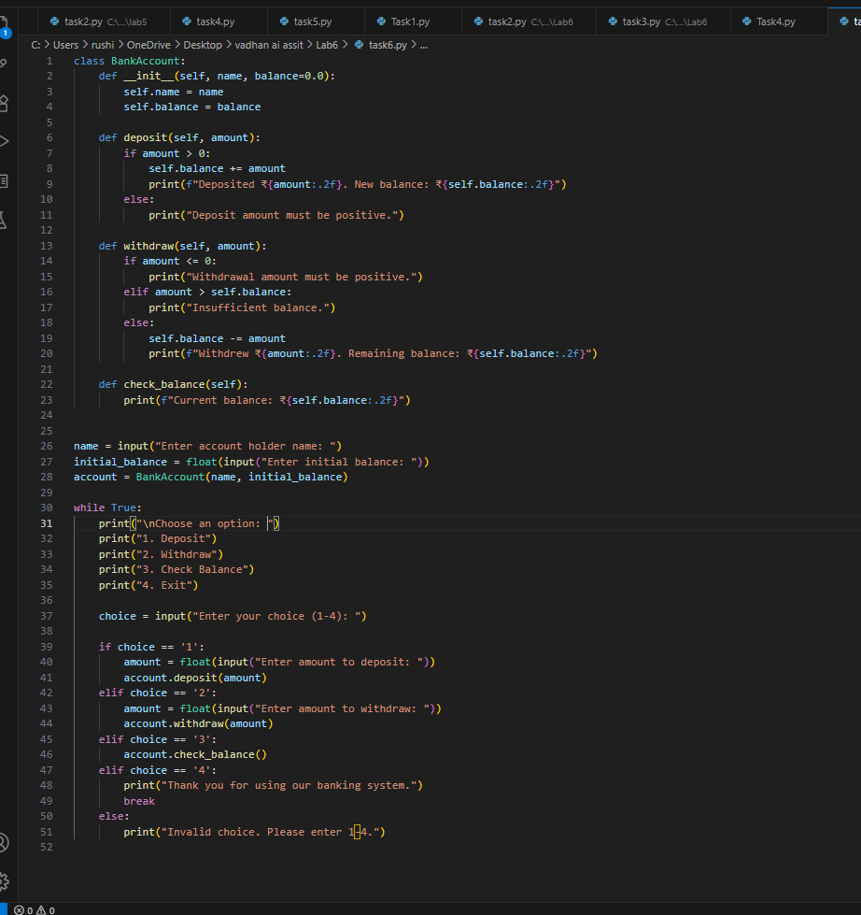  Expected Output#5  - Python code with explanation  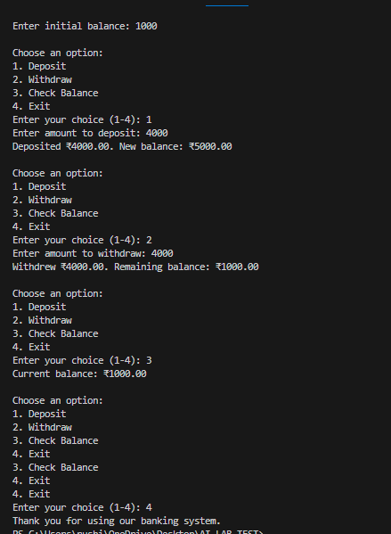  EXPLANTATION: Task 5G implements a simple bank account system using a class:  - The BankAccount class has attributes for the account holder's name and balance.  - Methods include:  - Deposite(amount): Adds money to the account if the amount is positive.  - Withdraw(amount): Removes money if the amount is positive and there is enough balance.  - Check_balance(): Prints the current balance.  - The program prompts the user for their name and initial balance, then repeatedly offers options to deposit, withdraw, check balance, or exit.  Note: Report should be submitted a word document for all tasks in a single document with prompts, comments & code explanation, and output and if required, screenshots  Evaluation Criteria:  Criteria Max Marks  Class 1.0  Loops 1.0  Conditional Statements 0.5  Total 2.5 Marks |  |  |  |  |  | Week3 - Wednesday

