NAME: VADHAN GANJI
HALL TICKECT NO: 2403a52266
BATCH: 10
SUBJECT : AI ASSISTED CODING
LAB TEST-2
--------------------------------------------------------------------------------------------------------------------------------------
Subgroup O —
AI Completion (Classes, Loops, Conditionals)
O.1 — [S01O1] Shopping Cart with Discounts
Scenario (AI completion):
Context: An e-commerce app needs a shopping cart class with support for discount rules.
Your Task:
• Create a ShoppingCart class.
• Methods: add_item(name, price, qty), apply_discount(percent),
total().
• Ensure discount applies to the grand total only once.
AI Assistance Expectation:
• Use AI completion for class boilerplate, constructor, and method stubs.
• Add conditionals to prevent discount below 0%.
Sample Input:
cart = ShoppingCart()
cart.add_item("Shoes", 2000, 1)
cart.add_item("Socks", 200, 3)
cart.apply_discount(10)
print(cart.total())
Sample Output:
2600
Acceptance Criteria:
• Handles multiple items.
• Discount correctly applied.
Deliverables:
• Prompt for AI completion.
• Final class ShoppingCart.
• Test script with 3+ items.
CODE:
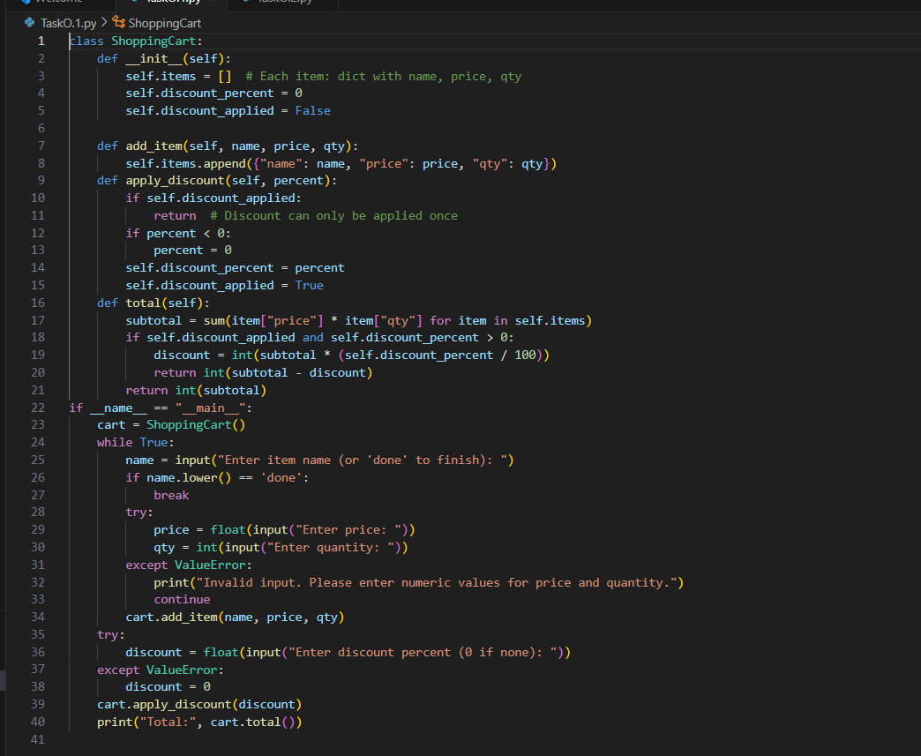
OUTPUT:
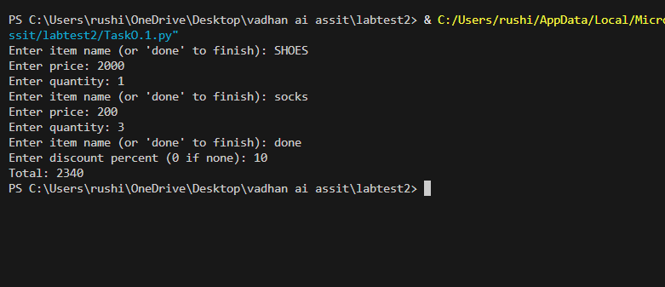
O.2 — [S01O2] Generate Multiplication Tables
Scenario (AI completion):
Context: A training platform needs dynamic generation of multiplication tables for
learners.
Your Task:
• Write a function generate_tables(n, upto) that prints multiplication tables up
to n, each table going till upto.
• Use nested loops.
• Validate inputs (n > 0, upto > 0).
AI Assistance Expectation:
• Use AI to complete nested loops.
• Insert input validation conditionals.
Sample Input:
generate_tables(2, 3)
Sample Output:
1 x 1 = 1
1 x 2 = 2
1 x 3 = 3
2 x 1 = 2
2 x 2 = 4
2 x 3 = 6
Acceptance Criteria:
• Correct multiplication results.
• Neatly formatted output.
Deliverables:
• Prompt for AI completion.
• Python script tables.py.
• Example run screenshots
CODE:
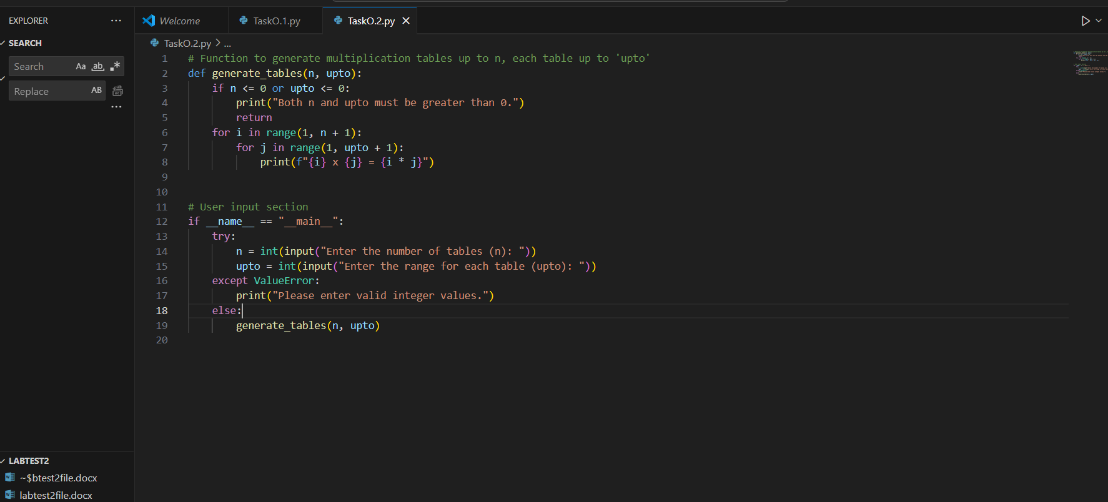
OUTPUT:
