Inheritance:

1)Create a base class called Shape with data members for height and width

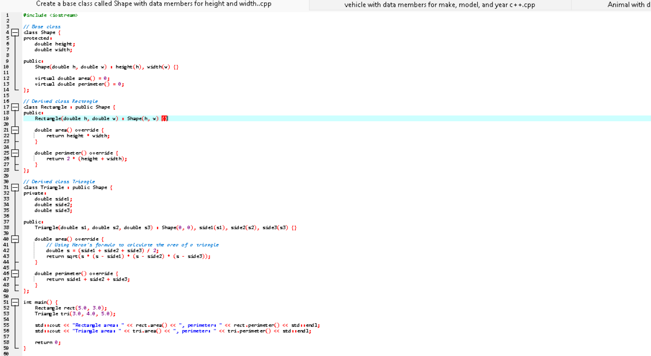

1. Create a base class called vehicle with data members for make, model, and year

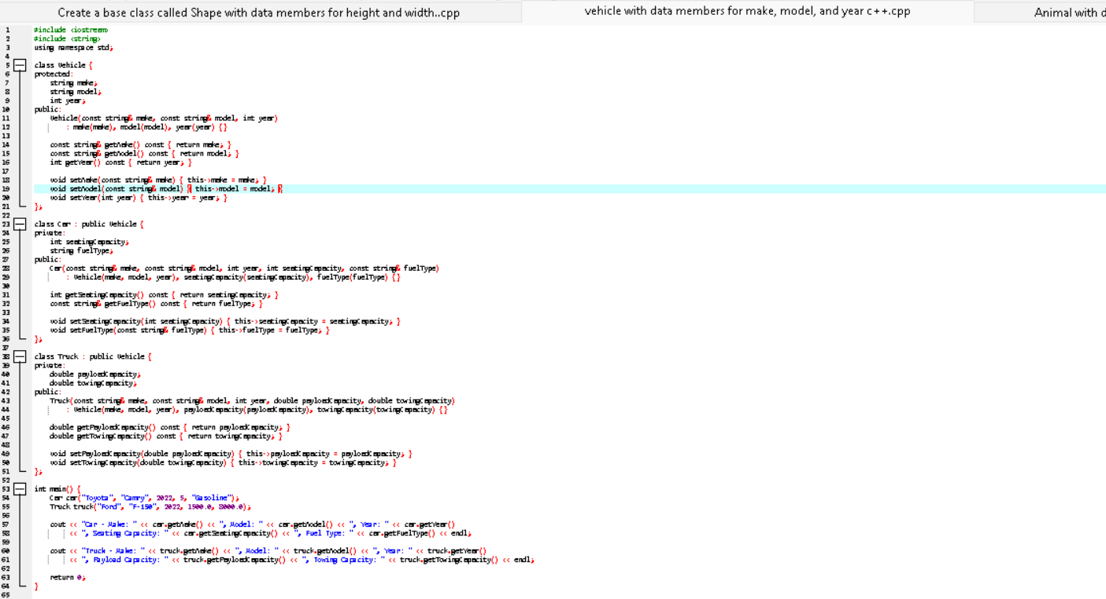

1. Create a base class called Animal with data members for name, species, and age.

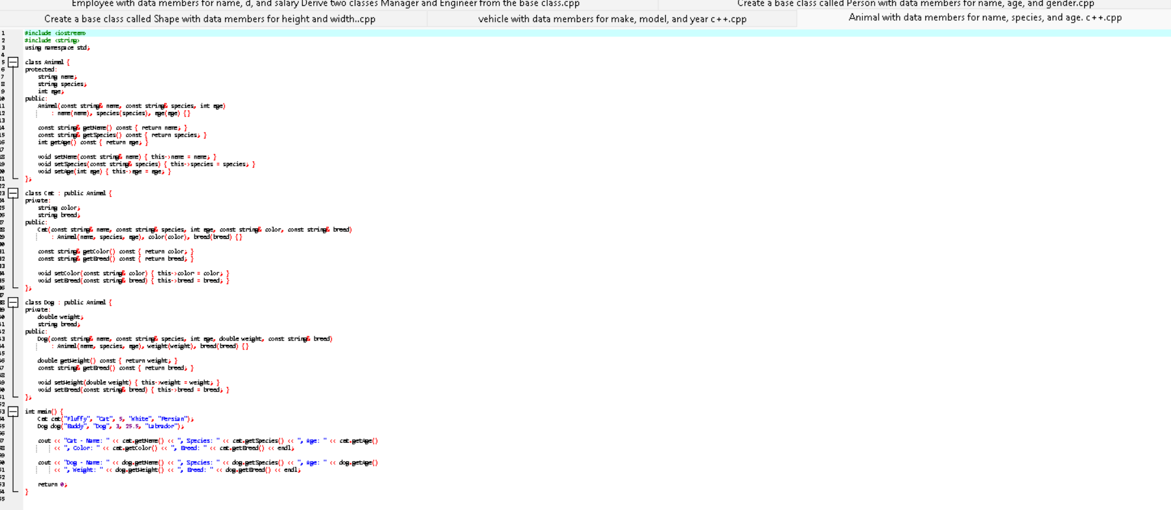

1. Create a base class called Employee with data members for name, d, and salary.

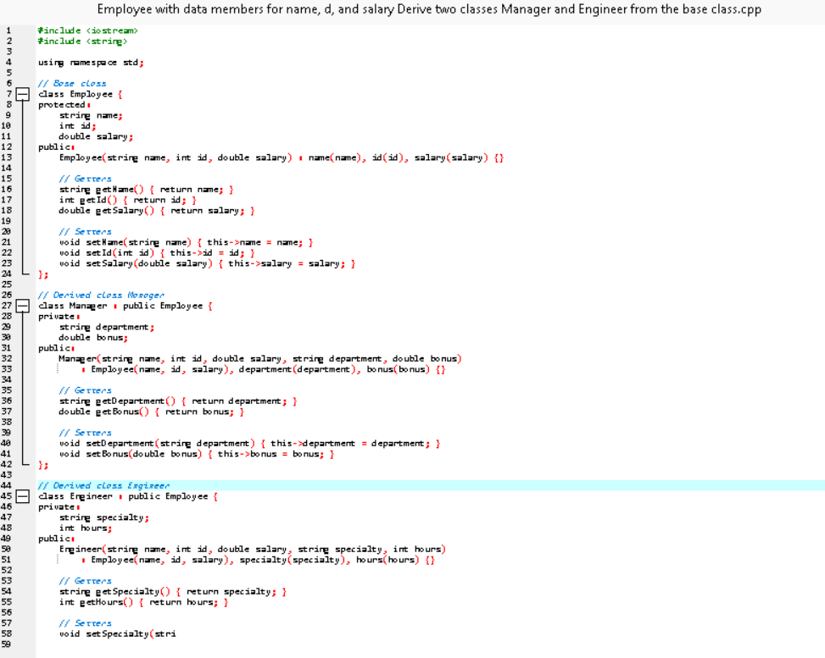

1. Create a base class called Person with data members for name, age, and gender.

