1) 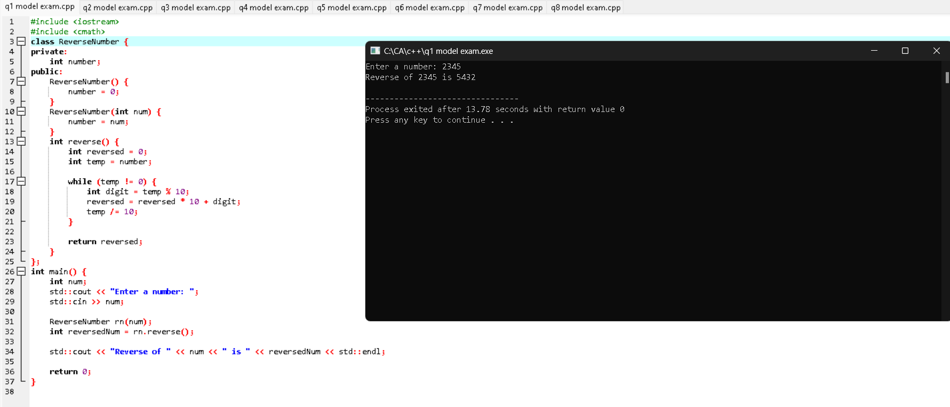

2) 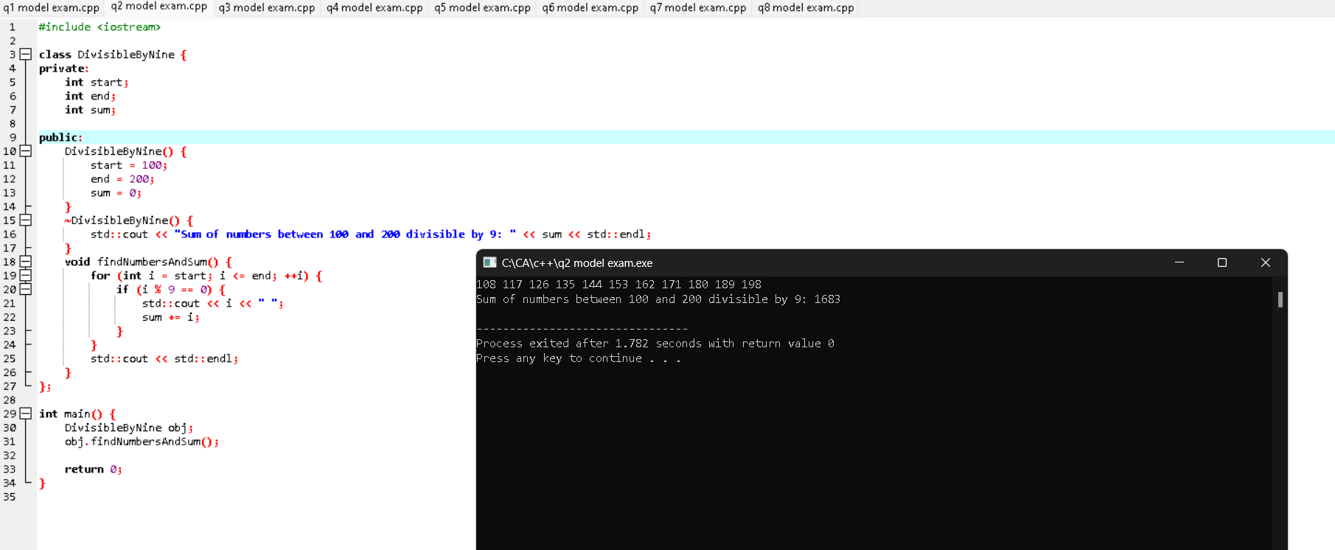

3) 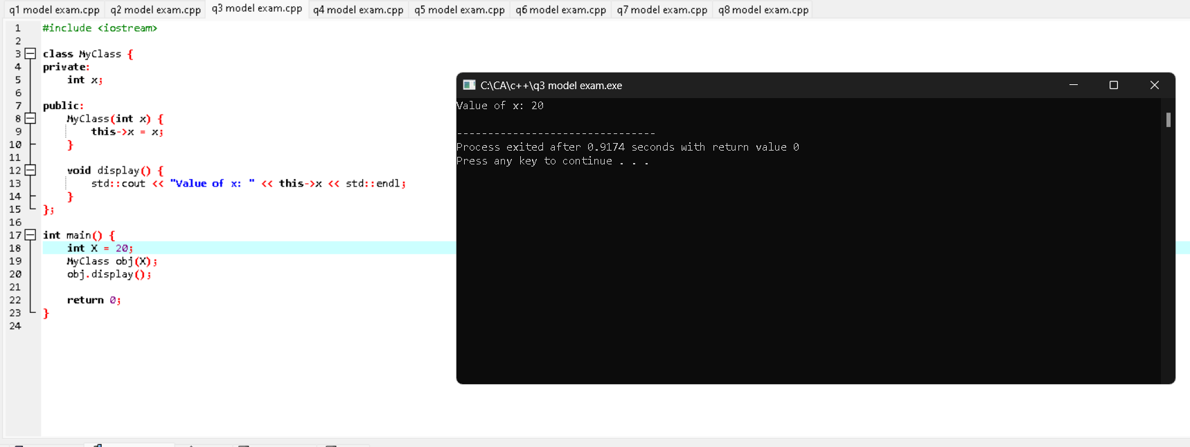

4) 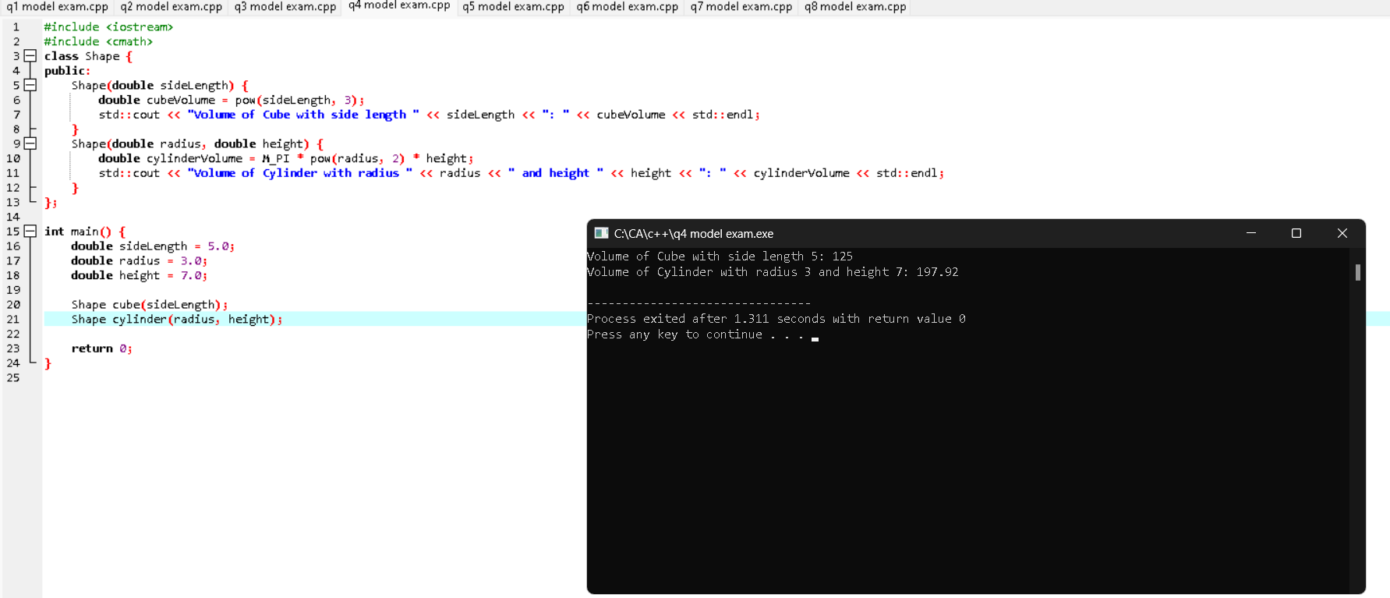

5) 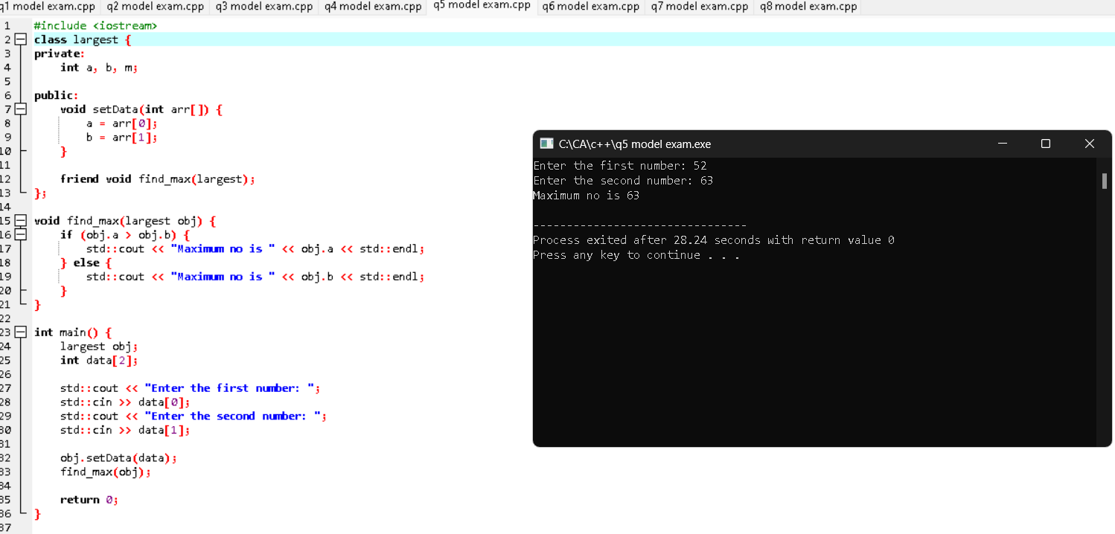

6)

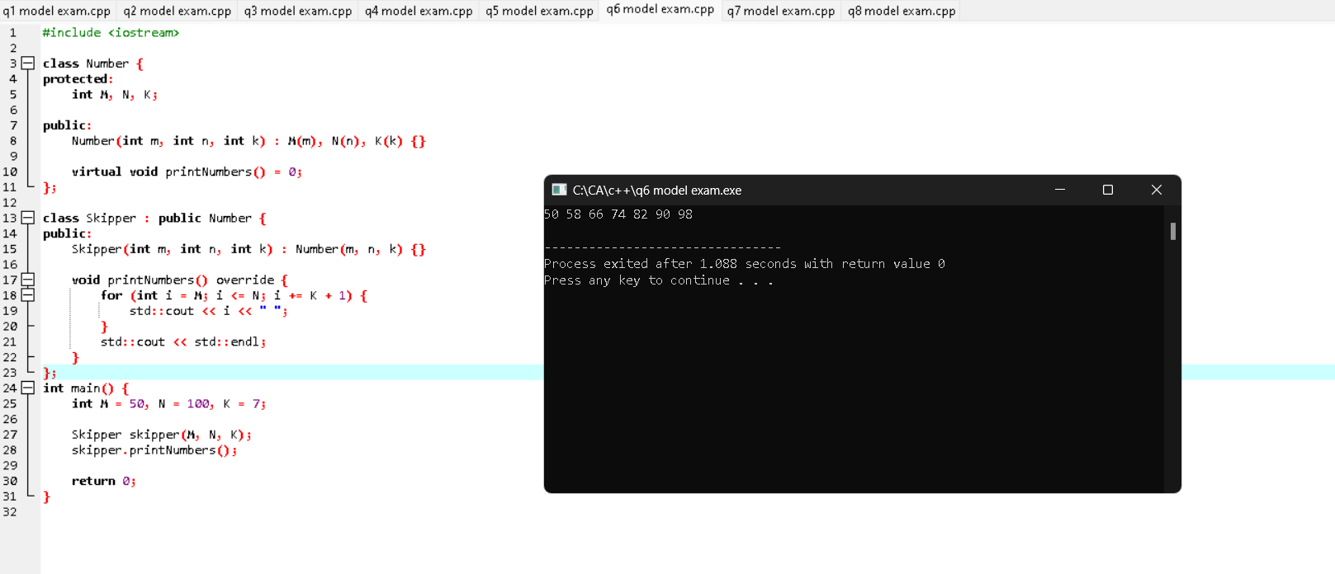

8) #include <iostream>

class Student {

private:

float marks[4];

float totalMarks;

float aggregate;

char grade;

public:

void enterMarks() {

std::cout << "Enter marks in four subjects:\n";

for (int i = 0; i < 4; ++i) {

std::cout << "Subject " << i + 1 << ": ";

std::cin >> marks[i];

totalMarks += marks[i];

}

}

void calculateAggregate() {

aggregate = totalMarks / 4.0;

}

void calculateGrade() {

if (aggregate > 75) {

grade = 'D';

} else if (aggregate >= 60 && aggregate < 75) {

grade = 'S';

} else if (aggregate >= 40 && aggregate <= 50) {

grade = 'T';

} else {

grade = 'F';

}

}

void displayResult() {

std::cout << "Total marks: " << totalMarks << std::endl;

std::cout << "Aggregate: " << aggregate << std::endl;

std::cout << "Grade: ";

switch (grade) {

case 'D':

std::cout << "Distinction";

break;

case 'S':

std::cout << "Second Division";

break;

case 'T':

std::cout << "Third Division";

break;

case 'F':

std::cout << "Fail";

break;

default:

std::cout << "Invalid Grade";

}

std::cout << std::endl;

}

};

int main() {

Student student;

student.enterMarks();

student.calculateAggregate();

student.calculateGrade();

student.displayResult();

return 0;

}

Ouput:

