EXP13. DEMONSTRATE INFRASTRUCTURE AS A SERVICE (IAAS) BY CREATING A VIRTUAL MACHINE USING A PUBLIC CLOUD SERVICE PROVIDER (AZURE), CONFIGURE WITH REQUIRED MEMORY AND CPU.

AIM:

To demonstrate infrastructure as a service (iaas) by creating a virtual machine using a public cloud service provider (azure), configure with required memory and cpu.

PROCEDURE:

STEP1: CREATE AN ACCOUNT IN MICROSOFT AZURE.

STEP2: GOTO RESOURCE GROUPAND CREATE A RESOURCE GROUP.

STEP3: GIVE NECESSARY THINGS FOR RESOURCE GROUP.

STEP4: CREATE A VIRTUAL NETWORK FOR TO CREATE A VIRTUALMACHINE .

STEP5: NOW CREATE A VIRTUAL MACHINE WITH UR IP ADDRESS ANUSERNAME AND PASSWORD FOR YOUR VIRTUAL MACINE.

STEP6: AND YOUR VIRTUAL MACHINE IS DEPLOYED.

STEP7: NOW CONNECT THE VIRTUAL MACHINE AND DOWNLOAD THE RDP FILETO OPEN YOUR WINDOWS VIRTUAL MACHINE.

STEP8: NOW RESIZE THE VIRTUAL MACHINE SIZE.

STEP9: CREATED A NEW WINDOWS VIRTUAL MACHINE

IMPLEMENTATION:

STEP1:CREATE AN ACCOUNT IN MICROSOFT AZURE.

STEP2: GOTO RESOURCE GROUP AND CREATE A RESOURCE GROUP.
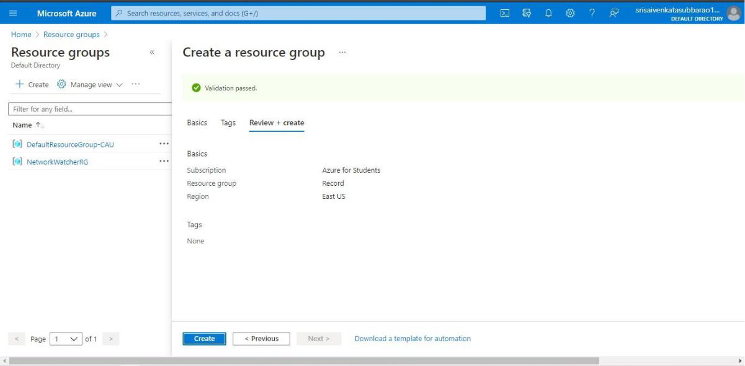

STEP3: GIVE NECESSARY THINGS FOR RESOURCE GROUP.
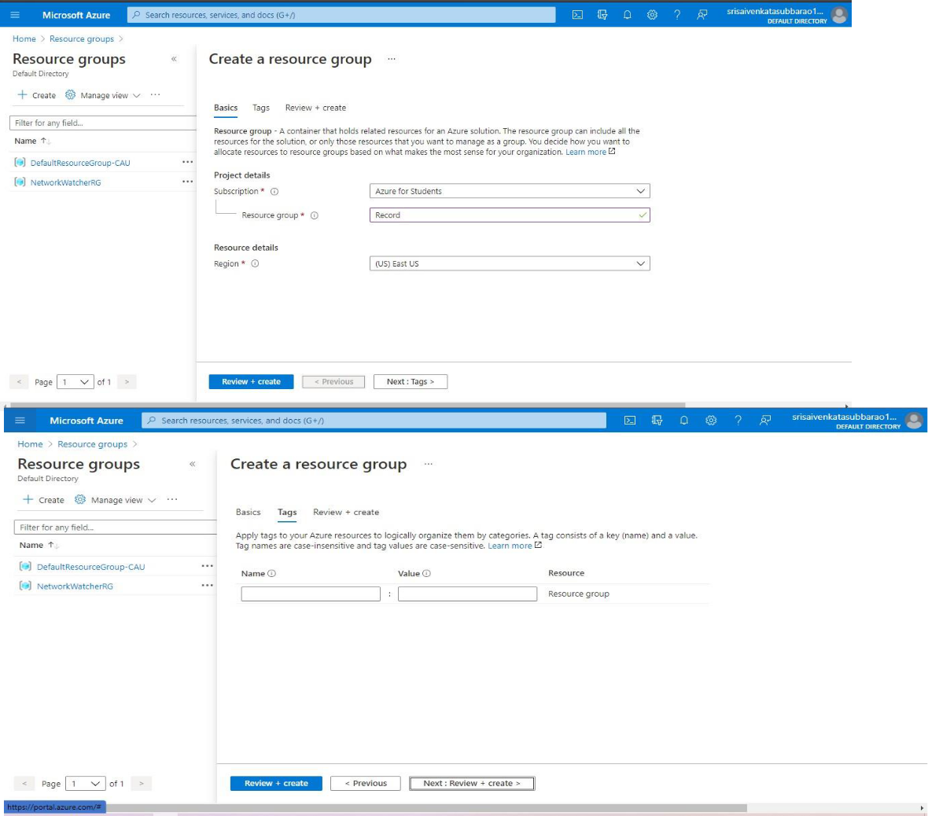

STEP4: CREATE A VIRTUAL NETWORK FOR TO CREATE A VIRTUALMACHINE .
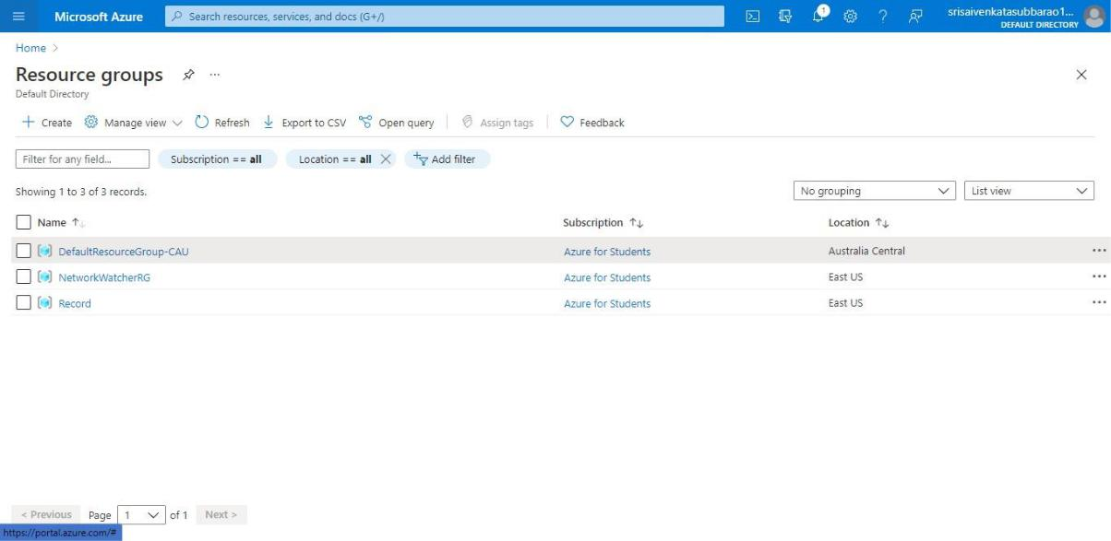
STEP5: NOW CREATE A VIRTUAL MACHINE WITH UR IP ADDRESS ANUSERNAME AND PASSWORD FOR YOUR VIRTUAL MACINE.

STEP6: AND YOUR VIRTUAL MACHINE IS DEPLOYED.
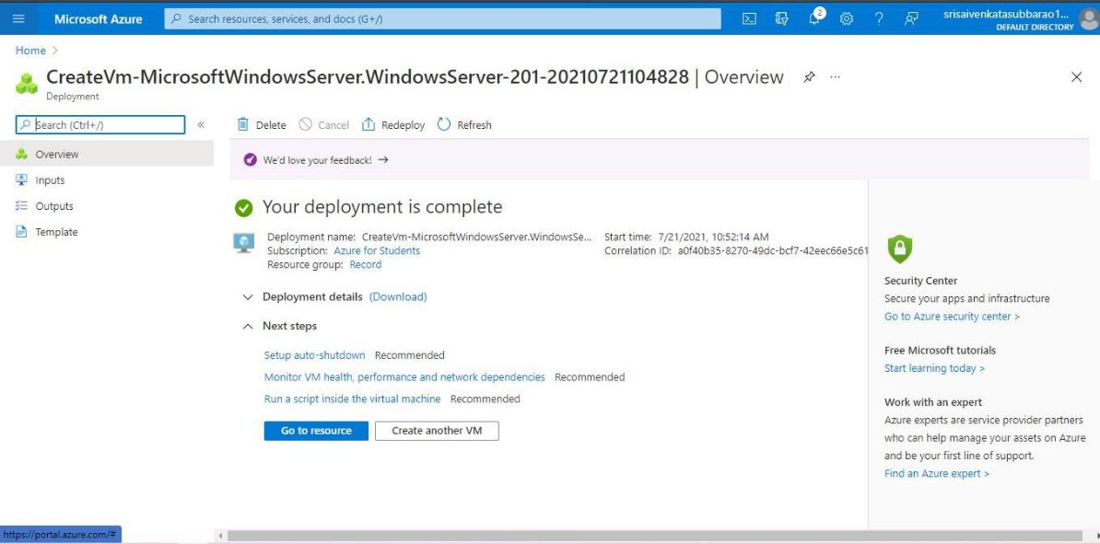

STEP7: NOW CONNECT THE VIRTUAL MACHINE AND DOWNLOAD THE RDP FILETO OPEN YOUR WINDOWS VIRTUAL MACHINE.

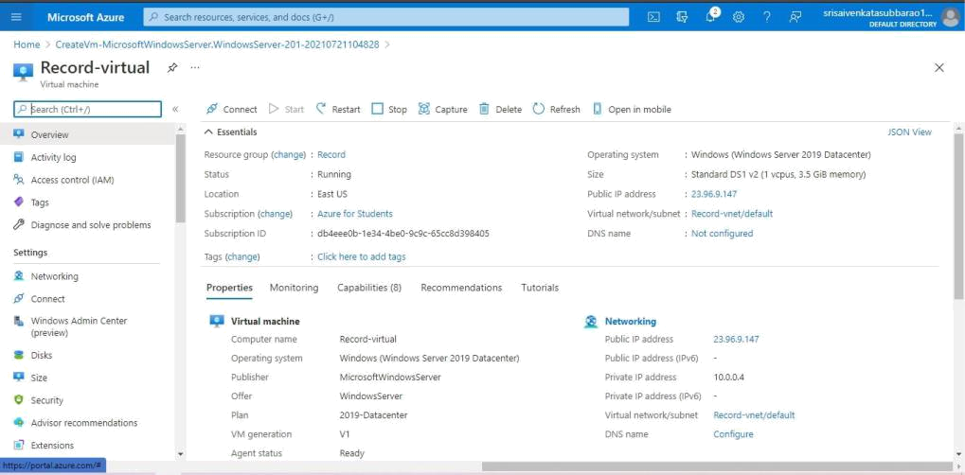

STEP8: CREATED A NEW WINDOWS VIRTUAL MACHINE.


