EXP15.CREATE A SIMPLE WEB SITE USING ANY PUBLIC CLOUD SERVICE PROVIDER (AZURE/GCP/AWS) AND CHECK THE PUBLIC ACCESSIBILITY OFTHE STORED FILE TO DEMONSTRATE STORAGE AS A SERVICE

AIM: CREATE A SIMPLE WEB SITE USING ANY PUBLIC CLOUD SERVICE PROVIDER (AZURE/GCP/AWS) AND CHECK THE PUBLIC ACCESSIBILITY OFTHE STORED FILE TO DEMONSTRATE STORAGE AS A SERVICE

Procedure:

STEP1: FIRSTLY, GO TO APPSERVICE TO CREATE AN WEBAPP.

STEP2: ENTER THE RESOURCE GROUP AND WEBAPP NAME AND REGIONAND SELECT THE LINUX OS.

STEP3: AFTER ENTER THE ALL THE NECESSARY THINGS CLICK THEREVIEW AND CREATE AND CLICK THE CREATE THE WEB APP.

IMPLEMENTATION:

STEP1: FIRSTLY, GO TO APPSERVICE TO CREATE AN WEBAPP.
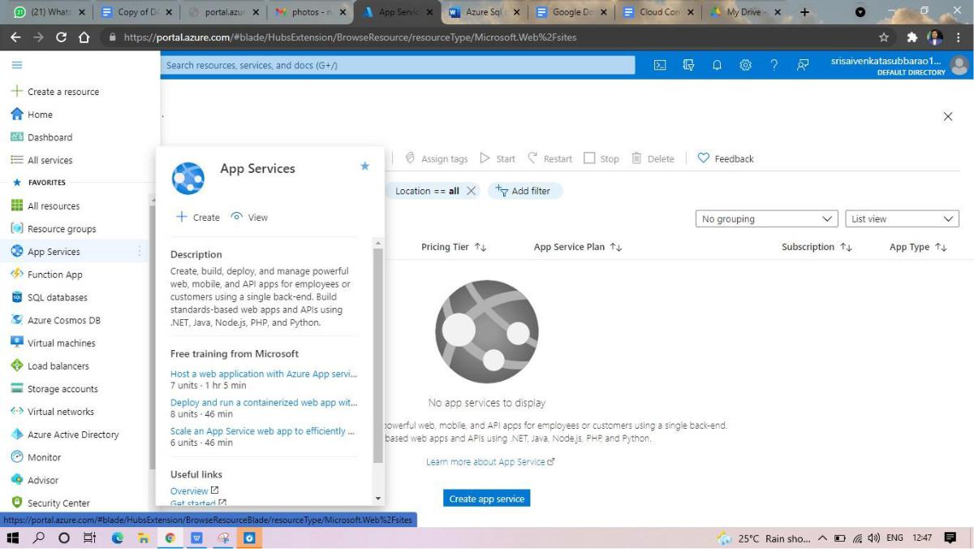

STEP2: ENTER THE RESOURCE GROUP AND WEBAPP NAME AND REGIONAND SELECT THE LINUX OS.
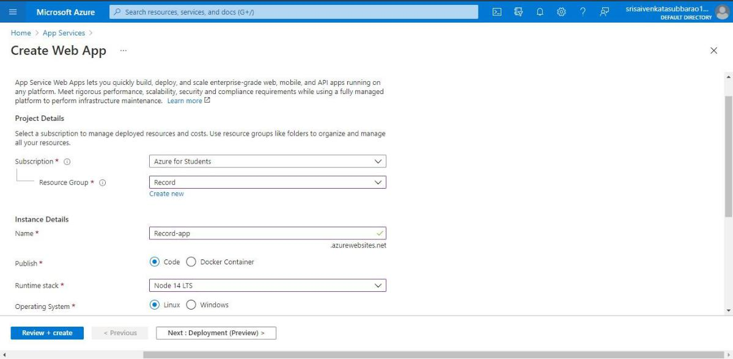

STEP3: AFTER ENTER THE ALL THE NECESSARY THINGS CLICK THEREVIEW AND CREATE AND CLICK THE CREATE THE WEB APP.
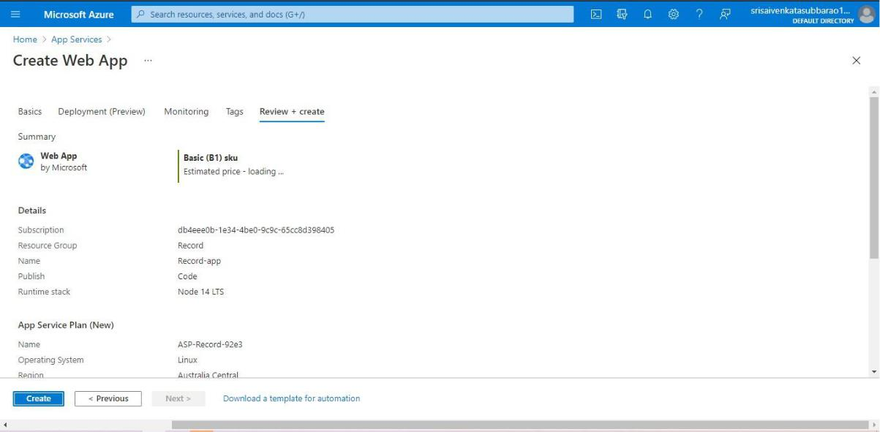
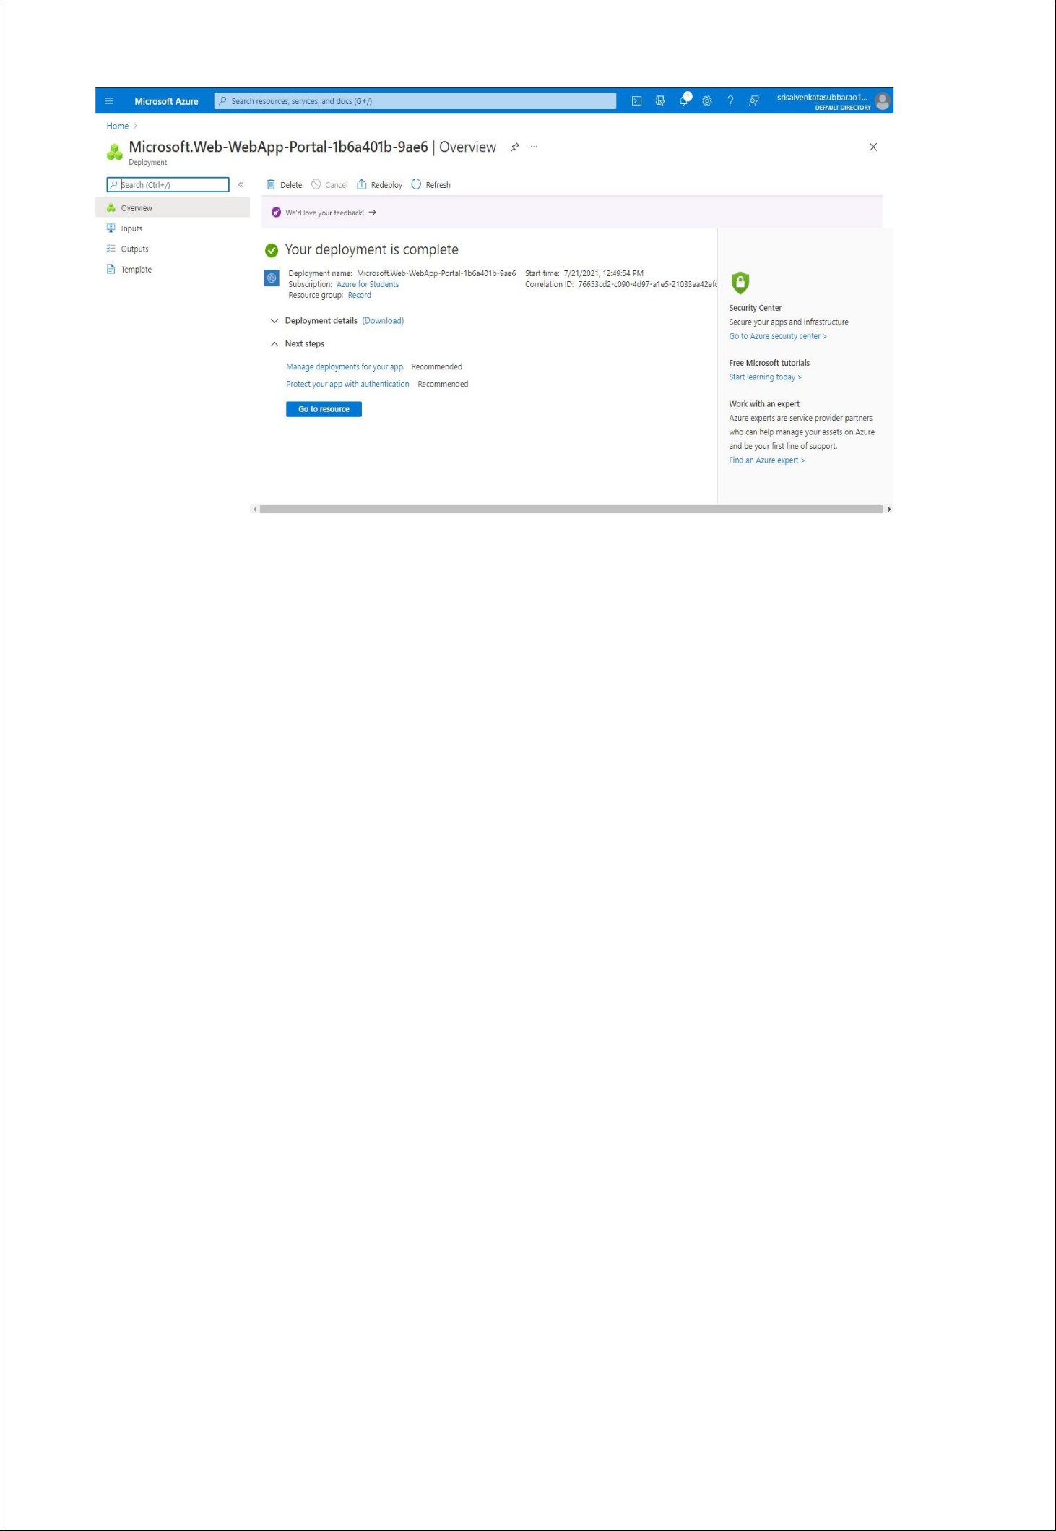

STEP4: AND OUR DEPLOYMENT IS COMPLETED.

STEP5: GOTO WEBSITE URL LINK.
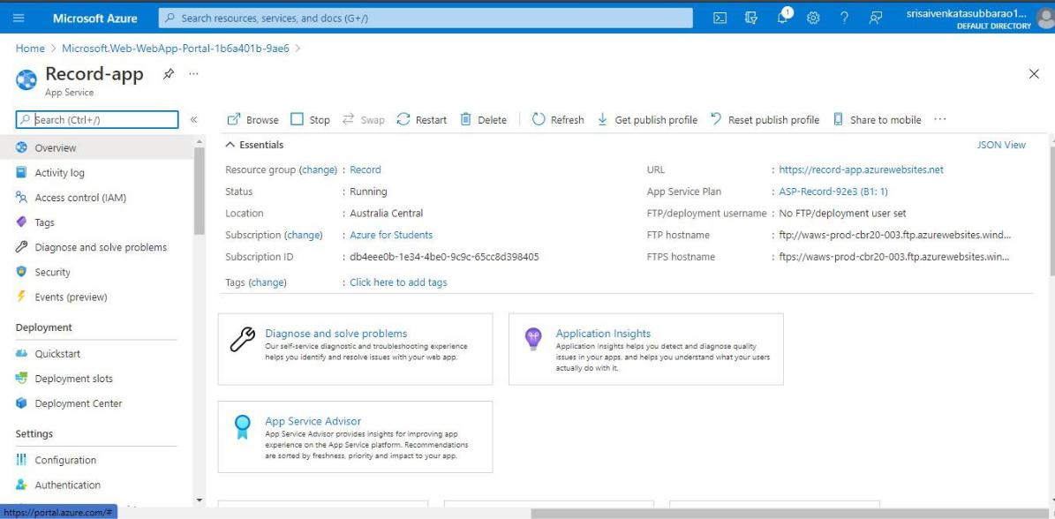

STEP6: THIS IS OUR WEBAPP SERVICE.
