EXP19.CREATE A STORAGE SERVICE USING ANY PUBLIC CLOUD SERVICE PROVIDER (AZURE/GCP/AWS) AND CHECK THE PUBLIC ACCESSIBILITY OFTHE STORED FILE TO DEMONSTRATE STORAGE AS A SERVICE.

AIM:

PROCEDURE:

STEP1: OPEN AZURE AND GOTO STORAGE ACCOUNTS AND CREATESTOROAGE ACCOUNT

STEP2: ENTER THE RESOURC GROUP AND AND STORAGE ACCOUNT NAMEAND REVIEW AND CREATE AND CLICK TH CREATE AND YOUR STORAGE ACCOUNT WILL BE DEPLOYED SUCESSFULLY.

STEP3: OUR STORAGE ACCOUNT IS CREATED.

STEP4: GOTO STATIC WEBSITE

STEP5: AND ENABLE AND ENTER YOUR INDEX AND ERROR HTML FILES NAMES.

STEP6: AND GOTO STORAGE EXPLORR(REVIEW) AND AND GOTO BLOBCONTAINERS AND WEB AND UPLOAD THE TWO HTML FILES INIT

STEP7: AND AGAIN RETURN TO STATIC WEBSITE AND OPEN THE PRIMARYLINK AND YOUR WEB PAGE IS CREATED

IMPLEMENTATION:

STEP1: OPEN AZURE AND GOTO STORAGE ACCOUNTS AND CREATESTOROAGE ACCOUNT
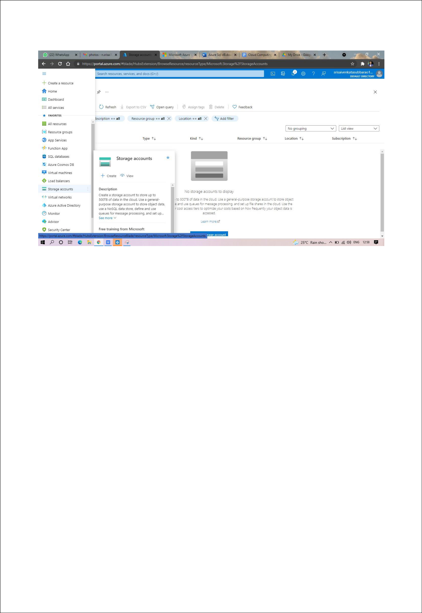

STEP2: ENTER THE RESOURC GROUP AND AND STORAGE ACCOUNT NAMEAND REVIEW AND CREATE AND CLICK TH CREATE AND YOUR STORAGE ACCOUNT WILL BE DEPLOYED SUCESSFULLY.
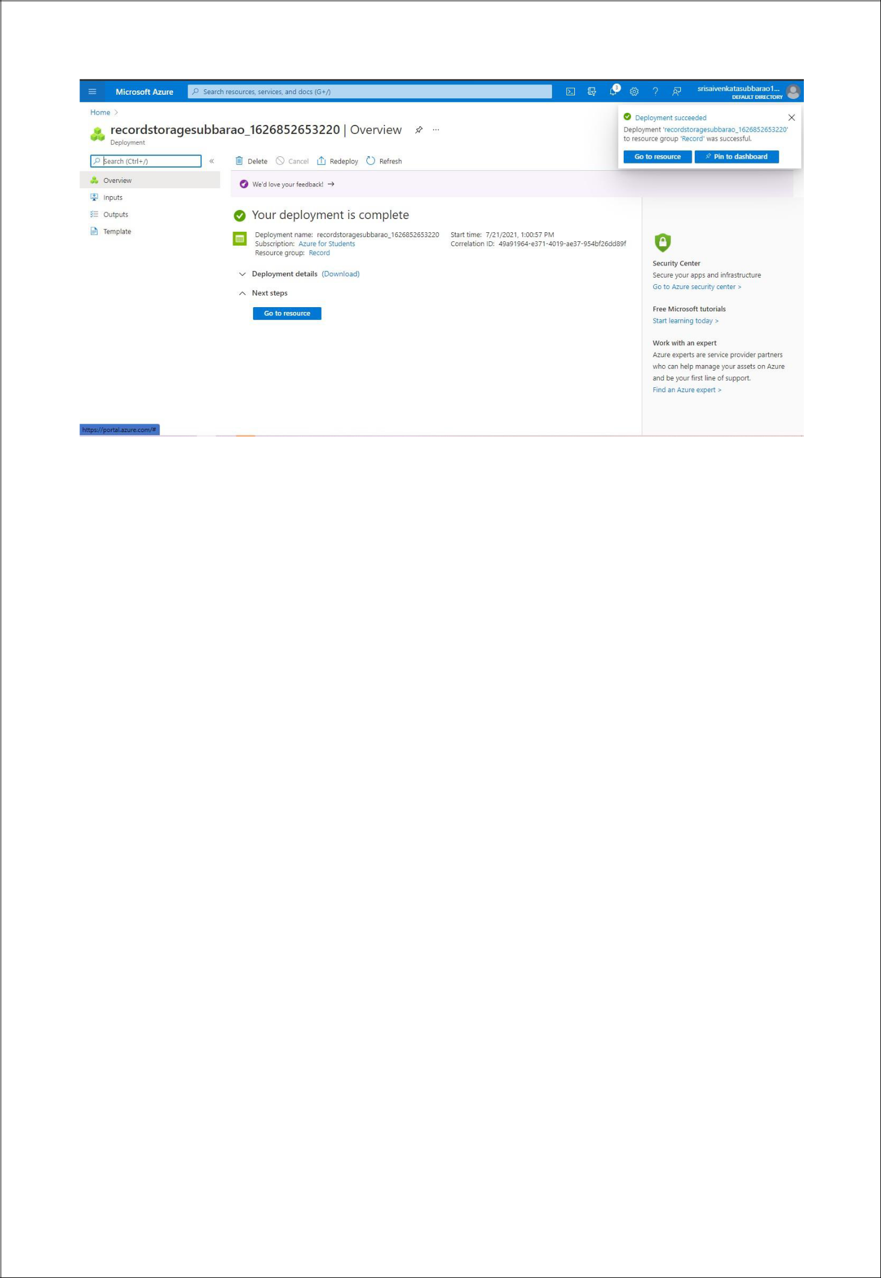

STP3: AND OUR STORAGE ACCOUNT IS CREATED.
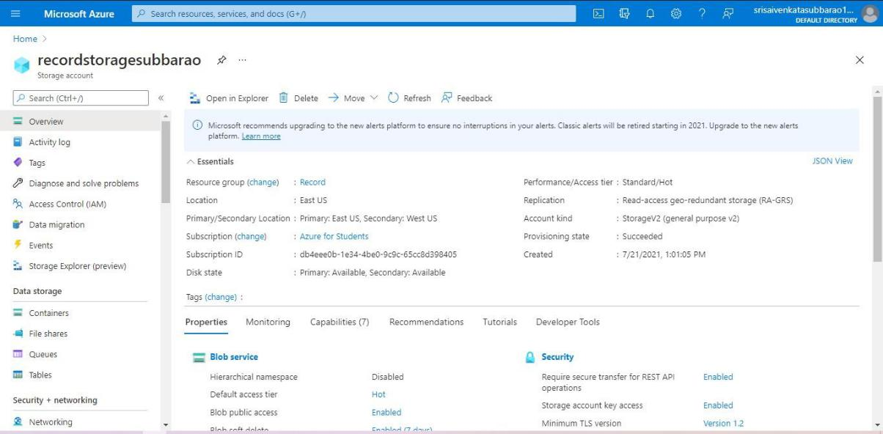

STEP4: GOTO STATIC WEBSITE
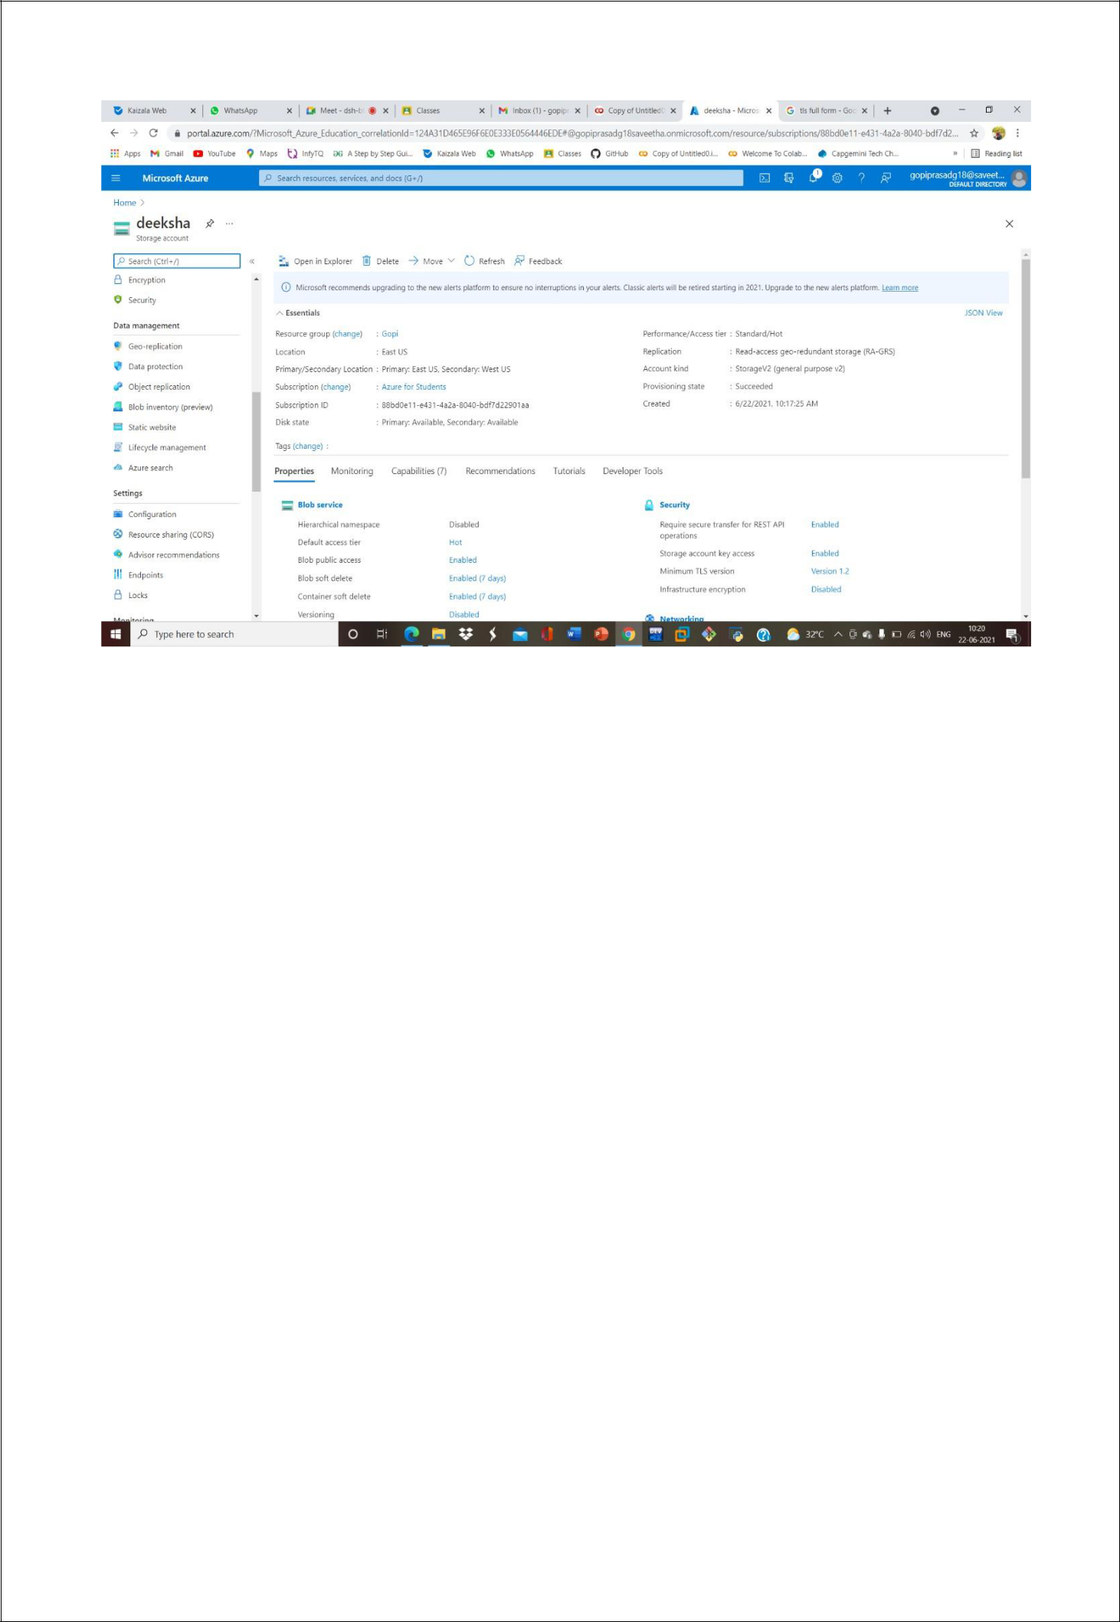

STEP5: AND ENABLE AND ENTER YOUR INDEX AND ERROR HTMLFILESNAMES.
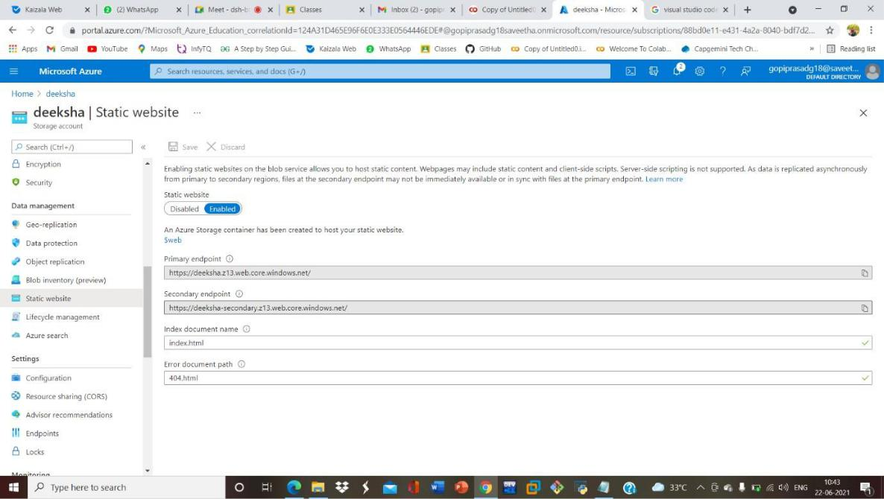
STEP6: AND GOTO STORAGE EXPLORR(REVIEW) AND AND GOTO BLOBCONTAINERS AND WEB AND UPLOAD THE TWO HTML FILES INIT
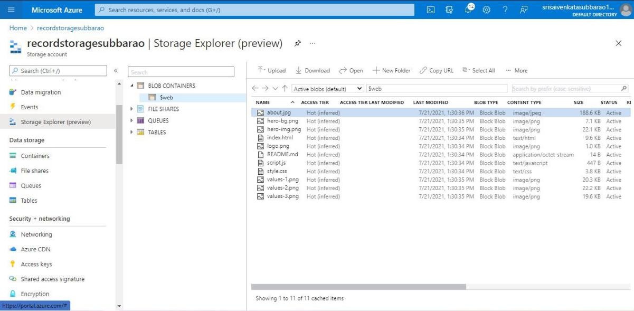

STEP7: AND AGAIN RETURN TO STATIC WEBSITE AND OPEN THE PRIMARYLINK AND YOUR WEB PAGE IS CREATED


