EXPNO 8: CREATE A VIRTUAL MACHINE WITH 1 CPU, 2GB RAM AND 15GB STORAGE DISK USING A TYPE 2 VIRTUALIZATION SOFTWARE.

DATE:

AIM:

To create a virtual machine with 1 cpu, 2gb ram and 15gb storage disk using a type 2 virtualization software.

PROCEDURE:

STEP 1:Dowload VMware workstation and installed as type 2hypervisor.

STEP2:Dowload ubuntu or tiny OS as iso image file.

STEP 3: In VMware workstation->create new VM.

STEP 4: Do the basic configuration settings.

STEP 5: Created tiny OS virtual machine.

STEP 6: Launch the VM.

IMPLEMENTATION:

STEP 1:DOWLOAD VMWARE WORKSTATION AND INSTALLED AS TYPE 2HYPERVISOR
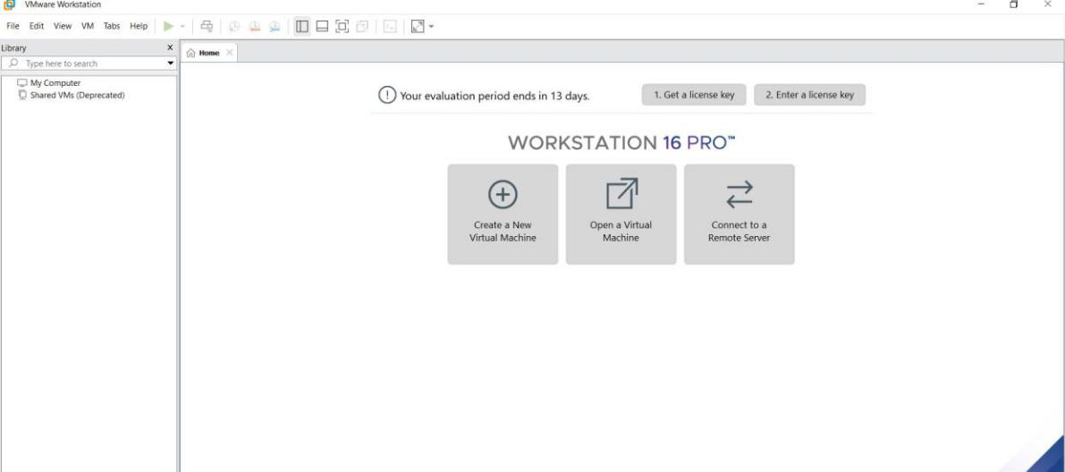
STEP2: DOWLOAD UBUNTU OR TINY OS AS ISO IMAGE FILE
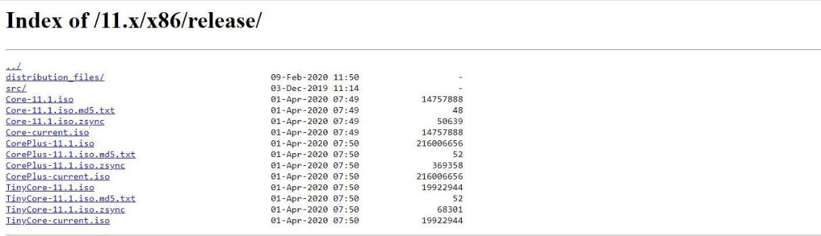

STEP 3: IN VMWARE WORKSTATION->CREATE NEW VM
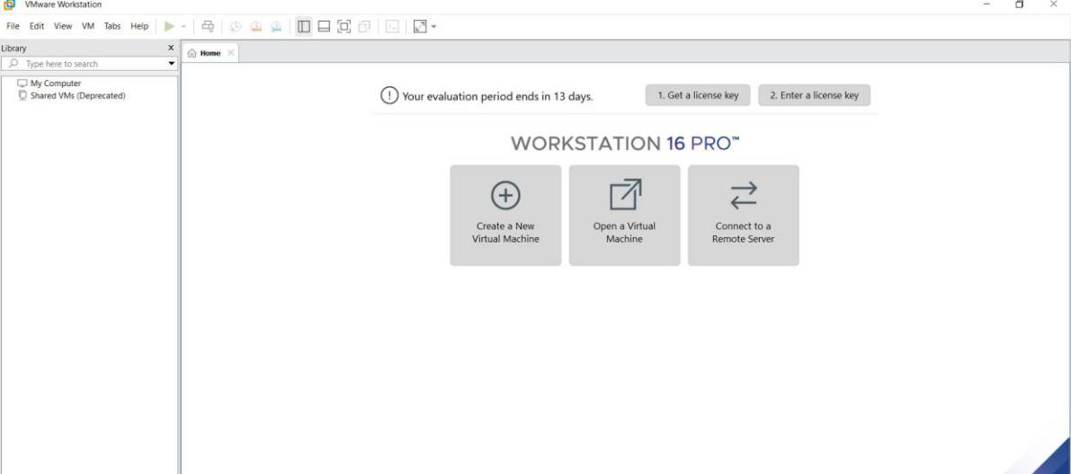

STEP 4: DO THE BASIC CONFIGURATION SETTINGS.
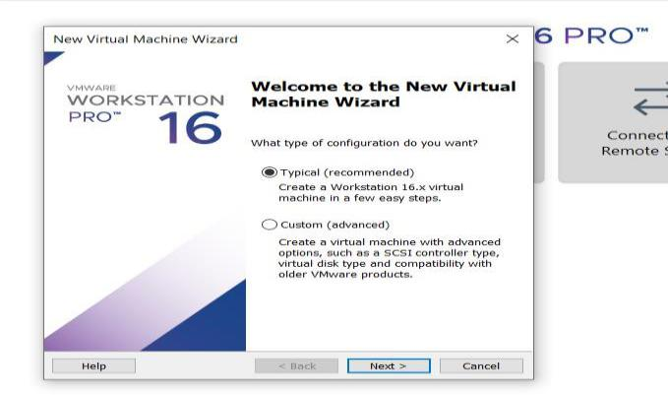
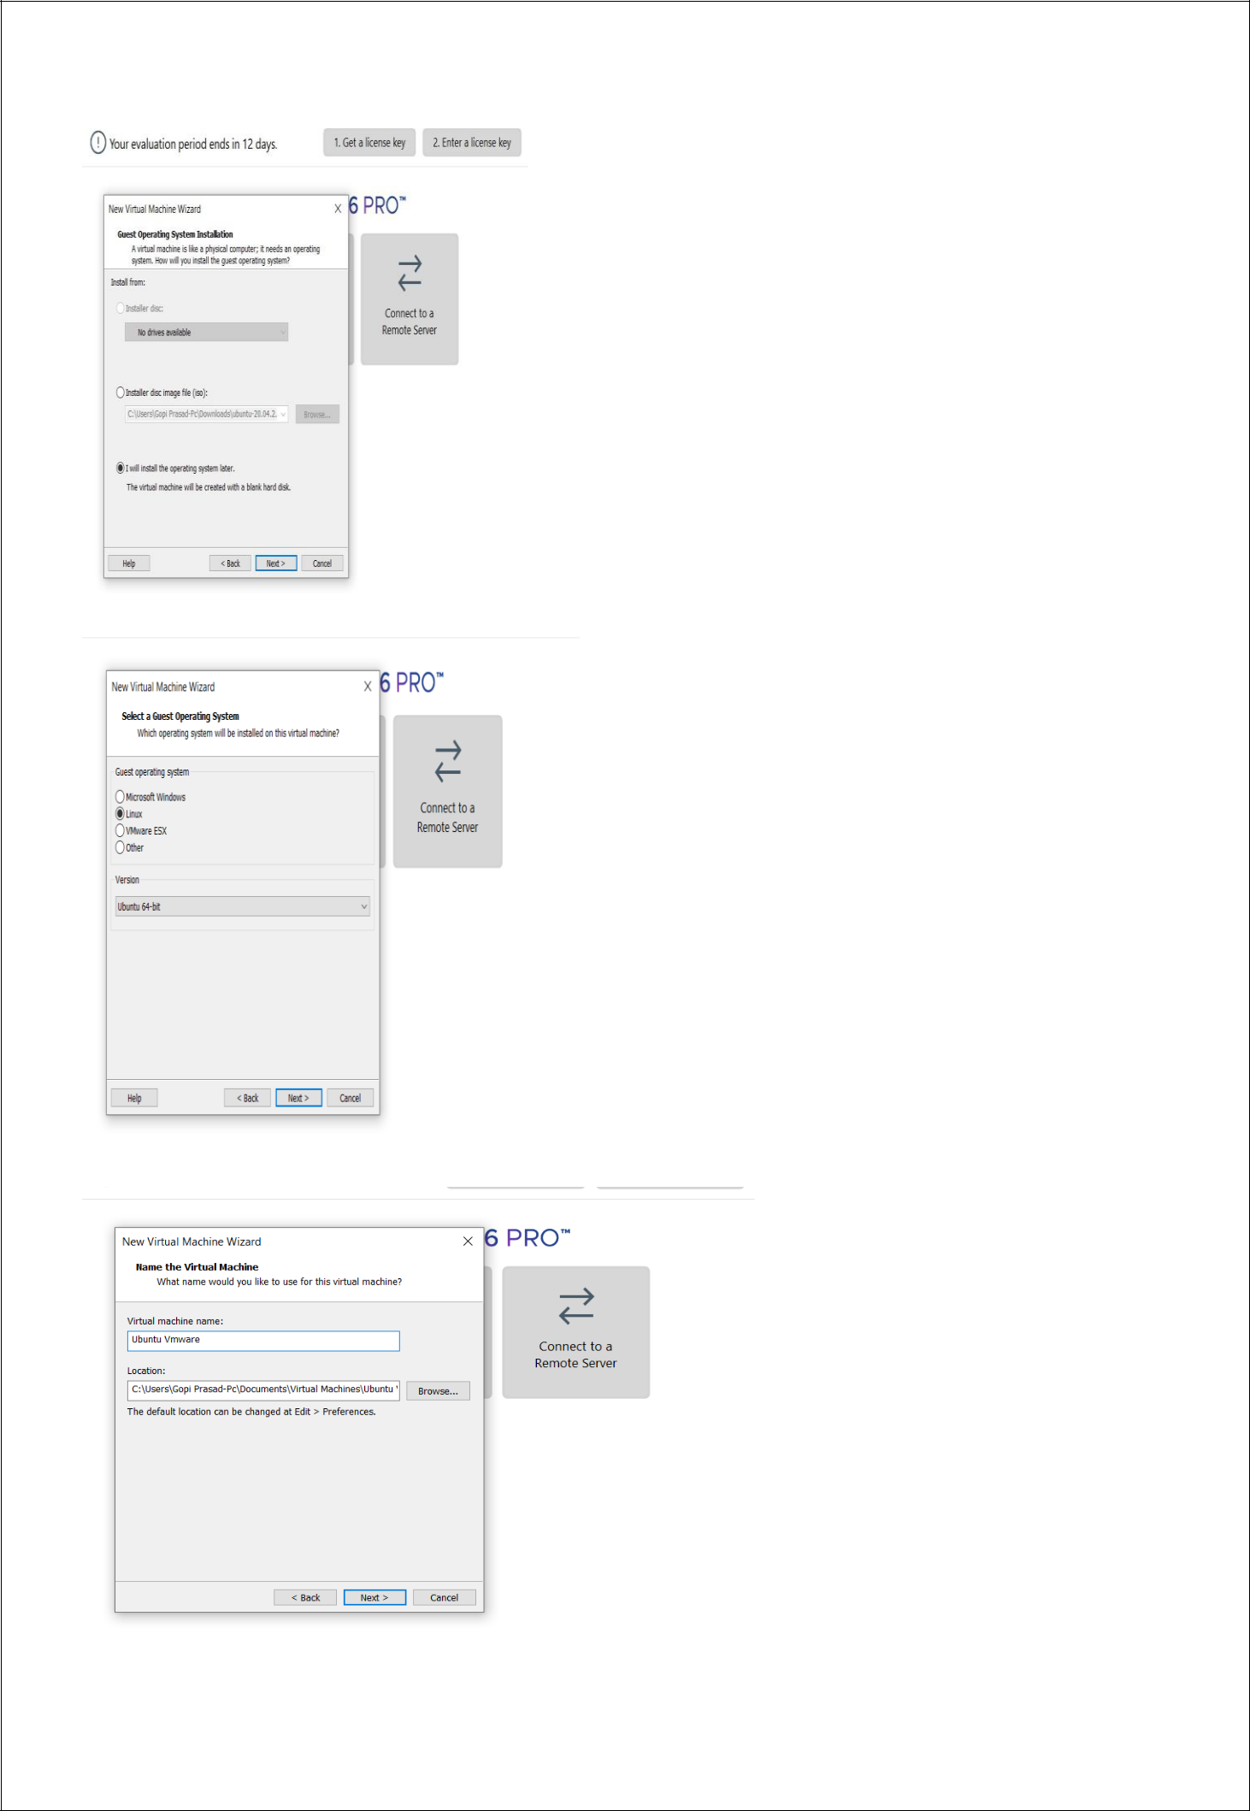
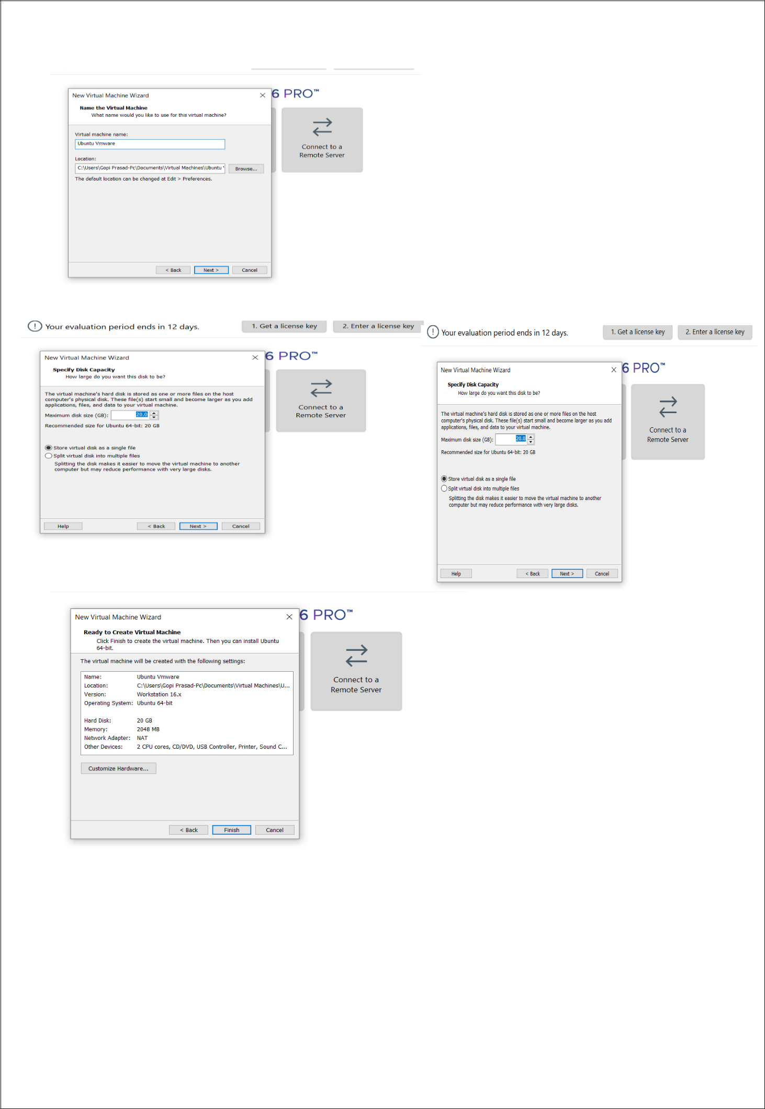

STEP 5: CREATED TINYOS VIRTUAL MACHINE
