PROJECT REPORT ON

ARIA AI PRODUCTIVIY
(AI Productivity)

By

Vadher Dhruvil | (2302106060)



DEPARTMENT OF COMPUTER SCIENCE AND APPLICATION

SHREYARTH UNIVERSITY

2025-2026

DEPARTMENT OF COMPUTER SCIENCE AND APPLICATION

SHREYARTH UNIVERSITY

2025-2026

CERTIFICATE

Date: / /

This is to certify that Mr.Vadher Dhruvil, from SHREYARTH UNIVERSITY having Enrollment No. 2302106060 , have completed project documentation and fully developed on the problem definition of semester VI during the academic year 2025-26 having Title Project Title in a group consisting of Group member number(1).

Institute Guide Head of the Department

Company Certificate

ACKNOWLEDGEMENT
We would thank God for being able to complete this project with success. Then We would like to thank our faculty whose valuable guidance has been the ones that helped us patch this project and make it full proof success his suggestions and his instructions has served as the major contributor towards the completion of the project. Secondly we would also like to thank our parents who supported in our project.

Vadher Dhruvil | (2302106055)

Table of Contents
ABSTRACT VI
Chapter 1 Introduction 2
  - Need of the system 2
  - Detailed Problem Definition 2
  - Viability of the System 2
  - Presently Available Systems 2
  - Future Prospects 3
Chapter 2 Analysis 4
  - Requirement Analysis 4
    - Authentication 4
    - Process Data 4
  - Project Model 6
    - Advantages 7
  - Schedule Representation 7
  - Feasibility Study 8
    - Technical Feasibility 8
    - Economical Feasibility 8
    - Operational Feasibility 8
Chapter 3 Technical Specification 10
3.1 Hardware Specification 10
3.1.1 RAM 10
3.1.2 Hard Drive Storage needed 10
3.1.3 Other Hardware requirement 10
Chapter 4 Design layout. 11
4.1.1 Screenshot 17
Chapter 5 Testing. 15
Testing Methods 16
5.1.1White Box Testing 17
5.1.2Black Box Testing 17
Conclusion……………………………………… 18
BIBLIOGRAPHY 19

ABSTRACT

This project report covers the design and development of ARIA (Advanced Responsive Intelligence Agent), a desktop-based AI Productivity application built using Python and CustomTkinter. ARIA integrates task management, Pomodoro timer, habit tracking, productivity scoring, nearby place discovery, and an AI-powered chatbot into a unified interface. The system uses SQLite for local data persistence and communicates with Pollinations AI for natural language coaching responses. The design incorporates a modular sidebar-driven architecture with multiple functional frames. The technical specification includes a Python back-end using CustomTkinter, SQLite, and the Requests library, running on Windows with voice output via PowerShell speech synthesis. The platform is designed to be user-friendly, motivating, and data-driven, with potential for future cloud sync and mobile integration.

Company Profile

Overview of the Company

IBM is a leading global technology and consulting company founded in 1911 and headquartered in Armonk, New York, USA. It is widely recognized for its long history of innovation and strong influence on the development of the IT industry. IBM offers a broad range of products and services, including computer hardware, software, cloud computing, data analytics, and consulting solutions for businesses worldwide. The company played a key role in the evolution of mainframe computers and continues to lead in advanced technologies like artificial intelligence and quantum computing.

IBM’s AI platform, Watson, is used by organizations to analyze large volumes of data and support better decision-making. In recent years, IBM has focused heavily on hybrid cloud solutions, helping companies manage data across both private and public cloud environments. It serves various industries such as healthcare, banking, education, retail, and government sectors. Known for its strong research and development culture, IBM holds numerous patents and continues to drive technological advancements, making it a trusted partner for digital transformation globally.

CHAPTER-1

INTRODUCTION

Need of the system
    - ARIA is designed to facilitate the selling of products through productivity. It allows users to post products they want to sell on a website, making it a platform for selling products. Its main objective is to obtain the best value and the highest price for the products. This is achieved by allowing multiple users to participate in the tasks, driving up the price of the product.
    - Many professionals struggle with scattered productivity tools, lack of motivation, and poor time management. Without a centralized system, tracking tasks, maintaining habits, and measuring productivity becomes difficult. houses, which can be limited in terms of reach and accessibility. With ARIA, users can reach a global audience, increasing the chances of achieving peak productivity by having all tools in one intelligent application.

Detailed problem definition
    - The traditional public task system has several limitations, including:
    - Inconvenience: Physical tasks require buyers to be physically present, which can be inconvenient for those who are not located near the time.
    - Limited accessibility: Traditional task houses may not be accessible to people with disabilities or those who live in remote areas.
    - Limited participation: Traditional tools are often limited to single-purpose use, making it hard to specific geographic location, making it difficult for people from far and wide to participate.

    - State-level accessibility: It can be used on any Windows desktop, making it accessible to students and professionals alike.
    - Convenience: It provides a convenient all-in-one workspace for productivity, eliminating the need to switch between separate apps.

Viability of the system
    - Scalable and Flexible: ARIA provides a flexible and easy-to-use task management solution for individuals and businesses. It offers modules for task listing management, enabling users to manage their products and bids effectively.
    - Efficient task management: It provides a centralized platform for managing tasks, making it easy to track bids, users, and buyers, and make informed sales decisions.

Presently available system
    - Manual record-keeping: Records are maintained manually, which can be time-consuming and prone to errors.
    - Lack of user-friendliness: The system is not user-friendly, making it difficult for users to navigate and use.
    - Standalone system: The existing system is based on a standalone system, which can make it difficult to integrate with other systems.
    - These limitations can lead to inefficiencies and inaccuracies, making it difficult for organizations to manage their tasks effectively.
    - www.etask.com

Future prospects

    - ARIA has potential for future expansion, including:
      - Adding Consignor features: The system can be expanded to include additional features, such as delivering details and customized reporting of delivery.
      - Providing high security for tasks: The system can be designed to provide high security for tasks, ensuring that transactions are secure and protected from fraud.

CHAPTER-2 ANALYSIS

Requirement Analysis

User Interaction
      - Bidders: Regular users interact with all eight modules: Dashboard, Tasks, Pomodoro, Habits, Plan, Relax Agent, AI Chat, and AI Coach. The app runs locally with no login or authentication required.
      - Tasks: The user component is a crucial aspect of an online task system, enabling users to create and manage their tasks like Inventory Management.
      - Administrators: Admins must authenticate with higher security measures to manage platform policies, user accounts, and task data.

Process data

Auction Data Management:
  - Task Entries: When a user lists an item for tasks, ARIA processes data such as the item’s title, description, starting bid price, task start/end time, reserve price, and any attached images.
  - Bidding Process: Each bid made by a registered user must be processed by ARIA, including validating the bid amount and storing the task details in the SQLite database.
  - Bid Updates: Each time a new bid is placed, It will update the task's status in real-time, displaying the new highest bid to other users.

User Data Processing:
  - Registration: When a user marks a habit as done, ARIA increments the streak counter, records today's date as last_done, and refreshes the habit cards display immediately.

Bid Management:
  - Real-Time Bidding: It processes and validate bids in real- time. When a bid is submitted, It checks the current bid status, validates the new bid, and updates the task accordingly.

Payment and Transaction Data:
  - Payment Processing: After an task concludes, It processes payments from the winning bidder. Payment data (amount, transaction ID, payment method) will be securely handled, and both buyer and user will be notified of successful transactions.

Auction Status Management:
  - Auction Timers: It continuously processes data related to task timing, ensuring that tasks start and end at the specified times. When an task ends, the system must process the final bid, notify the winning bidder and user, and transition the task to its completed status.

Data Validation and Integrity:
  - Input Validation: It must validate all incoming data to ensure that no incorrect or malicious data is processed. For instance, empty task names or invalid date fields are rejected with a warning dialog before saving.
Data Consistency: It ensures that task data, user data, and bid data remain consistent across the platform

Advantages
      - Each successive version of the system provides improved features and better performance than the previous version.
      - The core modules such as Task Manager, Productivity Scoring, AI Coaching Assistant, and Chatbot are tested thoroughly, which reduces the chances of errors in the final product.
      - The model is flexible and allows easy modification of project scope and requirements with lower cost.
      - Continuous feedback at every stage helps in developing a better and more user-friendly final product.
      - The system improves both user productivity and mental well-being by combining task management with relaxation support..

Schedule Representation
- General project scheduling tools and techniques can be
- applied with minor modifications to software development projects.
- PERT (Program Evaluation and Review Technique) and CPM (Critical Path Method) are two important project scheduling
- methods that can be effectively applied to the development of this system.
- Both techniques are based on information gathered during the
- planning phase, including:

Decomposition of system functions such as task management, scoring,
chatbot, and location-based suggestions
- Selection of appropriate process model and task set
- Estimation of effort and development time
- Data and module decomposition
- Testing and implementation schedule
    - These scheduling methods help in
    - effective
time management, resource allocation
, and
successful project completion.

[Table 1: Schedule Representation]

ACTIVITY | START DATE | FINISH DATE
Requirement Analysis
System Analysis
System Design
System Coding
Testing and Integration

Feasibility Study:

Technical Feasibility:
      - Evaluate whether the necessary technologies are available and suitable for the project.
      - Currently available web technology: Python 3.10+ CustomTkinter.
      - Servers: CustomTkinter.
      - DBMS: SQLite.

Economical Feasibility:
      - Estimate the cost of developing ARIA. This includes costs for hiring developers, purchasing hosting services, acquiring third- party tools.

Operational Feasibility:
      - Operational feasibility is the measure of how well a proposed system solves the problems, and takes advantage of the opportunities identified during scope definition and how it satisfies the requirements identified in the requirements analysis phase of system development.

      - The operational feasibility assessment focuses on the degree to which the proposed development projects fits in with the existing business environment and objectives with regard to development schedule, delivery date, corporate culture and existing business processes.
      - To ensure success, desired operational outcomes must be imparted during design and development. These include such design- dependent parameters as reliability, maintainability, supportability, usability, predictability, disposability, sustainability, affordability and others.
      - These parameters are required to be considered at the early stages of design if desired operational behaviours are to be realized. A system design and development requires appropriate and timely application of engineering and management efforts to meet the previously mentioned parameters.
      - A system may serve its intended purpose most effectively when its technical and operating characteristics are engineered into the design. Therefore, operational feasibility is a critical aspect of systems engineering that needs to be an integral part of the early design phase.

CHAPTER-3 TECHNICAL SPECIFICATION

Hardware Specification:
    - Ram: 4GB
    - Hard Drive Storage Needed: 6GB
    - Other Hardware Requirements: None

Platform:
    - Supported Operating System: Windows XP and above LINUX.
    - Programmer Server: CustomTkinter Python 3.10+

Framework:
    - Mark-up Language: N/A (Desktop App).
    - Programming Language: Python 3.10+ SQLite3.

Technical Specification:
    - Front-End: CustomTkinter, CustomTkinter.
    - Back-End: SQLite3, CustomTkinter
    - IDE Tools: Visual Studio Code.
    - UML Tools: draw.io(N/A)
    - SRS Tools: Microsoft Word 2016.

CHAPTER-4

DESIGN LAYOUT

Home Page:-

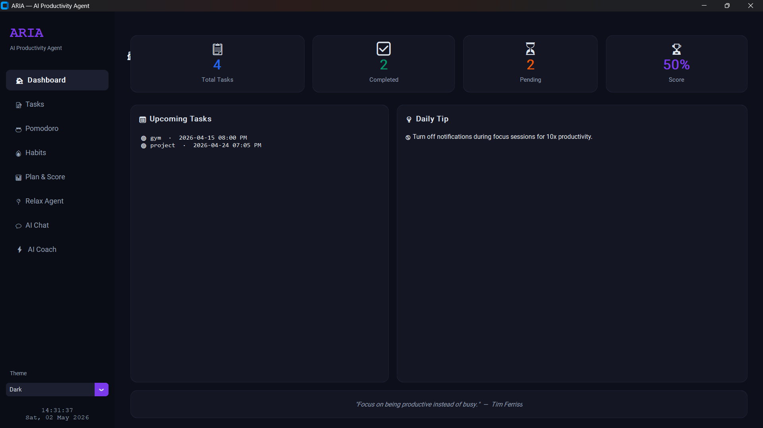
[Figure 7: Home Page]

Tasks page:-
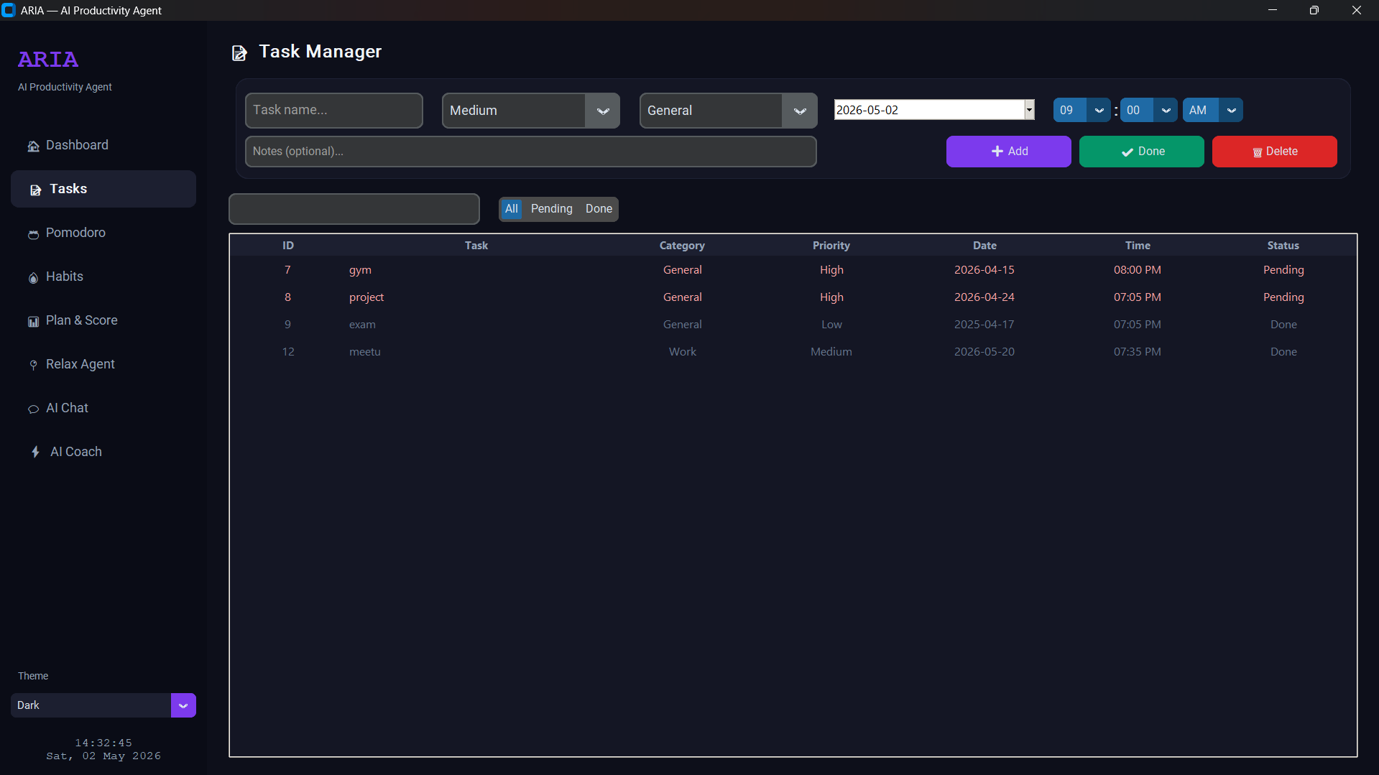

Habit tracker Page:-
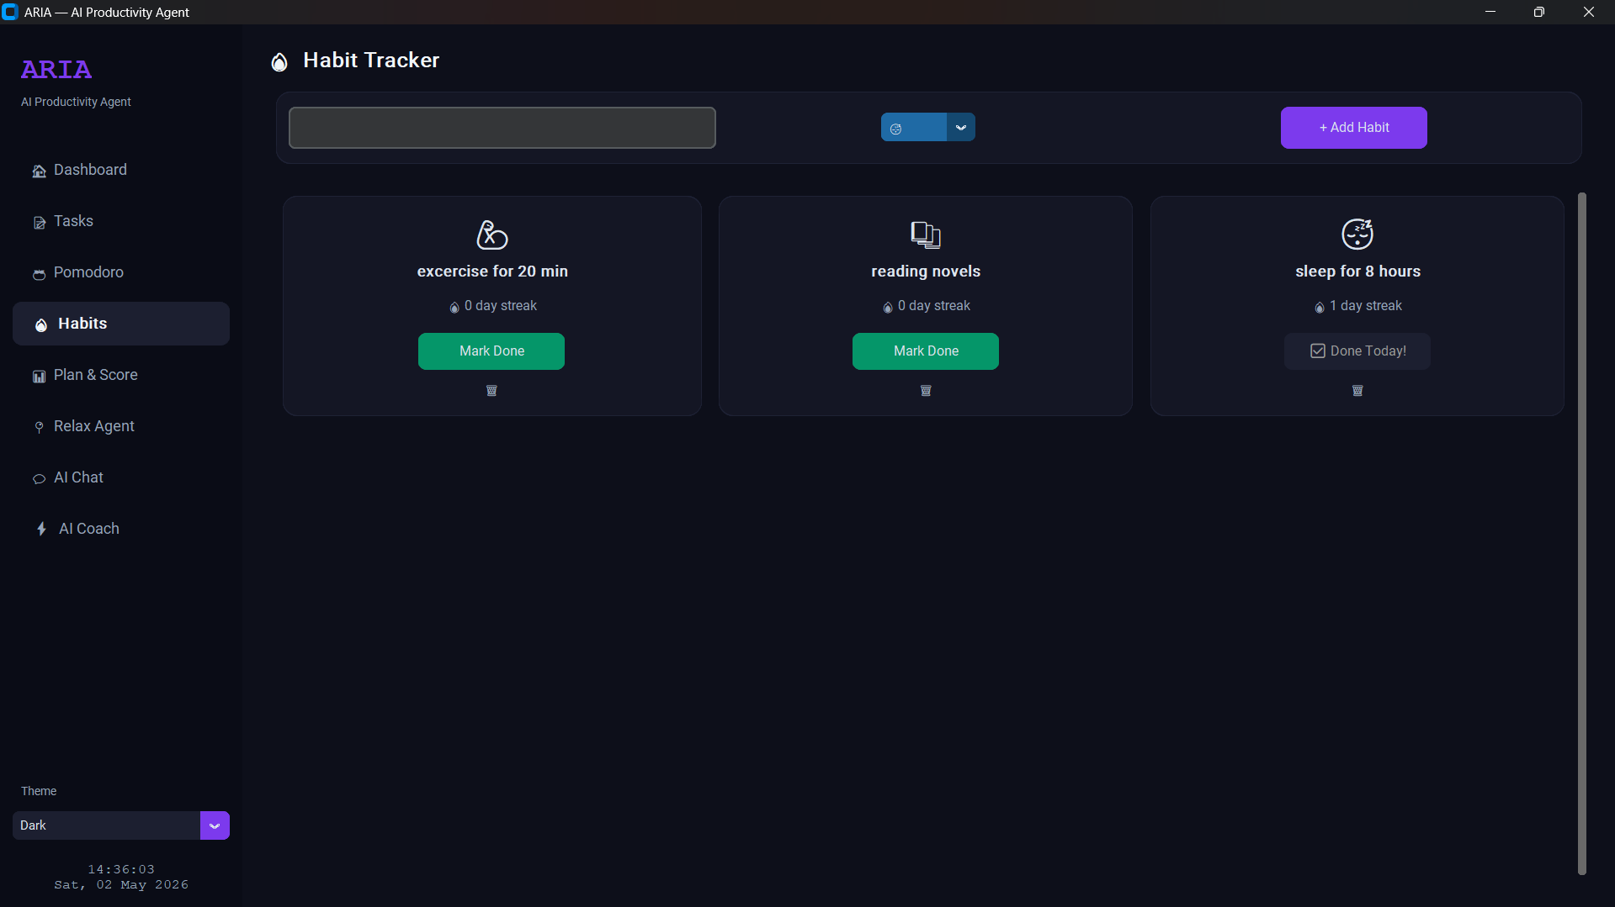
[Figure 9: Habit tracker Page]

Plan & Scoring Page:-
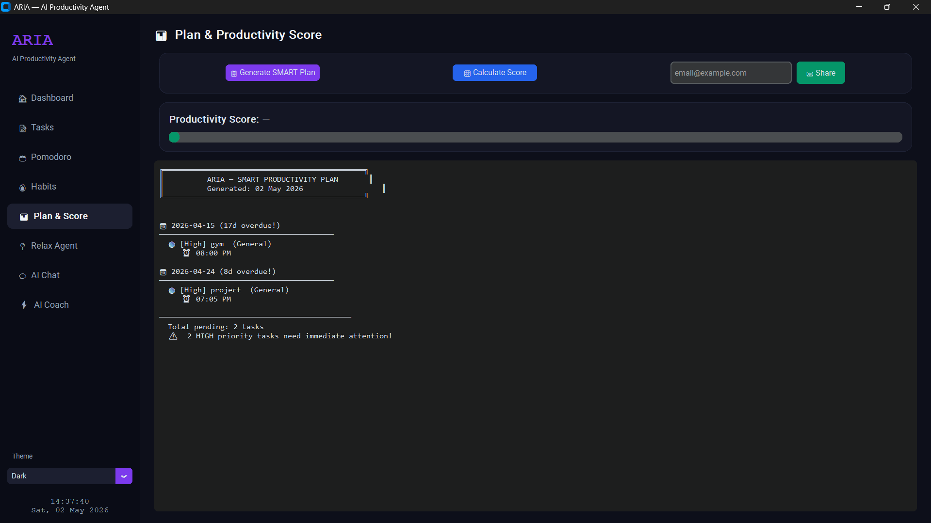
[Figure 10: Plan & Scoring Page]

Relax Agent Page:-

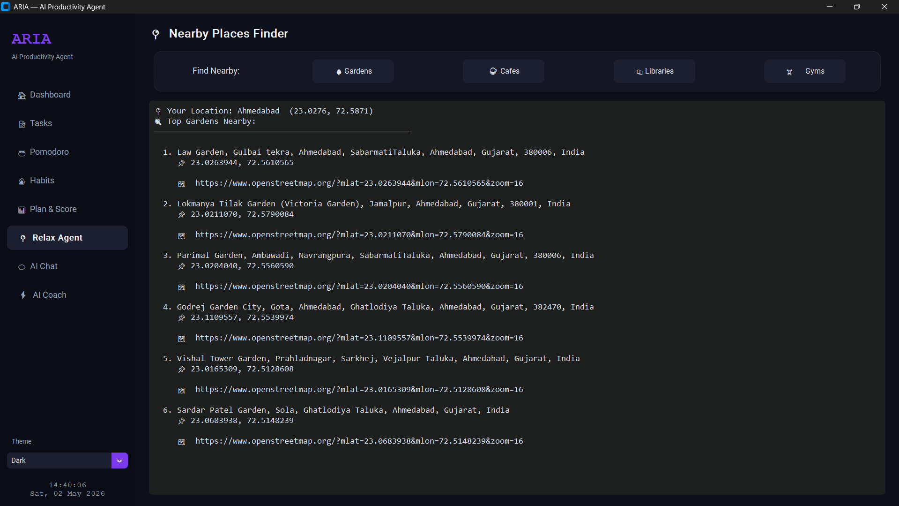
[Figure 11: Relax AgentPage]

Aria Chatbot Page:-

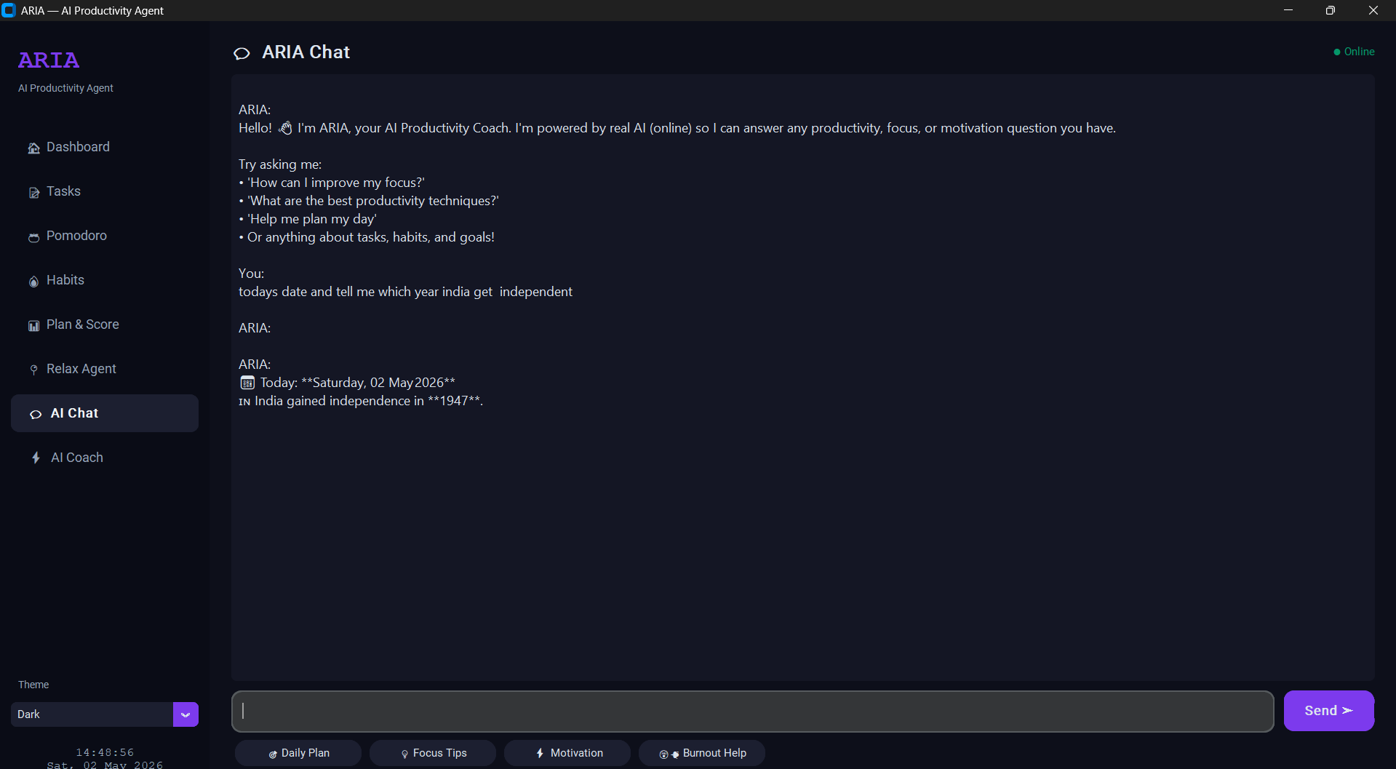
[Figure 12:Aria Chatbot Page]

Aria Coach Page:-

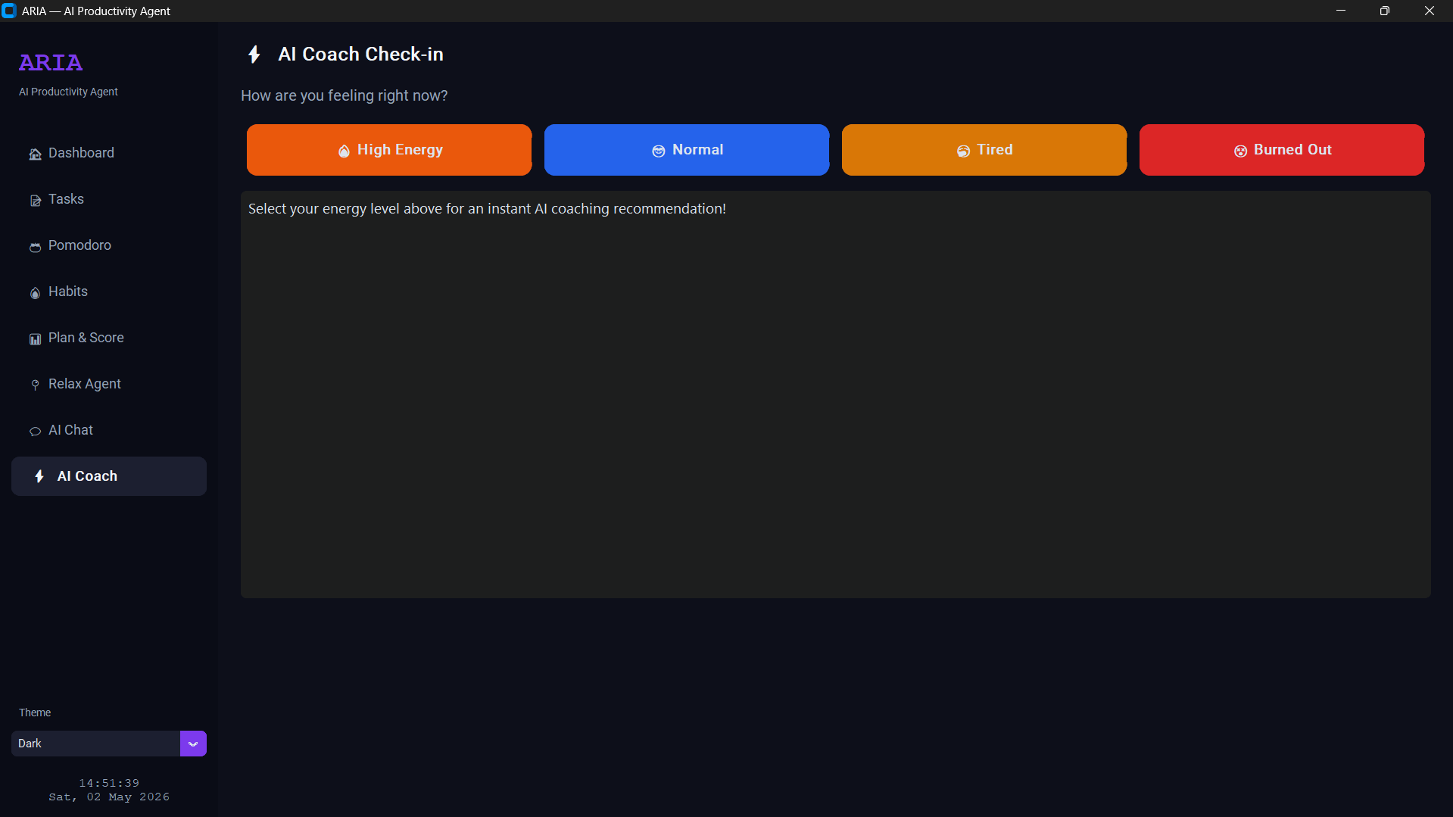
[Figure 12: Aria Coach Page]

Email page:-

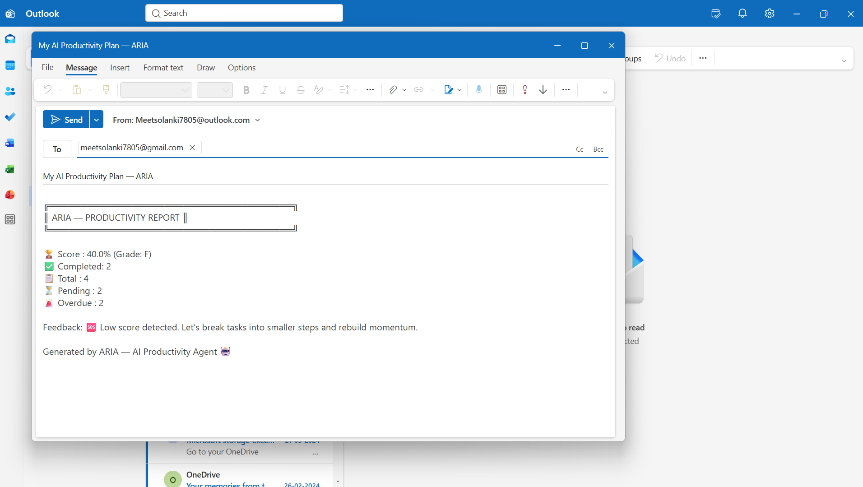
[Figure 12: EMAIL Page]

CHAPTER-5 TESTING

Testing Methods
There are different models of testing. On the basis of testing methods there are two types of testing:
- Black-box testing
- White-box testing

Black-box tests are used to demonstrate that software function is operationally, that input is properly accepted and output is correctly produced, and that integrity of external information is maintained.
White-box tests are used to examine the procedural details. It checks the logical paths by test case. It can also check the conditions, loops used in the software coding. It checks that loops are working correctly on defined boundary value.

WHITE-BOX TESTING
White-box testing sometimes called glass-box testing, is a test case design method that users the control structure of the procedural design to drive the test case. Always we are thinking that there is no necessary to execute or checks the loops and conditions. With using white-box testing methods, we have checked that,
      - All independent paths within a function have been executed at least once.
      - All logical decisions on their true and false side.
      - All loops working correctly at their boundary values and within their specified conditions

In our coding we test that all the loops work truly in each module. The one technique of white-box testing is basis path testing. It contains two parts, one is flow graph notation and the second is cyclometer complexity. In flow graph notation we are checking logical control of flow. By using cyclometer complexity, we find complexity of our project structure.

BLACK-BOX TESTING

The technique of testing without having any knowledge of the interior workings of the application is Black Box testing. The tester is oblivious to the system architecture and does not have access to the source code. Typically, when performing a black box test, a tester will interact with the system's user interface by providing inputs and examining outputs without knowing how and where the inputs are worked upon.

We used following problems in our coding to find errors in the following categories:
      - Incorrect or missing function.
      - Interface errors.
      - Error in database.
      - Performance errors.
      - Initialization and termination errors.

Unlike white-box testing, which is performed earlier in the testing process, black-box testing tends to be applied during later stages of testing.
By applying black-box techniques, we derive a set of test cases that satisfy following criteria. Test cases that reduce, by a count that is greater than one, the number of additional test cases must be designed to achieve reasonable testing.

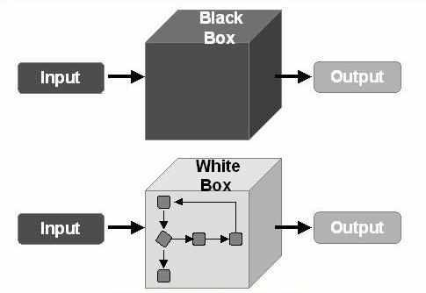

[Figure 8–Testing Methods]

CONCLUSION

In conclusion, the development of the ARIA website has effectively met the increasing need for a dynamic, user-friendly, and secure platform that enables users to buy and sell goods through a structured bidding system. By integrating essential features such as user registration, secure payment handling, real-time bidding updates, and automated task management, the platform significantly improves the overall user experience while maintaining transparency and fairness in every transaction.
The use of React for the front-end development ensures a highly responsive and interactive interface, allowing users to navigate the platform smoothly across different devices. At the same time, the implementation of robust backend technologies strengthens data security, reliability, and system performance These technical choices contribute to building trust among users and ensure safe handling of sensitive information.
Furthermore, the ARIA platform is designed with flexibility in mind, making it capable of supporting a wide range of bidding activities and task-based events. Its scalable architecture allows for future enhancements and increased user demand without compromising performance. Overall, ARIA stands as a reliable, efficient, and future-ready solution in the online bidding marketplace.

BIBLIOGRAPHY

BOOK REFERENCE
- Pro MERN Stack, Fifth Edition Authors: Vasan Subramanian

- Online Auctions by Luanne O'Loughlin (2001)

WEB REFFERENCE
- CustomTkinter Documentation
Link: https://www.studocu.com
- Academia Link:https://www.academia.edu/Online_Auction_Systems_A_Sur vey
- OpenStreetMap Nominatim API
Link: https://www.coursera.org/learn/task-theory

