Державний університет інформаційно-комунікаційних технологій
Кафедра інженерії програмного забезпечення

Моделювання та проектування програмного забезпечення

З В І Т

лабораторної роботи № 14

Виконав: студент групи ПД-31

Прізвище І.Б.: Петренко П.П.

Тема: Основні принципи проектування

- Завдання.

Відпрацювати взаємодію об'єктів.

- Тестовий приклад.

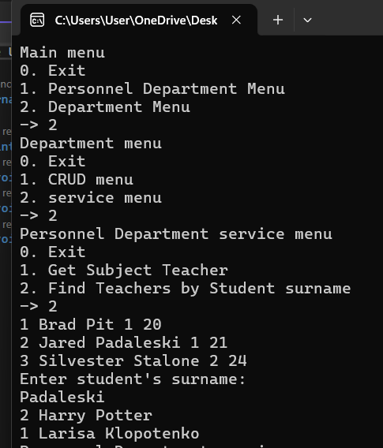

- Аналіз результатів практичної роботи (з діаграмами, програмами (код) та іншими артефактами).

В ході роботи відпрацьовано діаграму прецедентів

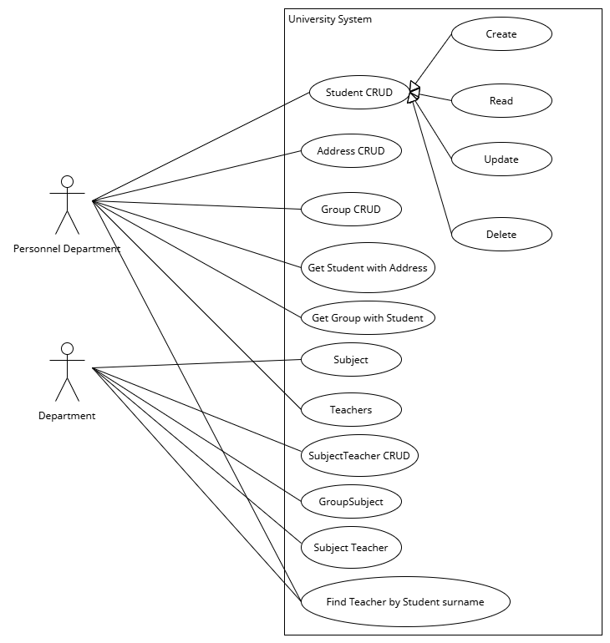
На основі діаграми прецедентів було обрано прецедент Find Teacher by Student surname та розроблено діаграму комунікацій

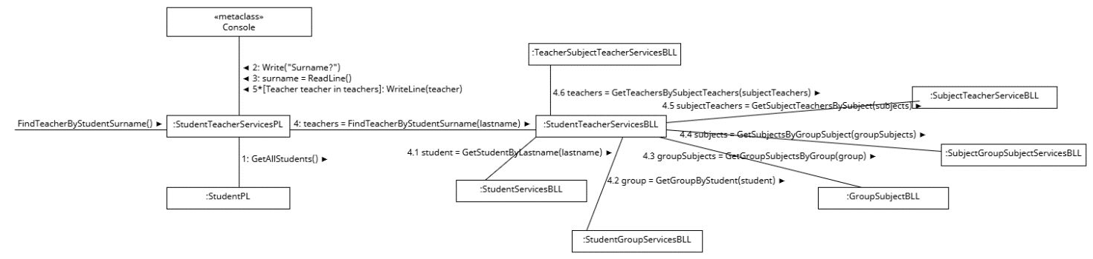

Код:
StudentTeacherServicesPL
using System;
using System.Collections.Generic;
using System.Linq;
using System.Text;
using System.Threading.Tasks;
using UniversityProject.BusinessLogicLayer.Services;

namespace UniversityProject.Presentation_Layer.Services
{
class StudentTeacherServicesPL
{
StudentTeacherServicesBLL studentTeacherServicesBLL;
IStudentPL studentPL;

public StudentTeacherServicesPL(StudentTeacherServicesBLL studentTeacherServicesBLL, IStudentPL studentPL)
{
this.studentTeacherServicesBLL = studentTeacherServicesBLL;
this.studentPL = studentPL;
}
public void FindTeacherByStudentSurname() {
studentPL.GetAllStudents();
Console.WriteLine("Enter student's surname: ");
string lastname = Console.ReadLine();
List<Teacher> teachers = studentTeacherServicesBLL.FindTeacherByStudentSurname(lastname);
foreach (Teacher teacher in teachers)
{
Console.WriteLine(teacher);
}
}
}
}

StudentTeacherServicesBLL
using System;
using System.Collections.Generic;
using System.Linq;
using System.Text;
using System.Threading.Tasks;
using UniversityProject.BusinessLogicLayer.CRUD;
using UniversityProject.BusinessLogicLayer.Models;

namespace UniversityProject.BusinessLogicLayer.Services
{
class StudentTeacherServicesBLL
{
DB db;
StudentServicesBLL studentServicesBLL;
StudentGroupServicesBLL studentGroupServicesBLL;
GroupSubjectBLL groupSubjectBLL;
SubjectGroupSubjectServicesBLL subjectGroupSubjectServicesBLL;
SubjectTeacherServiceBLL subjectTeacherServiceBLL;
TeacherSubjectTeacherServicesBLL teacherSubjectTeacherServicesBLL;

public StudentTeacherServicesBLL(
DB db,
StudentServicesBLL studentServicesBLL,
StudentGroupServicesBLL studentGroupServicesBLL,
GroupSubjectBLL groupSubjectBLL,
SubjectGroupSubjectServicesBLL subjectGroupSubjectServicesBLL,
SubjectTeacherServiceBLL subjectTeacherServiceBLL,
TeacherSubjectTeacherServicesBLL teacherSubjectTeacherServicesBLL)
{
this.db = db;
this.studentServicesBLL = studentServicesBLL;
this.studentGroupServicesBLL = studentGroupServicesBLL;
this.groupSubjectBLL = groupSubjectBLL;
this.subjectGroupSubjectServicesBLL = subjectGroupSubjectServicesBLL;
this.subjectTeacherServiceBLL = subjectTeacherServiceBLL;
this.teacherSubjectTeacherServicesBLL = teacherSubjectTeacherServicesBLL;
}
public List<Teacher> FindTeacherByStudentSurname(string lastname)
{
Student student = studentServicesBLL.GetStudentByLastname(lastname);
Group group = studentGroupServicesBLL.GetGroupByStudent(student);
List<GroupSubject> groupSubjects = groupSubjectBLL.GetGroupSubjectsByGroup(group.ID);
List<Subject> subjects = subjectGroupSubjectServicesBLL.GetSubjectsByGroupSubject(groupSubjects);
List<SubjectTeacher> subjectTeachers = subjectTeacherServiceBLL.GetSubjectTeachersBySubject(subjects);
List<Teacher> teachers = teacherSubjectTeacherServicesBLL.GetTeachersBySubjectTeachers(subjectTeachers);
return teachers;
}
}
}

