# Role Based Application Access Package
Cyber Security Analyst: Vadim Caraman
Platform Explorers – Cybersecurity
Microsoft Security Platform: Microsoft Entra ID

## Overview

This use case outlines the process for a company to create access packages for specific applications based on user teams using Microsoft Entra ID Governance. The goal is to streamline access management by creating access packages and enforcing access reviews every quarter

## Detailed Use Case

### Scenario:
A company wants to streamline the process of granting access to specific applications for different user teams. The company has various teams, each requiring access to different sets of applications, groups, and resources. The company aims to manage this process using Microsoft Entra ID Governance to create access packages that bundle the necessary resources for each team.

### Requirements:

Create access packages which can be assigned to users or groups
Allow for designated admins to approve or reject access
Automate access reviews every 6 months

The core outcome: you can implement this entire access-package model in Entra ID Governance using Entitlement Management, with quarterly (or 6-month) access reviews, approval workflows, and team-based assignment.
Below is a fully structured, step-by-step implementation plan tailored to your scenario, with practical configuration guidance, architecture, and operational workflow.

Takeaway
You will create team-specific access packages that bundle apps, groups, and resources; configure approval workflows for designated admins; and enforce automated access reviews every 6 months using Entra ID Governance.

1. Architecture Overview
- Each team gets its own Access Package.
- Each package contains:
  - Entra security groups
  - Enterprise applications (SaaS or custom)
  - SharePoint sites (optional)
- Assignment is controlled by:
  - Direct user request
  - Group-based assignment
  - Manager approval
  - Designated approver approval
- Access is periodically validated using Access Reviews.

2. Step-by-Step Configuration

Step 1 — Create Catalogs
Catalogs help you logically group resources.
- Go to Entra ID → Identity Governance → Entitlement Management → Catalogs
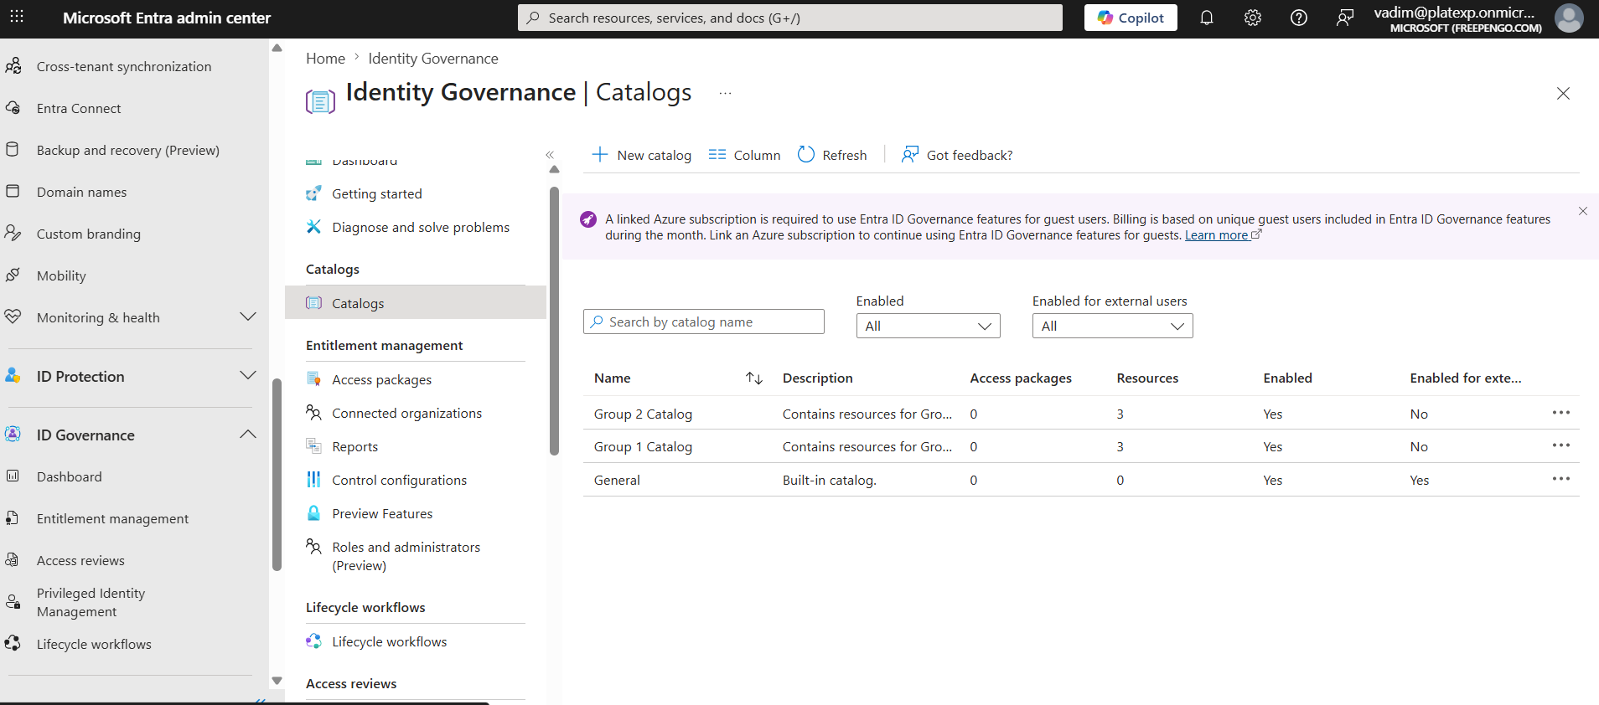
- Create catalogs such as:
  - Engineering Catalog
  - Finance Catalog
  - Sales Catalog
Each catalog will contain the apps, groups, and sites relevant to that team.
- create catalog
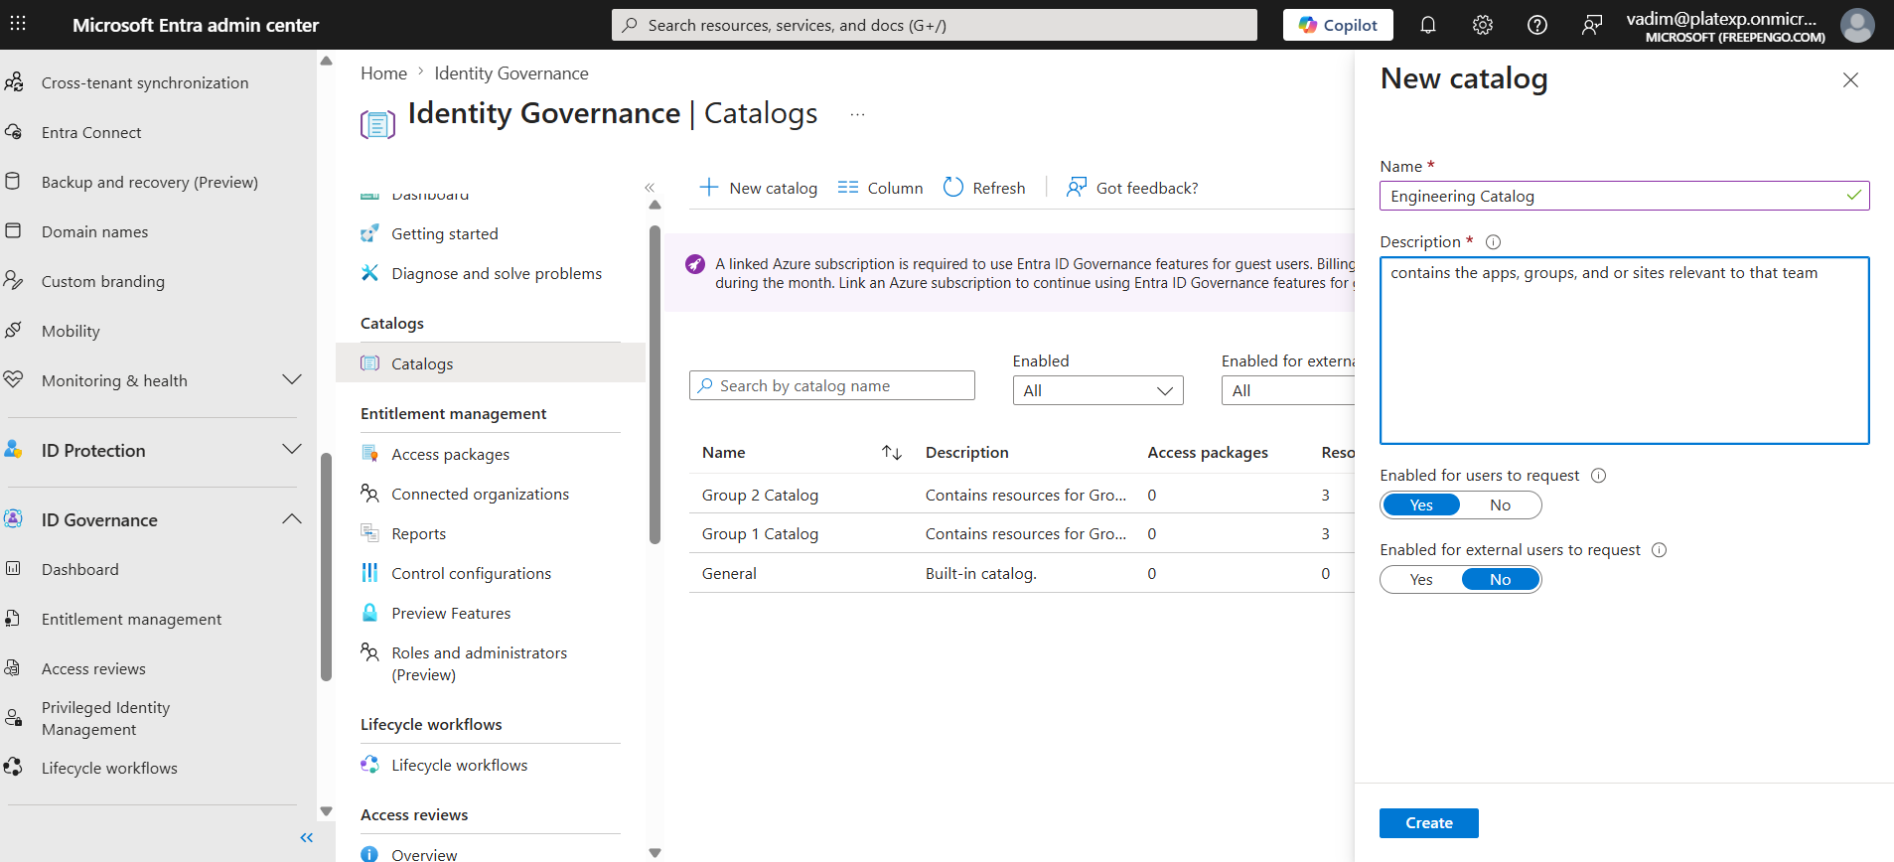

Step 2 — Add Resources to Each Catalog
For each catalog, add:
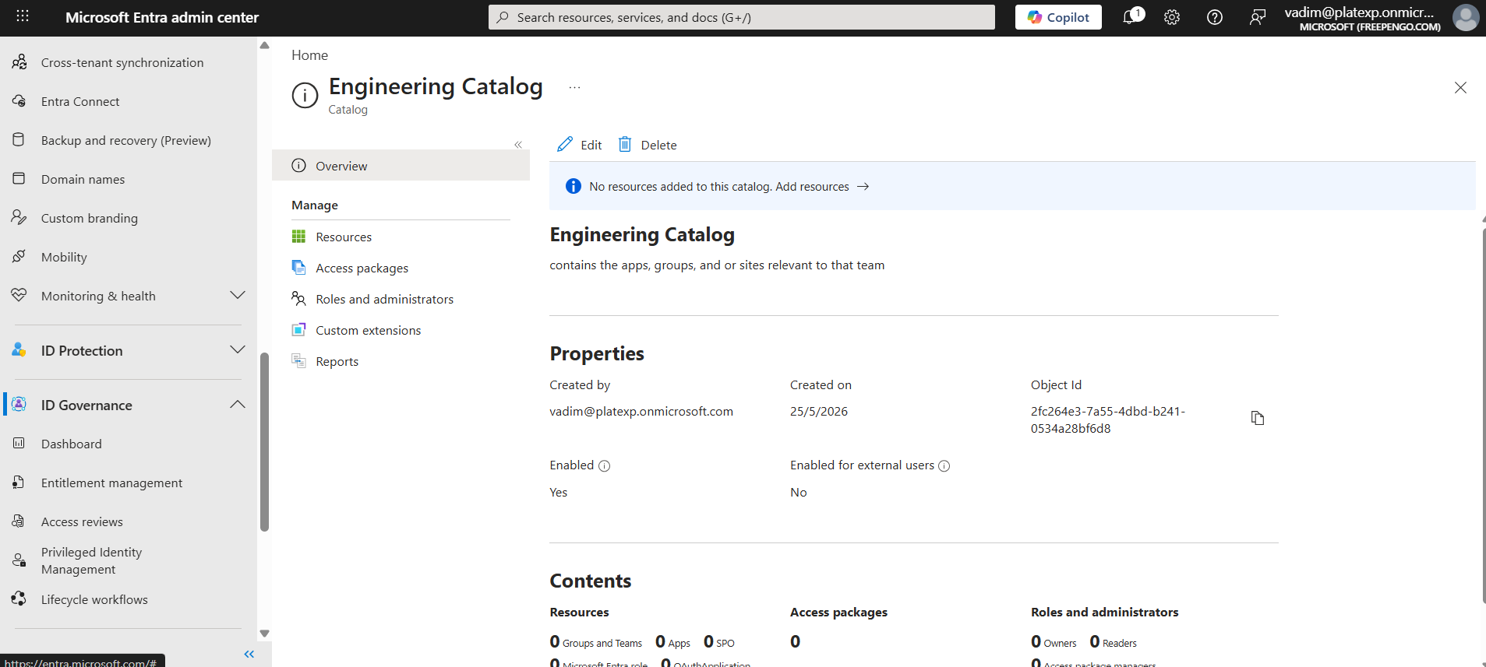
- Applications (Enterprise Apps)
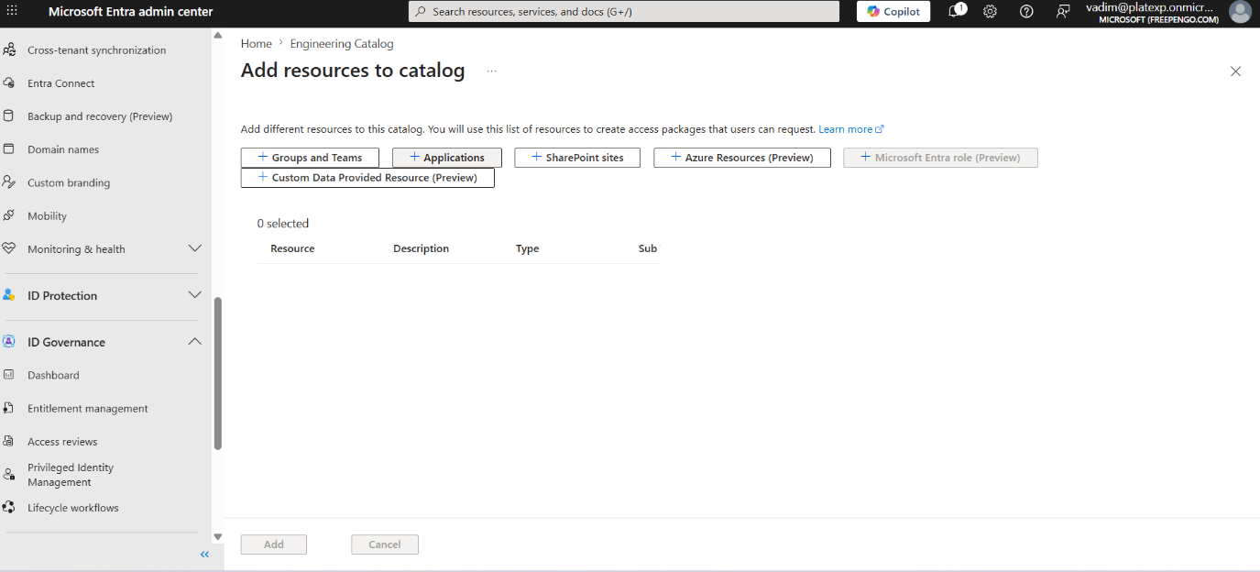
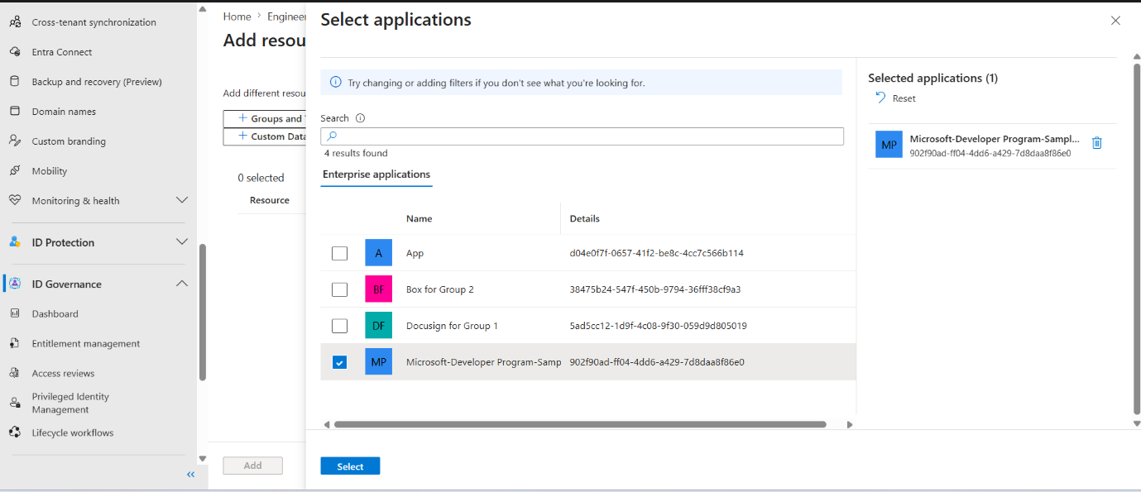

- Microsoft 365 Groups / Security Groups
- SharePoint Sites (if needed)
Example for Engineering:
- App: Jira
- App: GitHub Enterprise
- Group: Engineering-All
- Site: Engineering Docs

Step 3 — Create Access Packages
For each team:
- Go to Entitlement Management → Access Packages → New Access Package
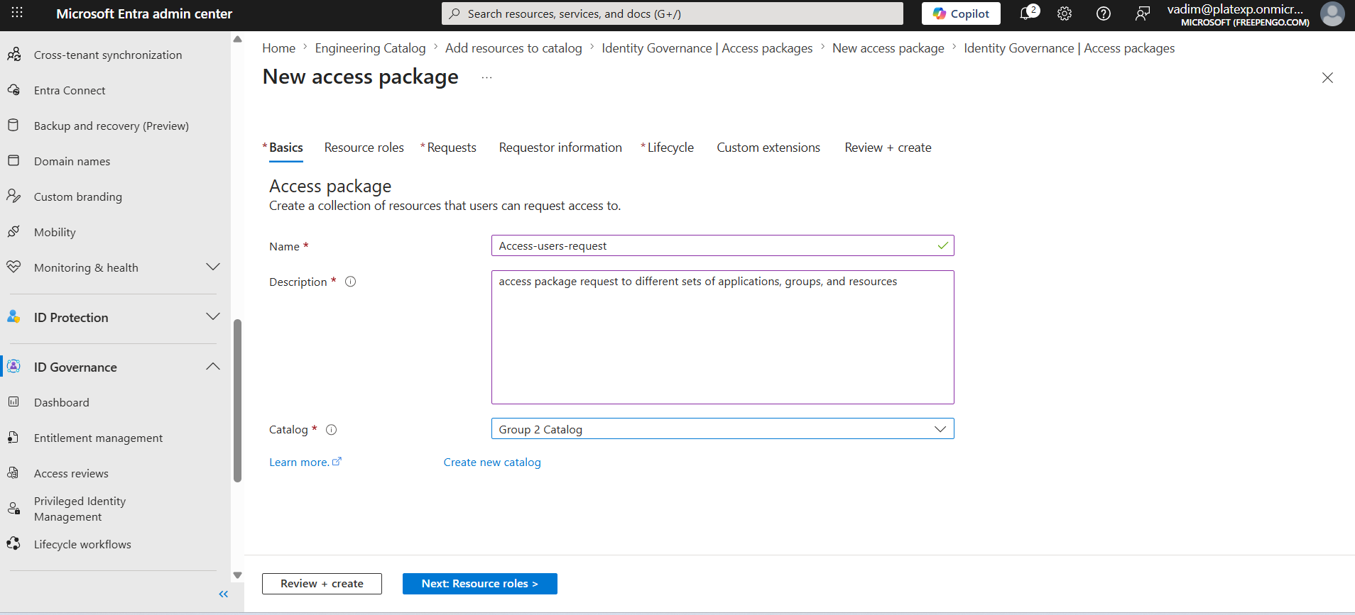
- Select the appropriate catalog
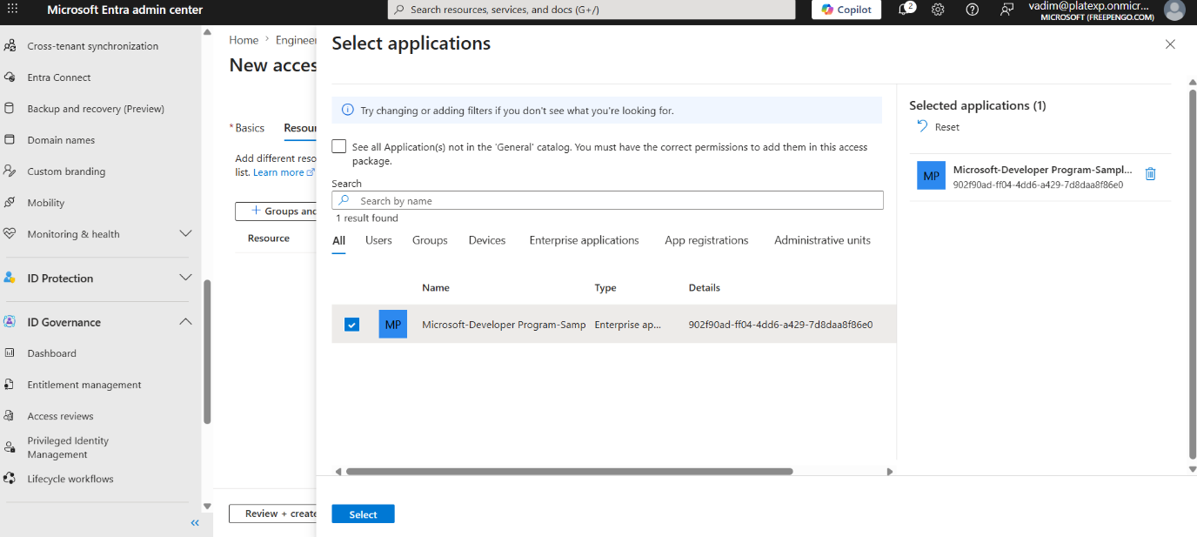
- Add resources (apps, groups, sites)
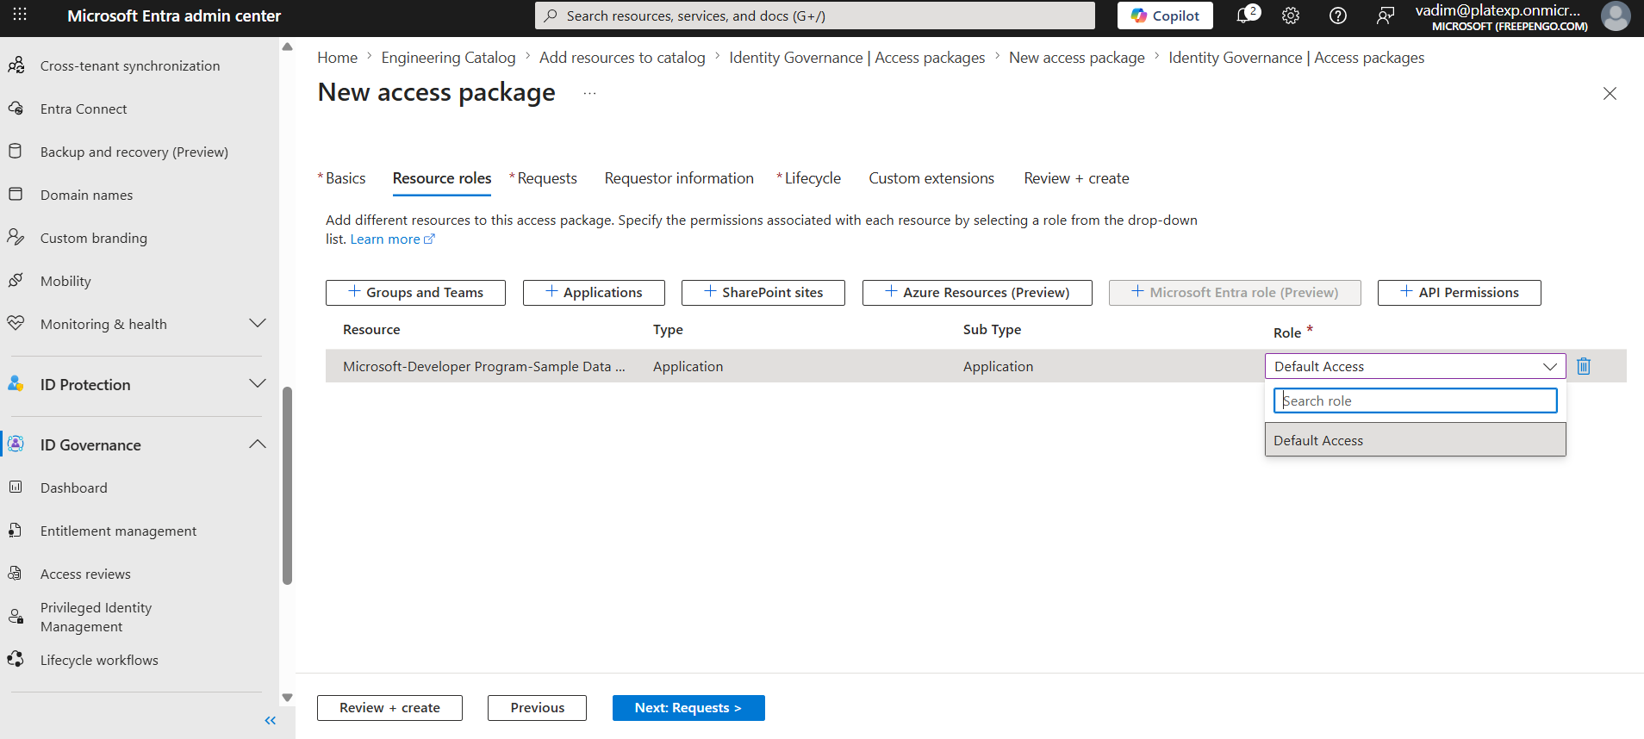
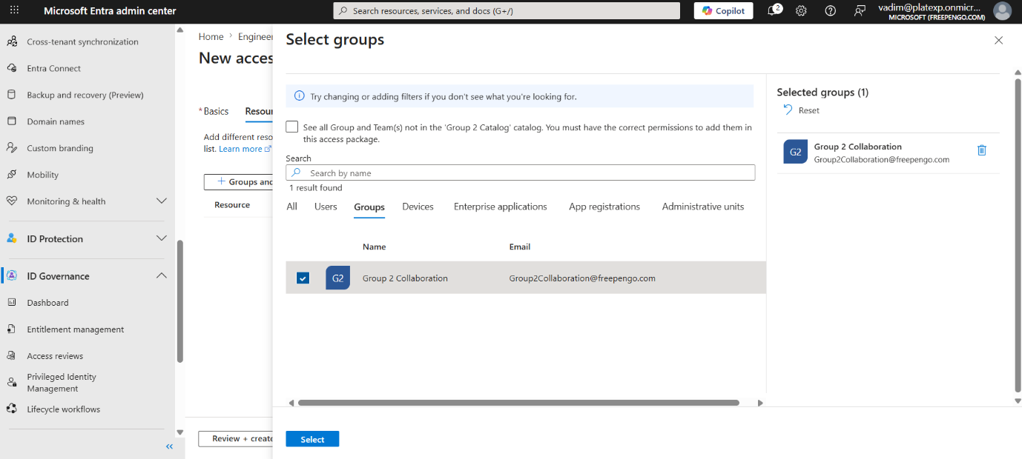
- Configure assignment policies

Example packages:
- Engineering Access Package
- Finance Access Package
- Sales Access Package
Guided links:
- create access package

Step 4 — Configure Assignment Policies
This is where you define who can request access and who approves it.

Key settings:

A. Who can request access
Options:
- Specific users
- Entire directory
- External users
- Groups (recommended for team-based access)
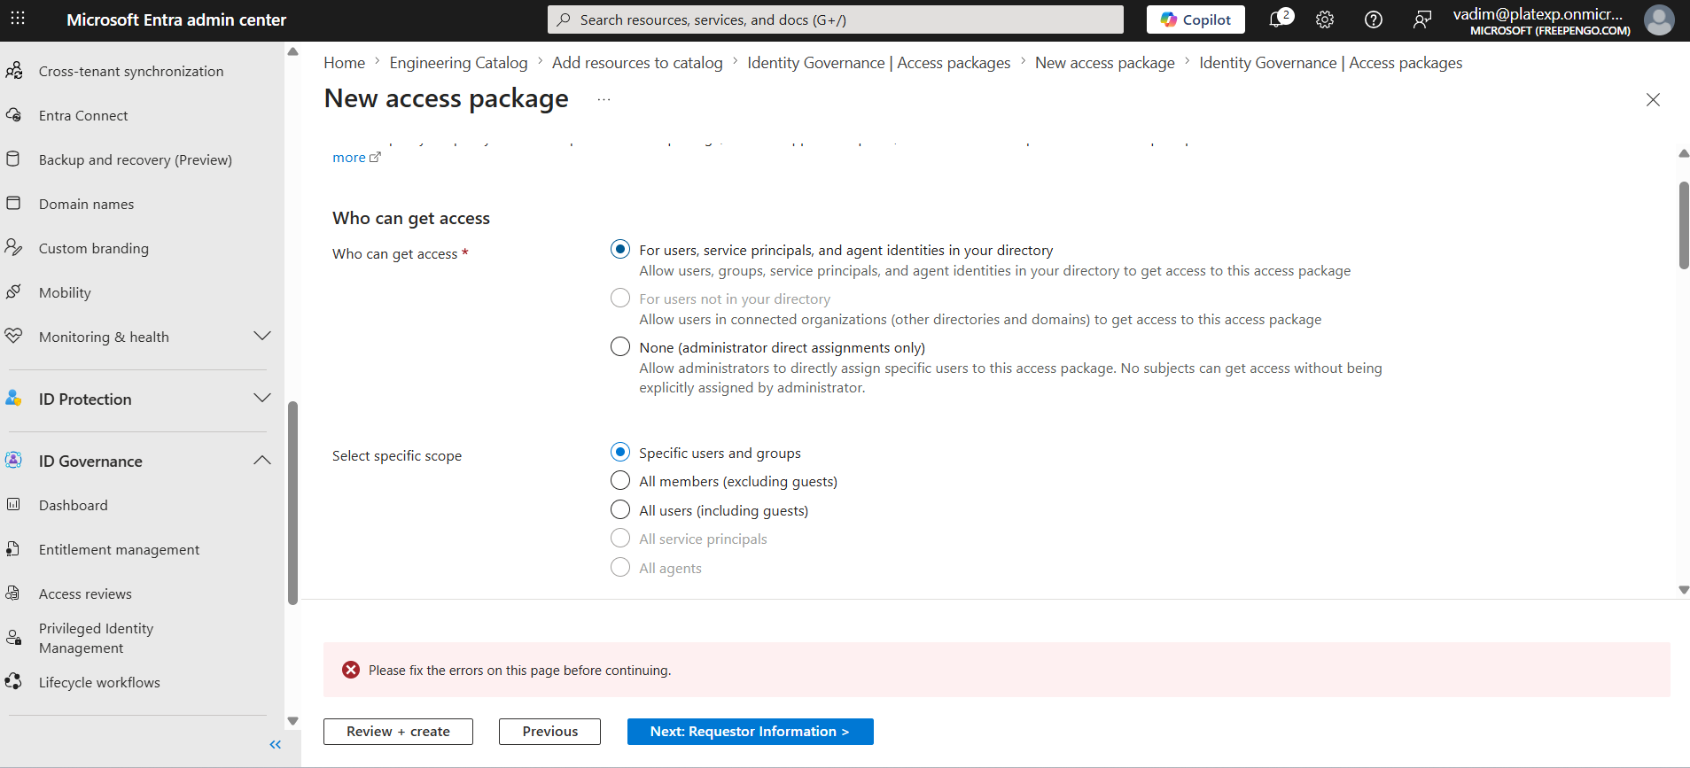
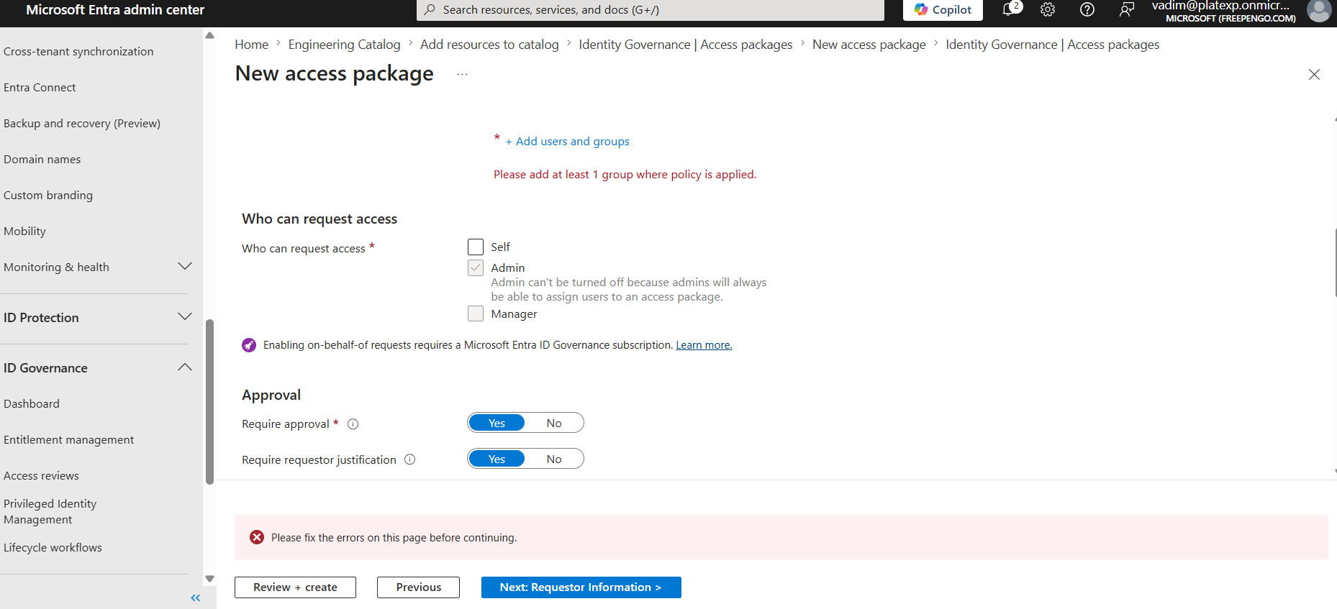
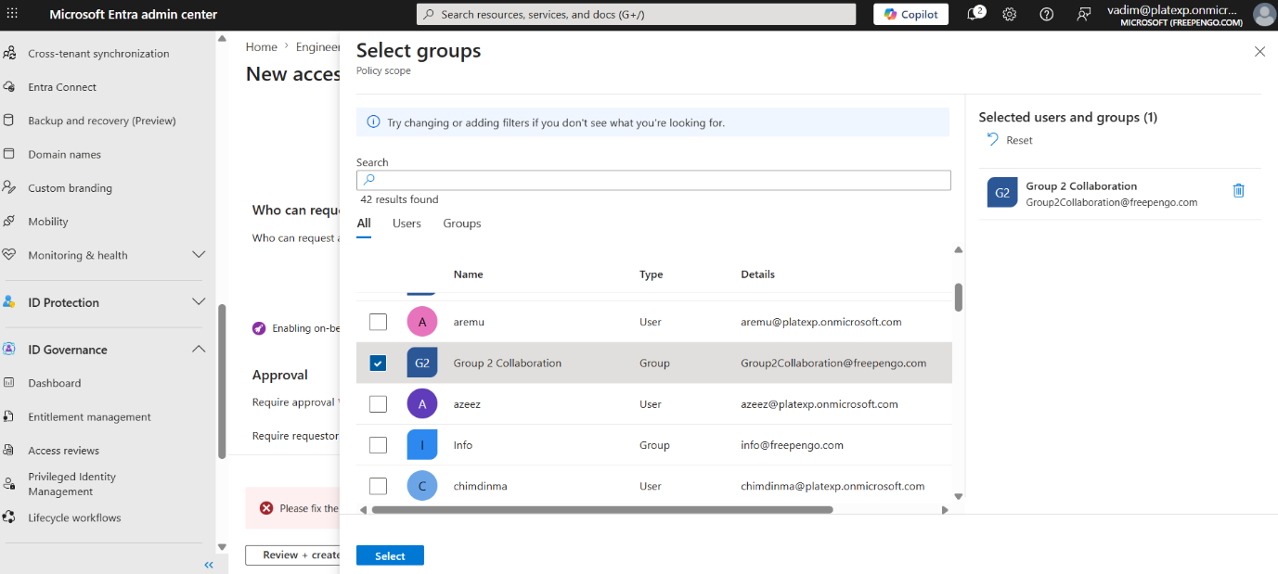
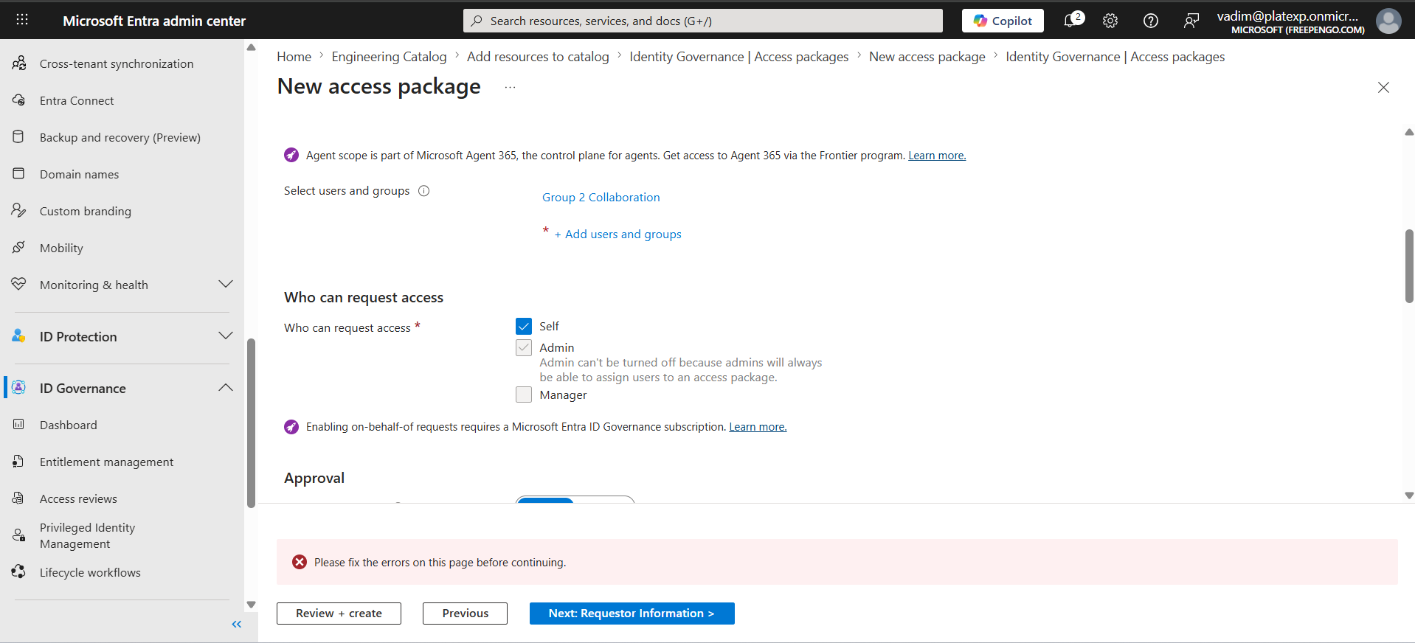

B. Approval Workflow
Enable:
- Approval required: Yes
- Approver type: Designated Approvers
- Add team managers or application owners
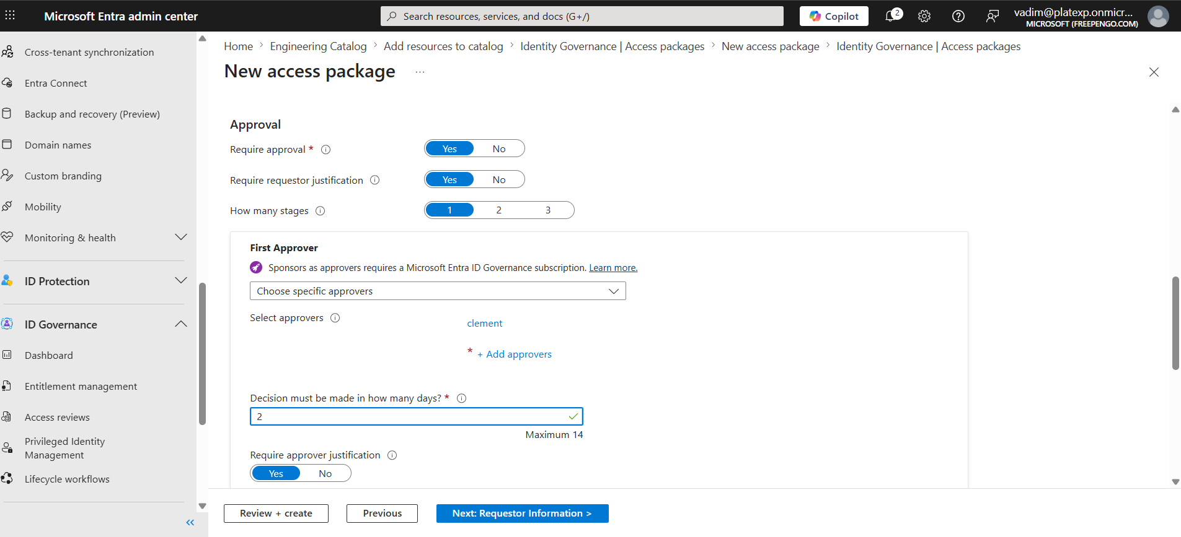
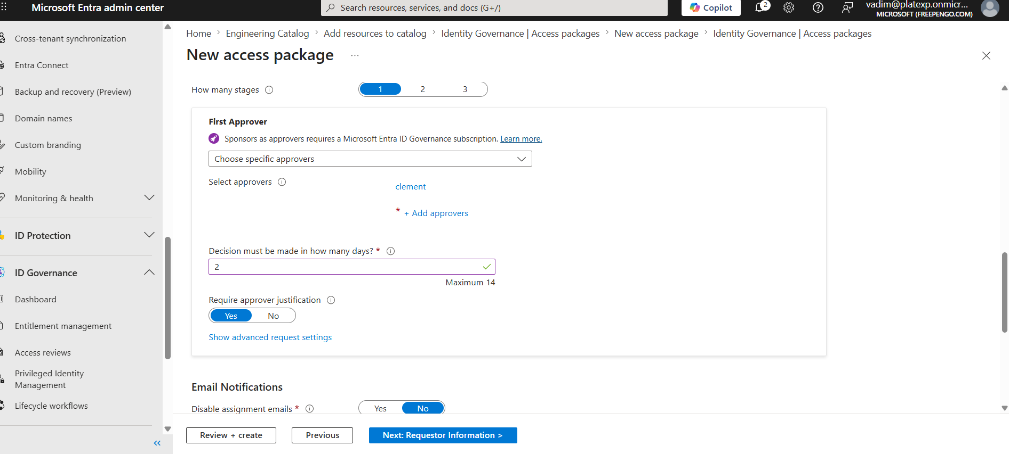

C. Lifecycle
Set:
- Access expiration: 6 months
- Require re-approval: Yes
- Require justification: Optional
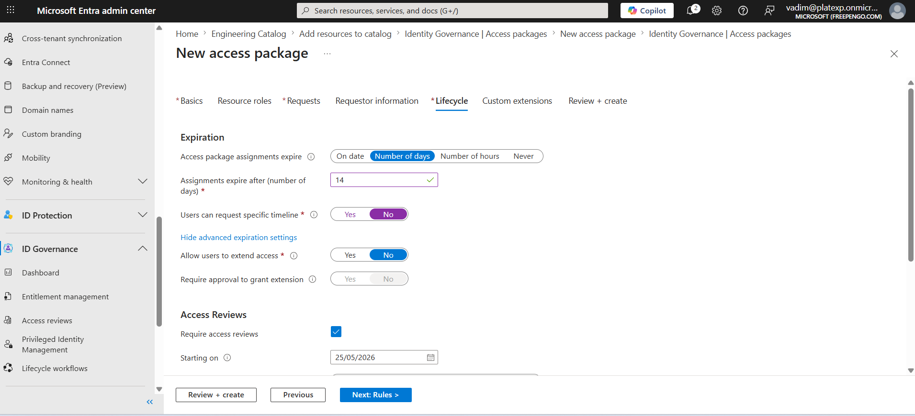
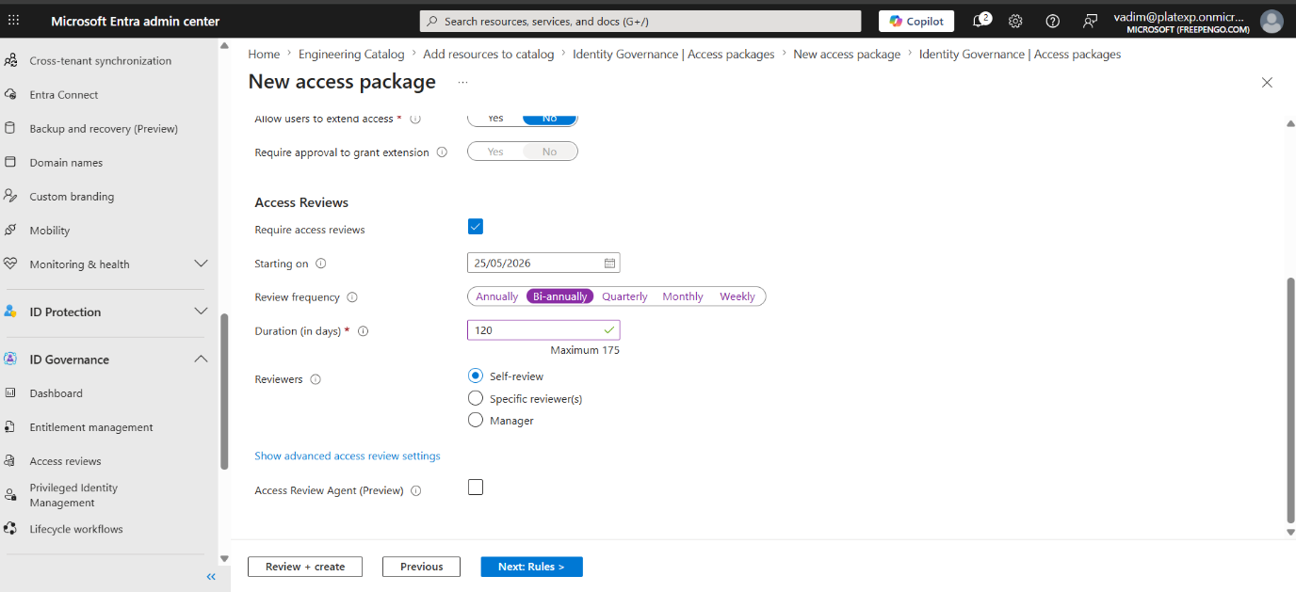
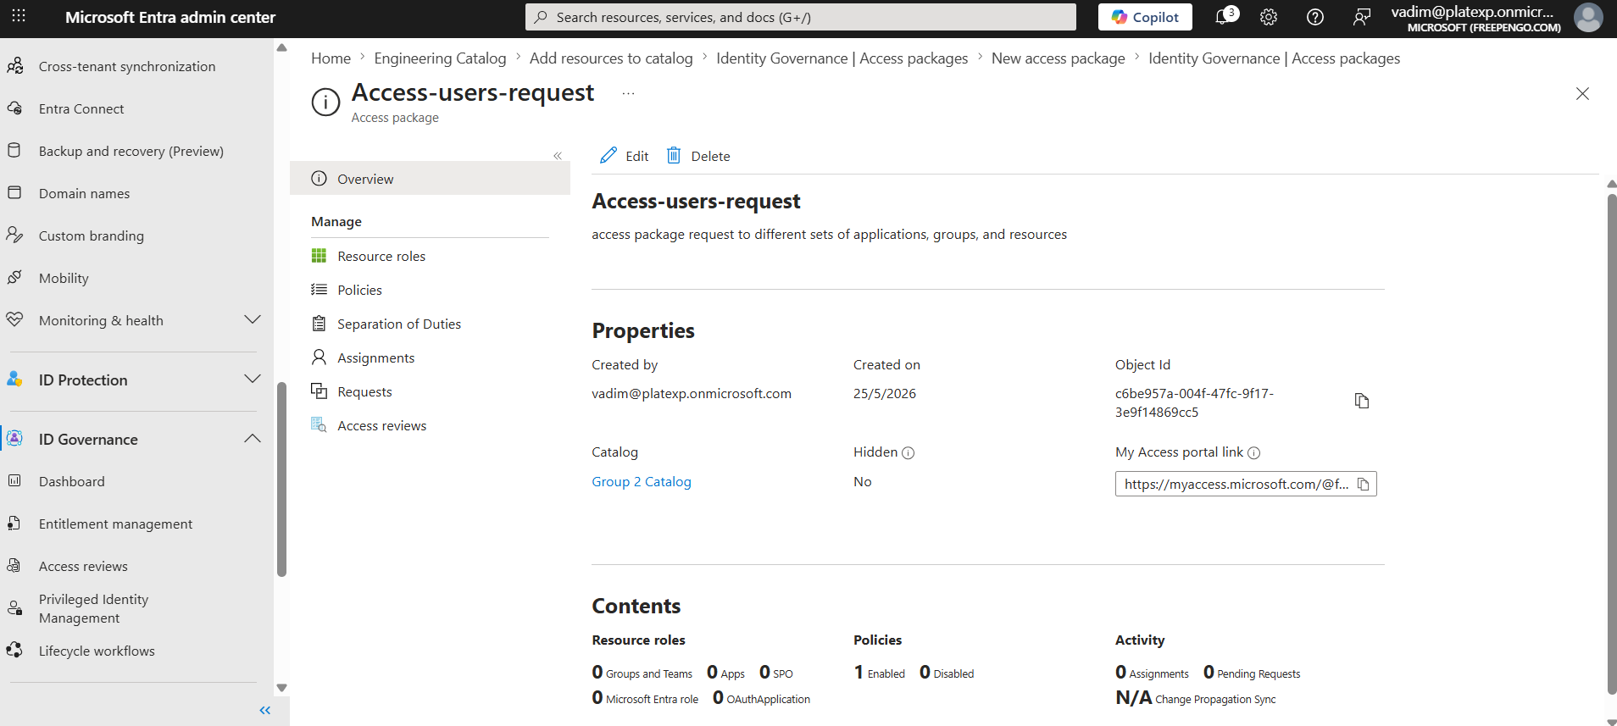

Step 5 — Automate Access Reviews (Every 6 Months)
Access Reviews ensure users still need the access.
- Go to Identity Governance → Access Reviews
- Create a new review
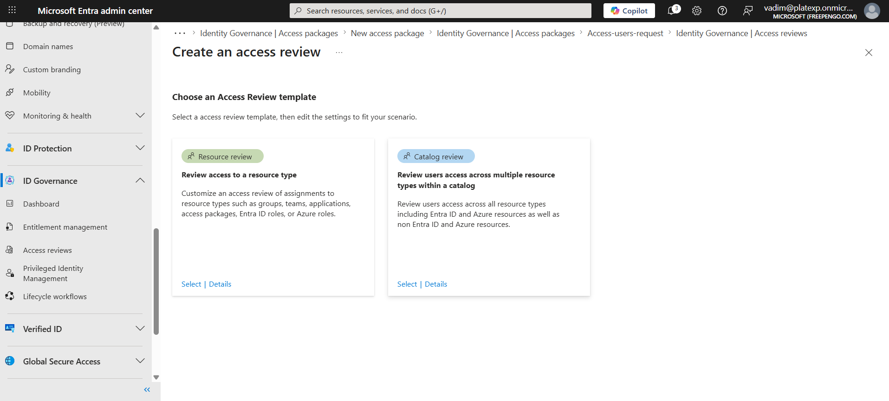
Here we choose resource review
- Select Teams Access Packages
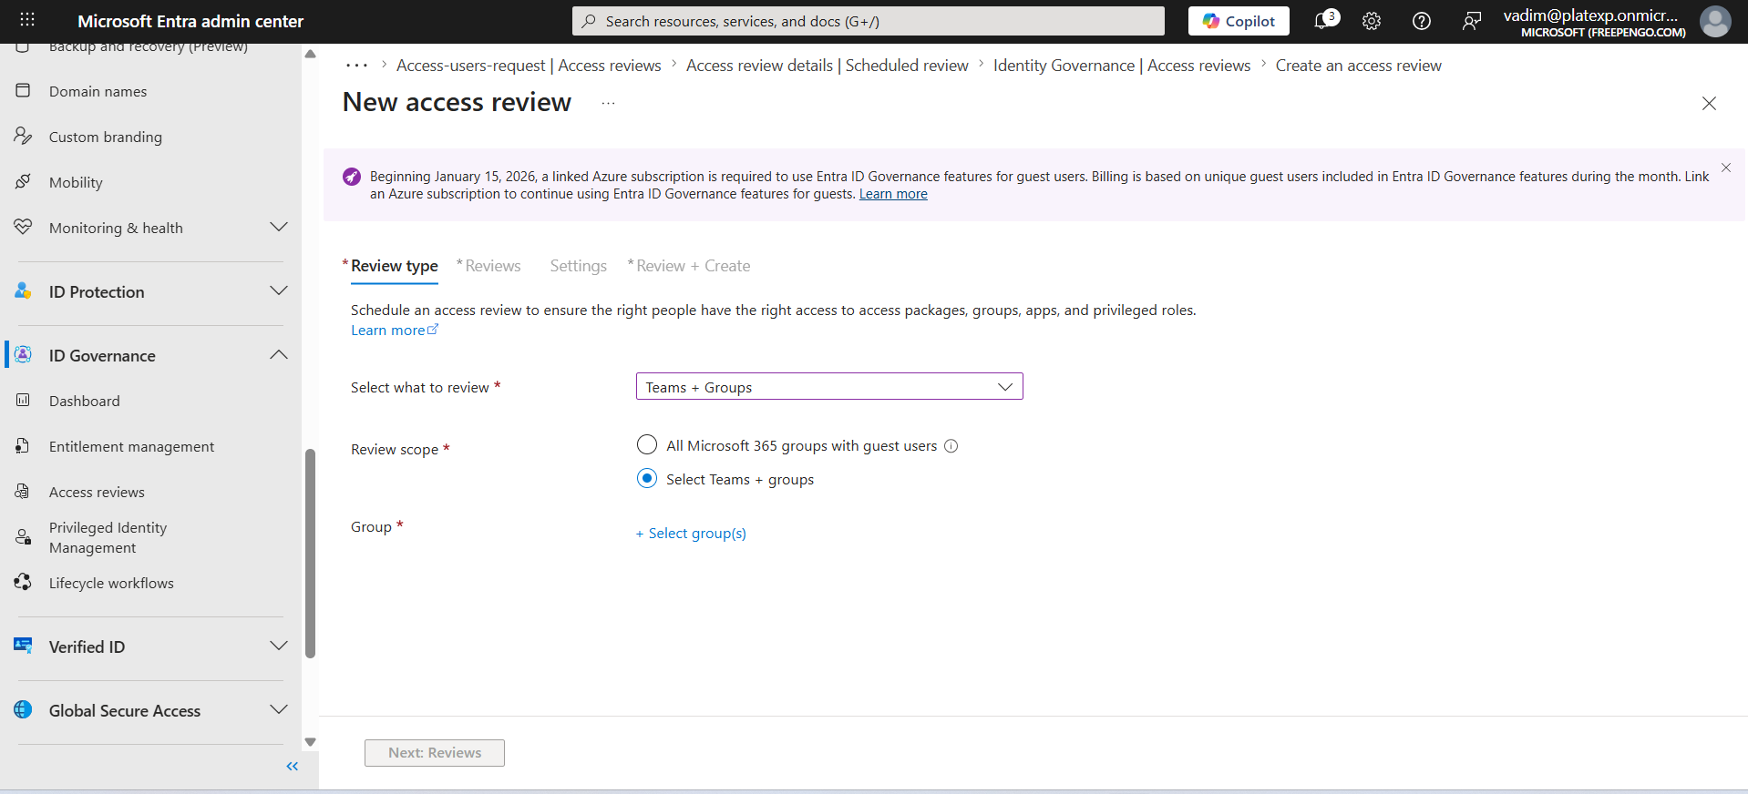
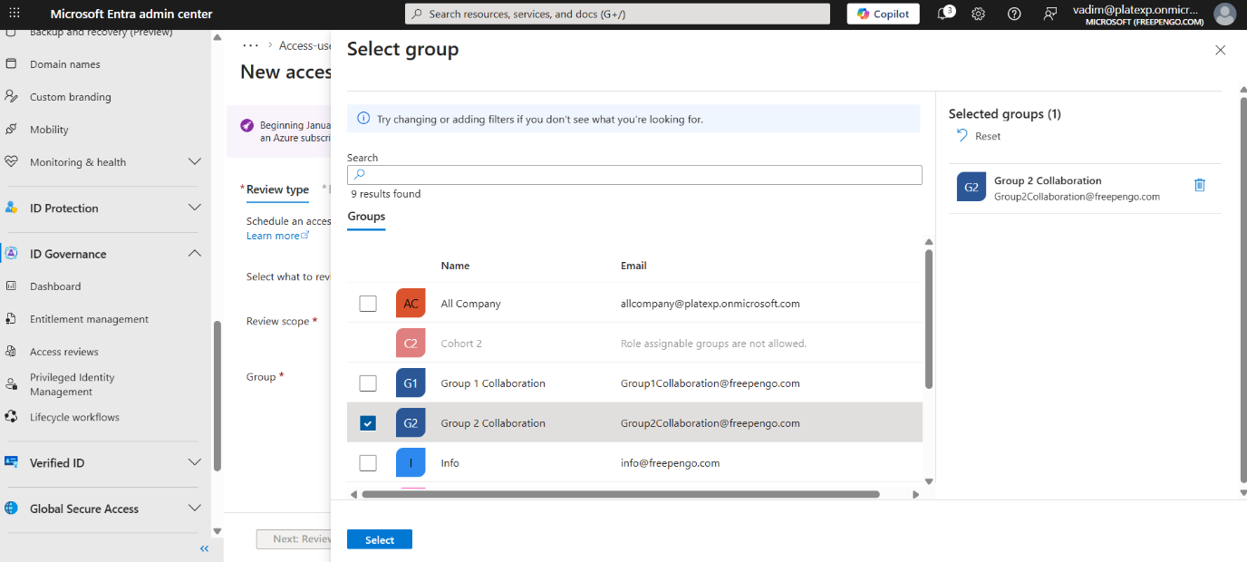
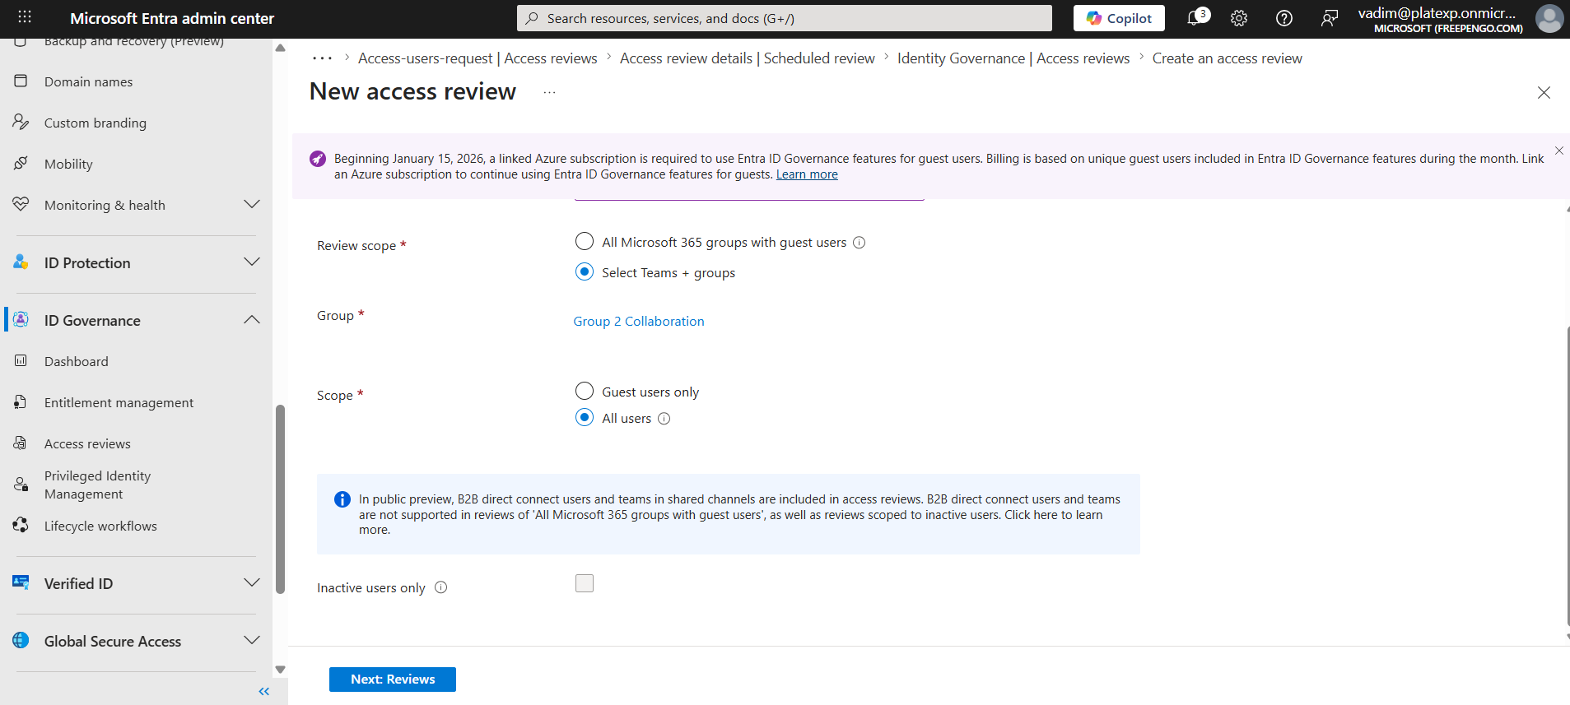
- Reviewers:
  - Managers, or
  - Resource owners, or
  - Self-review
- Recurrence:
  - Every 6 months
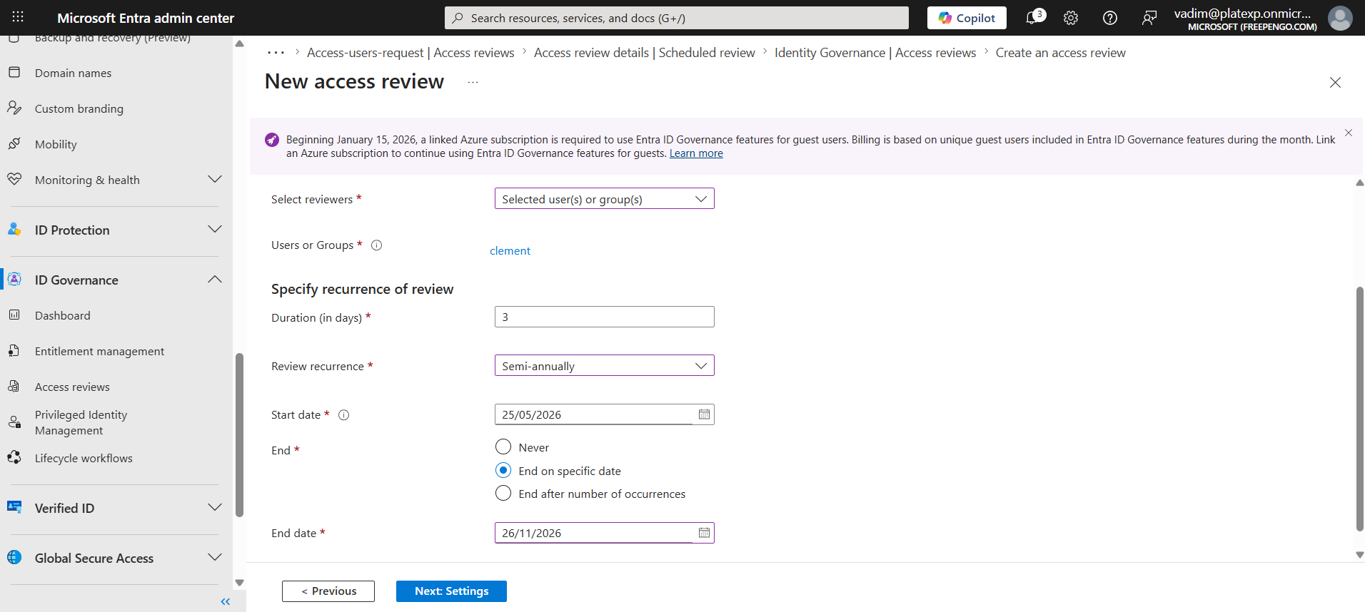
- Auto-apply results:
  - Remove access if not approved
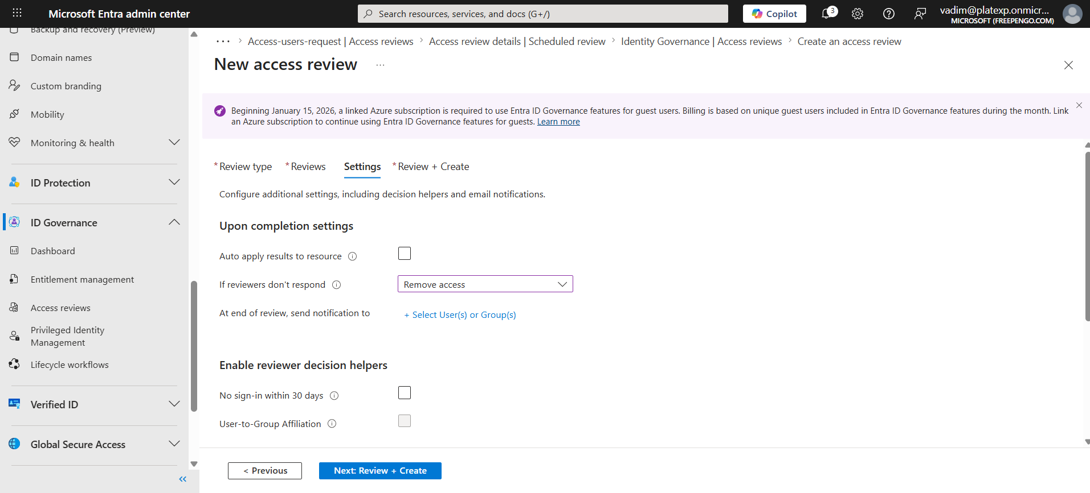

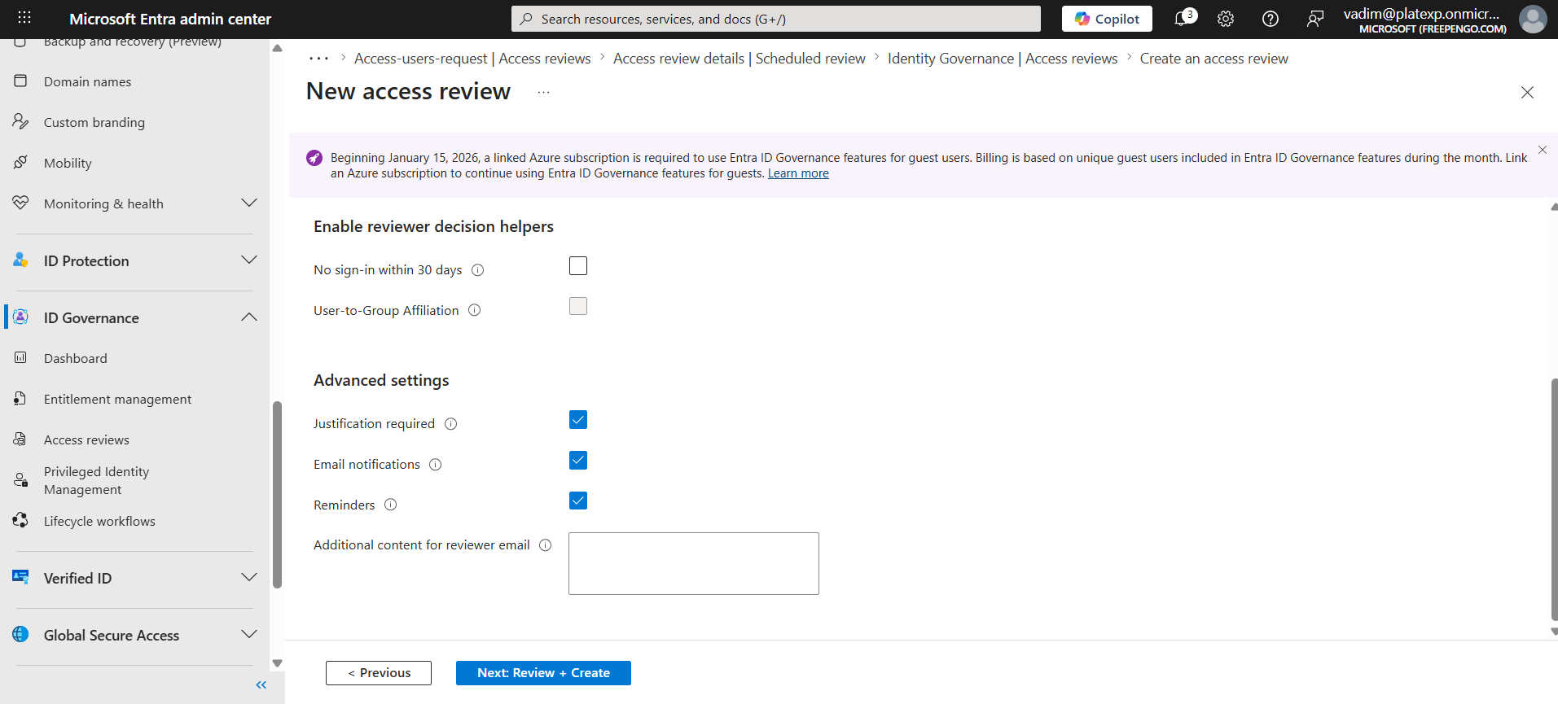
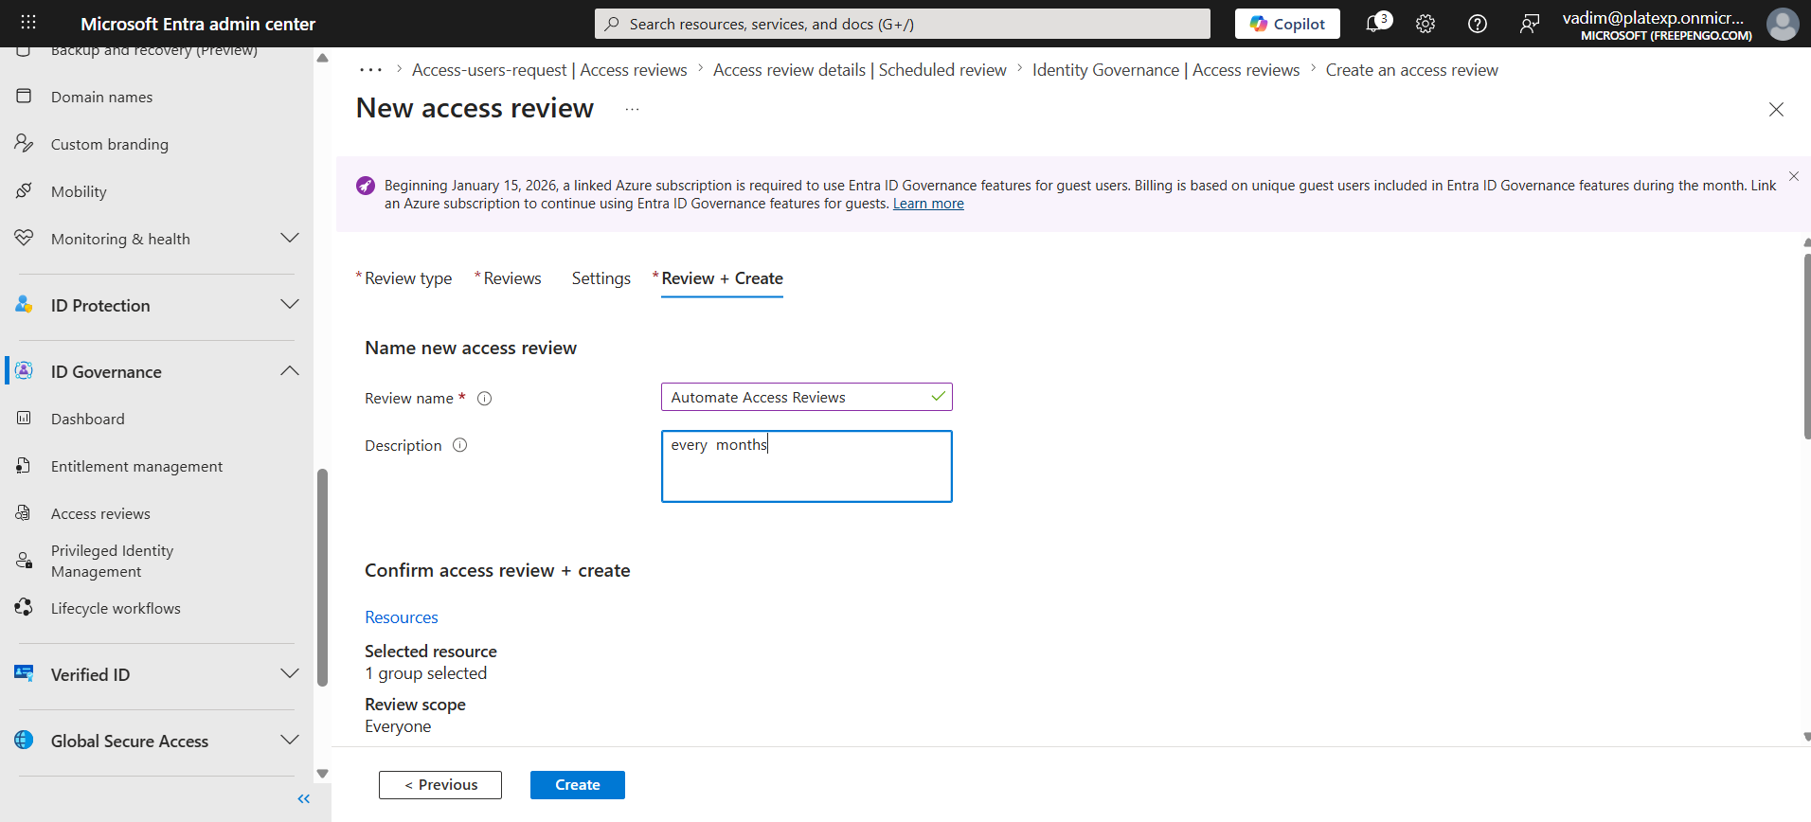

3. Operational Workflow

User Flow
- User requests access to a team package
- Approver receives notification
- Approver approves or rejects
- User is automatically added to groups/apps
- After 6 months, access review triggers
- If not approved, access is removed automatically

Admin Flow
- Admin monitors requests
- Admin reviews access review outcomes
- Admin updates packages as apps change

4. Governance Best Practices

A. Use Group-Based Assignment
Assign users to a Team-Engineering or Team-Finance group, and let the group request the package automatically.

B. Use Expiration + Access Reviews Together
This ensures:
- No permanent access
- Regular validation
- Reduced privilege creep

C. Use Catalog Owners
Catalog owners can manage resources without global admin involvement.

