EMULSIFIER
Analogue Film Stock Rendering Engine - User Manual v2.01

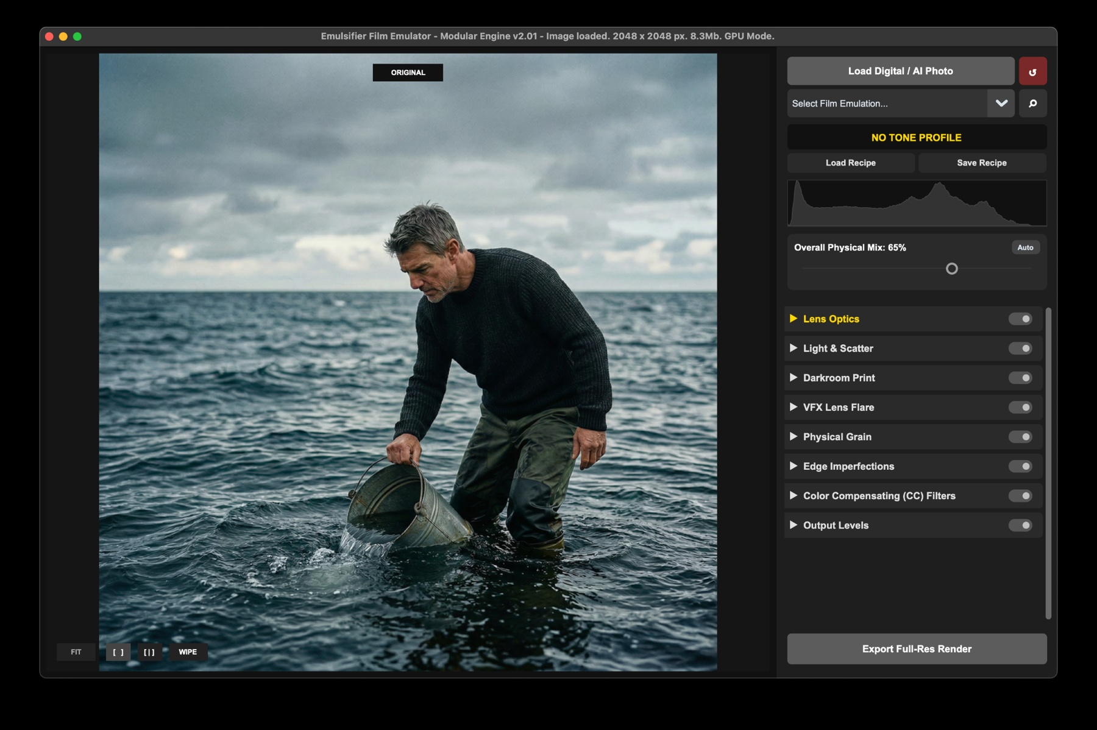
A practical guide to loading images, choosing film profiles, grading with the physical pipeline, comparing results, and exporting full-resolution renders.

1. What Emulsifier does
Emulsifier is a film-emulation renderer designed to make digital and AI-generated images feel less sterile and more physically photographed. Instead of placing a simple color filter or LUT over the image, it processes the photo through a staged pipeline: lens behavior, light scatter, film response, darkroom-style printing, grain, edge falloff, color-compensating filters, and final output levels.
The goal is creative control. You can work quickly with a lightweight preview, compare the original and dehanced result, save recipes, and then export a full-resolution render using the same settings.
Best starting point: Load an image, choose a film profile, click Auto in Overall Physical Mix, then fine-tune the pipeline modules from top to bottom.

2. Quick start workflow
- Load a digital or AI-generated photo using the Load Digital / AI Photo button, drag-and-drop, or Cmd/Ctrl+V.
- Choose a film emulation from the profile dropdown, or open the gallery to compare profiles visually.
- Use Overall Physical Mix to control how strongly the film profile affects the image. Auto is a useful first pass.
- Open one rendering module at a time and adjust only the sliders that support the look you want.
- Use Side-by-Side or Wipe view to compare the grade against the original.
- Zoom in to inspect grain, color fringing, and texture.
- Save the look as a recipe if you want to reuse it.
- Click Export Full-Res Render when the preview is ready.

3. Main workspace overview
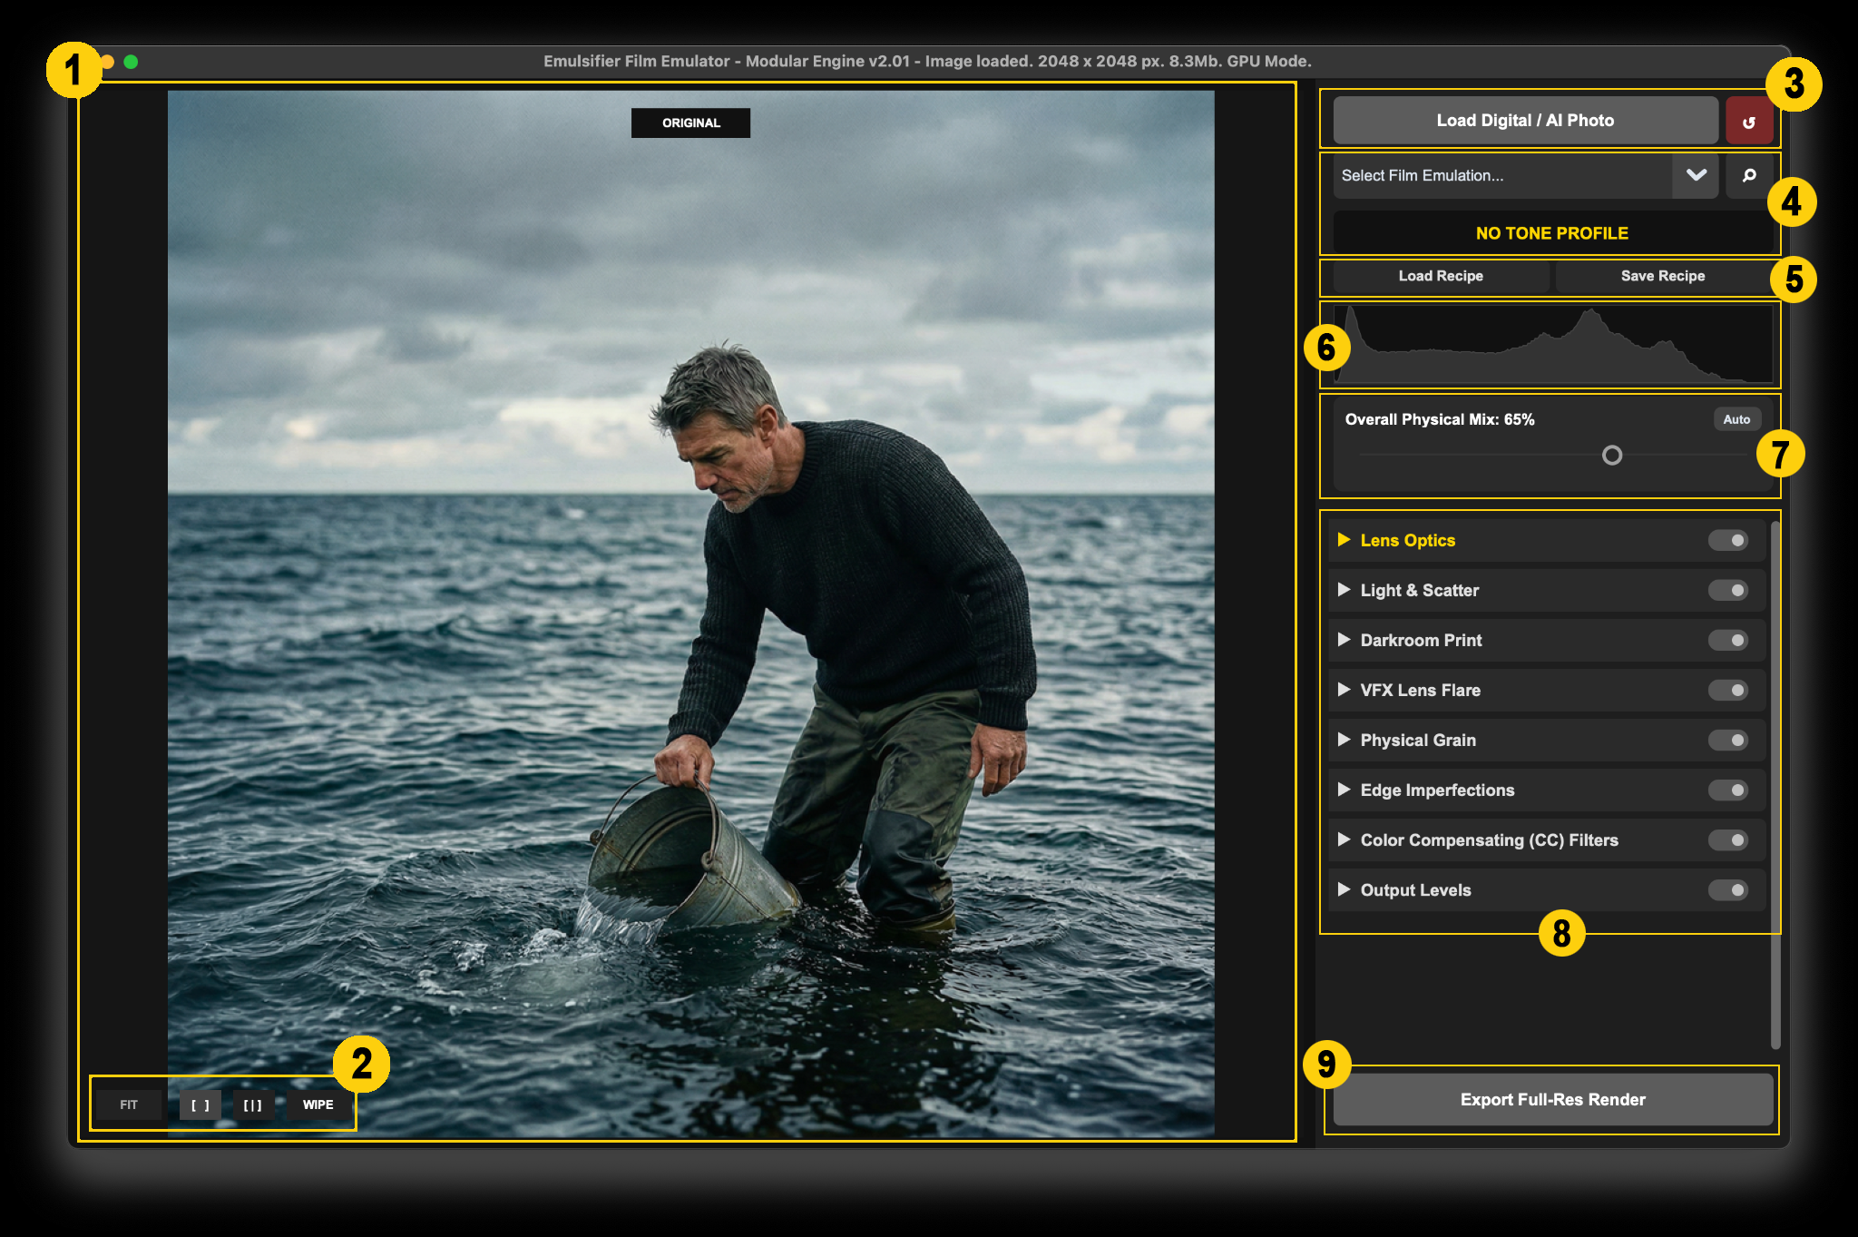
Figure 1 - Main interface, annotated.
1. Preview canvas: The main image area. It shows the original, processed result, or comparison view depending on the selected mode.
2. View buttons: FIT returns the image to the screen size. The bracket buttons switch comparison modes. WIPE enables the draggable before/after divider.
3. Load and reset: Load an image or reset the entire workspace to default settings.
4. Film profile, Gallery and Active profile label: Select a film profile from the dropdown or open the gallery to compare multiple profiles visually.
5. Recipe controls: Load or save a complete settings preset.
6. Dual histogram: Compares original luminance against processed luminance.
7. Physical mix: Controls the global strength of the film profile. Auto analyzes the image and suggests a safe mix.
8. Pipeline modules: Expandable sections for lens, light, print, flare, grain, edge, color filters, and levels.
9. Export: Renders the result at full resolution.

4. Loading images, profiles, and recipes

Loading an image
You can load, drag & drop a JPG, PNG, TIFF image, or simply paste clipboard contents. Large images are previewed through a lightweight proxy so sliders remain responsive. When you export, Emulsifier applies the same grading math to the full-resolution original.

Choosing a film profile
Film profiles stored in a local profiles folder. A selected profile supplies the base tone and color response that the rest of the pipeline works utilizes. The active profile name appears in yellow below the dropdown. Notice that, while Emulsifier comes with about 20 ready-made Film-stock profiles, they are more of a perceptual interpretation of stock emulsion, rather than a true digital reproduction of densitometry & sensitometry response of a real life film-stock.

Recipes
A recipe stores the current film profile and sliders states as a reusable JSON setup. Use Save Recipe when you have built a look you want to apply to other images. Use Load Recipe to restore and apply previously saved grading.

5. Emulsion Gallery / Lightbox
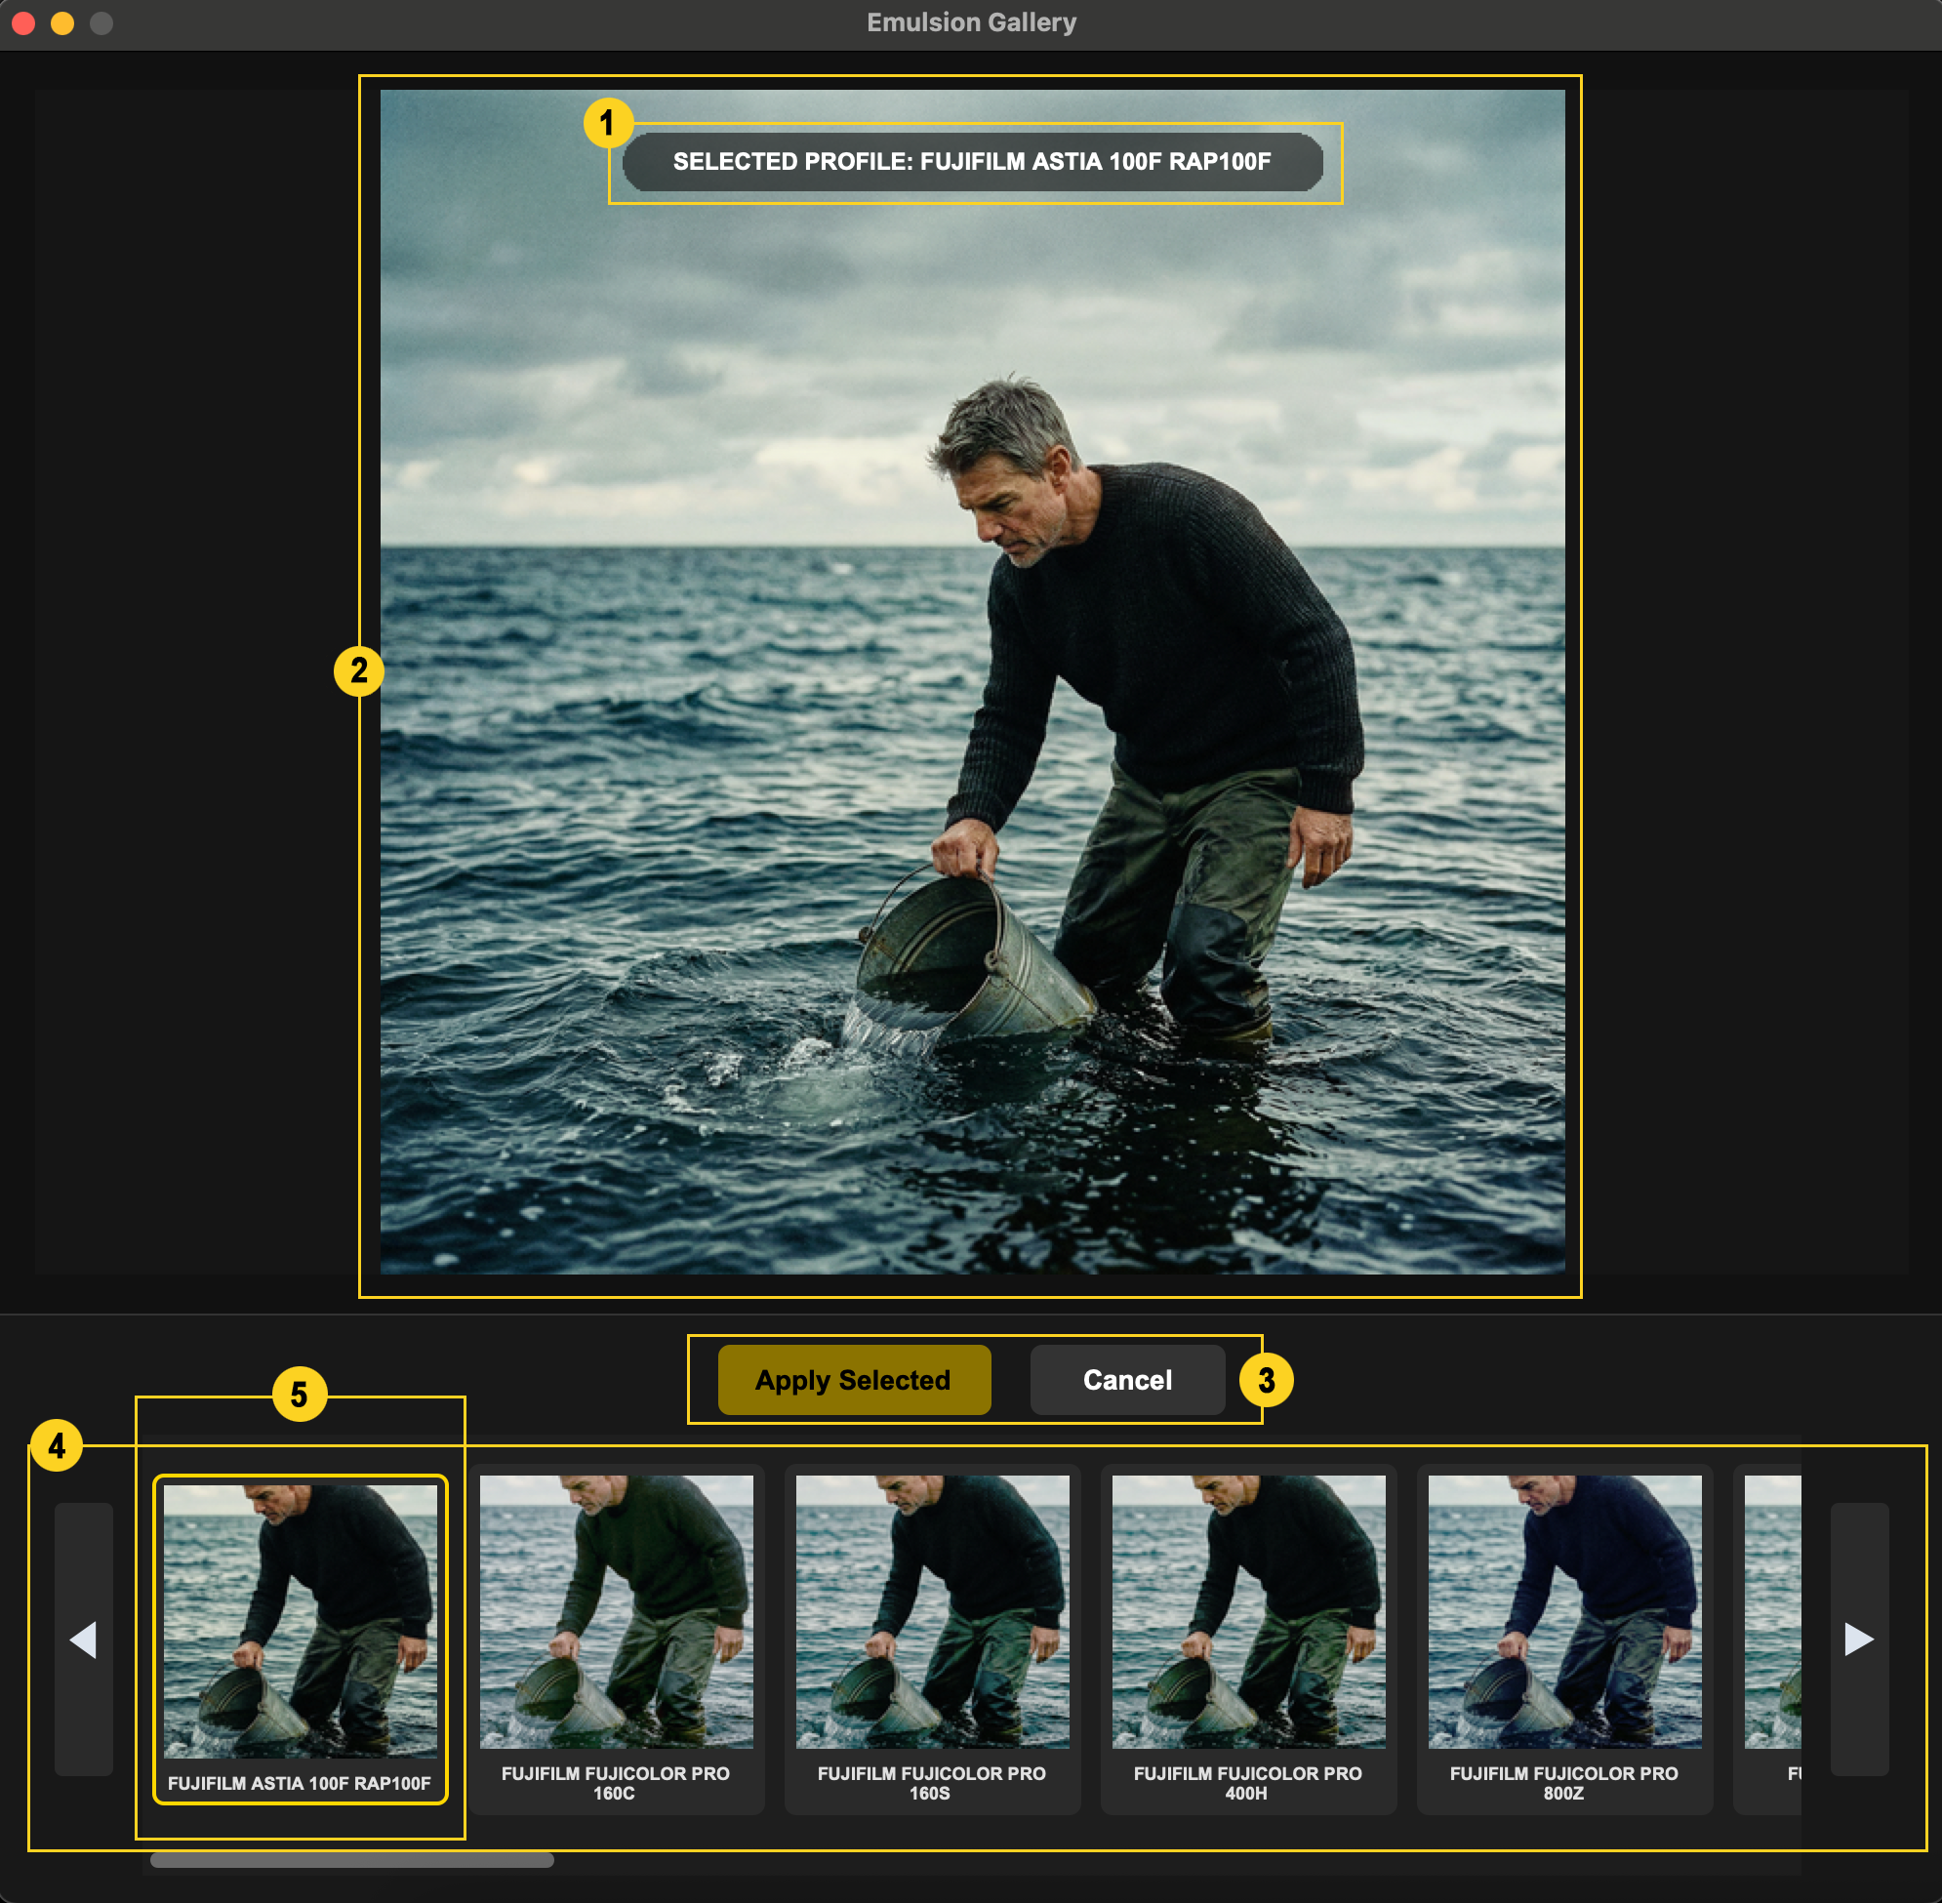
Figure 2 - Emulsion Gallery / Lightbox.
1. Selected profile: Shows the currently selected film profile.
2. Large preview: Displays the selected profile applied to the image.
3. Apply & Cancel buttons: Applies the highlighted profile or closes the gallery
(Tip: you can use Esc key to abort and close the window as well).
4. Filmstrip: Shows thumbnail previews of available film profiles applied to the image
(Tip: use arrow keys to navigate).
5. Selected thumbnail: Yellow border marks the profile currently selected in the gallery.

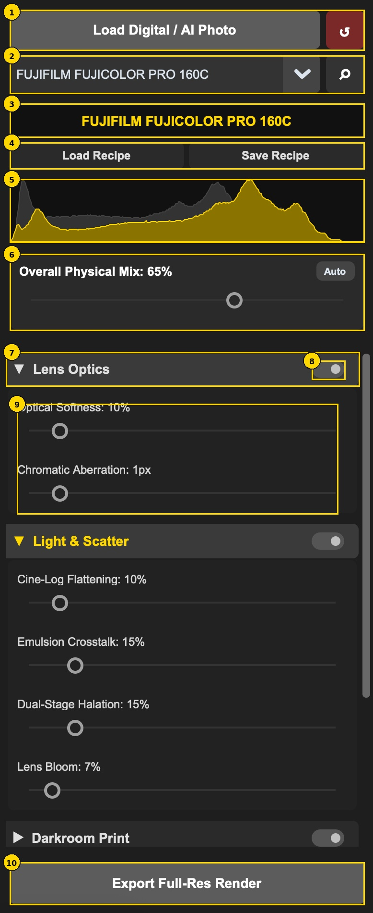
6. Control panel and histograms
1. Load / reset: Start a new image or reset the current grade.
2. Profile selector: Choose a film profile or open the gallery.
3. Current profile: Confirms which film stock is active.
4. Recipes: Load or save complete looks.
5. Dual histogram: Grey shows the original image; gold shows the processed image.
6. Physical mix: Global profile intensity. Auto protects midtones from being over-flattened.
7. Module header: Click to expand or collapse a module.
8. Bypass switch: Temporarily disables that module without deleting slider values.
9. Sliders: Drag to adjust; right-click a slider to reset it to default.
10. Export: Render the full-resolution image.

Reading the dual histogram
The grey histogram is the original image and does not move. The gold histogram is the processed result. Use this comparison as a reality check: if the gold shape is crushed hard into the left edge, shadows may be too dark; if it is pushed hard into the right edge, highlights may be clipped or too bright.

Figure 3 - Control panel close-up.

7. Comparing original and dehanced views

Side-by-Side view
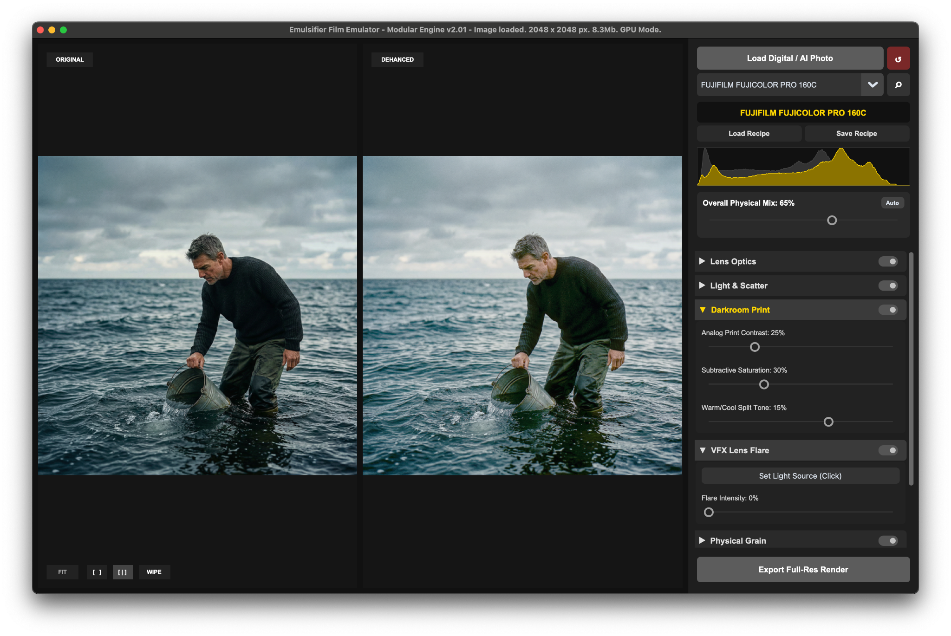
Figure 4 - Side-by-Side view.
Side-by-Side [ | ] View - places the original image on the left and the dehanced result on the right.
Use it when you want to judge the overall mood, color balance, contrast, and atmosphere of the grade.
Zooming in (click on the image and use mouse scrolling wheel to zoom in or out further) in this mode – will show you zoomed area of the original image on the left and the dehanced result on the right.

Wipe view
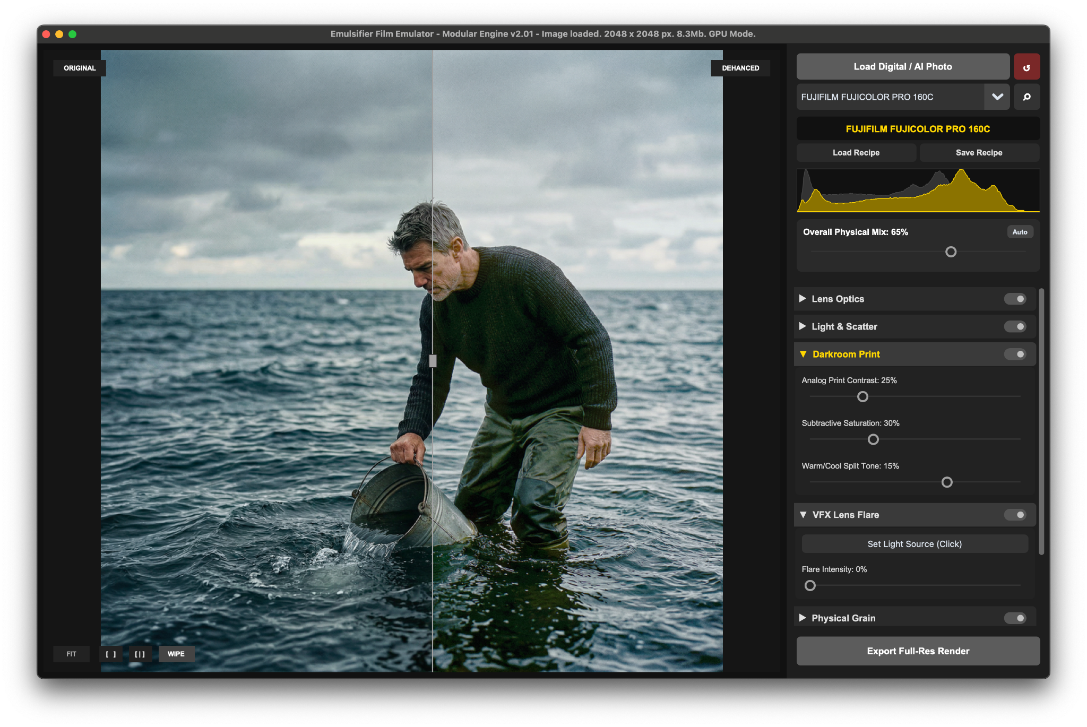
Figure 5 - Wipe view.
WIPE view - overlays the processed image over the original and adds a draggable divider.
Use it for precise comparison in the same physical location of the image - for example skin tone shifts, halation around a lamp, grain visibility, or edge softness.

Tip: Quick original flash
In Single [ ] view, hold the / key to temporarily show the original image. Release the key to return to the dehanced result. This is useful when your eyes have adapted to the grade and you need a quick reality check.

8. Zoomed Inspector
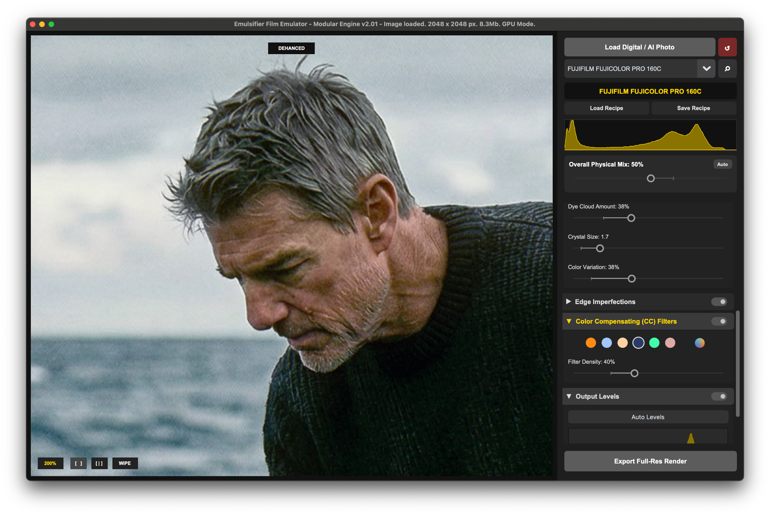
Figure 6 - Zoomed inspection view.
Click the image preview to punch into a 1:1 inspection view. Use the scroll wheel to zoom further, up to approximately 250%. Click again to return to fit view. When zoomed in, hold Spacebar and drag to pan around the image.
Use zoom for: Checking grain size, color variation, chromatic aberration, texture loss, skin detail, and whether the image still feels photographic rather than digitally processed.

9. The physical rendering pipeline
The modules are arranged in the order the image passes through the simulated photographic process. For a natural result, adjust from top to bottom. Each module has a bypass switch, so you can quickly check whether that stage is helping or hurting the image.

Lens Optics
Breaks the clinical sharpness of digital capture before the film response is applied.
Control | Use it for
Optical Softness | Softens harsh micro-contrast and blends pixels in a lens-like way: Modern digital sharpness feels highly artificial. Vintage lenses naturally bloom light and lack hyper-sharp micro-contrast. This slider softly binds the pixels together before grain is applied. Advisory: Use 10-20% to make digital skin look creamy, organic, and less like a smartphone photo.
Chromatic Aberration | Simulates imperfect optical glass (color fringing) where different colors of light travel at different speeds, splitting red and blue channels near high-contrast edges. Advisory: Keep under 3px to give the subconscious feel of an older anamorphic cinema lens

Light & Scatter
Alters the image to simulate the complex, imperfect chemical reactions of physical film.
Control | Use it for
Cine-Log Flattening | Digital images usually have contrast and punch baked in. If you apply a heavy film curve to an already “punchy” image, shadows instantly crush into black voids. This slider "flattens" the image first, feeding “softer” light into the emulsion.
Emulsion Crosstalk | In real film, the Cyan, Magenta, and Yellow dye layers are chemically impure. When you expose the green layer, it accidentally "bleeds" into the red layer. The Result: It creates complex, subtractive vintage color twists, like deep Cyans and rich oranges - that are impossible to replicate with standard HSB sliders.
Dual-Stage Halation | Creates warm red/orange glow around strong highlights and high-contrast edges. In real world dynamics - bright light travels through the film base, “bounces off” the shiny backplate of the camera, and scatters back into the bottom-most Red dye layer. The Result: That magical, glowing crimson "halo" around neon signs, practical lamps, and high-contrast sky edges.
Lens Bloom | Simulates light scattering across the glass elements inside the lens barrel, similar to using a Pro-Mist filter. It blooms highlights softly without the harsh red tint of halation.

Darkroom Print
Controls the final character of the “developed negative”, as if it were printed onto photographic paper.
Control | Use it for
Analog Print Contrast | Digital contrast makes colors look neon and artificial. Analog contrast steepens the image density organically. Use this to bring "snap" and depth back into a flat image without breaking the color palette.
Subtractive Saturation | In physical film, pure white (burnt paper) and pure black (thick dye) physically cannot hold color. Digital algorithms allow bright skies to be 100% saturated neon blue. This slider organically desaturates extreme highlights and shadows, rolling them off into pleasing, natural pastels.
Warm/Cool Split Tone | Simulates slight chemical temperature imbalances during darkroom development. Pushing positive (+25%) maps warmth into the highlights for a nostalgic, golden-hour feel. Pushing negative (-25%) pushes cyan into the shadows for a modern "teal-and-orange" cinematic look.

VFX Lens Flare
Adds an interactive light source that is anchored to a point in the image.
Tip: Click "Set Light Source", then click anywhere on your image preview to mathematically anchor the flare's origin point to a practical light (like the sun or a streetlamp) in your image.
Control | Use it for
Set Light Source | Use this to place the source of the flare in the image
Flare Intensity | Controls how visible the simulated flare is.

Physical Grain
Adds non-linear, photographic texture rather than flat digital noise.
Control | Use it for
Dye Cloud Amount | Controls how visible the grain/dye cloud texture is.
Crystal Size | Controls the coarseness of the grain pattern.
Color Variation | Allows you to blend between structural monochrome crystals (0%) and fully colored chemical dye clouds (100%)

Edge Imperfections
Adds lens falloff and edge behavior that draws attention toward the center.
Control | Use it for
Field Flatness Softness | Softens the outer field to mimic older or imperfect lenses.
Field Flatness Creep | Controls how far the edge softness creeps toward the center.
Vignette Intensity | Darkens the corners.
Vignette Creep | Controls the width and softness of the vignette falloff.

Color Compensating (CC) Filters
Simulates placing colored gels in front of the lens.
Physics: Simple apps slap a flat color overlay across your image, destroying contrast. Emulsifier, on the iother hand, uses an advanced luminosity gradient. It analyzes the per-pixel brightness of your photo, burning a deep version of your chosen color into the shadows and dodging a bright version into the highlights.
Most importantly, it perfectly preserves your absolute blacks and pure whites so the image never feels "washed out."
Control | Use it for
Filter color | Choose from 6 calibrated presets (CTO, CTB, Golden Hour, Cinematic Night, Cyberpunk, Sepia) or click the Custom Colored Filter (gradient colorwheel button) to mix your own.
Filter Density | Controls the opacity of the filter. Defaults to a highly organic 25%.

Output Levels
A final, purely digital safety net, occurring at the very end of the pipeline. Authentic tonal curves often leave the shadows slightly raised or "milky." Use the three interactive triangles beneath the histogram to ensure your final export looks perfect on modern digital screens. Right-click anywhere on the tool to reset it.
Control | Use it for
Black Point | Moves the darkest point back toward true black if the film result is too lifted.
Midtone / Gamma | Adjusts middle brightness without changing the entire pipeline.
White Point | Restores highlights if the film response made them too dull.
Auto Levels | Attempts a quick correction based on image distribution.

10. Practical grading recipes

Natural film pass
- Choose a profile in the gallery.
- Click Auto in Overall Physical Mix.
- Keep Optical Softness around 10-20%.
- Use modest halation and bloom.
- Use Wipe view to check that skin and highlights still look believable.

AI dehancing pass
- Start with Cine-Log Flattening to reduce artificial punch.
- Add a small amount of Optical Softness.
- Use Subtractive Saturation to reduce neon color behavior.
- Add grain only after the tone and color feel right.
- Zoom in and check that texture does not overpower the image.

Cinematic weathered look
- Use a colder or lower-saturation film profile.
- Raise Emulsion Crosstalk and Subtractive Saturation.
- Add edge softness and a light vignette.
- Use Output Levels only at the end if the image becomes too milky.

11. Shortcuts and interaction reference
Action | Result
Drag-and-drop / Cmd-Ctrl+V | Load or paste an image.
Cmd/Ctrl+Z | Undo.
Cmd/Ctrl+Y or Cmd/Ctrl+Shift+Z | Redo.
Right-click slider | Reset that individual slider to its default value.
/ key | Temporarily show original image in Single view.
Spacebar, not zoomed, Single view | Toggle distraction-free fullscreen.
Spacebar + drag, zoomed in | Pan around the zoomed image.
Click preview | Toggle between fit and 1:1 zoom.
Mouse wheel while zoomed | Zoom in or out.
Left/Right arrows in gallery | Move between film profiles.
Esc | Exit fullscreen or close the gallery.

12. Exporting and troubleshooting

Exporting
Use Export Full-Res Render only after the preview is ready. The preview may use a smaller working proxy for speed, but export applies the same settings to the original file when available.

Common issues
Symptom | What to try
No profile selected | Some controls require a film profile. Load an image and choose a profile first.
Result feels washed out | Lower Overall Physical Mix, try Auto, or reduce Cine-Log Flattening. Use Output Levels at the end.
Highlights glow too much | Reduce Dual-Stage Halation, Lens Bloom, or Flare Intensity.
Grain is too obvious | Lower Dye Cloud Amount or Crystal Size. Check at 100% zoom, not only fit view.
Color feels too stylized | Reduce Emulsion Crosstalk, Subtractive Saturation, CC Filter Density, or Physical Mix.
Performance is slow | Keep working in preview mode and export only when the look is approved. Avoid unnecessary extreme settings on very large images.

13. Final grading checklist
- The film profile supports the image rather than overpowering it.
- The histogram is not unintentionally crushed or clipped.
- Skin tones and important objects still look believable.
- Halation and bloom appear only where they make visual sense.
- Grain is visible at 100% but not distracting at normal viewing size.
- The image still has a clear subject and readable contrast.
- A recipe has been saved if the look should be reused.
- The final image has been exported at full resolution.

