V1:Questions examples

V2:Text questions

I: multichoice with radiobuttons; mt=0.1

S: What's between orange and green in the spectrum?

+:yellow

-:red

-:blue

I: multichoice with checkboxes; MT=0.2

S: What two people are entombed in Grant's tomb?

-: No one

+: Grant

+: Grant's wife

-: Grant's father

I: short answer 1

S: What unit is used for length in International System of Units

+: metre

I: short answer 2

S: Who's buried in Grant's tomb?

+: Grant

+: Ulysses S. Grant

+: Ulysses Grant

I: short answer 3

S: Two plus two equals

+: four

+: 4

I: numerical 1; mt=0.4

S: When was Ulysses S. Grant born?

+: 1822

TOL:5

I: numerical 2; mt=0.4

S: What is the value of pi (to 3 decimal places)?

+: 3.14159

TOL: 0.0005

I: Matching

S: Match the following countries with their corresponding capitals.

L1: Canada

R1: Ottawa

L2: Italy

R2: Rome

L3: Japan

R3: Tokyo

L4: India

R4: New Delhi

R5: Paris

R6: Moscow

I: Matching with equal answers

S: Mark true and false statements.

L1:Two is grater then five

R1:false

L2:Three is lower then seven

R2: true

L3:Five is greater than two

R3:true

L4:Ten is not equal to ten

R4: false

I: ordering

S: Order the four oceans in size, with the largest first.

1: Pacific

2: Indian

3: Atlantic

4: Arctic

I: Essay

S: Write an essay about how it is important to be able to write an essay.

V2:Questions with images, equations and tables

I:Question with images

S: Four charged particles are displayed on drawing. Which are attracted?

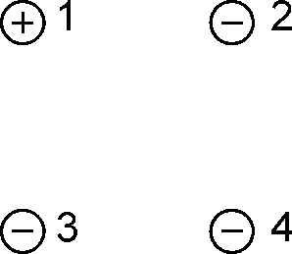

+:1 and 2

+:1 and 3

+:1 and 4

-: 2 and 3

-: 2 and 4

-: 3 and 4

I: Question with mathype equations

S: Electric current flows in the positive direction of the  axis. Specify direction of magnetic induction vector at a point on the positive direction of the axis

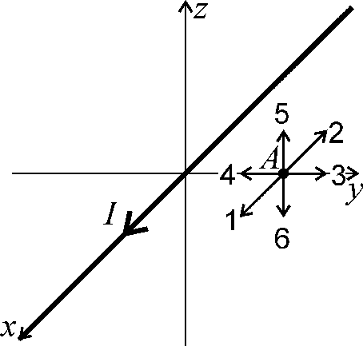

-

-: positive direction of the  axis (1)

-: negative direction of the  axis (2)

-: positive direction of the  axis (3)

-: negative direction of the  axis (4)

+: positive direction of the  axis (5)

-: negative direction of the  axis (6)

I: Question with mathype equations 2

S: The figure shows the relative position of surfaces and point charges. Select the surfaces, the flow of the electric field vector through which is zero.

-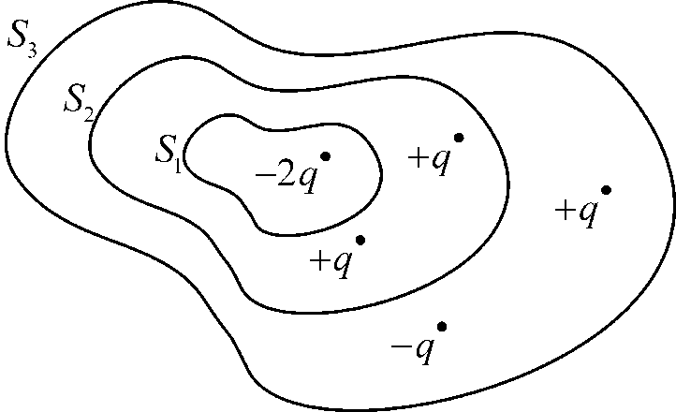

-:

+:

+:

I: Question with OMML equations

S: The figure shows the relative position of surfaces and point charges. Select the surfaces, the flow of the electric field vector through which is zero.

-

-: $S_{1}$

+: $S_{2}$

+: $S_{3}$

I: Tables

S: The table shows the values of current in a circuit with the same power source, but with different resistance. Specify power source voltage

|  |  |
| --- | --- |
| $$R$$ | $$I$$ |
| 1 kOhm | 20 mA |
| 2 kOhm | 10 mA |
| 5 kOhm | 400 mA |

+:20

V1: Questions with errors

V2:Converter should show errors while processing following questions

I: Multichoice. Right answer not specified

S: What two people are entombed in Grant's tomb?

-: No one

-: Grant

-: Grant's wife

-: Grant's father

I: Numerical. Incorrect number format 1

S: When was Ulysses S. Grant born?

+: MDCCCXXII

TOL:5

I: Numerical. Incorrect number format 1

S: When was Ulysses S. Grant born?

+: 1822

TOL:five

I: Numerical. Too much answers

S: When was Ulysses S. Grant born?

+: 1821

+: 1822

+: 1823

TOL:1

I: Numerical. Too much tolerances

S: When was Ulysses S. Grant born?

+: 1822

TOL:5

TOL:3

I: Matching. Too few answers (R)

S: Match the following countries with their corresponding capitals.

L1: Canada

L2: Italy

L3: Japan

L4: India

R1: Ottawa

R2: Rome

R3: Tokyo

I: Ordering. Too few items

S: Order the four oceans in size, with the largest first.

1: Pacific

2: Indian

I:Question does not contain S part