УДК: 53.043, 533

PACS: 47.10.ab

DOI:

Full name: Vadym Alexievich Ostanin

Self employed

**Effects of repulsion and attraction between spinning objects in fluid medium**

**V.A. Ostanin**

03039, 16 Demiivska Str, Kyiv, Ukraine

**Abstract**

**Purpose.** The purpose of this study is to investigate behavior of pair of spinning objects in the fluid medium. This study was inspired by magnetic effects caused by "spin" property of electrons.

**Methods.** The practical experiment uses a pair of plastic cylinders that driven by motors and spin close to each other in air at an atmospheric pressure.

**Results.** Spinning objects with opposite directions speed up air flow in gap that reduce air pressure between spinning objects and attracts them. Vise-versa spinning objects with same directions damp air flow in gap that increase air pressure between spinning objects that repel them. Dependency between directions of spinning objects and observed ​effects had been verified by numerical simulation in OpenFOAM framework.

**Conclusions.** Observed repulsion and attractioneffects will be helpful to manipulate objects where magnetic or other interaction isn’t possible. Also, it could be used as analogy to magnetic repulsion and attractioneffects between two current-carrying wires.

**Introduction.**

When any industries require contactless interaction between objects, like push or pull, for any reason, usually used magnetic, electromagnetic, electrostatic instruments.

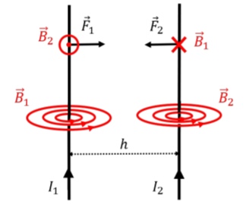[https://phys.libretexts.org/@api/deki/files/15981/clipboard_e7c36ea393f5021931c1bf0796b0bdc62.png](https://phys.libretexts.org/@api/deki/files/15981/clipboard_e7c36ea393f5021931c1bf0796b0bdc62.png?revision=1)



