УДК: 53.043, 532.5, 533.6.01, 533.16, 533.17

PACS: 47.10.-g, 47.32.-y

DOI:

Full name: Vadym Alexeevich Ostanin

Self employed engineer

**Эффекты отталкивания и притяжения между вращающимися цилиндрами в флюидах**

**В.A. Останин**

03039, Украина, Киев, ул. Демеевская 16

**Аннотация**

**Актуальность:** Предложен метод управляемого притяжения и отталкивания вращающегося круглого тела в несжимаемой вязкой жидкости. В этом исследовании представлен обзор и численное моделирование эффектов притяжения/отталкивания, вызванных парой вращающихся дисков.

**Цель:** Целью данного исследования является объяснение принципов, лежащих в основе эффектов притяжения/отталкивания пары вращающихся круглых объектов в жидкой среде, и исследование зависимости силы взаимодействий от относительных направлений вращения дисков и свойств жидкости. Флюидные эффекты отталкивания и притяжения могут быть использованы как метод управляемого бесконтактного взаимодействия без магнитного поля. Это исследование было вдохновлено магнитными эффектами, вызванными «спиновым» свойством электронов и «двухтактным» эффектом между двумя проводниками с током.

**Методы:** В практическом эксперименте используется пара пластиковых труб, которые приводятся в движение двигателями и вращаются рядом друг с другом в воздухе при атмосферном давлении. Численное моделирование помогает предсказать величину силы, создаваемой вращающимися цилиндрами.

**Результаты:** Пара соседних вращающихся цилиндров образует между собой пространство высокого или низкого давления воздуха в зависимости от направления вращения. Вращение соседних дисков с противоположными направлениями вращения заставляет соседний поток поддерживать циркуляцию воздуха в зазоре, что снижает давление воздуха между вращающимися объектами и притягивает их. И наоборот, вращающиеся диски с одинаковым направлением гасят и сжимают воздушные потоки в зазоре, что увеличивает давление воздуха между вращающимися предметами и отталкивает их. Связь между направлениями вращения объектов и наблюдаемыми эффектами была проверена численным моделированием с использованием программного обеспечения OpenFOAM версии 9.

**Выводы:** Наблюдаемые эффекты отталкивания и притяжения можно использовать для манипулирования предметами в тех случаях, когда магнитное или иное бесконтактное взаимодействие невозможно. Кроме того, его можно использовать как аналогию эффектов магнитного отталкивания и притяжения между двумя проводниками с током.

**Ключевые слова:** Притяжение отталкивание вязкая жидкость вращение цилиндры

**Repulsion and attraction between spinning cylinders in viscous fluids**

**V.A. Ostanin**

03039, 16 Demiivska Str, Kyiv, Ukraine

**Abstract**

**Purpose.** The method of controlled attraction and repulsion of a rotating round object in an incompressible viscous fluid are proposed. This study provides an overview and numerical simulation of the attract/repel effects caused by a pair of spinning discs. The purpose of this study is to explain the principles behind the attract/repel effects of a pair of rotating circular objects in a fluid medium and to investigate the dependence of the force of interactions on the relative directions of disks’ rotation and fluids’ properties. Fluid effects of repulsion and attraction can be used as a method of controlled non-contact interaction without a magnetic field. This study was inspired by the magnetic effects caused by the "spin" property of electrons and the "push-pull" effects between two current-carrying conductors.

**Methods.** The practical experiment uses a pair of plastic tubes that are driven by motors and rotate next to each other in air at atmospheric pressure. Numerical simulations help predict the amount of force produced by rotating cylinders.

**Results.** Pair of adjacent rotating cylinders forms a space of high or low air pressure between them, depending on the direction of rotation. The rotation of adjacent disks with opposite directions of rotation causes the adjacent flow to help keep the air circulating in the gap, which reduces the air pressure between the rotating objects and attracts them. Conversely, rotating disks with the same direction dampen and compress the air flows in the gap, which increases the air pressure between the rotating objects and repels them. The relationship between the directions of rotation of objects and the observed effects was verified by numerical simulation using the OpenFOAM software version 9.

**Conclusions.** The observed effects of repulsion and attraction can be used to manipulate objects in cases where magnetic or other non-contact interactions are not possible. In addition, it can be used as an analogy for the effects of magnetic repulsion and attraction between two current-carrying conductors.

**Keywords**: attraction repulsion viscosity liquid rotation cylinders

1. **Introduction.**

This article describes the experiment of controlled attraction and repulsion in a viscous air medium and provides a numerical simulation of the observed effects in an incompressible fluid viscous laminar vortex-free medium of gas and liquid with Reynolds number from for air, and up to for water between two spinning discs. This effect is useful for the engineering task of non-contact interaction between objects, when electric or magnetic fields can adversely affect the engineering task. The described effect was discovered under inspiration from the study of magnetic effects caused by the “spin” property of an electron in conductors with current, but, as will be shown in the article, similar effects are observed in fluid media. These effects are described initially in the article [1]. The object of the study is two plastic cylinders 10 cm long and 5 cm in diameter, driven by engines. The subject of the study is the attraction and repulsion effects that occur between rotating cylinders, and it is also studied how the effects depend on the interactions of fluid circulations around the cylinders. Combining or colliding circulation leads to an increase or decrease in pressure in the space between the cylinders, respectively. A practical experiment was carried out in an air stationary viscous medium at atmospheric pressure. For a visual explanation of the effects, the results of numerical simulations for air and water at a cylinder speed of RPM are given.

1. **Methods**

The experimental equipment (**Fig. 1.**) consists of two smooth plastic cylinders 50 mm in diameter and 100 mm long. They are driven by two independent motors powered by a direct current source. One of the cylinders is suspended on a thin wire to the frame, and the second is in a free position for manipulating it by hand. Wire was used in place of thread to reduce untwisting due to the untwisting properties of thread under tension. Around the installation, the air is 25 ̊ stationary with atmospheric pressure. With both motors turned on, the cylinders spin up to a stable speed of approximately 10^4 RPM. The rotation speed was measured with a digital tachometer with an accuracy of 0.05%.

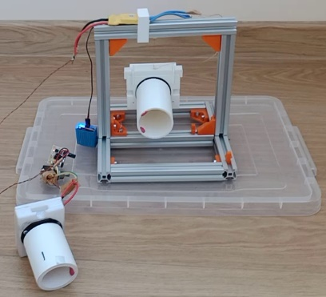

**Fig. 1.** Experiment equipment

Initial data:

- cylinder radius

– cylinder angular velocity

– air density at 25 ̊

*–* kinematic viscosity of air at 25 ̊

*–* dynamic viscosity of air at 25 ̊ =

– water density at 25 ̊

*–* kinematic viscosity of water at 25 ̊

*–* dynamic viscosity of water at 25 ̊ =

By giving each cylinder (**Fig. 2.**) a rotation, a boundary layer will form on the rotating body of revolution due to the sticking condition to the body surface with the effect of “no-slip condition”, which means that at the boundary of a solid object, a viscous fluid flows with zero velocity relative to this border (**Fig. 3.**). As each cylinder rotates, this creates a very thin "boundary layer" around the cylinder, the air next to the cylinder simply rotates with it at the same speed (**Fig. 4.**). The cylinder literally drags air along with it. And in the next layers, rotation in a viscous medium creates an irrotational circulation of the flow in a circle around the cylinder.

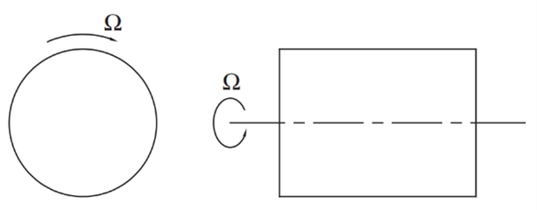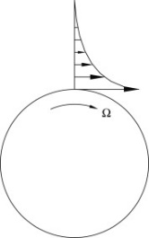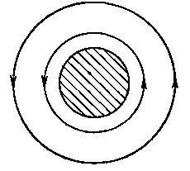

**Fig. 2.** Rotating cylinder geometry

**Fig. 3.** Boundary layer flow over a rotating disc [2].

**Fig. 4.** Circulation around cylinder

Initially, under the given experimental conditions, the cylinders rotated in opposite directions, then the manual cylinder was brought up to the hanging cylinder. At the same time, the attraction of the hanging cylinder to the hand one at a distance of 5 or less centimeters were observed. By changing the experimental conditions and rotating the cylinders in one direction, the hand cylinder was also brought up to the hanging cylinder, and at a distance of 5 or less centimeters, the hanging cylinder was observed to repulse the hand cylinder.

To confirm the causes of the observed effects, OpenFOAM version 9 numerical simulation software with a PISO solver was used. The model includes the calculation of turbulent flows using the Large Eddy Simulation method. The calculation results and graphs are shown after running the simulation for 40 seconds. The results for 4 simulations are presented in the article. The difference between the simulations is presented in the table (**Table 1.**)

|  |  |  |
| --- | --- | --- |
| Simulation name | Spin direction of one of the cylinders (0.orig/U) | transportProperties |
| Attraction in air | code  #{  const fvPatch& boundaryPatch = patch();  const vectorField& Cf = boundaryPatch.Cf();  vectorField rot(Cf.size(), vector(0,0,0));  rot = -10000.0/60*6.28*vector(0,0,1)^(Cf-vector(0.075,0.0, 0.0));  operator==(rot);  #}; | transportModel Newtonian;  nu nu [ 0 2 -1 0 0 0 0 ] 1.56e-05;  rho rho [ 1 -3 0 0 0 0 0 ] 1.185; |
| Repulsion in air | code  #{  const fvPatch& boundaryPatch = patch();  const vectorField& Cf = boundaryPatch.Cf();  vectorField rot(Cf.size(), vector(0,0,0));  rot = 10000.0/60*6.28*vector(0,0,1)^(Cf-vector(0.075,0.0, 0.0));  operator==(rot);  #}; | transportModel Newtonian;  nu nu [ 0 2 -1 0 0 0 0 ] 1.56e-05;  rho rho [ 1 -3 0 0 0 0 0 ] 1.185; |
| Attraction in water | code  #{  const fvPatch& boundaryPatch = patch();  const vectorField& Cf = boundaryPatch.Cf();  vectorField rot(Cf.size(), vector(0,0,0));  rot = -10000.0/60*6.28*vector(0,0,1)^(Cf-vector(0.075,0.0, 0.0));  operator==(rot);  #}; | transportModel Newtonian;  nu nu [ 0 2 -1 0 0 0 0 ] 0.903e-06;  rho rho [ 1 -3 0 0 0 0 0 ] 997.3; |

|  |  |  |
| --- | --- | --- |
| Repulsion in water | code  #{  const fvPatch& boundaryPatch = patch();  const vectorField& Cf = boundaryPatch.Cf();  vectorField rot(Cf.size(), vector(0,0,0));  rot = 10000.0/60*6.28*vector(0,0,1)^(Cf-vector(0.075,0.0, 0.0));  operator==(rot);  #}; | transportModel Newtonian;  nu nu [ 0 2 -1 0 0 0 0 ] 0.903e-06;  rho rho [ 1 -3 0 0 0 0 0 ] 997.3; |

1. **Results**
   1. **One cylinder**

As the speed of the boundary layers increases the viscous air flow around the cylinder, forming separate irrotational circulations of air flows in the form of concentric circles (**Fig. 5.**). With a sharp start of the rotation of the cylinder, vortex flows can first be observed, but after a few seconds, the circulation becomes without vortex. Viscous friction significantly affects the behavior of the medium. The circulation of fluid flows, due to the forces of viscous friction, occurs around a rotating cylinder. In the boundary zone of air and cylinder, the pressure is the lowest due to the high flow velocity (**Eq. 1.**), which is consistent with the Bernoulli equation for viscous fluids:

|  |  |
| --- | --- |
|  | (1) |

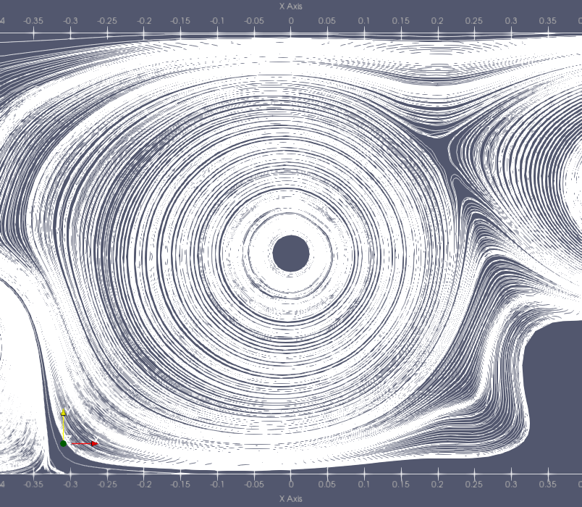

**Fig.** **5.** Single cylinder circulation simulation with RPM

The fluid circulation rate around the cylinder is inversely proportional to the distance from the cylinder (**Eq. 2.**)(**Fig. 6.**).

|  |  |
| --- | --- |
|  | (2) |

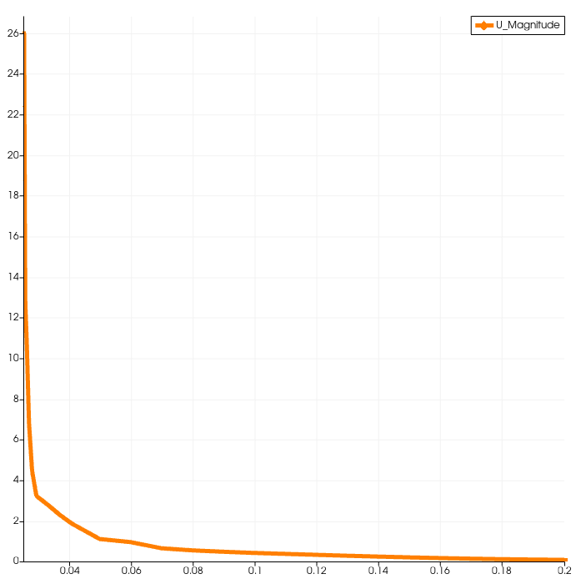

**Fig. 6.** Single cylinder velocity distribution in meters, RPM

When rotating, the cylinder entrains adjacent layers of air, causing it to circulate. Irrotational circulations of a viscous medium cover the entire space outside the cylinder, provided that the space around is boundless. But if the space is limited, for example by walls, then vortices appear in the region of the walls. But the flow velocity in these swirls is much less than the main flow near the cylinder, so they are not considered in the observations of the effects. The greater the viscous friction, the more stable the circulations, and the slower the circulation speed decreases, moving away from the cylinder. The fluid flow velocity is different near the walls and away from them. If we introduce a transverse (perpendicular to the velocity vector) coordinate of the distance from the surface of the cylinder r, then the fluid velocity is a function of this distance v(r) (**Fig. 6.**). This dependence is determined by the momentum transfer in the transverse direction or otherwise by the velocity gradient, as in the case of a viscous gas:

|  |  |
| --- | --- |
|  | (3) |

Force of interaction of adjacent layers touching on the surface :

|  |  |
| --- | --- |
|  | (4) |

Moving away from the cylinders, the circulation rate decreases, keeping the pressure close to stationary, which is higher relative to the vicinity of the cylinder (**Fig. 7.**).

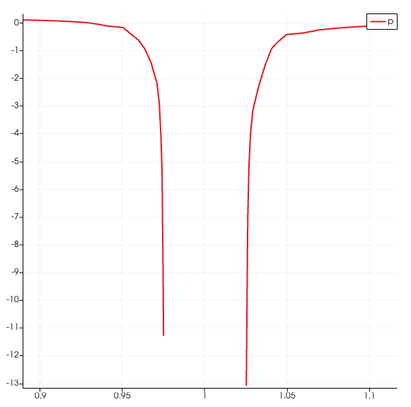

**Fig. 7.** Data representation of the kinematic pressure of simulation

**3.2. Fluid attraction effect**

For numerical simulation near the surface of the cylinder, where higher accuracy is required, a fine mesh is used. Moving away from the surface, the mesh becomes coarser (**Fig. 8.**).

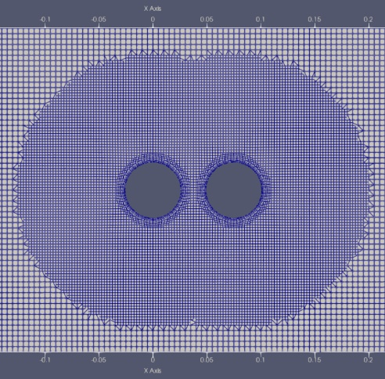

**Fig. 8**. Computational grid.

Two cylinders with a diameter of 0.05 meters at a distance of 0.025 meters from each other are set to rotate in opposite directions, for example, one cylinder is set to rotate counterclockwise and the other clockwise. Between the cylinders, the flows converge, maintaining the circulation rate above zero, and lowering the pressure between them (**Fig. 9.**). The circulation rate of the fluid flow between the cylinders does not decrease to zero, but it is maintained due to the circulation of the neighboring cylinder (**Fig. 10.**). The pressure difference of outside the cylinders and between the cylinders creates an attractive force acting on each cylinder separately, directed from the outside of each cylinder to the inside of the space between the cylinders (**Fig. 11.**).

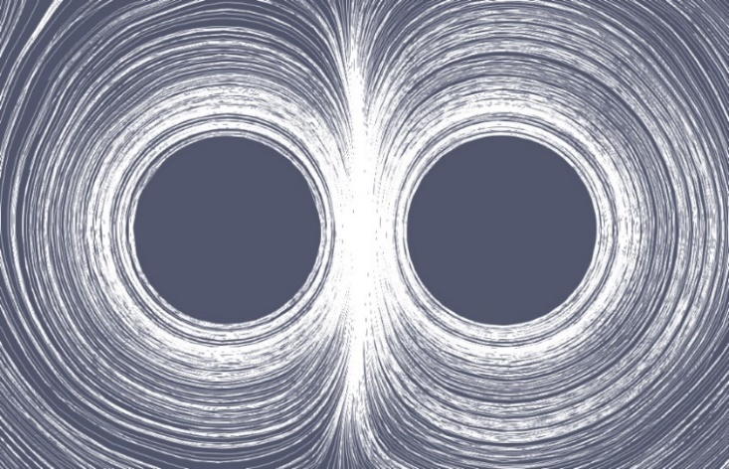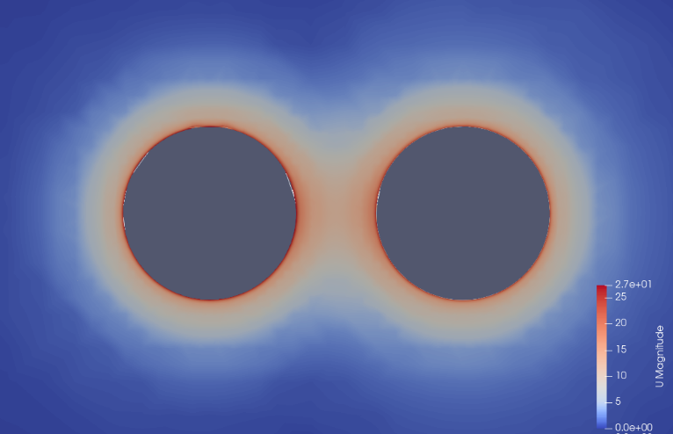

**Fig. 10.** Air flow velocity distribution view of simulation

**Fig. 9.** Air flow circulation stream tracer of simulation

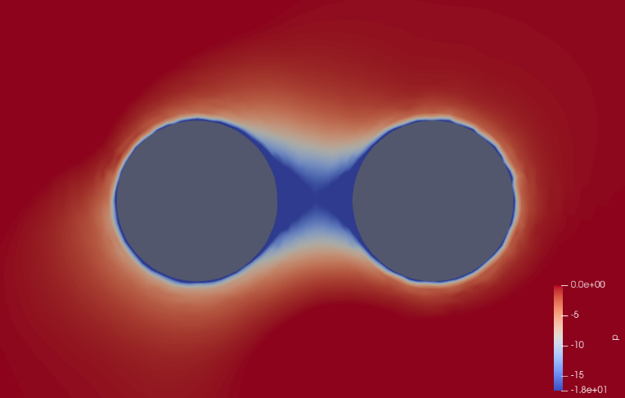

b)

**Fig. 11.** Air pressure distribution view of simulation.

The force acting due to the difference between external and internal pressure is calculated using the formula from the definition of pressure:

|  |  |
| --- | --- |
|  | (5) |

Then the force is equal to the product of the pressure difference and the area of the surface under pressure:

|  |  |
| --- | --- |
|  | (6) |

From the simulation results (**Fig. 12.**) the pressure between the cylinders between the cylinders:

|  |  |
| --- | --- |
| . | (7) |

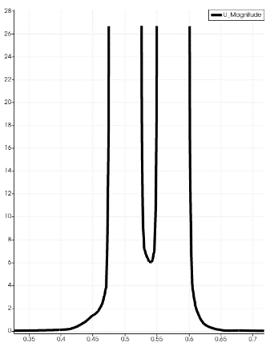 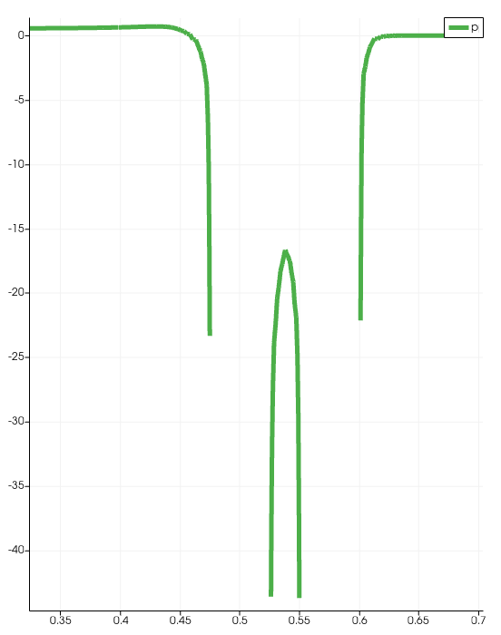

b)

a)

**Fig. 12.** Data representation of simulation:

a) Air velocity; b) Kinematic pressure

If we set the atmospheric pressure outside the cylinders as stationary as , because the numerical simulation specifies the stationary kinematic pressure as , where the fluid velocity is negligible compared to the velocity of the cylinder itself, then the pressure difference (**Eq. 5.**) relative to the atmospheric one is equal to:

|  |  |
| --- | --- |
|  | (8) |

The area of the external pressure contact towards the space between the cylinders is equal to half of the surface of the cylinder:

|  |  |
| --- | --- |
|  | (9) |
|  | (10) |

Using the pressure difference (**Eq. 6.**) and the contact area (**Eq. 9.**), the force (**Eq. 6.**) is calculated as:

|  |  |
| --- | --- |
|  | (11) |

Using the formulas above (**Eq. 5, 9.**), calculating the force . To do this, we set for water as well as for air, because the external pressure is equal to the kinematic pressure as . The internal pressure between the cylinders is given from the kinematic pressure distribution graph (**Fig. 13.**).

|  |  |  |
| --- | --- | --- |
|  | | (12) |
|  | | (13) |
|  | (14) |

Using the pressure difference and the contact area , the force is calculated as:

|  |  |
| --- | --- |
|  | (15) |

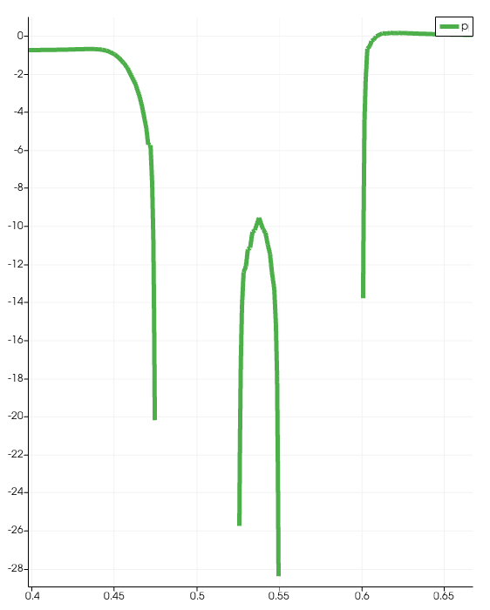

**Fig. 13.** Water kinematic pressure distribution graph of simulation.

**3.3. Fluid repulsion effect**

Both cylinders are set to rotate in the same direction, for example, one cylinder is set to rotate counterclockwise and the other clockwise. As their speed increases, their boundary layers accelerate the flow of air around each of them, forming separate air currents in the form of concentric circles. By bringing the cylinders closer as the velocity of the boundary layer increases, the air flows around the cylinders combine to form a single stream (**Fig. 14.**). But not all flow moves laminarly around the cylinders. The air flows near the boundary layer of the cylinder, pressed down by the external atmospheric pressure, are still trying to move around each of the cylinders. But trying to move between the cylinders, they meet the oncoming flow from the neighboring cylinder.

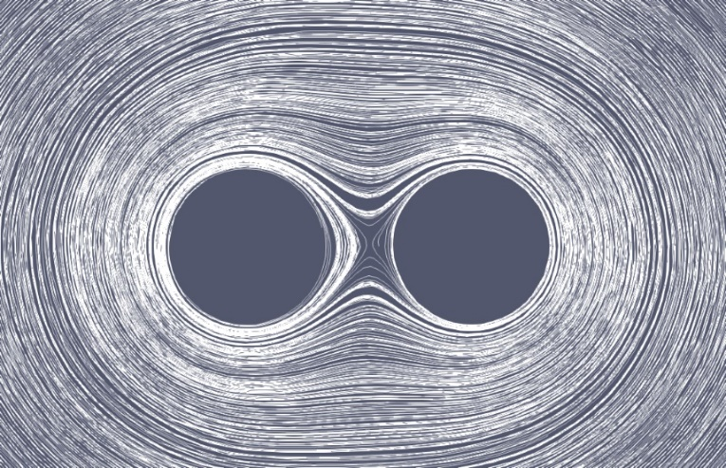

**Fig. 14.** Air flow circulation using stream tracer of simulation

This collision of flows stops the circulation in the center and creates excess pressure between the cylinders (**Fig. 15.**). This excess pressure is greater than atmospheric pressure, and thanks to it, both cylinders tend to push off from the zone between the cylinders. Also, due to the collision of oncoming circulation flows, the flow velocity between the cylinder tends to zero (**Fig. 16.**).

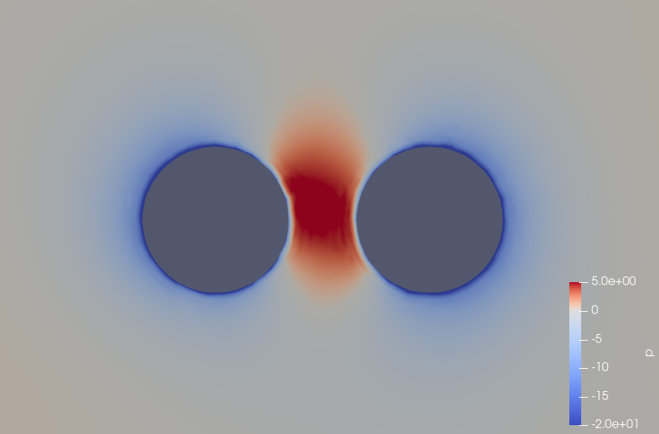

**Fig. 15.** Air pressure distribution view of simulation.

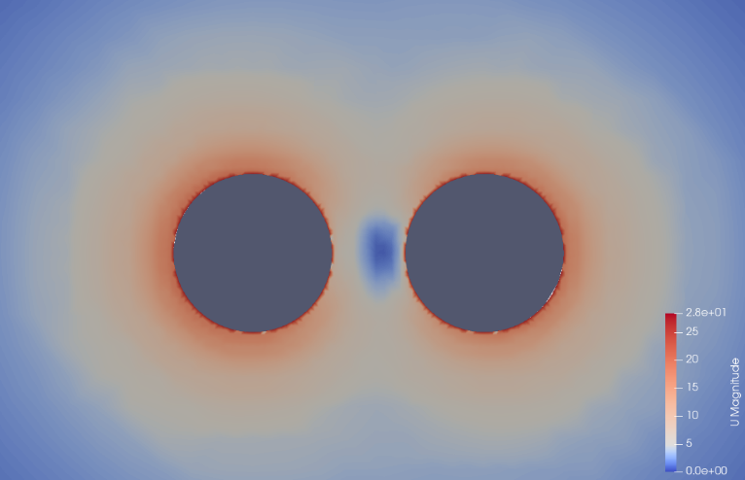

**Fig. 16.** Air flow velocity view

Using the formulas above (**Eq. 5, 6, 9, 10.**) and the data from the graph (**Fig. 17.**) the repulsive force can be calculated as:

|  |  |
| --- | --- |
| . | (16) |
|  | (17) |
|  | (18) |
| . | (19) |
|  | (20) |
|  | (21) |

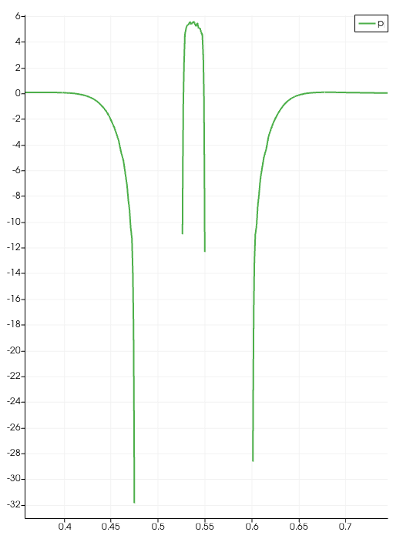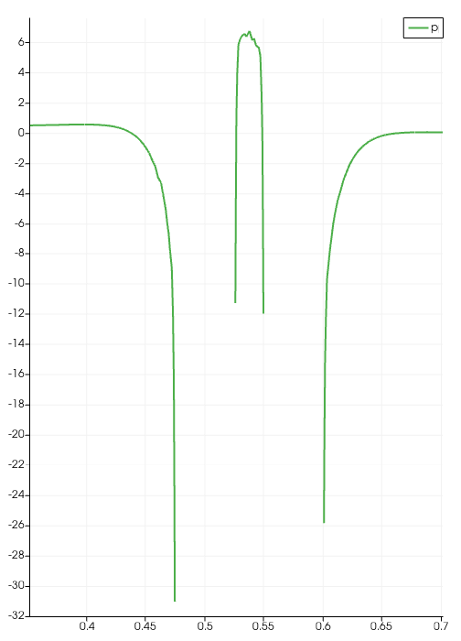

**Fig. 17.** Kinematic pressure distribution:

a) Air; b) Water

**4. Сonclusions**

The attraction and repulsion effects between two rotating cylinders in an incompressible viscous fluid are experimentally and numerically confirmed by the presence of pressure differences for a rotation speed of , which corresponds to Reynolds numbers of for air, and for water , but for at lower speeds, the same effects were also observed. This work showed that the effects are more pronounced in water than in air. When solving engineering problems of non-contact and non-magnetic interaction, the aqueous medium or medium with higher dynamic viscosity is more suitable that causes the greater strength of the effects.

Additional materials can be requested by e-mails: [vadym.ostanin@gmail.com](mailto:vadym.ostanin@gmail.com), [vadym.ostanin@dxc.com](mailto:vadym.ostanin@dxc.com)

**REFERENCES**

1. **Title:** On the Attraction between Two Rotating Parallel Cylinders in Some Viscous Liquids  
   **Authors:** Nukiyama, D.  
   **Journal:** Japanese Journal of Astronomy and Geophysics, Vol. 2, p.193-207  
   **Bibliographic Code:** 1925JaJAG...2..193N
2. Butikov E.I. Physics Book 1 pages 348-349;
3. Peter R.N. Childs.Rotating Flow,DOI: 10.1016/B978-0-12-382098-3.00006-8, Chapter 6
4. R. Feynman, R. Leighton, M. Sands. Feynman Lectures on Physics. Volume 2. Electromagnetism and matter, § 4. Circulation, § 1. Viscosity, § 2. Viscous flow
5. G. Birkhoff “Hydrodynamics”, 1960, pages 32-33.
6. V.A. Budarin “Method of calculating fluid motion”, 2006, pages 31-38, 98.
7. B.N. Yuryev “Experimental aerodynamics” “Part 1” “Theoretical foundations of experimental aerodynamics”, 1939, pages 96-113

**Ефекти відштовхування і тяжіння між циліндрами, що обертаються, у флюїдах**

B.О. Останін

03039, Україна, Київ, вул. Деміївська 16

**Анотація**

**Актуальність:** Запропоновано метод керованого тяжіння і відштовхування круглого тіла, що обертається, в несжимаемой в'язкій рідині. У цьому дослідженні представлений огляд і чисельне моделювання ефектів тяжіння/відштовхування, викликаних парою дисків, що обертаються.

**Мета:** Метою даного дослідження є пояснення принципів, що лежать в основі ефектів тяжіння/відштовхування пари обертових круглих об'єктів у рідкому середовищі, та дослідження залежності сили взаємодій від відносних напрямків обертання дисків та властивостей рідини. Флюїдні ефекти відштовхування та тяжіння можуть бути використані як метод керованої безконтактної взаємодії без магнітного поля. Це дослідження було надихнуте магнітними ефектами, викликаними «спіновою» властивістю електронів та «двотактним» ефектом між двома провідниками зі струмом.

**Методи:** У практичному експерименті використовується пара пластикових труб, які рухаються двигунами і обертаються поруч один з одним у повітрі при атмосферному тиску. Чисельне моделювання допомагає передбачити величину сили, створюваної циліндрами, що обертаються.

**Результати:** Пара сусідніх циліндрів, що обертаються, утворює між собою простір високого або низького тиску повітря в залежності від напрямку обертання. Обертання сусідніх дисків з протилежними напрямками обертання змушує сусідній потік підтримувати циркуляцію повітря в зазорі, що знижує тиск повітря між об'єктами, що обертаються, і притягує їх. І навпаки, диски, що обертаються, з однаковим напрямком гасять і стискають повітряні потоки в зазорі, що збільшує тиск повітря між предметами, що обертаються, і відштовхує їх. Зв'язок між напрямками обертання об'єктів і ефектами, що спостерігаються, був перевірений чисельним моделюванням з використанням програмного забезпечення OpenFOAM версії 9.

**Висновки:** Ефекти відштовхування і тяжіння, що спостерігаються, можна використовувати для маніпулювання предметами в тих випадках, коли магнітна або інша безконтактна взаємодія неможлива. Крім того, його можна використовувати як аналогію ефектів магнітного відштовхування та тяжіння між двома провідниками зі струмом.

**Ключові слова:** Притягнення відштовхування в'язкість рідина обертання циліндри