Georgi Georgiev
University of bedfordshire
CIS099 - Assignment 2

Contents
Introduction 2
Project Background and Problem Identification. 2
Project Proposal 2
Aims and Objectives 2
Aim(s) 2
Objectives and Scope 3
Secondary Market Research 3
Expense Manager 3
Money Manager Expense & Budget 4
Project Constraints 4
Project Risks 4
Justification of Selection of Particular Technologies or Techniques 5
Methodology 5
Stakeholders 5
Functional Requirements 5
Usability Requirements 6
Mobile App Development / Implementation 6
Testing 9
App Evaluation Plan 9
Discussion / Critical Analysis / Reflection / Conclusion 10
What went well and what went wrong? 10

Introduction

Project Background and Problem Identification.
Many young people nowadays who have finally become adults and are now living independently, may earn more money than they may need for their preferred or afforded lifestyle though the fact that they have some spare money may have for some reason encaptivated them to develop bad spending habits on things that they may not require or want, and for that sole reason it was decided to create an app that helps one keep track of their spending habits.
The idea was to create a calendar app that would use a budget filter defined by the user to graphically display colors on the days of the calendar that would represent how much the user has spent on a given day as well as the ability to enter and list the things that the user has bought on that given day.
This project was based on the idea of keeping track of costs and therefore make one more acquainted with their own spending habits.

Project Proposal
As already mentioned, the idea is to produce a calendar app that would help a user keep track of their spending habits, however, it is also necessary to build this app according to the assignment specifications, which means that it will be necessary to have all the app data saved on an external database rather than the app itself, this is to fulfil the requirement of an advanced solution for the saving and loading of data.
The project brief also asks for the use of a Google API and for that requirement, it is proposed the use of a storage solution such as Firebase, which fits the requirements of having a Google API, for the authentication aspect of the application and a database (Cloud Firestore or Realtime Database).
The required need for the usage of multimedia will be fulfilled by the calendar and its day-colouring functionality.

Aims and Objectives

Aim(s)
The aim of this project is to produce a deliverable that can fit the assignment requirements and fulfil all the necessary needs of its respective course unit in order to achieve a high passing grade. This means that, more than anything, the application developed must be a functional product as its highest priority, and if, as stated in the brief, this is not the case, then it may be considered that the effort was a failure as it will likely cause the assignment to fail.

Objectives and Scope
The highest priority objective in this deliverable is to produce an application that meets the brief requirements, doing so while being relevant, functional and fit for a chosen purpose and use-case. This implies the usage of fast and disorganized project methodologies in order to initially create and obtain a solution that works, which is a highly realistic use-case for application development in many different companies, where the production of a rushed but functional product is better than a late product or no product at all, this allows for a more stress free development as future iterations can be delivered to fix bugs and to better organize and optimize the codebase.
With this in mind, it is first targeted the creation of the main core functionality of the app, which is the calendar and display of coloured days depending on the given amount spent on a given day. After that, it is implemented all the functionality that retrieves the data from the user regarding the colours used for different configurable budgets, and finally the user registration and login processes are created as well as well as ensuring that all of the user inputted data is validated to ensure a smooth experience for the users.

Secondary Market Research
It was done some market research to find some similar apps that have proximate functionalities to the app being developed, the research was conducted by looking for “expense tracking” apps, bellow is listed some of the more trending search results:

Expense Manager
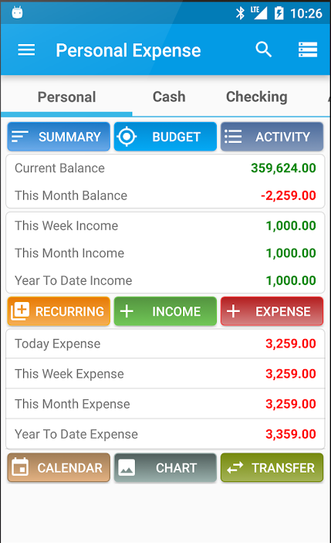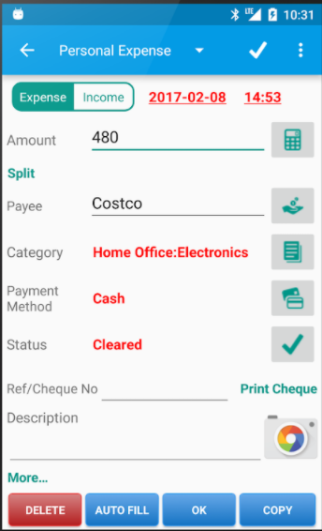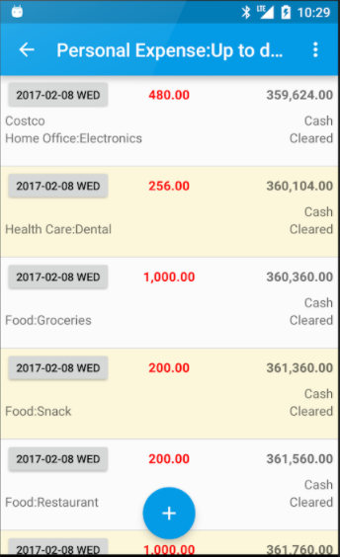
This app has some interesting ideas but it seems very purposed to keep track of costs from a more business oriented perspective as it has options to set the location and ref/check number of a given payment which are features that are not very relevant for the puirpose of the app being developed in this given report.
The big downside of this app is the usage of an outdated design and the fact that it doesn’t seem to be following any color schemes.

Money Manager Expense & Budget
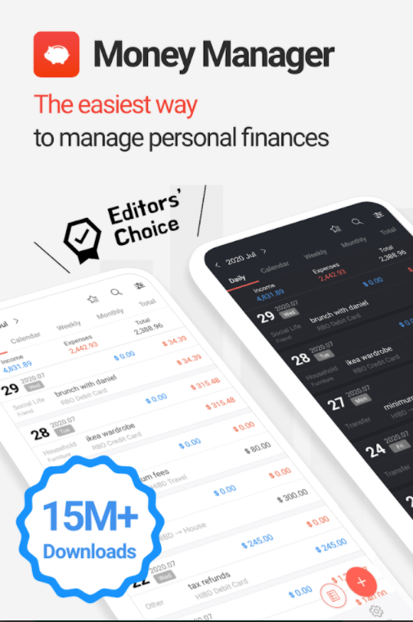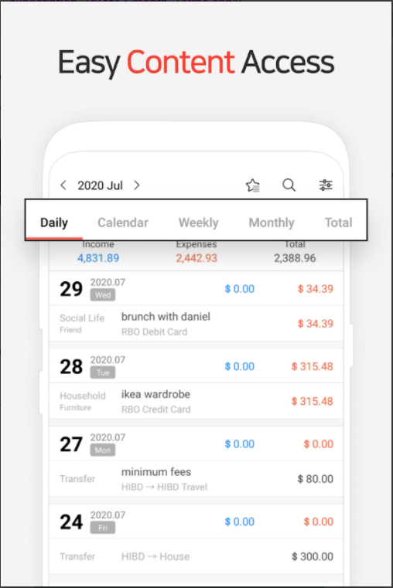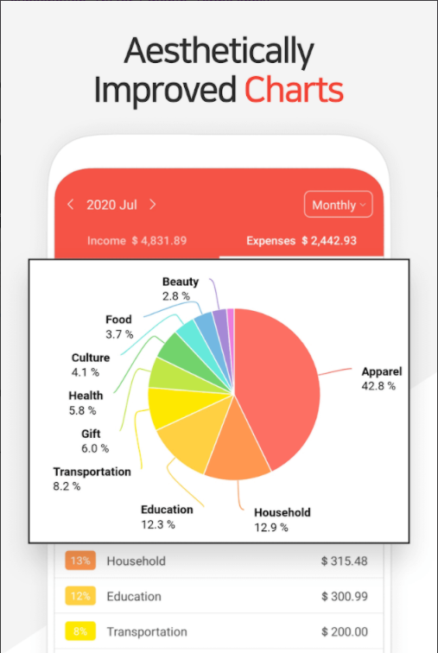
This app, in comparison to the previous one, looks a lot more stylish, modern and it is even rated as the “Editor’s Choice”, however, this is not a free app or even one that can be acquired with a one-time purchase, instead it requires the user to have a Google Play Pass subscription in order to unlock most of its useful features as well as remove all of the very intrusive ads.

Project Constraints
The primary reason for taking the prioritization of the delivery of the product so seriously is due to past experiences in developing products using technologies in which there was little to no technical knowledge or experience in conducting and creating such a product, it is known now that the delivery of a complete product is the most valuable attribute in such circumstances. To add to that, despite the large amount of time that was provided to complete the project it was still not very significant when put in scale with the potential size of a project like, due to this, corners have to be cut in order to ensure that a product is delivered.

Project Risks
The scope of this project was kept small in order to maximise the chances of success of completion and it can therefore be said that the risks were minimized as much as they could, though, despite that there were still risks nonetheless, such as unexpected bugs that came along the way which took far too long to resolve, which again, can be attributed to the lack of technical knowledge as well as experience.
The risks above in combination with the time available as well as frustration were also a cause for another unprecedented risk, the frustration and its consequential lack of determination to carry on with the project.

Justification of Selection of Particular Technologies or Techniques
In this project it was used a hybrid technology to create the mobile application, the reason being that it is easier to make changes to it and have these changes reflected in real time in the actual application being developed rather than wait for it to compile entirely every time a change is made.
Another reason, though not entirely relevant for this assignment, was the ability to compile the application for different platforms as given that it’s a hybrid solution it has the flexibility to compile for both android and iOS devices.
The hybrid technology used was the React Native Framework which is a JavaScript framework, developed and open-sourced by Facebook and backed by its popularity and the many existent open-sourced React-community made components.
The assignment brief had originally suggested the use of Adobe PhoneGap, which seemed easier to use, however, the skill of knowing such a technology is not very relevant for employers and so it was chosen to use React Native instead as it is a highly sought after skill that on its own can land many jobs in 2021.

Methodology
The methodology that taken on, was one that wasn’t fully in accordance to the defined principles of agile, but it was agile based where possible, however, there were many back and fourths that had to take place in order to fix unnoticed bugs and problems that popped up in the queerest ways, besides that some of the features were also not implemented in accordance to the agile principles, where for example some of the features would be built first and then designed later.

Stakeholders
This application had no stakeholders other than the developer themselves, as not delivering a working product meant the failure of the assignment which meant, failure of the University Unit which is a great investment for a student.

Functional Requirements
Login/ Register: The app must have a functional secure login and register functionality that at no point expose the user credentials over unsafe communication or storage of the information.
Sign-Out: The app must possess the ability for the user to sign out as other users of the given device may want to also use it at the same time.
Database Storage Connectivity: The app must have a proper Database connection set up in a singular storage such that anywhere on the app this data can be easily accessed and modified.
Logic for the app’s main functionality: The application must possess the ability to process the data that it is being served in a way that is useful to the user and that fits the application’s purpose.

Usability Requirements
The application must be designed such that it is focussed around accommodating the user needs, which means that it must also have a good design that is consistent across the whole application, it must work well with different device dimensions, it must have simple and short and readable forms for entering details as well as a clear and intuitive navigation.

Mobile App Development / Implementation
During the development of the application the first step was a version control, for this project it was GitHub and the method for trying out new features was by using branches, it would be used a dev branch for implementing new features and this would then be merged to the main branch once a given feature was complete, this would facilitate troubleshooting as it made very accessible and easy to switch between versions and compare if for example a specific behaviour was happening before the implementation of a given feature, this was naturally also possible by reverting to past commits, hence the use of a version control in the first place, but by using branches it would also help get used to what it would be like to develop an app within a team of developers where each developer is appointed a dev-branch for implementing features.
It was then created a React Native project and researched on useful node-modules to use for the project, a particular crucial node-module for the project was the React Native calendar module as this brought in an existing highly customizable component to use in React, which if it hadn’t existed it may have been required to build a calendar entirely from scratch, further delaying the project. As previously mentioned, this is one of the great advantages of using React Native, it is the fact that there are so many already existent tools and components that can just be installed and used completely free of charge.
Once the calendar component was imported with some basic stock data it was time to link it to Firestore and ensure that it displayed data that came straight from the Firestore database after this was achieved the UI of the calendar was then optimized and after that it was implemented a few screens for the user to enter data that would be saved on the Firestore, this data would be then loaded by the Calendar screen whenever it was accessed, this method of implementation helped avoid further complication such as bringing in state managers, which would have made it much more difficult and time consuming to implement the app.
Lastly, the login and register screen were created and then a few more features were added to the app such as the auto-complete for usual expenses, this feature, as well as any other, can be observed in the app video demonstration.
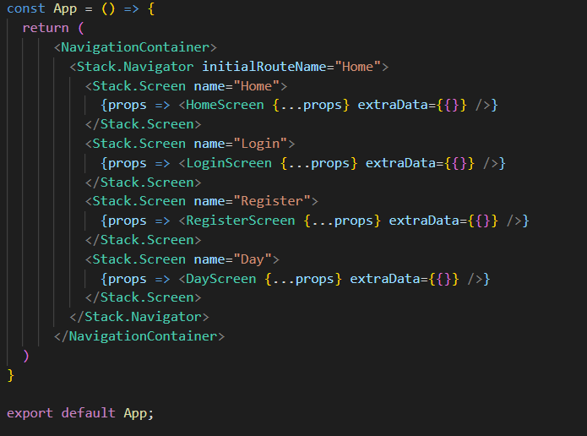
This is the implementation of the stack navigator, the main way that the application is navigated.
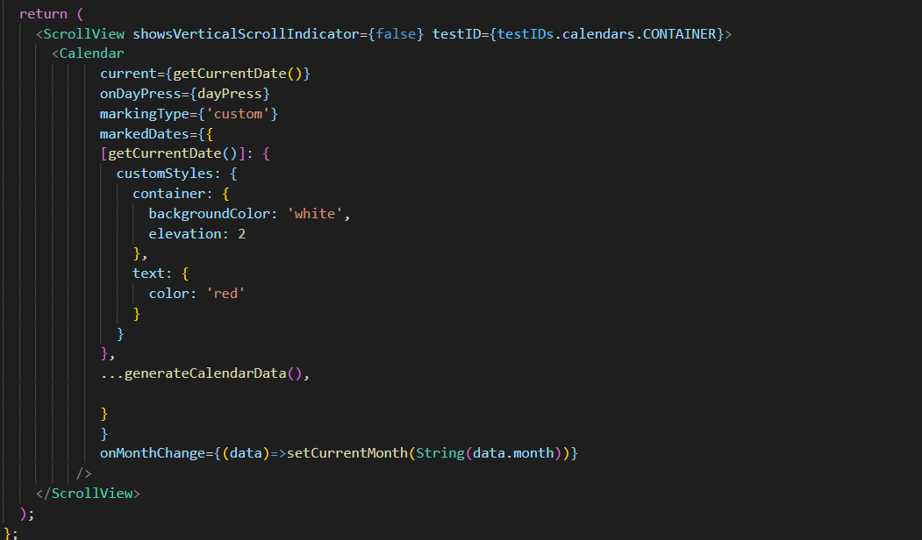
In the above is shown how the calendar screen is rendered and it can be seen that it uses a Calendar component for that, it also has a few custom styles and a lot of other dynamic data that is passed into the component once the app is running and receiving data from the firestore.
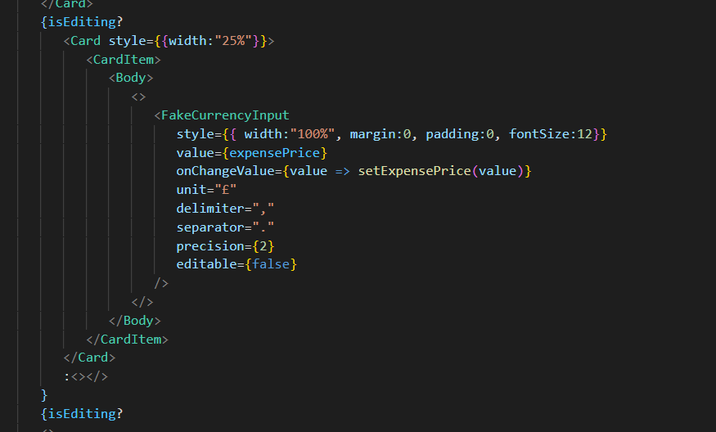
The above shows another very useful component for obtaining valid currency from the user, and that is the “FakeCurrencyInput”.
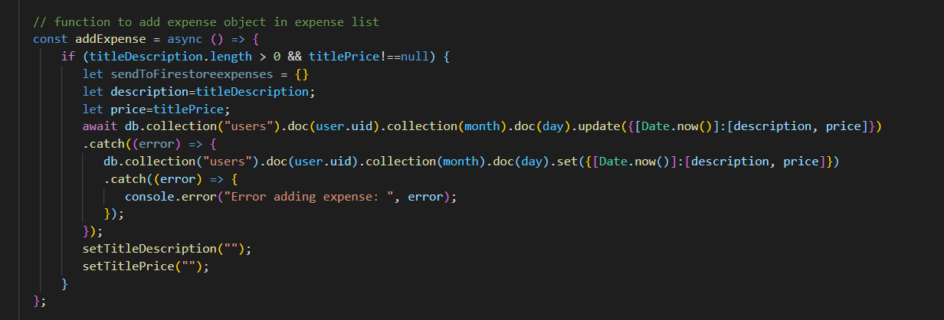
To set and update data on the Firestore the, above method are often used, namely (db.collection…) set and update. To get data from the Firestore it is used the following:
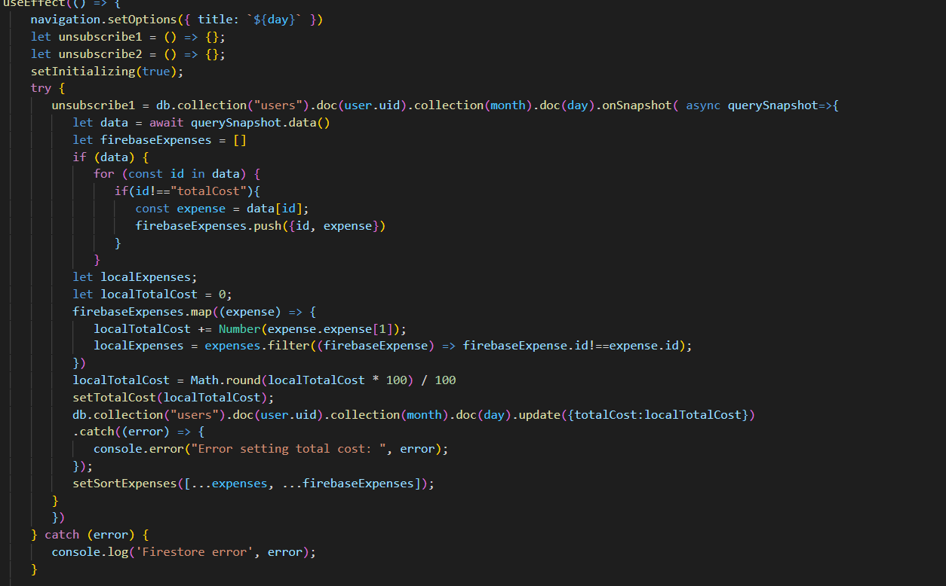
In the above, a Firestore subscription is created where the data stays synchronized with the Firestore, meaning that if the Firestore data is changed by the current application, or even by another application altogether it automatically re-renders the current screen and re-subscribes to any new possible upcoming changes again.
That concludes a general overview of the programming, a more detailed overview is provided by the video presentation of this project.

Testing
The testing conducted on the app was all done manually as it was developed, at this stage of the application it is not necessary to write testing scripts as doing so would have delayed the outcome of the project, potentially causing it not to be delivered.
Conducting manual tests on the application was unreliable enough, especially while working on it, it seemed that the hot reload environment of React was always breaking therefore requiring a full recompilation of the project which always took a long time.

App Evaluation Plan
The app developed was decided to put to test to evaluate whether or not it has meet the user requirements, in order to do that it was decided to have a few users try it out, it was issued copies of this app to multiple people so they could have a go at tracking their own spending habits.
In order to keep track the evaluation it was decided to inspect the data saved on the Firestore that was collected from these users and without diving into the more private data, such as the actual spending habits of the users, which would be unethical, it was just analysed on whether or not the users continued to use the app the initial trial and it was observed that most users stopped using it altogether. As part of the evaluation it was then asked the users on whether or not have continued to use the app and as to why they had stopped using it if that was the case.
The feedback received revealed that the design of the app is not very well polished as well as the features are not that many which make the app seem very limited. Additionally, some pointed that adding animations might make the app a little more interesting despite its simplicity.

Discussion / Critical Analysis / Reflection / Conclusion
As suggested throughout the report the biggest shortcoming of this project was the lack of experience and lack of help as far as developing the app went, though another big factor was the development of the app as a single individual, not having another person to work with as a team and instead having to work and figure everything out by oneself can sometimes prove really difficult as many of the programming deterrents in this project were fairly simple when looking back on them, if there had been another person to double check the code, they could have easily spotted the faults and led the project right back onto the right track.
If this project was to be completed again, it would likely be done so a lot more efficiently as the completion of this has generated a fair amount of experience, but also said experience also says that it would be better to try doing it as a team as a lot more can be accomplished by two or more people, especially when one of the assignment requirements were to create an app with excellent commercial potential, such a requirement cannot be easily by a single individual working on their own.
Moreover, the learning experience and programming required to complete the application as well as the documentation of the process would be made easier if it had been possible to focus solely on it and not have other outside obligations and responsibilities such as a job to pay the bills.
All in all, it can be concluded that this assignment proved much more difficult than expected but the learning experienced gained as well as various self-improvement benefits such as time-management have made it worthwhile even if it does not achieve a high grade.

