

Individual report unit number

Marian Terchila – 1819263 – marian.terchila@study.beds.ac.uk

UNIT NAME

UNIVERSITY OF BEDFORDSHIRE



# Contents

Contents 1

Introduction 2

App Introduction 2

Project background and problem identification 2

Solve the problem & aim of the project (JournaliZZe) 2

Aims and Objectives 2

Secondary Market Research 3

1) Daylio: Diary, Journal, Mood Tracker 3

2) Moodflow: Mood Tracker, Journal, Self-Improvement 4

3) Bearable - Symptoms & Mood tracker 4

App design 5

Primary market research 5

App prototype 8

Home page 8

Menu page 8

Mood tracker page 9

Habit tracker Page 10

Journal Page 10

Personas 11

App evaluation plan 13

Determine the goals 13

Explore the questions 13

Choose evaluation methods 13

Identify the practical issues 13

Decide how to deal with the ethical issues 13

Evaluate, interpret and present the data 13

# Introduction

This report outlines the thought process when designing a mobile application, prototyping it, analyzing the competitors on the marketplace, studying the target audience and providing an implementation plan.

# App Introduction

## Project background and problem identification

Keeping track of time has become quite difficult nowadays. We are running between jobs, school and numerous other activities. Everything is moving so fast and so do we. We keep busy. This is why we are faced with a demand for alternative ways of organizing. Traditional ways of organizing, such as agendas, calendars, or journals, may be inconvenient and time-consuming. It is no longer feasible to carry notebooks around as people prefer to carry all their data in one place, stored on their smart gadgets and connected to the cloud. The fact that the cloud allows you access to your data at any time and on multiple devices is a breakthrough in the way we traditionally store information.

## Solve the problem & aim of the project (JournaliZZe)

Although there are a multitude of apps on the market meant to help to organize your time such as calendars, agendas, habits trackers or mood trackers, they come as standalone applications and they often lack in appetizing design. Thus, our mission is to solve this problem by bringing together all these features under a creative, user-friendly design. Through our app we also hope to bring artists closer to audiences, as we are going to collaborate with artists in order to create attractive designs each month. The user-friendly interface is paramount in our project and is a major stimulus for our project. The app we have designed to tackle this problem is entitled JournaliZZe.

## Aims and Objectives

**JournaliZZe** is meant to store the user’s data and generate monthly statistics in an innovative format, which allows you to easily track your evolution from month to month. What differentiates us from other similar apps is the constant change of design. Consequently, each month we will collaborate with artists in order to redesign the whole user interface. This way we keep our users, standing out from similar apps which are using the same user interface for the entire lifespan of the application.

## Secondary Market Research

In the following paragraphs we are going to look at 3 similar apps which we found on Google Play. We chose these three maps because they were downloaded by a large number of people (over 10 000) and they largely have positive reviews.

### 1) Daylio: Diary, Journal, Mood Tracker

This app seems almost identical to JournaliZZe in terms of functionality. Daylio is a mood/habit tracker with a neat, modern-looking design and a ton of features. The app has a mood tracker which simply asks the user to pick one of the five smiley faces representing moods. The mood data can then be transferred into a graphical representation, from simple line graphs to colored dots at the end of each month. The other important feature is the habit tracker, where the users pick from a pre-made selection of habits or tasks. Both the mood tracker and the habit tracker can then evaluate the data and display statistics, for example how many times did the user go to sleep early in that given month and how it correlates with their moods. A diary and a journal are part of this app, however these functions are often found on pre-installed software on any mobile device and so are not considered a plus.

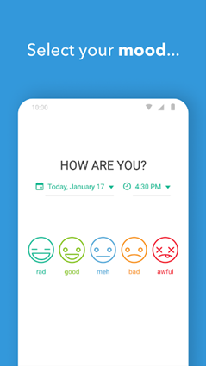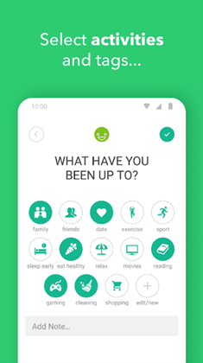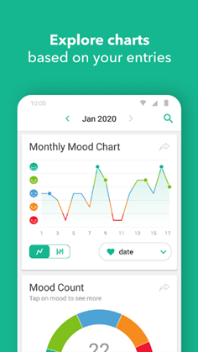

The monetizing strategy for this app is free to download and buy to customize. There seems to be a large variety of customization, however, all of it is in line with the static modernist design of the app, so the user only customizes icons, colors and can add their own activities or habits to keep track of. The functionality of this app is its main selling point, but its design is rather unattractive, boring and unoriginal.

**Pros**: large variety of graphs and statistics, easy to use interface

**Cons**: general and impersonal design, very limited customization options

### 2) Moodflow: Mood Tracker, Journal, Self-Improvement

This app is almost identical to the previous app in terms of functionality. The only noticeable difference is in the design of the app, which tends to use more vivid colors and defined shapes. Additionally, this app also markets itself as a “self-improvement” app, emphasizing the planning and organizational utility of the app.

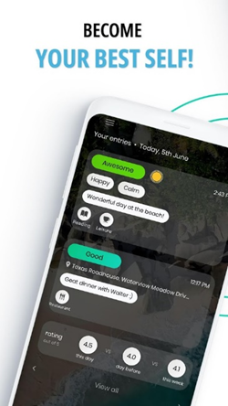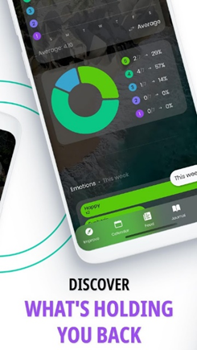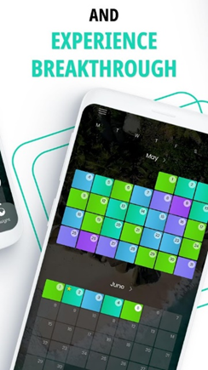

**Pros**: Customizable charts and graphs

**Cons**: the interface is not very user-friendly, the customization process is not well explained , a large amount of ads

### 3) Bearable - Symptoms & Mood tracker

The biggest difference and a selling point of Bearable is its connection to **health**. In Bearable, users can keep track not only of their moods and habits, but also of their symptoms if they are ill. This is done via a friendly-looking UI where the user can pick, for example, whether their fever is “moderate” or “severe”, and their current mood. This input is then transferred into statistics and the user can find out how impactful are their symptoms on their mood.

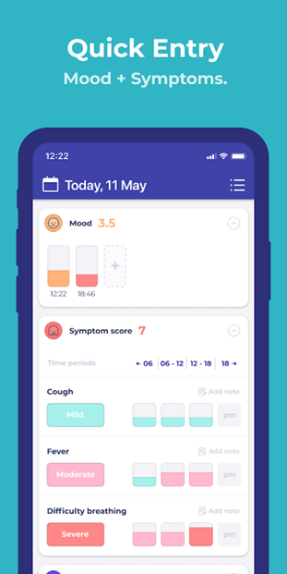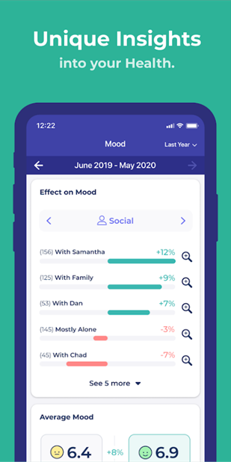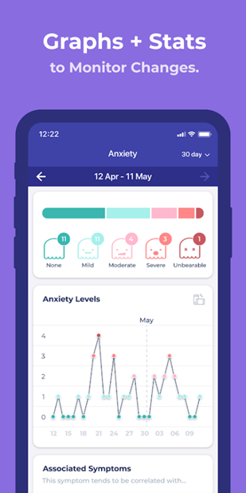

**Pros**: tracking symptoms, can gather data about sleep or step count from the device, connects the mood data with the symptoms data

**Cons**: design is static and tied to the name/brand, some features not that useful (reminders or alarms), generic-looking graphs

# App design

## Primary market research

For the primary market research, a questionnaire was created with possible answers for each question.

The first question is meant to identify the age-ranges of our potential users, so we get a better understanding of the people we’ll have to deal with. According to our results, most of our respondents are aged between 18 and 35 (7 out of 10).

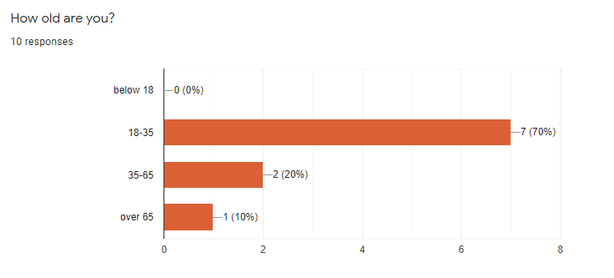

The following two questions are meant to filter from all results only the people who use habit trackers. That way we can mainly focuss on their preferences, since their oppinions are the only ones that matter.

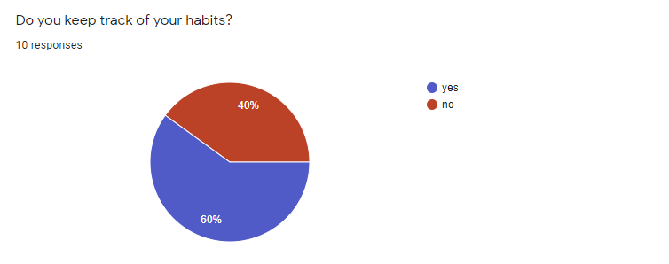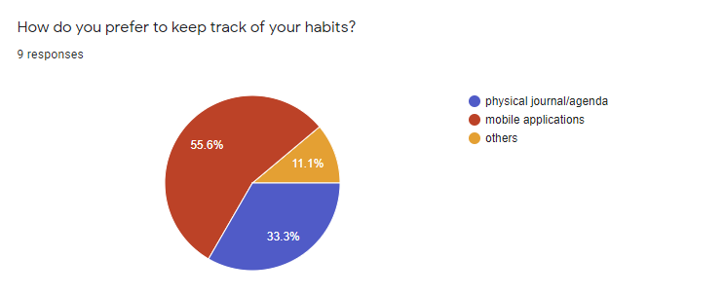

Through the next question we wanted to make sure that our users appreciate a good design and that the design its one of the main reasons why they would chose one app over another.

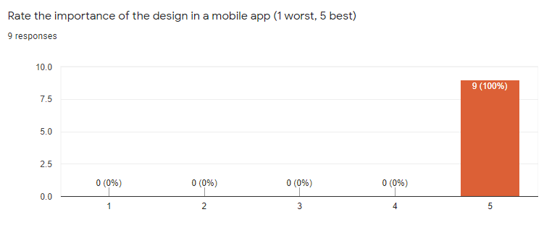

Furthermore, to put more emphasis on a good design we asked our recipients to rate the functional aspect of an app and we drew the conclusion that, although the functionality is important for most users a good app design has priority (given the fact that 9 out of 9 users rated the design as very important, while only 6 out of 10 rated the functionality).

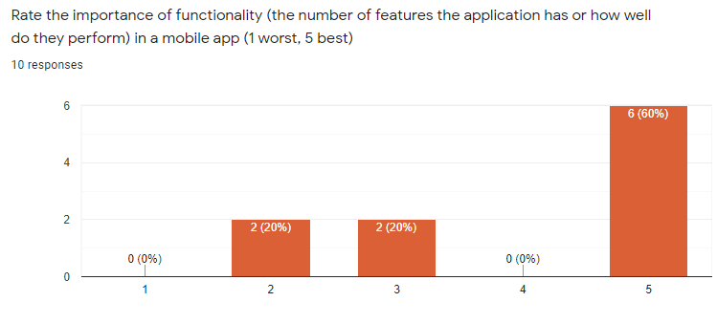

As the graph below shows, the majority of users appreciate a monthly change in design.

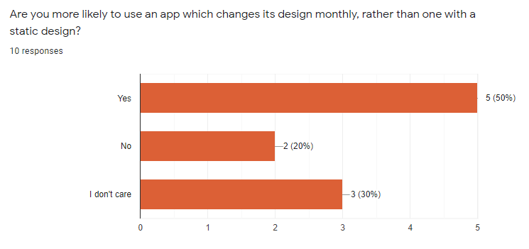

## App prototype

In the following paragraphs we are going to detail our vision regarding the app. All the illustrations below were made exclusively for this app, as envisioned by our featured artist for January. The theme we have chosen is “mountains and wilderness”. Accordingly, we are going to present the main pages of our app: the main page, the menu page, the mood tracker page, the habit tracker page, and the journal page.

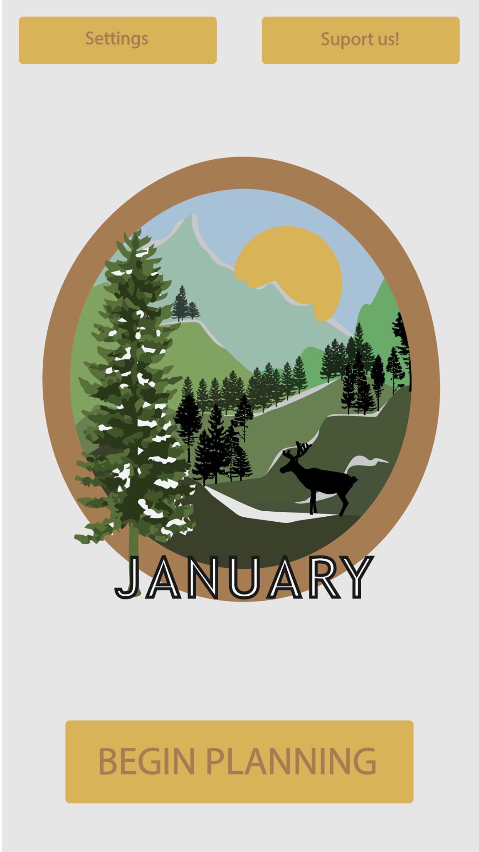

### Home page

The home page contains the **Settings** button which will take the user to his account page where he can modify his sensitive information (email, password, etc). The **support us** button is going to take the user to our patreon page since this is the way were monetizing the application, we don’t use monthly subscriptions or bully the users with adds. The **Begin planning** button opens the menu page.

### Menu page

The menu page consists of three buttons where each one of them takes you to the appropriate page.

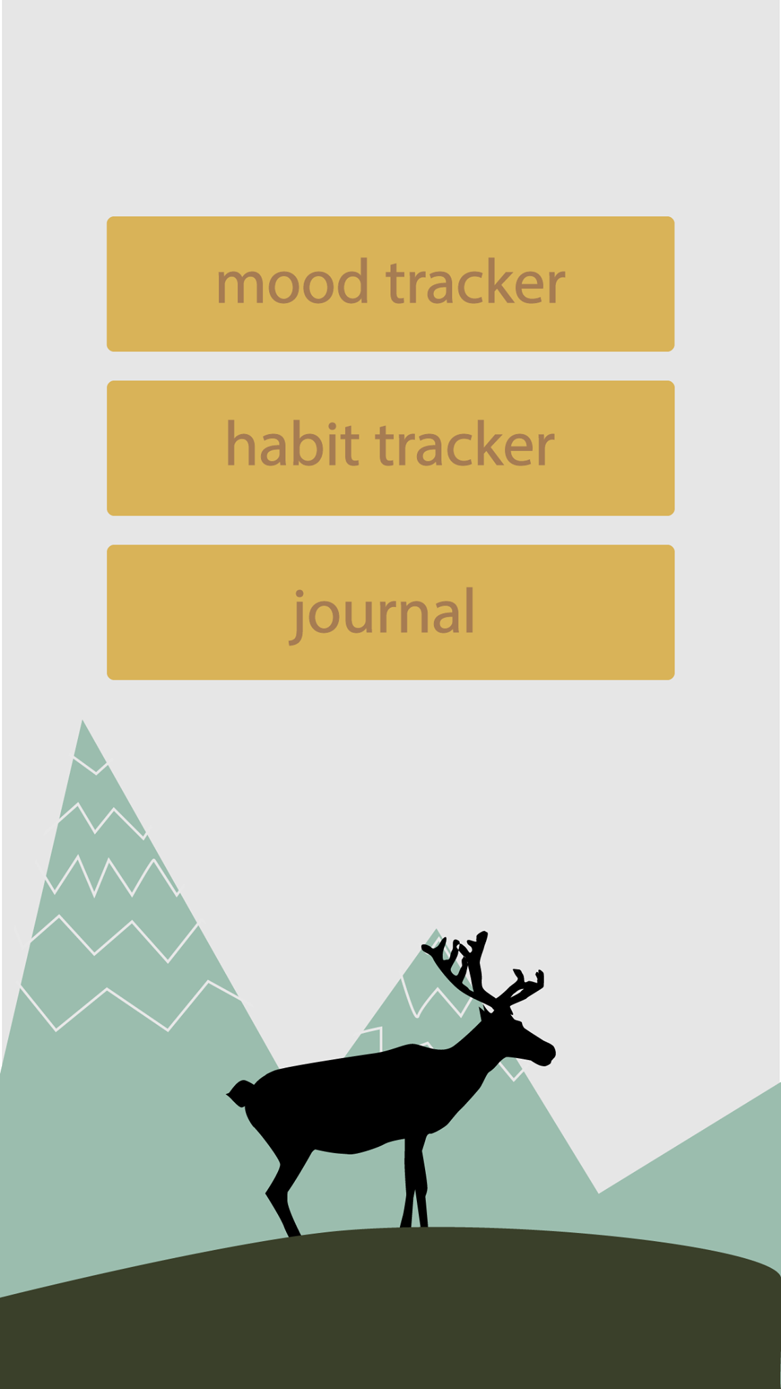

### Mood tracker page

At the beginning of each month the user is presented with an empty graph. This graph takes the shape of an illustration which changes each month. In this case, for month January, the theme which we have chosen is “mountains and wilderness”. Accordingly, the mood is represented by a mountain which can be colored by the user. As you can see in the attached picture, each polygon has a number which represents a day from the current month (there are 31 polygons in the mountain, as January has 31 days). The user will evaluate each day by filling up a polygon with one of the provided colors (light yellow means a good day, dark green a horrible day). As the days pass you can have an overview of how your month was. It is worth mentioning that both the habit tracker page and journal page are linked to the mood tracker page, therefore each time when the user taps on a polygon it also prompts them to fill up the habits for the given day and write a short note.

We believe that this way of showcasing the mood tracker is more efficient than the classical way (a simple statistic), as at the end of the month, regardless of how good or bad your days were, the final product is going to be beautifully colored 😊. In other words, all your moods combined created something beautiful at the end of the month. This may motivate users to have a more positive attitude on life and be more motivated.

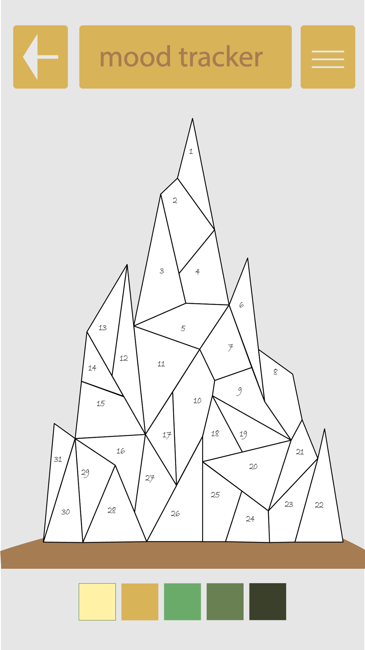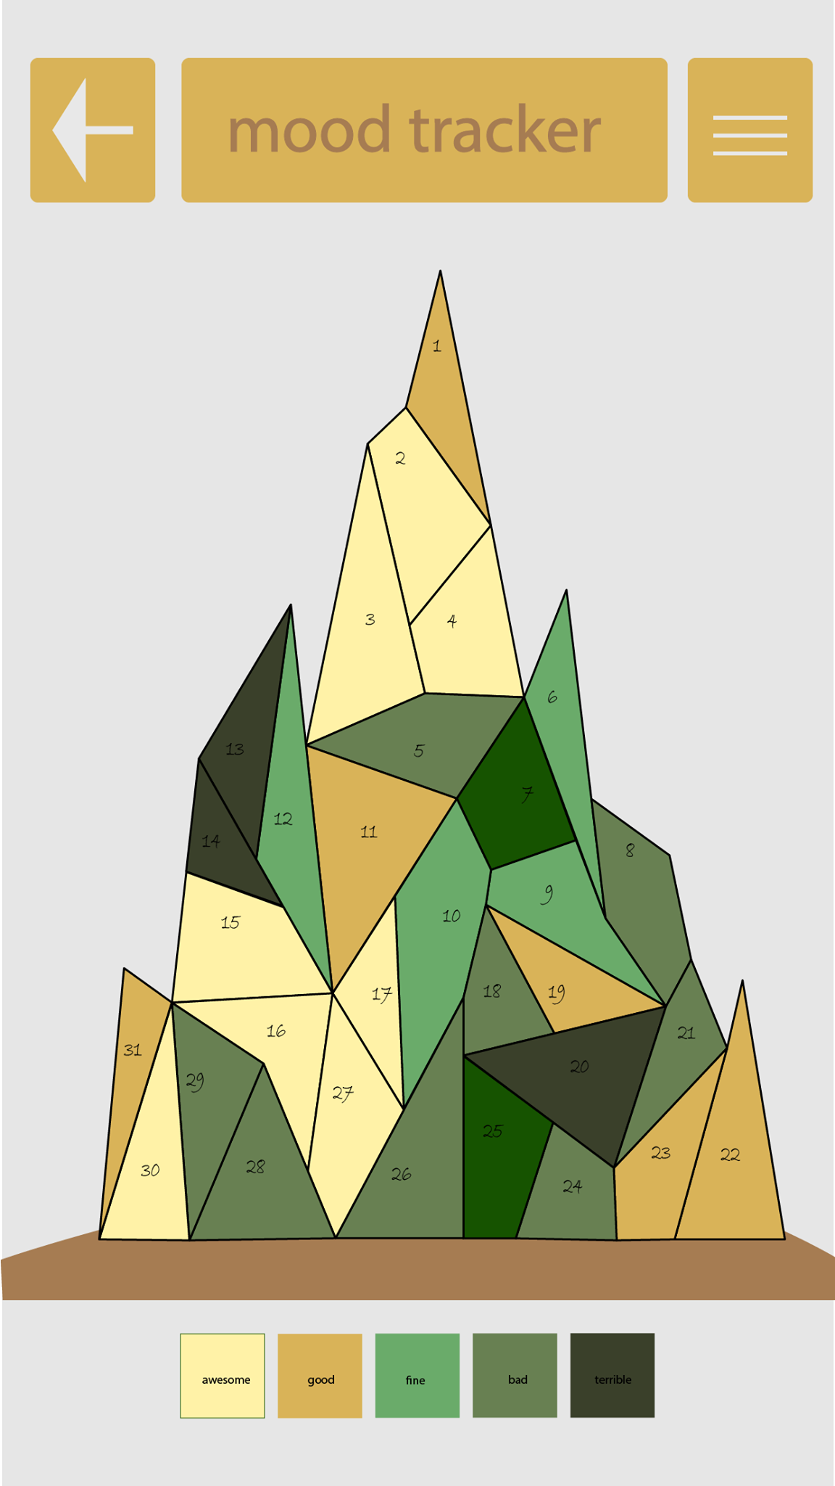

### Habit tracker Page

The user can add habits to be tracked by clicking on the plus button. That will prompt the user to a new window which asks the user to pick a name for the habit and set the frequency (daily, weekly, monthly etc). Every time they complete the habit, they mark it as done by tapping on the habit that adds a triangle to the UI.

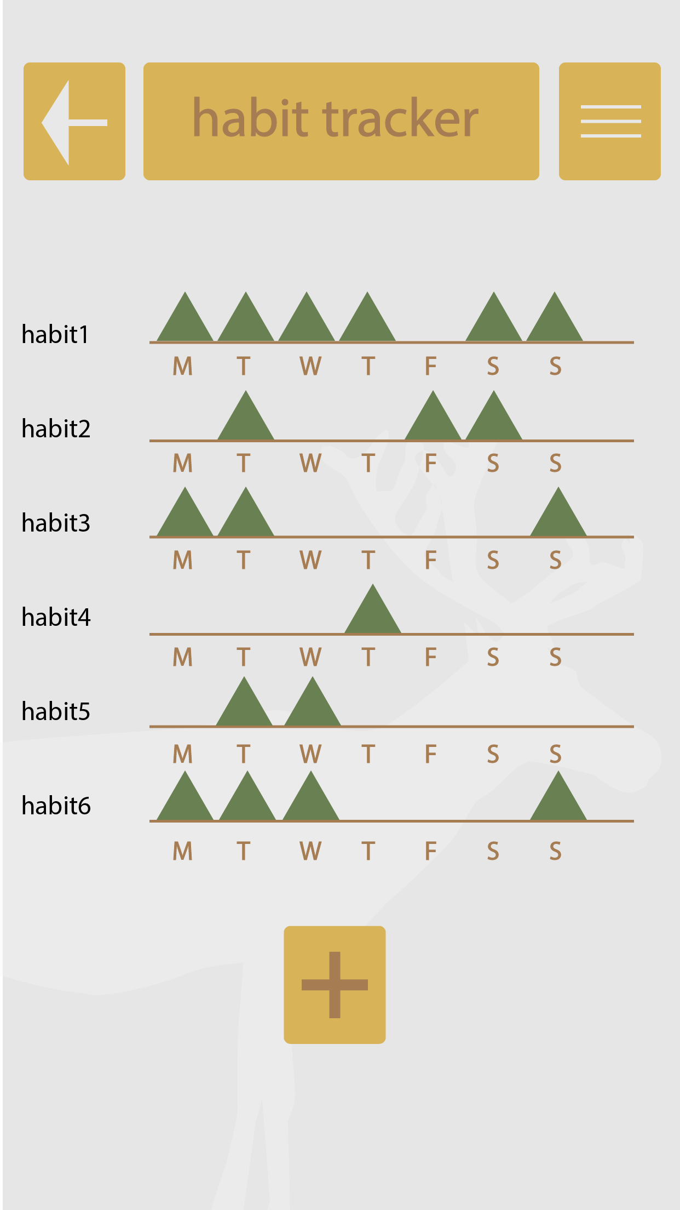

### Journal Page

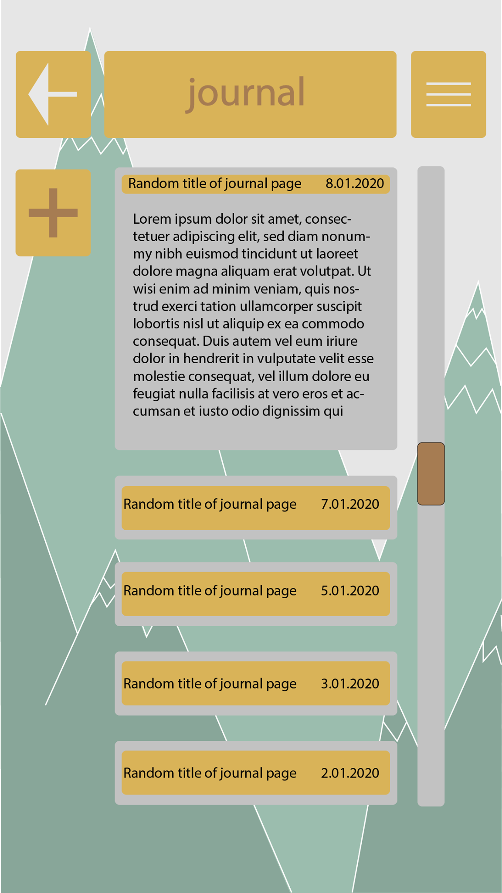

Each day the user leaves a short note regarding his or her day. It can be as long as they want, and they can even attach photos there.

## Personas

**Full name**: Annie Richards

**Age**: 27 years old

**Occupation**: Lawyer

**Location**: Brighton

**Education**: She has a first-class degree in law from the University of Harvard from which she graduated in 2018.

**Employment**: She has been working as a lawyer for a few months and she finds it difficult to keep all her things organized. She has never had another job before so the transition from student to full-time employee is taking her some time.

**Family status**: She lives alone with her cat In London where she also has to pay the rent. She is engaged to a guitar player and they play together in an indie band.

**Hobbies**: She plays the drum in her and her fiancé’s band. She likes old movies and comedies.

**A typical day in her life**: Annie wakes up early in the morning and makes breakfast. She has been trying to follow a healthy diet based on cereals, fresh vegetables, and fruits. She feeds the cat and leaves for work. Once that’s done, she heads towards the studio so she and the band can rehearse for a few hours. Then both she and her fiancé have dinner out. She comes back around 8 pm and spends some quality time with her cat. Before going to sleep she always meditates for at least half an hour. Twice a week she also goes to the gym, where she practices yoga. In the weekends, she cleans the apartment and goes to the cinema to watch movies with her friends.

**Goals**: Her goal is to become a member of a famous indie band. Since she finds her job really stressful, and she hopes to be able at some point to give it up and pursue her musical dream.

**Scenario**:

Annie has had a very stressful week at work. She did a lot of overtime and she missed on some band rehearsals. She is back to eating fast food and this week she completely forgot to attend her yoga classes. She wants to re-establish order in her life, so she looks on google play for an application that could help her with that.

**Use case workflow:**

1. 1.01.2021 - She downloads the application on her mobile phone
2. Creates an account
3. Defines the habits she wants to track:
   1. eat healthy – daily
   2. rehearse with the band – 5 days a week
   3. yoga classes – Saturdays and Sundays
   4. meditation – daily
4. Each day before heading to sleep she writes a short note about how her day was and checks the habits if that’s the case. She also evaluates each day in the mood tracker section.
5. 30 days later she receives the statistics for the January month. These statistics contain:
   1. individual charts which detail the success ratio of her habit
   2. the progress she made in the attempt of achieving her goals
   3. an overview of her mood tracker (in this case, the completely colored mountain)
6. As a new month starts, she decides whether she wants to import her previous habits or not. She can add new ones or delete from the existing ones.

**Full name**: Valentine Jones

**Age**: 19

**Occupation**: unemployed

**Location**: Feshiebridge

**Education**: finished college in July, but took one year off to take care of his father and practice drawing

**Employment**: he is currently unemployed, but he works the land and takes care of the house

**Family Status**: He lives with his family in a small house in Feshiebridge. His father has developed some health issues which kept him from going outside. His mother is the only person employed in the house. She works as a teacher in the near-by village. With his mother gone most of the day, Valentine has to take care of his father, as well as of the house and their animals (20 chicken, 2 pigs, 5 cats, and 2 dogs).

**Hobbies**: His main hobby is drawing, and he hopes that one day he will become an illustrator. He also likes to read science fiction and design characters for his science fiction comics. He also enjoys fishing with his friend Jack.

**A typical day in his life**: Valentine wakes up at 5 am to feed the animals. He also prepares breakfast for his mother and father. After breakfast, he drives his mother to school, and then he returns home. Once he is back home, he goes back to drawing characters for his science fiction project. He has to ensure that his father gets his medicine and he also takes care of the house (clean, wash the dishes, and other chores). He then feeds the animals and makes lunch. In the afternoon he goes to pick his mother from school and afterwards he meets with his friends to play football.

**Goal**: he wants to go to Arts University and become a graphic designer. In order to do that he needs to improve his drawing skills and build a portfolio.

**Scenario**: It is the 7th of January, the day when Valentine was supposed to buy medicine for his father. After he takes his mother to school, he meets his friend Jack who asks him to join him in a football game. They spend the entire morning playing football and Valentine gets back home to cook lunch. He does his chores and then picks his mother up from school. In the evening, Valentine meets his friends and when he comes back home in the evening, he sees the ambulance in front of his house. Because he forgot to buy insulin for his father, he developed diabetic ketoacidosis and needed medical assistance. Valentine realized that he cannot keep up with his tasks, and his failure to do so might have grave consequences for those he loves. Moreover, he realizes that he spends too much time playing with his friends and too little time working for his portfolio. Thus, he decides to install JournaliZZe.

**Use case workflow:**

1. 8.01.2021 - He downloads the application on his mobile phone
2. Creates an account
3. Defines the habits he wants to track:
   1. Buy meds for father – once every two weeks
   2. Work on portfolio – daily
   3. Go fishing – every Saturday
   4. Drive mother to school and pick her up– Monday to Friday
   5. Housekeeping – Monday to Friday
4. Each day before heading to sleep he writes a short note about how his day was and checks the habits if that’s the case. He also evaluates each day in the mood tracker section.
5. On first of February he receives the statistics for the November month. These statistics contain:
   1. individual charts which detail the success ratio of his habit
   2. the progress he made in the attempt of achieving his goals
   3. an overview of his mood tracker
6. As a new month starts, he decides whether he wants to import his previous habits or not. He can add new ones or delete from the existing ones.

# App evaluation plan

## Determine the goals

The main goal of the app evaluation is to receive relevant feedback from the users who used it and based on their suggestion to improve the application, so it suits their needs.

## Explore the questions

The target audience will be asked to fill up a form where they have to answer a few questions regarding the application and provide suggestions to improve the current version.

* What features would you like the app to have in the next version?
* On a scale from 1 to 10 how easily you find navigating throughout the application?
* Are you please by the current interface (colours used, layout, components placement, etc)?
* On a scale from 1 to 10 how relevant do you find the statistics from the end of each month?
* Have you noticed an improvement in your life since you started using the app?

## Choose evaluation methods

This application is made by people for the people so it wouldn’t be relevant if we wouldn’t use as one of our evaluation methods ‘Quick and dirty’. The user’s behaviour will be monitored and based on the information we harvest group or individual discussions will be held. Furthermore, by the end of the process, a specialist in the field will analyze all the data and write a detailed report to help us draw some conclusions.

## Identify the practical issues

At the current stage, the application is still in the development process which makes it unavailable to the customers. Once a prototype version is released, we can finally ask for feedback and make the corrections to suit their necessities.

## Decide how to deal with the ethical issues

An ethical issue is that the application is meant to be accessed only by the users 18+ since we don’t want to store children’s data. The problem is that we cannot accurately identify the age of the user at this time.

## Evaluate, interpret and present the data

The harvested data will be examined by both developer and specialists, based on the conclusion that they came up with we’ll document the results and use the data to draw some charts.

**Thank you!**

