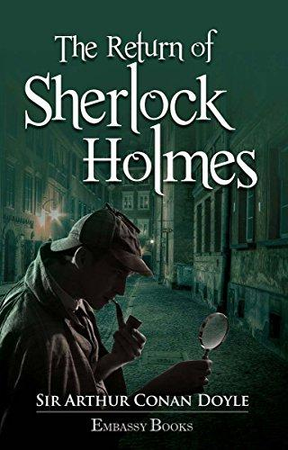

**Sherlock**

**In the year
1878
I took my degree
Of Doctor of Medicine
Of the University of London,
And proceeded to Netley
To go through the course
Prescribed for surgeons
In the army.
Having completed my studies**