PostgreSQL Observability Production Deployment Runbook
Ubuntu-only production procedure for bare-metal PostgreSQL servers monitored from a dedicated observability server.
Prepared for: PostgreSQL active/passive production estate
Scope: pgwatch, Grafana, pgBadger, Nginx, and PostgreSQL contact points
Date: 2026-05-16

1. Purpose
This document describes a production-grade deployment procedure for Ubuntu environments where PostgreSQL runs on bare-metal servers and the observability stack runs on one separate Ubuntu monitoring server. It is intentionally different from the local Docker Desktop POC: the PostgreSQL servers are not containerized, and the observability server is the only place where pgwatch, Grafana, pgBadger, and report publishing components are hosted.
The design uses a central pull model. pgwatch connects to each PostgreSQL server using a restricted monitoring role and stores collected metrics in its metrics repository. Grafana reads from the pgwatch metrics repository. pgBadger reads PostgreSQL log files copied or streamed from the database servers, generates static HTML reports, and Nginx publishes those reports.

2. Target Architecture
Layer | Host Type | Production Placement | Notes
PostgreSQL | Bare-metal Ubuntu servers | Existing primary, standby, and future PostgreSQL servers | No observability containers on database servers. Only users, grants, extensions, and logging settings are added.
pgwatch | Dedicated Ubuntu observability server | Containerized or upstream pgwatch deployment | Pulls metrics over PostgreSQL connections. Stores data in pgwatch metrics database.
Grafana | Dedicated Ubuntu observability server | Containerized or package deployment | Reads pgwatch metrics database through PostgreSQL datasource.
pgBadger | Dedicated Ubuntu observability server | Ubuntu package or source install | Processes PostgreSQL logs collected from bare-metal database servers.
Nginx | Dedicated Ubuntu observability server | Ubuntu package | Publishes pgBadger HTML reports over HTTP/HTTPS.

3. Flow and Orchestration Diagram
The production flow is shown below in a Word-friendly format. Each row shows who initiates the connection, what is moved, and where the data is stored or displayed.
Step | Initiator | Source | Destination | Data / Action | Frequency
1 | pgwatch collector | Bare-metal PostgreSQL primary/standby | pgwatch metrics repository | Pulls metrics using SQL over PostgreSQL connection. No agent is required on the database host. | Every collection interval
2 | Grafana | pgwatch metrics repository | Grafana dashboard panels | Runs read-only SQL queries against pgwatch_metrics datasource. | When dashboard loads or refreshes
3 | Log collection job | PostgreSQL log directory or journal on each DB host | Observability server log landing directory | Copies PostgreSQL logs by rsync/scp/journalctl or another approved log shipping method. | Scheduled, usually 5 to 15 minutes
4 | pgBadger job | Copied PostgreSQL logs | Static HTML report files | Parses logs and generates per-server/per-instance HTML reports. | Scheduled after log collection
5 | Nginx | pgBadger HTML report directory | DBA/SRE browser | Publishes the static pgBadger reports over restricted HTTP/HTTPS. | On user access

Logical dependency chain:
PostgreSQL servers -> pgwatch collector -> pgwatch metrics DB -> Grafana dashboards
PostgreSQL servers -> log collection -> pgBadger reports -> Nginx report site
Important distinction: pgwatch reads live PostgreSQL statistics through SQL connections. pgBadger does not connect to PostgreSQL for metrics; it reads PostgreSQL log files and converts them into reports.

4. Contact Points and Firewall Matrix
Source | Destination | Port | Direction | Purpose | Exposure
Observability server | Every PostgreSQL server | 5432/tcp | Outbound from monitoring | pgwatch SQL metric collection | Allow only monitoring server IP in pg_hba.conf and firewall.
Observability server | Every PostgreSQL server | 22/tcp | Outbound from monitoring | pgBadger log collection using SSH/rsync/journalctl | Use SSH keys restricted to log read paths or a dedicated log shipping account.
Admins/users | Grafana | 443/tcp preferred, 3000/tcp internal | Inbound to monitoring | Dashboards | Expose through Nginx reverse proxy or VPN. Avoid public unauthenticated access.
DBA/admins | pgwatch Web UI | 8080/tcp internal | Inbound to monitoring | Add/edit monitored sources | Restrict to VPN/admin subnet only.
Admins/users | Nginx pgBadger reports | 443/tcp preferred, 8081/tcp internal | Inbound to monitoring | HTML log reports | Restrict to DBA/SRE users because reports may include query text.
Grafana | pgwatch metrics DB | localhost or Docker network 5432/tcp | Local only | Grafana PostgreSQL datasource | Do not expose publicly.

5. Production Server Inventory Template
Role | Hostname | IP/FQDN | PostgreSQL Port | Database Names | Monitoring Notes
Primary | pg-prod-primary-01 | <primary-ip-or-fqdn> | 5432 | <db1, db2> | Allow pgwatch_monitor from observability server.
Standby | pg-prod-standby-01 | <standby-ip-or-fqdn> | 5432 | <db1, db2> | Read-only metrics. Validate pg_is_in_recovery=true.
Observability | obs-pgmon-01 | <monitoring-ip-or-fqdn> | N/A | pgwatch_metrics | Runs pgwatch, Grafana, pgBadger, Nginx.

5.1 Differentiating Multiple PostgreSQL Servers and Instances
In production, pgwatch and pgBadger must identify each monitored endpoint uniquely. The endpoint is not just the server name. It is the combination of hostname, PostgreSQL port, database name, and role. This matters when a single Ubuntu server runs more than one PostgreSQL instance.
Scenario | How to Identify It | pgwatch Source Count | pgBadger Report Split
Two servers like the POC | Different hostnames or IPs, usually same port 5432. Example: pg-prod-primary-01:5432 and pg-prod-standby-01:5432. | One source per host/database endpoint. At minimum one source for primary and one for standby. | Separate report folder per server, for example /var/www/pgbadger/pg-prod-primary-01 and /var/www/pgbadger/pg-prod-standby-01.
One server with multiple PostgreSQL instances | Same hostname/IP but different ports and different data/log directories. Example: pg-db-01:5432 and pg-db-01:5433. | One source per port/database endpoint. The port must be part of the source name. | Separate report folder per instance, for example /var/www/pgbadger/pg-db-01-p5432 and /var/www/pgbadger/pg-db-01-p5433.
Many servers and many databases | Use a naming standard that includes environment, application, host, port, role, and database. | One source per monitored database if database-level metrics are required; otherwise monitor the main operational database plus instance-level metrics. | Separate reports by host and port. Optionally split by database if logs are separated.

Recommended naming standard:
<environment>-<application>-<hostname>-p<port>-<role>-<database>

Examples:
prod-erp-pg-prod-primary-01-p5432-primary-erpdb
prod-erp-pg-prod-standby-01-p5432-standby-erpdb
prod-crm-pg-db-01-p5432-primary-crmdb
prod-crm-pg-db-01-p5433-primary-auditdb
For a single Ubuntu server running multiple PostgreSQL instances, confirm these are unique for each instance: systemd service name, data directory, log directory, PostgreSQL port, pg_hba.conf, postgresql.conf, and pgwatch source name.
Instance | Host | Port | Data Directory | Log Directory | pgwatch Source Name | pgBadger Report URL
Instance A | pg-db-01 | 5432 | /var/lib/postgresql/17/main | /var/lib/postgresql/17/main/log | prod-app-pg-db-01-p5432-primary-appdb | https://pgbadger.example.internal/pg-db-01-p5432/
Instance B | pg-db-01 | 5433 | /pgdata/17-audit | /pgdata/17-audit/log | prod-audit-pg-db-01-p5433-primary-auditdb | https://pgbadger.example.internal/pg-db-01-p5433/

6. Ubuntu Prerequisites
Ubuntu 22.04 LTS or 24.04 LTS on the observability server.
Network reachability from observability server to all PostgreSQL servers on PostgreSQL and SSH/log shipping ports.
DNS names or stable IP addresses for each PostgreSQL server.
NTP/chrony enabled on all servers. Time drift will make dashboard and log correlation unreliable.
A secret storage process for production passwords. Do not keep production passwords in Git.
sudo apt update
sudo apt install -y ca-certificates curl gnupg lsb-release ufw chrony jq
sudo systemctl enable --now chrony

7. Prepare Each Bare-Metal PostgreSQL Server
Run these steps on each production PostgreSQL server. The examples assume PostgreSQL 17, but the same model works for supported PostgreSQL versions with minor path changes.

7.1 Create Monitoring Role
sudo -iu postgres psql

CREATE ROLE pgwatch_monitor
LOGIN
PASSWORD '<use-secret-store-generated-password>'
CONNECTION LIMIT 10;

GRANT pg_monitor TO pgwatch_monitor;

-- Repeat CONNECT grants for every database that pgwatch should monitor.
GRANT CONNECT ON DATABASE observability_demo TO pgwatch_monitor;

7.2 Enable pg_stat_statements
pgwatch and Grafana become much more useful when pg_stat_statements is enabled. This requires shared_preload_libraries and therefore a PostgreSQL restart during a maintenance window.
-- In each monitored database:
CREATE EXTENSION IF NOT EXISTS pg_stat_statements;
# postgresql.conf
shared_preload_libraries = 'pg_stat_statements'
pg_stat_statements.track = all
track_io_timing = on
track_activity_query_size = 4096

7.3 Restrict pg_hba.conf
# Replace <OBSERVABILITY_SERVER_IP> with the monitoring server IP.
# Prefer hostssl if TLS is configured.
hostssl all pgwatch_monitor <OBSERVABILITY_SERVER_IP>/32 scram-sha-256

# If TLS is not yet available, use this only inside a trusted private network:
host all pgwatch_monitor <OBSERVABILITY_SERVER_IP>/32 scram-sha-256
sudo systemctl reload postgresql

7.4 Configure Logs for pgBadger
pgBadger does not collect live metrics. It reads PostgreSQL logs and generates reports. The following settings make the logs useful while keeping production overhead reasonable. Tune thresholds based on workload and storage capacity.
# postgresql.conf
logging_collector = on
log_destination = 'stderr'
log_directory = 'log'
log_filename = 'postgresql-%Y-%m-%d_%H%M%S.log'
log_rotation_age = '1d'
log_rotation_size = '1GB'
log_line_prefix = '%t [%p]: [%l-1] user=%u,db=%d,app=%a,client=%h '

log_min_duration_statement = 1000 # start with 1 second; tune per SLA
log_checkpoints = on
log_connections = on
log_disconnections = on
log_lock_waits = on
deadlock_timeout = '1s'
log_temp_files = 0 # log all temp files; raise if too noisy
log_autovacuum_min_duration = '10s'
Restart PostgreSQL if logging_collector or shared_preload_libraries changed. Reload is enough for many logging threshold changes, but plan a restart when in doubt.

8. Prepare the Ubuntu Observability Server

8.1 Install Docker Engine and Compose Plugin
sudo apt update
sudo apt install -y ca-certificates curl gnupg
sudo install -m 0755 -d /etc/apt/keyrings
curl -fsSL https://download.docker.com/linux/ubuntu/gpg | sudo gpg --dearmor -o /etc/apt/keyrings/docker.gpg
sudo chmod a+r /etc/apt/keyrings/docker.gpg

echo \
"deb [arch=$(dpkg --print-architecture) signed-by=/etc/apt/keyrings/docker.gpg] https://download.docker.com/linux/ubuntu \
$(. /etc/os-release && echo $VERSION_CODENAME) stable" | \
sudo tee /etc/apt/sources.list.d/docker.list > /dev/null

sudo apt update
sudo apt install -y docker-ce docker-ce-cli containerd.io docker-buildx-plugin docker-compose-plugin
sudo systemctl enable --now docker

8.2 Install pgBadger and Nginx
sudo apt update
sudo apt install -y pgbadger nginx rsync
sudo mkdir -p /var/lib/pgbadger/incoming /var/www/pgbadger
sudo chown -R root:www-data /var/www/pgbadger
sudo chmod -R 0750 /var/www/pgbadger

8.3 Recommended Directory Layout
/opt/postgres-observability/
compose.yml
.env # root-owned, 0600
grafana/
datasources/pg_ds.yml
dashboards/
pgwatch/
sources.sql or sources.yml
pgbadger/
run-pgbadger.sh

/var/lib/pgbadger/incoming/
pg-prod-primary-01/
pg-prod-standby-01/

/var/www/pgbadger/
pg-prod-primary-01/index.html
pg-prod-standby-01/index.html

9. Deploy pgwatch and Grafana
For long-running production use, pin versions and keep persistent volumes for pgwatch storage, Grafana state, and pgwatch configuration. The upstream pgwatch project recommends the production pgwatch image or its supplied production compose files for long-term deployments. Avoid treating the local POC Docker Desktop compose as a production file because it also creates sample PostgreSQL nodes.
The important production rule is that pgwatch and Grafana run on the observability server only, while monitored PostgreSQL servers are added as remote sources.
sudo mkdir -p /opt/postgres-observability/grafana/datasources
sudo chown -R root:root /opt/postgres-observability
sudo chmod 0750 /opt/postgres-observability
Grafana PostgreSQL datasource provisioning must include the database in jsonData. Without this, Grafana 12 PostgreSQL panels may connect but fail with no default database configured.
# /opt/postgres-observability/grafana/datasources/pg_ds.yml
apiVersion: 1
datasources:
- name: pgwatch metrics (postgres)
uid: pgwatch-metrics
type: postgres
url: pgwatch-postgres:5432
access: proxy
user: pgwatch
secureJsonData:
password: '<pgwatch-metrics-password>'
jsonData:
database: pgwatch_metrics
sslmode: disable
postgresVersion: 1700
isDefault: true
editable: false
version: 1

10. Register PostgreSQL Sources in pgwatch
Add one pgwatch source per monitored PostgreSQL endpoint. For active/passive setups, monitor both the primary and the standby. The standby should use standby-compatible preset metrics where available.
Source Name | Host | Port | Database | Role | Connection String Pattern
prod-erp-pg-prod-primary-01-p5432-primary-erpdb | pg-prod-primary-01.example.internal | 5432 | erpdb | Primary | postgresql://pgwatch_monitor:<secret>@pg-prod-primary-01.example.internal:5432/erpdb?sslmode=require
prod-erp-pg-prod-standby-01-p5432-standby-erpdb | pg-prod-standby-01.example.internal | 5432 | erpdb | Standby | postgresql://pgwatch_monitor:<secret>@pg-prod-standby-01.example.internal:5432/erpdb?sslmode=require
prod-crm-pg-db-01-p5432-primary-crmdb | pg-db-01.example.internal | 5432 | crmdb | Primary instance on shared host | postgresql://pgwatch_monitor:<secret>@pg-db-01.example.internal:5432/crmdb?sslmode=require
prod-audit-pg-db-01-p5433-primary-auditdb | pg-db-01.example.internal | 5433 | auditdb | Second instance on same host | postgresql://pgwatch_monitor:<secret>@pg-db-01.example.internal:5433/auditdb?sslmode=require

Recommended pgwatch source metadata: group = production, preset_config = full or a tuned production preset, preset_config_standby = full/standby-compatible preset, enabled = true.
The source name is what operators will see in Grafana dashboard dropdowns. Keep it human-readable but unique. If two PostgreSQL instances run on the same server, include p5432, p5433, or the actual port in the source name. If a server hosts multiple business databases and each needs database-level monitoring, create separate pgwatch sources per database.

11. Configure pgBadger Log Collection
pgBadger can read local files, copied files, or journalctl output. For production separation, keep log collection read-only from the observability server. Do not give the observability server broad shell access to database hosts if a restricted log shipper account is possible.
# Example log pull from the observability server.
sudo mkdir -p /var/lib/pgbadger/incoming/pg-prod-primary-01
rsync -az postgres@pg-prod-primary-01:/var/lib/postgresql/17/main/log/*.log \
/var/lib/pgbadger/incoming/pg-prod-primary-01/
# /opt/postgres-observability/pgbadger/run-pgbadger.sh
#!/usr/bin/env bash
set -euo pipefail

HOSTS=("pg-prod-primary-01" "pg-prod-standby-01")

for host in "${HOSTS[@]}"; do
mkdir -p "/var/www/pgbadger/${host}"
pgbadger \
--quiet \
--jobs 2 \
--prefix '%t [%p]: [%l-1] user=%u,db=%d,app=%a,client=%h ' \
--outfile "/var/www/pgbadger/${host}/index.html" \
/var/lib/pgbadger/incoming/${host}/*.log
done
sudo chmod 0750 /opt/postgres-observability/pgbadger/run-pgbadger.sh
sudo crontab -e

# Example: refresh reports every 15 minutes
*/15 * * * * /opt/postgres-observability/pgbadger/run-pgbadger.sh >/var/log/pgbadger-refresh.log 2>&1

12. Configure Nginx for pgBadger Reports
# /etc/nginx/sites-available/pgbadger
server {
listen 80;
server_name pgbadger.example.internal;

root /var/www/pgbadger;
index index.html;

autoindex on;

location / {
try_files $uri $uri/ =404;
}
}

sudo ln -s /etc/nginx/sites-available/pgbadger /etc/nginx/sites-enabled/pgbadger
sudo nginx -t
sudo systemctl reload nginx
For production, place Nginx behind TLS and restrict access using VPN, SSO, mTLS, or at minimum IP allow-lists. pgBadger reports may include SQL text, usernames, application names, client addresses, errors, and timing information.

13. How to Read pgwatch Metrics
Dashboard / Metric Area | What It Shows | How to Interpret | First Actions
Instance state / uptime | Primary or standby state and restart age | Unexpected restart resets uptime and can explain cache churn or connection storms. | Check PostgreSQL logs, system journal, failover tooling.
TPS / QPS | Transaction and query throughput over time | Sudden drops indicate application outage, lock pileup, or network issue. Sudden spikes may be load or runaway clients. | Correlate with active sessions, locks, CPU, and top queries.
Sessions by state | Active, idle, idle in transaction, waiting sessions | High idle in transaction can block vacuum and bloat tables. | Find client/application, terminate only after business approval.
Locks and waiting | Lock mode counts and blocked activity | Growing waits are usually more urgent than high connection count alone. | Identify blocker query and application owner.
DB size and growth | Database and relation growth | Fast growth may be ingest, bloat, temp spill, or retention failure. | Check table size, bloat, temp files, autovacuum.
WAL rate / replication | WAL generation and standby lag | High WAL with lag means standby or archive path cannot keep up. | Check network, disk, replication slots, archive command, long transactions.
pg_stat_statements | Top queries by calls, runtime, IO, mean time | High total time is user impact; high mean time is slow individual query; high calls can be chatty app behavior. | Review plans, indexes, parameter patterns, application batch behavior.
Cache hit / IO timing | Read efficiency and IO time | Low hit ratio plus high IO timing suggests memory pressure, missing indexes, or large scans. | Check top IO queries and table/index scan metrics.
Bloat estimates | Approximate table/index wasted space | Use as a warning signal, not an exact rebuild command. | Confirm with deeper bloat checks before vacuum full/repack.

14. How to Read pgBadger Reports
pgBadger Section | What to Look For | Operational Meaning
Overview | Log volume, events, sessions, query counts | Use this to validate whether the report period is complete and representative.
Slowest queries | Highest duration and normalized slow statements | Best starting point for user-facing latency investigations.
Most time consuming queries | Total accumulated time by normalized query | High business impact even if each call is only moderately slow.
Most frequent queries | Statements executed very often | Can reveal chatty application patterns, missing batching, or polling loops.
Temp files | Queries creating temporary files | Often points to insufficient work_mem, missing indexes, large sorts/hashes, or bad plans.
Checkpoints | Frequent or long checkpoints | May indicate WAL pressure, checkpoint tuning needs, or storage bottlenecks.
Locks / deadlocks | Lock waits and deadlocks from logs | Use with pgwatch lock dashboards to correlate exact time and statement text.
Connections | Connection spikes and disconnect patterns | Can reveal missing pooling, app restarts, or connection leaks.
Errors | SQL errors and fatal messages | Useful for application defects, permission issues, and failed migrations.

Use pgwatch for near-real-time condition and trend detection. Use pgBadger when you need SQL text, historical log context, slow query evidence, or a report for a specific incident window.

15. Validation Checklist
From observability server, psql can connect to every monitored PostgreSQL host using pgwatch_monitor.
pgwatch source list contains primary and standby entries, enabled and grouped as production.
Grafana datasource test succeeds and includes jsonData.database = pgwatch_metrics.
Database Overview dashboard shows primary/standby metrics after one to two collection intervals.
pgBadger job can read or receive logs from every PostgreSQL host.
Nginx can serve pgBadger reports only to approved users or networks.
Backups exist for pgwatch metrics/config database and Grafana dashboards.
Secrets are outside Git and rotated through the approved production process.

16. Backup and Retention
Back up pgwatch configuration and metrics storage. Metrics history is operational evidence.
Export or provision Grafana dashboards as code. Avoid relying only on UI changes.
Define pgwatch metrics retention by business need and disk capacity, for example 30 to 90 days for detailed metrics and longer for downsampled summaries.
Define pgBadger report retention separately from raw PostgreSQL log retention. Reports may be smaller than logs but can expose SQL text.
Monitor disk usage under pgwatch metrics storage, /var/lib/pgbadger, and /var/www/pgbadger.

17. Security Requirements
Use least-privilege database roles. Grafana should have SELECT-only access to the pgwatch metrics database.
Restrict pgwatch Web UI to DBA/SRE networks only.
Use TLS for PostgreSQL monitoring connections where the network is not fully trusted.
Use TLS and authentication for Grafana and pgBadger report access.
Do not expose PostgreSQL, pgwatch admin, Grafana, or pgBadger reports directly to the public Internet.
Treat pgBadger reports as sensitive because query text, users, clients, and errors may appear in the output.

18. Rollback Plan
If pgwatch causes unexpected load, disable the source in pgwatch first. This stops metric collection without changing PostgreSQL.
If PostgreSQL logging volume is too high, raise log_min_duration_statement and log_temp_files thresholds, then reload PostgreSQL.
If Grafana dashboards fail after provisioning changes, restore the previous datasource YAML and restart Grafana.
If pg_stat_statements must be removed, schedule a PostgreSQL restart after removing it from shared_preload_libraries.

19. Production Cutover Sequence
Build observability server and apply OS hardening.
Install Docker Engine, pgBadger, Nginx, and backup tooling.
Configure PostgreSQL monitoring user, pg_hba.conf, pg_stat_statements, and logging on one non-critical server first.
Register that server in pgwatch and validate Grafana.
Enable pgBadger log collection for that server and validate report generation.
Repeat registration for primary and standby production nodes.
Define alerts, retention, backup, ownership, and operational handover.

20. References
pgwatch project: https://github.com/cybertec-postgresql/pgwatch
pgwatch Docker installation documentation: https://pgwat.ch/v4.x/tutorial/docker_installation.html
Grafana PostgreSQL datasource documentation: https://grafana.com/docs/grafana/latest/datasources/postgres/configure/
Grafana provisioning documentation: https://grafana.com/docs/grafana/latest/administration/provisioning/
pgBadger documentation: https://access.crunchydata.com/documentation/pgbadger/11.1/pdf/pgbadger.pdf

POC Snaps:
Grafana:
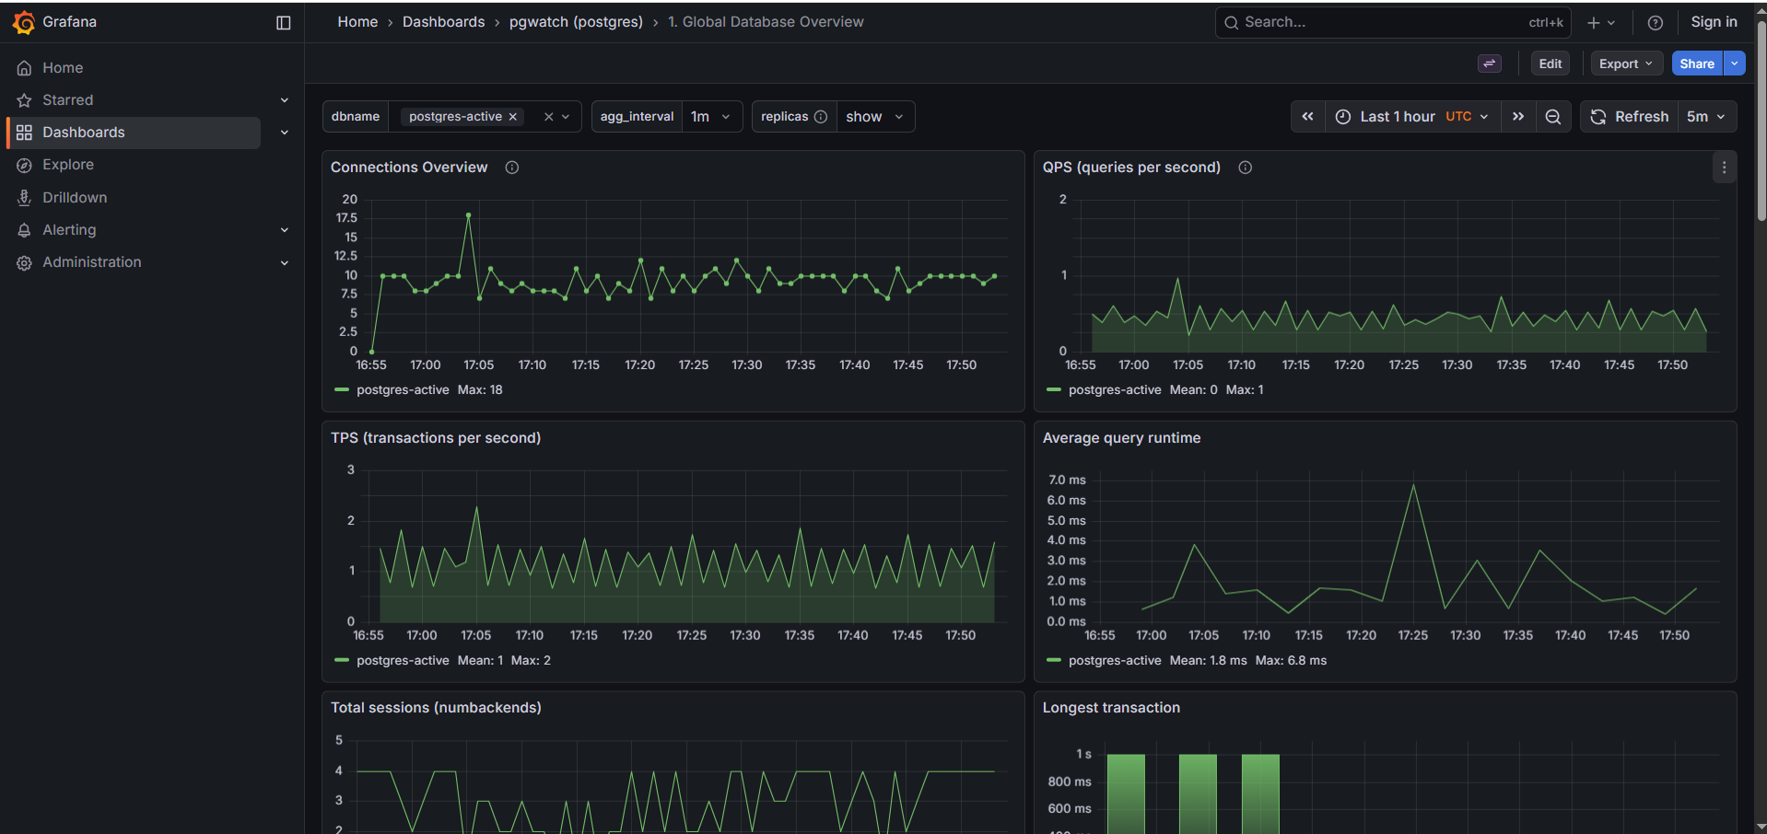

pgBadger
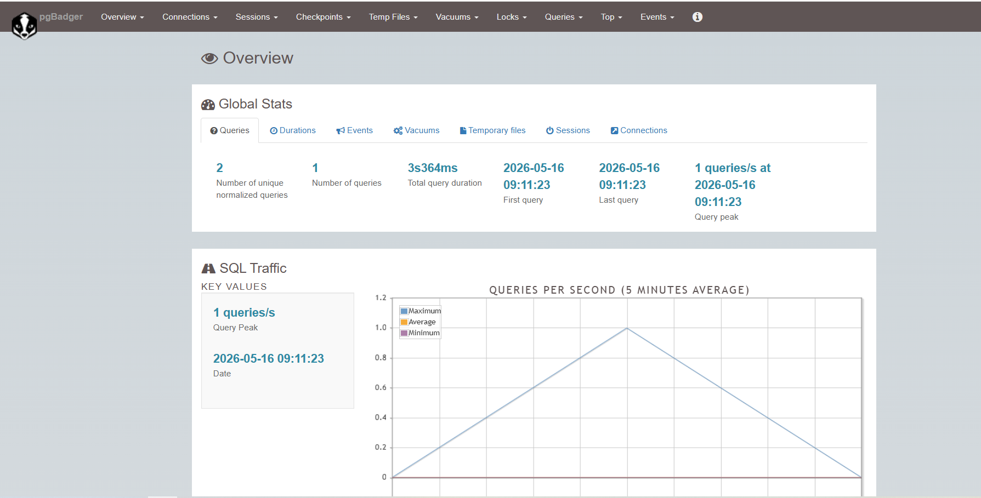

PGwatch
