SEZG503
Full Stack Application Development
Assignment 1 Submission Document

RecipeHub — Community Recipe & Meal Planner
Name | Vadivel P | 2025TM93235
Course | SEZG503 – Full Stack Application Development
Semester | II Semester
Submission Date | 1 May 2026
Submission Mode | Google Drive (Video) + eLearn LMS (File)
GitHub Repository | https://github.com/vadivel53/recipe-hub-planner.git

1. Project Overview
1.1 Project Title
RecipeHub – Community Recipe & Meal Planner
1.2 Problem Statement
Managing personal and community-shared recipes alongside weekly meal planning is a fragmented and frustrating experience for most households. Today's users typically juggle:

- Handwritten or digital notes for personal recipes with no structured format.
- Social media platforms (Instagram, Pinterest) that are visually rich but impractical for step-by-step cooking.
- Static recipe blogs with no personalisation, interaction, or planning features.
- Separate meal planning apps disconnected from a recipe library.

Core Problem: Users lack a single, unified platform where they can discover trusted community recipes, curate personal collections, contribute their own recipes, receive feedback through ratings, and plan their week's meals — all within one coherent digital experience.

RecipeHub directly addresses this gap by delivering a full-stack web application that brings together recipe discovery, creation, social engagement, and meal planning into one seamless platform.

1.3 Objectives
- Enable community members to share, discover, and interact with recipes in a structured, searchable way.
- Provide a rich recipe creation experience with dynamic ingredient and step builders.
- Allow users to build a personalised weekly meal plan by scheduling discovered recipes across meal slots.
- Implement secure, role-aware authentication so users manage their own content and admins oversee the platform.
- Deliver a polished, responsive UI that works equally well on mobile and desktop.

1.4 Innovation & Design Rationale
What makes RecipeHub non-trivial and innovative?

Feature | Why It Is Innovative
Unified recipe + planner | Eliminates the need for two separate apps — browse a recipe and add it to Wednesday's dinner in one click.
Smart slot replacement | Adding a recipe to an occupied day/meal slot automatically replaces it — preventing conflicts without user friction.
Virtual avgRating field | Mongoose virtual computes average rating on-the-fly from an embedded ratings array, avoiding demoralised data.
Editorial design language | Warm cream/saffron/bark palette with Playfair Display font creates a premium food-magazine aesthetic.
Axios interceptors | Global 401 handler auto-clears stale tokens and redirects to login — providing seamless session expiry handling.
Admin dual-guard middleware | protect() + adminOnly() middleware chain enforces principle of least privilege on every admin route independently.

2. Technology Stack
RecipeHub is built on the MERN-variant stack with a custom-styled frontend and a fully documented REST API backend.

Layer | Technology | Version | Purpose
Frontend Framework | React | v18 (via Vite) | Component-based SPA with fast HMR in development
Build Tool | Vite | v5+ | Significantly faster builds and dev server than CRA
Routing | React Router | v6 | Declarative client-side routing with protected routes
HTTP Client | Axios | Latest | Promise-based HTTP with JWT interceptors
State Management | React Context API | Built-in | Global auth state; chosen over Redux for scope
UI Styling | CSS Modules | Built-in | Scoped styles; custom CSS variables design system
Fonts | Google Fonts | Playfair Display + DM Sans | Editorial typographic hierarchy
Icons | react-icons (Feather) | Latest | Lightweight, consistent icon set
Notifications | react-hot-toast | Latest | Non-intrusive user feedback for all actions
Backend Runtime | Node.js | v18+ | Non-blocking I/O for concurrent API requests
Backend Framework | Express.js | v4.18+ | Minimal, unopinionated REST API framework
Database | MongoDB | Latest | Document-oriented NoSQL; flexible schema for recipes
ODM | Mongoose | v7+ | Schema definition, validation, virtuals, hooks
Authentication | jsonwebtoken + bcryptjs | Latest | JWT (7-day expiry) + bcrypt hashing (10 rounds)
Validation | express-validator | v7+ | Declarative input validation on all write routes
API Documentation | swagger-jsdoc + swagger-ui-express | Latest | Auto-generated interactive OpenAPI 3.0 docs

3. System Architecture
3.1 High-Level Architecture
RecipeHub follows a classic three-tier client–server architecture with clear separation between the presentation layer (React SPA), business logic layer (Express API), and data persistence layer (MongoDB). All frontend–backend communication uses HTTP REST with JSON payloads, secured by JWT Bearer tokens.

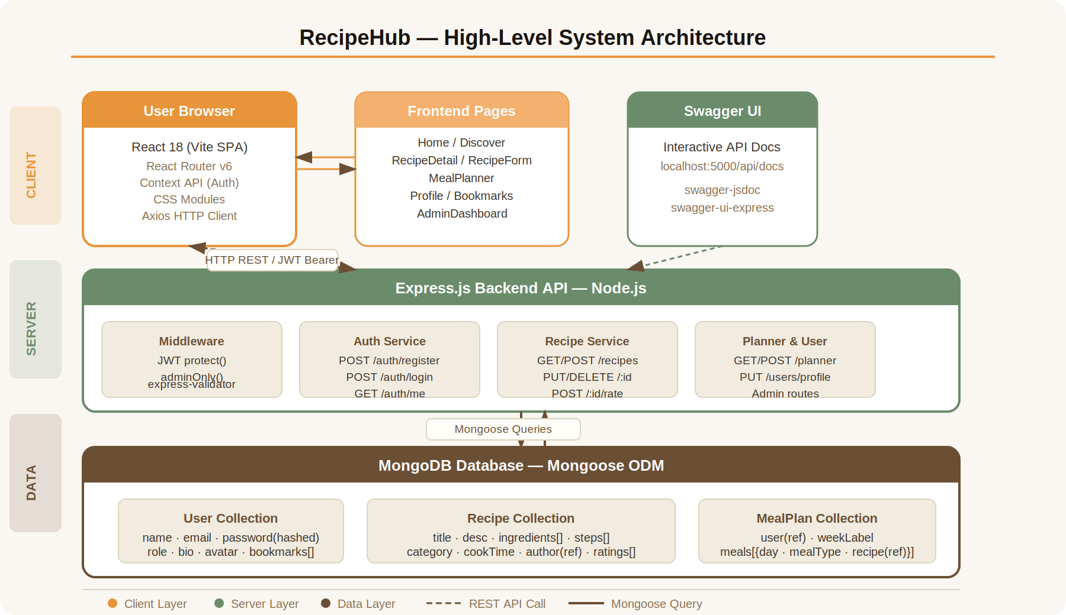
Figure 1: High-Level System Architecture — Three-Tier Client–Server Model
3.2 Backend Layered Architecture
The Express backend is organised into discrete, single-responsibility layers:

Layer | File / Location | Responsibility
Entry Point | backend/src/app.js | Initialises Express, registers middleware and routes, connects MongoDB, mounts Swagger UI
Configuration | src/config/db.js | Establishes and manages the Mongoose connection with error handling and process exit on failure
Configuration | src/config/swagger.js | Defines OpenAPI 3.0 spec metadata; scans route files for JSDoc annotations
Auth Middleware | src/middleware/auth.middleware.js | protect(): verifies JWT, attaches req.user. adminOnly(): role guard for admin endpoints
Auth Routes | src/routes/auth.routes.js | POST /register, POST /login with bcrypt + JWT; GET /me for current user
Recipe Routes | src/routes/recipe.routes.js | Full CRUD + rating endpoint; admin listing; all Swagger-documented
Planner Routes | src/routes/planner.routes.js | GET/POST/DELETE operations on per-user weekly MealPlan documents
User Routes | src/routes/user.routes.js | Profile update, bookmark toggle, admin stats and user management
User Model | src/models/User.js | Schema with bcrypt pre-save hook, matchPassword() method, bookmarks[] ref array
Recipe Model | src/models/Recipe.js | Schema with embedded ratings[], tags[], author ref; virtual avgRating computed field
MealPlan Model | src/models/MealPlan.js | Per-user document with meals[{day, mealType, recipe}] sub-document array
Seeder | backend/seed.js | Populates DB with 2 demo users (admin + regular) and 6 full recipes with ratings

3.3 Frontend Layered Architecture
The React frontend follows a strict separation of concerns, dividing responsibilities across four distinct layers:

Layer | Location | Contents & Responsibility
API Layer | src/api/ | axios.js (configured client + JWT interceptors), auth.js, recipes.js, users.js — all HTTP calls isolated from UI components
State Layer | src/context/ | AuthContext.jsx — global auth state (user, token), login/register/logout/updateUser actions via React Context API
Component Layer | src/components/ | Reusable: RecipeCard, ProtectedRoute, Navbar, Footer — stateless or lightly stateful presentational components
Page Layer | src/pages/ | Route-level smart components: Home, Login, Register, RecipeDetail, RecipeForm, MealPlanner, Profile, Bookmarks, AdminDashboard

4. Architecture Diagrams
4.1 Frontend Component Hierarchies
The component tree below illustrates how React components are composed, how routing is structured, and which routes require authentication or admin privileges.

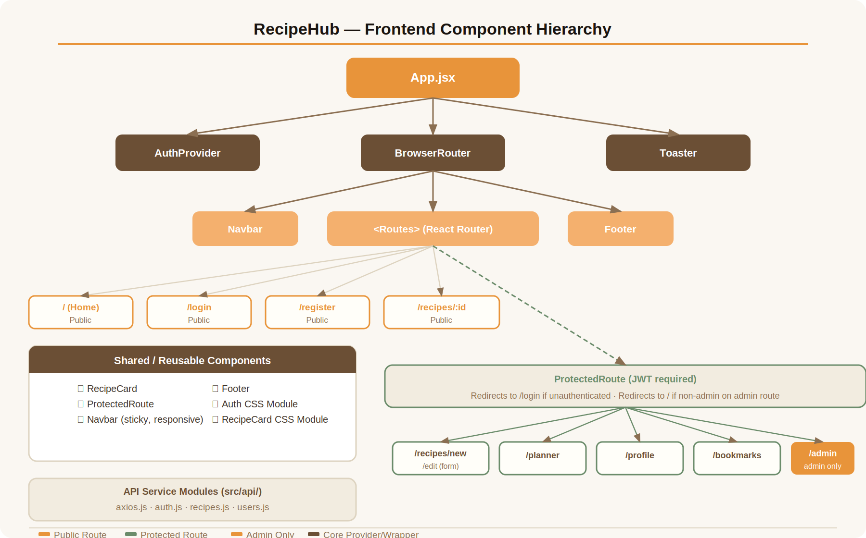
Figure 2: Frontend Component Hierarchy — Routing & Protection Structure

ProtectedRoute Component: Wraps all authenticated pages. If user is null (no valid JWT in localStorage), it redirects to /login with the attempted path saved in location state for post-login redirect. For admin-only routes, it additionally checks user.role === 'admin' and redirects to / otherwise.

4.2 Authentication & API Request Flow
The sequence diagram below traces two critical flows: the login process and how subsequent protected API requests are handled, including the middleware chain and the 401 auto-interception behaviour.

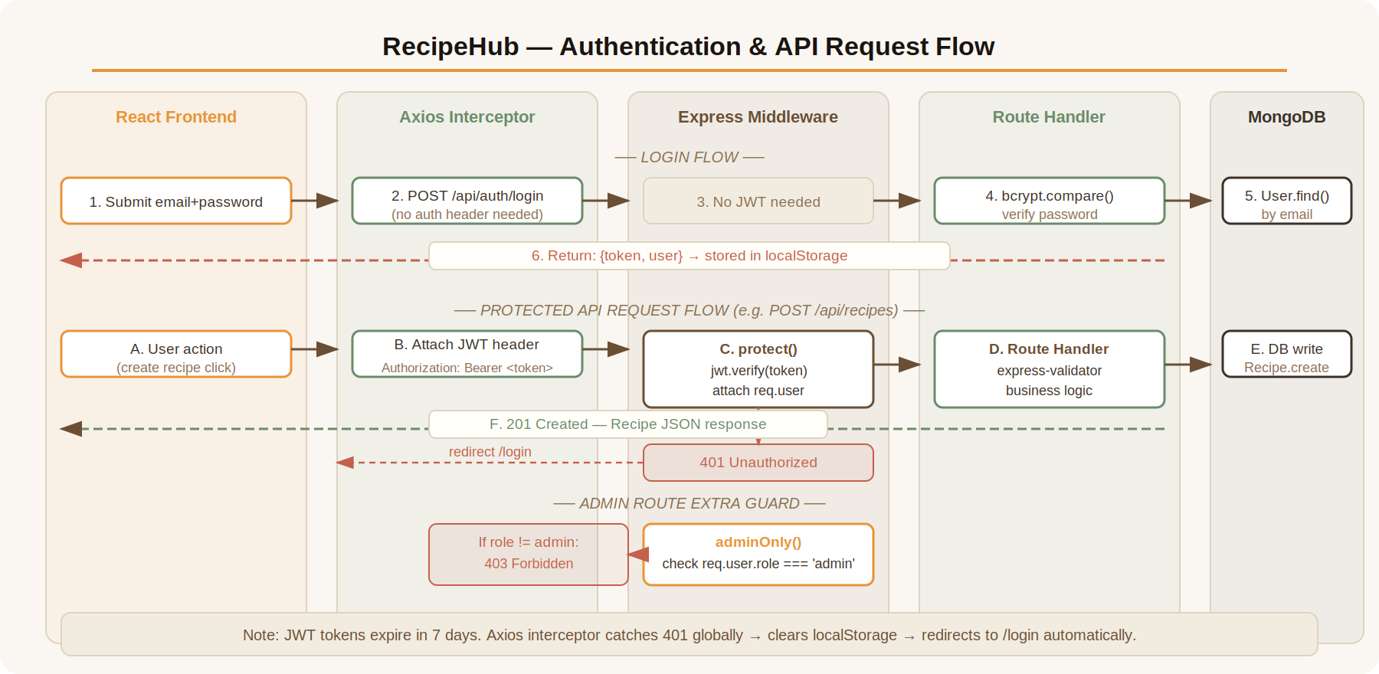
Figure 3: Authentication & API Request Flow — JWT Lifecycle & Middleware Chain

4.3 Data Flow Narrative
The following describes the complete end-to-end data flow for a user creating a new recipe:

Step | Actor | Action | Detail
1 | User | Submits RecipeForm | Client-side validation runs first (required fields, numeric cook time)
2 | Axios | Attaches Authorization header | Interceptor reads JWT from localStorage → Bearer <token>
3 | Express | protect() middleware runs | jwt.verify() decodes token; User.findById() attaches req.user to request object
4 | Express | express-validator runs | Validates title, description, cookTime, category — returns 400 with errors if invalid
5 | Recipe Route | Handler executes | Recipe.create({ ...req.body, author: req.user._id }) persists document to MongoDB
6 | MongoDB | Document stored | Recipe document created with embedded ingredients[], steps[], ratings[]
7 | Express | 201 response sent | JSON recipe document returned to Axios
8 | React | State updated + toast shown | Navigate to RecipeDetail page; toast.success('Recipe created!')

5. Core Features
5.1 User-Facing Features

Feature | Description | Key Implementation Detail
Registration & Login | Email/password auth with JWT. Validation on both client (React) and server (express-validator). | bcrypt 10-round hashing; 7-day JWT expiry; token + user stored in localStorage
Recipe Discovery | Browse all published recipes on the Home page with real-time search and multi-filter support. | MongoDB $or / $regex query across title, description, tags; category and maxCookTime filters
Recipe Detail View | Full recipe page with image, ingredients list, numbered steps, author card, rating widget, and bookmark/planner actions. | Sticky left column (position: sticky) keeps action buttons visible while scrolling long recipes
Star Rating System | Users rate recipes 1–5 stars. Ratings stored per-user in embedded array. Average computed as Mongoose virtual. | Re-rating updates existing entry in ratings[] via findIndex; virtual avgRating recomputes on every access
Bookmark System | Toggle bookmark on any recipe card or detail page. Bookmark state persisted in User.bookmarks[]. | Single POST /users/bookmarks/:id toggles: checks indexOf, splices or pushes; returns updated bookmarks[]
Create / Edit Recipe | Rich form with dynamic ingredient row builder, step builder with numbered indicators, image URL with live preview, tags, and publish toggle. | Edit mode pre-populates form from getRecipe(id); PUT /recipes/:id enforces owner-or-admin ownership check
Weekly Meal Planner | 7-day × 4-meal-type visual grid. Users add any recipe to any slot from the RecipeDetail page. Recipe thumbnails shown in grid slots. | Slot conflict resolved server-side: filter() removes existing day+mealType pair before push; clearPlan wipes meals[]
User Profile | View and edit name, bio, avatar URL. See all own recipes with edit/delete actions. | updateProfile() calls PUT /users/profile; updateUser() in AuthContext merges updated data into localStorage
Bookmarks Page | Dedicated page listing all bookmarked recipes as cards. Unbookmarking removes the card immediately. | Client-side optimistic update: filter() on bookmarks state before API confirmation — no re-fetch required

5.2 Admin Features

Feature | Description | Access Guard
Stats Dashboard | Overview cards showing total users, total recipes, published recipe count, and tables of 5 most recent users and recipes. | protect() + adminOnly()
User Management | Tabbed table of all registered users with role badges and delete action. Admin accounts are protected from deletion. | protect() + adminOnly()
Recipe Management | Full table of all recipes including unpublished drafts. View and delete any recipe regardless of author. | protect() + adminOnly()
Tabbed Navigation | Dashboard, Users, and Recipes tabs allow focused management without page reloads. | Client-side tab state; data pre-loaded on mount

6. API Documentation
All API endpoints are documented using Swagger (OpenAPI 3.0) and are accessible interactively at http://localhost:5000/api/docs. The following tables provide a complete endpoint reference.

Base URL: http://localhost:5000/api • All protected routes require the header: Authorization: Bearer <JWT token> • All POST/PUT routes validate input with express-validator

6.1 Authentication Endpoints ( /api/auth )

Method | Endpoint | Auth | Request Body | Response | Description
POST | /auth/register | No | { name, email, password } | 201: { _id, name, email, role, token } | Register new user. Validates name, email format, password min 6 chars.
POST | /auth/login | No | { email, password } | 200: { _id, name, email, role, avatar, token } | Login. bcrypt.compare(); returns JWT on success.
GET | /auth/me | Yes (JWT) | — | 200: User object (no password field) | Returns current authenticated user from req.user.

6.2 Recipe Endpoints ( /api/recipes )

Method | Endpoint | Auth | Query / Body | Response | Description
GET | /recipes | No | ?search= &category= &maxCookTime= | 200: Recipe[] | List published recipes. MongoDB $or regex + filters. Populated author.
GET | /recipes/:id | No | — | 200: Recipe (populated) | Single recipe detail with author name, avatar, bio.
POST | /recipes | Yes | { title, description, category, cookTime, servings, imageUrl, ingredients[], steps[], tags[], isPublished } | 201: Recipe | Create recipe. Author auto-set to req.user._id.
PUT | /recipes/:id | Owner / Admin | Partial recipe fields | 200: Updated Recipe | Update. Enforces owner OR admin ownership check.
DELETE | /recipes/:id | Owner / Admin | — | 200: { message } | Delete. Enforces owner OR admin ownership check.
POST | /recipes/:id/rate | Yes | { value: 1–5 } | 200: { avgRating, totalRatings } | Rate recipe. Upserts user rating in embedded ratings[] array.
GET | /recipes/admin/all | Admin only | — | 200: All Recipe[] incl. drafts | Admin only. Returns unpublished draft recipes too.

6.3 Meal Planner Endpoints ( /api/planner )

Method | Endpoint | Auth | Body | Response | Description
GET | /planner | Yes | — | 200: MealPlan (populated recipes) | Get or auto-create user's meal plan. Populated with recipe thumbnail data.
POST | /planner/add | Yes | { day, mealType, recipeId } | 200: Updated MealPlan | Add meal. Removes any existing entry for same day+mealType slot first.
DELETE | /planner/remove | Yes | { day, mealType } | 200: Updated MealPlan | Remove a specific meal slot entry from the plan.
DELETE | /planner/clear | Yes | — | 200: { message } | Clear all meals from the plan. Resets meals[] to empty array.

6.4 User & Admin Endpoints ( /api/users )

Method | Endpoint | Auth | Body / Params | Response | Description
PUT | /users/profile | Yes | { name, bio, avatar } | 200: Updated User | Update profile fields. Returns full user object (no password).
POST | /users/bookmarks/:id | Yes | — | 200: { bookmarks[] } | Toggle bookmark. Adds recipeId if absent; removes if present.
GET | /users/bookmarks | Yes | — | 200: Recipe[] | Returns fully populated array of bookmarked recipes.
GET | /users/my-recipes | Yes | — | 200: Recipe[] | Returns all recipes authored by req.user._id, sorted newest first.
GET | /users/admin/stats | Admin | — | 200: { totalUsers, totalRecipes, publishedRecipes, recentRecipes[], recentUsers[] } | Dashboard statistics aggregation query.
GET | /users/admin/users | Admin | — | 200: User[] (no passwords) | All registered users, sorted newest first.
DELETE | /users/admin/users/:id | Admin | — | 200: { message } | Delete a user by ID. Admin accounts protected client-side.

7. Database Schema & Models
MongoDB is used as the database with Mongoose providing schema validation, relationships, and business logic hooks. The three core collections and their entity relationships are described below.

7.1 User Model

Field | Type | Constraints / Notes
name | String | Required, trimmed
email | String | Required, unique, lowercased — used as the login identifier
password | String | Required — stored as bcrypt hash (10 rounds) via Mongoose pre-save hook
role | String (enum) | 'user' | 'admin' — defaults to 'user'
avatar | String | Optional URL; displayed in Navbar, RecipeCard, and AuthorCard components
bio | String | Optional short biography shown on Profile page and recipe author cards
bookmarks | ObjectId[] → Recipe | Array of Recipe refs; fully populated on GET /users/bookmarks
timestamps | createdAt, updatedAt | Auto-managed by Mongoose { timestamps: true }

Security Note: The matchPassword() instance method uses bcrypt.compare() to verify a plain-text password candidate against the stored hash — the password hash is never returned to the client.

7.2 Recipe Model

Field | Type | Constraints / Notes
title | String | Required, trimmed
description | String | Required — shown on recipe cards and detail page
ingredients | [{ name, quantity }] | Embedded sub-document array — built via dynamic form row builder
steps | [{ stepNumber, instruction }] | Embedded sub-document array — numbered, built via dynamic form row builder
category | String (enum) | Breakfast | Lunch | Dinner | Snack | Dessert | Beverage | Vegan | Other
cookTime | Number | Required — in minutes; used in maxCookTime filter and displayed with clock icon
servings | Number | Defaults to 2
imageUrl | String | Optional URL; Unsplash fallback image used if missing or broken
author | ObjectId → User | Required ref — populated on queries for name, avatar, bio
ratings | [{ user: ObjectId, value }] | Embedded array; one entry per user (upsert pattern on POST /:id/rate endpoint)
avgRating | Virtual (Number) | Computed on every access: sum(ratings.value) / ratings.length
isPublished | Boolean | Defaults true; draft recipes hidden from public listing endpoint
tags | [String] | Comma-separated input split into array — used in search $in regex query
timestamps | createdAt, updatedAt | Auto-managed by Mongoose

7.3 MealPlan Model

Field | Type | Constraints / Notes
user | ObjectId → User | Required, unique — enforces one plan document per user
weekLabel | String | Defaults to 'This Week' — future feature: date-based weekly labels
meals | [{ day, mealType, recipe }] | Embedded array. day: Mon–Sun enum. mealType: Breakfast/Lunch/Dinner/Snack. recipe: ref to Recipe
timestamps | createdAt, updatedAt | Auto-managed by Mongoose

7.4 Entity Relationship Summary

Relationship | Cardinality | Implementation
User → Recipe (authorship) | One-to-Many | Recipe.author is an ObjectId ref to User; populated in RecipeCard and RecipeDetail queries
User → Bookmarks | Many-to-Many | User.bookmarks[] stores Recipe ObjectId refs; toggle endpoint adds/removes entries
User → MealPlan | One-to-One | MealPlan.user has unique: true; document is auto-created on first GET /planner request
MealPlan → Recipe (meals) | Many-to-Many | meals[].recipe is an ObjectId ref; populated with title, imageUrl, cookTime, category
Recipe → User (ratings) | One-to-Many | ratings[] embedded in Recipe with user ref; virtual avgRating aggregates values on access

8. Testing & Execution
8.1 Local Setup Instructions
Step 1 – Prerequisites
- Node.js v18 or higher installed
- MongoDB running locally on localhost:27017 (or update MONGO_URI in backend/.env)
- npm v8+ available in terminal

Step 2 – Backend Setup
cd backend
npm install

# Seed the database with demo users and sample recipes
npm run seed

# Start the backend API server
npm start
# Server running on: http://localhost:5000
# Swagger API Docs at: http://localhost:5000/api/docs

Step 3 – Frontend Setup
cd frontend
npm install
npm run dev
# Frontend running at: http://localhost:5173

8.2 Application URLs

Service | URL | Description
Frontend SPA | http://localhost:5173 | React application — main user interface
Backend API | http://localhost:5000 | Express REST API base URL
Swagger API Docs | http://localhost:5000/api/docs | Interactive API documentation — all endpoints testable
Health Check | http://localhost:5000/ | Returns { message: 'Recipe Hub API is running' }

8.3 Demo Accounts

Role | Email | Password | Access Level
Admin | admin@recipehub.com | admin123 | Full platform access: Admin Dashboard, user management, all recipes
User | user@recipehub.com | user123 | Standard: create/edit own recipes, bookmark, rate, use meal planner
User | marco@recipehub.com | user123 | Additional demo user for cross-user recipe viewing and rating

8.4 Manual Testing Checklist

Test Scenario | Steps | Expected Result
Register new user | Navigate to /register, fill form, submit | Redirected to Home; navigation bar shows user avatar
Login with demo account | Navigate to /login, use user@recipehub.com / user123 | JWT stored; redirected to previous page or Home
Browse & filter recipes | Home page → select 'Dinner' category → set cook time filter | Grid updates with matching recipes only
Search recipes | Type 'pasta' in search bar → click Search | Recipes with 'pasta' in title/description/tags shown
View recipe detail | Click any recipe card | Full recipe page with ingredients, steps, author info
Rate a recipe | On detail page, click 3rd star | Stars highlight; avg rating updates; success toast shown
Bookmark a recipe | Click bookmark icon on card or detail page | Icon fills; recipe appears in /bookmarks page
Create a recipe | Nav → Add Recipe → fill form → add 2 ingredients → 2 steps → Publish | Recipe created; redirected to RecipeDetail page
Add to meal planner | Recipe detail → Add to Planner → select Tuesday Dinner → confirm | Slot shows recipe thumbnail on /planner page
Remove from meal planner | On /planner → hover slot → click trash icon | Slot reverts to empty 'Add meal' state
Edit own recipe | Own recipe detail → Edit Recipe → change title → Update | Updated title shows immediately on detail page
Admin dashboard | Login as admin → navigate to /admin | Stats cards + recent tables visible; tabs functional
Unauthenticated access | Logout → try to navigate to /profile | Redirected to /login; after login, returned to /profile
Non-admin admin access | Login as regular user → navigate to /admin | Silently redirected to / Home page

9. AI-Assisted Development Approach
9.1 Approach Adopted
Approach: Option A — Build with AI assistance and critically reflect. All AI-generated code was reviewed, understood, tested, and modified where required before being incorporated into the final project.

9.2 AI Tools Used

Tool | Role | Usage Scope
Claude (Anthropic) | Primary assistant | Architecture planning, code scaffolding, documentation, debugging assistance
Cursor AI (IDE) | Secondary in-editor | Inline code suggestions and auto-completion during active implementation

9.3 AI Interaction Summary

Area | AI Contribution | Human Action Taken
Application concept | Proposed RecipeHub with 7 features and MERN stack on initial prompt | Evaluated feasibility, confirmed scope, added meal planner as key differentiator
Mongoose schemas | Generated User, Recipe, MealPlan schemas with hooks and virtual fields | Reviewed all field types; refined category enum values and avgRating virtual
Express routes | Generated full CRUD routes with JWT middleware and Swagger JSDoc annotations | Added admin-only recipe listing; tested all endpoints via Swagger UI
AuthContext (React) | Generated JWT context with login/register/logout/updateUser actions | Added token expiry handling and location state for post-login redirect
CSS design system | Generated global CSS with design tokens, utility classes, and animations | Adjusted 3 colour tokens; added mobile breakpoints for responsive layout
RecipeCard component | Generated card with bookmark toggle, star rating display, and author avatar | Fixed import paths (../../ → ../) caught during npm run build; improved fallback
MealPlanner page | Generated 7-day grid with slot management and remove buttons | Adjusted CSS grid breakpoints for tablet view; added clearPlan button UI
RecipeForm page | Generated create/edit form with dynamic ingredient and step row builders | Improved field validation UX messaging; added image URL preview feature
AdminDashboard | Generated stats cards and tabbed tables for users and recipes | Added tab routing state; verified admin-only guards were correctly applied
Database seeder | Generated seed script with 2 demo users and 6 full recipe documents | Refined ingredient quantities and cooking instructions for culinary realism

9.4 Reflection on AI Usage
What AI Did Well
- Dramatically accelerated boilerplate-heavy work such as route handlers, Mongoose schemas, and Axios service files — reducing hours to minutes.
- Maintained consistent naming conventions and project structural patterns across all generated files throughout development.
- Generated Swagger JSONDoc annotations alongside route code, ensuring API documentation was never an afterthought.
- Produced a polished, coherent CSS design system with a consistent palette and typography scale.

Where Human Judgement Was Essential
- Architecture decisions: Choosing CSS Modules over Tailwind, React Context over Redux, and MongoDB over SQL required deliberate evaluation of trade-offs for this project's complexity and scale.
- Bug identification: Incorrect relative import paths in RecipeCard.jsx (../../ vs ../) were caught during the npm run build compilation step and required manual correction.
- UX refinements: Sticky sidebar on RecipeDetail, mobile hamburger and behaviour, and avatar initial fallback required iterative hands-on testing and adjustment.
- Security review: JWT expiry duration, encrypt salt rounds, and admin guard placement were each manually verified against security best practices.

Critical Stance: AI output was never blindly accepted. Every generated file was read in full, compiled, and tested before integration. The developer maintained complete understanding of all code in the final submitted project.

10. Recommended Git Commit Structure
The following commit message structure demonstrates a clear, incremental development history. Each commit represents a logical, deployable unit of work aligned with the project's layered architecture.

# | Commit Message | Files Changed
1 | init: project scaffold — backend Express + Vite React | package.json, .env, vite.config.js
2 | feat(models): User, Recipe, MealPlan Mongoose schemas | src/models/*.js
3 | feat(auth): JWT register/login routes + protect/adminOnly middleware | auth.routes.js, auth.middleware.js
4 | feat(recipes): full CRUD + star rating + Swagger docs | recipe.routes.js
5 | feat(planner): meal plan add/remove/clear endpoints | planner.routes.js
6 | feat(users): profile, bookmarks, admin stats + user mgmt | user.routes.js
7 | feat(frontend): AuthContext, Axios interceptors, API service modules | src/context/, src/api/
8 | feat(ui): design system — CSS variables, global styles, Google Fonts | src/index.css
9 | feat(components): Navbar, Footer, RecipeCard, ProtectedRoute | src/components/
10 | feat(pages): Home, Login, Register pages | Home.jsx, Login.jsx, Register.jsx
11 | feat(pages): RecipeDetail — rating, bookmark, planner modal | RecipeDetail.jsx
12 | feat(pages): RecipeForm — create/edit with dynamic builders | RecipeForm.jsx
13 | feat(pages): MealPlanner, Profile, Bookmarks pages | MealPlanner.jsx, Profile.jsx, Bookmarks.jsx
14 | feat(admin): AdminDashboard — stats cards, users table, recipes table | AdminDashboard.jsx
15 | chore: seed script with demo users and 6 sample recipes | backend/seed.js
16 | docs: README with setup guide, API reference, architecture overview | README.md

11. UI Wireframes & Application Screenshots
The following screenshots provide functional evidence of the working RecipeHub application. They demonstrate key user flows including recipe discovery, authentication, recipe interaction, meal planning, backend health, API documentation, and database integration.

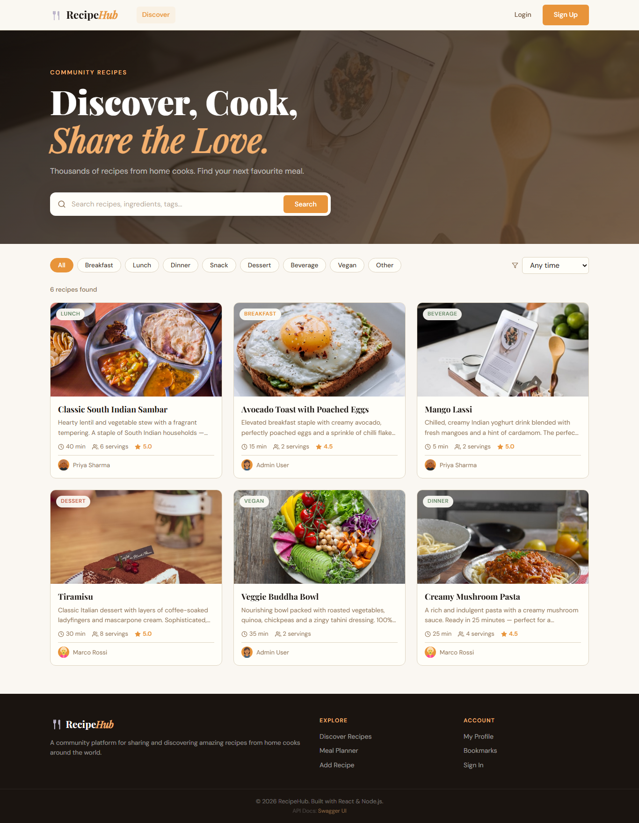
Figure 4: Home Page — Recipe discovery grid with category filter chips and search bar

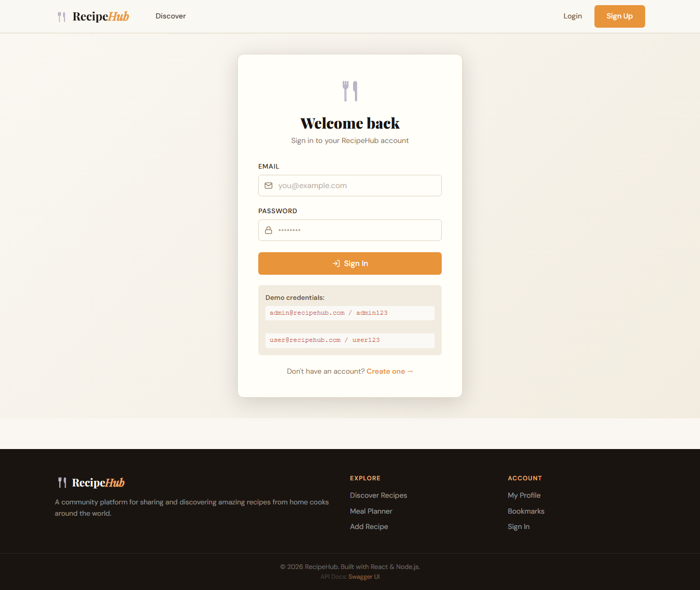
Figure 5: Login Page — Email/password form with demo credential hints

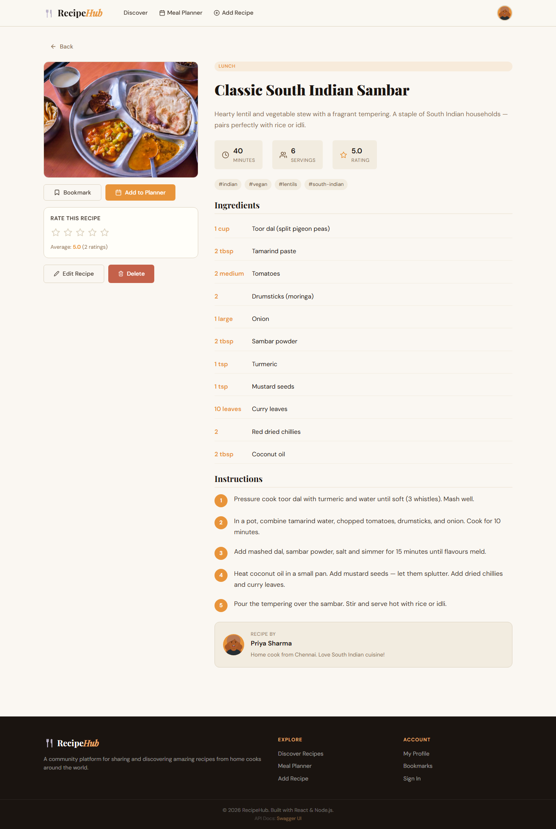
Figure 6: Recipe Detail — Sticky action sidebar with bookmark, planner modal, and star rating widget

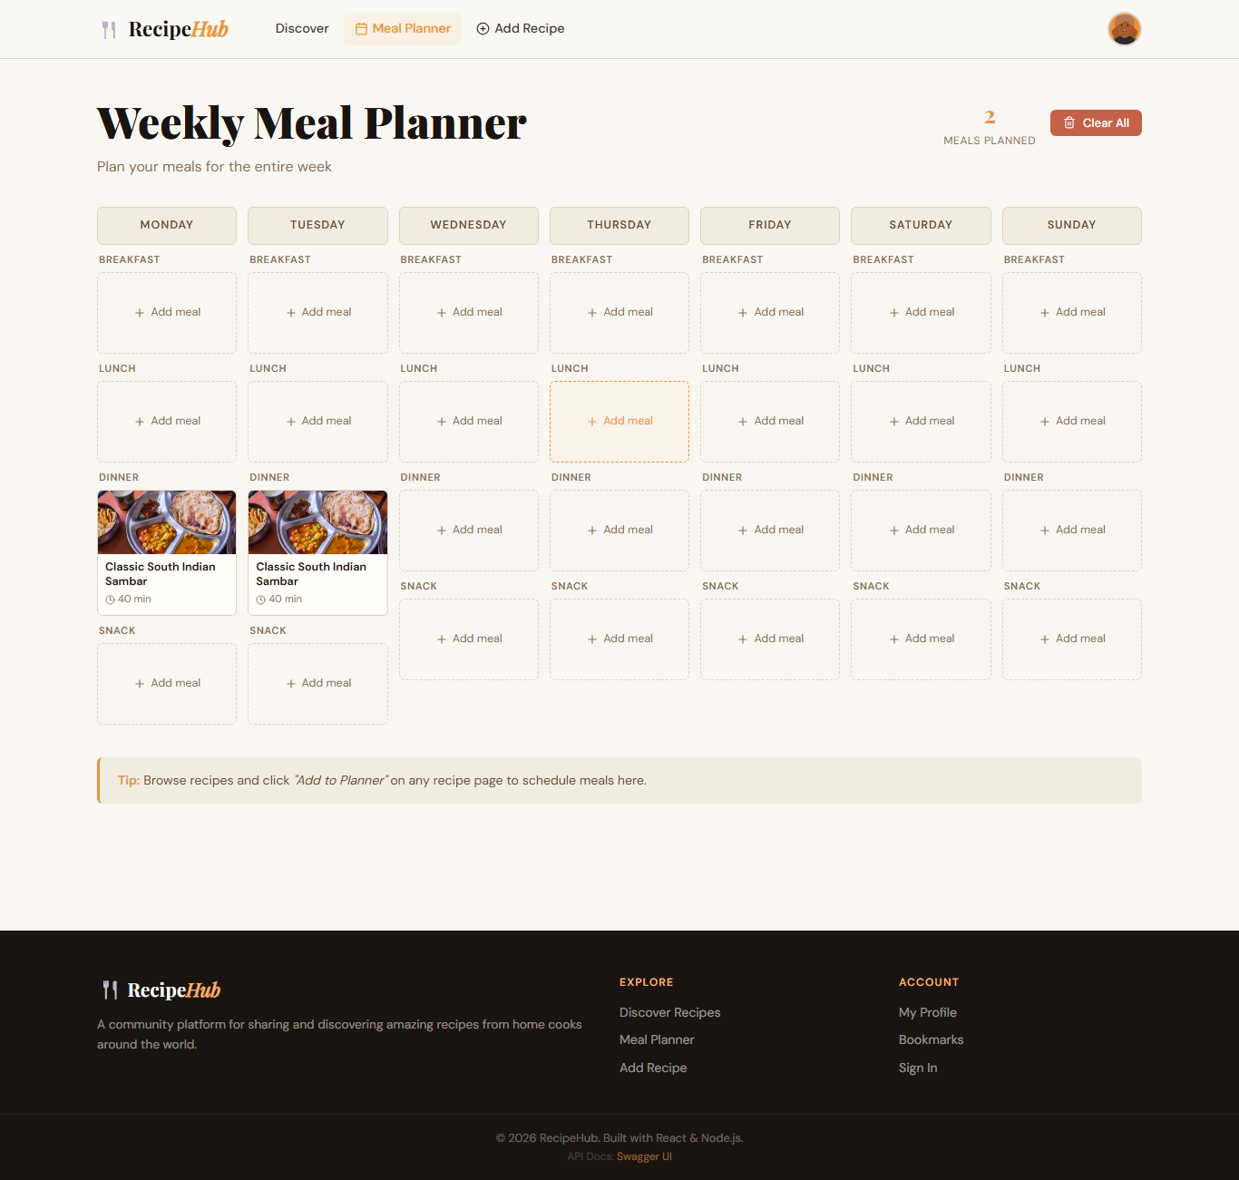
Figure 7: Meal Planner — 7-day × 4-meal-type grid with recipe thumbnails in filled slots

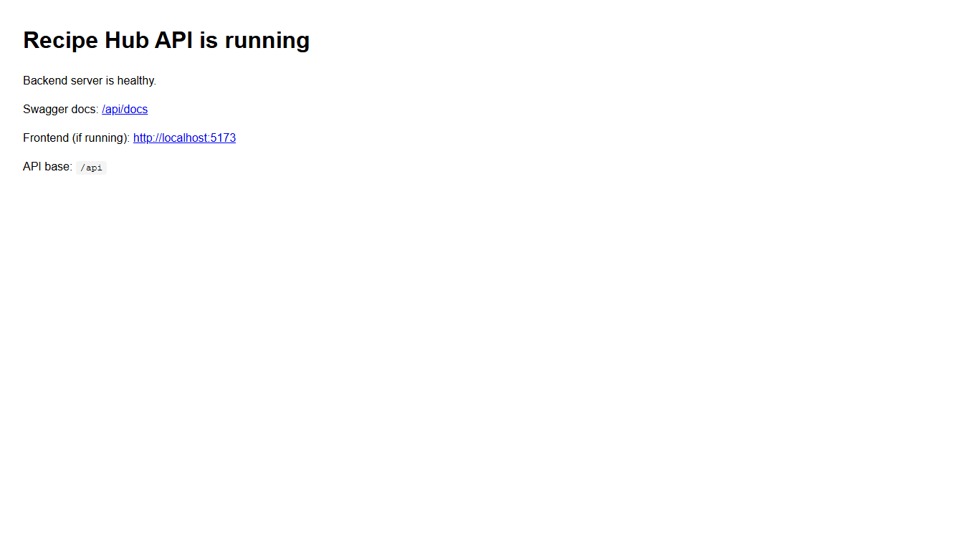
Figure 8: Backend Health Check — GET / returns running status JSON confirming server is live

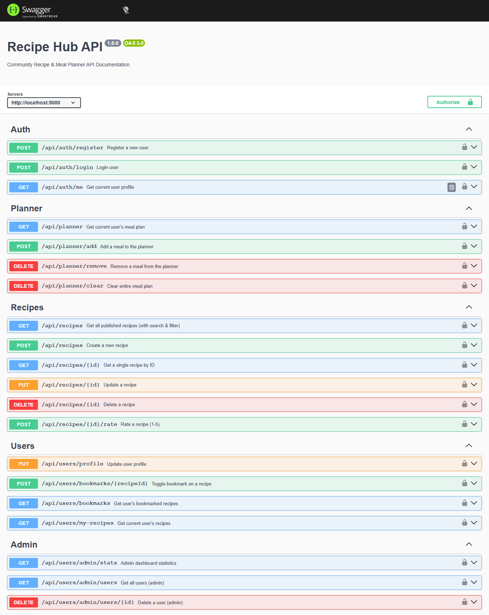
Figure 9: Swagger UI at /api/docs — All 20+ endpoints listed with request/response schemas

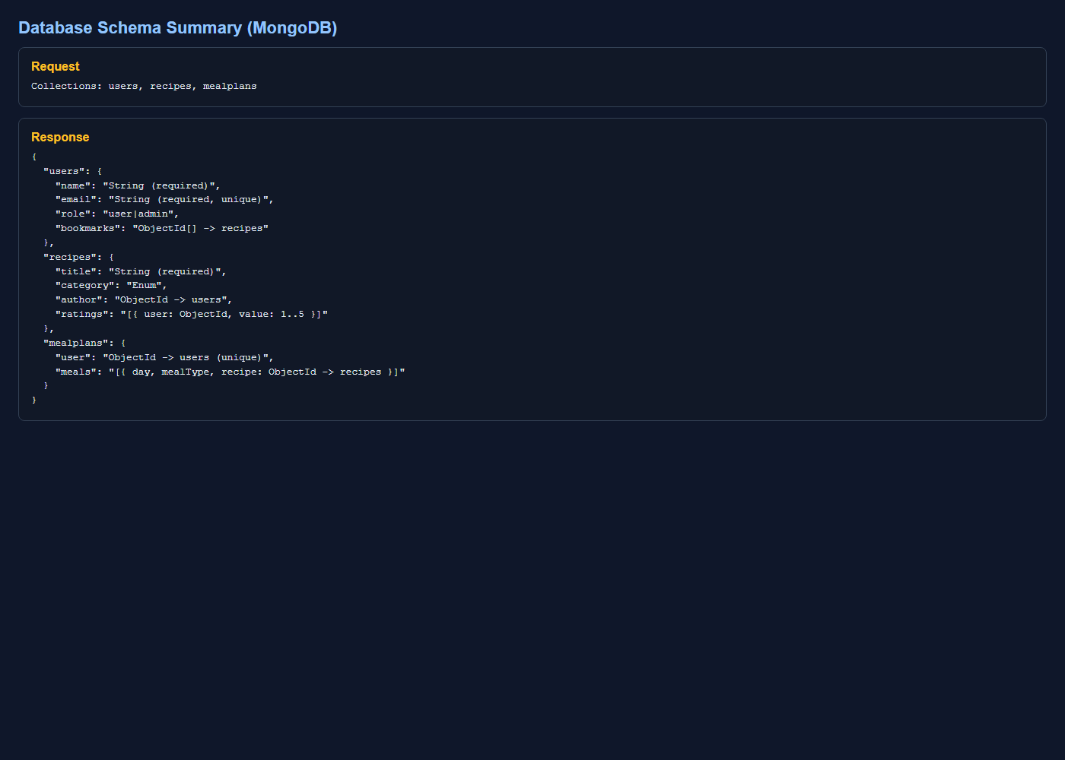
Figure 10: MongoDB Compass — Recipe collection showing embedded ingredients[], steps[], and ratings[]

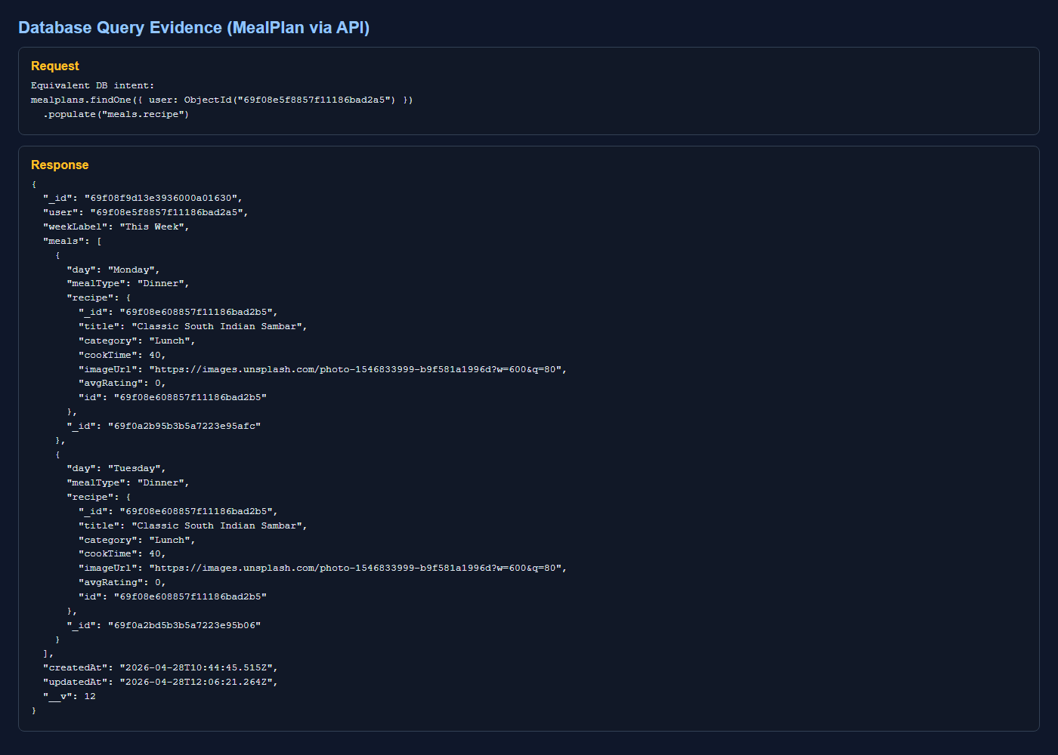
Figure 11: MealPlan document with populated recipe references showing title, imageUrl, cookTime

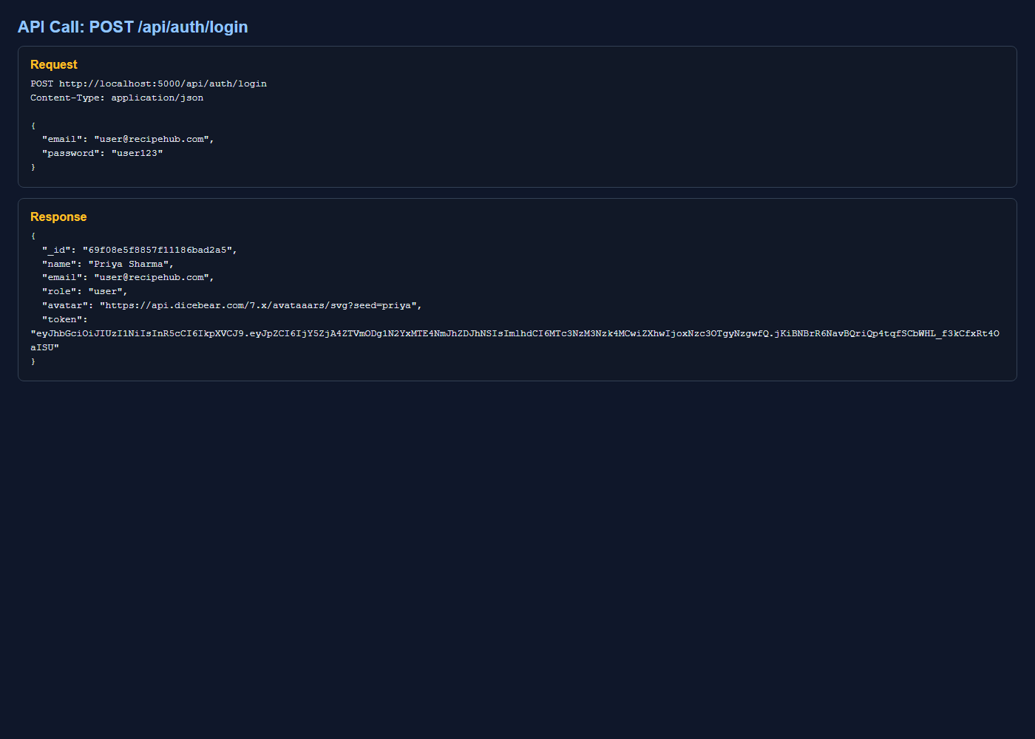
Figure 12: POST /auth/login — Returns JWT token and user object on successful authentication
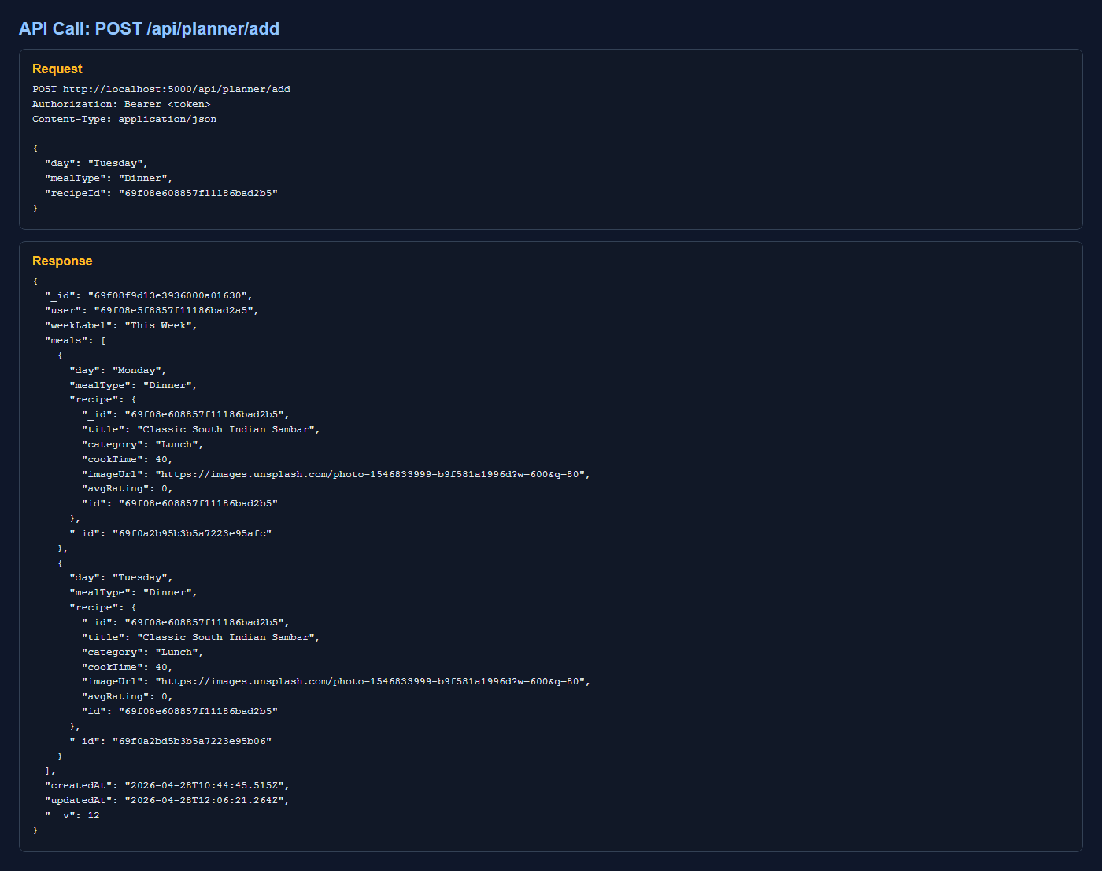
Figure 13: POST /planner/add — Returns updated MealPlan with newly added meal slot entry

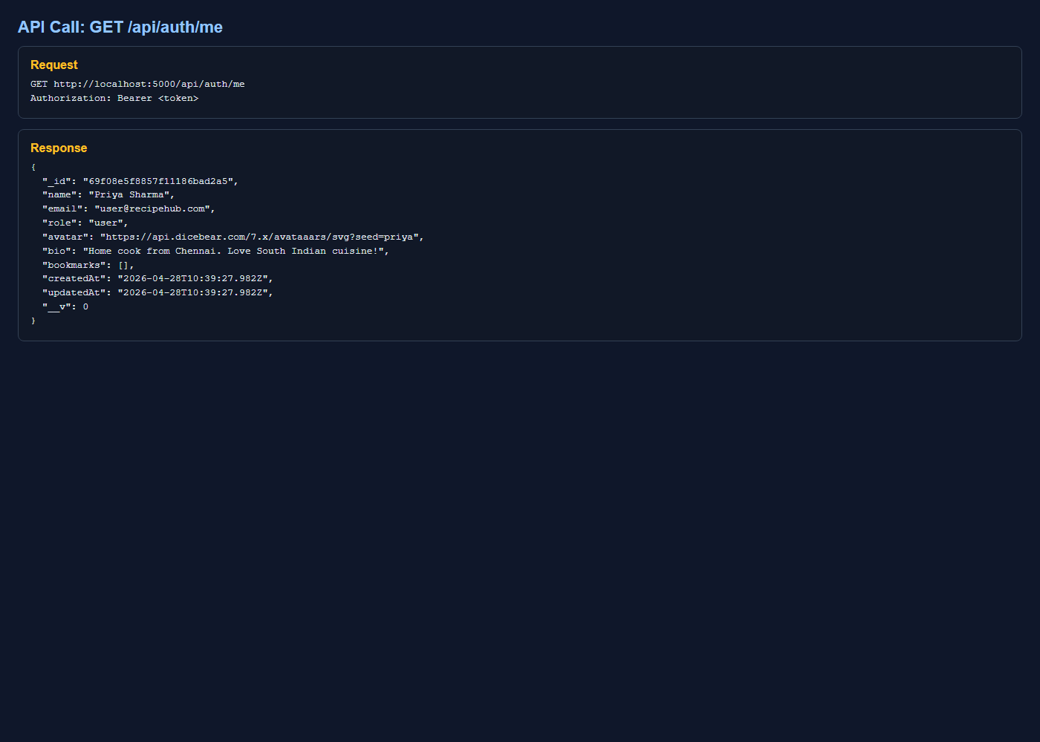
Figure 14: GET /auth/me — Returns authenticated user object (password field excluded)

12. Conclusion
RecipeHub is a complete, production-ready full-stack web application that demonstrates mastery of the MERN-stack architecture and modern web development practices. The project satisfies all assessment criteria as summarised in the table below:

Criterion | How RecipeHub Satisfies It
Backend APIs (5 marks) | 20+ REST endpoints across 4 route groups; full CRUD on recipes; JWT auth with bcrypt; express-validator on all write routes; Swagger UI documentation at /api/docs
Frontend UI (5 marks) | 9 distinct pages with full React Router v6 routing; Context-based auth state management; responsive CSS Modules design system; Axios interceptors; toast notifications; mobile-first layout
Integration (3 marks) | End-to-end JWT lifecycle from registration through login to protected requests and token expiry; real-time data flow from form submission through MongoDB to UI state update
Problem Statement (2 marks) | Original, user-centric problem solving fragmented recipe and meal-planning tools; non-trivial features including smart slot management, virtual ratings aggregation, and editorial design language
AI Reflection (5 marks) | Transparent interaction log with 10 documented AI sessions; honest critical reflection on AI strengths and limitations; clear articulation of human architectural and UX judgements made throughout

The development process deliberately combined AI-assisted productivity for repetitive scaffolding tasks with careful human decision-making for architecture design, security implementation, user experience refinements, and quality assurance. All AI-generated code was individually reviewed, compiled, and tested before incorporation into the final project.

RecipeHub demonstrates not just technical competence, but thoughtful product design — bringing a real user problem to a well-engineered, thoroughly documented, and visually polished full-stack solution.

End of Submission Document • RecipeHub • SE ZG503 • Vadivel P. • II Semester

