Initial DataFrame shape: (201, 6)

Date Open High Low Cls Volume

0 2024-01-01 129.66 133.97 125.17 130.58 4015

1 2024-01-02 161.87 167.03 155.56 157.36 9241

2 2024-01-03 148.60 156.97 142.22 154.84 17884

3 2024-01-04 138.68 142.55 132.78 135.50 18814

4 2024-01-05 153.94 157.17 148.90 149.65 8166

Cleaned DataFrame shape: (198, 6)

📊 Linear Regression Evaluation:

MAE: 7.447514619262843

RMSE: 44.743083847954296

R2 Score: -2040.63449461884

📊 Random Forest Evaluation:

MAE: 0.1096505270107092

RMSE: 0.1447553447480265

R2 Score: 0.9786304496988535

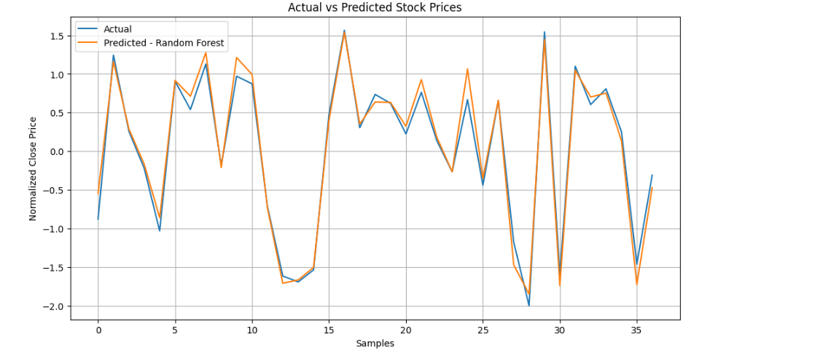

Epoch 1/10

/usr/local/lib/python3.11/dist-packages/keras/src/layers/rnn/rnn.py:200: UserWarning: Do not pass an `input_shape`/`input_dim` argument to a layer. When using Sequential models, prefer using an `Input(shape)` object as the first layer in the model instead.

super().__init__(**kwargs)

**4/4** ━━━━━━━━━━━━━━━━━━━━ **4s** 52ms/step - loss: 0.4223

Epoch 2/10

**4/4** ━━━━━━━━━━━━━━━━━━━━ **0s** 54ms/step - loss: 0.1734

Epoch 3/10

**4/4** ━━━━━━━━━━━━━━━━━━━━ **0s** 56ms/step - loss: 0.0841

Epoch 4/10

**4/4** ━━━━━━━━━━━━━━━━━━━━ **0s** 55ms/step - loss: 0.1274

Epoch 5/10

**4/4** ━━━━━━━━━━━━━━━━━━━━ **0s** 55ms/step - loss: 0.0816

Epoch 6/10

**4/4** ━━━━━━━━━━━━━━━━━━━━ **0s** 60ms/step - loss: 0.0832

Epoch 7/10

**4/4** ━━━━━━━━━━━━━━━━━━━━ **0s** 56ms/step - loss: 0.0870

Epoch 8/10

**4/4** ━━━━━━━━━━━━━━━━━━━━ **0s** 57ms/step - loss: 0.0734

Epoch 9/10

**4/4** ━━━━━━━━━━━━━━━━━━━━ **0s** 54ms/step - loss: 0.0750

Epoch 10/10

**4/4** ━━━━━━━━━━━━━━━━━━━━ **0s** 54ms/step - loss: 0.0760

**1/1** ━━━━━━━━━━━━━━━━━━━━ **0s** 342ms/step

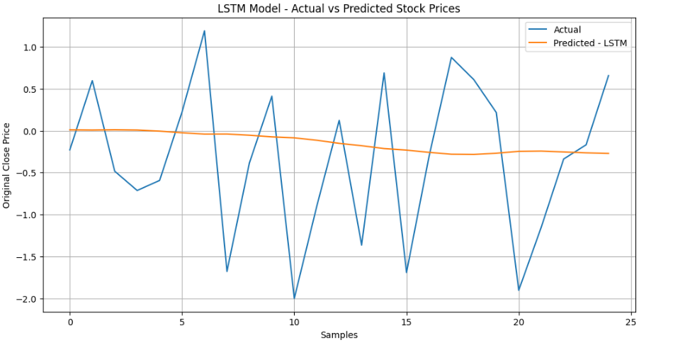

Initial DataFrame shape: (201, 6)

Date Open High Low Cls Volume

0 2024-01-01 129.66 133.97 125.17 130.58 4015

1 2024-01-02 161.87 167.03 155.56 157.36 9241

2 2024-01-03 148.60 156.97 142.22 154.84 17884

3 2024-01-04 138.68 142.55 132.78 135.50 18814

4 2024-01-05 153.94 157.17 148.90 149.65 8166

Cleaned DataFrame shape: (198, 6)

📊 Linear Regression Evaluation:

MAE: 7.447514619262843

RMSE: 44.743083847954296

R2 Score: -2040.63449461884

📊 Random Forest Evaluation:

MAE: 0.1096505270107092

RMSE: 0.1447553447480265

R2 Score: 0.9786304496988535

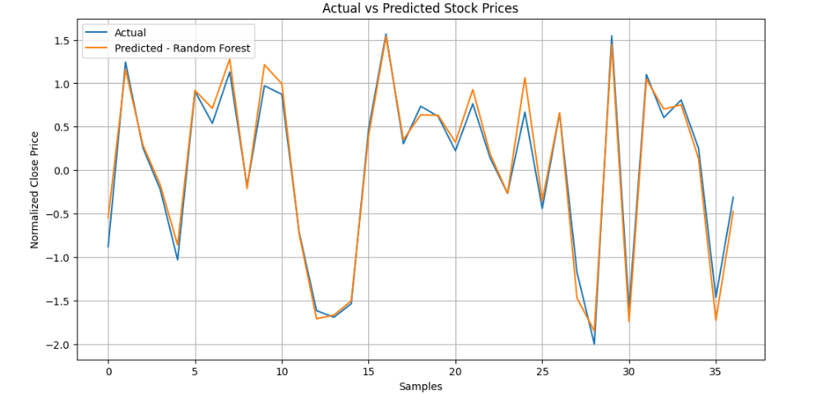

Epoch 1/10

/usr/local/lib/python3.11/dist-packages/keras/src/layers/rnn/rnn.py:200: UserWarning: Do not pass an `input_shape`/`input_dim` argument to a layer. When using Sequential models, prefer using an `Input(shape)` object as the first layer in the model instead.

super().__init__(**kwargs)

**4/4** ━━━━━━━━━━━━━━━━━━━━ **4s** 54ms/step - loss: 0.3353

Epoch 2/10

**4/4** ━━━━━━━━━━━━━━━━━━━━ **0s** 57ms/step - loss: 0.1049

Epoch 3/10

**4/4** ━━━━━━━━━━━━━━━━━━━━ **0s** 56ms/step - loss: 0.1314

Epoch 4/10

**4/4** ━━━━━━━━━━━━━━━━━━━━ **0s** 55ms/step - loss: 0.1006

Epoch 5/10

**4/4** ━━━━━━━━━━━━━━━━━━━━ **0s** 59ms/step - loss: 0.0781

Epoch 6/10

**4/4** ━━━━━━━━━━━━━━━━━━━━ **0s** 55ms/step - loss: 0.0885

Epoch 7/10

**4/4** ━━━━━━━━━━━━━━━━━━━━ **0s** 51ms/step - loss: 0.0807

Epoch 8/10

**4/4** ━━━━━━━━━━━━━━━━━━━━ **0s** 57ms/step - loss: 0.0736

Epoch 9/10

**4/4** ━━━━━━━━━━━━━━━━━━━━ **0s** 59ms/step - loss: 0.0772

Epoch 10/10

**4/4** ━━━━━━━━━━━━━━━━━━━━ **0s** 54ms/step - loss: 0.0872

**1/1** ━━━━━━━━━━━━━━━━━━━━ **0s** 306ms/step

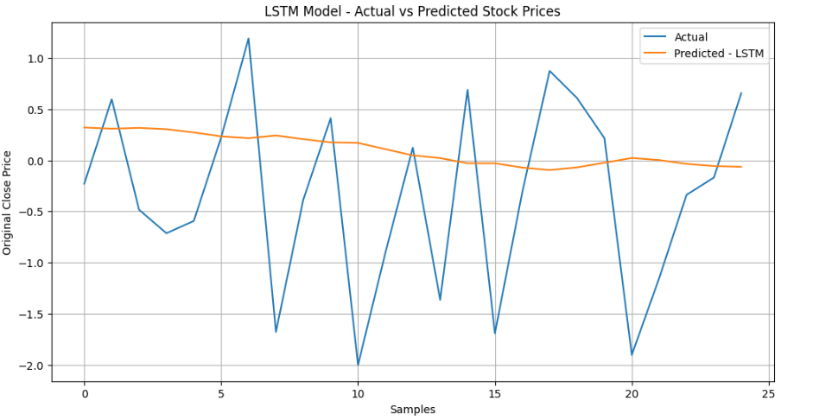

Colab notebook detected. To show errors in colab notebook, set debug=True in launch()

IMPORTANT: You are using gradio version 3.48.0, however version 4.44.1 is available, please upgrade.

--------

Running on public URL: [https://edbd1633990321b8b1.gradio.live](https://edbd1633990321b8b1.gradio.live/)

This share link expires in 72 hours. For free permanent hosting and GPU upgrades, run `gradio deploy` from Terminal to deploy to Spaces (<https://huggingface.co/spaces>)

