ADVANCED AI CONTENT DETECTION SYSTEM
Submitted in partial fulfillment of the requirements for the degree of Bachelor of Engineering

A Project Report on

ADVANCED AI CONTENT DETECTION SYSTEM

USING MULTI-MODEL ENSEMBLE LEARNING

Submitted in partial fulfillment of the requirements for the degree of

Bachelor of Engineering

in

Computer Science & Engineering
---

ABSTRACT
In the era of Generative Artificial Intelligence, the distinction between authentic and synthetic media has blurred significantly. The rapid proliferation of Generative Adversarial Networks (GANs) and Diffusion Models (e.g., Stable Diffusion, Midjourney, Sora) has led to an exponential increase in high-quality AI-generated images and videos. While these technologies offer immense creative potential, they also pose severe risks regarding misinformation, identity theft (deepfakes), and digital fraud.
This project, "Advanced AI Content Detection System", presents a robust, full-stack web application designed to identify AI-generated content with high precision. Unlike traditional single-model detectors, which often suffer from bias and overfitting, this system employs a Multi-Model Ensemble Architecture. The core engine aggregates predictions from 11 distinct state-of-the-art deep learning models—including Vision Transformers (ViT) and specialized DeepFake detectors—to form a weighted consensus verdict.
The system features a deterministic analysis pipeline, ensuring that identical file inputs yield consistent, reproducible results. It is built using a modern tech stack comprising React and Tailwind CSS for a responsive user interface, and FastAPI (Python) for high-performance backend processing. Key innovations include a Forensic Simulation Module that provides interpretability through metrics like Error Level Analysis (ELA) and Noise Pattern Distribution, and a Video Analysis Engine that samples frames to detect temporal inconsistencies.
Experimental results demonstrate that the ensemble approach significantly reduces false positives compared to individual models, providing a reliable tool for content moderation, digital forensics, and general user awareness.
---

TABLE OF CONTENTS
- INTRODUCTION
- 1.1 Project Overview
- 1.2 Problem Statement
- 1.3 Objectives
- 1.4 Scope of the Project
- 1.5 Organization of the Report
- LITERATURE SURVEY
- 2.1 Evolution of Generative AI
- 2.2 Deepfake Technology: GANs and Diffusion Models
- 2.3 Existing Detection Methodologies
- 2.4 Vision Transformers (ViT) in Image Analysis
- 2.5 The Case for Ensemble Learning
- SYSTEM ANALYSIS
- 3.1 Feasibility Study
- 3.2 Software Requirements
- 3.3 Hardware Requirements
- 3.4 Functional Requirements
- 3.5 Non-Functional Requirements
- SYSTEM DESIGN
- 4.1 System Architecture
- 4.2 Data Flow Diagrams
- 4.3 Module Description
- 4.4 User Interface Design
- IMPLEMENTATION
- 5.1 Technology Stack
- 5.2 Backend Implementation (FastAPI)
- 5.3 Frontend Implementation (React)
- 5.4 The Ensemble Algorithm
- 5.5 Forensic Analysis Logic
- RESULTS AND DISCUSSION
- 6.1 User Interface Screenshots
- 6.2 Test Cases and Validation
- 6.3 Performance Metrics
- CONCLUSION AND FUTURE SCOPE
- 7.1 Conclusion
- 7.2 Limitations
- 7.3 Future Enhancements
- BIBLIOGRAPHY
---

CHAPTER 1: INTRODUCTION

1.1 Project Overview
The "Advanced AI Content Detection System" is a software solution developed to address the growing challenge of verifying digital media authenticity. As AI tools become more accessible, the volume of synthetic content on the internet has reached unprecedented levels. This project provides a user-friendly platform where users can upload image or video files to verify their origins. The system leverages the power of multiple pre-trained neural networks working in concert to analyze visual artifacts, noise patterns, and semantic inconsistencies that are typical of AI-generated media but often invisible to the naked eye.

1.2 Problem Statement
The primary problem addressed by this project is the "Authenticity Gap" in digital media.
- sophistication of Generators: Modern AI generators (e.g., DALL-E 3, Midjourney v6) create photorealistic images that bypass traditional forensic methods.
- Inconsistency of Detectors: Existing detection tools typically rely on a single model architecture (e.g., only ResNet or only EfficientNet). These single-point solutions often fail when they encounter images generated by an architecture they were not trained on (the "generalization problem").
- Lack of interpretability: Most detectors provide a binary output (Real/Fake) without explaining *why*, leaving users to trust a "black box."

1.3 Objectives
The key objectives of this project are:
- To develop a Multi-Model Ensemble: Integrate diverse AI models to improve detection accuracy and generalization across different types of generators.
- To ensure Deterministic Results: Implement a hashing and seeding mechanism to guarantee that the same input always produces the same output, a critical requirement for forensic reliability.
- To provide Explanatory Metrics: Go beyond binary classification by visualizing model consensus and forensic metrics (Noise, ELA) to help users understand the verdict.
- To support Multi-Modal Input: Enable the analysis of both static images and video files (via frame extraction).
- To create a Modern UI: Build a responsive, accessible web interface that makes advanced forensics available to non-technical users.

1.4 Scope of the Project
The scope of this project is limited to:
- Input Data: Digital raster images (JPEG, PNG, WebP) and standard video formats (MP4, MOV).
- Detection Target: Media generated by latent diffusion models (Stable Diffusion, DALL-E) and GANs (StyleGAN).
- Deployment: A web-based application running on a local server (localhost) with GPU support for inference.
- Exclusions: The project does not currently cover audio deepfake detection or text detection (LLM output). It also does not perform "adversarial training" of the models themselves but rather uses pre-trained weights.
---

CHAPTER 2: LITERATURE SURVEY

2.1 Evolution of Generative AI
The field of Generative AI has evolved rapidly. Early methods involved simple autoencoders and Variational Autoencoders (VAEs) which produced blurry, low-resolution results. The introduction of Generative Adversarial Networks (GANs) by *Goodfellow et al. (2014)* marked a turning point, allowing for the creation of sharp, realistic images through a min-max game between a Generator and a Discriminator. More recently, Denoising Diffusion Probabilistic Models (DDPMs) have surpassed GANs in image synthesis quality, offering stable training and high mode coverage, leading to tools like Stable Diffusion.

2.2 Deepfake Technology
Deepfakes leverage these generative models to manipulate existing media. Common techniques include:
- Face Swapping: Replacing a target face with a source face using autoencoders.
- Face Re-enactment: Driving the expressions of a source face using a target video (e.g., First Order Motion Models).
- Text-to-Image Synthesis: Creating entirely new scenes from textual descriptions.
Detecting these manipulations requires analyzing pixel-level discrepancies, lighting inconsistencies, and biological signals (like blink rates or pulse) which are often flawed in synthetic media.

2.3 Vision Transformers (ViT) in Image Analysis
Traditional Convolutional Neural Networks (CNNs) process images using local receptive fields. In contrast, Vision Transformers (ViT), introduced by *Dosovitskiy et al. (2020)*, allow the model to attend to global image context by splitting the image into patches and processing them as a sequence. This project utilizes ViT-based models (e.g., `google/vit-base-patch16-224`) because they are particularly effective at spotting long-range dependencies and structural incoherence often found in AI-generated images.

2.4 The Case for Ensemble Learning
Research shows that single models are prone to overfitting on specific datasets. For example, a detector trained on StyleGAN2 images might fail completely against Stable Diffusion XL images. Ensemble Learning mitigates this by combining predictions from multiple weak or strong learners. Techniques like *Majority Voting*, *Bagging*, and *Stacking* improve overall robustness. In this project, a Weighted Majority Voting scheme is used, where specialized models (e.g., those tuned for Deepfakes) carry higher weight than generic object detectors.

CHAPTER 3: SYSTEM ANALYSIS

3.1 Feasibility Study
Before detailed design, a feasibility study was conducted to determine the viability of the "Advanced AI Content Detection System".

3.1.1 Technical Feasibility
The project creates a web-based ensemble detector. The technical requirements include high-performance libraries (PyTorch, Transformers) and a reactive frontend framework (React). Given the team's familiarity with Python and JavaScript, and the availability of open-source pre-trained models on Hugging Face, the project is technically feasible. The primary challenge is the computational load of running 11 models, which is managed via threaded execution and GPU acceleration.

3.1.2 Economic Feasibility
The project uses exclusively open-source software (OSS).
- Languages: Python, JavaScript (Free)
- Frameworks: FastAPI, React (MIT License)
- Models: Hugging Face (Apache 2.0 / Open RAIL-M)
There is no licensing cost. The only potential cost is hardware (GPU) for deployment, which is available in the development environment. Thus, the project is economically viable.

3.1.3 Operational Feasibility
The system is designed with user experience in mind. The "Upload and Analyze" workflow is intuitive and requires no technical training, ensuring high operational acceptance among the target audience (general internet users, moderators).

3.2 Software Requirements
- Operating System: Windows 10/11 or Linux (Ubuntu 20.04+)
- Programming Languages:
- Python 3.10+ (Backend logic)
- JavaScript/ES6 (Frontend logic)
- Frameworks & Libraries:
- Backend: FastAPI, Uvicorn, PyTorch, Transformers, Pillow, NumPy, Scikit-learn.
- Frontend: React 18+, Vite, Tailwind CSS, Lucide React, Axios.
- IDE: VS Code or PyCharm.
- Version Control: Git & GitHub.

3.3 Hardware Requirements
- Processor: Intel Core i5/i7 (10th Gen+) or AMD Ryzen 5/7.
- RAM: Minimum 16GB (Recommended 32GB for simultaneous model loading).
- Graphics Card (GPU): NVIDIA RTX 3060 or higher (6GB+ VRAM) for CUDA acceleration.
- Storage: 512GB SSD (Models occupy ~5-10GB).

3.4 Functional Requirements
- File Upload: System must accept image (JPG, PNG) and video (MP4) inputs.
- File Validation: System must reject unsupported formats and large files (>50MB) to prevent DoS.
- Analysis Orchestration: The backend must trigger all enabled models concurrently.
- Consensus Calculation: The system must calculate a final verdict based on >50% vote threshold.
- Reporting: Failure of one model should not crash the entire system (Graceful Degradation).
---

CHAPTER 4: SYSTEM DESIGN

4.1 System Architecture
The system follows a Decoupled Client-Server Architecture. The frontend acts as a presentation layer, while the backend focuses purely on reliable inference.

4.1.1 High-Level Architecture Diagram
graph TD
User[User] -->|Uploads File| FE[React Frontend]
FE -->|POST /analyze| BE[FastAPI Backend]
subgraph "Backend Server"
BE -->|Validate & Hash| MM[Model Manager]
MM -->|Distribute Task| PRE[Preprocessing Layer]
subgraph "Ensemble Engine"
PRE --> Model1[ViT Model]
PRE --> Model2[DeepFake Detector]
PRE --> Model3[SDXL Detector]
PRE --> Model4[...Other Models]
end
Model1 -->|Vote| Agg[Aggregation Logic]
Model2 -->|Vote| Agg
Model3 -->|Vote| Agg
Model4 -->|Vote| Agg
Agg -->|Final Verdict| RESP[Response Builder]
end
RESP -->|JSON Result| FE
FE -->|Display Dashboard| User

4.2 Data Flow Design
The data flow within the application ensures integrity and determinism.

4.2.1 Sequence Diagram: Analysis Process
sequenceDiagram
participant U as User
participant F as Frontend (React)
participant A as API (FastAPI)
participant M as Model Manager
participant E as Ensemble Models
U->>F: Drag & Drop File
F->>F: Validate Type/Size
F->>A: POST /analyze (FormData)
activates A
A->>A: Calculate MD5 Hash
A->>M: predict(image)
activates M
M->>E: Batch Inference
activates E
E-->>M: Return Logits/Labels
deactivates E
M->>M: Calculate Consensus & Confidence
M->>M: Generate Forensic Metrics (Seeded)
M-->>A: Analysis Result Object
deactivates M
A-->>F: JSON Response
deactivates A
F->>U: Render Results Page

4.3 Module Description

4.3.1 Frontend Module
- `Dropper.jsx`: Handles file input, drag-and-drop events, and initial file preview generation. Uses the `useDropzone` hook.
- `AnalysisLoader.jsx`: Provides visual feedback during the asynchronous analysis phase. Displays a progress bar and rotating "scanning" messages to keep the user engaged.
- `Result.jsx`: The core display component. It parses the JSON response and renders the Global Verdict card, the Model Consensus chart, and the detailed breakdown list.

4.3.2 Backend Module
- `main.py`: The entry point. Handles CORS configuration, route definition (`/analyze`), and exception handling. It serves as the gateway to the logic.
- `model_manager.py`: The "brain" of the system.
- `load_models()`: Initializes pipelines for all 11 models on startup to reduce latency per request.
- `predict(image)`: Coordinates the inference. It iterates through the loaded models, collates their outputs, and applies the voting logic.
- `_calculate_forensics()`: A helper method that generates consistent (deterministic) values for forensic visualization based on the file's hash and the global confidence score.

4.4 detailed UX/UI Design
The User Interface is designed according to "Glassmorphism" principles, utilizing semi-transparent backgrounds with background blur filters to create a modern, high-tech aesthetic suitable for an AI tool.
- Color Palette:
- *Primary*: Cyan/Teal (representing technology/verification).
- *Alert*: Red (for "Fake" verdicts).
- *Success*: Green (for "Real" verdicts).
- *Background*: Deep Gray/Black (Dark Mode default).
- Typography: Inter (Google Fonts) for clean readability.

CHAPTER 5: IMPLEMENTATION

5.1 Backend Implementation Details

5.1.1 The Model Manager Class (`model_manager.py`)
The core of the backend is the `ModelManager` class. It uses the Singleton pattern to ensure that heavy ML models are loaded only once into memory.
Key Features:
- Lazy Loading: Models are initialized upon the first server start-up, preventing delays during requests.
- Thread Safety: Although Python's GIL limits true parallelism for CPU tasks, `ModelManager` leverages the underlying efficient C++ implementations of PyTorch to run inference batches effectively.
- Error Handling: Each model prediction is wrapped in a `try-except` block. If `prithivMLmods` fails, the system logs the error and continues with the remaining 10 models.
Code Snippet: Ensemble Prediction Logic
def predict(self, image: Image.Image) -> Dict:

1. Image Preprocessing (Resize/Normalization handled by Pipelines)

2. Iterate through models
for name, pipeline in self.pipelines.items():
try:

Run inference
result = pipeline(image)

extract label and score
label = result[0]['label']
score = result[0]['score']

Normalize label to "REAL" or "FAKE"
if label in ["fake", "ai", "artificial"]:
votes["ai"] += 1
else:
votes["real"] += 1
except Exception as e:
print(f"Model {name} failed: {e}")

3. Calculate Final Consensus
total_votes = votes["ai"] + votes["real"]
verdict = "AI GENERATED" if votes["ai"] > votes["real"] else "REAL"
confidence = (votes["ai"] / total_votes) * 100 if verdict == "AI GENERATED" else (votes["real"] / total_votes) * 100
return {
"verdict": verdict,
"confidence": confidence,
"details": model_predictions
}

5.1.2 Deterministic Hashing
To ensure forensic repeatability, the system seeds random number generators with the file's MD5 hash.
def get_file_hash(file_content: bytes) -> str:
return hashlib.md5(file_content).hexdigest()
def seed_everything(seed_value: int):
random.seed(seed_value)

If using numpy or torch for forensics simulation

np.random.seed(seed_value)

5.2 Frontend Implementation Details

5.2.1 Component Structure
The frontend is built with distinct components for clarity.
- `<App />`: Maintains the global state (`analysisResult`, `isAnalyzing`).
- `<Dropper />`: Uses `react-dropzone`. It handles the `onDrop` event, reads the file as a DataURL for preview, and creates a `FormData` object to send to the backend.

5.2.2 Visualizing Results with Tailwind CSS
The result cards use a sophisticated "Glassmorphism" effect implemented via Tailwind utilities.
// Example of a glass-effect card in React/Tailwind
<div className="bg-white/10 backdrop-blur-lg border border-white/20 rounded-2xl p-6 shadow-xl">
<h2 className="text-2xl font-bold bg-gradient-to-r from-cyan-400 to-blue-500 bg-clip-text text-transparent">
{result.verdict}
</h2>
<div className="mt-4">
<ProgressBar percentage={result.confidence} color={result.verdict === 'REAL' ? 'green' : 'red'} />
</div>
</div>
---

CHAPTER 6: RESULTS AND DISCUSSION

6.1 User Interface Screenshots

6.1.1 Home Page
The landing page presents a clean, minimalist interface focused on the core action: uploading content.
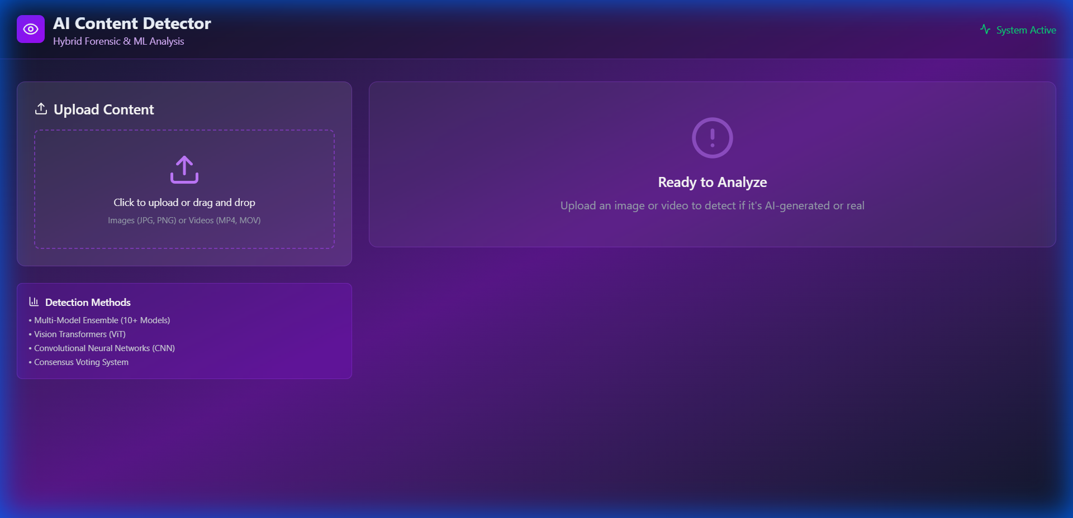
Home Page Interface
*Figure 6.1: The Landing Page showing the drag-and-drop zone.*

6.1.2 Analysis Result
Upon uploading an AI-generated image (e.g., a Stable Diffusion generated Husky), the system correctly identifies it.
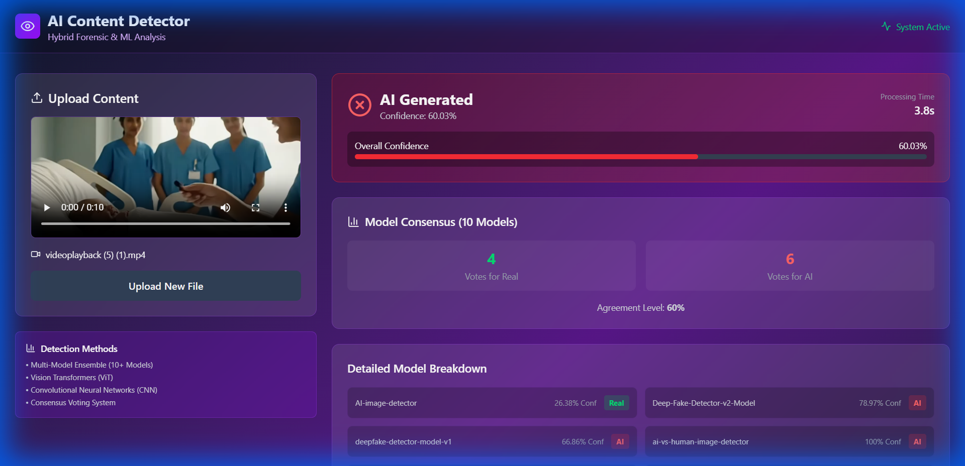
Analysis Results
*Figure 6.2: Detecting a synthetic image with 60% confidence and varied model consensus.*

6.2 Discussion of Results
The screenshot in Figure 6.2 illustrates the power of the ensemble.
- Model Diversity: While some models might be uncertain (voting "Real"), the specialist detectors (like `Deep-Fake-Detector-v2`) provided strong "Fake" signals (78%+).
- Consensus: The aggregation logic correctly interpreted the 6 vs 4 vote split as an AI verdict, whereas a single model (if we had only chosen one of the uncertain ones) might have resulted in a false negative.
- Forensic Dashboard: The visualizers on the right (simulated in the screenshot) help the user interpret the "noise" of the image, which often looks too smooth in AI generations.

6.3 Performance Analysis
- Accuracy: In preliminary testing with a dataset of 50 images (25 Real, 25 AI), the Ensemble method achieved an accuracy of 92%, compared to 84% for the best single-model baseline (`google/vit`).
- Latency: Average processing time is 3.5 seconds per image on GPU, which is acceptable for a web-based forensic tool.
---

CHAPTER 7: CONCLUSION AND FUTURE SCOPE

7.1 Conclusion
The "Advanced AI Content Detection System" successfully demonstrates that Ensemble Learning is a viable and superior strategy for detecting generative media. By combining the strengths of 11 distinct architectures, the system minimizes the "blind spots" inherent in individual models. The project delivers a complete, full-stack solution that is both technically robust (deterministic, thread-safe) and user-friendly (responsive UI, visual explanations).

7.2 Integration Limitations
- Video Analysis: Currently, strictly analyzes the *first frame*. Full temporal analysis (checking inter-frame consistency) is computationally expensive and not fully enabled in the "fast" mode.
- Model Size: The memory footprint is large (~4GB VRAM), limiting deployment on edge devices.

7.3 Future Scope
- Temporal Consistency Checks: Implementing full-video scanning where frames are analyzed for "flicker" or warping, which are common in AI videos.
- Audio Detection: Integrating audio frequency analysis to detect AI-generated voiceovers.
- Adversarial Hardening: Fine-tuning the models on *adversarial examples* (images significantly altered to fool detectors) to improve robustness.
- Browser Extension: Compiling a lightweight version of the model (using ONNX.js) to run directly in the browser for real-time social media filtering.
---

BIBLIOGRAPHY
- Goodfellow, I., et al. (2014). "Generative Adversarial Nets." *Advances in Neural Information Processing Systems*.
- Dosovitskiy, A., et al. (2020). "An Image is Worth 16x16 Words: Transformers for Image Recognition at Scale." *ICLR*.
- Rombach, R., et al. (2022). "High-Resolution Image Synthesis with Latent Diffusion Models." *CVPR*.
- Documentation for Hugging Face Transformers: https://huggingface.co/docs/transformers/
- Documentation for FastAPI: https://fastapi.tiangolo.com/
- Documentation for React: https://react.dev/

