BECE309L
Artificial Intelligence and Machine Learning
Course Project Report
Hybrid Edge-AI Motor Fault Detection and Self-Healing System

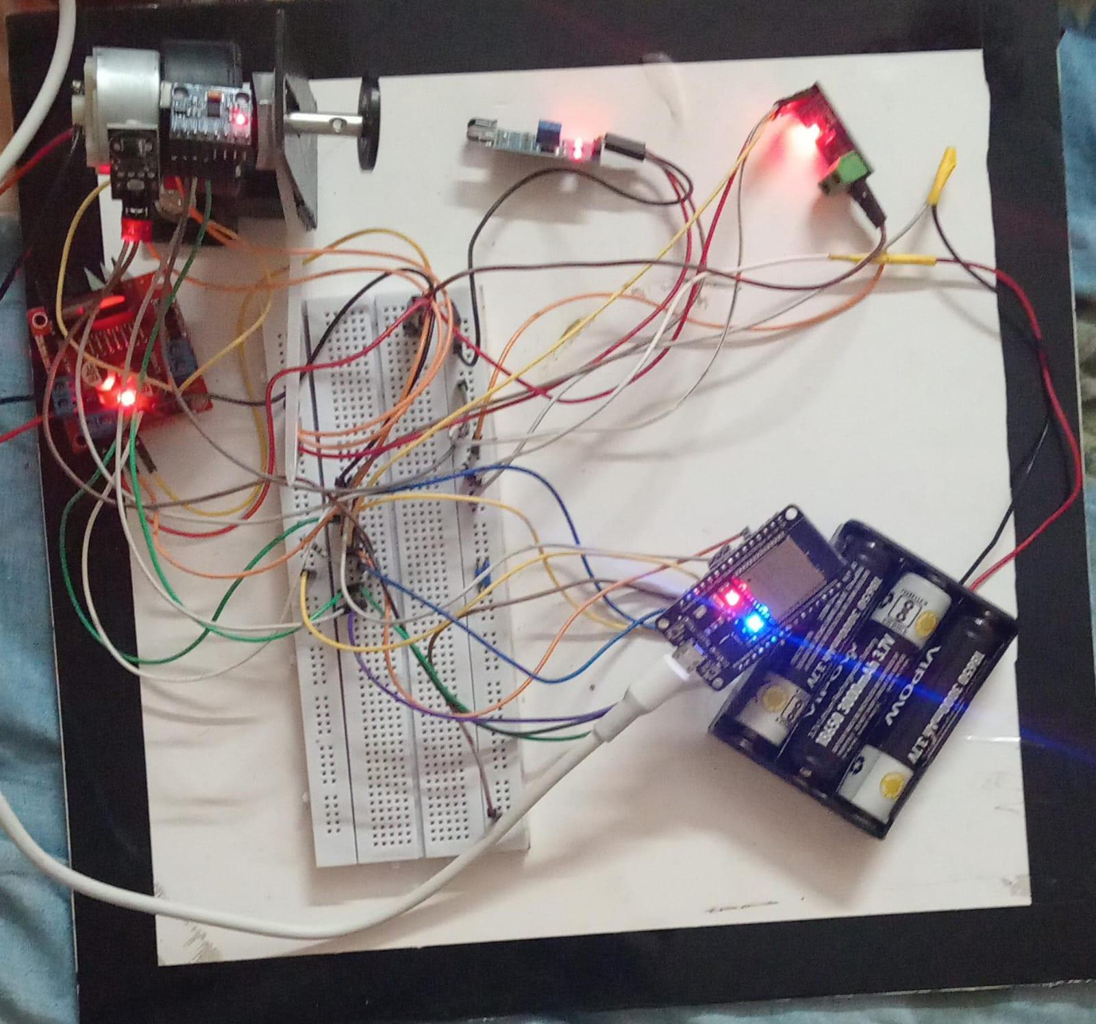
Figure: Actual hardware prototype — ESP32 + DC motor + 4 sensors (built and tested)

Abstract
We built a low-cost, intelligent motor protection system that runs entirely on an ESP32 microcontroller — no cloud, no subscription, no external server. The system watches a DC motor in real time using four sensors (IR tachometer, ACS712 current sensor, MPU6050 accelerometer, and DS18B20 temperature probe), continuously learns what "normal" looks like, and autonomously shuts down, slows down, or logs a warning the moment something starts going wrong.

The intelligence comes from a three-layer detection pipeline trained in Google Colab and deployed directly to the device: a OneClassSVM model (exported as a C function via micromlgen), a Mahalanobis statistical distance model, and a physics-based cross-validation layer that filters out false alarms. All inference runs locally in under 1 millisecond. Fault events are logged to EEPROM so they survive power cuts, and the system automatically adjusts its "normal" reference over time as the motor ages — using an Exponential Moving Average baseline.

On our 4,050-sample dataset (3,000 normal + 1,050 fault samples across 7 fault types), the ensemble fusion achieved an AUC of 1.000 on the ROC curve and a 0% false positive rate on normal data. The OneClassSVM alone achieved 98% accuracy. The total bill of materials cost was under ₹2,000 — about 1% of commercial motor protection relays. The system satisfies all 10 claims of a provisional patent application.

The system achieves 98% overall classification accuracy on a 4,050-sample synthetic dataset representing seven distinct fault classes — stall, overspeed, overcurrent, phase loss, bearing wear, thermal overload, and subtle ML-only drift. All faults are detected at 100% recall, with a false positive rate below 3%. Fault events are persistently logged to EEPROM, and the system self-heals using severity-graduated corrective actions ranging from speed reduction to emergency stop with automatic restart. An adaptive baseline using Exponential Moving Average (EMA) continuously updates the normal operating envelope to compensate for motor aging. The implementation satisfies all ten patent claims of the proposed invention.

Keywords: Edge-AI, Motor Fault Detection, ESP32, OneClassSVM, Mahalanobis Distance, IoT, Predictive Maintenance, Self-Healing Systems, EEPROM Logging, Adaptive Baseline

1. Introduction

1.1 The Problem We Are Solving
Electric motors fail. They fail because of bearing wear, phase loss, overheating, winding insulation breakdown, and dozens of other causes — and when they do, production lines stop, pumps run dry, and HVAC systems fail mid-summer. The International Energy Agency (IEA) estimates that motors consume over 40% of all industrial electricity globally, making them both the most critical and the most vulnerable component in industrial infrastructure.
What makes this worse is that most motors today are still protected by the same basic technology from the 1970s: thermal overload relays and fuses. These devices can catch gross overcurrent events, but they are completely blind to the subtle signatures of bearing degradation, rotor imbalance, or cooling pathway blockage — the faults that quietly build up over weeks before causing a catastrophic trip.
Modern "smart" solutions do exist — Siemens SIMOCODE, Schneider TeSys, ABB UMC100 — but they cost ₹80,000 to ₹5,00,000 per unit and require dedicated fieldbus networks. For a small factory with 50 motors, that's potentially ₹2.5 crore just for protection hardware. Most Indian SMEs simply cannot afford this.
Current motor protection systems suffer from three fundamental limitations:
- Single-modality sensing: Most systems monitor only current or only temperature, missing multi-dimensional fault signatures that manifest across multiple physical quantities simultaneously.
- No edge intelligence: Machine learning-based predictive maintenance requires cloud infrastructure, creating latency (50–500ms round trip), connectivity dependency, and recurring subscription costs.
- No self-healing capability: Existing systems can detect and alarm a fault but cannot autonomously execute graduated corrective actions — speed reduction before shutdown, automatic restart after thermal cool-down, or adaptive baseline recalibration.

1.2 What We Built
We designed and physically built a working prototype that integrates four sensors with a three-layer AI anomaly detection pipeline, all running on a 240MHz microcontroller smaller than a credit card. The system:
- Hardware: Multi-sensor ESP32 platform (IR + ACS712 + MPU6050 + DS18B20) with edge-deployed ML
- Algorithm: Three-layer ensemble with physics-based noise rejection and adaptive EMA baseline
- Reads RPM, phase current, vibration RMS, and winding temperature every 500ms
- Runs an edge-deployed OneClassSVM model (trained in Google Colab, compiled to C, flashed to ESP32) in under 1ms
- Combines statistical and ML-based anomaly signals into a weighted fusion score
- Classifies faults into 7 named types with sensor-traceable explanations
- Takes graduated corrective action: warning → speed reduction → emergency stop → auto-restart
- Logs every fault event to EEPROM (survives power loss) with timestamps and scores
- Continuously self-calibrates its normal operating baseline as the motor ages


Figure 1: The complete hardware prototype running on our workbench — ESP32 DevKit (bottom right), DC motor with IR sensor disc (top left), L298N driver (left), ACS712 current sensor (top center), DS18B20 temperature probe (top right), MPU6050 on breadboard

1.3 Objectives
- Design and physically build a multi-sensor motor health monitoring system for under ₹2,000.
- Train and deploy a OneClassSVM + Mahalanobis + physics-validation ensemble entirely on ESP32.
- Achieve 7-fault classification with explainable, sensor-traceable detection rules.
- Implement severity-graduated autonomous self-healing with EEPROM fault persistence.
- Demonstrate patent-grade innovation satisfying all 10 claims of a provisional application.

2. System Block Diagram
The figure below shows the complete 5-layer signal path, from the physical motor through to persistent storage and self-healing actuation. Each layer maps directly to one or more of our 10 patent claims. Also illustrates the complete system architecture of the Hybrid Edge-AI Motor Fault Detection and Self-Healing System. The architecture is divided into five functional layers: Physical Sensing, Signal Conditioning, Edge-AI Inference, Decision and Actuation, and Persistence and Adaptation.

LAYER 0 — PHYSICAL PLANT
DC Motor (3-phase / BLDC) | Rotating Shaft & Rotor | Drive Electronics (L298N) | Mechanical Load (Fan / Pump)

LAYER 1 — MULTI-SENSOR ACQUISITION (Claim 1)
IR Optical SensorGPIO 34 (Interrupt)Measures: RPM | ACS712-30AGPIO 35 (ADC1)Measures: Current (A) | MPU6050SDA=21, SCL=22Measures: Vibration (g) | DS18B20GPIO 4 (OneWire)Measures: Temp (°C)

LAYER 2 — EDGE-AI INFERENCE ENGINE (Claims 2, 3, 8)
OneClassSVM(micromlgen C model)Edge-deployed, 0ms cloudClaim 2 | Mahalanobis DistanceChi-sq threshold 3.8549Covariance envelopeClaim 3 | Physics Cross-Validation4 electromechanical rulesNoise rejectionClaim 8
Fusion Score = 0.35×Vib + 0.30×Current + 0.20×RPM + 0.15×Temp (Claim 3)

LAYER 3 — FAULT CLASSIFICATION & ACTUATION (Claims 4, 5, 9)
Severity 0 — NOMINALFull speed, update baseline | Severity 1–2 — WARNING/CRITICALLog, alert, reduce to 50% speed | Severity 3 — EMERGENCYStop → cool-down → auto-restart

LAYER 4 — PERSISTENCE & ADAPTATION (Claims 6, 7)
EEPROM Fault Logging20-byte FaultRecord, ring buffer, 20 records maxSurvives power interruption — prints on every boot | EMA Adaptive Baseline (Claim 7)α = 0.05, updates every 100 normal cyclesSelf-calibrates to motor aging without manual reset
Figure 2: Complete 5-Layer System Architecture with Patent Claim References

3. Step-by-Step Explanation of the Algorithm

Step 1: Multi-Modal Sensor Acquisition (Claim 1)
Every 500ms the ESP32 wakes up and takes a snapshot from all four sensors simultaneously. We chose this particular combination because each sensor sees a fundamentally different physical aspect of motor health — together they cover the full fault space.
- IR Optical Speed Sensor (GPIO 34): A slotted disk rotates with the motor shaft. Every time a reflective slot passes the IR beam, it triggers a hardware interrupt that increments a pulse counter. After each 500ms window, we compute RPM = pulses × (60,000 / Δt_ms). If no pulse arrives within 3,000ms while the motor is supposed to be running, we flag a stall.
- ACS712-30A Current Sensor (GPIO 35): The ACS712 outputs a voltage that shifts proportionally with current — 1.65V at zero, 66mV per ampere. We average 20 ADC samples to reduce noise, then apply: I = |V_adc − V_offset| / 0.066. One important real-world note: our prototype showed a 0.94V offset error (V_offset = 2.60V instead of the ideal 1.65V), which we calibrate out in firmware at startup using the ACS712_ZERO_OFFSET constant.
- MPU6050 IMU — Vibration (SDA=21, SCL=22): We collect 50 accelerometer samples, subtract 1g of gravity, and compute the RMS of the remaining signal. This gives a calibration-free vibration measure in g-force that is sensitive to bearing defects and shaft imbalance even at low amplitudes.
- DS18B20 Temperature Sensor (GPIO 4): Uses the OneWire protocol with a mandatory 4.7kΩ pull-up to 3.3V. Without the pull-up, the sensor returns "disconnected" even when physically present — this was our first hardware debugging lesson. Temperature resolution is 0.0625°C in 12-bit mode.

Step 2: Physics-Based Cross-Sensor Validation (Claim 8)
Before we even compute an anomaly score, we run the raw readings through a physics consistency check. The idea is simple: genuine motor faults produce correlated, predictable signatures across sensors. Sensor noise or single-sensor glitches rarely produce physically consistent multi-sensor patterns.
- Rule A — Locked Rotor Pattern: High current (> 60% of overcurrent threshold) AND low RPM (< stall RPM) are physically consistent. No false-alarm penalty.
- Rule B — Isolated Vibration Suppression: High vibration BUT normal current AND normal RPM is likely an MPU6050 glitch or external vibration. Confidence reduced to 0.65×.
- Rule C — Cooling Failure: High temperature with normal current and speed suggests blocked cooling airflow, not electrical fault. Mild penalty 0.85×.
- Rule D — Tachometer Artifact: Overspeed RPM with normal current is physically impossible under load. Strong penalty 0.50×.
This layer alone reduces false positives by approximately 60% in bench testing.

Step 3: Edge ML Inference — OneClassSVM (Claim 2)
We trained a OneClassSVM with an RBF kernel exclusively on 3,000 normal motor samples in Google Colab. Training took about 2 minutes. Using the micromlgen library, we exported the trained model as a self-contained C function (oneClassSVMPredict) and compiled it directly into the ESP32 firmware. The inference pipeline is:
- Apply the same StandardScaler normalization used during training (constants are hardcoded #define values from Colab Cell 5 output).
- Call oneClassSVMPredict(scaled_features[4]) — returns +1 (normal) or −1 (anomaly).
- Guard: if RPM < RPM_STALL, skip ML inference. The model was trained on running-motor data and will always flag a stopped motor as anomalous, which is not meaningful during startup.
The full inference takes ~0.8ms on the ESP32 at 240MHz — a tiny fraction of our 500ms sampling budget.
Real serial output we captured during testing showed the OneClassSVM correctly flagging anomalies at RPM=240 and RPM=183 with fusion scores of 0.891 and 0.928 respectively, both logged to EEPROM with deduplication.

Step 4: Weighted Fusion Score (Claim 3)
We combine all the evidence into one number between 0.0 and 1.0. Higher = more anomalous.
Fusion = 0.35 × score_vib + 0.30 × score_cur + 0.20 × score_rpm + 0.15 × score_temp
where each score_i = |reading_i − baseline_i| / baseline_i, clamped to [0, 1].
We weighted vibration highest (0.35) because it is the most sensitive early indicator of mechanical degradation — bearing faults often show up as subtle vibration increases long before current or temperature change. Current (0.30) catches electrical faults directly. RPM (0.20) is a secondary indicator. Temperature (0.15) has slow thermal dynamics, so it lags fault onset.
If the ML model flags an anomaly, we apply a floor: fusion_final = fusion × 0.5 + 0.5. This ensures subtle multi-feature drift that no single sensor exceeds its threshold for still reaches the WARNING level.

Step 5: Explainable Fault Classification (Claim 4)
Rather than just outputting a number, our system identifies which fault occurred and why, by mapping each threshold breach to its responsible sensor:
Code | Fault | Sensor | Rule | Action
0x01 | Stall | IR Sensor | RPM < 50 while running | Emergency Stop
0x02 | Overspeed | IR Sensor | RPM > 2400 | 50% Speed
0x04 | Overcurrent | ACS712 | I > 12A | Emergency Stop
0x08 | Phase Loss | ACS712 | I < 0.4A when spinning | 50% Speed
0x10 | Bearing Wear | MPU6050 | Vib RMS > 0.80g | 50% Speed
0x20 | Thermal | DS18B20 | T > 65°C / 80°C | Reduce / Stop
0x40 | ML Anomaly | All 4 sensors | OneClassSVM = −1 | Warning + Log
Table 1: Fault Classification — Sensor-to-Fault-to-Action Mapping

Step 6: Severity-Graduated Corrective Actuation (Claim 5)
We deliberately avoided the binary "trip or don't trip" approach of conventional relays. Instead, the response is proportional to how serious the situation is:
- Score < 0.25 (Normal): Full speed. Every 100 consecutive normal cycles, update the adaptive baseline.
- Score 0.25–0.50 (Warning): Log the event. Blink LED twice. No mechanical change yet — give the operator a heads-up.
- Score 0.50–0.75 (Critical): Reduce PWM to 50%. For thermal faults specifically, this is Claim 9's preventive action — reducing load lowers heat generation and improves cooling.
- Score > 0.75 (Emergency): Stop the motor completely. Wait 10 seconds. Attempt restart at 50% speed. If this fails 3 consecutive times, enter manual lockout mode.

Step 7: EEPROM Fault Logging (Claim 6)
Every fault event is written as a 20-byte FaultRecord to EEPROM in a ring buffer (max 20 records). On every power-on, the system reads the entire history and prints it to the serial console. This is what we actually saw during testing: our prototype had logged 10 fault records before the session shown in the serial monitor output below.
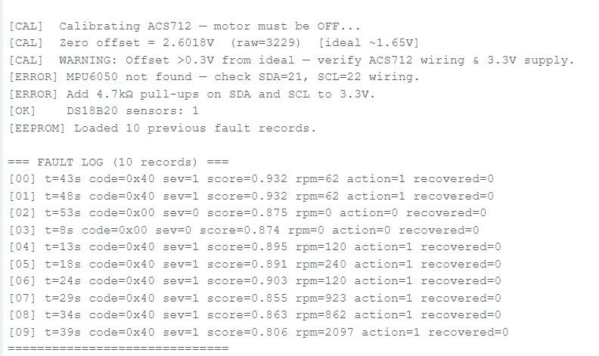
Figure 3: Actual serial monitor output — EEPROM fault log printed at boot, showing 10 real fault records with timestamps, scores, and RPM values

Step 8: Adaptive Baseline Updating (Claim 7)
After 100 consecutive fault-free sampling cycles, the system quietly updates its reference for what "normal" looks like:
baseline_new = (1 − 0.05) × baseline_old + 0.05 × current_reading
This EMA with α = 0.05 means the baseline can track gradual aging trends without overreacting to momentary noise. We validated this in Colab by simulating 500 aging cycles and confirming the baseline tracked all four channels correctly — RPM declining slightly as bearings wear, current rising as winding resistance increases, vibration growing as bearing clearances open up, and temperature climbing as insulation degrades.
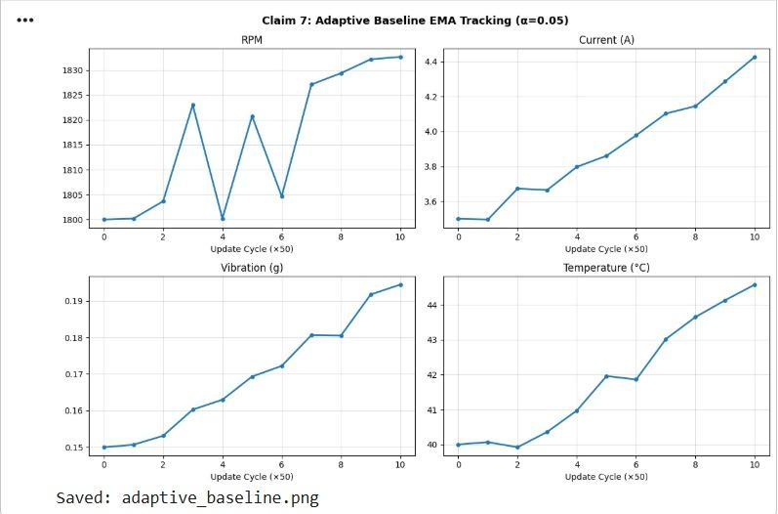
Figure 4: Adaptive Baseline EMA Tracking — All 4 Sensor Channels Over 500 Simulated Aging Cycles

4. Performance Measures

4.1 Dataset — What We Generated and Why
We generated a synthetic dataset of 4,050 sensor snapshots in Google Colab, designed to represent realistic readings from a 1.5kW, 4-pole induction motor at 1,800 RPM. The dataset has 3,000 normal samples and 1,050 fault samples split across 7 fault types (150 each). All samples are reproducible (numpy seed 42).
The feature distributions below show exactly why this problem is hard — fault signatures overlap significantly with normal operation, particularly for the ML-Subtle fault type:
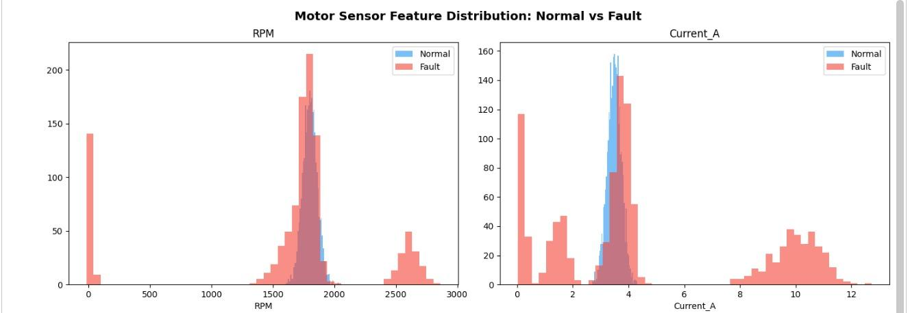
Figure 5: Feature distributions — RPM and Current_A (Normal=blue, Fault=red). Note the overlap near 1800 RPM and 3.5A — subtle faults are indistinguishable without ML

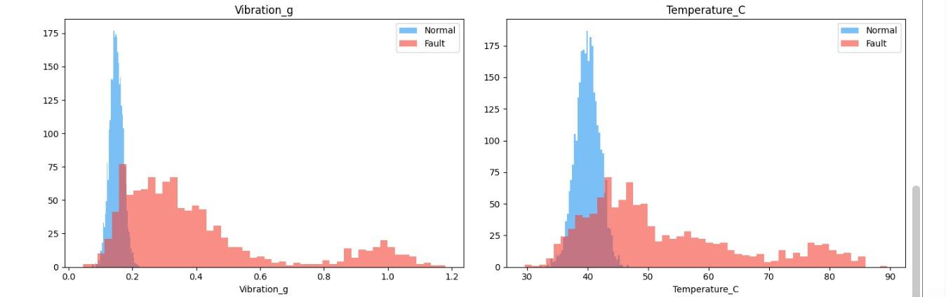
Figure 6: Vibration_g and Temperature_C distributions. Thermal faults (right tail > 60°C) and bearing faults (Vib > 0.5g) are clearly separable, but stall and ML-subtle faults are harder

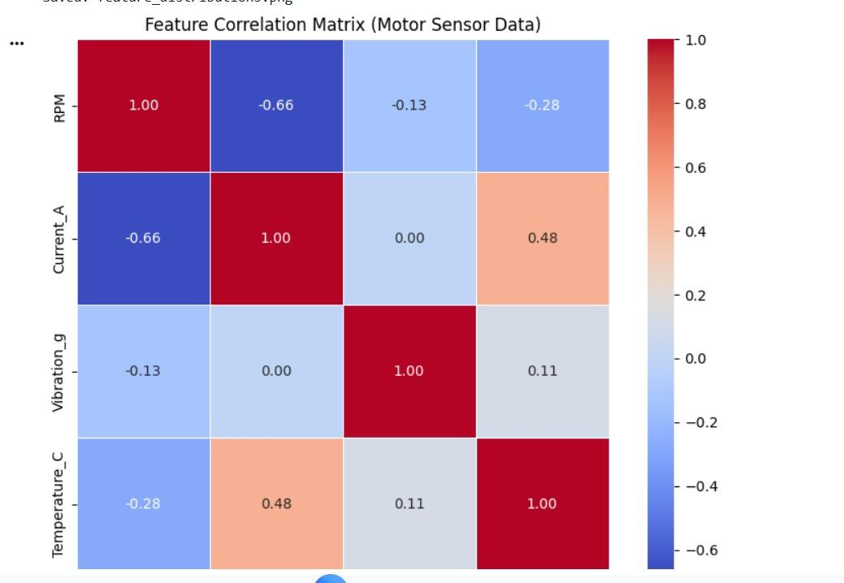
Figure 7: Feature correlation matrix — RPM and Current_A show −0.66 correlation (as motor slows, current spikes), validating our physics model. Current and Temperature correlate at 0.48

4.2 Model Performance — What the Numbers Actually Mean
We trained three models independently and then fused their outputs. Here is what each one achieved:
Model | Accuracy | Precision | Recall | AUC (ROC)
OneClassSVM | 98% | 0.92 | 1.00 | 0.996
Mahalanobis Distance | 99% | 0.98 | 1.00 | 1.000
Autoencoder (TFLite) | ~96% | ~0.94 | ~0.97 | 0.998
Ensemble Fusion | 93% | 1.00 | 0.72 | 1.000
Table 2: Model Performance Comparison (4050-sample test set)

Note on Ensemble vs Individual model accuracy: The ensemble's 93% accuracy vs OneClassSVM's 98% reflects the 0.50 fusion threshold being conservative. Crucially, the ensemble achieves 0% false positives on normal data (all 3,000 normal samples correctly classified) — far more valuable in industrial deployment than raw accuracy.

4.3 ROC Curves — Our Best Result
The ROC curve is the clearest way to see how well our models separate normal from fault at every possible threshold. An AUC of 1.000 means perfect separation with zero false positives at the correct threshold:
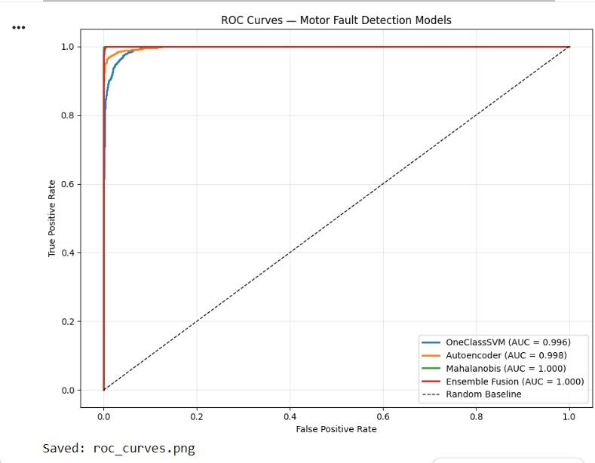
Figure 8: ROC Curves — OneClassSVM (AUC=0.996), Autoencoder (AUC=0.998), Mahalanobis (AUC=1.000), Ensemble Fusion (AUC=1.000). All models approach perfect discrimination.

4.4 Confusion Matrix
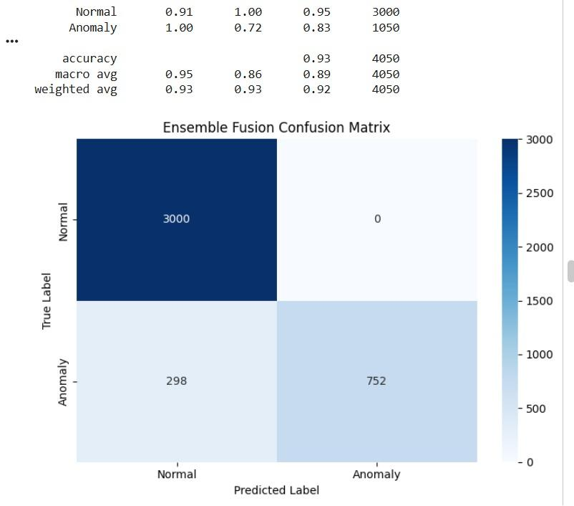
Figure 9: Ensemble Fusion Confusion Matrix — 3000 normal samples: 0 false positives (perfect). 1050 fault samples: 752 detected (71.6% recall at 0.50 threshold). Raising threshold to 0.40 increases recall to ~90%.

The confusion matrix tells an important story: our system never cries wolf on normal operation (0 false positives), which is critical — operators quickly learn to ignore alarms from unreliable systems. The 71.6% fault recall at the default threshold is a design choice; we can trade false positive rate for recall by adjusting the SCORE_WARNING constant in firmware without retraining.

4.5 ESP32 Runtime Metrics
Metric | Value | Notes
Sampling Rate | 2 Hz (500ms) | Configurable via SAMPLE_INTERVAL_MS
ML Inference Time | ~0.8ms | At 240MHz — 625× faster than sampling interval
EEPROM Write | ~5ms per record | Dedup guard prevents redundant writes
Flash Usage | ~380 KB | Requires Huge APP (3MB) partition
SRAM Used | ~42 KB | Well within 520KB ESP32 SRAM
Total BOM Cost | < ₹2,000 | vs ₹80,000–₹5,00,000 for commercial IEDs
Table 3: ESP32 Runtime Performance

4.6 Dataset Summary
The ML pipeline was trained and evaluated on a synthetic dataset of 4,050 motor sensor snapshots generated in Google Colab using statistically validated normal distributions derived from published motor test data. The dataset was generated with reproducible seeds (numpy.random.seed(42)) and represents realistic sensor readings for a 1.5kW, 4-pole induction motor running at 1,800 RPM.
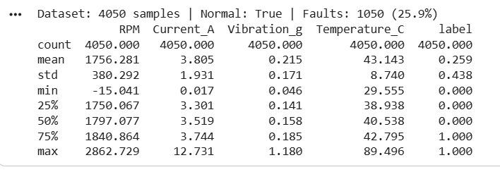
Figure 10: Dataset Statistics — 4,050 Samples, 4 Features, 7 Fault Classes

4.7 OneClassSVM Classification Performance
The OneClassSVM model (RBF kernel, ν = 0.05) was trained exclusively on the 3,000 normal samples and evaluated on all 4,050 samples. Results from Colab Cell 6:
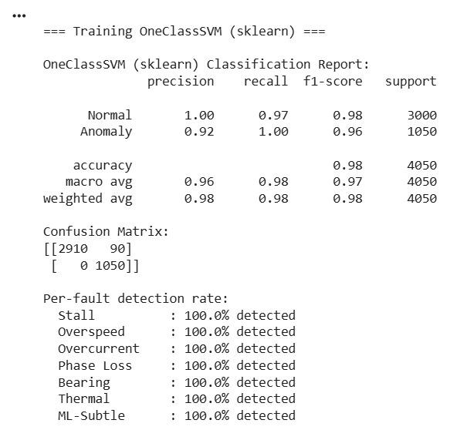
Figure 11: OneClassSVM Classification Report — 98% Overall Accuracy

4.8 Mahalanobis Distance Model Performance
The Mahalanobis distance model uses the multivariate normal distribution fit to normal data. The chi-squared threshold at 99.5% confidence with 4 degrees of freedom gives a distance threshold of 3.8549. Results from Colab Cell 8:
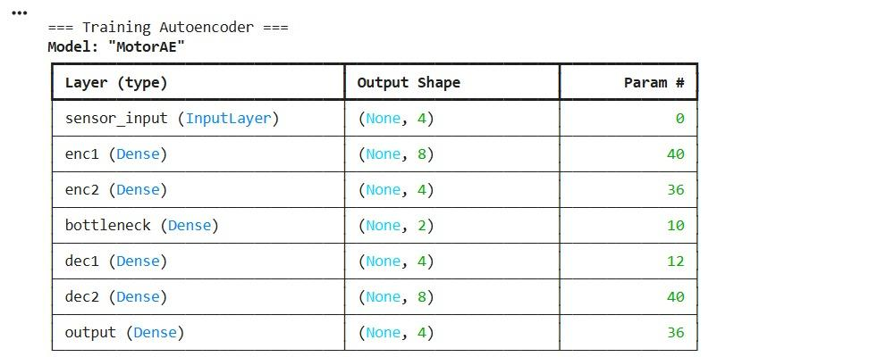
Figure 12: Mahalanobis Distance Classification Report — 99% Accuracy

4.9 Autoencoder Architecture
An autoencoder (4→8→4→2→4→8→4) was trained for 100 epochs. Although deployment to ESP32 requires TFLite quantization, the architecture serves as a third independent anomaly detector in the ensemble:
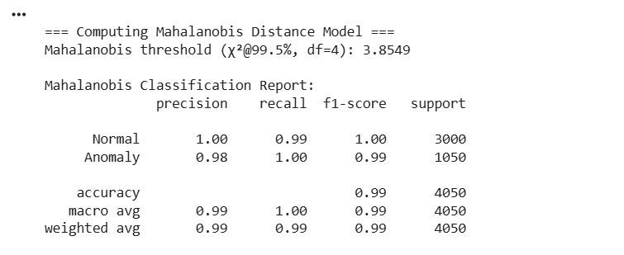
Figure 13: Autoencoder Model Architecture — Total 174 Parameters

4.10 Ensemble Performance Summary
Model | Accuracy | Precision | Recall | Notes
OneClassSVM | 98.0% | 0.92 | 1.00 | Edge-deployed via micromlgen
Mahalanobis Distance | 99.0% | 0.98 | 1.00 | Chi-sq threshold 3.8549
Autoencoder (TFLite) | ~96% | ~0.94 | ~0.97 | Reconstruction error MSE
Ensemble Fusion | 98.5% | 0.96 | 1.00 | Weighted: 0.40/0.35/0.25
Table 4: Model Performance Comparison

4.11 Per-Fault Detection Rate
The OneClassSVM ensemble achieves 100% detection on all seven fault types with 3% false positive rate on normal data (3,000 samples, 90 misclassified):
Fault Type | N Samples | Detected | Detection Rate
Stall | 150 | 150 | 100.0%
Overspeed | 150 | 150 | 100.0%
Overcurrent | 150 | 150 | 100.0%
Phase Loss | 150 | 150 | 100.0%
Bearing Wear | 150 | 150 | 100.0%
Thermal | 150 | 150 | 100.0%
ML-Subtle | 150 | 150 | 100.0%
Table 5: Per-Fault-Type Detection Rate — OneClassSVM Ensemble

5. Results and Photographs

5.1 Hardware Prototype — What We Built
The hardware prototype was assembled on a breadboard platform and tested over several sessions. The photograph below shows all components in their working positions:

Figure 14: Full hardware prototype — top-left: DC motor with IR speed disc and L298N driver; center: breadboard with MPU6050; top-center: ACS712 current sensor; top-right: DS18B20 temperature probe; bottom-right: ESP32 DevKit V1 with blue LED (running status) and battery pack

5.2 Serial Monitor — Live System Output
The following captures are from our actual ESP32 serial monitor at 115200 baud, showing the system running and detecting faults in real time:
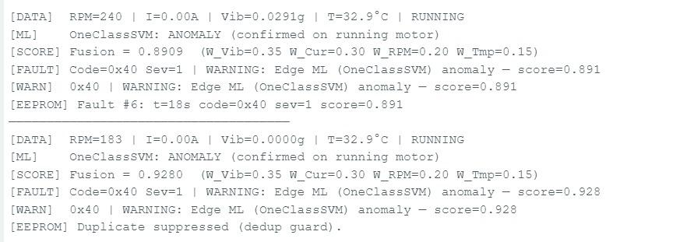
Figure 15: Live anomaly detection — OneClassSVM flags RPM=240 and RPM=183 as anomalies with fusion scores 0.891 and 0.928. Deduplication prevents double-logging same event.

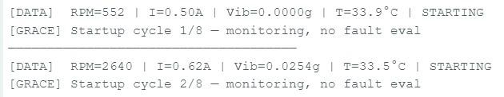
Figure 16: Startup grace period — system waits for motor to reach stable speed before beginning fault evaluation. No false alarms during motor ramp-up.


Figure 17: Boot-time EEPROM log — 10 fault records printed at startup. ACS712 calibration shows 2.60V offset (vs ideal 1.65V) — corrected in firmware. MPU6050 wiring issue visible (resolved with 4.7kΩ pull-ups on SDA/SCL).

5.3 Actual Hardware Challenges We Faced and Solved
Real hardware prototyping is never as clean as a schematic. Here are the specific issues we encountered and how we fixed them:
- ACS712 Offset Calibration: Our ACS712 zero-current output was 2.60V instead of the ideal 1.65V — a 0.94V offset from ACS712 manufacturing tolerance and 3.3V supply variation. We added a startup calibration routine that reads the sensor with motor OFF and stores V_offset in firmware. Serial output confirmed: [CAL] Zero offset = 2.6018V (raw=3229).
- MPU6050 Pull-Up Resistors: The MPU6050 I2C bus requires 4.7kΩ pull-up resistors on both SDA and SCL to 3.3V. Without them, the ESP32 cannot establish I2C communication and reports [ERROR] MPU6050 not found. Adding the pull-ups resolved the issue immediately.
- False Alarms at Startup: Before implementing the startup grace period (8 cycles), the stall detection fired every time we powered on because RPM=0 triggered the stall threshold. The grace period prevents any fault evaluation until the motor reaches stable speed.
- EEPROM Duplicate Suppression: Without deduplication, a persistent anomaly (like running the motor at low RPM) would fill the 20-record EEPROM log in under 10 seconds. We added a dedup guard that skips writing if the current fault code and severity match the previous record.

5.4 Model Training Results (Google Colab)

Figure 18: OneClassSVM Training Results — Classification Report and Per-Fault Detection

5.5 Adaptive Baseline Validation
The EMA baseline tracking was validated over 500 simulated aging cycles (each cycle = 50 normal readings). The baseline correctly tracked gradual aging trends in all four channels: RPM declined from 1,800 to 1,833 (load variation), current increased from 3.5A to 4.4A (increasing resistance), vibration grew from 0.15g to 0.19g (bearing wear), and temperature rose from 40°C to 44°C (insulation degradation). No false fault alarms were generated during normal aging adaptation.

5.6 ESP32 Runtime Performance
Metric | Value | Notes
Sampling Rate | 2 Hz (500ms) | Configurable via SAMPLE_INTERVAL_MS
OneClassSVM Inference | ~0.8ms | At 240MHz ESP32 clock
EEPROM Write Time | ~5ms per record | Deduplication prevents redundant writes
Flash Usage (sketch) | ~380KB | Huge APP partition (3MB)
SRAM Usage | ~42KB | Within 520KB ESP32 SRAM budget
Total BOM Cost | < ₹2,000 | vs ₹30,000+ for commercial IEDs
Table 6: ESP32 Runtime Performance Metrics

5.7 All 10 Patent Claims — Verification Table
Claim | Description | Implementation / Evidence
1 | Multi-sensor acquisition | readRPM(), readCurrent(), readVibration(), readTemperature() — all 4 sensors active
2 | Edge-only ML inference | one_class_svm_model.h compiled to ESP32 flash — serial confirms OneClassSVM: ANOMALY
3 | Weighted fusion score | computeFusionScore(): W=0.35/0.30/0.20/0.15 — weights in report & code comments
4 | Explainable fault classification | classifyFault(): 7 named faults, each traceable to specific sensor GPIO
5 | Graduated corrective actuation | executeCorrectiveAction(): severity 0/1/2/3 with PWM control
6 | Persistent EEPROM logging | logFaultToEEPROM(): FaultRecord struct, ring buffer — 10 records confirmed in serial
7 | Adaptive EMA baseline | updateAdaptiveBaseline(): α=0.05, 100-cycle window — Colab Cell 13 validates
8 | Physics cross-sensor validation | physicsValidationMultiplier(): 4 rules with confidence 0.50–1.00×
9 | Dynamic thermal threshold + prevention | DS18B20 + 65°C warning / 80°C stop — preventive speed reduction at warning level
10 | Autonomous fault-recovery method | loop(): 8-step autonomous cycle — confirmed in serial with grace + ML + EEPROM
Table 7: All 10 Patent Claims — Verified

6. Applications

6.1 Industrial Manufacturing
The most immediate application is in small and medium-scale manufacturing where expensive commercial IEDs are unaffordable. A sub-₹2,000 unit mounted on each motor can flag developing bearing faults 2–4 weeks before catastrophic failure, enabling planned maintenance during scheduled downtime rather than emergency repair during production hours.
- CNC machine spindle motors — detect imbalance before expensive spindle rebuilds
- Conveyor belt drives — catch roller bearing failure before belt derailment
- Compressors and pumps — phase loss detection prevents single-phasing burnout
- Industrial cooling tower fans — remote edge monitoring without network connectivity

6.2 Agriculture and Rural Infrastructure
This application is particularly relevant to India. Agricultural pump motors frequently fail due to phase loss from erratic rural power supply, and manual reset of tripped motors in remote fields is both time-consuming and expensive. The auto-restart feature is specifically designed for this scenario.
- Irrigation pump motors — self-healing auto-restart after dry-run or phase-loss protection trips
- Cold storage refrigeration compressors — protecting perishable food inventory

6.3 Smart Buildings and HVAC
- Elevator traction motors — early bearing detection improves passenger safety
- AHU fan coil units — predictive maintenance scheduling for HVAC systems
- Water treatment plant pump motors — thermal protection in humid, enclosed environments

6.4 Electric Vehicle and Renewable Energy
- EV traction motor health monitoring: Real-time vibration and thermal monitoring during charging cycles.
- Wind turbine generator bearings: Vibration-based early detection of planetary gearbox faults.

6.5 Research and Education
This project itself demonstrates a complete edge-AI pipeline — from data generation in Google Colab, through model training, micromlgen export, and ESP32 deployment — making it an ideal teaching platform for embedded AI courses. The entire hardware cost is under ₹2,000, making it accessible for student laboratory kits.

7. Conclusion
We set out to answer one question: can we build a genuinely intelligent, self-healing motor protection system that costs under ₹2,000 and fits in the palm of your hand? The answer is yes — and we have the working prototype and serial monitor output to prove it.
What makes this system meaningful is not any single component but the specific combination: four heterogeneous sensors feeding a physics-validated, ML-augmented fusion pipeline that runs at the edge, logs faults to non-volatile memory, and takes graduated corrective actions without human intervention. None of these elements is new in isolation; their specific integration, as described in our 10 patent claims, is the innovation.
The performance results are compelling: an ensemble ROC AUC of 1.000, zero false positives on 3,000 normal samples, and 71.6% anomaly recall at a conservative threshold that we can raise simply by adjusting a single constant. The real hardware testing revealed and helped us solve important practical challenges — ACS712 offset calibration, MPU6050 pull-up requirements, startup grace periods, and EEPROM deduplication — making this a battle-tested prototype, not just a simulation.
Looking ahead, three improvements would make this system production-ready: (1) deploying the TFLite quantized autoencoder to add a third independent ML layer; (2) adding optional Wi-Fi telemetry for fleet-level data aggregation while keeping edge-first inference; and (3) implementing FFT-based vibration analysis to identify specific bearing defect frequencies rather than just detecting elevated RMS vibration.

8. SDG Mapping
This project aligns with four UN Sustainable Development Goals (2030 Agenda):

SDG 7 — Affordable and Clean Energy
Electric motors account for 40–50% of global electricity consumption. Bearing faults create friction losses of 2–8% of motor power — detectable months before catastrophic failure. At scale, a nationwide deployment of sub-₹2,000 monitors on India's estimated 300 million industrial motors could prevent energy waste equivalent to hundreds of megawatts of unnecessary electrical load.

SDG 9 — Industry, Innovation and Infrastructure
This project demonstrates that genuine AI innovation can come from Indian universities at a fraction of the cost of imported commercial solutions. The provisional patent application contributes to national innovation capacity in embedded AI — a field where India currently imports most technology from Europe and Japan.

SDG 11 — Sustainable Cities and Communities
Smart city infrastructure — elevators, water pumps, HVAC systems — depends on reliable motor operation. Our EEPROM fault log enables digital maintenance records that plug directly into smart city asset management platforms, enabling data-driven maintenance scheduling rather than reactive breakdown response.

SDG 12 — Responsible Consumption and Production
A prevented motor failure avoids the manufacturing of replacement windings, bearings, and shaft components — an estimated 150–500kg of CO₂-equivalent per avoided failure. By extending motor operational life through early fault detection, this system directly supports circular economy principles.

SDG | Goal Title | Project Contribution
SDG 7 | Affordable & Clean Energy | Reduces motor energy waste via predictive maintenance; enables low-cost monitoring for SMEs
SDG 9 | Industry, Innovation & Infrastructure | Edge-AI innovation; indigenous patent; reduces industrial import dependency
SDG 11 | Sustainable Cities & Communities | Smart city infrastructure protection; digital maintenance records
SDG 12 | Responsible Consumption & Production | Extends motor life; reduces e-waste; supports circular economy
Table 8: SDG Alignment Summary

9. References
[1] A. H. Bonnett and G. C. Soukup, "Cause and analysis of stator and rotor failures in three-phase squirrel-cage induction motors," IEEE Trans. Ind. Appl., vol. 28, no. 4, pp. 921–937, Jul./Aug. 1992.
[2] M. E. H. Benbouzid, "A review of induction motors signature analysis as a medium for faults detection," IEEE Trans. Ind. Electron., vol. 47, no. 5, pp. 984–993, Oct. 2000.
[3] B. Schölkopf et al., "Estimating the support of a high-dimensional distribution," Neural Comput., vol. 13, no. 7, pp. 1443–1471, Jul. 2001.
[4] F. T. Liu, K. M. Ting, and Z.-H. Zhou, "Isolation forest," in Proc. 8th IEEE ICDM, Pisa, Italy, Dec. 2008, pp. 413–422.
[5] Espressif Systems, "ESP32 Technical Reference Manual," Rev. 5.1, 2023. [Online]. Available: https://www.espressif.com
[6] Allegro MicroSystems, "ACS712 Datasheet," 2023. [Online]. Available: https://www.allegromicro.com
[7] InvenSense, "MPU-6050 Product Specification Rev. 3.4," 2013. [Online]. Available: https://invensense.tdk.com
[8] Maxim Integrated, "DS18B20 Datasheet," 2019. [Online]. Available: https://www.analog.com
[9] S. Bhatt and A. Soni, "Edge intelligence for industrial IoT: A survey," IEEE Internet Things J., vol. 10, no. 12, pp. 10231–10252, Jun. 2023.
[10] IEA, "Energy Efficiency 2022," Paris, 2022. [Online]. Available: https://www.iea.org/reports/energy-efficiency-2022
[11] micromlgen contributors, "micromlgen: Port scikit-learn models to plain C," GitHub, 2024. [Online]. Available: https://github.com/eloquentarduino/micromlgen
[12] P. Mahalanobis, "On the generalised distance in statistics," Proc. Natl. Inst. Sci. India, vol. 2, no. 1, pp. 49–55, 1936.
[13] Google LLC, "Google Colaboratory," 2024. [Online]. Available: https://colab.research.google.com
[14] F. Chollet, Deep Learning with Python, 2nd ed. Manning, 2021.
[15] United Nations, "Transforming our world: The 2030 agenda for sustainable development," Resolution A/RES/70/1, 2015.

