Prepared by Om Vadiya

Assignment Session-1
Subject : SQL
Q.1 ) Install MySQL or PostgreSQL on your system and create a new database named 'music_streaming_app' using the command line or GUI tool of your choice.
=>
CREATE DATABASE music_streaming_app;

Q.2) Inside the 'music_streaming_app' database, create a table called 'playlists' with columns: playlist_id (integer, primary key), name (varchar), and created_by (varchar).
CREATE TABLE playlist
(
playlist_id int AUTO_INCREMENT PRIMARY KEY,
name varchar(30),
created_by varchar(30)
);

Q.3) Insert three sample rows into the 'playlists' table representing playlists like 'Bollywood Hits', 'Chill Vibes', and 'Workout Mix', each created by a different user.
insert into playlist (name, created_by) values
('Bollywood Hits', 'Amit'),
('Chill Vibes', 'Sahil'),
('Workout Mix', 'Riya');

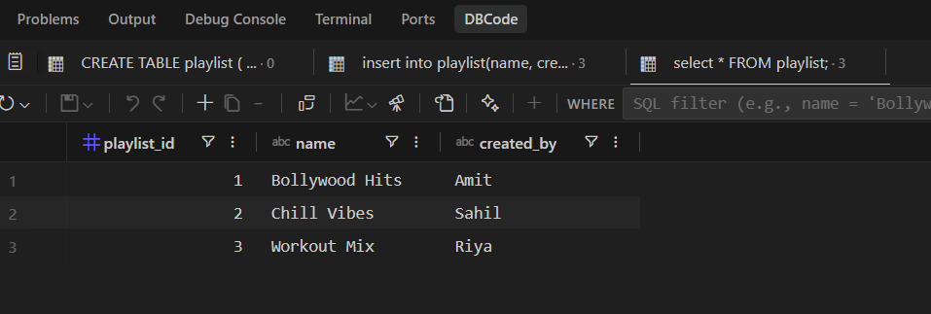
Q.4) Write an SQL SELECT query to display all playlists created by the user 'Amit' from the 'playlists' table. Use the WHERE clause to filter by the 'created_by'
select * from playlist where created_by='Amit';

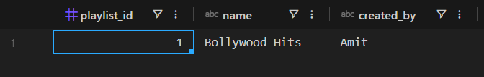

Q.5) Open ChatGPT or Copilot and ask it to explain the difference between a table, a row, and a column in SQL using an example from a food delivery app like Zomato. Paste the explanation you receive into your assignment.
Concept | Definition | Orientation | Zomato Example | Role in Database
Table | A structured collection of related data organized into rows and columns, representing a specific entity. | The entire grid / dataset | The orders table (contains all order details across the app) | Groups all information related to a single subject (e.g., orders, restaurants, users).
Column (Field / Attribute) | A specific property or attribute that every record in the table possesses, defined with a data type (text, number, date). | Vertical (↕) | restaurant_name, total_amount, order_status | Defines what kind of data can be stored for each record.
Row (Record / Tuple) | A single, complete entry containing values for each column for one specific instance. | Horizontal (↔) | (101, 'Pooja', 'Biryani Blues', 350.00, 'Delivered') | Represents one real-world event or object (e.g., one specific customer order).

