Vadiya Om
Data SCIENCE
Assignment Session-2
Subject-: SQL
Q1) Install MySQL Community Server or SQLite on your system and verify the installation by connecting to the database using the command line or a GUI tool like MySQL Workbench or DB Browser for SQLite.

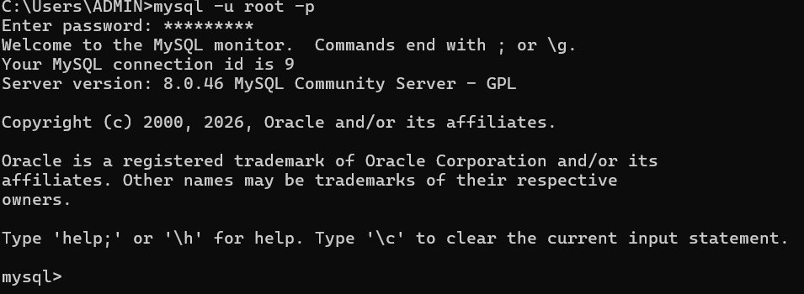

Q2) Create a new database named 'foodie_app' to simulate a Zomato-style backend.

CREATE DATABASE foodie_app;

Q3) Write a CREATE TABLE statement to define a 'restaurants' table in the 'foodie_app' database with the following columns: id (integer, primary key), name (varchar/character, max 100), cuisine (varchar/character, max 50), rating (decimal, e.g., 4.5), and location (varchar/character, max 100).

↓
.
.
↓

create table Restaurant (
id int primary key,
name varchar(100),
cuisine varchar(50),
rating float,
location varchar(100)
);

Q4) Design and create a 'users' table for a Flipkart-style app with columns: user_id (primary key), username, email, phone_number, and created_at (date/time). Pick appropriate data types for each column. Think about which columns should be unique and which data types best fit email and phone numbers.
CREATE TABLE User (
User_id INT PRIMARY KEY,
User_name VARCHAR(50),
Email VARCHAR(30) NOT NULL,
Phone_number VARCHAR(10),
Created_at DATE
);

Q5) Intentionally make a mistake in your CREATE TABLE statement (such as missing a comma or using an unsupported data type), run it, and then fix the error based on the message you receive. Take a screenshot of the error and the corrected SQL statement for your records.

