Prepared by Om Vadiya

Assignment Session-4
Subject : SQL

Q1) Create a table named MusicPlaylist with columns: id, song_name, artist, genre, and duration. Insert at least 5 records representing songs from your favorite Spotify playlist, then write a SELECT statement to retrieve all columns for all songs.
CREATE TABLE musicplaylist (id INT PRIMARY KEY,
song_name VARCHAR(255),
artist VARCHAR(255),
genre VARCHAR(255),
duration INT);
-------------------------------------------------------------------------------------------------------------
INSERT INTO musicplaylist (id, song_name, artist, genre, duration) VALUES
(1, 'True Colours', 'Ap Dhillon', 'Pop', 240),
(2, 'Enemy', 'Imagine Dragons', 'Rock', 220),
(3, 'Shape of You', 'Ed Sheeran', 'Pop', 234),
(4, 'Levitating', 'Dua Lipa', 'Pop', 203),
(5, 'Stay', 'The Kid Laroi', 'Pop', 215);
----------------------------------------------------------------------------------------------------------------
SELECT * FROM musicplaylist;

Q2) Write a SQL query to display only the song_name and artist columns from the MusicPlaylist table, showing just the first 3 records using the LIMIT keyword.
SELECT song_name, artist FROM musicplaylist LIMIT 3;

Q3) Suppose you have a table named FoodOrders with columns: id, restaurant, food_item, and order_date. Write a SQL query to list all unique restaurant names where you have placed orders, using the DISTINCT keyword.
create table FoodOrder (
Id int auto_increment primary key,
restaurant varchar(30),
food_item varchar (30),
order_date date
);
------------------------------------------------------------------------------------
INSERT INTO FoodOrder (id, restaurant, food_item, order_date)
VALUES
(1, 'Dominos', 'Pizza', '2026-10-01'),
(2, 'McDonalds', 'Burger', '2026-10-02'),
(3, 'Dominos', 'Garlic Bread', '2026-10-03'),
(4, 'Pizza Hut', 'Pasta', '2026-10-04'),
(5, 'McDonalds', 'French Fries', '2026-10-05'),
(6, 'KFC', 'Paneer', '2026-10-06');
------------------------------------------------------------------------------------
SELECT DISTINCT restaurant
FROM FoodOrder;

Q4) Write a SQL query on the FoodOrders table to select food_item as 'Dish' and order_date as 'Date Ordered', displaying only these two columns with the column aliases in the output.
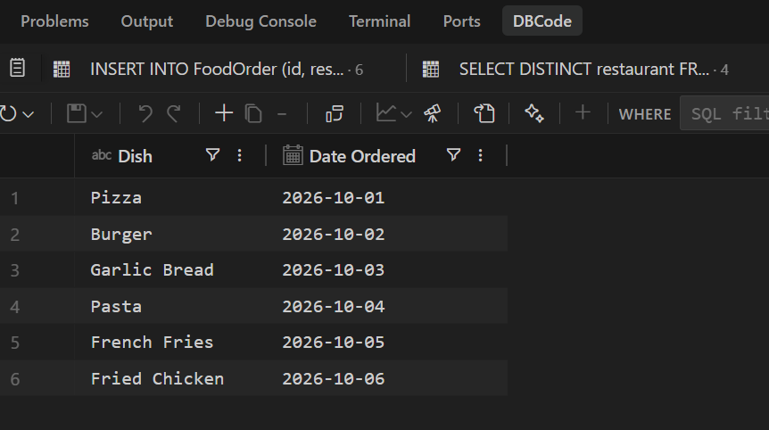
SELECT
food_item AS 'Dish',
order_date AS 'Date Ordered'
FROM FoodOrder;

Q5) You tried running this query: SELECT DISTINCT food_item, restaurant FROM FoodOrders LIMIT 2, but it returns an error or doesn't work as expected. Identify and fix the mistake in the query. Check the correct placement and usage of the LIMIT keyword in SQL syntax.
SELWCT DISTINCT food_items,restaurant
FROM FoodOrder LIMIT 2;

