A Mixed Strategy Based Improved Whale Optimization Algorithm

For Multilevel Thresholding Image Segmentation
A PROJECT REPORT
Submitted in partial fulfilment of requirements for the award of the degree.

BACHELOR OF TECHNOLOGY IN
ELECTRONICS AND COMMUNICATION ENGINEERING
By
Ms. Boddupalli Rajasree 21471A04I5 Ms. Parella Durga Panchakshari 21471A04K8 Mr. Vadlamani Sai 21471A04M0
Mr. Guduri Sunny 21471A04J0
Mr. Janjanam Raghavendra 21471A04J5
Under the guidance of Dr J Brahmaiah Naik
Professor

DEPARTMENT OF ELECTRONICS AND COMMUNICATION ENGINEERING

NARASARAOPETA ENGINEERING COLLEGE (AUTONOMOUS)
NARASARAOPET.
(Accredited by NBA and NAAC with ‘A+’ Grade, NIRF Rank 251-300 band & an ISO 9001:2015 Certified Institution)
Approved by AICTE, New Delhi, Permanently Affiliated to JNTUK, Kakinada KOTAPPAKONDA ROAD, YALLAMANDA, NARASARAOPET- 522601
May 2025

NARASARAOPETA ENGINEERING COLLEGE (AUTONOMOUS)
(Approved by AICTE, New Delhi, Accredited Quadruple by NBA, accredited by NAAC with ‘A+’ Grade, Permanently Affiliated to J.N.T.U.K, Kakinada, Kotappakonda Road, Yallamanda, Narasaraopet – 522601 Palnadu (Dist.), Andhra Pradesh.)
DEPARTMENT OF ELECTRONICS AND COMMUNICATION ENGINEERING

CERTIFICATE

This is to certify that the Project entitled A Mixed Strategy Based Improved Whale Optimization Algorithm For Multilevel Thresholding Image Segmentation is the Bonafede work carried out by Ms. Boddupalli Rajasree (21471A04I5), Ms. Parella Durga Panchakshari (21471A04K8), Mr. Vadlamani Sai (21471A04M0), Mr. Guduri Sunny (21471A04J0), and Mr. Janjanam Raghavendra (21471A04J5) in partial fulfilment of the requirements for the award of the degree Bachelor of Technology in Electronics and Communication Engineering from Narasaraopeta Engineering College during the year 2022-23 under my supervision and guidance.

Guide Head of the Department
(Dr. J. BRAHMAIAH NAIK) (Dr. V. VENKATA RAO)

External Examiner

ACKNOWLEDGEMENTS

It is our pleasure to express our deep and sincere gratitude to our Project Guide and Project Co-ordinator Dr. J. Brahmaiah Naik, Professor for extending his sincere and heartfelt guidance throughout this project work.

It is our desire to express sincere thanks to our project coordinator Dr. Y.V. Lakshmaiah Professor, for extending his cooperation and guidance throughout this project work.
We are greatly indebted to Dr. V. Venkata Rao, Professor & Head of the Department, for providing motivation and valuable suggestions at every stage of our course of study.
We are thankful to our principal Dr. S. Venkateswarlu for providing us sparkling environment during our course of study.
We also express sincere thanks to Sri M. V. Koteswara Rao, Chairman of Narasaraopeta Engineering College, Narasaraopet for providing excellent infrastructural facilities to complete our course.
We extend our sincere thanks to all other Teaching and Teaching Faculty members
of the department for their cooperation and encouragement throughout our course of study.

We affectionately acknowledge our friends for their motivation and suggestions which helps us in successfully completing our course.
We have no words to acknowledge the warm affection, constant inspiration, and encouragement that we received from our Parents and Family Members.

PROJECT ASSOCIATES
Ms. Boddupalli Rajasree 21471A04I5 Ms. Parella Durga Panchakshari 21471A04K8 Mr. Vadlamani Sai 21471A04M0
Mr. Guduri Sunny 21471A04J0

Mr. Janjanam Raghavendra 21471A04J5

ABSTRACT

In this work, a new multilevel image segmentation method based on an improved Whale Optimization Algorithm (WOA) is presented. Although WOA has demonstrated potential in a number of optimization problems, its efficacy may be hampered by its vulnerability to local optima. In order to overcome this, we suggest a Mixed-Strategy Improved Convergence WOA (MSICWOA) that strengthens its optimization capabilities by combining a nonlinear convergence factor, an adaptive weight coefficient, and a k-point initialization approach. After that, the MSICWOA is used with Otsu cross variance and Kapur entropy as objective functions to identify the best thresholds for multilevel grayscale image segmentation. Results from experiments on benchmark functions show that MSICWOA outperforms other optimization methods in terms of search accuracy and convergence speed. Moreover, it successfully overcomes local optima. Experiments on image segmentation using typical datasets verify that the MSICWOA-Kapur technique is effective in precisely and quickly identifying multilevel thresholds.

LIST OF FIGURES

Figure No. | Figure Name |  | Page No.
Figure 1.1 | Example of local segmentation |  | 11
Figure 1.2 | Example of global segmentation |  | 11
Figure 3.1 | Bubble net feeding behaviour of humpback whales |  | 22
Figure 4.1 | Variation of a with respect to u |  | 30
Figure 4.2 | Multilevel image segmentation using MSICWOA |  | 32
Figure 5.1 | Original images: (a) Lena;  (b) Baboon; (c) Starfish; (d)  Couple; (e) Cameraman; (f)  Pepper; (g) Tree; (h) Building |  | 33
Figure 5.2 | Histograms corresponding to the original images: (a) Lena;(b) Baboon; (c) Starfish; (d) Couple; (e) Cameraman; (f) Pepper; (g) Tree; (h) Building |  | 34
Figure 5.3 | Segmented images for different thresholds using proposed method |  | 35
Figure 5.4 | Friedman rank comparison of PSNR |  | 41
Figure 5.5 | Friedman rank comparison of SSIM |  | 42
Figure 5.6 | Friedman rank comparison of FSIM  detected stone for Sample image-1 |  | 42
Figure 5.7 | Segmented results of proposed method using Kapur method |  | 44
Figure 5.11  Figure 5.12 | Comparative analysis of Otsu and Kapur methods in terms of PSNR  Comparative analysis of Otsu and Kapur methods in terms of SSIM |  | 51  51

LIST OF TABLES

Table No. | Table Name | Page No.
Table 5.1 | Performance analysis of PSNR of proposed method using Otsu entropy | 37
Table 5.2 | Performance analysis of SSIM of proposed method using Otsu entropy | 38
Table 5.3 | Performance analysis of FSIM of proposed method using Otsu entropy | 39
Table 5.4 | Performance analysis of PSNR of proposed method using Kapur entropy | 45
Table 5.5 | Performance analysis of SSIM of proposed method using Kapur entropy | 46
Table 5.6 | Performance analysis of FSIM of proposed method using Kapur entropy | 46

LIST OF ABBREVATIONS

WOA - WHALE OPTIMIZATION ALGORITHM
CPSO - COEFFICIENT-BASED PARTICLE SWARM
OPTIMIZATION
GSA - GRAVITATIONAL SEARCH ALGORITHM
SI - SWARM INTELLIGENCE
MCE - MINIMUM CROSS ENTROPY
PSNR - PEAK-SIGNAL TO NOICE RATIO
SSIM - STRUCTURAL SIMILARITY INDEX MEASURE
FSIM - FEATURE SIMILARITY INDEX MEASURE
MATLAB - MATRIX LABORATORY

CONTENTS
PAGE NO.
ABSTRACT i
LIST OF FIGURES ii
LIST OF TABLES iii
LIST OF ABBREVIATIONS iv

CHAPTER 1 | : | INTRODUCTION
 | 1.1 | INTRODUCTION | 7
 | 1.2 | FUNDAMENTALS OF IMAGE PROCESSING | 7
 | 1.3  1.4  1.5  1.6  1.7 | BASIC STEPS IN DIGITAL IMAGE PROCESSING  OBJECTIVE OF IMAGE PROCESSING  MOTIVATION OF IMAGE SEGMENTATION  APPLICATIONS OF IMAGE SEGMENTATION  ORGANIZATION OF PROJECT REPORT | 8  12  13  13  14
CHAPTER 2 | : | LITERATURE REVIEW
 | 2.1 | INTRODUCTION | 15
 | 2.2 | REVIEW OF IMAGE THRESHOLDING METHODS | 15
CHAPTER 3 | : | EXISTING METHOD
 | 3.1 | WHALE OPTIMIZATION | 22
 | 3.2 | MULTILEVEL THRESHOLDING USING  EXISTING METHOD | 24
CHAPTER 4 | : | PROPOSED METHOD
 | 4.1 | INTRODUCTION | 27
 | 4.2  4.3  4.4 | PROPOSED ALGORITHM  MULTILEVEL THRESHOLDING USING MSICWOA  EVALUTATION METRICS | 28  31
CHAPTER 5 | : | RESULT ANALYSIS
 | 5.1 | INTRODUCTION | 34
 | 5.2 | EXPERIMENTAL SETTINGS | 43
CHAPTER 6 | :  6.1  6.2 | CONCLUSION AND FUTURE SCOPE  CONCLUSION  FUTURE SCOPE | 53  53
REFERENCES |  |  | 54
APPENDIX |  |  | 58

CHAPTER-1
INTRODUCTION
1.1 Introduction
Technological advances in digital imaging, computer processors and mass storage devices fueled the growth of image processing. The huge volume of digital image data produced everyday has become more and thus these could ever be examined manually. Electronically perceiving, analyzing and understanding the image and processing it according to the specific human requirements has become a challenging task.
For image analysis and understanding, the image segmentation is a key step of image processing and computer vision. A qualified segmentation is a prerequisite for subsequent processing such as scene understanding, parameter measurement and object recognition etc. In this project, efforts are made to develop a method to yield effective segmentation. In this chapter, the following topics are covered
    - Image segmentation

    - Objective of image segmentation

    - Motivation of image segmentation

    - Problem statement

    - Applications of image segmentation

    - Chapter wise organization of project report

  - Fundamentals of Image Processing
The term monochrome image or simply image, refers to a two- dimensional light intensity function f (x, y), where x and y denote spatial coordinates and the value of f at any point (x, y) is proportional to the brightness (or gray level) of the image at that point. A digital image is an image f (x, y) that has been discretized both in spatial coordinates and brightness. A digital image can be considered a matrix whose row and column indices identify a point in the image and the corresponding matrix element value identifies the gray level at that point. The elements of such a digital array are called image elements or picture elements or pixels or pels.

As light is a form of energy, f (x, y) must be nonzero and finite, that is 0<f(x,y)< ∞. The Basic nature of f (x, y) may be characterized by two components:
- The amount of source light incident on the scene being viewed and
- The amount of light reflected by the objects in the scene.
Appropriately, they are called the illumination and reflectance components, and are denoted by i(x, y) and r (x, y), respectively.
The functions i(x, y) and r (x, y) combine as a product to form f (x, y) as
f (x, y) = i (x, y) * r (x, y) (1.1)
Thus, an image can be processed on a computer by representing it as an array of pixels, which can be stored and can be processed easily.
  - Basic Steps in Digital Image Processing
Digital images can be processed for different applications. The following are the various steps involved for processing of digital images.
- Image acquisition
- Image enhancement
- Image restoration
- Image compression
- Image segmentation
- Representation & description
- Object recognition
    - Image acquisition
Image acquisition is the creation of digital images, such as of a physical scene or of the interior structure of an object. A digital image may be created directly from a physical scene by a camera or similar device. Alternatively, a digital image may be obtained from another image in an analog medium, such as photographs, photographic film, or printed paper, by an image scanner or similar device. Many technical images such as those acquired with tomographic equipment, side-scan sonar, or radio telescopes are actually obtained by complex processing of non- image data. The digitalization of analog real-world data is known as digitizing, and involves sampling (discretization) and quantization.

    - Image enhancement
The principal objective of enhancement is to pre-process an image so that the result is more suitable than the original image for a specific application. The word specific is important, because it establishes at the outset that the techniques discussed are very much problem oriented. Image enhancement approaches fall into two broad categories: spatial domain methods and frequency domain methods and. The spatial domain refers to the image plane itself, and approaches in this category are based on direct manipulation of pixels in image. Frequency domain processing techniques are based on modifying the Fourier transform of an image. There is no general theory of image enhancement. When an image is processed for visual interpretation, the viewer is the ultimate judge of how well a particular method works. Visual evaluation of image quality is a highly subjective process, thus making the definition of a good image an elusive standard to analyze algorithm performance.
    - Image restoration
As in image enhancement, the ultimate goal of restoration techniques is to improve an image in some predefined sense. Although there are areas of overlap, image enhancement is largely a subjective process, while image restoration is for the most part an objective process. Restoration attempts to reconstruct or recover an image that has been degraded by using a priori knowledge of the degradation phenomenon. Thus, restoration techniques are oriented toward modeling the degradation and applying the inverse process in order to recover the original image. This approach usually involves formulating a criterion of goodness that will yield an optimal estimate of the desired result. By contrast, enhancement techniques basically are heuristic procedures designed to manipulate an image in order to take advantage of the psychophysical aspects of the human visual system. For example, contrast stretching is considered as an enhancement technique because it is based primarily on the pleasing aspects it might present to the viewer, whereas removal of image blur by applying a de-blurring function is considered a restoration technique.
    - Image compression
Every day, an enormous amount of information is stored, processed, and transmitted digitally. Image compression addresses the problem of reducing the amount

of data required to represent a digital image. The underlying basis of the reduction process is the removal of redundant data. From a mathematical viewpoint, this amounts to transforming a 2-D pixel array into a statistically uncorrelated data set. The transformation is applied prior to storage or transmission of the image. At some time later, the compressed image is decompressed to reconstruct the original image or an approximation of it.
    - Image segmentation
Segmentation subdivides an image into its constituent regions or objects. The level to which the subdivision is carried depends on the problem being solved. That is, segmentation should stop when the objects of interest in an application have been isolated. For example, in the automated inspection of electronic assemblies, interest lies in analyzing images of the products with the objective of determining the presence or absence of specific anomalies, such as missing components or broken connection paths. There is no point in carrying segmentation past the level of detail required to identify those elements. Segmentation of nontrivial images is one of the most difficult tasks in image processing. Segmentation accuracy determines the eventual success or failure of computerized analysis procedures. For this reason, considerable care should be taken to improve the probability of rugged segmentation.
The algorithm used for bio-medical image segmentation differs from that used for natural image segmentation as the images generated for bio-medical analysis differ from that of the images generated from the natural scenery. Similarly, the lighting conditions for natural image formation are different than that of underwater images. But image segmentation is applied for various applications such as handwriting recognition, biometrics, satellite image analysis for weather forecasting, disease classification etc. So, a number of segmentation processes are developed by various researchers where each is appropriate for a particular application. Thus, it remains still a challenging problem from image processing perspective. Image segmentation is a set of operations applied to a digital image for extracting objects from the image or dividing the image into meaningful regions based on certain characteristics of the image such as intensity, color, texture etc. for extraction of information from the input image. The segmentation can be local segmentation (concerned with specific part or region of the image) or global segmentation (concerned with segmentation in the whole

image, consisting of a large number of pixels). The example of local segmentation and global segmentation is shown in figure 1.1 and figure 1.2 respectively. In global segmentation, the foreground is separated out from the background. Separating the foreground from background is an important pre-processing in image analysis. The main purpose is to acquire some useful information in the image for higher level image processing. In this project, the work is focused on global image segmentation.

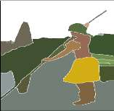
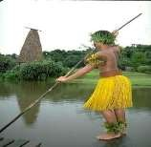
Segmentationn

Figure 1.1: Example of local segmentation

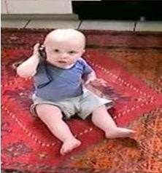
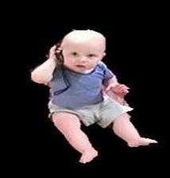
Segmentation

Figure 1.2: Example of global segmentation

    - Representation and description

After an image has been segmented into regions by methods, the resulting aggregate of segmented pixels usually is represented and described in a form suitable for further computer processing. Basically, representing a region involves two choices:
- we can represent the region in terms of its external characteristics (its boundary), or
- we can represent it in terms of its internal characteristics (the pixels comprising the

region). Choosing a representation scheme, however, is only part of the task of making the data useful to computer. The next task is to describe the region based on the chosen representation. For example, a region may be represented by its boundary and the boundary is described by features such as its length, the orientation of the straight line joining its extreme points, and the number of concavities in the boundary. An external representation is chosen when the primary focus is on shape characteristics. An internal representation is selected when the primary focus is on region properties such as color and texture. Sometimes it may be necessary to use both type of representation. In either case, the features selected as descriptors should be as insensitive as possible to variations in size, translation, and rotation. Thus, a digital image can be processed by using the steps discussed above based on the application needed.
  - Objective of image segmentation
The objective of segmentation is to simplify and/or change the representation of an image into something that is more meaningful and easier to analyze. Image segmentation is typically used to locate objects and boundaries (lines, curves, etc.) in images. More precisely, image segmentation is the process of assigning a label to every pixel in an image such that pixels with the same label share certain characteristics. Segmentation has two objectives. The first objective is to decompose the image into parts for further analysis. In simple cases, the environment might be well enough controlled so that the segmentation process reliably extracts only the parts that need to be analyzed further. In complex cases, such as extracting a complete road network from a grayscale aerial image, the segmentation problem can be very difficult and might require application of a great deal of domain building knowledge. The second objective of segmentation is to perform a change of representation. The pixels of the image must be organized into higher-level units that are either more meaningful or more efficient for further analysis (or both). A critical issue is whether or not segmentation can be performed for many different domains using general bottom-up methods that do not use any special domain knowledge.
The main objective of this project is to extract the region of interested areas which helps to diagnose the disease in a perfect way. It is obtained with multilevel thresholding by maximizing the Kapur entropy with the help of hybrid Constriction

coefficient-based Particle Swarm Optimization (CPSO)and Gravitational Search Algorithm (GSA) soft computing technique. Finally, the performance of proposed method is measured with the well-known performance evaluation parameters.
  - Motivation of image segmentation
The human eye perceives rays of light and the human brain perceives people, cars, buildings, and all the objects that make up the world. A camera perceives rays of light, and a computer perceives dots of color. This discrepancy between the human and computer visual experiences has been a major impediment for development of computer vision. The pertinent questions revolve around solutions where colored dots need to be converted into a cup of coffee on the procedure of programming computers to detect and recognize the objects. It becomes expedient at this stage to recognize the relevant part of the image to be examined. The obvious answer is: the set of pixels which compose the object, searching across all conditions of pixel is not feasible. It is mandatory that such search is rationally limited; optimization techniques need to be developed to meet the requirements. These things motivated us to propose new technique for better extraction of objects and its regions.
  - Applications of image segmentation
Some of the practical applications of image segmentation are:
- Content-based image retrieval
- Machine vision
- Medical imaging, including volume rendered images from computed tomography and magnetic resonance imaging.
- Locate tumors and other pathologies
- Measure tissue volumes
- Diagnosis, study of anatomical structure
- Surgery planning
- Virtual surgery simulation
- Intra-surgery navigation
- Object detection
- Locate objects in satellite images (roads, forests, crops, etc.)

- Recognition Tasks
- Face recognition
- Fingerprint recognition
- Iris recognition
- Traffic control systems 17.Video surveillance
  - Organization of project report
In chapter 1, introduction to image processing along with need of segmentation including applications are presented. The rest of the report is organized as follows: Chapter 2 provides the literature review related to multilevel image thresholding using optimization algorithms. Chapter 3 describes the existing method, Chapter 4 provides the problem statement along with objective of the project and working of proposed method. Chapter 5 deals with result analysis on benchmark images and real time images using image quality assessment metrics. Chapter 6 provides conclusion and future scope of our project.

CHAPTER-2
LITERATURE REVIEW
2.1 Introduction
Image segmentation is the process of dividing an image into several regions with different characteristics and extracting the target region of interest, which is the premise of image processing and pattern recognition. Image segmentation technology is currently employed extensively in a variety of industries, including remote sensing satellites [1], intelligent transportation [2], agriculture [3], medical health [4], aerospace technology [5], and others. Commonly used image segmentation methods include threshold segmentation method [6], region extraction method [7], clustering segmentation method [8], and segmentation method based on deep learning [9]. Because of its straightforward computation, great processing efficiency, and reliable performance, the threshold segmentation method has evolved into the most fundamental and commonly applied picture segmentation technology. According to the quantity of thresholds, threshold segmentation techniques can be classified as single-level threshold segmentation or multilevel threshold segmentation. Single-level
threshold segmentation only needs one threshold to segment the image into target and background. Multilevel threshold segmentation needs to determine multiple thresholds to segment the image into multiple regions. Because the threshold directly affects the result of image segmentation, the threshold also directly affects the final effect of image processing and pattern recognition. Therefore, the difficulty and key of the threshold segmentation method are to solve the optimal threshold. Commonly used criteria for finding the optimal threshold are the Otsu method [10] and Kapur entropy [11].
2.2 Review of image thresholding methods
The optimization problem of multilevel threshold segmentation is challenging. The swarm intelligent optimization algorithm can obtain the optimal solution of multiple thresholds in a short amount of time because the number of thresholds needed to improve the effect of image threshold segmentation is frequently large. Traditional optimization methods’ calculation costs and times to solve the optimal threshold are difficult to accept. As a result, in recent years [12–18], swarm intelligent optimization
algorithms have been widely used in picture threshold segmentation.

Maximizing of inter-class variance to determine the optimal threshold has proposed by Otsu which yields good results with two class problems. However, its application to multiclass problems found to be computationally very expensive. The issues regarding convergence of fast Otsu’s technique developed by Reddi et al. [7] have investigated by Lee et al. [8]. An automatic image segmentation has proposed by Boukharouba et al. [9] which exploits the variations in the form of the histogram.
Optimal threshold selection by maximizing the correlation between the original and thresholded bi-level image has proposed by Brink [10]. And this method was criticised by Cseke et al. [11] that method was same as Otsu’s method. A fast iterative search method to select optimal threshold for single and two dimensional distributions has proposed by Dong et al. [12]. Hou et al. [13] has found that Otsu’s method more inclined towards larger class variance. Liu et al. [14] proposed K-means method for multilevel thresholding and also found that it is equivalent to Otsu’s method. Saha et al. [15] presented a method for thresholding which is based on intensity based class uncertainity and also properties such as histogram, homogeneity and morphology. Belkasim et al. [16] proposed a method for an optimal threshold selection based on phase correlation between gray level image and its binary counterpart. Kwon [17] has proposed an optimal threshold detection technique based on cluster analysis for colour images. A formula has proposed by Qiao et al. [18] which is based on weighted sum of within class variance and intensity contrast between objects and background for threshold selection. Zhang et al. [19] proposed optimal threshold detection scheme based on the spatial features of the histogram. Chen et al. [20] proposed a criterion de-emphasizing the heterogeneity of the background while emphasizing the homogeneity of the object gray level distribution. Hu et al. [21] presented a scheme in which threshold is founded by minimizing the classification error within the constrained variable background range.
The ability of swarm intelligence (SI)-based optimization algorithms to greatly improve the speed and stability of the optimization process has made them popular in recent years as some of the standard techniques for multilevel thresholding image segmentation. The goal function frequently employs the Otsu method or certain entropy functions like Kapur, Tsallis, or Minimum Cross Entropy (MCE), and segmentation techniques based on swarm intelligence optimization algorithms frequently employ some novel computing techniques to enhance algorithm performance. Because they may identify a more practical solution with a very low computation cost, which can cut operation time and increase solution accuracy, swarm intelligence optimization algorithms have gained popularity in the optimization field. Their benefits include high precision, quick operating speed, easy and efficient computation, and suitability for large-scale parallel solutions. Particle swarm optimization (PSO) [12], artificial bee colony algorithm (ABC) [13], firefly algorithm (FA), bat algorithm (BA) [14], moth–flame optimization (MFO) [15], cuckoo search (CS) [16], bacterial foraging optimization algorithm (BFO) [17], gray wolf optimizer (GWO) [18], and others are examples of common swarm intelligence optimization algorithms. These novel optimization techniques have so far been used in the picture segmentation domain. Wu Peng used maximum entropy in conjunction with the firefly algorithm (FA) to segment images. The experimental findings show that the technique can enhance accuracy and anti-noise performance while rapidly and precisely determining the ideal thresholds. By combining PSO and the gravitational search algorithm (GSA), Chao Yuan et al. [19] presented a multilevel thresholding image segmentation technique based on the generalized inverse particle swarm optimization and gravity search hybrid algorithm (GOPSOGSA). According to the experimental findings, the suggested approach requires more processing time but outperforms the GSA in segmentation accuracy. Pare et al. [16] extended the energy curve of grayscale images into color images and proposed ELR-CS (Egg Laying Radius) based on CS (cuckoo search). The experimental findings demonstrate that a higher segmentation accuracy can be achieved by employing the CS-Kapur energy curve in the color image segmentation process. Prateek Agarwal [20] successfully reduced computation time and achieved the optimization of the ideal threshold by applying histograms based on bimodal and multimodal thresholds as well as the social spider algorithm (SSA) to the multilayer thresholding segmentation of grayscale images. Hao Gao et al. [21] addressed the issues of high computation and lengthy calculation times by applying a modified artificial bee colony algorithm to multilayer thresholding image segmentation. The problem of high processing costs in multilevel thresholding segmentation is successfully resolved by a gray image segmentation technique [22] based on the month swarm algorithm (MSA) that uses Kapur entropy. Energy-Masi-MSA, a multilevel thresholding segmentation technique based on Masi entropy, was introduced by Ashish Kumar Bhandari [23]. The MSA performs better than other meta heuristic algorithms in terms of threshold evaluation index and computational complexity reduction. GWO was utilized by Abdul Kayom et al. [24] to determine the optimal threshold for grayscale images where Otsu and Kapur entropy were present. The experimental findings indicate that the proposed approach is more stable and has a greater convergence precision than PSO and BFO. A multilayer thresholding segmentation technique for grayscale pictures based on the CSA and Kapur entropy was presented by Pankaj Upadhyay et al. [25]. Comparing PSNR, SSIM, FSIM, and calculation time, the experimental results demonstrate that the proposed method has better accuracy in solution and segmentation effect. Emperor penguin optimization (EPO) was enhanced by Zhikai Xing [26] by adding techniques including opposition-based learning, Gaussian mutation, and Levy flight to the algorithm to increase its search capabilities. Furthermore, different kinds of color images are segmented using enhanced EPO. Aneesh Wunnava [27], Mohamed Abd Elaziz [28], and Erick Rodriguez-Esparza [29] used Harris Hawks Optimization (HHO) and enhanced HHO to multilevel thresholding image segmentation, with positive outcomes. A modified remora optimization algorithm (MROA) [30] been put out for image segmentation and global optimization applications. The experimental findings demonstrate its potential as a technique for image segmentation and global optimization issues. In order to partially address the problem of operational efficiency, an increasing number of scholars are beginning to employ intelligent optimization algorithms to multilevel thresholding picture segmentation as they develop rapidly. These study findings further show that intelligent optimization techniques for multilevel thresholding image segmentation are feasible and effective.
Recently, a swarm intelligence optimization system called the Whale Optimization system (WOA) [31] was developed that simulates whale hunting. WOA provides robust optimization capabilities, fewer parameters, and a simpler structure than traditional algorithms like PSO and GSA.WOA has attracted a lot of attention from the scientific community and has been effectively used to solve a variety of real-world issues, such as talent stability prediction, multilevel thresholding image segmentation, constrained engineering design problems, water resource demand forecasting, multi-objective optimization, large-scale and high-dimensional optimization, optimal single mobile robot scheduling, and real-time task scheduling in multiprocessor systems. Integrating the histogram and the Parzen window technique by Wang et al. [32], histogram modification by Sen et al. [33] and minimizing a weighted sum of square errors of objectives by et al. [34] has proposed for threshold selection. A thresholding method based on detection of edges by Carnicer et al. [35], transition region based thresholding by Hu et al. [36], automatic volumetric segmentation scheme by Chen [37], thresholding strategy based on standard deviation by Li et al. [38] and a thresholding strategy based on the notion of fractional differentiation Nakib et al. [39] for finding out the optimal threshold for segmentation. A real time automatic machine vision system has been developed by Maria et al. [40] and Jianlai et al. [41] based on FPGA technology. An enhanced histogram based thresholding method has also been suggested by Cristo et al. [42] to automatically detect stars in astronomical images. It is a swarm intelligence optimization method that is influenced by biology, and the idea behind it derives from the functions and behaviors of real organisms, such as spotted hyena optimization (SHO) algorithm, firefly algorithm (FA), dragonfly algorithm (DA) [21], artificial bee colony (ABC) [43], particle swarm optimization (PSO) [44] and WOA, etc. Kayalvizhi et al. [45] proposed an improved bacterial foraging optimization algorithm (IBF) and a multilevel threshold image segmentation method based on a histogram, taking Kapur and Otsu as the objective function, respectively, and using IBF to solve the optimal threshold. Experimental results show that this method has better robustness and fast convergence than PSO and genetic algorithm (GA). The ABC was enhanced by Bhandari et al. [46] and used for satellite image segmentation. The optimal threshold is solved using ABC using Kapur, Otsu, and Tsallis as the respective objective functions. According to experimental findings, this approach may pick thresholds effectively and precisely. The energy curve of the color image was enlarged by Pare et al. [47] from the histogram to the energy curve, which was then used as the input for multilevel threshold segmentation of the color image. With Kapur, Otsu, and Tsallis as the various target functions, the ELR-CS algorithm is suggested, and CS is utilized to determine the ideal threshold for color picture segmentation. Studies demonstrate that the suggested CS Kapur method can successfully and reliably solve the color picture’s optimal threshold problem and produce good image segmentation outcomes. Naidu et al. [48] first proposed a multilevel threshold segmentation method based on Shannon and fuzzy entropy FA.
The experimental results show that compared with other comparison algorithms, this method has better performance in PSNR, SSIM, MSE, and CPU. Aziz et al. [49] proposed to apply the WOA and moth flame optimization algorithm (MFO) to the multilevel threshold segmentation of images. The experimental results are analyzed according to the best fitness value, PSNR and SSIM, time complexity, and variance analysis test. The experimental results showed that using MFO and WOA to solve the optimal threshold for image segmentation, the image segmentation quality of MFO is better than WOA. A multilevel threshold segmentation method based on adaptive wind-driven optimization (AWDO) was proposed by Baby Resma et al. [50]. The optimal threshold of threshold segmentation problem for cerebral magnetic resonance images is solved using AWDO, which takes Kapur and Otsu as objective functions. According to experimental findings, this method’s picture segmentation quality is superior to that of the contrast algorithm when compared to GA, PSO, BF, and other algorithms. In order to solve the appropriate threshold of the picture segmentation problem, Ewees et al. [51] suggested a hybrid algorithm of the whale algorithm and particle swarm (WOAPSO), using the Otsu and fuzzy entropy as the corresponding objective functions. Without compromising the accuracy of the image
segmentation, the algorithm’s time complexity can be efficiently decreased. Elaziz et al. [52]applied an enhanced Harris Hawks Optimizer (HHO) to multilevel threshold image segmentation, and the experimental results showed that the algorithm achieved
better image segmentation results. Anitha et al. in [53] proposed an improved whale optimization algorithm (IWOA), using IWOA to solve the optimal threshold of the color multilevel image threshold segmentation problem, with PSNR, SSIM, and FSIM, the best fitness value, CPU is used as the evaluation index, and Wilcoxon is used to evaluating the performance of the algorithm.
The experimental results show that the multilayer color image threshold segmentation quality of the IWOA algorithm is superior than that of the comparative methods. In 2016, Australian scholar Seyedali Mirjalili proposed a WOA inspired by the special predatory behavior of humpback whales [54]. WOA implements the local search of the algorithm using the encircling prey and the bubble network assault mechanism, and implements the global search of the algorithm using the random learning approach. In addition, the WOA has the advantages of simple principles, easy understanding, and implementation, and few parameters to be adjusted. It performs well in solving complex optimization problems and has become one of the research hotspots in the field of intelligent computing in recent years. However, WOA also has several drawbacks when tackling complex optimization issues, including a sluggish convergence rate, poor convergence precision, and a propensity to easily become trapped by a local optimum. Numerous academics have conducted extensive research on the improvement and application of WOA.
In 2017, Ying Ling et al. [55] proposed Lévy flight trajectorybased whale optimization algorithm (LWOA). The advantage of LWOA is the introduction of Lévy flight, which balances the exploration and exploitation abilities of LWOA to a certain extent. The disadvantage of LWOA is that there is no guidance of the optimal individual in the position update formula based on Lévy flight, and the local search ability is weak. In addition, the value of each component after multiplying the elements at the same position of vectors A and D in LWOA is larger, which makes the position probability of whales far away from prey after position update, resulting in weak local search ability of the algorithm. In 2018, Guojiang Xiong et al. [56] proposed an improved whale optimization algorithm (IWOA), which proposed two prey search strategies, effectively balancing the exploration and exploitation abilities of the algorithm. The disadvantage of IWOA is that rand in the calculation formula of A and C is a random number between [0,1], rather than a random vector between [0,1], which leads to the new position generated after the whale position update in the encircling prey stage is located on the line between the whale and the prey, rather than around the prey, resulting in slow convergence of the algorithm. In 2019, G Ren et al. [57] presented a hybrid improved whale optimization algorithm (HIWOA). The nonlinear population initialization method proposed by HIWOA divides the population’s members into three groups based on fitness values, and the members of the three groups collaborate to update the positions of the members of the population. While HIWOA provides the advantage of lessening the likelihood that the algorithm may suffer local stagnation, it has the drawback of having poor local search performance. In 2020, Farinaz et al. [58] proposed a grouping whale optimization algorithm (GWOA), which uses the grouping method to update the position in the stage of encircling prey, improving the global search ability of the algorithm. However, the whale’s position probability is far away from the prey after the position update in the encircling prey stage, resulting in the weak local search ability of the algorithm. In 2021, MA Elaziz et al. [59] proposed a whale optimization algorithm (MLWOA) based on multiple leaders. The advantage of MLWOA is that the multi leader mechanism is used to enhance the exploration ability, and the Lévy flight path is used to make the algorithm more robust and avoid premature convergence of the algorithm, the disadvantage is that the local search ability is not strong. In 2022, Li, M et al. [60] proposed a whale optimization algorithm (AVWOA) based on adaptive inertial weights and a variable bubble net attack position update strategy. A variable bubble net attack position updating approach and adaptive inertial weights that alter with each whale’s fitness are used to update the population’s individuals. The advantage of AVWOA is that it improves the algorithm’s ability to perform global searches, but the disadvantage is that it has weak local exploitation abilities and low solution accuracy.
In conclusion, the enhanced WOA described in the literature has poor exploitation ability and a slow convergence speed during the encircling prey and bubble net attack stages. There is no guidance from exceptional individuals throughout the random search stage, which reduces the likelihood of producing potential candidates after the position update. As a result, as neither solution quality nor the accuracy of the enhanced algorithm are very good, nor does the improved WOA in the literature have a superior capacity to explore and exploit the balance method. It is suggested that MSICWOA be used to enhance the algorithm’s performance in order to address these issues.

CHAPTER-3
EXISTING METHOD
3.1 Whale optimization algorithm
In 2016, Australian scholar Mirjalili et al. proposed a WOA [24] by imitating the predation behavior of humpback whales in nature. Humpback whales forage by creating distinctive bubbles in a circular or ‘‘9’’ shaped path, a behavior known as bubble net foraging. Fig. 1 illustrates the bubble net attacking behavior of humpback whales. Standard WOA simulates humpback whales’ unique foraging behavior of bubble net, which can be divided into three stages, that is, encircling prey, bubble net attack stage, and random search stage. WOA has the advantages of simple operation, few parameters to be adjusted, strong versatility and optimization ability. It has been widely concerned by scholars and has been widely used in biomedicine, production scheduling, robotics, data mining, and other fields.

Figure 3.1: Bubble net feeding behavior of humpback whales.

The optimization process of the WOA is:
- First, randomly generate n whales in the search space to form the initial population. Second, randomly generate a random number to determine whether the whales are attacking the bubble net, encircling prey, or randomly searching for food. Finally, the WOA iterates until the iteration termination condition is met.
Step1: Initialize the population
- Let the population size be $n$.
- Let the $i^{th}$individual in the population is given as $X_{i}=[X_{i1,}X_{i2,……}X_{id}]$ (where $d$is the dimensionality of problem which means number of unknowns to be calculated).
- Each population is initialized as $X_{i}=LB+rand \left(UB-LB\right) for i=1 to n$
Where LB- lower bound of image intensity , which is taken as 0
UB- upper bound of image intensity, which is taken as 255.
$rand$ -random number in the interval [0,1]
Step 2: Encircling prey stage
Let $X^{*}$ be the position of prey (i.e. position of optimal individual whale)
Let $X_{i}$ be the position of $i^{th}$ whale in the population.
Then the position update formula is given as follows:
$X_{i}\left(t+1\right)= X^{*}\left(t\right)-\vec{A }* \vec{D}$ (3.1)
$\vec{D}=|\vec{C}{*X}^{*}\left(t\right)-X_{i}\left(t\right)|$ (3.2)
Where $t$ is the current iteration number and $t+1$ is the next iteration number.
$\vec{A }=2a*\vec{r_{1} }–a$ (3.3)
$\vec{C }=2\vec{r_{2} }$ (3.4)
$\vec{r_{1} }$ and $\vec{r_{2} }$ are the random vectors in the interval [0,1] and ‘$a$’ is the convergence factor.
The value of ‘$a$’ decreases linearly from 2 to 0 as the number of iterations increases, the formula for calculating ‘$a$’ is given as $a=2-\frac{2t}{T}$ (where ‘$T$’ is the maximum number of iteration)
Step 3: Bubble net attack stage
Bubble net attack simulates the behavior of whales using spiral bubble nets to capture prey. The updated formula for the position of the bubble net attack is given below:
$X_{i}\left(t+1\right)= \vec{D^{'}}*e^{bl}*\cos\left(2πl\right)+X_{best}\left(t\right)$ (3.5)
Where $b$ is the constant used to define the shape of the logarithmic spiral, $l$ is the random number between [−1,1].
Step 4: Random search stage
In addition to bubble net foraging behavior, whales also randomly search for food. During the random search stage, each whale updates the position of other random whales, expanding the search area. The position of the random search stage is expressed as follows:
$X_{i}\left(t+1\right)= X_{r}\left(t\right)-\vec{A }* \vec{D}$ (3.6)
$\vec{D}=|\vec{C}*X_{r}\left(t\right)-X_{i}\left(t\right)|$ (3.7)
3.2 Multilevel Thresholding using Existing Algorithm
3.2.1 Otsu Entropy
Let an image I have L gray levels.
Let the number of pixels with gray level ‘$i$’ are $n_{i}$.
Then the total number of pixels in an image ‘$N$’ is given as $N=\sum_{i=0}^{L-1}{n_{i}}$
The probability of occurrence of gray level ‘$i$’ is given as $P_{i}=\frac{n_{i}}{N} i=0,1,….L-1$
If the gray value $t$ is used as the threshold, the threshold $t$ will divide the image into two regions, and the pixel region with gray level [1, $t$] is the target, and the gray level is [$t$ +1, L−1] pixel area is the background.
The proportion of the number of target pixels to the total number of pixels in the whole image is $ω_{0}$ and the average gray level is $μ_{0}$.
The proportion of the number of background pixels to the total number of pixels in the whole image is $ω_{1}$ and the average gray level is $μ_{1}$.
The total average gray value of the image is recorded as $μ$ and the variance between classes is recorded as $v$.
$ω_{0}=\sum_{i=0}^{t}{P_{i}}$ and $μ_{0}=\sum_{i=0}^{t}{\frac{iP_{i}}{ω_{0}}}$
$ω_{1}=\sum_{i=t+1}^{L-1}{P_{i}}$ and $μ_{1}=\sum_{i=t+1}^{L-1}{\frac{iP_{i}}{ω_{1}}}$
Cross variance is calculated as $v(t)=ω_{0}ω_{1}{(μ_{0}-μ_{1})}^{2}$
The objective function to compute optimal threshold is given as $t_{best}=argmax[v\left(t\right)]$
3.2.2 Kapur Entropy
Let the threshold $t$ divide the image I into target and background area.
Entropy $H_{0}$ of background area and entropy $H_{1}$ of target area are given as follows:
$H_{0}=-\sum_{i=0}^{t}{\frac{P_{i}}{ω_{0}}} ln⁡(\frac{P_{i}}{ω_{0}})$ where $ω_{0}=\sum_{i=0}^{t}{P_{i}}$
$H_{1}=-\sum_{i=t+1}^{L-1}{\frac{P_{i}}{ω_{1}}} ln⁡(\frac{P_{i}}{ω_{1}})$ where $ω_{1}=\sum_{i=t+1}^{L-1}{P_{i}}$
The threshold that maximizes the sum of the entropy $H_{1}$ of the target area and the entropy $H_{0}$ of the background area is the optimal threshold $t_{best}$.
The objective function to compute optimal threshold is given as $t_{best}=argmax[H_{0}+H_{1}]$
3.2.3 Multilevel Image Thresholding
Step1 : Initialize the population
- Let the population size be $n$.
- Let the $i^{th}$individual in the population is given as $X_{i}=[X_{i1,}X_{i2,……}X_{id}]$ (where $d$is the dimensionality of problem which means number of unknowns to be calculated).
- Each population is initialized as $X_{i}=LB+rand \left(UB-LB\right) for i=1 to n$
Where LB- lower bound of image intensity , which is taken as 0
UB- upper bound of image intensity, which is taken as 255.
$rand$ -random number in the interval [0,1]
Step 2: Calculate the fitness of all Whales using Otsu or Kapur entropy objective functions.
Step 3: Calculate the parameter $\vec{A }$ as $\vec{A }=2a*\vec{r_{1} }–a$. Where ‘$a$’ is the convergence factor.
The value of ‘$a$’ decreases linearly from 2 to 0 as the number of iterations increases, the formula for calculating ‘$a$’ is given as $a=2-\frac{2t}{T}$ (where ‘$T$’ is the maximum number of iteration)
Step 4: Update the position of each whale based on ‘$p$’ value (a random value in [0,1]) and $\vec{A }$ as follows:
If $p≤0.5$ and if |$\vec{A }|≤1$ then $X_{i}\left(t+1\right)= X^{*}\left(t\right)-\vec{A }* \vec{D}$
Where $\vec{D}=|\vec{C}{*X}^{*}\left(t\right)-X_{i}\left(t\right)|$
If $p≤0.5$ and if |$\vec{A }|>1$ then $X_{i}\left(t+1\right)= X_{r}\left(t\right)-\vec{A }* \vec{D}$
Where $\vec{D}=|\vec{C}*X_{r}\left(t\right)-X_{i}\left(t\right)|$
If $p>0.5$ then $X_{i}\left(t+1\right)= \vec{D^{'}}*e^{bl}*\cos\left(2πl\right)+X_{best}\left(t\right)$
Where $b$ is the constant used to define the shape of the logarithmic spiral, $l$ is the random number between [−1,1].
Step 5: Update the optimal solution (The whale with best fitness)
Step 6: Repeat from steps 2 to 5 until required number of iterations are completed.

CHAPTER-4
PROPOSED METHOD
4.1 Introduction
In WOA, prey is the best individual in the population, so whales close to prey are more likely to improve the solution quality. After updating the position of the whale, trying to make the position of the whale around the prey. The position of the whale in space after updating its position in the stage of encircling prey is related to the absolute value of each component in the product of the coefficients $\vec{A }$ and $\vec{D}$. The position of the updated whale will be far from the prey if the absolute value of each component in the product of $\vec{A }$ and $\vec{D}$ is large, and the algorithm’s ability to do local searches will be poor. Otherwise, the updated whale’s position is close to its prey, and the algorithm’s local search ability is strong. As a result, the algorithm’s ability for local search is determined by the location update formula of the encircling prey stage. In order to overcome this, we suggest a Mixed-Strategy Improved Convergence WOA (MSICWOA) that strengthens its optimization capabilities by combining a nonlinear convergence factor, an adaptive weight coefficient, and a k-point initialization approach. After that, the MSICWOA is used with Otsu cross variance and Kapur entropy as objective functions to identify the best thresholds for multilevel grayscale image segmentation.
The key contributions of this project are as follows:
- K-point initialization: We define "k-point" explicitly and suggest a new initialization technique based on k-points.
- Developing the Mixed-method Improved Convergence Whale Optimization Algorithm (MSICWOA): To improve its optimization performance, we present MSICWOA, an improved WOA that includes an adaptive weight coefficient, a nonlinear convergence factor, and the k-point initialization method.
- Multilevel image segmentation: Using both Otsu's technique and Kapur's entropy as objective functions, we show how well MSWOA performs multilevel thresholding segmentation of grayscale images.
- Performance evaluation: Using metrics like Peak Signal-to-Noise Ratio (PSNR), Structural Similarity Index Measure (SSIM), Feature Similarity Index Measure (FISM), and computing time, we assess the effectiveness of our suggested approach.

4.2. Proposed Algorithm

The k-point initialization technique, the nonlinear convergence factor, and the adaptive weight coefficient are used in a mixed-strategy- Improved Convergence based improved whale optimization algorithm (MSICWOA) to improve the WOA's search capabilities. Furthermore, multilevel thresholding gray image segmentation in conjunction with the Otsu method and Kapur entropy, respectively, is subjected to the MSICWOA.
4.2.1 Population Initialization Based on k-Point Search Strategy
The quality of the initial population affects the accuracy and convergence speed of swarm intelligent optimization methods, as noted by Haupt et al. [30] and Gondro et al. [31]. A better starting solution can help locate the global optimal solution and speed up the algorithm's pace of convergence. The problem to be optimized global optimal solution, however, is typically unknown. The WOA and other swarm intelligence optimization algorithms often create initial population people at random, without any prior information. The initial population's diversity affects an algorithm's search efficiency and accuracy to some extent, which the random initialization approach cannot ensure. In this work, we propose a novel search strategy termed k-point and apply it to the algorithm for population initialization, drawing inspiration from the binary search strategy and the opposition-based learning method.
Algorithm 1: Population initialization based on $k$ -point search strategy
Set population size $N$, dimensionality $d$ and lower bound $lb$ and upper bound $ub$ of search space
$for$ $i$ = 1 to $N$ do

$for$ j = 1 to $d$ do
$$X_{i}^{j}={lb}_{i}^{j}+rand\left(0,1\right)*({ub}_{i}^{j}-{lb}_{i}^{j})$$
$end for$
$$end for$$
$for$ $i$ = 1 to $N$ do

$for$ j = 1 to $d$ do
$${LX}_{i}^{j}={({lb}_{i}^{j}+X_{i}^{j})}/k$$
$${RX}_{i}^{j}={({ub}_{i}^{j}+X_{i}^{j})}/k$$
$$end for$$
$$end for$$
Combine $X\left(N\right),LX\left(N\right),RX\left(N\right)$ and select $N$ individuals with best fitness as initial population.
4.2.2 Nonlinear Convergence Factor and Adaptive Weight Coefficient
The basic WOA, like other swarm intelligence optimization algorithms, struggles to find the best solution because to an imbalance between global and local search capabilities. It's crucial to figure out how to balance its capacity for exploration and development. Exploration ability requires that the group search a larger area in order to keep the algorithm from settling into the local optimum; exploitation ability mainly uses the group's current knowledge to look for a neighborhood of the solution space, which significantly affects the algorithm's rate of convergence. Equation (8) is utilized in the basic WOA to regulate the local or global search. The algorithm does a random global search with a chance of 0.5 when A < 1. The algorithm conducts a local search when A < 1, and convergence factor a largely determines the value of A. Therefore, the change in convergence factor $a$ is essential to finding the optimal solution. The original WOA algorithm's convergence speed is unnecessarily sluggish since the convergence factor a drops linearly as the number of iterations increases. A greater value of $a$ makes it easier for the algorithm to escape the local extremum in the first step of iteration; in the middle stage, to guarantee a faster rate of convergence, $a$ should be quickly decreased to a smaller value as the number of iterations increases; a smaller $a$ should be chosen to maximize the algorithm's convergence accuracy, even though the optimal solution's search range is essentially decided afterward. We offer a nonlinear adjustment technique that speeds up convergence without modifying the original convergence factor's fluctuating trend, preserving the algorithm's capacity for both local and global exploration. The precise formula is as given in the following equation.
$a=1-{(2^{\frac{t}{T_{max}}}-1)}^{u}$ (15)
where $u$ is a constant coefficient, which is used to adjust the attenuation degree of convergence factor a; and the value range of $u$ is greater than 0; $t$ is the number of iterations; and $T_{max}$ is the maximum number of iterations. The curve of $a$ changing with$u$ for $T_{max}=500$ is shown in figure 4.1.

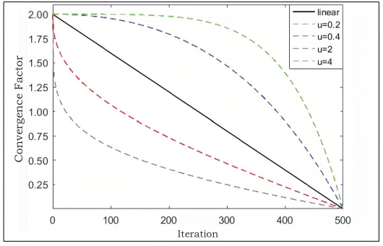
Figure 4.1: Variation of $a$ with respect to $u$
As shown in Figure 4.1, when the attenuation degree of convergence factor a changes from slow to rapid, compared with the basic WOA, A ≥ 1 accounts for a larger proportion of iterations, and the random global exploration ability of the algorithm is enhanced, while the local development ability is weakened; on the contrary, when the attenuation degree of convergence factor a changes from fast to slow, A ≥ 1 takes up a smaller proportion of iterations, and the local development ability of the algorithm is enhanced, while the random global exploration ability is weakened. In this project, u = 0.4 was selected to enhance the local development ability of the algorithm and improve the convergence speed and accuracy of the algorithm.
In the basic WOA, the position of prey is the location of the optimal solution. However, in the process of algorithm execution, the location of prey $X^{*}\left(t\right)$ in Equations (3.1), (3.5) and (3.7) is not fully utilized. In this project, the adaptive weight coefficient is presented to make use of the optimal solution to increase the accuracy of the algorithm. The ideal solution is located at the prey's position in the basic WOA. However, the location of prey $X_{i}\left(t\right)$ in Equations (3.1), (3.5), and (3.7) is not fully exploited throughout algorithm execution. This study presents the adaptive weight coefficient, which utilizes the optimal solution to improve algorithm accuracy. The following is the definition of the adaptive weight coefficient $ω$.

$ω(t)=1-\frac{2}{π}arccos⁡(\frac{t}{T_{max}})$ (4.1)

$X_{i}\left(t+1\right)= {ω\left(t\right)*X}^{*}\left(t\right)-A* D$ (4.2)

$X_{i}\left(t+1\right)=D^{'}*e^{bl}*\cos\left(2πl\right)+\left[1-ω\left(t\right)\right]*X^{*}\left(t\right)$ (4.3)

$X_{i}\left(t+1\right)=ω\left(t\right)*X_{rand}-A* D$ (4.4)

The value of $ω$ has clearly raised from 0 to 1. The adaptive weight coefficient w in equations (4.2)–(4.4) rises with the number of iterations, meaning that the prey position is closer to the theoretical optimal solution at the end of each iteration, increasing the algorithm's optimization accuracy; in the spiral update, the whale keeps getting closer to its prey as the number of iterations increases. A minor weight is added to the algorithm to improve its local search capacity, which may allow it to determine whether a better solution is available close to the prey while updating the location.
4.3 Multilevel Thresholding Using MSICWOA
The proposed MSICWOA algorithm is applied for multilevel image thresholding applications by taking Otsu and Kapur entropy as objective functions. The basic idea of using the MSICWOA to search for the optimal threshold is to transform the threshold search into the minimum or maximum search of the objective function using the Otsu or Kapur method. In this process, a group of thresholds can be regarded as the position values of individual whales in the search space. Therefore, the continuous adjustment of the whale position means that the threshold is searched for continuously until convergence accuracy is reached or the stop condition of the optimization algorithm is satisfied. The operational flow is shown in figure 4.2.
4.4 Evaluation metrics
- Mean Square Error (MSE):
$MSE=\frac{1}{MN}\sum_{j=1}^{M}{\sum_{k=1}^{N}{{[I\left(j,k\right)-I^{'}\left(j,k\right)]}^{2}}}$ (4.5)
Where M,N are the row and column dimensions of input image $I$. $I^{'}$ is the segmented image.
- Peak Signal to Noise Ratio (PSNR):
$PSNR=10\log_{10}(\frac{{255}^{2}}{MSE})$ (4.6)
- Structural Similarity Index Measure (SSIM)
$SSIM= \frac{\left(2μ_{I}μ_{I^{'}}+C1\right)(2σ_{II^{'}}+C2)}{({μ_{I}}^{2}+{μ_{I^{'}}}^{2}+C1)({σ_{I}}^{2}+{σ_{I^{'}}}^{2}+C2)}$ (4.7)
Where $μ_{A}$ is the mean of source image $I$ and $μ_{I^{'}}$ is the mean of segmented image $I^{'}$,$σ_{II^{'}}$is the co-variance of $I$ and $I^{'}$, ${σ_{I}}^{2}$ is the variance of $I$ and ${σ_{I^{'}}}^{2}$ is the variance of $I^{'}$, $C1$ and $C2$ are constants.
- Feature Similarity Index Measure (FSIM)
$FSIM\left(I,I^{'}\right)=\frac{\sum_{X}{S_{L}(x){PC}_{m}(x)}}{\sum_{X}{{PC}_{m}(x)}}$ (4.8)
Where $PC$ is the phase consistency and $S_{L}$ is the quality measure between source image $I$ and segmented image $I^{'}$.
The higher the value of PSNR and SSIM, the lower is the distortion degree of the segmented image, and the higher the quality of the segmented image. The lower the value of MSE, the higher is the value of FSIM and the lower the error rate.

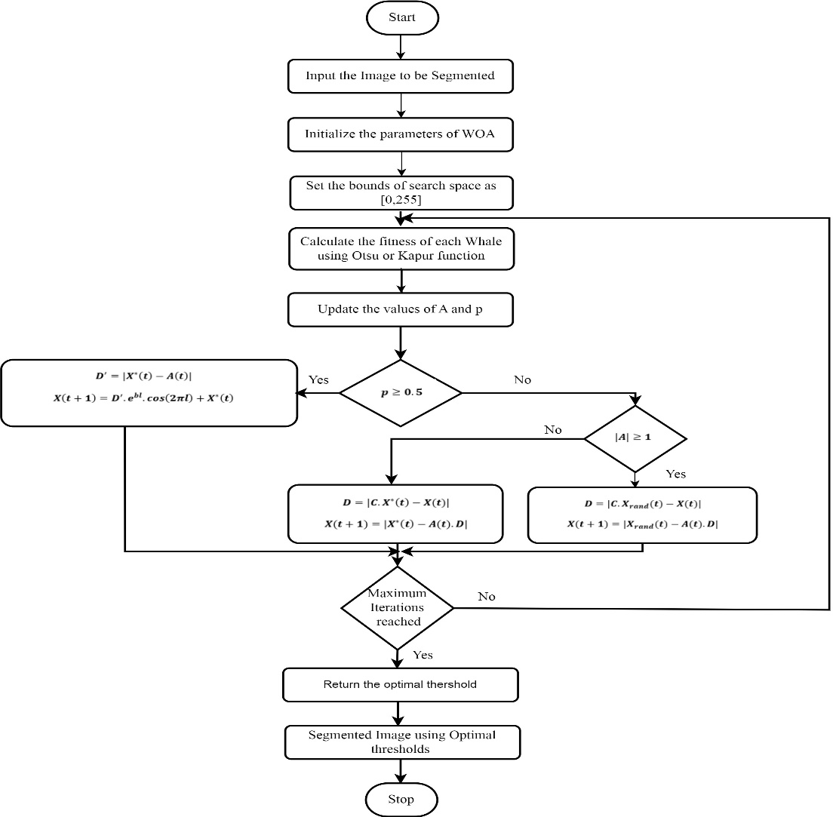
Figure 4.2: Multilevel Image Thresholding using MSICWOA

CHAPTER-5
RESULT ANALYSIS
5.1 Introduction
To verify the effectiveness of the MSICWOA algorithm in solving the multilevel threshold segmentation problem, the Otsu and Kapur entropy are taken as the objective function to solve the optimal threshold and is compared with existing method. Figure 5.1 illustrates eight benchmark images. These pictures were from the Benchmarks 500 (BSDS500) dataset and the Berkeley Segmentation Dataset.

Figure 5.1: Original images: (a) Lena; (b) Baboon; (c) Starfish; (d) Couple; (e) Cameraman; (f) Pepper;(g) Tree; (h) Building

Figure5.2: Histograms corresponding to the original images: (a) Lena; (b) Baboon; (c) Starfish;(d) Couple; (e) Cameraman; (f) Pepper; (g) Tree; (h) Building
The color pictures had turned gray. Lena and Baboon were 512 × 512 in size, Cameraman and Pepper were 256 × 256, and the other images were 481 × 321. Figure 2 displays the original images of the benchmark images: (a) Lena, (b) Baboon, (c) Starfish, (d) Couple, (e) Cameraman, (f) Pepper, (g) Tree, and (h) Building. The histogram curves for each of the images in figure 2 are displayed in figure 5.2.
5.1 Experimental Settings
The population size of all algorithms is set to NP=40, the maximum number of iterations is T=300, and each image is run independently 30 times in order to accurately compare the impacts of different image segmentation techniques. Otsu and Kapur are taken as the objective function to solve the optimal threshold, and the number of threshold TH is 2, 3, 5, and 8, respectively. In particular, the 10-threshold level, 15-threshold level, 20-threshold level, 25-threshold level, and 30-threshold level were also considered for the proposed algorithm. Since this work focused on gray images, gray level L was 255, that is, the value range of each pixel was [0, 255]. Therefore, for the m-level optimization problem, the search space was [0, 255]^{m}.
In order to evaluate the segmentation effect of the eight algorithms, the commonly used peak signal-to-noise ratio (PSNR), structural similarity (SSIM), feature similarity (FSIM), and CPU time were selected as the evaluation criteria of the quality of image segmentation. As a common image evaluation standard in image segmentation, PSNR is used to compare the signal-to-noise ratio between the original image and the segmented image. The value range of SSIM is [0, 1], and the larger the value is, the more similar the structures of the two images are. When two images are the same, the value of SSIM is equal to 1. FSIM is a variant of SSIM whose principle is that all pixels in an image are not of the same importance. Some special pixels, such as those on the edge of objects, are more important in defining the structure of objects than those of other background areas. Therefore, more weight should be given to these pixels in calculation to highlight the important features of an image.
5.1 Analysis of Otsu results based on proposed method
On the eight images that were chosen, execute multilevel threshold segmentation using MSICWOA using Otsu as the objective function to solve the ideal threshold. The maximum values of objective function, PSNR, FSIM and SSIM in Otsu threshold algorithm show the success of threshold algorithm. In other words, the greater the value of these three assessment indicators, the better is the algorithm’s ability to segment images. The results show that the proposed algorithm MSICWOA is larger than the objective functions, PSNR, FSIM, and SSIM provided by existing algorithm. The segmented images for different threshold levels are presented in figure 5.3 for different input images using Otsu as objective function.

Image | No. of Thresholds=2 | No. of Thresholds=4 | No. of Thresholds=6 | No. of Thresholds=8
Lena | 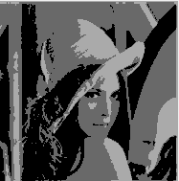 | 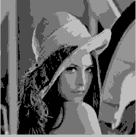 | 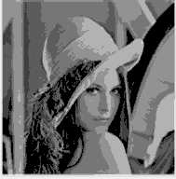 | 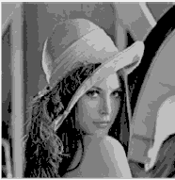
Baboon | 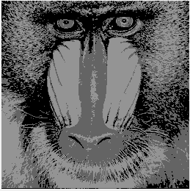 | 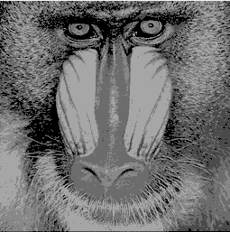 | 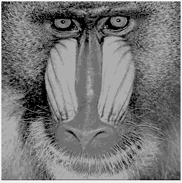 | 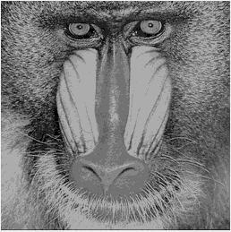
Cameraman | 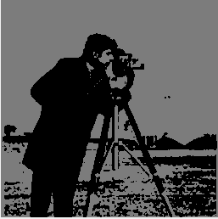 | 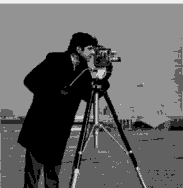 | 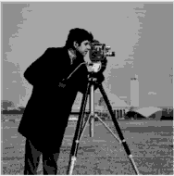 | 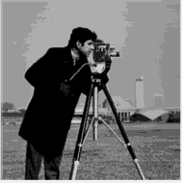
Starfish | 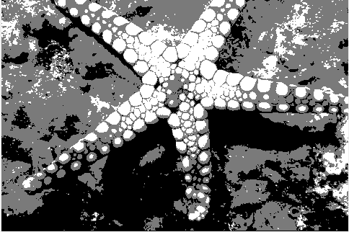 | 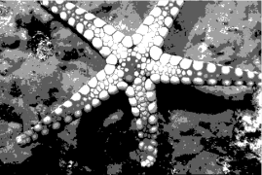 | 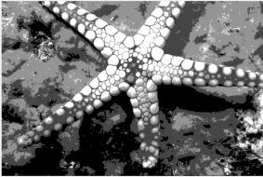 | 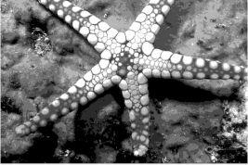
Peppers | 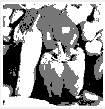 | 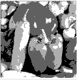 | 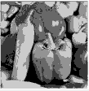 | 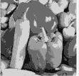
Tree | 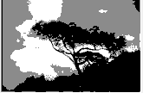 | 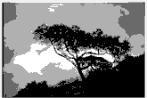 | 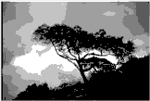 | 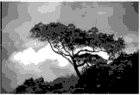
Building | 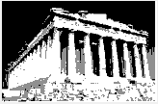 | 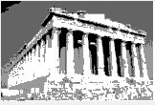 | 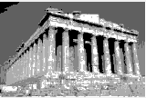 | 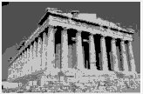

Figure 5.3: Segmented images for different thresholds using proposed method
PSNR, SSIM, and FSIM obtained by existing and proposed algorithms with Otsu as the objective function are reported in Tables 5.1–5.3. The performance of the suggested approach in comparison to WOA (Whale Optimization Algorithm) and MSWOA (Mixed Strategy Whale Optimization Algorithm) is demonstrated by the Otsu entropy results across parameters including PSNR, SSIM, and FSIM. The observations and insights are detailed in table 1, table 2 and table3 respectively. From table 1, the suggested approach consistently performs better than WOA and MSWOA for all thresholds and images. The resilience of the suggested approach in managing challenging segmentation tasks is demonstrated by the performance improvement that becomes more noticeable at higher thresholds. PSNR for the Lena image clearly improves quality, rising from 20.58 (WOA) to 27.40 for 8 thresholds and from 11.90 (WOA/MSWOA) to 20.70 for 2 thresholds. With eight thresholds, the PSNR for the Cameraman image increases from 20.89 (WOA) to 29.05, confirming that the suggested approach maintains image quality. From table 2, For all images and thresholds, the suggested approach shows better SSIM values than WOA and MSWOA, particularly at higher thresholds. This suggests that structural details have been better preserved. SSIM rises from 0.7589 (WOA) to 0.8429 for 8 thresholds and from 0.3200 (WOA) to 0.6016 for 2 thresholds for the Starfish picture. Better structural fidelity is demonstrated by the Couple image, where SSIM increases from 0.4242 (WOA) to 0.6614 for two thresholds and from 0.7414 (WOA) to 0.8678 for eight thresholds. FSIM values from table 3 demonstrate how well the suggested approach captures perceptually important information, particularly at higher thresholds. FSIM rises for the Tree picture from 0.6901 (WOA) to 0.7491 for two thresholds and from 0.8321 (WOA) to 0.8607 for eight thresholds. From 0.6202 to 0.7491 for two thresholds and from 0.7974 to 0.8694 for eight thresholds, for example, FSIM continuously improves for the Building picture.
Table 5.1: Performance Analysis of PSNR of proposed method using Otsu entropy

Image | No. of Thresholds | WOA | MSWOA | Proposed
Lena | 2 | 11.90 | 11.90 | 20.70
Lena | 3 | 14.10 | 14.10 | 23.31
Lena | 5 | 19.16 | 19.21 | 23.89
Lena | 8 | 20.58 | 22.58 | 27.40
Baboon | 2 | 11.58 | 11.58 | 19.91
Baboon | 3 | 13.54 | 13.63 | 21.40
Baboon | 5 | 17.27 | 17.18 | 22.37
Baboon | 8 | 20.02 | 20.39 | 23.37
Starfish | 2 | 12.62 | 12.70 | 20.90
Starfish | 3 | 15.26 | 15.26 | 23.56
Starfish | 5 | 19.05 | 19.59 | 25.45
Starfish | 8 | 23.17 | 25.23 | 28.80
Couple | 2 | 12.11 | 12.11 | 20.20
Couple | 3 | 14.27 | 14.27 | 21.95
Couple | 5 | 16.89 | 18.12 | 23.96
Couple | 8 | 20.74 | 25.32 | 24.60
Cameraman | 2 | 12.23 | 12.23 | 18.86
Cameraman | 3 | 14.55 | 15.72 | 21.77
Cameraman | 5 | 18.62 | 18.62 | 27.50
Cameraman | 8 | 20.89 | 20.99 | 29.05
Peppers | 2 | 12.30 | 12.30 | 19.21
Peppers | 3 | 14.41 | 14.48 | 22.32
Peppers | 5 | 18.02 | 19.57 | 25.65
Peppers | 8 | 22.35 | 22.73 | 26.60
Tree | 2 | 13.99 | 13.99 | 21.04
Tree | 3 | 16.51 | 16.74 | 22.91
Tree | 5 | 20.04 | 21.38 | 24.25
Tree | 8 | 25.02 | 25.46 | 28.87
Building | 2 | 12.06 | 12.06 | 17.33
Building | 3 | 13.93 | 14.08 | 20.90
Building | 5 | 17.75 | 18.41 | 24.80
Building | 8 | 20.81 | 20.97 | 24.89

Table 5.2: Performance Analysis of SSIM of proposed method using Otsu entropy

Image | No. of Thresholds | WOA | MSWOA | Proposed
Lena | 2 | 0.3847 | 0.3847 | 0.6918
Lena | 3 | 0.4686 | 0.4686 | 0.7647
Lena | 5 | 0.6989 | 0.7030 | 0.7783
Lena | 8 | 0.7231 | 0.8016 | 0.8392
Baboon | 2 | 0.4442 | 0.4442 | 0.6754
Baboon | 3 | 0.5212 | 0.5214 | 0.7407
Baboon | 5 | 0.7103 | 0.7050 | 0.7910
Baboon | 8 | 0.8007 | 0.8035 | 0.8343
Starfish | 2 | 0.3200 | 0.3240 | 0.6016
Starfish | 3 | 0.4414 | 0.4414 | 0.6915
Starfish | 5 | 0.6167 | 0.6384 | 0.7543
Starfish | 8 | 0.7589 | 0.8545 | 0.8429
Couple | 2 | 0.4242 | 0.4242 | 0.6614
Couple | 3 | 0.5046 | 0.5046 | 0.7492
Couple | 5 | 0.6270 | 0.6583 | 0.8295
Couple | 8 | 0.7414 | 0.8336 | 0.8678
Cameraman | 2 | 0.4337 | 0.4337 | 0.7459
Cameraman | 3 | 0.4822 | 0.5240 | 0.7465
Cameraman | 5 | 0.6137 | 0.6141 | 0.8439
Cameraman | 8 | 0.6727 | 0.6758 | 0.8774
Peppers | 2 | 0.3726 | 0.3726 | 0.6846
Peppers | 3 | 0.4709 | 0.4741 | 0.7470
Peppers | 5 | 0.6170 | 0.6654 | 0.8151
Peppers | 8 | 0.7639 | 0.7606 | 0.8520
Tree | 2 | 0.4957 | 0.4957 | 0.6804
Tree | 3 | 0.5199 | 0.5461 | 0.7338
Tree | 5 | 0.6437 | 0.6706 | 0.7741
Tree | 8 | 0.7954 | 0.8140 | 0.8304
Building | 2 | 0.3527 | 0.3527 | 0.7168
Building | 3 | 0.4602 | 0.4778 | 0.7708
Building | 5 | 0.6884 | 0.6980 | 0.8579
Building | 8 | 0.7581 | 0.7601 | 0.8458

Table 5.3: Performance Analysis of FSIM of proposed method using Otsu entropy

Image | No. of Thresholds | WOA | MSWOA | Proposed
Lena | 2 | 0.6671 | 0.6671 | 0.6848
Lena | 3 | 0.7146 | 0.7146 | 0.7661
Lena | 5 | 0.8016 | 0.8046 | 0.7803
Lena | 8 | 0.8757 | 0.9075 | 0.8699
Baboon | 2 | 0.6880 | 0.6880 | 0.7328
Baboon | 3 | 0.7501 | 0.7509 | 0.7963
Baboon | 5 | 0.8179 | 0.8148 | 0.8241
Baboon | 8 | 0.8640 | 0.8666 | 0.8497
Starfish | 2 | 0.5530 | 0.5544 | 0.6182
Starfish | 3 | 0.6409 | 0.6409 | 0.7041
Starfish | 5 | 0.7679 | 0.7747 | 0.7583
Starfish | 8 | 0.8562 | 0.8652 | 0.8585
Couple | 2 | 0.6262 | 0.6262 | 0.7140
Couple | 3 | 0.6909 | 0.6909 | 0.7822
Couple | 5 | 0.7681 | 0.7896 | 0.8719
Couple | 8 | 0.8464 | 0.8412 | 0.8877
Cameraman | 2 | 0.6281 | 0.6281 | 0.7527
Cameraman | 3 | 0.6756 | 0.7103 | 0.7679
Cameraman | 5 | 0.7913 | 0.7924 | 0.8495
Cameraman | 8 | 0.8361 | 0.8375 | 0.9081
Peppers | 2 | 0.6110 | 0.6110 | 0.6913
Peppers | 3 | 0.6662 | 0.6663 | 0.7702
Peppers | 5 | 0.7504 | 0.7713 | 0.8357
Peppers | 8 | 0.8077 | 0.8125 | 0.8651
Tree | 2 | 0.6901 | 0.6901 | 0.6897
Tree | 3 | 0.7026 | 0.7144 | 0.7624
Tree | 5 | 0.7764 | 0.7935 | 0.7968
Tree | 8 | 0.8321 | 0.8469 | 0.8607
Building | 2 | 0.6202 | 0.6202 | 0.7491
Building | 3 | 0.6784 | 0.6793 | 0.8049
Building | 5 | 0.7384 | 0.7470 | 0.8657
Building | 8 | 0.7974 | 0.8181 | 0.8694

The Friedman average ranking values of existing and proposed methods for PSNR, FSIM and SSIM are presented from figures 5.4 to 5.6.

Figure 5.4: Friedman rank comparison of PSNR
The average value of PSNR produced by existing method at two thresholds is 13.48dB while that of proposed method is 13.98dB. When it comes to four thresholds, the average value of PSNR produced by existing method is 17.63dB and that of proposed method is 18.22dB. The average value of PSNR produced by existing method at six thresholds is 20.83dB while that of proposed method is 21.29dB. When it comes to eight thresholds, the average value of PSNR produced by existing method is 22.72dB and that of proposed method is 23.3dB. As the threshold levels increases, the quality of segmented images is nearer to the input images, there by producing improved performance metric value.

Figure 5.5: Friedman rank comparison of SSIM

Figure 5.6: Friedman rank comparison of FSIM
The average value of SSIM produced by existing method at two thresholds is 0.532 while that of proposed method is 0.538. When it comes to four thresholds, the average value of SSIM produced by existing method is 0.667 and that of proposed method is 0.675. The average value of SSIM produced by existing method at two thresholds is 0.783 while that of proposed method is 0.792. When it comes to four thresholds, the average value of SSIM produced by existing method is 0.831 and that of proposed method is 0.839. As the threshold levels increases, the quality of segmented images is nearer to the input images, there by producing improved performance metric value.
The average value of FSIM produced by existing method at two thresholds is 0.698 while that of proposed method is 0.705. When it comes to four thresholds, the average value of FSIM produced by existing method is 0.800 and that of proposed method is 0.809. The average value of FSIM produced by existing method at two thresholds is 0.857 while that of proposed method is 0.866. When it comes to four thresholds, the average value of FSIM produced by existing method is 0.895 and that of proposed method is 0.905. As the threshold levels increases, the quality of segmented images is nearer to the input images, there by producing improved performance metric value.
From the evaluation metrics, it is clear that for all the thresholds levels and for all input images, the performance of proposed method is better than the existing method in terms of obtaining the optimal thresholds for image segmentation, which produces better values of fitness function there by yielding good performance in terms of PSNR, FSIM and SSIM.
5.2 Analysis of Kapur results based on proposed method
Segmentation results of proposed method for various thresholds on benchmark images using Otsu entropy as objective function is illustrated in figure 5.7. The findings for Kapur entropy also reveal that the suggested technique performs better than WOA and MSWOA for PSNR, SSIM, and FSIM metrics, as indicated in tables 5.4, 5.5, and 5.6. From the findings, the following conclusions can be made. Table 4 shows that the suggested approach is effective at handling complex segmentations because it produces noticeably higher PSNR values, especially at higher thresholds. With two thresholds, the PSNR for the Lena image rises from 14.39 (WOA) to 20.55, and with eight thresholds, it rises from 21.83 (WOA) to 26.38. The PSNR improvement for the Baboon picture is significant, rising from 30.36 (WOA) to 29.22 for 8 thresholds and from 12.34 (WOA) to 18.36 for 2 thresholds. As indicated in table 5, the suggested approach consistently improves SSIM and outperforms WOA and MSWOA for all pictures and thresholds. This demonstrates its capacity to preserve the images' structural integrity. For two thresholds, the Cameraman image's SSIM increases from 0.5422 (WOA) to 0.7850, and for eight criteria, it increases from 0.7545 (WOA) to 0.8636. SSIM rises from 0.8215 (WOA) to 0.8712 for 8 thresholds and from 0.5251 (WOA) to 0.7005 for 2 thresholds for the Peppers picture. Particularly for images with intricate structures, the suggested method's ability to capture perceptual elements is further supported by the FSIM results in Table 6. From 0.5705 (WOA) to 0.6180 for two thresholds and from 0.8591 (WOA) to 0.8665 for eight criteria, the FSIM for the Starfish picture increases. In the case of the Tree image, FSIM increases from 0.8526 (WOA) to 0.8364 for 8 thresholds and from 0.6925 (WOA) to 0.6811 for 2 levels.
Image | No. of Thresholds=2 | No. of Thresholds=4 | No. of Thresholds=6 | No. of Thresholds=8
Lena | 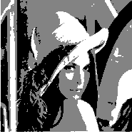 | 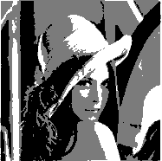 | 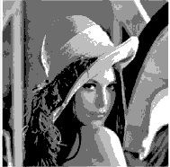 | 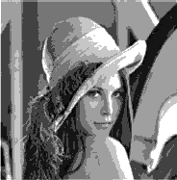
Baboon | 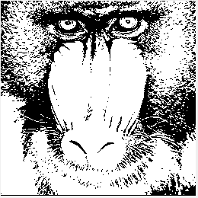 | 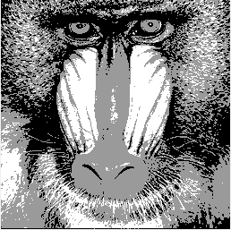 | 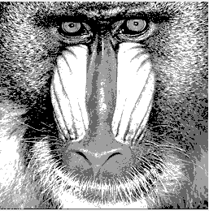 | 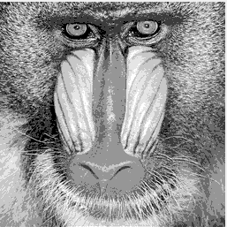
Cameraman | 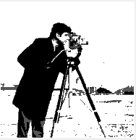 | 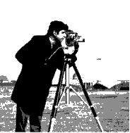 | 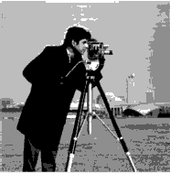 | 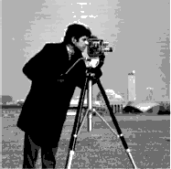
Starfish | 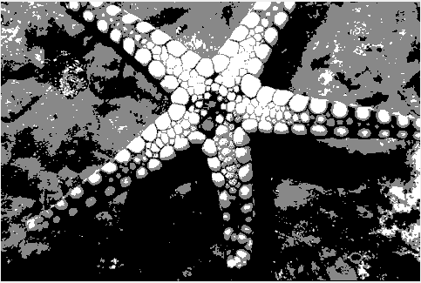 | 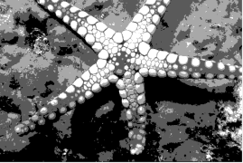 | 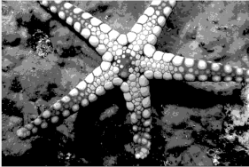 | 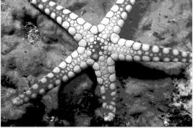
Couple | 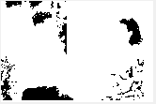 | 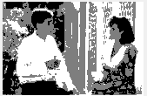 | 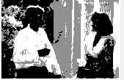 | 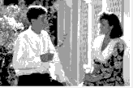
Peppers | 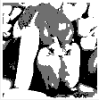 | 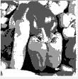 | 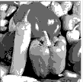 | 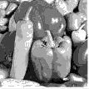
Tree | 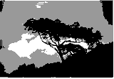 | 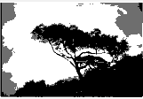 | 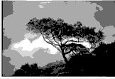 | 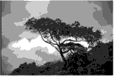
Building | 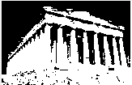 | 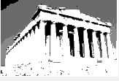 | 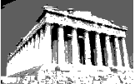 | 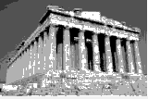

Figure 5.7: Segmentation results of proposed method using Kapur entropy

Table 5.4: Performance Analysis of PSNR of proposed method using Kapur entropy

Image | No. of Thresholds | WOA | MSWOA | Proposed
Lena | 2 | 14.39 | 14.48 | 20.55
Lena | 3 | 16.83 | 16.96 | 21.39
Lena | 5 | 19.79 | 19.87 | 24.75
Lena | 8 | 21.83 | 24.97 | 26.38
Baboon | 2 | 12.34 | 12.34 | 18.36
Baboon | 3 | 14.34 | 14.34 | 21.15
Baboon | 5 | 22.86 | 22.93 | 25.18
Baboon | 8 | 30.36 | 30.38 | 29.22
Starfish | 2 | 15.16 | 15.16 | 20.18
Starfish | 3 | 18.16 | 18.16 | 23.68
Starfish | 5 | 22.09 | 22.22 | 25.29
Starfish | 8 | 25.28 | 28.31 | 29.24
Couple | 2 | 14.29 | 14.29 | 17.11
Couple | 3 | 16.93 | 16.98 | 22.92
Couple | 5 | 20.53 | 20.73 | 22.51
Couple | 8 | 22.08 | 28.11 | 27.28
Cameraman | 2 | 14.73 | 14.90 | 18.20
Cameraman | 3 | 21.28 | 21.76 | 19.61
Cameraman | 5 | 25.68 | 26.07 | 26.53
Cameraman | 8 | 29.05 | 29.13 | 28.41
Peppers | 2 | 13.21 | 13.21 | 18.95
Peppers | 3 | 15.42 | 15.42 | 21.35
Peppers | 5 | 23.37 | 23.56 | 24.62
Peppers | 8 | 29.36 | 29.51 | 26.50
Tree | 2 | 16.41 | 16.57 | 21.22
Tree | 3 | 19.78 | 19.90 | 19.71
Tree | 5 | 22.18 | 22.50 | 23.92
Tree | 8 | 26.02 | 28.38 | 28.30
Building | 2 | 12.15 | 12.15 | 18.98
Building | 3 | 13.43 | 13.43 | 19.77
Building | 5 | 19.23 | 19.23 | 20.80
Building | 8 | 29.83 | 30.37 | 28.03

Table 5.5: Performance Analysis of SSIM of proposed method using Kapur entropy

Image | No. of Thresholds | WOA | MSWOA | Proposed
Lena | 2 | 0.4786 | 0.4835 | 0.6903
Lena | 3 | 0.5661 | 0.5726 | 0.7061
Lena | 5 | 0.6508 | 0.6486 | 0.7873
Lena | 8 | 0.7265 | 0.7891 | 0.8206
Baboon | 2 | 0.5174 | 0.5174 | 0.5278
Baboon | 3 | 0.6230 | 0.6230 | 0.6732
Baboon | 5 | 0.7901 | 0.7913 | 0.8160
Baboon | 8 | 0.9060 | 0.9072 | 0.8787
Starfish | 2 | 0.3768 | 0.3768 | 0.5902
Starfish | 3 | 0.5041 | 0.5041 | 0.6853
Starfish | 5 | 0.6502 | 0.6518 | 0.7572
Starfish | 8 | 0.7605 | 0.8450 | 0.8448
Couple | 2 | 0.4815 | 0.4815 | 0.4131
Couple | 3 | 0.5752 | 0.5751 | 0.7048
Couple | 5 | 0.6962 | 0.6997 | 0.6879
Couple | 8 | 0.7709 | 0.8581 | 0.8734
Cameraman | 2 | 0.5422 | 0.5457 | 0.7850
Cameraman | 3 | 0.6709 | 0.6544 | 0.7973
Cameraman | 5 | 0.7218 | 0.7273 | 0.8331
Cameraman | 8 | 0.7545 | 0.7540 | 0.8636
Peppers | 2 | 0.5251 | 0.5251 | 0.7005
Peppers | 3 | 0.6037 | 0.6037 | 0.7727
Peppers | 5 | 0.7289 | 0.7348 | 0.8464
Peppers | 8 | 0.8215 | 0.8279 | 0.8712
Tree | 2 | 0.5102 | 0.5167 | 0.6945
Tree | 3 | 0.6263 | 0.6335 | 0.6972
Tree | 5 | 0.6577 | 0.6677 | 0.7722
Tree | 8 | 0.7548 | 0.8441 | 0.8006
Building | 2 | 0.5730 | 0.5730 | 0.6880
Building | 3 | 0.6141 | 0.6141 | 0.7186
Building | 5 | 0.7225 | 0.7237 | 0.8061
Building | 8 | 0.8970 | 0.9104 | 0.8831

Table 5.6: Performance Analysis of FSIM of proposed method using Kapur entropy

Image | No. of Thresholds | WOA | MSWOA | Proposed
Lena | 2 | 0.6836 | 0.6850 | 0.6920
Lena | 3 | 0.7542 | 0.7558 | 0.6978
Lena | 5 | 0.8433 | 0.8436 | 0.8116
Lena | 8 | 0.8846 | 0.9066 | 0.8377
Baboon | 2 | 0.7335 | 0.7335 | 0.5855
Baboon | 3 | 0.7961 | 0.7961 | 0.7251
Baboon | 5 | 0.8968 | 0.8981 | 0.8474
Baboon | 8 | 0.9787 | 0.9790 | 0.9158
Starfish | 2 | 0.5705 | 0.5705 | 0.6180
Starfish | 3 | 0.6634 | 0.6634 | 0.6949
Starfish | 5 | 0.7758 | 0.7749 | 0.7762
Starfish | 8 | 0.8591 | 0.8668 | 0.8665
Couple | 2 | 0.6458 | 0.6458 | 0.5025
Couple | 3 | 0.7234 | 0.7232 | 0.7368
Couple | 5 | 0.8123 | 0.8124 | 0.6939
Couple | 8 | 0.8650 | 0.8901 | 0.8899
Cameraman | 2 | 0.6547 | 0.6563 | 0.7524
Cameraman | 3 | 0.7956 | 0.7848 | 0.7853
Cameraman | 5 | 0.8549 | 0.8690 | 0.8521
Cameraman | 8 | 0.9103 | 0.9097 | 0.8928
Peppers | 2 | 0.6453 | 0.6453 | 0.6767
Peppers | 3 | 0.7008 | 0.7008 | 0.7717
Peppers | 5 | 0.7880 | 0.7899 | 0.8508
Peppers | 8 | 0.8575 | 0.8578 | 0.8864
Tree | 2 | 0.6925 | 0.6949 | 0.6811
Tree | 3 | 0.7647 | 0.7664 | 0.7081
Tree | 5 | 0.7938 | 0.7984 | 0.8084
Tree | 8 | 0.8526 | 0.8643 | 0.8364
Building | 2 | 0.6069 | 0.6069 | 0.6792
Building | 3 | 0.6593 | 0.6593 | 0.7248
Building | 5 | 0.7682 | 0.7692 | 0.8061
Building | 8 | 0.9037 | 0.9046 | 0.9016

The Friedman average ranking values of existing and proposed methods for PSNR, FSIM and SSIM are presented from figures 5.8 to 5.10. The average value of PSNR produced by existing method at two thresholds is 13.48dB while that of proposed method is 13.98dB. When it comes to four thresholds, the average value of PSNR produced by existing method is 17.63dB and that of proposed method is 18.22dB. The average value of PSNR produced by existing method at six thresholds is 20.83dB while that of proposed method is 21.29dB. When it comes to eight thresholds, the average value of PSNR produced by existing method is 22.67dB and that of proposed method is 23.25dB. As the threshold levels increases, the quality of segmented images is nearer to the input images, there by producing improved performance metric value.

Figure 5.8: Friedman rank comparison of PSNR

Figure 5.9: Friedman rank comparison of SSIM
The average value of SSIM produced by existing method at two thresholds is 0.432 while that of proposed method is 0.463. When it comes to four thresholds, the average value of SSIM produced by existing method is 0.642 and that of proposed method is 0.653. The average value of SSIM produced by existing method at two thresholds is 0.744 while that of proposed method is 0.754. When it comes to four thresholds, the average value of SSIM produced by existing method is 0.788 and that of proposed method is 0.798. As the threshold levels increases, the quality of segmented images is nearer to the input images, there by producing improved performance metric value.
The average value of FSIM produced by existing method at two thresholds is 0.636 while that of proposed method is 0.644. When it comes to four thresholds, the average value of FSIM produced by existing method is 0.750 and that of proposed method is 0.755. The average value of FSIM produced by existing method at two thresholds is 0.799 while that of proposed method is 0.807. When it comes to four thresholds, the average value of FSIM produced by existing method is 0.832 and that of proposed method is 0.840. As the threshold levels increases, the quality of segmented images is nearer to the input images, there by producing improved performance metric value.

Figure 5.10: Friedman rank comparison of FSIM
From the evaluation metrics, it is clear that for all the thresholds levels and for all input images, the performance of proposed method is better than the existing method in terms of obtaining the optimal thresholds for image segmentation, which produces better values of fitness function there by yielding good performance in terms of PSNR, FSIM and SSIM.
According to the PSNR, SSIM, and FSIM results with m = 2, 3, 5, and 8 (as shown in Tables 5.1–5.6), the method based on Kapur entropy could obtain better data values under the same number of thresholds, and image segmentation quality and accuracy increased, showing a better segmentation effect. Figure 5.11 to 5.13 shows bar charts for Baboon with MSWOA– Otsu and MSWOA–Kapur with m = 2, 3, 5, and 8. It is obvious that the values of the Otsu- based method were smaller than those of the Kapur entropy-based method.
Figure 5.11: Comparative analysis Otsu and Kapur methods in terms of PSNR
Figure 5.12: Comparative analysis Otsu and Kapur methods in terms of SSIM
Figure 5.13: Comparative analysis Otsu and Kapur methods in terms of FSIM
From the evaluation metrics, it is clear that for all the thresholds levels and for all input images, the performance of proposed method is better than the existing method in terms of obtaining the optimal thresholds for image segmentation, which produces better values of fitness function there by yielding good performance in terms of PSNR, FSIM and SSIM.

CHAPTER-6
CONCLUSION AND FUTURE SCOPE
6.1 Conclusion
In this project, MSICWOA is proposed and applied to multi-threshold image segmentation. First, to improve the local search ability of the position update formula in the stage of encircling the prey the bubble net attack stage and the probability of generating excellent individuals in the random search stage, MSICWOA improved the update formula and important parameters of each search stage of WOA. Second, the combined mutation operator based on the individual fitness value is implemented to improve the algorithm’s exploration and exploitation abilities and sustain population variety. The algorithm is then modified by adding an improved removing similarity operation, and a selection strategy for the position update formula in the encircling prey stage and the random exploration stage is described. Multilevel threshold image segmentation is employed to test the viability of MSICWOA. MSICWOA evaluates grayscale benchmark images at different threshold levels. According to the results of the image segmentation, MSICWOA has a significant positive effect on image segmentation with excellent optimization abilities and a quick segmentation time. Experimental results show that MSICWOA has good performance in global optimization and image segmentation.

6.2 Future Scope
In the future, there is still much work to be done on the whale optimization algorithm. Mainly:
(1) Use MSICWOA for medical imaging problems, such as diagnosis of breast cancer and retinopathy.
(2) Multilevel threshold segmentation of color images with MSICWOA.
(3) To explore the solution method of optimal threshold quantity.
(4) MSICWOA can also be applied to other applications such as feature selection smart homes.

REFERENCES
[1] W. Cao, S. Martinis, S. Plank, Automatic SAR-based flood detection using hierarchical tile-ranking thresholding and fuzzy logic, in: Igarss, 2017.
[2] T. Naito, T. Tsukada, Robust license-plate recognition method for passing vehicles under outside environment, IEEE Trans. Veh. Technol. 49 (2000) 2309–2319.
[3] M. Guijarro, I. Riomoros, G. Pajares, P.J.C. Zitinski, E.i. agriculture discrete wavelets transform for improving greenness image segmentation in agricultural images, Comput. Electron. Agric. 118 (2015) 396–407.
[4] K.A. Santhos, A. Kumar, V. Bajaj, G.K.J.M.T. Singh, Applications, McCulloch’s algorithm inspired cuckoo search optimizer based mammographic image segmentation, Multimedia Tools Appl. 79 (2020).
[5] W. Huo, Y. Huang, J. Pei, X. Liu, J. Yang, Virtual SAR target image generation and similarity, in: Geoscience & Remote Sensing Symposium, 2016.
[6] B.J.A.S.C. Akay, A study on particle swarm optimization and artificial bee colony algorithms for multilevel thresholding, Appl. Soft Comput. 13 (2013) 3066–3091.
[7] A. Heimowitz, Y. Keller, Image segmentation via probabilistic graph matching, IEEE Trans. Image Process. 25 (2016) 4743–4752.
[8] J. Wang, W. Na, W. Rui, Research on medical image segmentation based on FCM algorithm, in: 2015 6th International Conference on Manufacturing Science and Engineering, 2015.
[9] J. Fu, J. Liu, H. Tian, Y. Li, Y. Bao, Z. Fang, H. Lu, Dual attention network for scene segmentation, in: 2019 IEEE/CVF Conference on Computer Vision and Pattern Recognition, CVPR, 2020.
[10] N. Otsu, A threshold selection method from gray-level histograms, IEEE Trans. Syst. Man Cybern. 9 (1979) 62–66.
[11] T.J.S.P. Pun, A new method for gray-level picture thresholding using the entropy of the histogram, Comput. Vis. Graph. Image Process. 2 (1985) 223–237.
[12] Patricia Suarez, Andres Iglesias, Akemi Galvez, Make robots be bats: specializing robotic swarms to the Bat algorithm, Swarm and Evolutionary Computation.
[13] S.I. Boushaki, N. Kamel, O. Bendjeghaba, A new quantum chaotic cuckoo search algorithm for data clustering, Expert Syst. Appl. 96 (2018) 358–372.
[14] G. Bekdaş, S.M. Nigdeli, X.S. Yang, Sizing optimization of truss structures using flower pollination algorithm, Appl. Soft Comput. (2015).
[15] A. Khairuzzaman, S. Chaudhury, Multilevel thresholding using grey wolf optimizer for image segmentation, Expert Syst. Appl. 86 (2017) 64–76.
[16] A. Ma, A. Rge, A. Samg, C. Stb, Upgraded whale optimization algorithm for fuzzy logic based vibration control of nonlinear steel structure - ScienceDirect, Eng. Struct. 192 (2019) 53–70.
[17] F.S. Gharehchopogh, An improved tunicate swarm algorithm with bestrandom mutation strategy for global optimization problems, J. Bionic Eng. 19 (2022) 1177–1202.
[18] F.S. Gharehchopogh, Advances in tree seed algorithm: A comprehensive survey, Archives Computat. Methods Eng. 29 (2022) 3281–3304.
[19] S. Ghafori, F.S. Gharehchopogh, Advances in spotted hyena optimizer: A comprehensive survey, Archives Comput. Methods Eng. 29 (2022) 1569–1590.
[20] M.J. Goldanloo, F.S. Gharehchopogh, A hybrid OBL-based firefly algorithm with symbiotic organisms search algorithm for solving continuous optimization problems, J. Supercomput. (2021) 1–34.
[21] M. Abedi, F.S. Gharehchopogh, An improved opposition based learning firefly algorithm with dragonfly algorithm for solving continuous optimization problems, Intell. Data Anal. 24 (2020) 309–338.
[22] D. Karaboga, B. Basturk, A powerful and efficient algorithm for numerical function optimization: artificial bee colony (ABC) algorithm, J. Global Optim. 39 (2007) 459–471.
[23] H.R.R. Zaman, F.S. Gharehchopogh, An improved particle swarm optimization with backtracking search optimization algorithm for solving continuous optimization problems, Eng. Comput. 38 (2022) 2797–2831.
[24] S. Mirjalili, A. Lewis, The whale optimization algorithm, Adv. Eng. Softw. 95 (2016) 51–67.
[25] P.D. Sathya, R. Kayalvizhi, Modified bacterial foraging algorithm based multilevel thresholding for image segmentation, Eng. Appl. Artif. Intell. (2011).
[26] A.K. Bhandari, A. Kumar, G.K. Singh, Modified artificial bee colony based computationally efficient multilevel thresholding for satellite image segmentation using Kapur’s Otsu and Tsallis functions, Expert Syst. Appl. 42 (2015) 1573–1601.
[27] S. Pare, A. Kumar, V. Bajaj, G.K. Singh, A multilevel color image segmentation technique based on cuckoo search algorithm and energy curve, Appl. Soft Comput. (2016) 76–102.
[28] M.S.R. Naidu, P. Rajesh Kumar, K. Chiranjeevi, Shannon and fuzzy entropy based evolutionary image thresholding for image segmentation, 2017, pp. 1643–1655.
[29] M. Abd El Aziz, A.A. Eweessc, A.E. Hassanien, Whale optimization algorithm and Moth–Flame Optimization for multilevel thresholding image segmentation, Expert Syst. Appl. (2017) 242–256.
[30] K.P. Baby Resma, M.S. Nair, I. Sciences, multilevel thresholding for image segmentation using Krill Herd optimization algorithm, J. King Saud Univ. Comput. Inform. Sci. (2018).
[31] A.A. Ewees, M. Abd Elaziz, D. Oliva, Image segmentation via multilevel thresholding using hybrid optimization algorithms, J. Electron. Imaging 27 (2018) .
[32] M. Abd Elaziz, Asghar Fujita Ali, Hamido Moayedi Hossein, A competitive chain-based Harris Hawks optimizer for global optimization and multi-level image thresholding problems, Appl. Soft Comput. (2020) 106347.
[33] J. Anitha, S. Pandian, S.A. Agnes, An efficient multilevel color image thresholding based on modified whale optimization algorithme, Expert Syst. Appl. (2021) 115003.
[34] Y. Zhou, Y. Ling, Q. Luo, Lévy flight trajectory-based whale optimization algorithm for global optimization, IEEE Access (2017) 6168–6186.
[35] G. Xiong, J. Zhang, D. Shi, Y. He, Parameter extraction of solar photovoltaic models using an improved whale optimization algorithm, Energy Convers. Manag. 174 (2018) 388–405.
[36] G. Ren, R. Yang, R. Yang, P. Zhang, X. Yang, C. Xu, B. Xu, H. Zhang, Y. Lu, Y. Cai, A parameter estimation method for fractional-order nonlinear systems based on improved whale optimization algorithm, Modern Phys. Lett. B 33 (2019).
[37] F. Hemasian-Etefagh, F. Safi-Esfahani, Group-based whale optimization algorithm, Soft Comput. 24 (2020).
[38] M.A. Elaziz, S. Lu, S. He, A multi-leader whale optimization algorithm for global optimization and image segmentation, Expert Syst. Appl. 175 (2021) 114841.
[39] M.D. Li, G.H. Xu, Y.W. Fu, T.W. Zhang, L. Du, Improved whale optimization algorithm based on variable spiral position update strategy and adaptive inertia weight, J. Intell. Fuzzy Systems 42 (2022) 1501–1517.
[40] G. Hu, B. Du, X. Wang, G. Wei, An enhanced black widow optimization algorithm for feature selection, Knowl.-Based Syst. (2022) 235.
[41] H. Song, J. Wang, L. Song, H. Zhang, J. Bei, J. Ni, B. Ye, Improvement and application of hybrid real-coded genetic algorithm, Appl. Intell. 52 (2022) 17410–17448.
[42] Z. Cheng, H. Song, J. Wang, H. Zhang, M. Zhang, Hybrid firefly algorithm with grouping attraction for constrained optimization problem, Knowl.-Based Syst. 220 (2021) 106937.
[43] J. Brest, M.S. Maucec, B. Boskovic, The 100-digit challenge: Algorithm jDE100, in: 2019 IEEE Congress on Evolutionary Computation, CEC, 2019.
[44] H.H. Song, J.Q. Wang, L. Song, H.Y. Zhang, J.L. Bei, J. Ni, B. Ye, Improvement and application of hybrid real-coded genetic algorithm, Applied Intelligence.
[45] J. Wang, M. Zhang, H. Song, Z. Cheng, K. Sun, Improvement and application of hybrid firefly algorithm, IEEE Access (2019) 1.
[46] G.M. Wu, Rammohan, Suganthan, Ponnuthurai, Problem Definitions and Evaluation Criteria for the CEC 2017 Competition and Special Session on Constrained Single Objective Real-Parameter Optimization, 2016.
[47] F. Wilcoxon, Individual comparisons by ranking methods, Biom. Bull. 1 (1945) 80–83.
[48] M. Han, Hybrid chicken swarm algorithm with dissipative structure and differential mutation, J. ZheJIang Univ.(Science Edition) 45 (3) (2018) 272–283.
[49] M.C. Zhou, Z. Zhao, C. Xiong, Q. Kang, An opposition-based particle swarm optimization algorithm for noisy environments, in: 2018 IEEE 15th International Conference on Networking, Sensing and Control, ICNSC, 2018.
[50] G. Yildizdan, M.K. Baykan, A novel modified bat algorithm hybridizing by differential evolution algorithm, Expert Syst. Appl. 141 (2019) 112949.
[51] D. Gupta, A.R. Dhar, S.S. Roy, A partition cum unification based geneticfirefly algorithm for single objective optimization, S¯adhan¯a 46 (2021).
[52] A.E. Ezugwu, J.O. Agushaka, L. Abualigah, S. Mirjalili, A.H. Gandomi, Prairie dog optimization algorithm, Neural Comput. Appl. 34 (2022) 20017–20065.
[53] Q. Huynh-Thu, M. Ghanbari, Scope of validity of PSNR in image/video quality assessment, Electron. Lett. 44 (2008) 800–801.
[54] U. Sara, M. Akter, M.S. Uddin, Image quality assessment through FSIM SSIM, MSE and PSNR—A comparative study, Computer and Communications 7 (2019) 11.
[55] W. Zhou, A.C. Bovik, H.R. Sheikh, E.P. Simoncelli, Image quality assessment: from error visibility to structural similarity, IEEE Trans. Image Process 13 (2004).
[56] L. Zhang, L. Zhang, X. Mou, D. Zhang, FSIM: A feature similarity index for image quality assessment, IEEE Trans. Image Process. 20 (2011) 2378–2386.

APPENDIX

MATLAB

A.1 Software description

MATLAB® is a high-performance language for technical computing. It integrates computation, visualization, and programming in an easy-to-use environment where problems and solutions are expressed in familiar mathematical notation. Typical uses include

Math and computation Algorithm development Data acquisition
Modeling, simulation, and prototyping

Data analysis, exploration, and visualization Scientific and engineering graphics
Application development, including graphical user interface building.

MATLAB is an interactive system whose basic data element is an array that does not require dimensioning. This allows you to solve many technical computing problems, especially those with matrix and vector formulations, in a fraction of the time it would take to write a program in a scalar non interactive language such as C or FORTRAN.

The name MATLAB stands for matrix laboratory. MATLAB was originally written to provide easy access to matrix software developed by the LINPACK and EISPACK projects. Today, MATLAB engines incorporate the LAPACK and BLAS libraries, embedding the state of the art in software for matrix computation.

MATLAB has evolved over a period of years with input from many users. In university environments, it is the standard instructional tool for introductory and advanced courses in mathematics, engineering, and science. In industry, MATLAB is the tool of choice for high-productivity research, development, and analysis.

MATLAB features a family of add-on application-specific solutions called toolboxes. Very important to most users of MATLAB, toolboxes allow you to learnand apply specialized technology. Toolboxes are comprehensive collections of MATLAB functions (M-files) that extend the MATLAB environment to solve particular classes of problems. Areas in which toolboxes are available include signal processing, control systems, neural networks, fuzzy logic, wavelets, simulation, and many others.

A.2 The MATLAB System

The MATLAB system consists of five main parts:

A.2.1 Development Environment

This is the set of tools and facilities that help you use MATLAB functions and files. Many of these tools are graphical user interfaces. It includes the MATLAB desktop and Command Window, a command history, an editor and debugger, and browsers for viewing help, the workspace, files, and the search path.

A.2.2 The MATLAB Mathematical Function

This is a vast collection of computational algorithms ranging from elementary functions like sum, sine, cosine, and complex arithmetic, to more sophisticated functions like matrix inverse, matrix Eigen values, Bessel functions, and fast Fourier transforms.

A.2.3 The MATLAB Language

This is a high-level matrix/array language with control flow statements, functions, data structures, input/output, and object-oriented programming features. It allows both "programming in the small" to rapidly create quick and dirty throw-away programs, and "programming in the large" to create complete large and complex application programs.

A.2.4 Graphics

MATLAB has extensive facilities for displaying vectors and matrices as graphs, as well as annotating and printing these graphs. It includes high-level functions for two- dimensional and three-dimensional data visualization, image processing, animation, and presentation graphics. It also includes low-level functions that allow you to fully customize the appearance of graphics as well as to build complete graphical user interfaces on your MATLAB applications.

A.2.5 MATLAB Application Program Interface (API)

This is a library that allows you to write C and Fortran programs that interact with MATLAB. It includes facilities for calling routines from MATLAB (dynamic linking), calling MATLAB as a computational engine, and for reading and writing MAT-files.

A.3 MAT LAB Working Environment

A.3.1 MATLAB Desktop
Mat lab Desktop is the main Mat lab application window. The desktop contains five sub windows, the command window, the workspace browser, the current directory window, the command history window, and one or more figure windows, which are shown only when the user displays a graphic.

The command window is where the user types MATLAB commands and expressions at the prompt (>>) and where the output of those commands is displayed. MATLAB defines the workspace as the set of variables that the user creates in a work session. The workspace browser shows these variables and some information about them. Double clicking on a variable in the workspace browser launches the Array Editor, which can be used to obtain information and income instances edit certain properties of the variable.

The current Directory tab above the workspace tab shows the contents of the current directory, whose path is shown in the current directory window. For example, in the windows operating system the path might be as follows: C:\MATLAB\Work,

indicating that directory “work” is a subdirectory of the main directory “MATLAB”; WHICH IS INSTALLED IN DRIVE C. clicking on the arrow in the current directory window shows a list of recently used paths. Clicking on the button to the right of the window allows the user to change the current directory. The easiest way to see which directories are soon the search path, or to add or modify a search path, is to select set path from the File menu the desktop, and then use the set path dialog box. It is good practice to add any commonly used directories to the search path to avoid repeatedly having the change the current directory.

The Command History Window contains a record of the commands a user has entered in the command window, including both current and previous MATLAB sessions. Previously entered MATLAB commands can be selected and re-executed from the command history window by right clicking on a command or sequence of commands.

This action launches a menu from which to select various options in addition to executing the commands. This is useful to select various options in addition to executing the commands. This is a useful feature when experimenting with various commands in a work session.

A.3.2 Getting Help

The principal way to get help online is to use the MATLAB help browser, opened as a separate window either by clicking on the question mark symbol (?) on the desktop toolbar, or by typing help browser at the prompt in the command window. The help Browser is a web browser integrated into the MATLAB desktop that displays a Hypertext Markup Language (HTML) document.
The Help Browser consists of two panes, the help navigator pane, used to find information, and the display pane, used to view the information. Self-explanatory tabs other than navigator pane are used to perform a search.

Project code

% function mswoa_segmentation_main(img_path, method, levels, max_iter, num_whales)
% MSWOA-based Multilevel Thresholding Image Segmentation
% Parameters:
% img_path: Path to the input image
% method: 'otsu' or 'kapur' for the thresholding method
% levels: Number of thresholds (m)
% max_iter: Maximum number of iterations
% num_whales: Population size
% Example usage of MSWOA for image segmentation
%mswoa_segmentation_main('lena.jpg', 'otsu', 5, 100, 30);
close all;
% Load and preprocess the image
img = imread('/MATLAB Drive/MSWOA final code/MSWOA final code/coin.jpg'); % Replace with your image file
levels = 10; % Number of thresholds
num_whales = 20; % Population on size
max_iter=100;
method='kapur';
if size(img, 3) == 3
img = rgb2gray(img); % Convert to grayscale if needed
end

% Algorithm parameters
lb = 1; % Lower bound for thresholds
ub = 256; % Upper bound for thresholds
u = 0.4; % Nonlinear convergence factor parameter

% Initialize whale population using k-point strategy
k = 20; % k-point search strategy parameter
tic
whales = initialize_population_kpoint(num_whales, levels, lb, ub, k);

% Evaluate initial fitness
fitness = evaluate_fitness(img, whales, method);
[best_fitness, best_index] = max(fitness);
best_position = whales(best_index, :);

% Optimization loop
for t = 1:max_iter
a = nonlinear_convergence_factor_proposed(t, max_iter, u);
omega = adaptive_weight_coefficient(t, max_iter);
for i = 1:num_whales
A = 2 * a * rand() - a;
p = rand();
if p < 0.5
if abs(A) < 1
% Shrinking encircling
whales(i, :) = update_position_shrinking(best_position, whales(i, :), A, omega);
else
% Random exploration
random_whale = whales(randi([1 num_whales]), :);
whales(i, :) = update_position_random(random_whale, whales(i, :), A, omega);
end
else
% Spiral updating
whales(i, :) = update_position_spiral(best_position, whales(i, :), omega);
end
end

% Ensure thresholds are within bounds
whales = max(min(whales, ub), lb);

% Evaluate fitness of updated population
fitness = evaluate_fitness(img, whales, method);

% Update best whale
[current_best_fitness, current_best_index] = max(fitness);
if current_best_fitness > best_fitness
best_fitness = current_best_fitness;
best_position = whales(current_best_index, :);
end
end

% Apply optimal thresholds to segment the image
segmented_img = segment_image(img, best_position);

% Display results
fprintf('Optimal thresholds: %s\n', mat2str(sort(round(best_position))));
figure, imshow(img, []), title('Input Image');
figure, imshow(segmented_img, []), title('Segmented Image for threshold=20');

% Compute metrics
psnr_value = psnr(double(img), segmented_img);
ssim_value = ssim(img, segmented_img);
fsim_value = FeatureSIM(img, segmented_img);
toc

% Display results
fprintf('PSNR: %.4f dB\n', psnr_value);
fprintf('SSIM: %.4f\n', ssim_value);
fprintf('FSIM: %.4f\n', fsim_value);
if size(img,3) == 1
[n_countR, x_valueR] = imhist(img(:,:,1));
end
Nt = size(img,1) * size(img,2);
for i = 1:256
if size(img,3) == 1
probR(i) = n_countR(i) / Nt;
end
end
figure
plot(probR)

