PING PONG
Design Document
Android game | Version 1.0 | October 2026
Developed by Subrahmanyam
A minimal, offline ping pong game. Black background, everything else white. Touch or tilt control, three difficulty levels, and an admin Setup screen for score, ball speed and paddle size.

Contents
1 Overview and goals
2 Platform and compatibility
3 Screen flow
4 Wireframes and screen specifications
5 Gameplay mechanics
6 Admin Setup specification
7 Controls: touch and tilt
8 Visual design
9 Technical architecture
10 Build, signing and release
11 Quality and test results
12 Known limits and future ideas

1 Overview and goals
Ping Pong is a single-player game against a computer opponent. It is built as a small, dependable app that installs on any Android phone or tablet from Android 9 to the latest version, works with no internet connection and asks for almost no permissions.
- Black background with the ball, paddles, lines and text in white, on every screen.
- Main menu with START GAME, SETUP and EXIT.
- Gyro (tilt) movement as an alternative to dragging a finger.
- Admin Setup screen: score to win, ball speed per level, paddle size per level (slider).
- Settings survive closing and reopening the app.
- No build or runtime errors of the kind met in earlier apps (see section 10).

2 Platform and compatibility
Item | Specification
Android versions | Android 9 (API 28) up to the latest. The build floor is Android 7 (API 24), so Android 9 is comfortably covered.
Devices | Phones and tablets. The court is a fixed 360 x 640 logical area, scaled to fit and centred, so any screen shape works.
Orientation | Portrait, locked.
Framework | Expo SDK 53, React Native 0.79.6, react 19.0.0, react-native-webview 13.13.5. Classic (non-new) architecture.
Game engine | HTML5 canvas and plain JavaScript, embedded in the app as a string and shown in a WebView.
Package id | com.subrahmanyam.pingpong
CPU types | All: armeabi-v7a, arm64-v8a, x86, x86_64.
Network | None needed. Fully offline.
Permissions | Only the default INTERNET declaration remains (unused). Storage, overlay and vibrate permissions are explicitly blocked.
Distribution | Signed release APK, sideloaded with ADB or file copy. Self-signed keystore is committed so later builds install over earlier ones.

3 Screen flow
The app has five screens. The device BACK button or gesture steps back one level; on the Main Menu it exits the app.
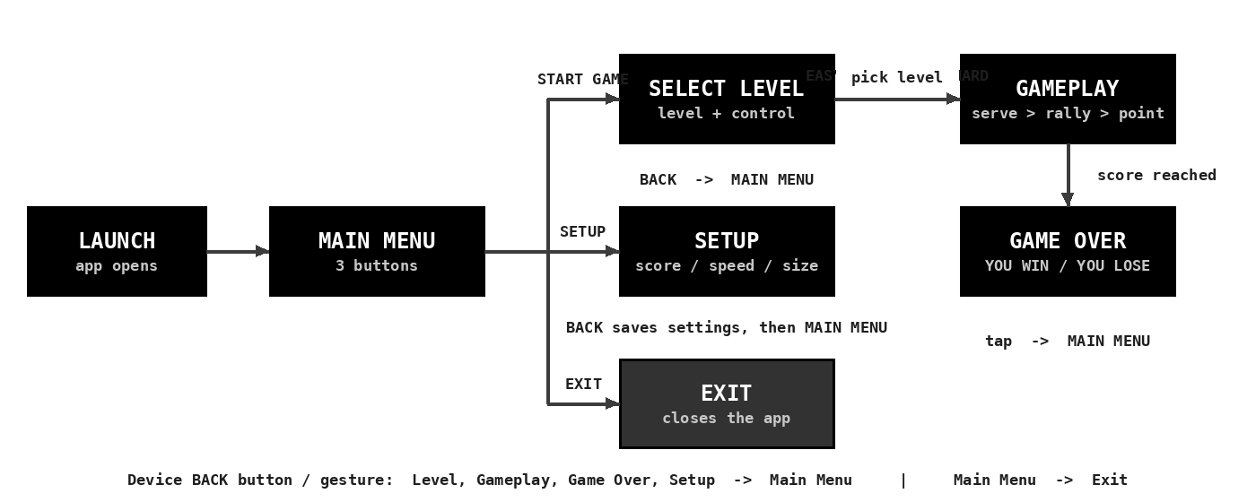

4 Wireframes and screen specifications
Wireframes are drawn from the real layout coordinates of the game. Amber numbered markers are annotations only and do not appear in the app. An interactive viewer is supplied as pingpong_wireframes.html.

4.1 Main Menu
Entry screen. Three full-width outlined buttons and the credit line.
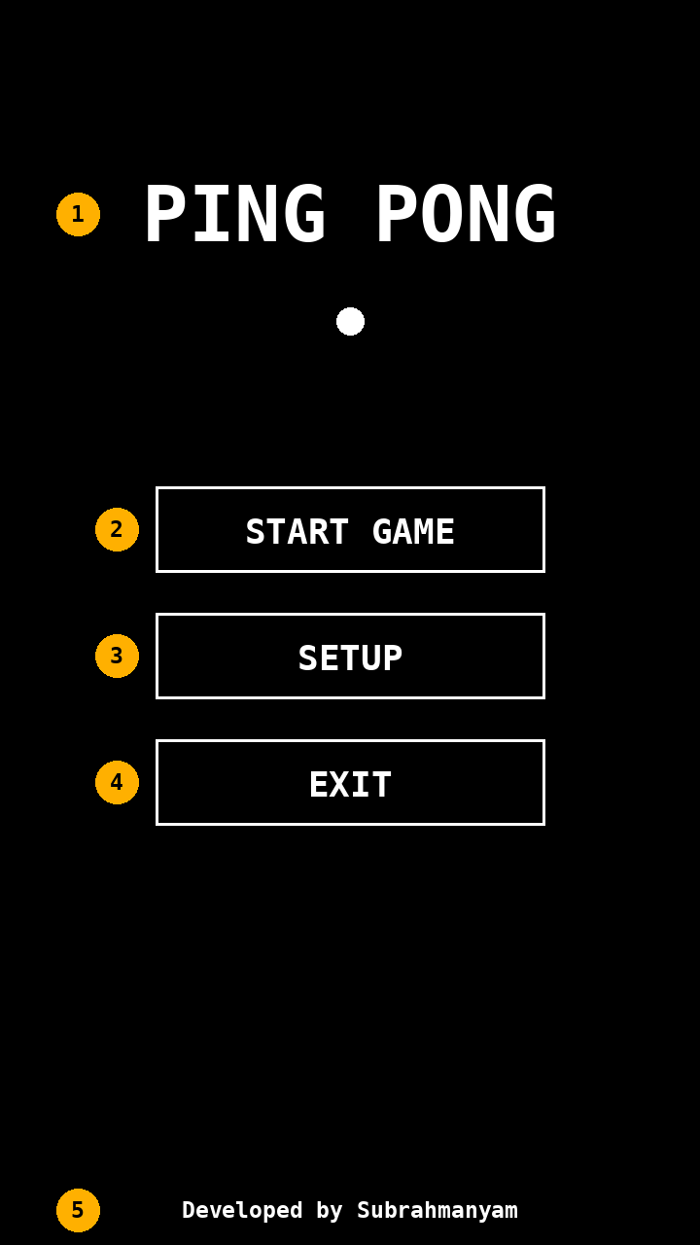
# | Element | Behaviour
1 | Title + ball | Static 'PING PONG' title with a single white ball.
2 | START GAME | Opens Select Level.
3 | SETUP | Opens the admin Setup screen.
4 | EXIT | Closes the application. The device BACK button does the same from this screen.
5 | Credit | 'Developed by Subrahmanyam' - shown on the menu of every app in this portfolio.

4.2 Select Level
Choose difficulty and control method. Tapping a level starts the match immediately.
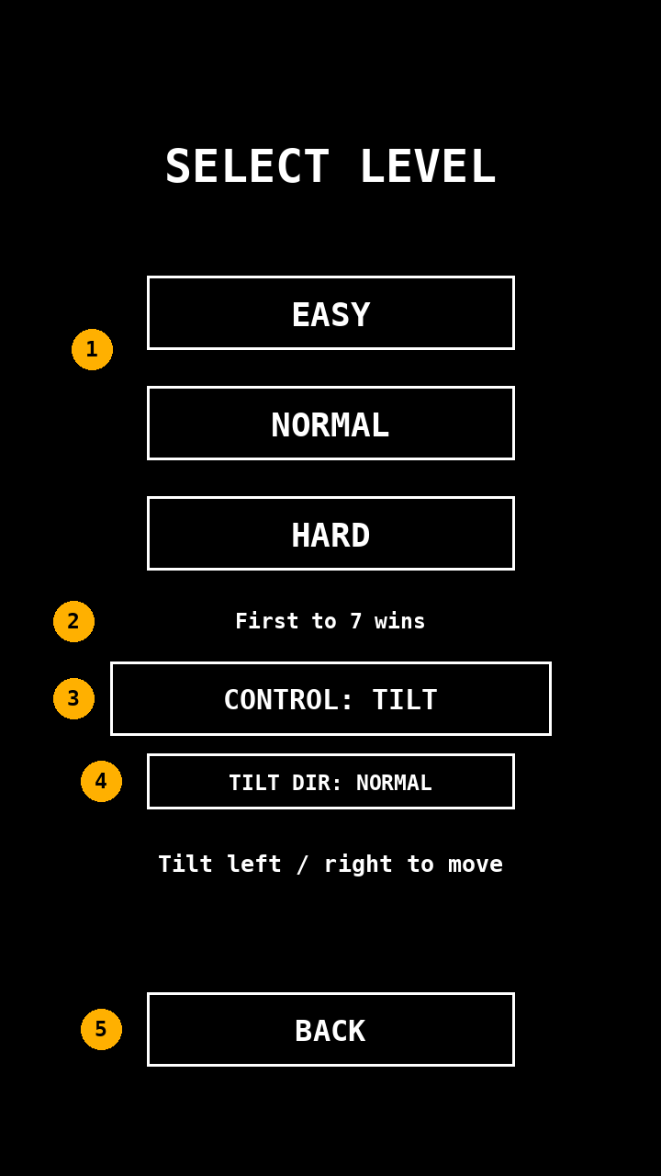
# | Element | Behaviour
1 | EASY / NORMAL / HARD | Starts a match using that level's Setup values (ball speed, paddle size) and AI behaviour.
2 | First to N wins | Read-only label showing the score-to-win from Setup.
3 | CONTROL: TOUCH / TILT | Toggles drag control and gyro (tilt) control. Choice is remembered.
4 | TILT DIR | Shown only in tilt mode. Flips the tilt direction if a particular device feels reversed.
5 | BACK | Returns to the Main Menu.

4.3 Setup (Admin)
Three configuration groups. Every change is stored on the device immediately.
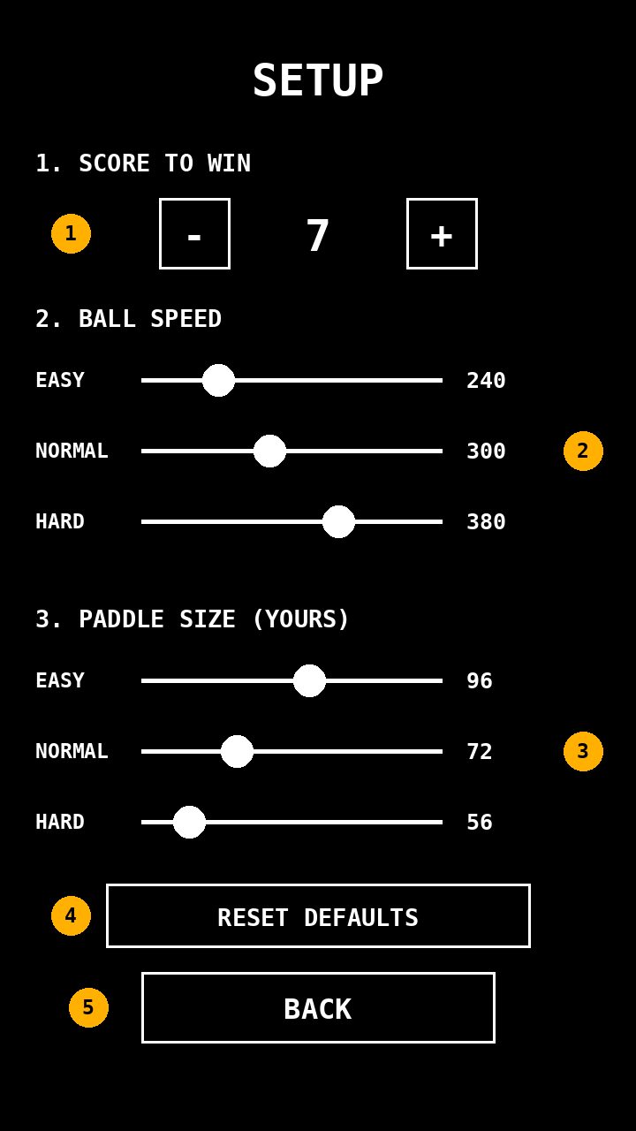
# | Element | Behaviour
1 | Score to win | - / + stepper. Range 3 to 21, default 7.
2 | Ball speed | One slider per level. Range 150 to 500, step 10. Defaults 240 / 300 / 380.
3 | Paddle size | One slider per level. Range 40 to 140, step 2, applied to the player's paddle. Defaults 96 / 72 / 56.
4 | RESET DEFAULTS | Restores every value on this screen.
5 | BACK | Saves and returns to the Main Menu.

4.4 Gameplay
Portrait court with the AI paddle at the top and the player paddle at the bottom.
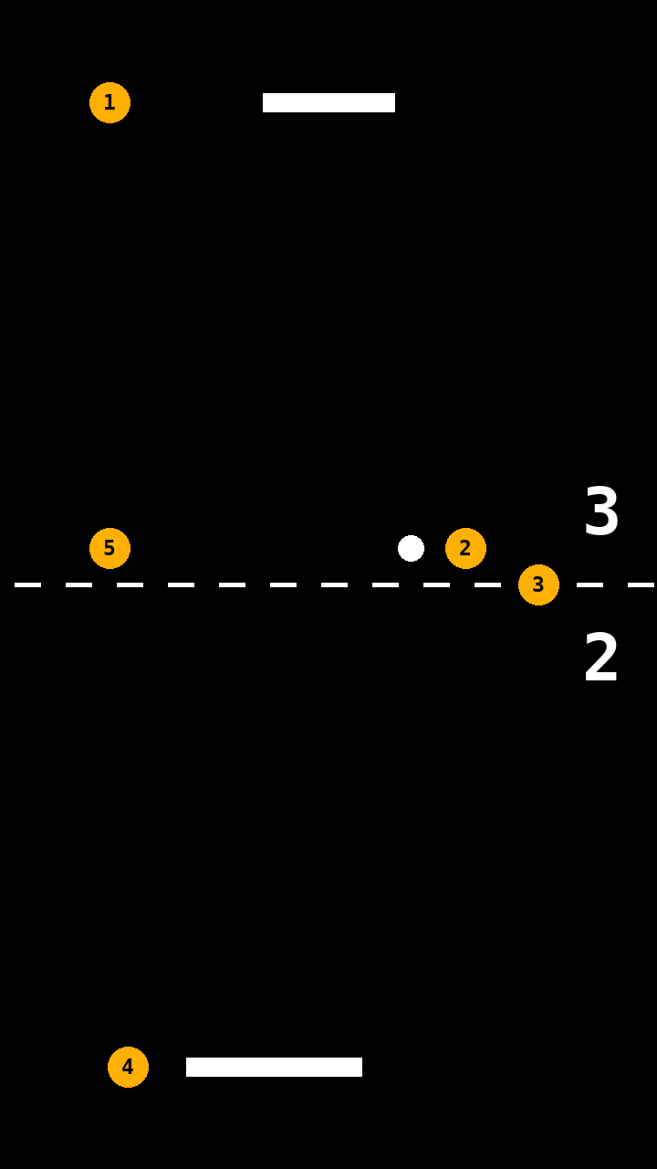
# | Element | Behaviour
1 | AI paddle | Fixed width of 72. Speed and aim error depend on the level.
2 | Ball | White ball. Speeds up 5% per paddle hit, up to a cap of twice the level's starting speed (hard limit 900).
3 | Score | AI score above the centre line, player score below.
4 | Player paddle | Width from Setup. Moves by dragging, or by tilting the device.
5 | Centre line | Dashed line, purely visual.

4.5 Game Over
Shown when either side reaches the configured score.
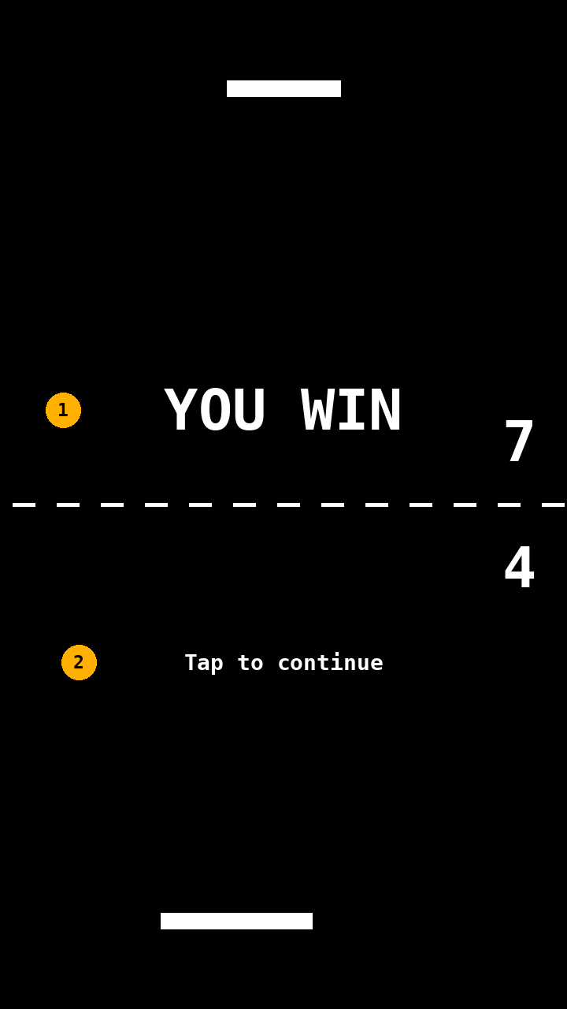
# | Element | Behaviour
1 | Result | 'YOU WIN' or 'YOU LOSE'.
2 | Tap to continue | Returns to the Main Menu.

5 Gameplay mechanics
Topic | Rule
Match | First side to reach the configured score wins. The score is checked after every point.
Serve | One-second pause, then the ball launches from the centre at a random angle of up to about 29 degrees from vertical. After a point, the ball is served toward the side that conceded.
Paddle hit | The bounce angle depends on where the ball strikes the paddle: the centre sends it straight, the edges send it at up to about 57 degrees.
Speed-up | Each paddle hit multiplies ball speed by 1.05 up to a cap of 2 x the level's starting speed (never above 900).
Walls | The left and right walls reflect the ball.
Collision method | Swept check against the paddle plane each frame, so even fast balls cannot pass through a paddle.
Frame step | Frame time is capped at 33 ms so a slow frame never causes a jump.
AI | The AI paddle tracks the ball only while it is travelling toward the AI, with a small random aim error that is re-rolled after each player hit. Otherwise it returns to the centre.
Sound | Short square-wave beeps for paddle hit, wall hit and points. Silent if the device blocks audio.

Level | AI speed | AI aim error | Notes
EASY | 170 units/s | up to 55 | Slow, inaccurate AI
NORMAL | 250 units/s | up to 28 | Balanced
HARD | 340 units/s | up to 8 | Fast, accurate AI

6 Admin Setup specification
Setup is reached from the Main Menu. Each value is clamped to its range, saved the moment it changes and re-checked when loaded, so a damaged or hand-edited saved value can never break the game.
Setting | Range | Step | Default | Applies to
1. Score to win | 3 - 21 | 1 | 7 | Every level. Match ends when either side reaches it.
2. Ball speed - EASY | 150 - 500 | 10 | 240 | Starting ball speed (units/s) on EASY.
2. Ball speed - NORMAL | 150 - 500 | 10 | 300 | Starting ball speed on NORMAL.
2. Ball speed - HARD | 150 - 500 | 10 | 380 | Starting ball speed on HARD.
3. Paddle size - EASY | 40 - 140 | 2 | 96 | Width of the player's paddle on EASY (slider).
3. Paddle size - NORMAL | 40 - 140 | 2 | 72 | Width of the player's paddle on NORMAL (slider).
3. Paddle size - HARD | 40 - 140 | 2 | 56 | Width of the player's paddle on HARD (slider).

- Sliders respond to touch and drag anywhere along the line, and the number to the right updates live.
- RESET DEFAULTS restores all seven values.
- The AI paddle width is fixed at 72, so a larger player paddle makes the game easier and a smaller one makes it harder.
- Setup is open to anyone using the app. A PIN lock is listed under future ideas.

7 Controls: touch and tilt

7.1 Touch
Drag a finger anywhere on the screen. The paddle follows the finger horizontally and stays inside the walls.

7.2 Tilt (gyro)
Tilting the device left or right moves the paddle that way. The tilt amount sets the paddle speed rather than its position, so holding a steady tilt keeps it moving and levelling the device stops it.
Parameter | Value
Sensor | Device motion (accelerometer with gravity) read inside the WebView. No native module and no permission needed.
Smoothing | Low-pass filter: new reading counts for 20%, previous value 80%.
Dead zone | About 2 degrees of tilt is ignored so the paddle rests when the device is held level.
Full speed | About 23 degrees of tilt gives the maximum paddle speed of 560 units/s.
Tablet handling | Readings are rotated using the screen orientation, so tablets whose natural orientation is landscape still map left and right correctly.
Reverse switch | TILT DIR: NORMAL / REVERSED on the Select Level screen, in case a device reports the opposite sign.
Fallback | If no sensor data arrives within 1.5 seconds, the game switches back to touch and shows a short notice.
Screen awake | The screen is kept awake while the app is open, since tilt play involves no touching.

8 Visual design
Aspect | Decision
Palette | Pure black (#000000) background. Ball, paddles, lines, borders and all text pure white (#FFFFFF). No other colours in the app.
Typography | Bold monospace. Sizes: title 44, headings 28, buttons 17-20, body 13-16 (logical units).
Buttons | 2-pixel white outline, no fill, centred label. Minimum height 40 for comfortable touch.
Court | Dashed white centre line, scores on the right of the line, paddles 10 high, ball radius 7.
Scaling | Logical 360 x 640 area scaled to the screen with equal margins, drawn at device pixel density for sharp lines.
System UI | Status bar hidden; splash and launcher icon are black with white paddles and ball.
Credit | 'Developed by Subrahmanyam' on the Main Menu.

9 Technical architecture
The app is a thin native shell around a self-contained web game.
Layer | Responsibility
React Native shell (App.js) | Hosts the WebView on a black background, keeps the screen awake, routes the device BACK button into the game and closes the app when the game asks.
WebView | react-native-webview showing the game from an HTML string with base URL https://localhost. This gives a secure origin and avoids the cleartext and file:// problems met earlier.
Game (canvas + JavaScript) | State machine: menu, levels, setup, serve, play, over. Fixed logical court, per-frame update and draw.
Bridge: game to app | The game posts the message 'exit' to the shell (EXIT button, or BACK on the menu), and the shell calls the Android exit.
Bridge: app to game | On BACK the shell runs window.__back() inside the game, which steps back one screen.
Crash recovery | If the WebView render process is killed (low memory), the shell recreates the WebView.
Storage | Browser localStorage inside the WebView: pp_cfg (score, speeds, sizes), pp_ctrl and pp_rev (touch/tilt and direction).

Dependencies (all pinned): expo ~53.0.0, expo-asset, expo-constants, expo-file-system, expo-font and expo-keep-awake declared directly, react 19.0.0, react-native 0.79.6, react-native-webview 13.13.5.

10 Build, signing and release
The build follows the same pipeline as the other apps: Expo prebuild, Gradle and GitHub Actions, producing a signed release APK on every push. No local Android SDK is needed.
Step | Detail
1. Install | npm install in the app folder.
2. Prebuild | expo prebuild --platform android --clean regenerates the android folder (it is git-ignored).
3. Keystore | The committed self-signed release keystore is copied into android/app.
4. Patch | A Python script removes the obsolete enableBundleCompression line and injects the release signing config using brace-depth tracking. It stops the build with a clear error if the expected structure is missing.
5. Build | gradlew assembleRelease (never debug, which needs a Metro server and crashes on device).
6. Verify and publish | apksigner verifies the signature, then the APK is uploaded as the PingPong-apk artifact.
Install | adb install -r PingPong.apk, or copy the file to the device and open it.

Problems from earlier apps and how this build avoids them
Known problem | Handled by
ERR_CLEARTEXT_NOT_PERMITTED in WebView | HTML embedded as a string with base URL https://localhost; no file:// loading, no network config.
Metro failure from expo-router | No expo-router. Plain App.js with registerRootComponent.
Wrong version combinations | SDK 53 set pinned: react-native 0.79.6, react 19.0.0, react-native-webview 13.13.5.
enableBundleCompression build error | Line removed by the patch script before Gradle runs.
Release signing lost by prebuild --clean | Signing config injected on every build from the committed keystore.
Launch crash: native module 'ExpoAsset' not found | expo-asset and the other Expo native packages are declared directly so autolinking includes them. Verified in the autolinking output.
Unused permissions in the APK | Storage, overlay and vibrate permissions blocked in app.json.

11 Quality and test results
The game logic was exercised headlessly with a simulated canvas, touch input and motion sensor. The build chain was re-run on a clean copy after the last change.
Area | Result
Menu, level select, Setup navigation | Pass: all buttons open the right screen; BACK steps back; EXIT and BACK-on-menu send the exit message.
Score setting | Pass: + and - work and clamp at 3 and 21; a 3-point match ends and returns to the menu.
Ball speed sliders | Pass: each level independent; limits 150 and 500; measured in-game speed matched the setting (240 and 500).
Paddle size sliders | Pass: limits 40 and 140; measured paddle widths 140 and 40 in play.
Reset and persistence | Pass: RESET DEFAULTS restores all values; saved settings reload.
Tilt control | Pass: right and left movement, dead zone, reversed setting, tablet rotation, no-sensor fallback.
Touch control | Pass.
Stability | Pass: 30,000 simulated frames with no errors.
Build chain | Pass: install, prebuild, signing patch, autolinking check and JavaScript bundle on a clean copy.

Automated checks: 29 passing. The checks cannot replace real hardware, so the device checklist below should be completed on each target device.
Device check | Pass / note
App opens and stays open on phone and tablet
All three levels playable
Tilt moves paddle in the expected direction
Setup changes visibly affect the game
Settings still there after closing and reopening
EXIT and BACK behave as described
Android 9 device tested
Newest Android device tested

12 Known limits and future ideas
- Tilt direction is based on the standard motion-sensor convention; if a device reports the opposite sign, use TILT DIR: REVERSED.
- Setup is not protected. A 4-digit admin PIN is a possible addition.
- Ideas: sound on/off, two-player mode on one device, best-score tracking, per-level AI speed in Setup, and a pause button.

Developed by Subrahmanyam

