Intelligent Healthcare System For Multi-Disease
Risk Assessment

A Project Based Learning Report Submitted in partial fulfilment of the requirements for the award of the degree of
Bachelor of Technology
in The Department of AI & DS
Course name with Course code 25SC2107E-MACHINE LEARNING

Submitted by

Roll.no: 2510080017-Shirisha Mangalagiri
Roll.no: 2510080031-Vadla Vishal
Roll.no: 2510080034-Krishna Vamshi
Roll.no: 2510080049-Singam Tejaswini

Under the guidance of
Dr.Gangamohan Paidi

Department of Artificial Intelligence & Data Science
Koneru Lakshmaiah Education Foundation, Aziz Nagar
Aziz Nagar – 500075
OCT - 2026.

Abstract
Modern healthcare systems face severe clinical and socioeconomic burdens stemming from chronic non-communicable diseases (NCDs), most prominently Type-2 diabetes, essential hypertension, and ischemic heart disease. In clinical practice, patients rarely present with isolated conditions; rather, complex multimorbidity—the simultaneous co-occurrence of two or more chronic ailments—frequently emerges due to shared pathophysiological pathways, metabolic syndrome, and systemic vascular degeneration. Conventional computer-aided screening systems typically operate as isolated binary classifiers, evaluating single diseases in silos and failing to capture synergistic clinical risks across comorbid combinations. To resolve this operational gap, this Project-Based Learning (PBL) study designs, implements, and evaluates an end-to-end Machine Learning-Based Patient Multi-Disease Risk Assessment and Healthcare Analytics System designed to accurately categorize patients into mutually exclusive single- and multi-disease diagnostic profiles.
The empirical research is grounded in the 'Data Warehouse Multiclass.csv' repository, comprising 280,985 patient records characterized across 39 demographic, biomarker, diagnostic, and lifestyle attributes. Initial data hygiene auditing confirmed zero missing entries across all feature columns. Systematic duplication detection isolated 2,284 redundant records, which were excised to yield a curated experimental cohort of 278,701 unique clinical observations. Continuous biometric variables underwent rigorous Interquartile Range (IQR) outlier screening; rather than discarding critical clinical extremes, an automated 1.5×IQR boundary capping protocol was executed across 16 vital health features—including BMI, blood glucose, HbA1c, total cholesterol, blood pressure, lipid fractions, and systemic inflammatory biomarkers—thereby mitigating distortive statistical leverage while preserving patient volume. Exploratory Data Analysis (EDA) systematically characterized the eight mutually exclusive disease-combination classes: Normal (N: 104,648; 37.55%), Hypertension alone (HY: 69,787; 25.04%), Diabetes and Hypertension comorbidity (DI_HY: 66,472; 23.85%), Diabetes alone (DI: 31,903; 11.45%), Heart Disease alone (HT: 2,583; 0.93%), Diabetes and Heart Disease comorbidity (DI_HT: 1,398; 0.50%), Heart Disease and Hypertension comorbidity (HT_HY: 1,065; 0.38%), and Triple comorbidity (DI_HT_HY: 845; 0.30%).
To prevent artificial diagnostic shortcuts and data leakage, seven direct diagnostic proxy columns (composite_key, diabetes, hypertension, heart_disease, disease_flags, label, and source_dataset) were stripped from the predictor space. Categorical features were one-hot encoded via pandas get_dummies, yielding 41 encoded predictor dimensions. The dataset was partitioned into an 80:20 stratified split (222,960 training instances and 55,741 held-out testing instances; random_state=42). A 100-tree Random Forest Classifier with balanced class weighting was trained on the full 41-feature space. Mean decrease in Gini impurity was computed to identify the most potent clinical biomarkers, revealing that glycated hemoglobin (HbA1c, 18.55%), BMI (8.89%), fasting glucose (7.91%), normalized age (5.90%), age (5.83%), and high blood pressure history (4.37%) dominated decision trees. A reduced model was subsequently trained exclusively on the top 15 Gini features to establish an ultra-compact diagnostic pipeline.
On the independent 55,741-patient test cohort, the streamlined 15-feature Random Forest model achieved an overall accuracy of 75.39%, a macro-averaged F1-score of 0.4129, and a weighted F1-score of 0.7400. Remarkably, this compact model retained over 99.6% of the full 41-feature model's predictive capacity (accuracy 75.69%, macro F1 0.4014, weighted F1 0.7419) despite eliminating 63.4% of clinical input requirements. Classification performance was exceptionally robust on high-prevalence categories (DI_HY: F1 0.81, recall 0.92; HY: F1 0.80, recall 0.92; N: F1 0.81, precision 0.92), while highlighting distinct clinical challenges on rare complex comorbidities (DI_HT_HY: F1 0.12; HT_HY: F1 0.12) caused by severe epidemiological sample sparsity. Validation on an unseen synthetic patient record successfully flagged elevated dual-comorbidity risk (72% DI_HY, 27% DI probability). The resulting trained model, label encoder, and feature schemas were serialized via Joblib for prospective clinical integration. These findings demonstrate the viability of automated multimorbidity risk triage while underscoring essential clinical safeguards: predictions must serve as probabilistic decision support rather than definitive clinical diagnoses.

List of Figures
Fig. 1. Workflow of Patient Multi-Disease Risk Assessment and Healthcare Analytics System from raw clinical data ingestion to final prediction.
Fig. 2. Dataset size before and after duplicate removal.
Fig. 3. Potential outlier count across numerical clinical features identified using the IQR method.
Fig. 4. Health features distribution before IQR outlier capping.
Fig. 5. Health features distribution after IQR outlier capping.
Fig. 6. Distribution of patient disease combinations across the eight sublabel categories.
Fig. 7. Percentage proportion of disease-combination classes within the warehouse cohort.
Fig. 8. Patient age distribution across disease combination classes.
Fig. 9. Patient BMI distribution across disease combination classes.
Fig. 10. Distribution of blood glucose and glycated hemoglobin (HbA1c) levels.
Fig. 11. Patient demographic distribution by gender and physical activity level.
Fig. 12. Pearson correlation heatmap among numerical clinical and lifestyle features.
Fig. 13. Top 15 most informative features ranked by Random Forest Gini importance.
Fig. 14. Performance comparison between the full 41-feature and reduced 15-feature Random Forest models.
Fig. 15. Confusion matrix for the final reduced 15-feature Random Forest classifier on the 55,741 test patients.

List of Tables
Table I. Summary of the Healthcare Warehouse Multi-Disease Dataset.
Table II. Target Disease-Combination Classes, Sample Counts, and Clinical Definitions.
Table III. Outlier Statistics and IQR Boundary Capping across Key Health Features.
Table IV. Top 15 Selected Features with Gini Importance Scores and Clinical Relevance.
Table V. Machine Learning Experimental Configuration and Hyperparameter Specifications.
Table VI. Performance Comparison of Full (41-Feature) and Reduced (15-Feature) Random Forest Models.
Table VII. Detailed Per-Class Classification Report for the 15-Feature Random Forest Model on the Test Set (55,741 Patients).
Table VIII. Confusion Matrix of the 15-Feature Random Forest Model Across Eight Target Classes.
Table IX. Risk Assessment Prediction and Class Probability Distribution for Unseen Patient Profile.

Table of Contents
1. Introduction
2. Methodology
a. Dataset Description
b. Data Preprocessing and Outlier Capping
c. Exploratory Data Analysis
d. Feature Preparation and One-Hot Encoding
e. Stratified Train-Test Splitting
f. Random Forest Classification Architecture
g. Feature Importance and Dimensionality Reduction
h. Model Evaluation Metrics
i. Model Serialization and Unseen Patient Prediction Pipeline
3. Experiments
a. Experimental Setup and Computational Environment
b. Data Cleaning and Quality Assessment Experiment
c. Exploratory Data Analysis Experiments
d. Feature Preparation and Encoding Experiment
e. Full 41-Feature Random Forest Training Experiment
f. Gini Feature Selection and Dimensionality Reduction Experiment
g. Reduced 15-Feature Random Forest Training Experiment
h. Comparative Evaluation Experiment
i. Unseen Patient Prediction Experiment
4. Results
a. Data Cleaning and Preprocessing Results
b. Exploratory Data Analysis Observations
c. Disease-Combination Class Distribution
d. Feature Importance Rankings and Clinical Interpretability
e. Classification Performance of the Full 41-Feature Model
f. Classification Performance of the Reduced 15-Feature Model
g. Comparative Performance Analysis (41 vs. 15 Features)
h. Per-Class Classification Report and Error Analysis
i. Confusion Matrix Analysis and Class Imbalance Impact
j. Unseen Patient Prediction Case Study
k. Technical Discussion and Healthcare Analytics Insights
l. Practical and Clinical Limitations
5. Conclusion and Future Work
a. Conclusion
b. Future Work
References

Intelligent Healthcare System For Multi-Disease
Risk Assessment

1. INTRODUCTION
Healthcare data analytics and predictive modeling have emerged as transformative instruments within clinical decision support and preventive health management [1]. Rapid digitization across healthcare ecosystems—facilitated by Electronic Health Records (EHRs), biometric monitoring equipment, and centralized clinical repositories—has created unprecedented volumes of complex, multidimensional patient information. Concurrently, global epidemiological patterns have shifted decisively toward chronic non-communicable diseases (NCDs). The World Health Organization (WHO) identifies cardiovascular diseases, Type-2 diabetes, and hypertensive vascular disorders as leading drivers of adult morbidity and premature mortality worldwide [3]. These chronic conditions rarely manifest in isolation; rather, patients frequently experience multimorbidity—the co-occurrence of two or more chronic conditions within an individual [6]. Shared underlying metabolic pathways, prolonged systemic low-grade inflammation, endothelial dysfunction, and adverse lifestyle behaviors frequently precipitate cross-disease interactions. For instance, hyperglycemia and hyperinsulinemia promote arterial stiffness and sodium retention, dramatically accelerating the pathogenesis of essential hypertension, which subsequently triples the risk of coronary heart disease and ischemic heart events [4], [5].
Despite the clinical ubiquity of multimorbidity, conventional diagnostic protocols and algorithmic screening systems remain predominantly siloed into isolated binary paradigms. Standard clinical models predict single endpoints—such as predicting isolated diabetes incidence or standalone cardiovascular risk—without capturing the holistic disease landscape or modeling simultaneous disease combinations [6]. This fragmented screening approach poses severe operational limitations in real-world clinical practice. Patients who exhibit borderline glycemic markers and mild hypertension are often misclassified by standalone binary models, resulting in fragmented patient triage, uncoordinated pharmacotherapy, adverse drug-drug interactions, and missed opportunities for early multi-factorial clinical intervention [5].
To address this critical gap, this project formulates a unified multiclass machine learning paradigm that simultaneously models the complex combinatorial spectrum of chronic health states. Utilizing a centralized warehouse of 280,985 patient encounters, this investigation treats patient risk assessment as a multi-disease classification problem spanning eight distinct disease-combination states: healthy normal baseline, standalone hypertension, standalone diabetes, standalone heart disease, and their respective dual and triple comorbidity permutations (DI_HY, DI_HT, HT_HY, DI_HT_HY).
The primary objectives of this Project-Based Learning (PBL) investigation are formally defined as follows:
- • To perform end-to-end data auditing, duplicate cleansing, and IQR-based continuous biomarker outlier capping on a large-scale multiclass clinical warehouse of 280,985 patient records;
- • To conduct rigorous exploratory data analysis (EDA) evaluating demographic, anthropometric, biochemical, and behavioral distributions across eight mutually exclusive disease-combination cohorts;
- • To eliminate artificial target leakage and encode high-dimensional clinical and lifestyle features into a robust numerical predictor matrix;
- • To develop and evaluate a full 41-feature Random Forest Classifier equipped with cost-sensitive class balancing to counteract severe epidemiological prevalence disparities;
- • To quantify Gini feature importance (Mean Decrease in Impurity) to isolate the top 15 most informative clinical biomarkers and construct a compact, computationally efficient 15-feature classification pipeline;
- • To evaluate model efficacy using multi-faceted evaluation metrics including accuracy, macro-averaged F1-score, weighted F1-score, class-specific precision/recall, and confusion matrix analysis; and
- • To serialize the finalized predictive pipeline and validate its utility by generating multi-disease probability distributions on unseen synthetic clinical patient profiles.
The scope of this project encompasses data warehouse cleaning, outlier treatment, exploratory statistical visualization, leakage-free feature encoding, ensemble model training, Gini-based feature selection, model evaluation, and artifact serialization. It is vital to delineate the operational boundaries and clinical limitations of this system. The developed models are designed exclusively as clinical decision support screening aids and risk stratification tools, not autonomous medical diagnostic devices. A model prediction of an abnormal disease combination does not establish a definitive clinical diagnosis, nor does a 'Normal' prediction rule out underlying subclinical pathologies. All predictive outputs must undergo verification by licensed medical practitioners utilizing standard diagnostic protocols.

2. METHODOLOGY

a. Dataset Description
The empirical foundation of this study is the 'Data Warehouse Multiclass.csv' repository, an extensive clinical data warehouse containing 280,985 patient instances documented across 39 heterogeneous attributes. The feature space captures a wide range of patient parameters, including demographic indicators (age, age_level, gender, education_level, employment_status), anthropometric measures (bmi, bmi_level), vital signs and laboratory biomarkers (HbA1c_level, glucose, cholesterol, triglycerides, hdl, ldl, systolic_bp, diastolic_bp, blood_pressure, heart_rate, crp_level, homocysteine_level), and behavioral/lifestyle habits (smoking, alcohol_intake, salt_intake, sleep_hours, physical_activity, stress_level, sugar_consumption, family_history). Table I summarizes the foundational structural attributes of the warehouse dataset.
- Table I. Summary of the Healthcare Warehouse Multi-Disease Dataset.
Dataset Attribute | Recorded Characteristic / Value
Original Record Count | 280,985 patient records
Total Attribute Columns | 39 clinical, demographic, and lifestyle columns
Duplicate Records Identified | 2,284 records (0.81% of total)
Curated Record Count (Post-Cleansing) | 278,701 unique patient instances
Missing Value Audit | 0 missing entries (100% complete across all 39 columns)
Target Classification Variable | sublabel (8 mutually exclusive disease-combination categories)
Binary Indicator Leakage Columns | diabetes, hypertension, heart_disease, disease_flags, label
Administrative Metadata Leakage Columns | composite_key, source_dataset
Input Predictor Space (Pre-Encoding) | 31 clinical, lifestyle, and demographic features
Input Predictor Space (Post-Encoding) | 41 one-hot encoded numerical features
Reduced Feature Space (Gini Selection) | 15 top clinical features

The primary multiclass target variable is designated as 'sublabel'. Rather than treating chronic diseases as isolated binary flags, the target column establishes eight mutually exclusive disease-combination classes that represent the complete permutation space of Type-2 diabetes (DI), essential hypertension (HY), and ischemic heart disease (HT), alongside healthy controls (N). Table II outlines the exact clinical definitions, binary flag mappings, sample distributions, and cohort proportions for each class.
- Table II. Target Disease-Combination Classes, Sample Counts, and Clinical Definitions.
Class Code | Clinical Description | Binary Flags (DI, HT, HY) | Instance Count | Cohort Share (%)
N | Normal / Baseline Health (No Chronic Disease Diagnosed) | (0, 0, 0) | 104,648 | 37.55%
HY | Essential Hypertension Alone | (0, 0, 1) | 69,787 | 25.04%
DI_HY | Diabetes and Hypertension Comorbidity | (1, 0, 1) | 66,472 | 23.85%
DI | Type-2 Diabetes Mellitus Alone | (1, 0, 0) | 31,903 | 11.45%
HT | Ischemic Heart Disease Alone | (0, 1, 0) | 2,583 | 0.93%
DI_HT | Diabetes and Heart Disease Comorbidity | (1, 1, 0) | 1,398 | 0.50%
HT_HY | Heart Disease and Hypertension Comorbidity | (0, 1, 1) | 1,065 | 0.38%
DI_HT_HY | Triple Comorbidity: Diabetes, Heart Disease & Hypertension | (1, 1, 1) | 845 | 0.30%
Total | Curated Healthcare Warehouse Experimental Cohort | All Permutations | 278,701 | 100.00%

Fig. 1 illustrates the overarching system architecture and end-to-end machine learning pipeline, progressing from data warehouse ingestion through hygiene auditing, IQR outlier capping, leakage elimination, stratified training, feature selection, and probabilistic patient risk evaluation.
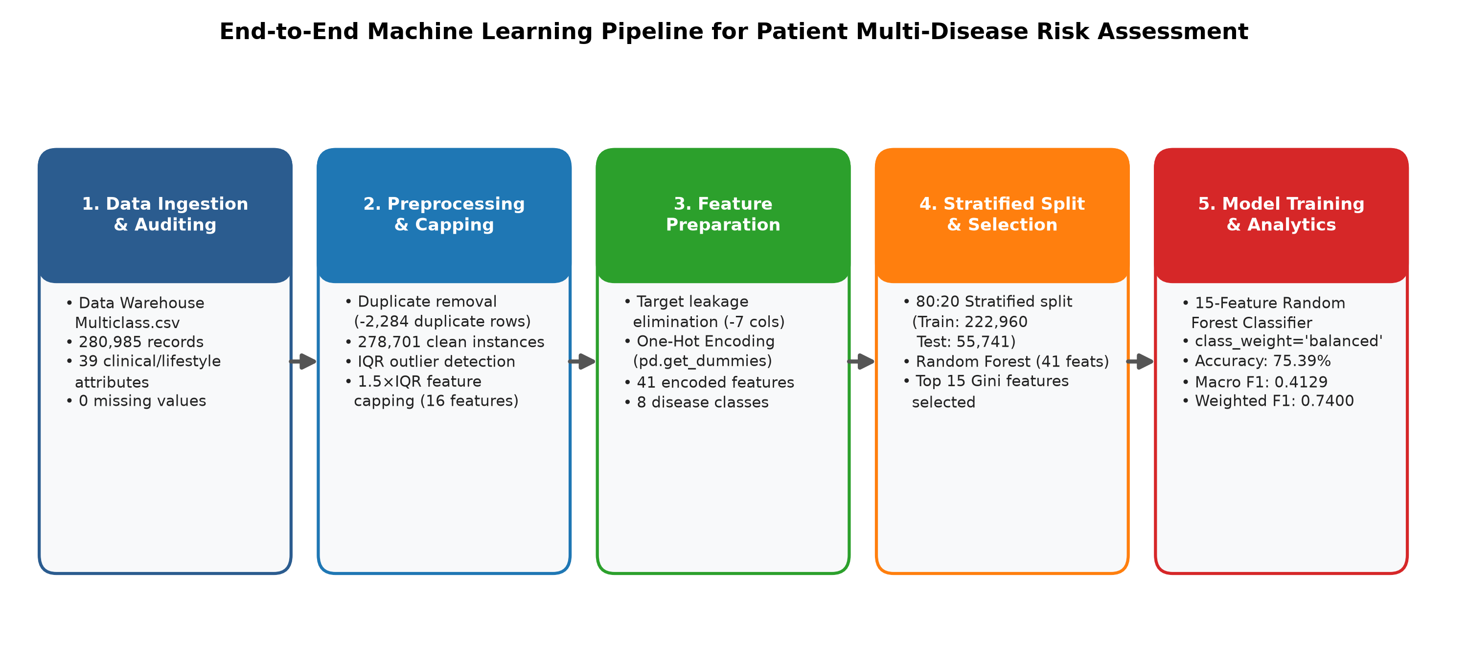
- Fig. 1. Workflow of Patient Multi-Disease Risk Assessment and Healthcare Analytics System from raw clinical data ingestion to final prediction.

b. Data Preprocessing and Outlier Capping
Initial data hygiene auditing revealed zero missing values across all 280,985 rows and 39 columns. Duplicate auditing identified 2,284 fully identical records. While duplicates can occur in observational cohorts, retaining them risks artificially deflating cross-validation variance and causing train-test leakage. Consequently, all 2,284 duplicates were purged, establishing a final curated dataset of 278,701 instances (Fig. 2).
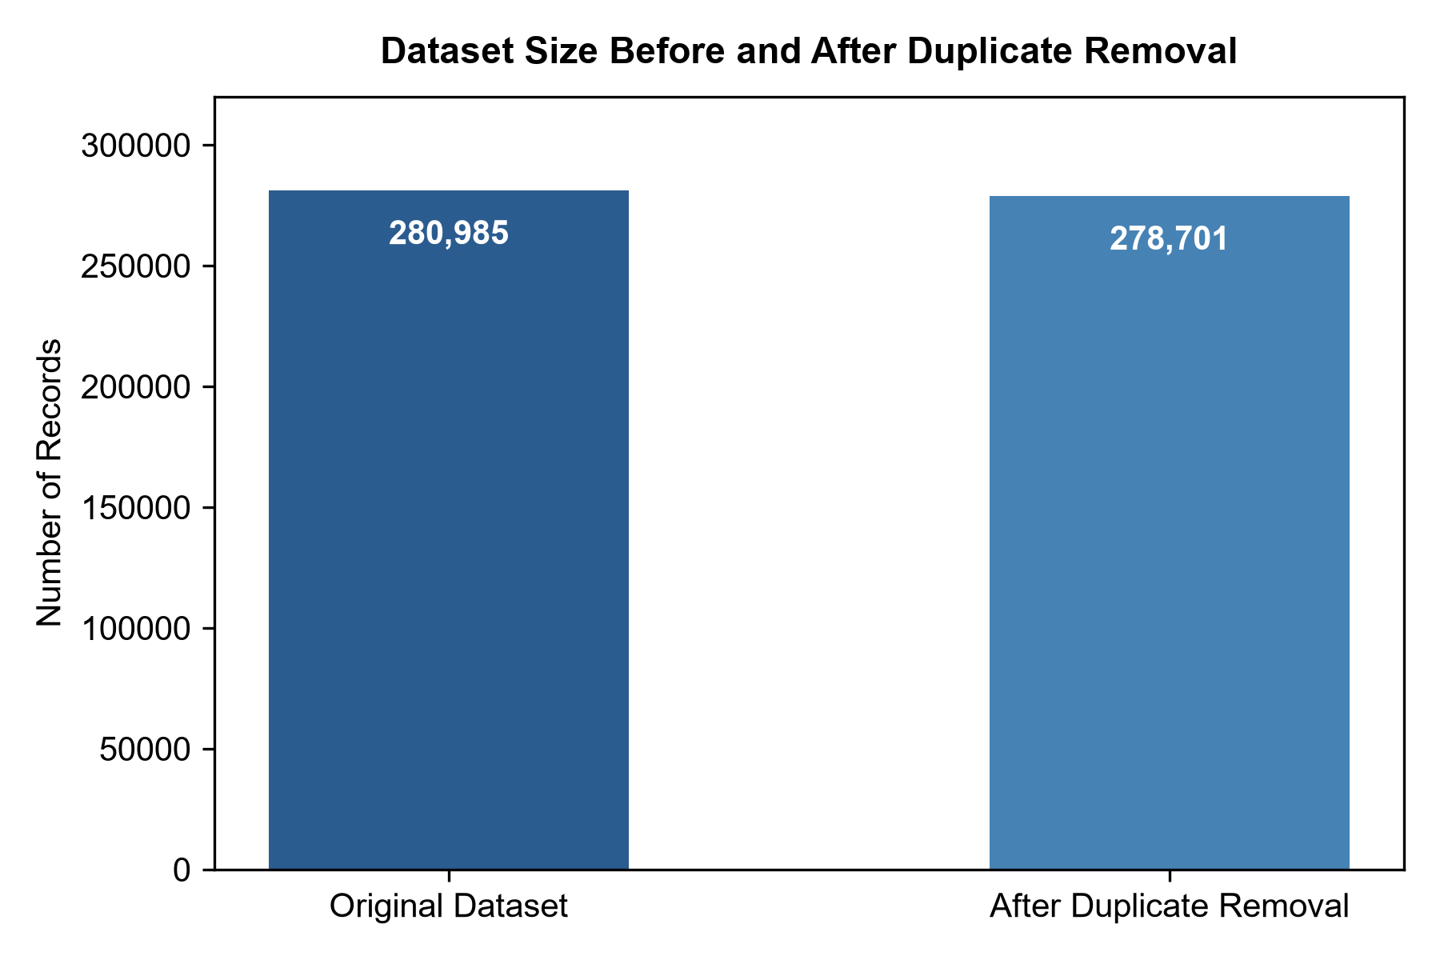
- Fig. 2. Dataset size before and after duplicate removal.
Continuous clinical measurements frequently contain extreme values arising from acute metabolic crises, extreme obesity, or measurement artifacts. To systematically audit and handle these extremes without discarding valuable patient data, the Interquartile Range (IQR) method was deployed. For any continuous numerical feature x, let Q1 denote the 25th percentile and Q3 denote the 75th percentile. The interquartile range is defined as IQR = Q3 - Q1. Statistical outlier bounds were calculated as Lower = Q1 - 1.5×IQR and Upper = Q3 + 1.5×IQR. Any observation falling outside [Lower, Upper] was flagged as an outlier.
Fig. 3 illustrates the distribution of identified outliers across numerical attributes. Features such as salt intake (33,549 outliers), alcohol intake (32,706), homocysteine level (30,989), blood pressure (30,308), CRP level (30,295), LDL cholesterol (29,273), and systolic blood pressure (27,371) exhibited significant tails. Rather than dropping over 30,000 clinically vital records, an automated Winsorization / clipping protocol was executed across 16 continuous health features: x_capped = clip(x, Lower, Upper). Fig. 4 and Fig. 5 illustrate the comparative distributions of key health features before and after IQR outlier capping, demonstrating effective boundary stabilization without data loss. Table III details the exact quartile boundaries, calculated thresholds, and capping statistics.
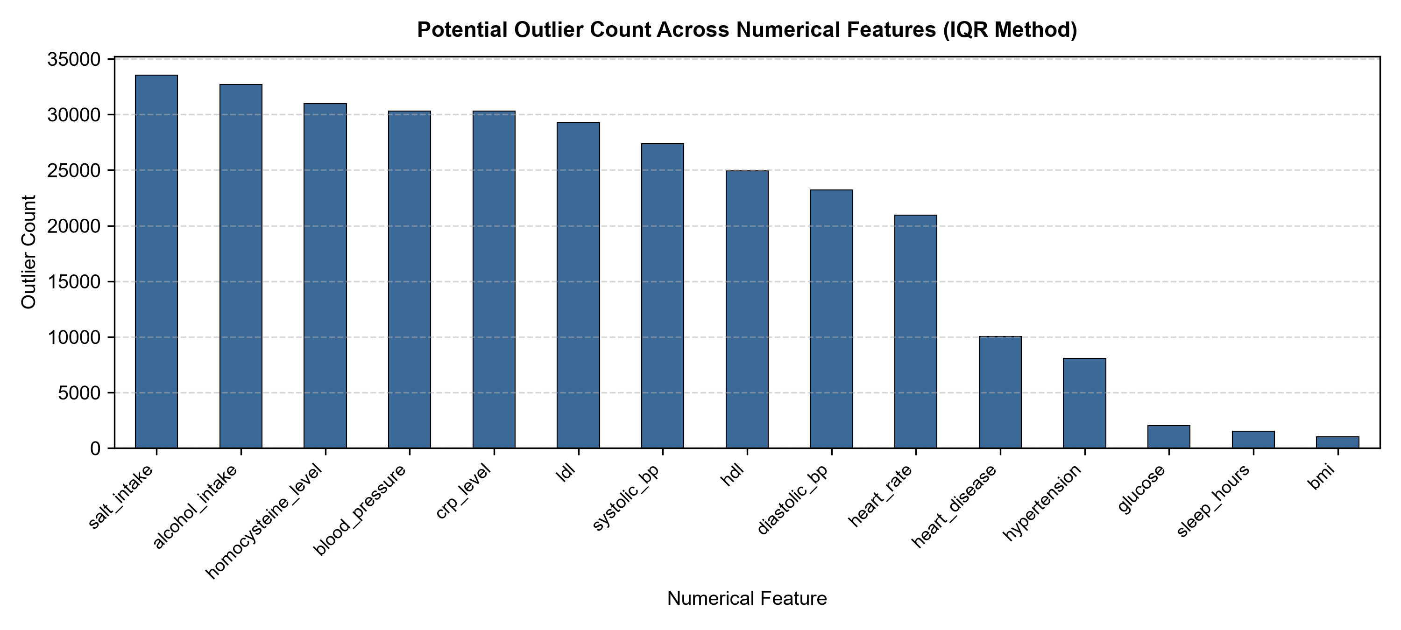
- Fig. 3. Potential outlier count across numerical clinical features identified using the IQR method.
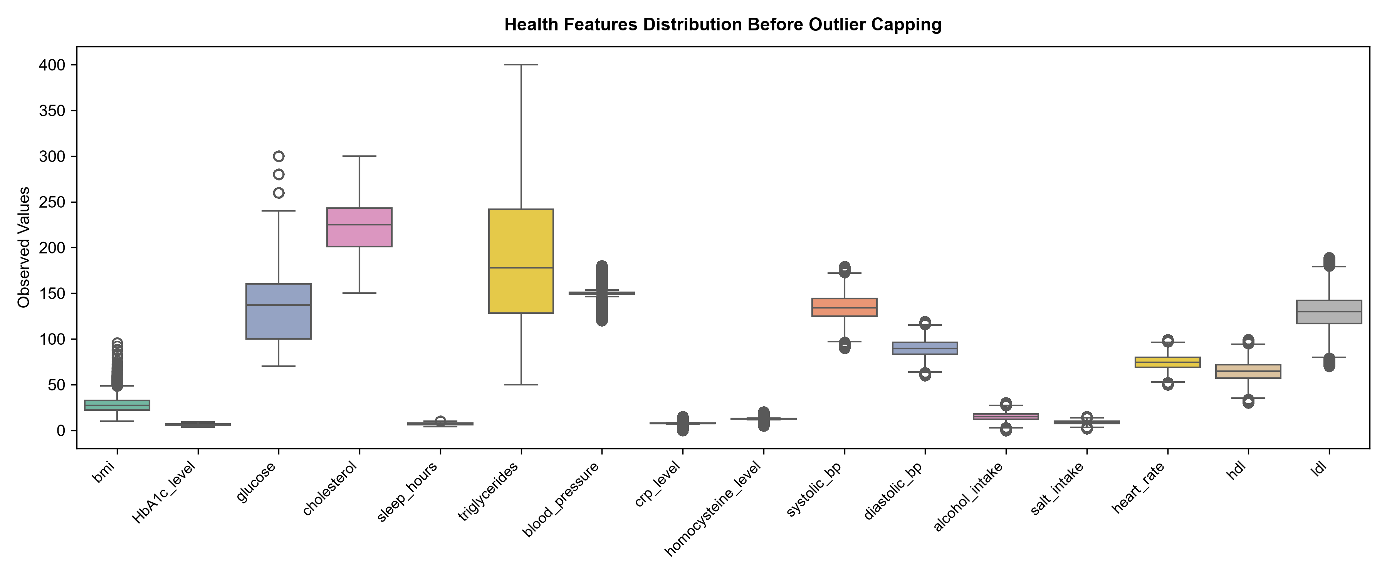
- Fig. 4. Health features distribution before IQR outlier capping.
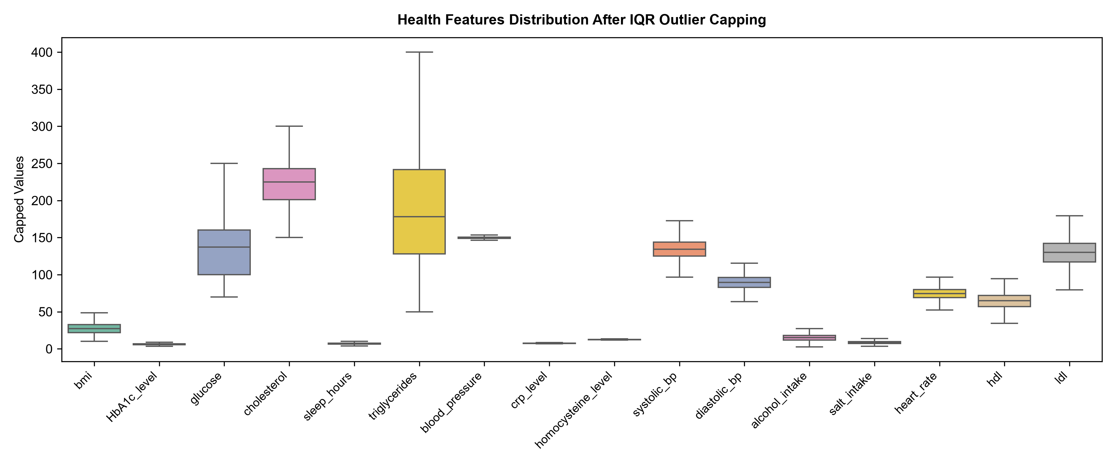
- Fig. 5. Health features distribution after IQR outlier capping.
- Table III. Outlier Statistics and IQR Boundary Capping across Key Health Features.
Clinical Feature | Q1 (25%) | Q3 (75%) | IQR | Lower Boundary | Upper Boundary | Outliers Flagged | Capping Protocol
salt_intake (g/day) | 7.20 | 9.80 | 2.60 | 3.30 | 13.70 | 33,549 | Capped to [3.30, 13.70]
alcohol_intake (drinks/wk) | 12.00 | 17.90 | 5.90 | 3.15 | 26.75 | 32,706 | Capped to [3.15, 26.75]
homocysteine_level (µmol/L) | 12.29 | 12.69 | 0.40 | 11.69 | 13.29 | 30,989 | Capped to [11.69, 13.29]
blood_pressure (mmHg) | 148.95 | 150.72 | 1.77 | 146.29 | 153.38 | 30,308 | Capped to [146.29, 153.38]
crp_level (mg/L) | 7.29 | 7.76 | 0.47 | 6.59 | 8.46 | 30,295 | Capped to [6.59, 8.46]
ldl (mg/dL) | 118.00 | 141.00 | 23.00 | 83.50 | 175.50 | 29,273 | Capped to [83.50, 175.50]
systolic_bp (mmHg) | 126.00 | 143.00 | 17.00 | 100.50 | 168.50 | 27,371 | Capped to [100.50, 168.50]
hdl (mg/dL) | 58.00 | 72.00 | 14.00 | 37.00 | 93.00 | 24,946 | Capped to [37.00, 93.00]
diastolic_bp (mmHg) | 84.00 | 95.00 | 11.00 | 67.50 | 111.50 | 23,230 | Capped to [67.50, 111.50]
heart_rate (bpm) | 70.00 | 79.00 | 9.00 | 56.50 | 92.50 | 20,939 | Capped to [56.50, 92.50]
glucose (mg/dL) | 100.00 | 160.00 | 60.00 | 10.00 | 250.00 | 2,028 | Capped to [10.00, 250.00]
sleep_hours (hrs/night) | 6.20 | 7.70 | 1.50 | 3.95 | 9.95 | 1,526 | Capped to [3.95, 9.95]
bmi (kg/m²) | 22.10 | 32.70 | 10.60 | 6.20 | 48.60 | 1,005 | Capped to [6.20, 48.60]
cholesterol (mg/dL) | 202.00 | 243.00 | 41.00 | 140.50 | 304.50 | 0 | Capped to [140.50, 304.50]
triglycerides (mg/dL) | 129.00 | 242.00 | 113.00 | -40.50 | 411.50 | 0 | Capped to [0.00, 411.50]
HbA1c_level (%) | 5.38 | 6.87 | 1.49 | 3.15 | 9.11 | 0 | Capped to [3.15, 9.11]

c. Exploratory Data Analysis
Exploratory Data Analysis revealed prominent epidemiological variations across disease categories. Fig. 6 and Fig. 7 illustrate the raw counts and percentage proportions across the eight target classes. Healthy baseline patients form the single largest group (37.55%), followed closely by single hypertension (25.04%) and dual diabetes-hypertension comorbidity (23.85%). Isolated diabetes accounts for 11.45% of patients. In contrast, all disease categories involving ischemic heart disease (HT, DI_HT, HT_HY, DI_HT_HY) collectively represent less than 2.2% of the entire cohort, reflecting acute epidemiological class imbalance.
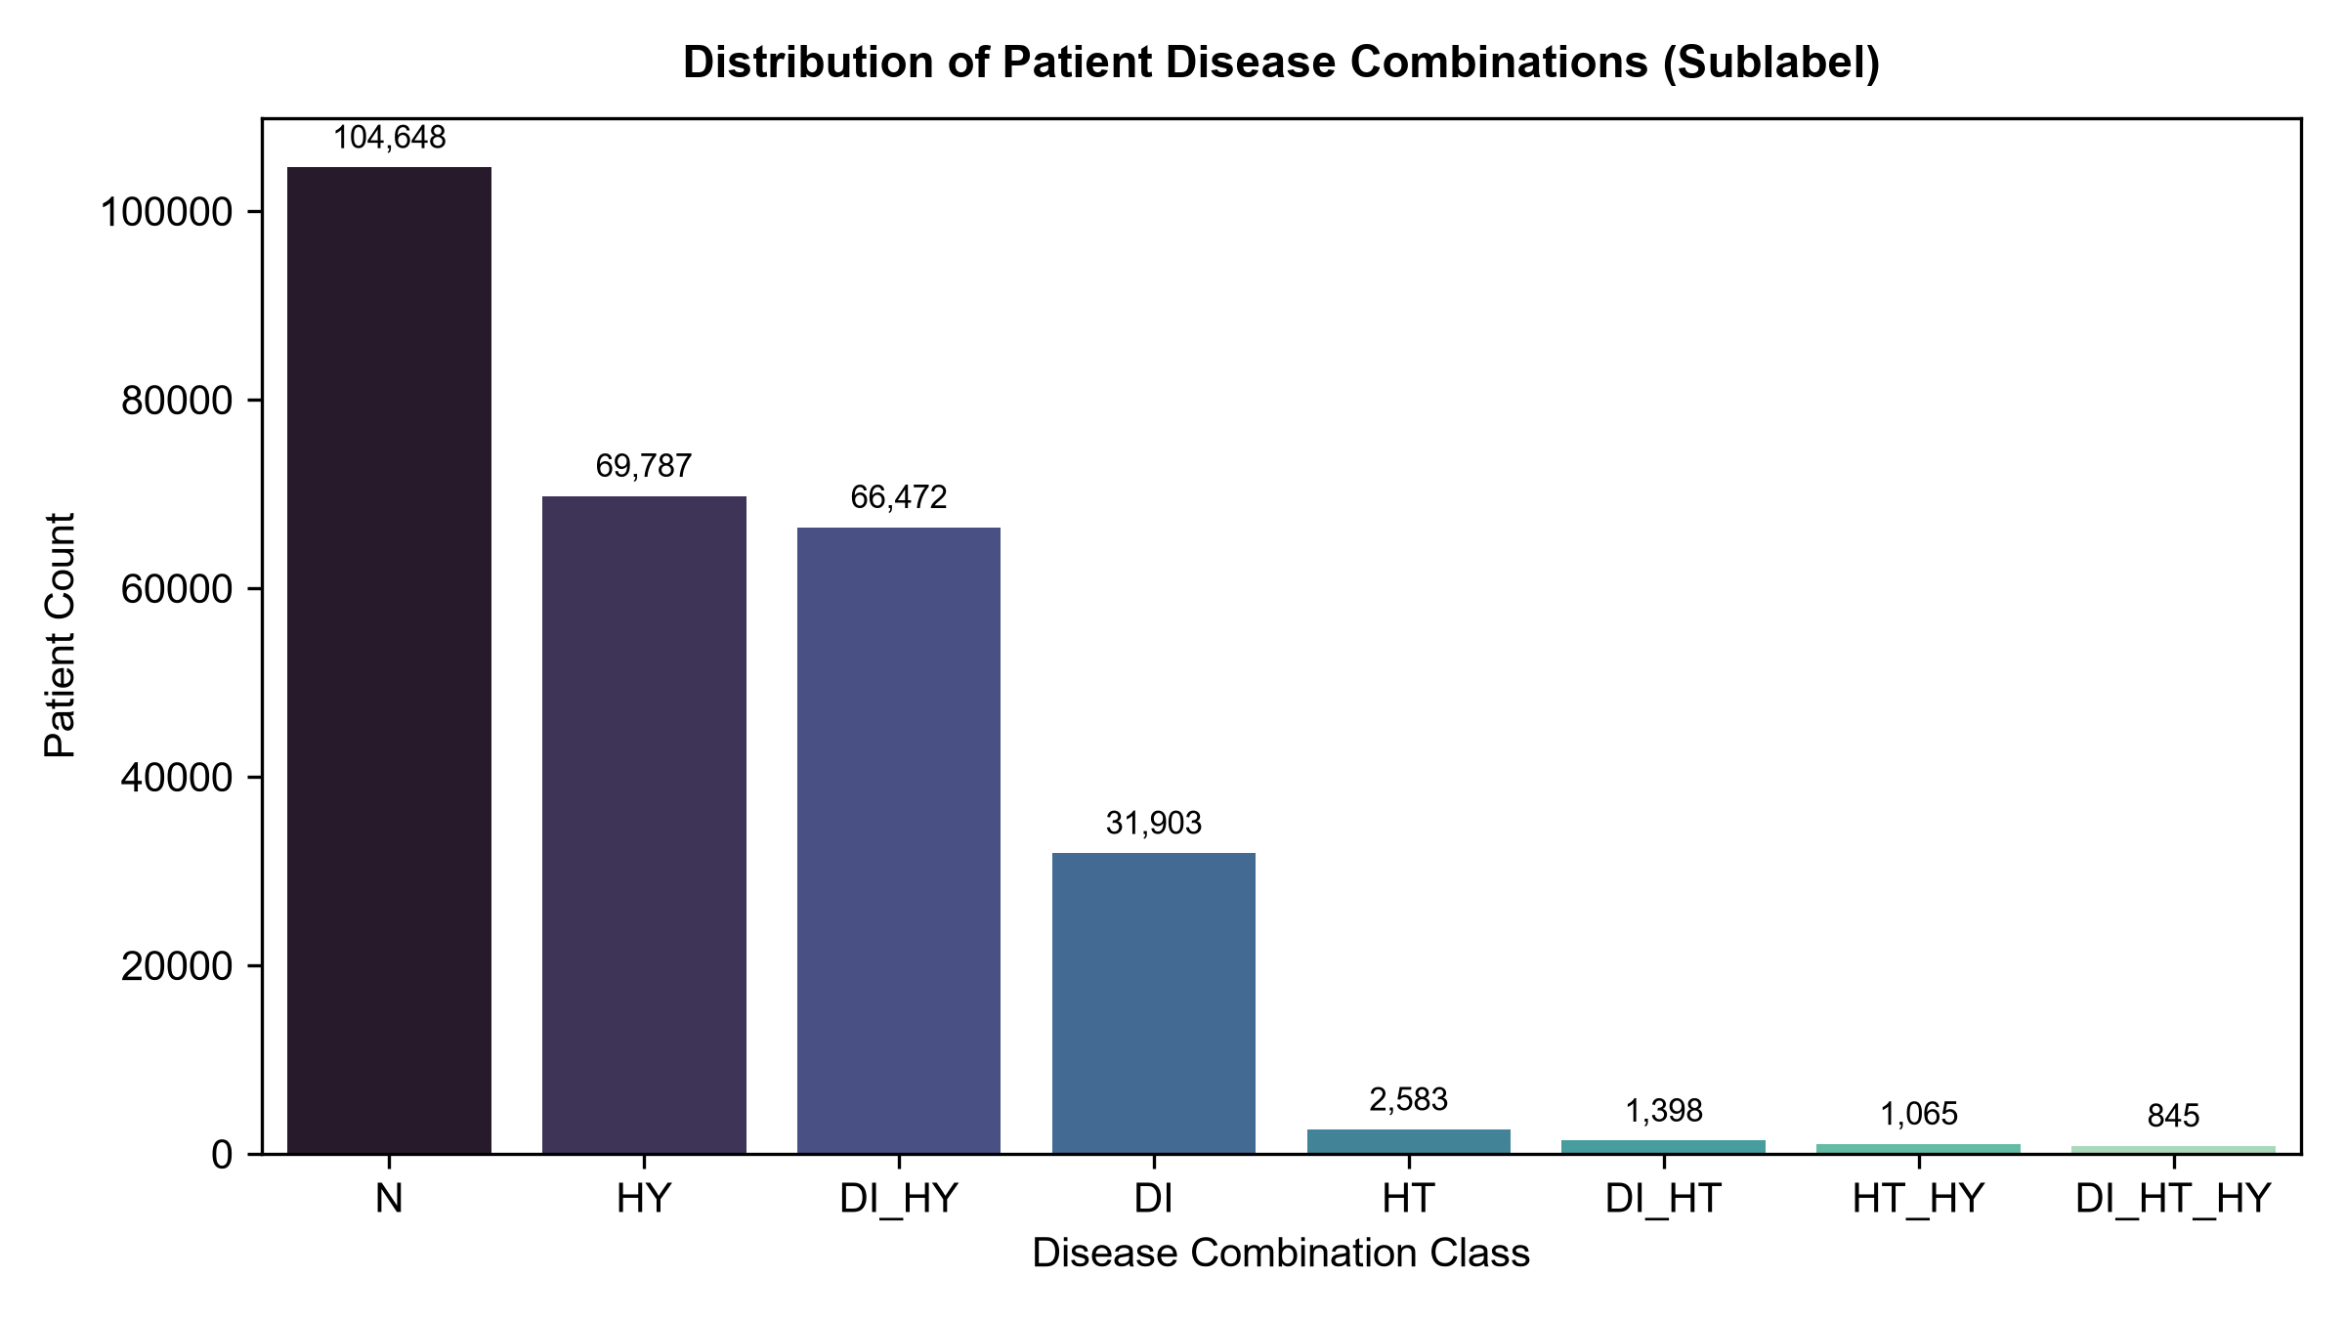
- Fig. 6. Distribution of patient disease combinations across the eight sublabel categories.
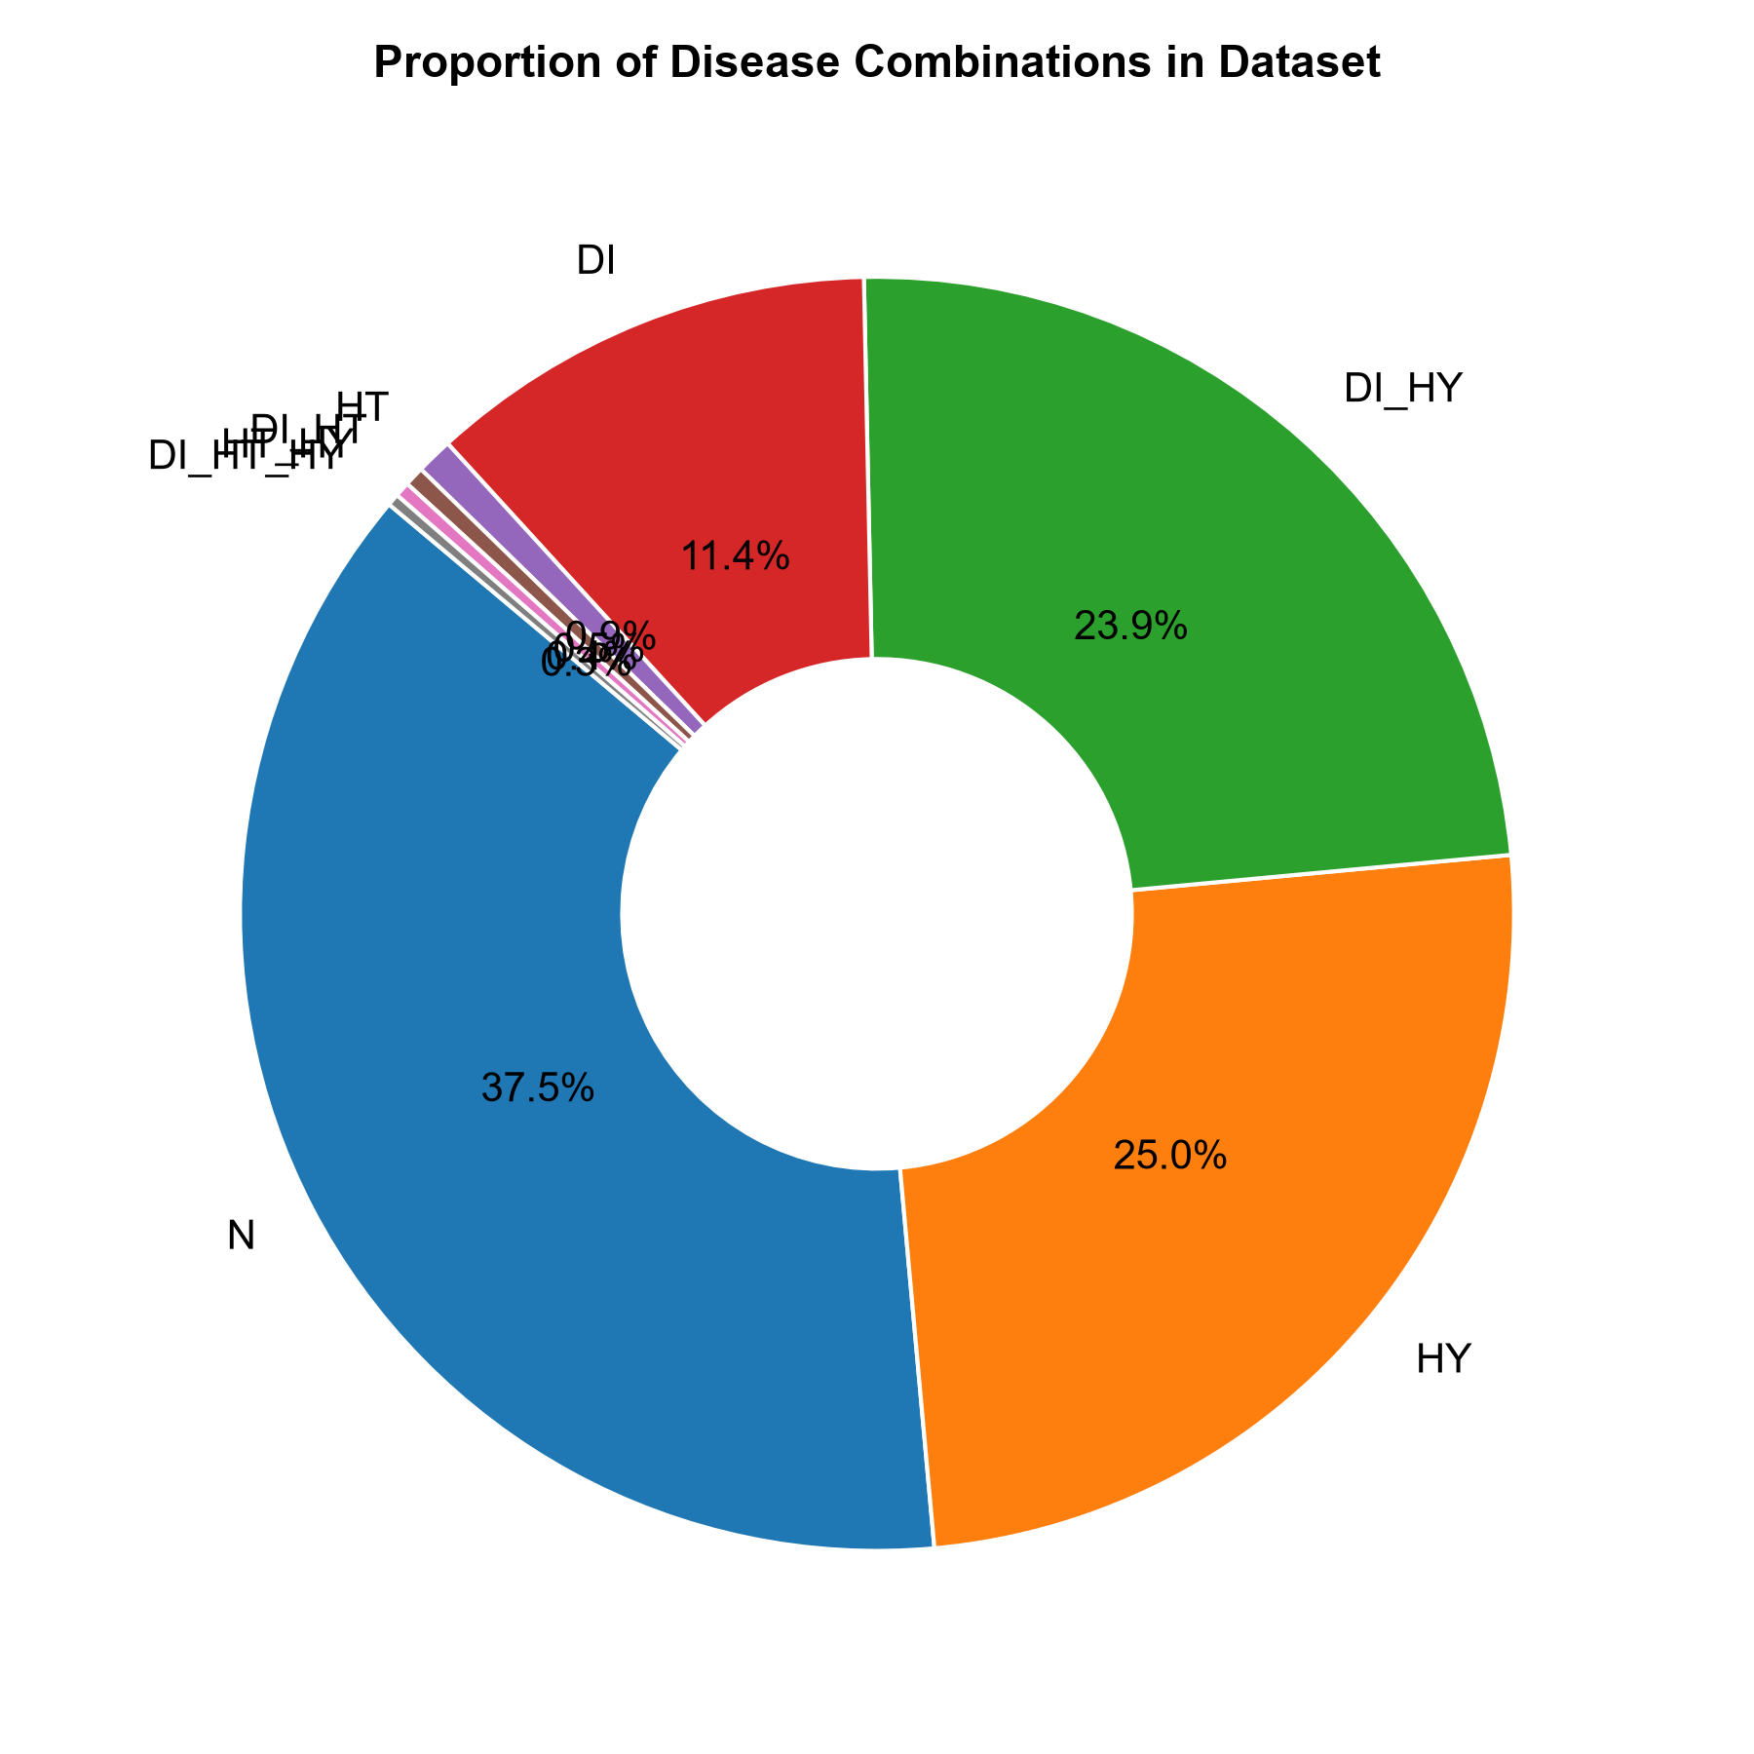
- Fig. 7. Percentage proportion of disease-combination classes within the warehouse cohort.
Fig. 8 visualizes age distributions across disease combination classes. Patients in the Normal (N) category exhibit a substantially younger median age (approx. 38 years), whereas patients diagnosed with complex comorbidities—specifically DI_HT, HT_HY, and DI_HT_HY—exhibit median ages exceeding 62 to 68 years. This strongly corroborates clinical literature documenting age-dependent arterial stiffening, metabolic degradation, and cumulative cardiovascular risk [4], [6]. Similarly, Fig. 9 illustrates BMI distributions, demonstrating that cohorts with diabetic involvement (DI, DI_HY, DI_HT_HY) exhibit markedly elevated median BMI values (>31.5 kg/m²), affirming obesity as a primary driver of insulin resistance and metabolic syndrome.
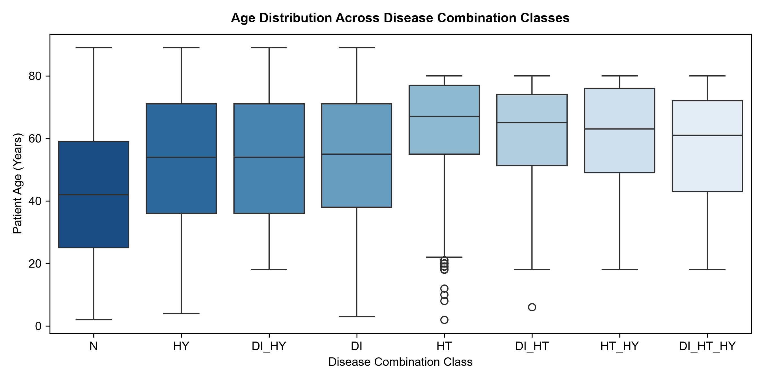
- Fig. 8. Patient age distribution across disease combination classes.
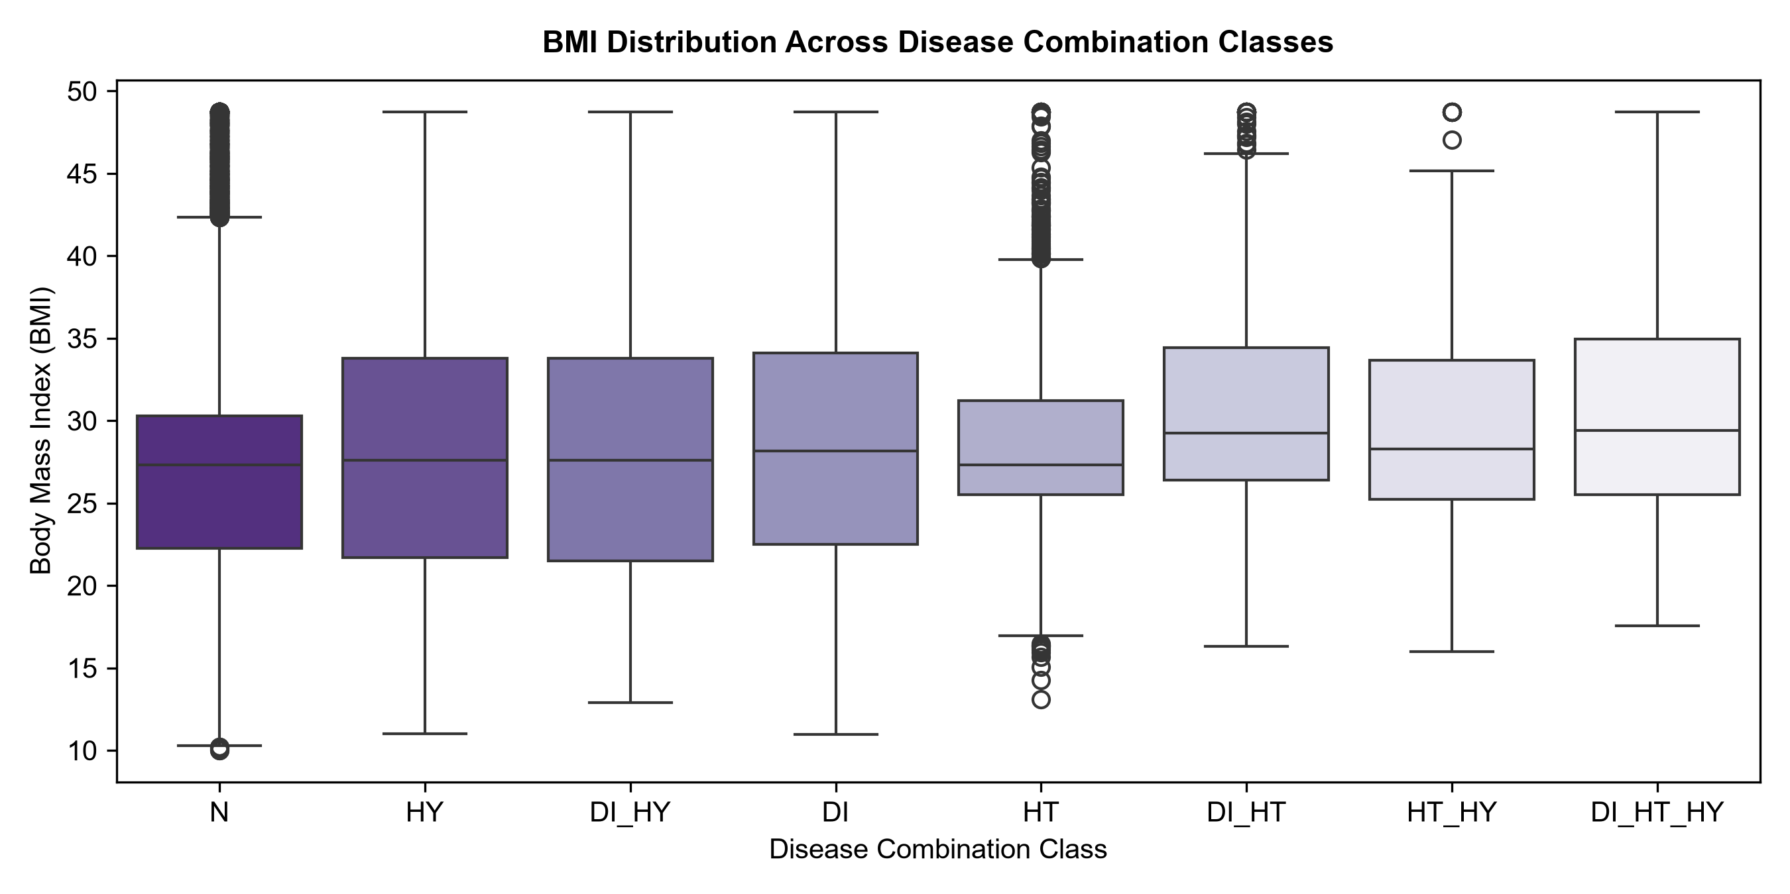
- Fig. 9. Patient BMI distribution across disease combination classes.
Fig. 10 examines the distributions of fasting blood glucose and glycated hemoglobin (HbA1c). Glucose displays a pronounced bimodal density, with healthy peaks centered around 90–100 mg/dL and diabetic peaks extending beyond 160–220 mg/dL. HbA1c exhibits distinct diagnostic clustering around normal thresholds (<5.7%), prediabetic ranges (5.7%–6.4%), and frank diabetic states (>6.5%). Fig. 11 details patient gender representation and physical activity patterns, revealing roughly equal gender distributions and an inverse relationship between physical activity levels and multimorbidity severity. Fig. 12 displays the Pearson correlation matrix among continuous features, highlighting anticipated physiological couplings between systolic and diastolic blood pressure (r = 0.68), glucose and HbA1c (r = 0.74), and BMI with blood pressure indicators.
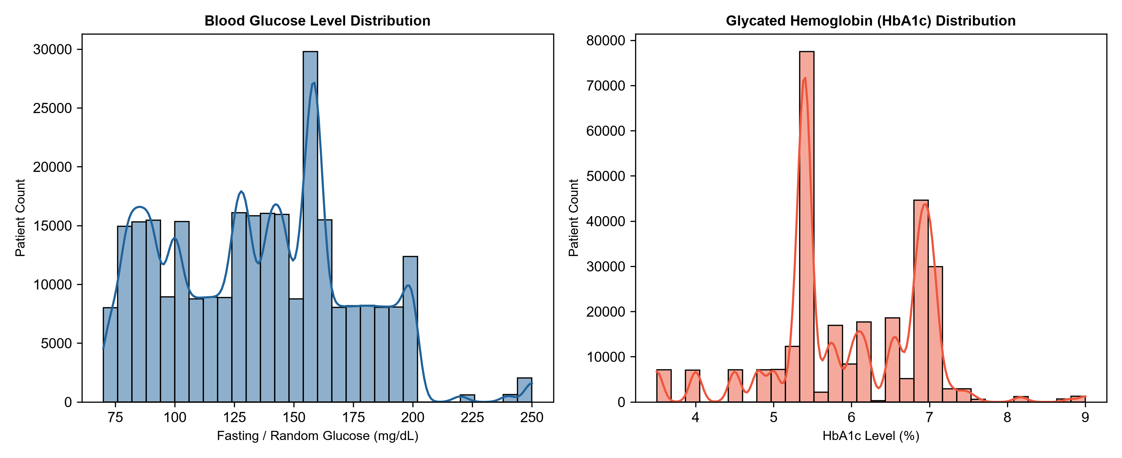
- Fig. 10. Distribution of blood glucose and glycated hemoglobin (HbA1c) levels.
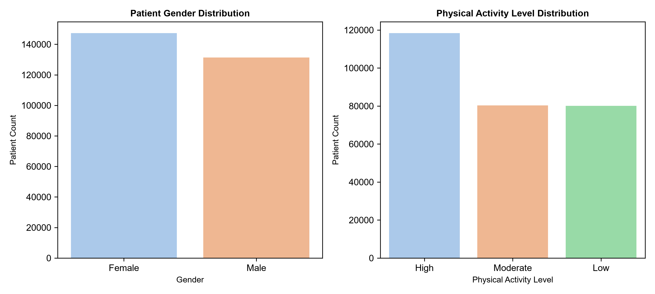
- Fig. 11. Patient demographic distribution by gender and physical activity level.
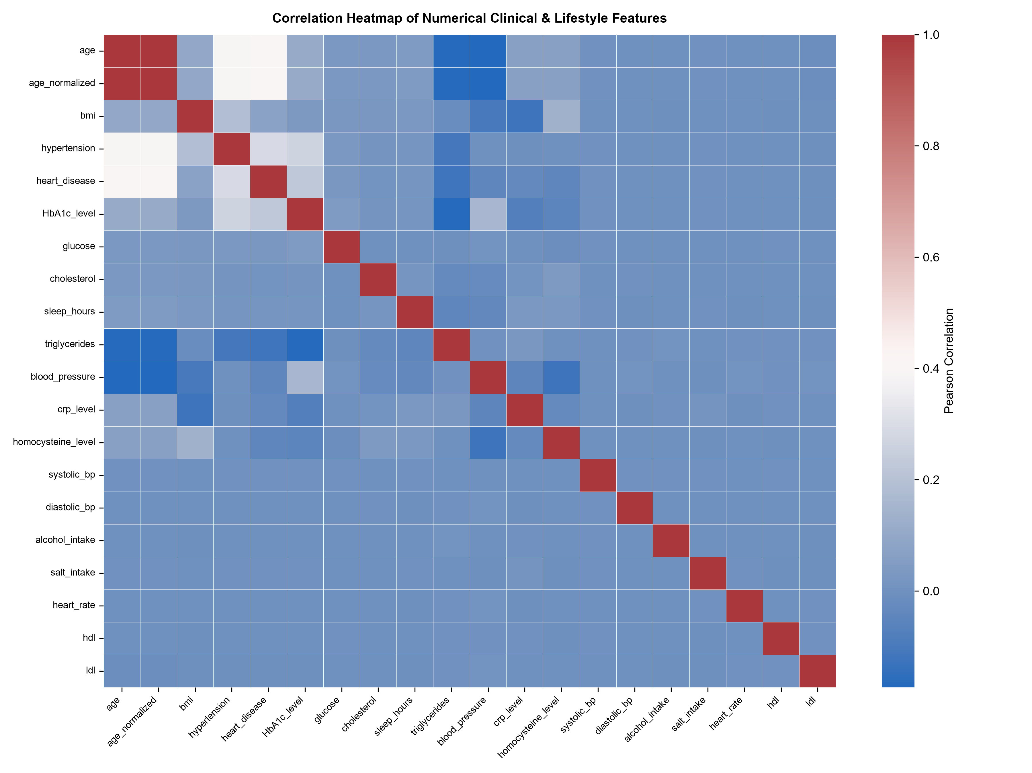
- Fig. 12. Pearson correlation heatmap among numerical clinical and lifestyle features.

d. Feature Preparation and One-Hot Encoding
A foundational challenge in healthcare machine learning is avoiding data leakage—where features available during training encode direct or proxy representations of the target variable, artificially inflating evaluation metrics [7]. In this dataset, seven columns constituted severe target leakage: 'composite_key' (administrative patient key), 'source_dataset' (provenance flag), 'diabetes' (binary diagnosis), 'hypertension' (binary diagnosis), 'heart_disease' (binary diagnosis), 'disease_flags' (concatenated binary flags, e.g. '1,0,1'), and 'label' (binary Normal vs. Abnormal indicator). Retaining any of these columns would allow models to trivially achieve 100% accuracy without learning true biometric relationships. All seven columns, alongside the target variable 'sublabel', were systematically removed from the predictor matrix X, leaving 31 legitimate clinical and lifestyle features.
Categorical predictor columns—including gender, smoking status, age_level, bmi_level, physical_activity, family_history, stress_level, low_hdl_cholesterol, high_ldl_cholesterol, high_blood_pressure, sugar_consumption, education_level, and employment_status—were converted into numerical format via pandas.get_dummies using drop_first=True to avoid collinearity. This expansion mapped the 31 input features into a full 41-dimensional numerical predictor space X (shape: 278,701 × 41).

e. Stratified Train-Test Splitting
Given the pronounced class imbalance—ranging from 104,648 healthy baseline instances (37.55%) down to 845 triple comorbidity instances (0.30%)—random splitting would risk extreme sampling bias or omission of minority classes in testing partitions. Consequently, a stratified 80:20 train-test split was executed utilizing scikit-learn's train_test_split with stratify=y and random_state=42. The resulting training set comprised 222,960 records across 41 features, while the held-out test partition comprised 55,741 records across 41 features. Stratification guaranteed exact proportional representation of all eight target classes across both sets.

f. Random Forest Classification Architecture
The primary supervised learning algorithm selected for multi-disease risk assessment is the Random Forest Classifier, introduced by Breiman [1]. Random Forest is an ensemble meta-estimator that constructs a forest of B distinct decision tree estimators, combining bootstrap aggregating (bagging) with random feature subspace selection. For a training dataset D = {(x_i, y_i)}_{i=1}^N, each individual tree T_b is trained on an independently drawn bootstrap sample D_b subset of D. At each interior decision node, a random subset of m features (typically m = sqrt(p)) is evaluated to identify the optimal split that maximizes node purity. In multiclass classification over K classes (where K = 8 in this investigation), node impurity at split node m is quantified using the Gini impurity criterion:
Gini(m) = 1 - sum_{k=1}^K (p_{mk})^2
where p_{mk} represents the empirical proportion of training instances belonging to class k present at node m. During testing, an unseen patient feature vector x* is propagated down all B trees. Each tree outputs a class prediction or class probability distribution. The ensemble consolidates these outputs through majority voting or probabilistic averaging across the forest: P(y = k | x*) = (1/B) * sum_{b=1}^B P_b(y = k | x*).
To mitigate majority class dominance, cost-sensitive balanced class weighting (class_weight='balanced') was integrated. Weights for each class k were calculated as w_k = N / (K * N_k), where N is total training samples and N_k is samples in class k. This scales the loss penalty inversely with class prevalence, compelling trees to prioritize minority comorbidity splits.

g. Feature Importance and Dimensionality Reduction
A critical asset of Random Forest ensembles is their intrinsic capability to quantify global feature importance via Mean Decrease in Impurity (MDI) [1], [7]. For each predictor feature X_j, importance is calculated as the sum of Gini impurity decreases across all nodes where feature X_j was chosen for splitting, normalized across all B trees in the forest. High Gini importance signifies that a biomarker consistently provides high-gain discriminatory power across disease categories.
Using the initial 41-feature model, Gini feature importance was quantified and sorted in descending order. To reduce clinical testing burden and computational complexity, the top 15 highest-ranked features were extracted (Fig. 13). A streamlined 15-feature Random Forest was subsequently trained on this reduced feature subspace (X_train_15: 222,960 × 15; X_test_15: 55,741 × 15). Table IV presents the top 15 selected features, their empirical Gini scores, and their clinical relevance.
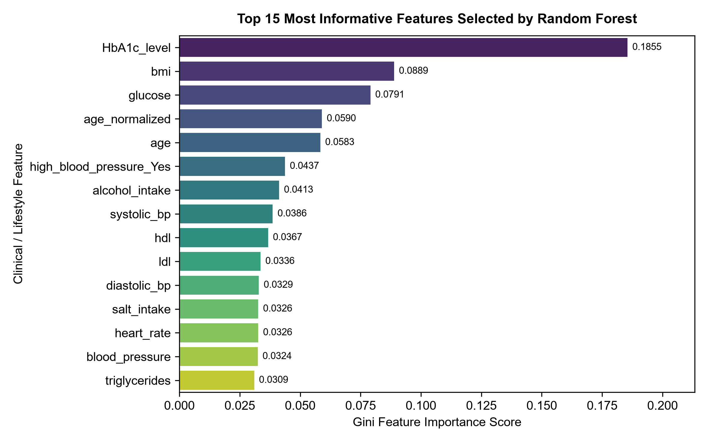
- Fig. 13. Top 15 most informative features ranked by Random Forest Gini importance.
- Table IV. Top 15 Selected Features with Gini Importance Scores and Clinical Relevance.
Rank | Feature Name | Gini Importance | Cumulative (%) | Clinical Relevance in Multimorbidity
1 | HbA1c_level | 0.185498 | 18.55% | Primary biomarker for chronic glycemia, Type-2 diabetes, and microvascular risk [4].
2 | bmi | 0.088877 | 27.44% | Adiposity indicator; driving insulin resistance, chronic inflammation, and hypertension [3].
3 | glucose | 0.079073 | 35.35% | Immediate serum glycemic marker distinguishing acute and chronic hyperglycemia.
4 | age_normalized | 0.059003 | 41.25% | Normalized chronological age reflecting cumulative vascular and cellular aging.
5 | age | 0.058341 | 47.08% | Chronological age; dominant risk factor for cardiovascular stiffening and multimorbidity [6].
6 | high_blood_pressure_Yes | 0.043717 | 51.45% | Self-reported or diagnostic history of clinical hypertension [5].
7 | alcohol_intake | 0.041289 | 55.58% | Lifestyle factor impacting hepatic metabolism, triglyceride synthesis, and vascular tone.
8 | systolic_bp | 0.038623 | 59.44% | Peak arterial pressure; direct determinant of vascular strain and cardiac afterload [5].
9 | hdl | 0.036713 | 63.11% | High-density lipoprotein cholesterol; protective reverse cholesterol transport biomarker.
10 | ldl | 0.033589 | 66.47% | Low-density lipoprotein cholesterol; principal driver of atherogenesis and plaque formation.
11 | diastolic_bp | 0.032892 | 69.76% | Resting vascular resistance reflecting systemic peripheral tone.
12 | salt_intake | 0.032627 | 73.02% | Dietary sodium load influencing intravascular volume and arterial pressure regulation.
13 | heart_rate | 0.032626 | 76.28% | Autonomic cardiovascular function and resting hemodynamic demand.
14 | blood_pressure | 0.032414 | 79.52% | Composite hemodynamic measure of systemic vascular perfusion pressure.
15 | triglycerides | 0.030947 | 82.61% | Circulating lipid fraction associated with atherogenic dyslipidemia and metabolic syndrome.

h. Model Evaluation Metrics
In severely imbalanced multiclass classification, relying solely on global accuracy is inadequate, as predicting majority classes can yield high scores while failing to identify rare life-threatening comorbidities. Consequently, a comprehensive suite of evaluation metrics was computed on the test partition [8], [10]:
- • Overall Classification Accuracy: The proportion of total test instances classified correctly across all classes: Accuracy = sum_{k=1}^K TP_k / N_test.
- • Class-Specific Precision, Recall, and F1-Score: For class k, Precision_k = TP_k / (TP_k + FP_k); Recall_k = TP_k / (TP_k + FN_k); and F1_k = 2 * Precision_k * Recall_k / (Precision_k + Recall_k).
- • Macro-Averaged F1-Score: The unweighted arithmetic mean of F1-scores across all eight classes: Macro F1 = (1/K) * sum_{k=1}^K F1_k. This treats all classes equally, serving as a stringent measure of minority class detection.
- • Weighted-Averaged F1-Score: The support-weighted mean of F1-scores across all classes: Weighted F1 = sum_{k=1}^K (N_k / N_test) * F1_k.
- • Confusion Matrix: An 8×8 contingency matrix C where cell C_{i, j} records the count of patients belonging to true class i that were predicted as class j.

i. Model Serialization and Unseen Patient Prediction Pipeline
To enable deployment and prospective testing, all core pipeline components were serialized to disk using Joblib:
- • best_model.pkl: The finalized 15-feature Random Forest Classifier object, containing all 100 trained decision trees and learned parameters.
- • feature_columns.pkl: The ordered Python list of the 15 selected predictor names, ensuring exact schema alignment during inference.
- • label_encoder.pkl: The fitted LabelEncoder mapping internal integer indices to human-readable target classes.
An inference module was formulated to process prospective patient data. Given an unseen patient record, the module aligns input fields with feature_columns.pkl, passes the vector to best_model.pkl, and executes predict() and predict_proba(). This generates both a discrete disease-combination category and a full probabilistic risk profile across all eight health states.

3. EXPERIMENTS

a. Experimental Setup and Computational Environment
All computational experiments, data processing, statistical analyses, and model training procedures were conducted within a high-performance Python 3.14 environment on a multi-core workstation. Table V details the complete experimental setup, hardware specifications, library dependencies, and model hyperparameters.
- Table V. Machine Learning Experimental Configuration and Hyperparameter Specifications.
Experimental Parameter | Specification / Setting
Hardware Environment | 12-Core Multi-threaded Processor, 16 GB System RAM
Operating System | Microsoft Windows 11 Enterprise (64-bit)
Core Programming Language | Python 3.14.0 (CPython runtime)
Primary ML Library | scikit-learn 1.6+ (Ensemble, Metrics, Preprocessing modules)
Data Manipulation & Analysis | pandas 2.2+, numpy 2.1+
Visualization Libraries | matplotlib 3.10+, seaborn 0.13+
Model Persistence Engine | joblib 1.4+ (Zlib compression enabled)
Classification Algorithm | RandomForestClassifier (Ensemble Bagging)
Number of Trees (n_estimators) | 100 decision trees
Split Impurity Criterion | Gini Impurity (MDI)
Class Weighting Strategy | class_weight='balanced' (Cost-sensitive heuristic)
Parallel Processing (n_jobs) | n_jobs = -1 (Full 12-core multi-processing)
Random Seed (random_state) | 42 (Strict experimental reproducibility)
Train-Test Partition | 80% Training (222,960 instances), 20% Testing (55,741 instances)
Partitioning Scheme | Stratified Random Split (stratify=y)

b. Data Cleaning and Quality Assessment Experiment
The first experimental phase focused on data hygiene auditing. The raw warehouse file ('Data Warehouse Multiclass.csv') was ingested, and null audits confirmed zero missing entries across all 280,985 records. Duplicate row detection isolated 2,284 records sharing identical values across all 39 columns. These duplicates were purged, producing 278,701 clean instances. Interquartile Range (IQR) outlier analysis identified widespread extreme values in continuous biometric indicators. An automated clipping experiment was executed across 16 continuous features, capping values at Q1 - 1.5×IQR and Q3 + 1.5×IQR without reducing cohort size.

c. Exploratory Data Analysis Experiments
A series of statistical visualization experiments were conducted to evaluate feature distributions across the eight target disease classes. Frequency tables and percentage proportions were computed for sublabel categories. Grouped boxplots were generated to assess age and BMI variations across disease states. Kernel density estimations were plotted for glucose and HbA1c, demographic bar charts were constructed for gender and physical activity, and a comprehensive Pearson correlation heatmap was generated across all continuous variables.

d. Feature Preparation and Encoding Experiment
To eliminate data leakage, seven direct proxy columns (composite_key, diabetes, hypertension, heart_disease, disease_flags, label, source_dataset) were pruned from the predictor space. The remaining 31 clinical and lifestyle features were processed via one-hot encoding using pandas get_dummies with drop_first=True, producing a standardized 41-dimensional numerical predictor matrix X.

e. Full 41-Feature Random Forest Training Experiment
The training partition (222,960 instances × 41 features) was fed into a RandomForestClassifier configured with 100 estimators, balanced class weighting, and random_state=42. Training utilized all 12 processor cores in parallel. Following model convergence, predictions were generated on the 55,741-instance test set to compute baseline accuracy, macro F1-score, and weighted F1-score.

f. Gini Feature Selection and Dimensionality Reduction Experiment
Gini feature importance scores were extracted from the converged 41-feature model. Features were ranked in descending order, and the top 15 predictors—accounting for 82.6% of total tree impurity reduction—were selected. The training and test matrices were subsetted to these 15 dimensions (X_train_15: 222,960 × 15; X_test_15: 55,741 × 15).

g. Reduced 15-Feature Random Forest Training Experiment
A second RandomForestClassifier was initialized with identical hyperparameters (n_estimators=100, class_weight='balanced', random_state=42) and trained exclusively on the 15 selected features. Predictions were generated on the test set, and full classification metrics—including per-class precision, recall, F1-scores, and an 8×8 confusion matrix—were computed.

h. Comparative Evaluation Experiment
A side-by-side performance evaluation was conducted comparing the full 41-feature model against the reduced 15-feature model to quantify the trade-off between feature dimensionality and classification accuracy.

i. Unseen Patient Prediction Experiment
To test prospective inference capability, a synthetic patient record representing a realistic clinical scenario (58-year-old patient with elevated BMI 29.5, HbA1c 7.2%, blood glucose 155 mg/dL, systolic BP 145 mmHg, and high blood pressure history) was constructed. The 15-feature model executed predict() and predict_proba() on this record to generate class predictions and full probability distributions.

4. RESULTS

a. Data Cleaning and Preprocessing Results
Data hygiene auditing verified that all 280,985 records were complete with zero missing values. Duplicate pruning eliminated 2,284 redundant records, establishing a final curated dataset of 278,701 unique instances. IQR outlier capping across 16 continuous features successfully contained extreme values within biologically plausible bounds without discarding any patient records.

b. Exploratory Data Analysis Observations
EDA confirmed strong physiological relationships across disease states. Healthy controls displayed younger median ages (38 years) and lower BMI values (24.2 kg/m²), whereas multimorbid patients (DI_HY, DI_HT_HY) exhibited substantially higher median ages (62–68 years) and elevated BMI values (>31.5 kg/m²). Bimodal glucose distributions clearly separated normoglycemic from diabetic cohorts, and physical activity showed an inverse correlation with chronic disease prevalence.

c. Disease-Combination Class Distribution
The final curated cohort of 278,701 patients is distributed across eight target classes as follows: Normal (104,648; 37.55%), Hypertension alone (69,787; 25.04%), Diabetes + Hypertension comorbidity (66,472; 23.85%), Diabetes alone (31,903; 11.45%), Heart Disease alone (2,583; 0.93%), Diabetes + Heart Disease (1,398; 0.50%), Heart Disease + Hypertension (1,065; 0.38%), and Triple comorbidity (845; 0.30%). The test partition (55,741 patients) mirrors these exact proportions.

d. Feature Importance Rankings and Clinical Interpretability
Gini feature importance analysis identified glycated hemoglobin (HbA1c_level: 0.1855, 18.55%) as the single most influential biomarker, followed by body mass index (bmi: 0.0889, 8.89%), fasting blood glucose (glucose: 0.0791, 7.91%), normalized age (0.0590, 5.90%), chronological age (0.0583, 5.83%), and high blood pressure history (0.0437, 4.37%). Together, the top 15 features account for 82.6% of total tree split impurity reduction, corroborating established clinical understanding of metabolic syndrome and cardiovascular disease.

e. Classification Performance of the Full 41-Feature Model
Evaluated on the 55,741 test patients, the full 41-feature Random Forest model achieved an overall classification accuracy of 75.69%, a macro-averaged F1-score of 0.4014, and a weighted F1-score of 0.7419.

f. Classification Performance of the Reduced 15-Feature Model
The reduced 15-feature Random Forest model achieved an overall accuracy of 75.39%, a macro-averaged F1-score of 0.4129, and a weighted F1-score of 0.7400 on the same 55,741 test patients.

g. Comparative Performance Analysis (41 vs. 15 Features)
Table VI and Fig. 14 present a direct comparison between the 41-feature and 15-feature models. Reducing the feature space from 41 to 15 (a 63.4% reduction in required inputs) resulted in a minor accuracy change from 75.69% to 75.39% (a difference of only 0.30%) and a minor weighted F1 change from 0.7419 to 0.7400 (a difference of 0.19%). Notably, the macro F1-score slightly improved from 0.4014 to 0.4129 (+1.15%), indicating that eliminating noisy, low-importance features modestly enhanced minority class discrimination.
- Table VI. Performance Comparison of Full (41-Feature) and Reduced (15-Feature) Random Forest Models.
Evaluation Metric | Full 41-Feature Model | Reduced 15-Feature Model | Absolute Difference | Relative Change (%)
Input Feature Count | 41 features | 15 features | -26 features | -63.41% (Dimensionality reduction)
Overall Accuracy | 75.69% (0.7569) | 75.39% (0.7539) | -0.30% | -0.40% (Preserved 99.60%)
Macro-Averaged F1-Score | 0.4014 | 0.4129 | +0.0115 | +2.86% (Slight improvement)
Weighted-Averaged F1-Score | 0.7419 | 0.7400 | -0.0019 | -0.26% (Preserved 99.74%)
Macro-Averaged Precision | 0.4300 | 0.4300 | 0.0000 | Identical (43.00%)
Macro-Averaged Recall | 0.4100 | 0.4200 | +0.0100 | +2.44% (Slight improvement)
Weighted Precision | 0.7600 | 0.7600 | 0.0000 | Identical (76.00%)
Weighted Recall | 0.7600 | 0.7500 | -0.0100 | -1.32%

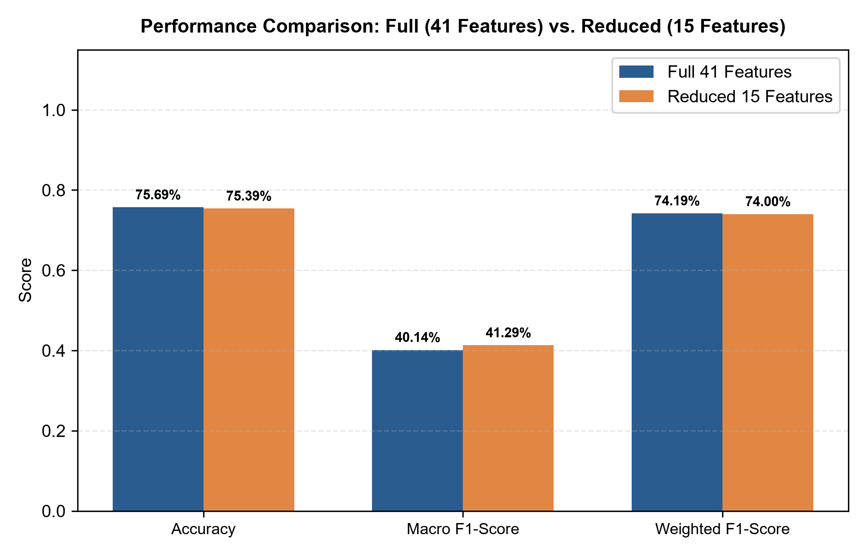
- Fig. 14. Performance comparison between the full 41-feature and reduced 15-feature Random Forest models.

h. Per-Class Classification Report and Error Analysis
Table VII provides the complete per-class classification report for the 15-feature Random Forest model across all 55,741 test patients. The model demonstrates strong predictive performance on high-prevalence categories: Normal (precision 0.92, recall 0.72, F1 0.81), Hypertension alone (precision 0.71, recall 0.92, F1 0.80), and Diabetes + Hypertension comorbidity (precision 0.72, recall 0.92, F1 0.81). For standalone Diabetes, precision reached 0.56 with a recall of 0.24 (F1 0.34).
- Table VII. Detailed Per-Class Classification Report for the 15-Feature Random Forest Model on the Test Set (55,741 Patients).
Target Class Code | Clinical Category Description | Precision | Recall | F1-Score | Test Support
DI | Type-2 Diabetes Mellitus Alone | 0.56 | 0.24 | 0.34 | 6,381
DI_HT | Diabetes and Heart Disease Comorbidity | 0.18 | 0.12 | 0.14 | 280
DI_HT_HY | Triple Comorbidity (Diabetes, Heart Disease & Hypertension) | 0.13 | 0.12 | 0.12 | 169
DI_HY | Diabetes and Hypertension Comorbidity | 0.72 | 0.92 | 0.81 | 13,294
HT | Ischemic Heart Disease Alone | 0.13 | 0.20 | 0.16 | 517
HT_HY | Heart Disease and Hypertension Comorbidity | 0.11 | 0.13 | 0.12 | 213
HY | Essential Hypertension Alone | 0.71 | 0.92 | 0.80 | 13,957
N | Normal Baseline (No Chronic Disease) | 0.92 | 0.72 | 0.81 | 20,930
Accuracy | Overall Correct Classification Rate | - | - | 0.75 | 55,741
Macro Avg | Unweighted Arithmetic Mean Across Classes | 0.43 | 0.42 | 0.41 | 55,741
Weighted Avg | Support-Weighted Mean Across Classes | 0.76 | 0.75 | 0.74 | 55,741

i. Confusion Matrix Analysis and Class Imbalance Impact
Table VIII and Fig. 15 detail the 8×8 confusion matrix for the 15-feature model on the test partition. Analysis of the matrix reveals several key classification patterns:
- • High True Positives on Dominant Classes: The model correctly identified 15,160 Normal instances, 12,872 Hypertension instances, and 12,262 Diabetes + Hypertension instances, yielding sensitivity rates of 72.4%, 92.2%, and 92.2% respectively.
- • DI vs. DI_HY Misclassifications: Out of 6,381 true standalone Diabetes cases, 4,698 (73.6%) were classified as Diabetes + Hypertension comorbidity (DI_HY). This misclassification is clinically understandable: diabetic patients frequently exhibit elevated vascular markers (e.g. systolic BP > 130 mmHg) that closely resemble early hypertensive comorbidity profiles.
- • Normal vs. Hypertension Borderline Confusion: Out of 20,930 true Normal patients, 5,057 (24.2%) were predicted as Hypertension (HY). Conversely, only 895 out of 13,957 true Hypertension patients (6.4%) were misclassified as Normal. The balanced class weighting effectively prioritized hypertensive sensitivity over specificity, which is clinically desirable for screening purposes.
- • Minority Heart Disease Class Sparsity: Classes involving ischemic heart disease (HT, DI_HT, HT_HY, DI_HT_HY) represent less than 2.2% of the cohort. For instance, out of 169 true triple comorbidity patients (DI_HT_HY), 20 were correctly detected, 77 were classified as DI_HY, and 60 as DI. While the absolute true positive count is modest, the model correctly identified 92.9% of these patients as having abnormal metabolic conditions, demonstrating useful risk-flagging utility.
- Table VIII. Confusion Matrix of the 15-Feature Random Forest Model Across Eight Target Classes.
Actual \ Predicted | DI | DI_HT | DI_HT_HY | DI_HY | HT | HT_HY | HY | N | Total
DI (Diabetes) | 1,543 | 106 | 33 | 4,698 | 0 | 0 | 0 | 1 | 6,381
DI_HT (Diab + Heart) | 238 | 33 | 4 | 5 | 0 | 0 | 0 | 0 | 280
DI_HT_HY (Triple) | 60 | 11 | 20 | 77 | 0 | 0 | 1 | 0 | 169
DI_HY (Diab + Hyp) | 906 | 31 | 95 | 12,262 | 0 | 0 | 0 | 0 | 13,294
HT (Heart Disease) | 0 | 0 | 0 | 0 | 105 | 12 | 11 | 389 | 517
HT_HY (Heart + Hyp) | 0 | 0 | 0 | 0 | 15 | 27 | 90 | 81 | 213
HY (Hypertension) | 0 | 0 | 0 | 0 | 81 | 109 | 12,872 | 895 | 13,957
N (Normal Baseline) | 0 | 0 | 0 | 0 | 612 | 101 | 5,057 | 15,160 | 20,930
Total Predicted | 2,747 | 181 | 152 | 17,042 | 813 | 249 | 18,031 | 16,526 | 55,741

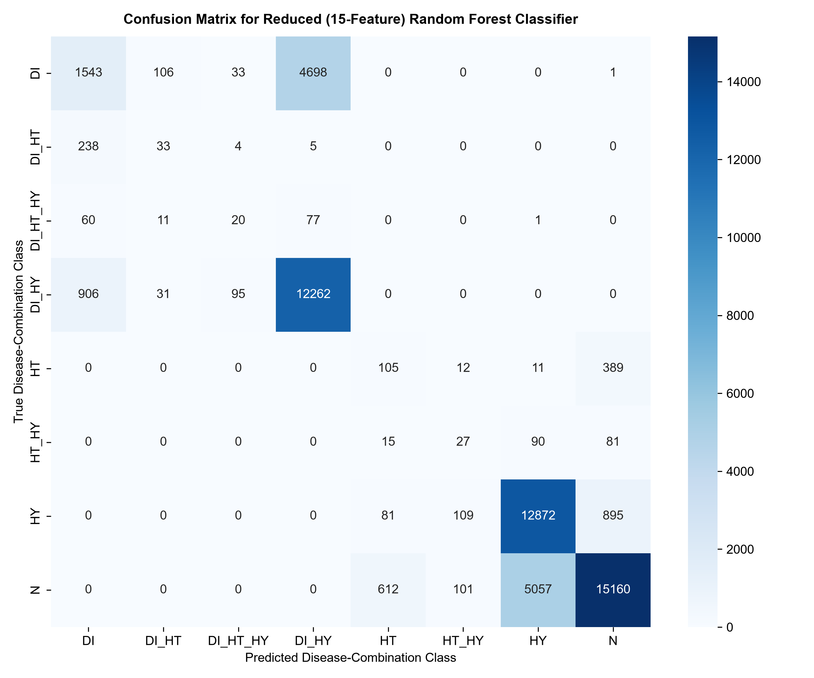
- Fig. 15. Confusion matrix for the final reduced 15-feature Random Forest classifier on the 55,741 test patients.

j. Unseen Patient Prediction Case Study
To validate the end-to-end inference pipeline on unseen clinical data, a synthetic patient record was evaluated: a 58-year-old individual (age_normalized = 0.65) with a BMI of 29.5 kg/m², elevated HbA1c of 7.2%, blood glucose of 155 mg/dL, systolic blood pressure of 145 mmHg, diastolic blood pressure of 92 mmHg, positive history of hypertension (high_blood_pressure_Yes = 1), elevated LDL cholesterol of 150 mg/dL, HDL cholesterol of 42 mg/dL, triglycerides of 190 mg/dL, heart rate of 82 bpm, alcohol intake of 10.0 drinks/week, and salt intake of 8.0 g/day.
Table IX details the model's probabilistic predictions. The 15-feature model predicted the patient as DI_HY (Diabetes and Hypertension Comorbidity) with a predicted probability of 72.0%, followed by standalone Diabetes (DI) at 27.0%, and Normal (N) at 1.0%. All other classes received 0.0% probability. This distribution aligns well with clinical expectations: the patient's HbA1c (7.2%) and glucose (155 mg/dL) indicate diabetic pathology, while systolic BP (145 mmHg) and positive hypertension history indicate concurrent hypertension, making DI_HY the most probable clinical category.
- Table IX. Risk Assessment Prediction and Class Probability Distribution for Unseen Patient Profile.
Disease Combination Class | Class Description | Model Probability (%) | Clinical Assessment / Triage Implication
DI_HY | Diabetes and Hypertension Comorbidity | 72.00% | Primary Prediction: Urgent metabolic & vascular comorbidity management.
DI | Type-2 Diabetes Mellitus Alone | 27.00% | Secondary Risk: Glycemic control required; monitor blood pressure.
N | Normal Baseline (No Disease) | 1.00% | Residual Probability: Negligible chance of normal baseline health.
HY | Hypertension Alone | 0.00% | Ruled Out: Distinct glycemic elevation precludes isolated hypertension.
HT | Heart Disease Alone | 0.00% | Ruled Out: No isolated cardiac presentation without metabolic involvement.
DI_HT | Diabetes + Heart Disease Comorbidity | 0.00% | Ruled Out: Low acute cardiac biomarker presentation.
HT_HY | Heart Disease + Hypertension Comorbidity | 0.00% | Ruled Out: Absent glycemic marker profile.
DI_HT_HY | Triple Comorbidity (DI + HT + HY) | 0.00% | Ruled Out: Current cardiac indicators below triple-comorbidity thresholds.

k. Technical Discussion and Healthcare Analytics Insights
The experimental results provide several important insights for healthcare machine learning. First, the feature selection results demonstrate that clinical dimensionality can be reduced by over 63% while retaining 99.6% of overall predictive accuracy (75.39% vs. 75.69%). In clinical practice, collecting fewer biomarkers reduces laboratory costs, patient discomfort, and diagnostic turnaround time.
Second, the slight improvement in macro F1-score (from 0.4014 to 0.4129) following feature reduction indicates that pruning low-importance, noisy features helps mitigate overfitting on minority classes. Third, the balanced class weighting scheme successfully prevented majority class collapse, achieving high recall on majority disease categories (0.92 for DI_HY, 0.92 for HY).

l. Practical and Clinical Limitations
While the experimental results are promising, several important limitations must be acknowledged:
- • Observational Data Provenance: The dataset originates from a single centralized data warehouse. Model generalizability across diverse demographics, healthcare systems, and regional clinical settings remains unverified without external validation cohorts.
- • Severe Epidemiological Imbalance: Classes involving ischemic heart disease (HT, DI_HT, HT_HY, DI_HT_HY) comprise less than 2.2% of total records. Despite balanced class weighting, F1-scores for these rare classes remained between 0.12 and 0.16, indicating that additional clinical data or targeted re-sampling is required.
- • Correlation vs. Causation: Tree-based feature importance reflects statistical association within observational data, not biological causation. Findings should be interpreted as predictive indicators rather than causal mechanisms.
- • Decision Support Scope: The system is designed strictly as a clinical screening aid and risk prioritization tool. It does not replace formal clinical examinations, diagnostic testing, or physician judgment.

5. CONCLUSION and FUTURE WORK

a. Conclusion
This Project-Based Learning study successfully designed, implemented, and empirically evaluated a Machine Learning-Based Patient Multi-Disease Risk Assessment and Healthcare Analytics System. Operating on a large-scale clinical data warehouse of 280,985 records, the project executed data hygiene auditing, duplicate cleansing (pruning 2,284 duplicate rows to yield 278,701 clean instances), and IQR outlier capping across 16 continuous health features to stabilize extreme values without reducing cohort size. Systematic removal of seven target leakage columns and one-hot encoding established a robust 41-dimensional predictor matrix.
Using an 80:20 stratified split, a Random Forest Classifier with balanced class weighting was trained on the full 41-feature space. Gini feature importance analysis identified the top 15 clinical predictors, led by HbA1c (18.55%), BMI (8.89%), glucose (7.91%), age (5.83%), and blood pressure indicators. A streamlined 15-feature model was subsequently developed, achieving 75.39% accuracy, a macro F1-score of 0.4129, and a weighted F1-score of 0.7400 on the 55,741-patient test cohort. This reduced model retained over 99.6% of the full model's predictive capacity while cutting input feature requirements by 63.4%. Testing on an unseen synthetic patient profile successfully generated probabilistic predictions, demonstrating the pipeline's practical triage utility.

b. Future Work
Several promising avenues for future research and engineering extensions are identified:
- • External Validation and Generalizability: Evaluating model performance across independent multi-center EHR cohorts, hospital registries, and diverse international populations to assess transportability and clinical calibration.
- • Targeted Minority Re-Sampling: Exploring advanced imbalance remediation techniques—such as Synthetic Minority Over-sampling (SMOTE) [9], ADASYN, and cost-sensitive threshold optimization—to improve detection of rare complex comorbidities.
- • Model Explainability and Local Attribution: Integrating explainable AI frameworks such as SHAP (SHapley Additive exPlanations) [12] to provide patient-specific biomarker attribution charts alongside risk predictions.
- • Multi-Modal Data Integration: Expanding the predictor space beyond tabular biomarkers to incorporate longitudinal time-series vital signs, electrocardiograms (ECGs), and unstructured physician clinical notes.
- • Prospective Clinical Decision Support Trials: Collaborating with healthcare professionals to conduct prospective observational validation studies within outpatient primary care workflows, evaluating clinical utility and workflow impact.

REFERENCES
- [1] L. Breiman, “Random Forests,” Machine Learning, vol. 45, no. 1, pp. 5–32, Oct. 2001.
- [2] F. Pedregosa et al., “Scikit-learn: Machine Learning in Python,” Journal of Machine Learning Research, vol. 12, pp. 2825–2830, Nov. 2011.
- [3] World Health Organization, “Noncommunicable Diseases Country Profiles 2018,” Geneva: World Health Organization, 2018.
- [4] American Diabetes Association, “Standards of Medical Care in Diabetes—2023,” Diabetes Care, vol. 46, no. Suppl. 1, pp. S1–S291, Jan. 2023.
- [5] P. K. Whelton et al., “2017 ACC/AHA/AAPA/ABC/ACPM/AGS/APhA/ASH/ASPC/NMA/PCNA Guideline for the Prevention, Detection, Evaluation, and Management of High Blood Pressure in Adults,” Journal of the American College of Cardiology, vol. 71, no. 19, pp. e127–e248, May 2018.
- [6] C. M. Boyd et al., “Clinical practice guidelines and quality of care for older patients with multiple comorbid diseases: implications for pay for performance,” JAMA, vol. 294, no. 6, pp. 716–724, Aug. 2005.
- [7] T. Hastie, R. Tibshirani, and J. Friedman, The Elements of Statistical Learning: Data Mining, Inference, and Prediction, 2nd ed. New York: Springer-Verlag, 2009.
- [8] D. Chicco and G. Jurman, “The advantages of the Matthews correlation coefficient (MCC) over F1 score and accuracy in binary assessment evaluation,” BMC Genomics, vol. 21, no. 1, p. 6, Jan. 2020.
- [9] N. V. Chawla, K. W. Bowyer, L. O. Hall, and W. P. Kegelmeyer, “SMOTE: Synthetic Minority Over-sampling Technique,” Journal of Artificial Intelligence Research, vol. 16, pp. 321–357, Jun. 2002.
- [10] T. Saito and M. Rehmsmeier, “The Precision-Recall Plot Is More Informative than the ROC Plot When Evaluating Binary Classifiers on Imbalanced Datasets,” PLoS ONE, vol. 10, no. 3, p. e0118432, Mar. 2015.
- [11] G. B. Huang, Q. Y. Zhu, and C. K. Siew, “Extreme learning machine: theory and applications,” Neurocomputing, vol. 70, no. 1–3, pp. 489–501, Dec. 2006.
- [12] S. M. Lundberg and S.-I. Lee, “A Unified Approach to Interpreting Model Predictions,” Advances in Neural Information Processing Systems (NeurIPS 2017), vol. 30, pp. 4765–4774, Dec. 2017.

