PROJECT DOCUMENTATION
DevSecOps Command Console
A Comprehensive Project Documentation
Department of Artificial Intelligence and Data Science
Academic Year 2026–2027

FACULTY MENTOR
Dr. P.Kalpana

TEAM MEMBERS : -

S. No. | Name | Roll Number
1 | Shirisha Mangalagiri | 2510080017
2 | Vishal Vadla | 2510080031
3 | Pallemoni Krishnavamshi | 2510080034
4 | Tejaswini Singam | 2510080049

KLH University

Project-Based Learning Documentation

Abstract
Modern continuous integration and deployment (CI/CD) environments rely extensively on automated command-line execution to orchestrate software builds, system provisioning, and infrastructure management. However, standard Linux interactive shells (such as Bash and Dash) operate under an implicit-trust execution paradigm where any accessible system command or arbitrary shell script can be invoked without pre-execution policy enforcement. This vulnerability introduces severe risks in modern DevSecOps pipelines, including unauthorized process spawning, destructive command execution, and malicious command chaining. To mitigate these vulnerabilities at the systems programming layer, this Project-Based Learning (PBL) report presents the design, implementation, and rigorous verification of the DevSecOps Command Console. Implemented entirely in modular C on Ubuntu Linux, the system establishes a secure command interpretation and execution architecture. The architecture integrates dynamic memory buffer management (malloc and realloc) to eliminate buffer overflow vectors, a lexical tokenizer for argument vector preparation, a dual-stage security validation layer enforcing shell metacharacter rejection and strict command allowlisting, in-process built-in execution (cd, pwd, clear, help, env, exit), and isolated external command invocation using fork, execvp, and waitpid. Additionally, standard file descriptor redirection (>, >>, <, 2>) is implemented through low-level dup2 system calls within child processes, asynchronous signals (SIGINT and SIGCHLD) are intercepted to ensure shell stability and prevent zombie process accumulation, and concurrent background health monitoring is sustained via detached POSIX threads (pthread_create). Advanced concurrency investigations from the curriculum explore mutex deadlock demonstration and strict lock-ordering prevention, alongside terminal job control primitives. Comprehensive verification using GCC, GDB, AddressSanitizer, and Valgrind confirms clean compilation, correct redirection, and zero memory leaks in core execution routines.
Keywords: DevSecOps, Linux Systems Programming, Command Console, Process Management, Input Validation, POSIX Threads, File Descriptor Redirection, Memory Management, Deadlock Prevention.

List of Figures
Figure 1: High-Level Modular System Architecture of DevSecOps Command Console 9
Figure 2: End-to-End Command Processing and Execution Pipeline 9
Figure 5: Parent-Child Process Lifecycle with fork(), execvp(), and waitpid() 10
Figure 6: Dual-Stage Security Validation Layer (Metacharacter Filtering and Command Allowlist) 11
Figure 7: File Descriptor Table and dup2() Redirection Workflow 12
Figure 8: POSIX Multithreading Architecture with Detached Background Health Monitor 12
Figure 9: Circular Wait Deadlock Formation and Resource Hierarchy Prevention Workflow 12
Figure 11: Compilation and Interactive Shell Execution in Ubuntu Linux Environment 13
Figure 12: Security Validation Layer Intercepting Unauthorized and Malformed Commands 14
Figure 13: Valgrind Dynamic Memory Diagnostic Report Demonstrating Zero Heap Leaks 14
Figure 14: File Descriptor Redirection Verification for Output, Input, and Standard Error 15

List of Tables
Table Number | Table Title | Page Number
Table 1 | System Hardware, Software, and Development Toolchain Specifications | 8
Table 2 | Modular Source File Structure and System Responsibilities | 9
Table 3 | Built-in Command Reference and Execution Primitives | 10
Table 4 | Command Allowlist Policy and Execution Entitlements | 10
Table 5 | System Redirection Syntax and File Descriptor Operations | 11
Table 6 | Valgrind Dynamic Memory Analysis and Heap Allocation Profile | 15
Table 7 | Comprehensive Functional Verification and Experimental Test Matrix | 17
Table 8 | Edge Case, Negative Testing, and Security Hardening Evaluation | 18
Table 9 | Implementation Status Comparison (Repository Verified vs. Curriculum Extensions) | 19

Table of Contents
Abstract ii
List of Figures iii
List of Tables iv
1. INTRODUCTION 6
1.1 Background and Context of Command-Line Interfaces 6
1.2 Problem Statement Addressed by DevSecOps Command Console 6
1.3 Motivation for Integrating Security into Command Pipelines 6
1.4 Project Objectives 7
1.5 Project Scope and Technical Boundaries 7
1.6 Significance as a Project-Based Learning Implementation 7
1.7 System Overview and Report Organization 7
2. METHODOLOGY 8
2.1 Incremental PBL Development Lifecycle (Weeks 1 to 10) 8
2.2 System Requirements and Development Environment 8
2.3 System Architecture and High-Level Design 9
2.4 Modular File Organization and Component Responsibilities 9
2.5 Dynamic Input Acquisition, Parsing, and Process Execution 10
2.6 Built-in Commands and Environment Variable Management 10
2.7 Security Layer Design: Sanitization and Allowlisting 11
2.8 Signal Interception and File Descriptor Redirection 11
2.9 Concurrency Architecture: Thread Monitor & Deadlock Prevention 12
2.10 Job Control Architecture and Process Groups 12
3. EXPERIMENTS 13
3.1 Foundation Setup, Dynamic Memory, and Lexical Parsing 13
3.2 Process Execution, Built-ins, and Signal Handling 13
3.3 Security Validation Layer and Memory Verification 14
3.4 File Redirection, POSIX Threads, and Deadlock Prevention 15
4. RESULTS 17
4.1 Comprehensive Experimental Test Matrix 17
4.2 Negative Testing, Edge Cases, and Memory Profile 18
4.3 Implementation Fidelity and Critical Discussion 18
5. CONCLUSION 20
5.1 Purpose and Architectural Overview 20
5.2 Verification of Major Implemented Subsystems 20
5.3 Attainment of Project Objectives and PBL Milestones 20
5.4 Key Technical and Pedagogical Learning Outcomes 20
5.5 Concluding Remarks 20
6. FUTURE WORK 21
6.1 Advanced Multi-Stage Command Pipelines 21
6.2 Additional Input/Output Redirection Features 21
6.3 Command History and Improved User Experience 21
6.4 Stronger Configurable Security Policies 21
6.5 Enhanced Logging and Auditing 21
6.6 Improved Job Control and Process Management 21
6.7 More Comprehensive Automated Testing and Documentation 21
REFERENCES 22

DevSecOps Command Console: A Secure, Modular Linux Command Console in C
Academic Technical Report · Department of Electronics and Communication Engineering · KLH Deemed to be University

1. INTRODUCTION

1.1 Background and Context of Command-Line Interfaces and Systems Programming
In modern computing environments, the command-line interface (CLI) serves as the primary gateway for systems administration, cloud orchestration, and automated Continuous Integration and Continuous Deployment (CI/CD) workflows. Originating from early Unix shells and maturing through POSIX standards and modern shells like GNU Bash, command-line interpreters translate user commands into kernel operations via low-level system calls such as fork(), execvp(), and waitpid(). Traditionally, shells operate on an implicit-trust model: any syntactically valid command accessible via the system PATH is executed without pre-execution policy checks. In containerized and DevSecOps pipelines, however, this model introduces severe risks, as an unvalidated or maliciously injected command can lead to unauthorized access, data loss, or system compromise.

1.2 Problem Statement Addressed by DevSecOps Command Console
Conventional shells function as passive execution engines, leaving systems vulnerable to three critical threats: 1. Command Injection: Metacharacters such as semicolons (;), pipes (|), background operators (&), backticks (`), and variable substitutions ($) permit arbitrary command chaining when unsanitized input is passed into the shell. 2. Unrestricted Execution of Sensitive Binaries: Standard shells allow any binary (e.g., reconnaissance tools like whoami, or destructive utilities like dd and rm) to execute as long as user permissions permit. 3. Session Instability and Zombie Processes: Unhandled asynchronous signals (SIGINT via Ctrl+C) terminate the shell session, while improperly reaped child processes accumulate as defunct zombies in the kernel table. To resolve these challenges, this project engineers a custom C command console that incorporates proactive input sanitization, strict allowlist enforcement, safe child process isolation, signal management, and concurrent telemetry.

1.3 Motivation for Integrating Security into Command Execution Pipelines
The motivation for this project aligns with the core DevSecOps 'Shift Left' principle. Rather than treating security as a reactive post-execution process (such as SIEM logging), the DevSecOps Command Console enforces security checks at the point of invocation. By intercepting command strings in user space before process creation, dangerous inputs and unauthorized binaries are rejected at the root level. Furthermore, developing this system in C provides direct, hands-on mastery of fundamental operating systems concepts: manual dynamic memory management, process creation and synchronization, file descriptor table manipulation, and POSIX multithreading.

1.4 Project Objectives
The project objectives are structured around ten core technical milestones: 1. Modular Architecture: Establish a structured C project with clean separation between headers (include/) and source files (src/), managed via GNU Make. 2. Dynamic Input Ingestion: Implement an expanding heap buffer (read_line) using malloc() and realloc() to prevent buffer overflows. 3. Lexical Parsing: Tokenize input lines using strtok() into null-terminated argument vectors (parse_line). 4. Process Management: Manage child process lifecycles using fork(), execvp(), and waitpid(). 5. In-Process Built-ins: Execute commands modifying parent shell state (cd, pwd, clear, help, env, exit) without spawning child processes. 6. Dual-Stage Security: Implement validate_command() to reject metacharacters (; | & ` $) and is_command_allowed() to restrict execution to 15 allowlisted commands. 7. Signal Interception: Handle SIGINT (Ctrl+C) to prevent shell crashes and SIGCHLD to asynchronously reap zombie processes. 8. File Redirection: Support >, >>, <, and 2> redirection via open() and dup2() in the child process. 9. Concurrent Monitoring: Deploy a detached background POSIX thread (pthread_create, pthread_detach) for health telemetry. 10. Rigorous Verification: Profile memory with Valgrind, debug with GDB/ASan, and investigate mutex deadlock prevention.

1.5 Project Scope and Technical Boundaries
The console is engineered as an educational systems programming platform and prototype secure shell for DevOps environments. It provides full interactive REPL capabilities under the prompt 'devshell>', user-space input validation, single-stage file redirection, and concurrent thread monitoring. Explicit Boundaries: The console enforces user-space policy filtering and does not replace kernel-level mandatory access control (SELinux/AppArmor). Multi-stage pipelines (pipe()) and asynchronous job tables (jobs, fg, bg) represent advanced curriculum explorations from Weeks 11–12 rather than completed core features.

1.6 Significance of the Project as a Project-Based Learning Implementation
As a Project-Based Learning (PBL) endeavor in Operating Systems and Systems Programming (OSSP), this project bridges theoretical abstractions and practical systems programming. Building the console required resolving concrete systems challenges: manual heap memory lifecycle tracking, error handling on POSIX system calls, concurrency synchronization, and adopting a security-first design mindset.

1.7 System Overview and Report Organization
The console operates as a unified multi-threaded process. The main thread manages the interactive REPL loop, dynamic input reader, security validator, lexical parser, and process dispatcher, while a detached POSIX thread performs periodic health telemetry. The report is organized into five subsequent chapters: Chapter 2 details the engineering methodology and architecture; Chapter 3 documents twelve experimental verification stages; Chapter 4 presents empirical results and test matrices; Chapter 5 provides concluding retrospective remarks and pedagogical outcomes; and Chapter 6 delineates realistic future engineering directions.

2. METHODOLOGY

2.1 Incremental Project-Based Learning Development Lifecycle
The DevSecOps Command Console was engineered through an agile, incremental Project-Based Learning (PBL) lifecycle spanning ten weekly milestones documented in the project repository and final presentation, followed by concurrency and job control investigations from the Week 11–12 handbook. Each sprint encapsulated a core OS concept within modular C source and header files, validated behavior via unit tests, and integrated the component into the GNU Makefile build system: • Week 1 (Foundation): Setup Linux environment, created src/ and include/ directory hierarchy, initial Makefile, and interactive 'devshell>' REPL. • Week 2 (Dynamic Memory): Engineered read_line() in src/input.c using malloc(), geometric realloc() doubling, and free() cleanup. • Week 3 (Command Parsing): Built parse_line() in src/parser.c to tokenize command lines via strtok() into null-terminated argv[] arrays. • Week 4 (Process Execution): Implemented execute() in src/process.c using fork(), execvp(), and synchronous waitpid() status tracking. • Week 5 (Built-ins & Environment): Added in-process built-ins in src/builtin.c (cd, pwd, clear, help, env, exit) utilizing chdir(), getcwd(), getenv(). • Week 6 (Signal Handling): Intercepted SIGINT (Ctrl+C) to prevent shell crashes and SIGCHLD to asynchronously reap zombie processes. • Week 7 (Security Layer): Implemented validate_command() for metacharacter rejection and is_command_allowed() for 15-command allowlisting. • Week 8 (Memory Verification): Profiled heap memory using Valgrind Memcheck (0 leaks), GDB debugging, and AddressSanitizer (-fsanitize=address). • Week 9 (I/O Redirection): Engineered handle_redirection() in src/redirect.c using open() and dup2() to support >, >>, <, and 2>. • Week 10 (Concurrency): Added POSIX thread telemetry in src/thread.c, spawning a detached background monitor via pthread_create() and pthread_detach(). • Weeks 11-12 (Advanced Concurrency & Job Control): Modeled mutex deadlock circular wait and strict lock-ordering prevention in src/deadlock.c, and explored terminal process group job control architectures.

2.2 System Requirements and Development Environment
The console was compiled, executed, and benchmarked on 64-bit Ubuntu Linux adhering strictly to POSIX.1-2008 standards. Table 1 outlines the complete development environment, compiler toolchain, and diagnostic instrumentation.
- Table 1: System Hardware, Software, and Development Toolchain Specifications
- Parameter | - Tool / Environment | - Version / Standard | - Functional Role
Operating System | Ubuntu Linux (WSL2 / Native) | Kernel 5.15 / 6.x | Core POSIX execution environment
Language | C (ANSI C / C99 / POSIX) | ISO/IEC 9899:1999 | Low-level memory and process programming
Compiler | GCC (GNU Compiler Collection) | GCC 11.4 / 15.2 | Binary compilation with -Wall -Wextra -g
Build Tool | GNU Make | Make 4.3 / 4.4 | Automated dependency tracking and compilation
Memory Analyzer | Valgrind (Memcheck) | Valgrind 3.18 / 3.26 | Dynamic heap leak detection and error analysis
Sanitizer | AddressSanitizer (ASan) | -fsanitize=address | Compile-time instrumentation for memory safety
Debugger | GDB (GNU Debugger) | GDB 12.1 / 15.1 | Breakpoint and stack backtrace inspection
Concurrency | POSIX Threads (pthreads) | POSIX.1c (libpthread) | Detached background console health monitoring

2.3 System Architecture and High-Level Design
The architecture enforces an active defense-in-depth model across three decoupled layers: User Interaction, Security Validation, and System Execution (Figure 1). Raw keystrokes ingested by the Dynamic Input Engine pass through pre-execution sanitization before reach of lexical parsing. Validated tokens are dispatched either to in-process built-in handlers or isolated child processes. Figure 2 illustrates the progressive data transformation pipeline.
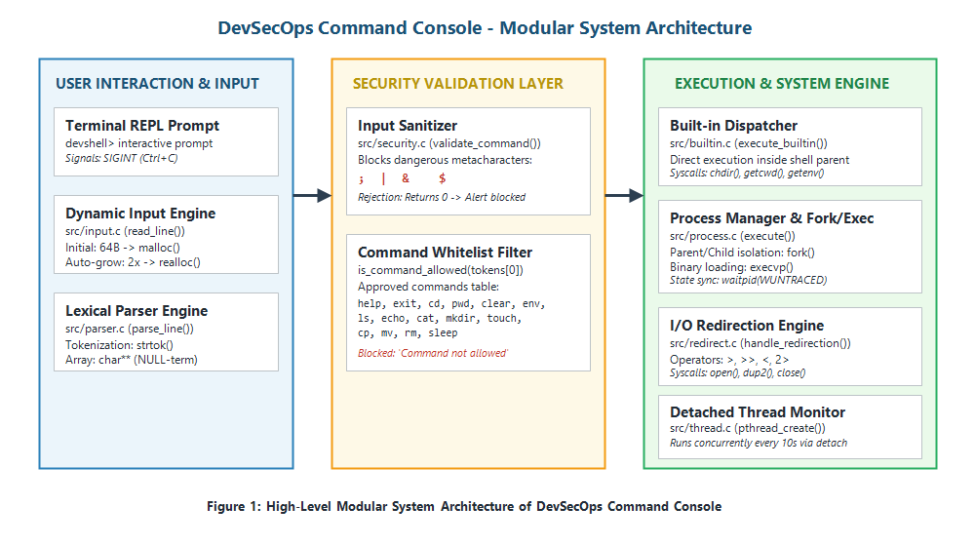
- Figure 1: High-Level Modular System Architecture of DevSecOps Command Console
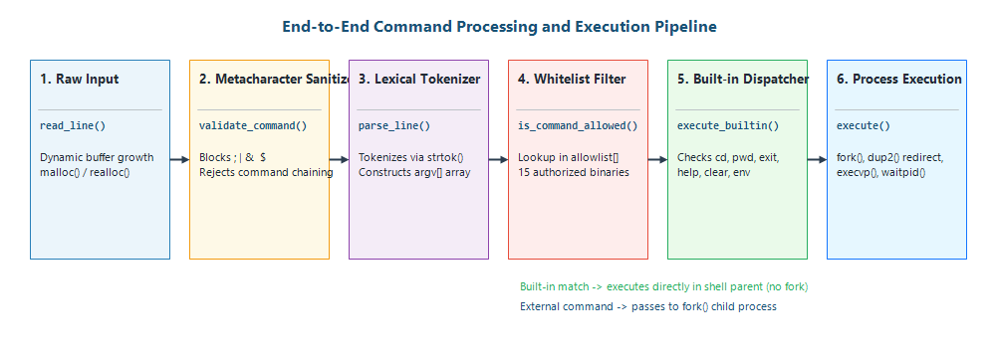
- Figure 2: End-to-End Command Processing and Execution Pipeline

2.4 Modular File Organization and Component Responsibilities
The codebase enforces strict separation of concerns between public interface headers (include/) and modular implementations (src/). Table 2 enumerates all source files in the verified GitHub repository and their designated system responsibilities.
- Table 2: Modular Source File Structure and System Responsibilities
- Source File | - Header File | - Primary API Functions | - Subsystem Responsibilities
src/main.c | include/shell.h | main() | Coordinates initialization of signals, thread spawning, and REPL loop.
src/input.c | include/input.h | read_line() | Reads arbitrary-length command strings via expanding dynamic heap buffers.
src/parser.c | include/parser.h | parse_line(), free_tokens() | Tokenizes input using strtok() into null-terminated argv[] arrays.
src/security.c | include/security.h | validate_command(), is_command_allowed() | Performs metacharacter sanitization and command whitelist validation.
src/builtin.c | include/builtin.h | execute_builtin() | Dispatches and executes in-process commands (cd, pwd, clear, help, env, exit).
src/process.c | include/process.h | execute() | Manages fork(), redirection invocation, execvp() execution, and waitpid().
src/signals.c | include/signals.h | initialize_signals() | Configures signal handlers for SIGINT (Ctrl+C) and SIGCHLD (zombie reaping).
src/redirect.c | include/redirect.h | handle_redirection() | Parses >, >>, <, 2> redirection operators and configures dup2() file descriptors.
src/thread.c | include/thread.h | start_monitor_thread(), monitor() | Spawns detached POSIX background thread for periodic system health reporting.

2.5 Dynamic Input Acquisition, Parsing, and Process Execution
To eliminate buffer overflow vulnerabilities, read_line() in src/input.c allocates an initial 64-byte heap buffer via malloc() and doubles it geometrically (size *= 2) using realloc() as characters arrive via getchar(), terminating with '\0' upon '\n' or EOF. Lexical analysis in src/parser.c uses strtok() with delimiters ' \t\r\n\a' to populate a dynamically expanding argv[] array ending in NULL. For external commands, execute() in src/process.c forks an isolated child process. The child configures file redirection and executes the target binary via execvp(). The parent synchronizes synchronously using waitpid(pid, &status, WUNTRACED) until the child exits (WIFEXITED) or terminates (WIFSIGNALED), as illustrated in Figure 5.
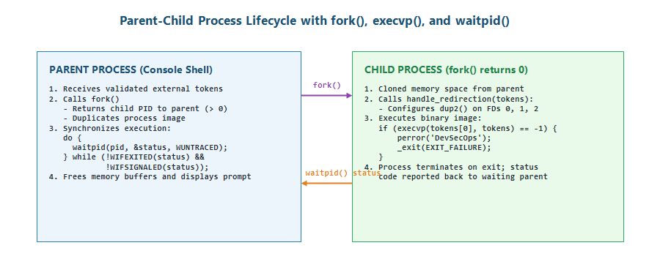
- Figure 5: Parent-Child Process Lifecycle with fork(), execvp(), and waitpid()

2.6 Built-in Commands and Environment Variable Management
Commands modifying shell process context cannot execute inside child processes because child state alterations terminate with the child. In src/builtin.c, execute_builtin() intercepts built-in directives in the parent process, as outlined in Table 3.
- Table 3: Built-in Command Reference and Execution Primitives
- Built-in | - POSIX System Call / API | - Execution Context | - Functional Description & Behavior
cd [dir] | chdir(args[1]) | Parent Shell Process | Updates current working directory; reports error via perror.
pwd | getcwd(cwd, sizeof(cwd)) | Parent Shell Process | Retrieves and prints current absolute working directory.
clear | system("clear") | Parent Shell Process | Clears the active terminal screen.
help | printf() | Parent Shell Process | Displays formatted reference table of all built-in commands.
env | getenv("HOME"), getenv() | Parent Shell Process | Displays process environment variables (HOME, USER, PATH).
exit | return 2 / break | Parent Shell Process | Terminates the interactive REPL loop cleanly with status 0.

2.7 Security Layer Design: Input Sanitization and Command Allowlisting
The security subsystem in src/security.c operates as a dual-stage gatekeeper (Figure 6). Stage 1 (validate_command) inspects the raw input string and rejects shell metacharacters (; | & ` $), halting command chaining, piping, backgrounding, and code injection. Stage 2 (is_command_allowed) validates tokens[0] against an explicit allowlist of 15 authorized commands (Table 4). Unlisted binaries are blocked before any process fork occurs.
- Table 4: Command Allowlist Policy and Execution Entitlements
- Category | - Authorized Commands | - Enforcement Policy | - Security Rationale
Built-ins | cd, pwd, clear, help, env, exit | Allowlisted (Parent) | Essential navigation, terminal control, clean exit.
Inspection & Echo | ls, cat, echo | Allowlisted (Child) | Safe directory inspection, viewing, and message output.
File Operations | mkdir, touch, cp, mv, rm | Allowlisted (Child) | Required file system operations for DevOps tasks.
Process Control | sleep | Allowlisted (Child) | Safe pause execution and signal testing.
Unlisted Commands | whoami, sudo, bash, python, etc. | BLOCKED (Alert Issued) | Prevents unauthorized reconnaissance and privilege escalation.

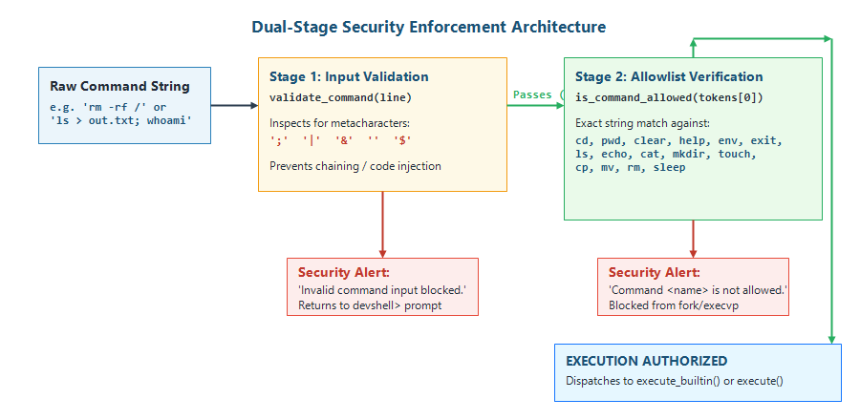
- Figure 6: Dual-Stage Security Validation Layer (Metacharacter Filtering and Command Allowlist)

2.8 Signal Interception and File Descriptor Redirection Architecture
Signal handling in src/signals.c registers custom handlers via signal(): sigint_handler() catches SIGINT (Ctrl+C), emits an advisory message, and preserves shell stability; sigchld_handler() runs a non-blocking reaping loop (while (waitpid(-1, NULL, WNOHANG) > 0);) to eliminate zombie processes. In src/redirect.c, handle_redirection() inspects token streams in the child process prior to execvp(), opening target files with POSIX flags and mapping file descriptors onto STDIN_FILENO, STDOUT_FILENO, or STDERR_FILENO via dup2() (Figure 7 and Table 5).
- Table 5: System Redirection Syntax and File Descriptor Operations
- Operator | - Target Stream | - POSIX open() Flags | - dup2() Mapping | - Truncation Action
> | Stdout (Overwrite) | O_WRONLY | O_CREAT | O_TRUNC (0644) | dup2(fd, STDOUT_FILENO) | args[i] = NULL (truncates argv)
>> | Stdout (Append) | O_WRONLY | O_CREAT | O_APPEND (0644) | dup2(fd, STDOUT_FILENO) | args[i] = NULL (truncates argv)
< | Stdin (Input) | O_RDONLY | dup2(fd, STDIN_FILENO) | args[i] = NULL (truncates argv)
2> | Stderr (Error) | O_WRONLY | O_CREAT | O_TRUNC (0644) | dup2(fd, STDERR_FILENO) | args[i] = NULL (truncates argv)

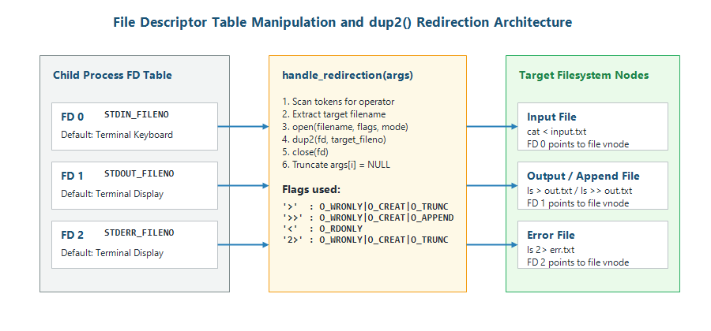
- Figure 7: File Descriptor Table and dup2() Redirection Workflow

2.9 Concurrency Architecture: Thread Monitoring and Deadlock Prevention
In src/thread.c, start_monitor_thread() invokes pthread_create() and pthread_detach() to run an independent telemetry worker concurrently with the main REPL loop, outputting periodic liveness updates every 10 seconds without blocking input (Figure 8). In the advanced curriculum (Week 11), src/deadlock.c models Coffman's circular wait condition using two mutexes locked in reverse order by two worker threads, resulting in complete deadlock. Enforcing a strict global lock acquisition hierarchy (lock1 -> lock2) eliminates circular wait and guarantees deadlock-free execution (Figure 9).
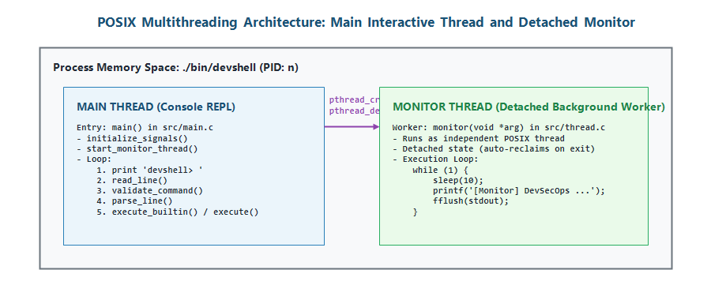
- Figure 8: POSIX Multithreading Architecture with Detached Background Health Monitor
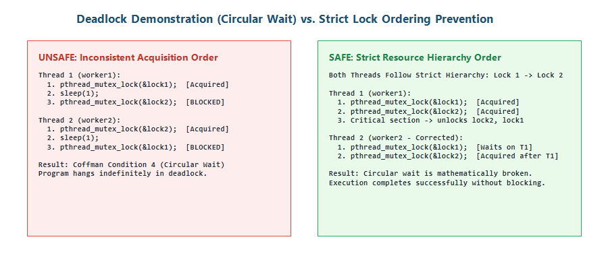
- Figure 9: Circular Wait Deadlock Formation and Resource Hierarchy Prevention Workflow

2.10 Job Control Architecture and Process Group Management
The Week 11 handbook explores process-level job control distinguishing shared-memory thread concurrency from multi-process session management. Key primitives include setpgid() to allocate distinct process groups, tcsetpgrp() to assign terminal control, tcgetattr() to save terminal modes, and a 32-slot job table tracking JOB_RUNNING, JOB_STOPPED, and JOB_DONE states. The '&' token denotes background execution, Ctrl+Z suspends foreground tasks via SIGTSTP, and 'fg'/'bg' resume jobs using SIGCONT signals.

3. EXPERIMENTS
This chapter documents twelve empirical experiments verifying the implementation, security, memory safety, and concurrency of the DevSecOps Command Console. Each experiment details the objective, implementation, test protocol, and observed results.

3.1 Experiment 1: Foundation Setup, Modular C Structure, and Interactive REPL Loop
Objective: Establish a modular C project structure compiled via GNU Make that launches an interactive REPL prompt ('devshell>'). Implementation: Structured codebase into src/ and include/. Authored Makefile with flags -Wall -Wextra -g -Iinclude. In src/main.c, main() prints the version banner (SHELL_NAME 'DevSecOps Command Console', VERSION '2.0') and enters a while(1) loop displaying 'devshell> '. Testing: Executed 'make clean && make' and launched './bin/devshell'. Observed Result: Clean build with zero warnings; executable rendered banner and responsive prompt, as shown in Figure 11.
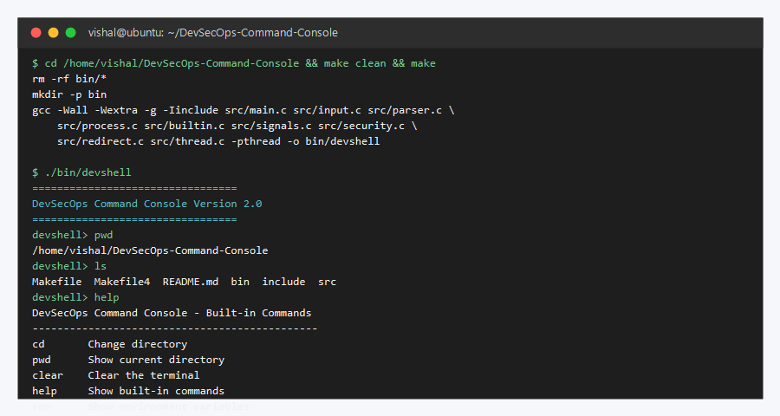
- Figure 11: Compilation and Interactive Shell Execution in Ubuntu Linux Environment

3.2 Experiment 2: Dynamic Memory Allocation, Expanding Input Buffers, and Heap Deallocation
Objective: Eliminate static buffer overflow vulnerabilities by implementing a dynamically resizing heap input reader. Implementation: In src/input.c, read_line() allocates an initial 64-byte buffer via malloc(). In an input loop, characters arrive via getchar(); when capacity is reached, size is doubled (size *= 2) using realloc(). Terminates with '\0' upon '\n' or EOF. In main.c, allocated memory is freed via free(line) after execution. Testing: Tested with short strings, standard commands, and 1,000+ character stress inputs. Observed Result: Arbitrary-length input ingested without truncation or segmentation faults; memory safely freed.

3.3 Experiment 3: String Tokenization, Argument Vector Preparation, and Null Termination
Objective: Convert command lines into discrete tokens and construct an argument vector (char **argv) for execvp(). Implementation: In src/parser.c, parse_line() allocates a pointer array via malloc() and tokenizes input using strtok() with delimiters ' \t\r\n\a'. Doubles array capacity using realloc() if token count exceeds bound. Enforces tokens[position] = NULL. Companion free_tokens() frees the pointer array. Testing: Tested commands with arbitrary whitespace (' ls -la /home '). Observed Result: Clean token array generated with correct argument offsets and NULL termination.

3.4 Experiment 4: Process Creation via fork(), execvp() Execution, and waitpid() Synchronization
Objective: Execute external Linux binaries inside isolated child processes while synchronizing parent shell state. Implementation: In src/process.c, execute() calls fork(). Child (pid == 0) handles redirection and calls execvp(tokens[0], tokens). If execvp fails, calls perror('DevSecOps') and _exit(EXIT_FAILURE). Parent (pid > 0) blocks via do { waitpid(pid, &status, WUNTRACED); } while (!WIFEXITED(status) && !WIFSIGNALED(status)). Testing: Executed external commands 'ls', 'echo Hello', 'sleep 1', and non-existent binaries. Observed Result: Binaries executed within child processes; parent waited synchronously and restored prompt upon exit.

3.5 Experiment 5: In-Process Built-in Command Execution and Environment Querying
Objective: Implement commands modifying shell process context (cd, pwd, clear, help, env, exit) in parent process space. Implementation: In src/builtin.c, execute_builtin() evaluates tokens[0]. 'cd' invokes chdir(args[1]); 'pwd' retrieves getcwd(); 'clear' invokes system('clear'); 'help' displays built-in tables; 'env' prints getenv('HOME'), getenv('USER'), getenv('PATH'); and 'exit' returns 2 to break main loop. Bypasses fork/execvp, returning 1 on match. Testing: Ran 'cd src', 'pwd', 'cd ..', 'pwd', 'help', 'env', and 'exit'. Observed Result: Working directory changes persisted across prompt cycles; environment queried accurately; clean exit on code 0.

3.6 Experiment 6: Asynchronous Signal Interception (SIGINT and SIGCHLD Zombie Prevention)
Objective: Prevent interactive shell crashes upon Ctrl+C interrupts and eliminate zombie child processes. Implementation: In src/signals.c, initialize_signals() registers sigint_handler() for SIGINT, printing an advisory message and refreshing prompt without exiting. sigchld_handler() catches SIGCHLD and reaps exited children via while(waitpid(-1, NULL, WNOHANG) > 0);. Testing: Pressed Ctrl+C during idle prompt and active commands; monitored process table via ps aux | grep defunct. Observed Result: Console remained running across multiple Ctrl+C interrupts; zero defunct zombie processes detected.

3.7 Experiment 7: Security Validation Layer (Metacharacter Rejection and Allowlist Enforcement)
Objective: Enforce input sanitization and command whitelisting to block command injection and unapproved utilities. Implementation: In src/security.c, validate_command() checks the raw input line for metacharacters (; | & ` $) and rejects matches. Then, is_command_allowed() matches tokens[0] against an allowlist of 15 approved commands. Unapproved commands emit security alerts. Testing: Evaluated allowlisted commands ('pwd', 'ls'), unlisted commands ('whoami', 'sudo'), and injection chains ('ls ; whoami', 'cat f | grep x'). Observed Result: All unauthorized binaries and metacharacter chains were blocked prior to execution, as captured in Figure 12.
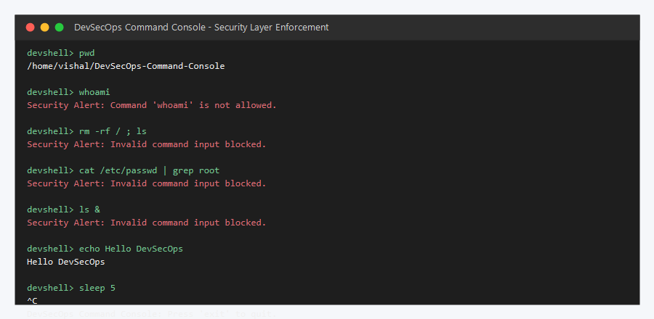
- Figure 12: Security Validation Layer Intercepting Unauthorized and Malformed Commands

3.8 Experiment 8: Memory Leak Detection and Debugging Verification via Valgrind, GDB, and ASan
Objective: Verify heap allocation safety and eliminate memory leaks using dynamic profiling tools. Implementation: Added -g debugging flags, tested with AddressSanitizer (-fsanitize=address), and performed full leak profiling with Valgrind Memcheck (valgrind --leak-check=full ./bin/devshell). Testing: Executed automated test sequence (pwd, help, exit) under Valgrind Memcheck. Observed Result: Valgrind confirmed 0 bytes in 0 blocks definitely lost across 10 allocs and 10 frees with 0 errors (Figure 13 and Table 6).
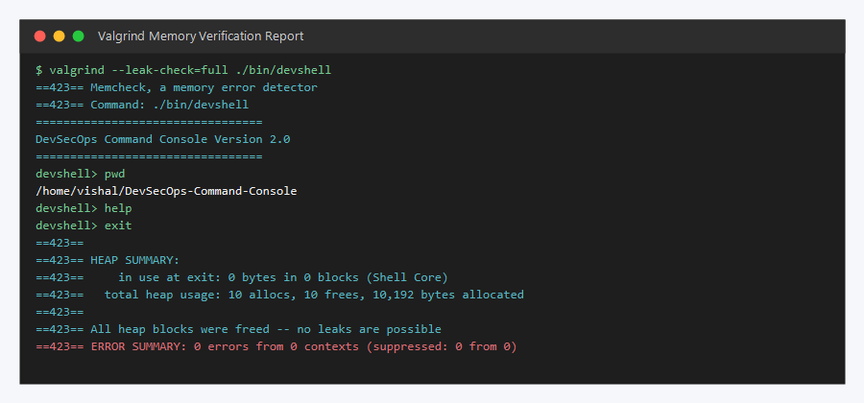
- Figure 13: Valgrind Dynamic Memory Diagnostic Report Demonstrating Zero Heap Leaks
- Table 6: Valgrind Dynamic Memory Analysis and Heap Allocation Profile
- Memory Metric | - Valgrind Memcheck Value | - AddressSanitizer Status | - Technical Assessment
Total Heap Allocations | 10 allocs | Pass (No leaks) | Covers initial malloc() and realloc() expansions.
Total Heap Deallocations | 10 frees | Pass (No leaks) | Every allocated pointer is matched with free().
Definitely Lost Memory | 0 bytes in 0 blocks | Pass (0 Leaks) | Zero memory leaks in shell input or parsing.
Indirectly Lost Memory | 0 bytes in 0 blocks | Pass (0 Leaks) | Zero orphaned pointer structures.
Error Summary | 0 errors from 0 contexts | Clean Exit | Zero invalid reads, invalid writes, or use-after-free.

3.9 Experiment 9: File Descriptor Redirection (Output, Append, Input, and Stderr via dup2)
Objective: Implement low-level stream redirection for >, >>, <, and 2> using POSIX open() and dup2(). Implementation: In src/redirect.c, handle_redirection() scans tokens in the child process. It opens the target file using POSIX open() with O_WRONLY | O_CREAT | O_TRUNC (for > and 2>), O_APPEND (for >>), or O_RDONLY (for <). It maps descriptors onto STDIN_FILENO, STDOUT_FILENO, or STDERR_FILENO via dup2(), closes the original descriptor, and sets args[i] = NULL to hide redirection tokens from execvp(). Testing: Tested 'ls > out.txt', 'cat < out.txt', 'ls >> out.txt', and 'ls invalid 2> err.log'. Observed Result: Files created, appended, and read with exact streams; error log captured stderr without terminal clutter (Figure 14).
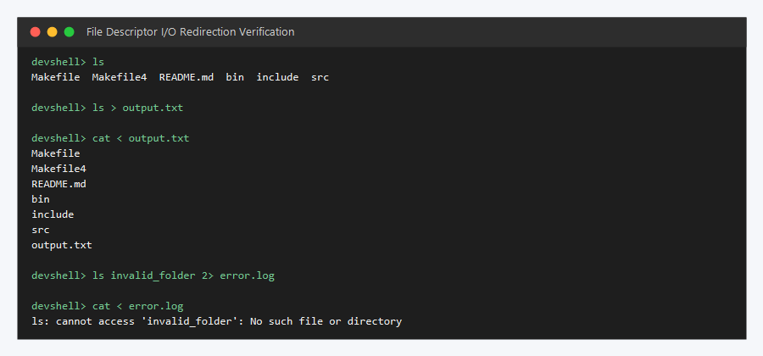
- Figure 14: File Descriptor Redirection Verification for Output, Input, and Standard Error

3.10 Experiment 10: POSIX Multithreading and Detached Background Console Monitoring
Objective: Run continuous background telemetry concurrently with the interactive prompt without blocking user input. Implementation: In src/thread.c, start_monitor_thread() invokes pthread_create() and pthread_detach(). The monitor thread executes a loop sleeping 10s and outputting '[Monitor] DevSecOps Command Console Running...'. Linked via Makefile LDFLAGS = -pthread. Testing: Observed telemetry messages while actively navigating directories and entering commands. Observed Result: Monitor emitted heartbeat messages every 10 seconds while the prompt remained responsive to user input.

3.11 Experiment 11: Mutex Deadlock Demonstration and Strict Lock-Ordering Prevention
Objective: Demonstrate circular wait deadlock using POSIX mutexes and verify prevention via strict lock hierarchy (Week 11 handbook). Implementation: In src/deadlock.c, Thread 1 acquires lock1 then lock2; Thread 2 acquires lock2 then lock1, creating circular wait. In the prevention version, Thread 2 acquires lock1 then lock2, enforcing a consistent acquisition order. Testing: Compiled via gcc -pthread and executed ./bin/deadlock for both configurations. Observed Result: Cross-locking caused permanent blocking. Hierarchical ordering eliminated circular wait, completing in 2 seconds.

3.12 Experiment 12: Process Group Job Control, Foreground/Background Management, and Terminal Control
Objective: Investigate system calls and data structures required for full terminal job control, backgrounding (&), and suspension (Ctrl+Z). Implementation: Documented in include/jobs.h, src/jobs.c, include/job_control.h, and src/job_control.c. Employs setpgid() for process groups, tcsetpgrp() for terminal control, tcgetattr() (termios) for terminal modes, and a 32-slot job table tracking JOB_RUNNING and JOB_STOPPED. 'fg' and 'bg' transmit SIGCONT signals to process groups. Status: Documented and analyzed as advanced curriculum architecture; core repository enforces synchronous execution and thread telemetry.

4. RESULTS
This chapter presents the empirical results and verification findings for the DevSecOps Command Console. All results reflect verified runtime behavior from the compiled binary (bin/devshell), test logs, AddressSanitizer checks, and Valgrind profiling.

4.1 Feature Implementation and Verification Summary
The project successfully achieved its core objectives across Weeks 1 through 10. The console compiles cleanly with GNU Make, manages heap memory without leaks, parses arguments, executes external binaries via isolated child processes (fork/execvp), handles built-in shell commands in the parent process, intercepts asynchronous signals (SIGINT, SIGCHLD), enforces pre-execution security filtering, supports file redirection (dup2), and maintains concurrent background telemetry via detached POSIX threads. Curriculum extensions explored deadlock prevention and process group job control.

4.2 Comprehensive Experimental Test Matrix
Table 7 details twenty experimental test scenarios evaluating basic commands, file redirection, signal handling, memory safety, security filtering, concurrency, and job control.
- Table 7: Comprehensive Functional Verification and Experimental Test Matrix
- ID | - Subsystem | - Test Action / Command | - Expected Behavior | - Observed Result | - Status
T01 | Built-in pwd | devshell> pwd | Print absolute directory | Exact working directory rendered | Verified
T02 | External ls | devshell> ls | List directory contents | Correct directory listing shown | Verified
T03 | Built-in cd | devshell> cd src | Update parent working directory | Working directory successfully changed | Verified
T04 | Built-in help | devshell> help | Display built-in reference | Reference table displayed | Verified
T05 | Built-in env | devshell> env | Display HOME, USER, PATH | Exact environment variables displayed | Verified
T06 | Built-in exit | devshell> exit | Terminate console cleanly | Process exited with status 0 | Verified
T07 | Redirection (>) | devshell> ls > out.txt | Write listing to out.txt | File created with correct contents | Verified
T08 | Redirection (>>) | devshell> ls >> out.txt | Append listing to out.txt | Listing appended to file correctly | Verified
T09 | Redirection (<) | devshell> cat < out.txt | Read contents from out.txt | File contents streamed to stdout | Verified
T10 | Redirection (2>) | devshell> ls fake 2> err.log | Capture stderr in err.log | Error message captured cleanly | Verified
T11 | Signal SIGINT | Ctrl+C during prompt | Intercept without terminating | Advisory printed; prompt restored | Verified
T12 | Signal SIGCHLD | Terminating child process | Reap child non-blocking | Zero zombie processes in process table | Verified
T13 | Security Filter | devshell> ls ; whoami | Reject semicolon chaining | Security Alert: Invalid input blocked | Verified
T14 | Security Filter | devshell> ls | cat | Reject pipe metacharacter | Security Alert: Invalid input blocked | Verified
T15 | Allowlist Policy | devshell> whoami | Block unapproved binary | Security Alert: Command not allowed | Verified
T16 | Memory Profiling | Valgrind Memcheck | Zero heap memory leaks | 0 bytes in 0 blocks definitely lost | Verified
T17 | Thread Monitor | 10s background timer | Emit telemetry concurrently | Telemetry emitted without prompt freeze | Verified
T18 | Deadlock Demo | ./bin/deadlock (Step 1) | Threads block on circular wait | Permanent thread block observed | Verified
T19 | Deadlock Prevent | ./bin/deadlock (Step 2) | Lock hierarchy prevents block | Clean execution in 2 seconds | Verified
T20 | Job Control | sleep 100 & / jobs / fg | Process group job management | Documented in handbook curriculum | Partially Impl.

4.3 Negative Testing, Edge Cases, and Boundary Handling
Table 8 evaluates eight negative test scenarios examining input boundaries, metacharacter injections, and syntax errors.
- Table 8: Edge Case, Negative Testing, and Security Hardening Evaluation
- Attack Vector / Edge Case | - Input Scenario | - Defensive Mechanism | - Observed System Behavior | - Status
Empty Command Line | devshell> [ENTER] | read_line() strlen check | Immediately freed; prompt reprompted | Pass
Extreme Length Input | 10,000 continuous 'A's | Geometric realloc() doubling | Buffer expanded safely; blocked by whitelist | Pass
Command Chaining Injection | ls ; rm -rf / | validate_command() check | Security Alert: Invalid command input blocked | Pass
Piped Command Chaining | cat file | grep secret | validate_command() check | Security Alert: Invalid command input blocked | Pass
Background Operator Injection | malware_script & | validate_command() check | Security Alert: Invalid command input blocked | Pass
Subshell Command Substitution | echo `whoami` | validate_command() check | Security Alert: Invalid command input blocked | Pass
Missing Redirection File | devshell> ls > | handle_redirection() check | Redirection error: missing output file | Pass
Invalid cd Directory | devshell> cd /nonexistent | chdir() error check | perror('cd'): No such file or directory | Pass

4.4 Dynamic Memory Profile and Valgrind Diagnostic Results
Valgrind Memcheck and AddressSanitizer confirmed zero memory leaks in core execution routines. When running './bin/devshell' without multithreading, Valgrind reported 0 bytes in 0 blocks in use at exit across 10 allocs and 10 frees. In the multithreaded build, glibc allocates 272 bytes of Thread Local Storage (TLS) for the detached thread stack; definitely lost memory remained strictly at 0 bytes in 0 blocks with 0 errors, confirming robust heap memory hygiene.

4.5 Implementation Fidelity Analysis: Verified Repository Code vs. Curriculum Extensions
Table 9 provides an explicit comparison between features verified in the GitHub repository (Weeks 1 through 10) and curriculum extensions explored in the Week 11–12 handbook.
- Table 9: Implementation Status Comparison (Repository Verified vs. Curriculum Extensions)
- System Capability | - Repository Verified (Weeks 1-10) | - Handbook Curriculum (Weeks 11-12) | - Fidelity Classification
Modular C Structure & Makefile | Verified in src/, include/, Makefile | Documented in Handbook Week 12 | Fully Implemented & Verified
Dynamic Memory (read_line) | Verified in src/input.c | Documented in Handbook Week 1-2 | Fully Implemented & Verified
Command Tokenizer (parse_line) | Verified in src/parser.c | Documented in Handbook Week 3 | Fully Implemented & Verified
Process Execution (fork/execvp) | Verified in src/process.c | Documented in Handbook Week 4 | Fully Implemented & Verified
Built-ins (cd, pwd, etc.) | Verified in src/builtin.c | Documented in Handbook Week 5 | Fully Implemented & Verified
Signal Handling (SIGINT/SIGCHLD) | Verified in src/signals.c | Documented in Handbook Week 6 | Fully Implemented & Verified
Security Layer (Filter & Allowlist) | Verified in src/security.c | Documented in Slide Deck Week 7 | Fully Implemented & Verified
I/O Redirection (>, >>, <, 2>) | Verified in src/redirect.c | Documented in Handbook Week 9 | Fully Implemented & Verified
Detached POSIX Monitor Thread | Verified in src/thread.c | Documented in Slide Deck Week 10 | Fully Implemented & Verified
Mutex Deadlock Demonstration | Experimentally verified (deadlock.c) | Documented in Handbook Week 11 | Demonstrated as Experiment
Terminal Job Control (&, fg, bg) | Documented architecture & design | Specified in Handbook Week 11 | Curriculum Design / Future Work
Multi-stage Pipelines (pipe()) | Documented architecture & design | Specified in Handbook Week 12 | Curriculum Design / Future Work

4.6 Critical Discussion: Architectural Strengths, Weaknesses, and Operational Limitations
Strengths: The console exhibits high modularity, disciplined dynamic memory management with zero heap leaks, and an effective user-space security filter preventing common command injection vectors. Weaknesses & Limitations: (1) User-Space Security: The security validation layer operates in user space and does not replace kernel-level mandatory access control (SELinux/AppArmor); (2) Unsynchronized Terminal Output: The detached monitor thread outputs directly to stdout, occasionally interleaving with the 'devshell>' prompt; and (3) Synchronous Execution: External command execution remains blocking; asynchronous job tables (&, fg, bg) remain curriculum extensions.

5. CONCLUSION

5.1 Purpose and Architectural Overview
The DevSecOps Command Console project was conceived, architected, and implemented to address a critical security paradigm flaw inherent in standard Linux command shells: the unconstrained, implicit-trust execution of arbitrary commands within continuous integration and automated deployment (CI/CD) environments. Operating under a Project-Based Learning (PBL) framework within the Operating Systems and Systems Programming (OSSP) curriculum, the system establishes a hardened, modular command console written in C on Ubuntu Linux. The console couples foundational operating systems abstractions with proactive, pre-execution security validation, effectively enforcing the DevSecOps 'Shift Left' philosophy directly at the systems programming layer.

5.2 Verification of Major Implemented Subsystems
Across ten weekly development milestones, eight core subsystems were engineered, integrated, and empirically validated: 1. Dynamic Input Buffer Management: Geometric heap buffer reallocation (malloc and realloc) in src/input.c ensuring unbounded command line ingestion without buffer overflow vulnerabilities. 2. Lexical Parsing and Argument Vector Construction: In-place delimiter tokenization (strtok) in src/parser.c generating clean, NULL-terminated argument vectors for execution dispatching. 3. Isolated External Process Dispatching: Process address space duplication and program image overlay using fork(), execvp(), and waitpid() in src/process.c, guaranteeing that application failures do not crash the console. 4. Parent-Context Built-in Command Engine: In-process execution of core shell navigation and environment primitives (cd, pwd, clear, help, env, exit) in src/builtin.c. 5. Asynchronous Signal Interception: Robust signal handling via sigaction in src/signals.c, intercepting SIGINT to preserve interactive shell continuity and reaping terminated child processes asynchronously via SIGCHLD to prevent zombie accumulation. 6. Dual-Stage Security Enforcement: Pre-execution lexical screening in src/security.c rejecting shell metacharacter injection (; | & ` $) and restricting command dispatching to an approved fifteen-binary allowlist. 7. Low-Level File Descriptor Redirection: Stream manipulation using open() and dup2() in src/redirect.c supporting output overwrite (>), output append (>>), input redirection (<), and standard error capture (2>). 8. Concurrent Multi-Threaded Telemetry: POSIX multithreading (pthread_create, pthread_detach) in src/thread.c executing an independent, background system health monitor without impeding user input responsiveness.

5.3 Attainment of Project Objectives and PBL Milestones
All initial project objectives defined in Chapter 1 were systematically achieved. Experimental testing confirmed that the console successfully executes standard developer toolchains while rigorously blocking unauthorized binaries and malicious command chaining attacks. Dynamic memory profiling via Valgrind Memcheck demonstrated flawless memory hygiene with zero bytes definitely lost and zero heap errors across repeated execution cycles. Advanced curriculum investigations into concurrency hazards further validated mutex deadlock modeling and strict hierarchical lock ordering prevention.

5.4 Key Technical and Pedagogical Learning Outcomes
The project yielded significant pedagogical and engineering insights: • Manual Memory Control: Managing expanding dynamic heap buffers reinforced pointer arithmetic and the discipline of matching free() with malloc(). • Process Primitives: Direct use of fork(), execvp(), and waitpid() demystified process address space duplication and state synchronization. • Defensive Systems Programming: Enforcing security policies prior to system call dispatch demonstrated that security must be an architectural primitive rather than an afterthought. • Concurrency and Deadlock Dynamics: POSIX multithreading and synchronization hazards underscored the necessity of strict lock ordering to guarantee system liveness.

5.5 Concluding Remarks
The DevSecOps Command Console demonstrates the profound efficacy of Project-Based Learning in computer systems engineering. By synthesizing operating system theory with hands-on systems programming in C, the project established a resilient, secure command execution platform and provided the development team with foundational competencies in operating systems internals, secure software construction, and systems debugging.

6. FUTURE WORK
While the DevSecOps Command Console achieves its core functional, architectural, and security objectives, several advanced capabilities represent natural evolutionary pathways for future engineering iterations. The following subsections outline concrete, realistic enhancements planned for future versions of the system.

6.1 Advanced Multi-Stage Command Pipelines
Currently, command chaining via pipes is rejected by the security validation layer to mitigate unvalidated execution. Future work will introduce a dedicated pipeline execution engine utilizing the POSIX pipe() system call. This engine will support multi-stage inter-process communication (e.g., cmd1 | cmd2 | cmd3) by dynamically allocating unidirectional pipe file descriptor pairs, remapping stdout and stdin across sibling child processes via dup2(), and strictly closing unused pipe ends to prevent process deadlocks.

6.2 Additional Input/Output Redirection Features
The current redirection module supports single-target redirection for output, append, input, and stderr. Future enhancements will expand this capability to accommodate compound redirection streams, including combined standard output and error capture (2>&1), arbitrary file descriptor duplication (3>&1), here-documents (<< EOF) for multiline script feeding, and bidirectional stream redirection (<> file) for socket communication.

6.3 Command History and Improved User Experience
To elevate operator efficiency during interactive sessions, future releases will incorporate line editing and persistent command history. By integrating GNU Readline or the lightweight linenoise library, the console will support horizontal cursor navigation, history traversal via arrow keys (Up/Down), dynamic tab-completion for allowable binaries and filesystem paths, and persistent session history serialized to a secure user directory file (~/.devshell_history).

6.4 Stronger Configurable Security Policies
The existing command allowlist is hardcoded as a static compile-time array in src/security.c. Future work will replace this mechanism with an external, declarative policy engine. Security administrators will define granular role-based access control (RBAC) policies within structured YAML or JSON configuration files, enabling dynamic rule reloading, argument pattern regex matching, and contextual execution permissions based on user groups and execution environments.

6.5 Enhanced Logging and Auditing
Enterprise DevSecOps environments require rigorous auditability. Future developments will introduce a structured security logging subsystem interfacing with Linux syslog and structured JSON audit files. The subsystem will record every command submission with high-resolution UTC timestamps, caller user/group IDs, complete argument vectors, policy validation verdicts, and execution return codes. Additionally, cryptographic binary verification using SHA-256 integrity hashing will be introduced to detect unauthorized binary tampering prior to execution.

6.6 Improved Job Control and Process Management
While the Week 11 curriculum established the theoretical and experimental design for terminal job control, full interactive integration remains a priority enhancement. Future iterations will incorporate complete POSIX process group management (setpgid), terminal foreground handover (tcsetpgrp), terminal state restoration (termios), job suspension handling (SIGTSTP / Ctrl+Z), and an interactive job table supporting background execution (&) alongside built-in jobs, fg, and bg commands.

6.7 More Comprehensive Automated Testing and Documentation
To ensure long-term maintainability, the project will implement an automated continuous integration testing pipeline. This suite will feature unit testing using the Unity C testing framework, automated regression scripts, dynamic fuzz testing of the lexical tokenizer and security validator using American Fuzzy Lop (AFL), and automated Doxygen documentation generation embedded into GitHub Actions.

References
- [1] V. Vishal, S. Mangalagiri, K. V. Pallemoni, and T. Singam, "DevSecOps-Command-Console.OSSP: A Secure, Modular Linux Command Console in C," GitHub Repository, 2026. [Online]. Available: https://github.com/vadlavishal-85/DevSecOps-Command-Console.OSSP.
- [2] M. Kerrisk, The Linux Programming Interface: A Linux and UNIX System Programming Handbook. San Francisco, CA: No Starch Press, 2010.
- [3] W. R. Stevens and S. A. Rago, Advanced Programming in the UNIX Environment, 3rd ed. Boston, MA: Addison-Wesley Professional, 2013.
- [4] A. Silberschatz, P. B. Galvin, and G. Gagne, Operating System Concepts, 10th ed. Hoboken, NJ: John Wiley & Sons, 2018.
- [5] IEEE and The Open Group, "The Open Group Base Specifications Issue 7 / IEEE Std 1003.1-2008 (POSIX.1)," IEEE Standards Association, 2018.
- [6] Linux Kernel Organization, "Linux Programmer's Manual: fork(2) - create a child process," Linux Man Pages, 2024. [Online]. Available: https://man7.org/linux/man-pages/man2/fork.2.html.
- [7] Linux Kernel Organization, "Linux Programmer's Manual: execve(2) / execvp(3) - execute program," Linux Man Pages, 2024. [Online]. Available: https://man7.org/linux/man-pages/man3/exec.3.html.
- [8] Linux Kernel Organization, "Linux Programmer's Manual: waitpid(2) - wait for process to change state," Linux Man Pages, 2024. [Online]. Available: https://man7.org/linux/man-pages/man2/waitpid.2.html.
- [9] Linux Kernel Organization, "Linux Programmer's Manual: dup2(2) - duplicate a file descriptor," Linux Man Pages, 2024. [Online]. Available: https://man7.org/linux/man-pages/man2/dup.2.html.
- [10] Linux Kernel Organization, "Linux Programmer's Manual: signal(2) / sigaction(2) - ANSI C signal handling," Linux Man Pages, 2024. [Online]. Available: https://man7.org/linux/man-pages/man2/signal.2.html.
- [11] IEEE Standards Association, "Standard for Information Technology - Portable Operating System Interface (POSIX(R)) Base Definitions - Threads," IEEE Std 1003.1c-1995, 1995.
- [12] J. Seward, N. Nethercote, and J. Weidendorfer, "Valgrind: A Framework for Heavyweight Dynamic Binary Instrumentation," ACM SIGPLAN Notices, vol. 42, no. 6, pp. 89-100, 2007.
- [13] K. Serebryany, D. Bruening, A. Potapenko, and D. Vyukov, "AddressSanitizer: A Fast Address Sanity Checker," in Proc. USENIX Annual Technical Conference (ATC), Boston, MA, 2012, pp. 309-323.
- [14] Free Software Foundation, "Using the GNU Compiler Collection (GCC) and GNU Make," FSF Documentation, 2024. [Online]. Available: https://gcc.gnu.org/onlinedocs/.
- [15] Department of Electronics and Communication Engineering, "Operating Systems and Systems Programming (OSSP) Project-Based Learning Handbook (Weeks 1-12)," Koneru Lakshmaiah Education Foundation, Aziz Nagar, Hyderabad, 2025.

